1. The Weekly… 🡪 Digital Marketing in Your Monthly Budget  
   30K+ 🡪 Start Now (and link it to https://dexon.websblog.in/what-do-we-do/  
   **This was supposed to be edited. Or image was supposed to be replaced.  
   But I found that image is removed. Now there is no attraction left in Hero section.**  
   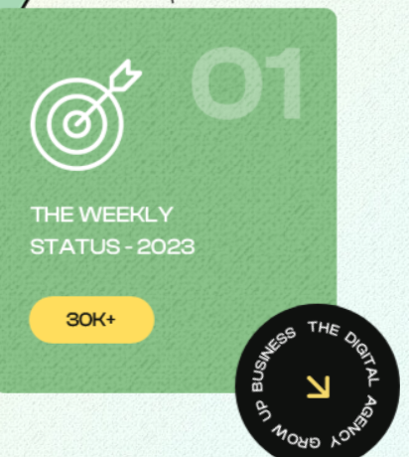

1. Home page  
   Backgrouns is white. Please use any light color other than white.  
   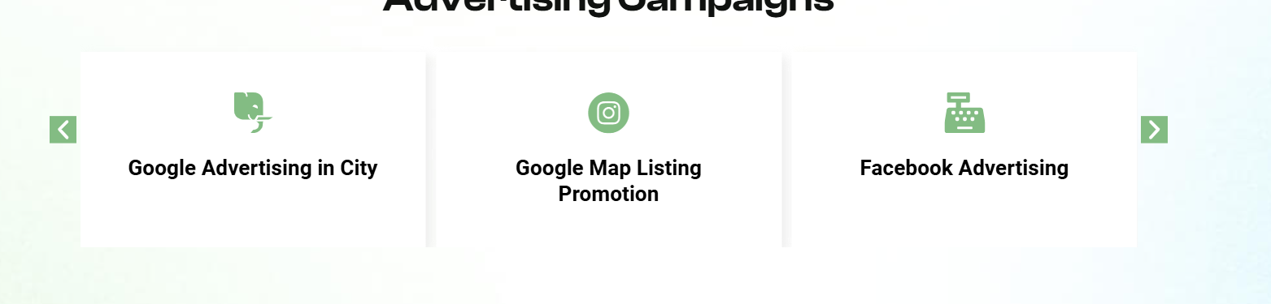  
   It is done. You have changed it to pink. I want to change it’s pink color. How can I do it myself?  
   **Please send me a video as how can I change color.**
2. https://dexon.websblog.in/contact-us/  
     
   **C. Where this form is going?** [**info@aDigitalGrowth.com**](mailto:info@aDigitalGrowth.com) **added email in formidable from**

**For the last one (Printed Flyers), I am attaching an xls file (Flyer Package).  
For this page, your team has not taken data from above requested xls file (Flyer Package).  
Please do it. done**  
  
**Corrections – Jan 24, 2025**

**5. At many pages, buttons (monthly/yearly) not working properly. For example at** [**https://dexon.websblog.in/reply-to-google-reviews-building-trust-one-response-at-a-time/**](https://dexon.websblog.in/reply-to-google-reviews-building-trust-one-response-at-a-time/) **we can see that it Is not written (Monthly, Yearly). Only 2 boxes are there. Please ask your team to check all pages for this problem and correct wherever the problem is. done   
  
6. In https://dexon.websblog.in/creation-of-videos-for-social-media-captivate-your-audience-with-compelling-content/  
There is difference in Monthly and Yearly Boxes. In Monthly, there is a text line above price. In yearly, that line is missing. Please ask your team to maintain regularlity.**

7. Home Page  
A. Please send video to change color of boxes (for example, pink box).

B. Please remove these graphics. done  
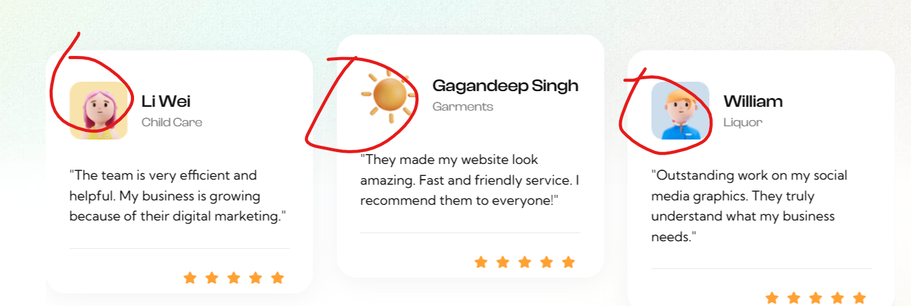

C. Footer Menu  
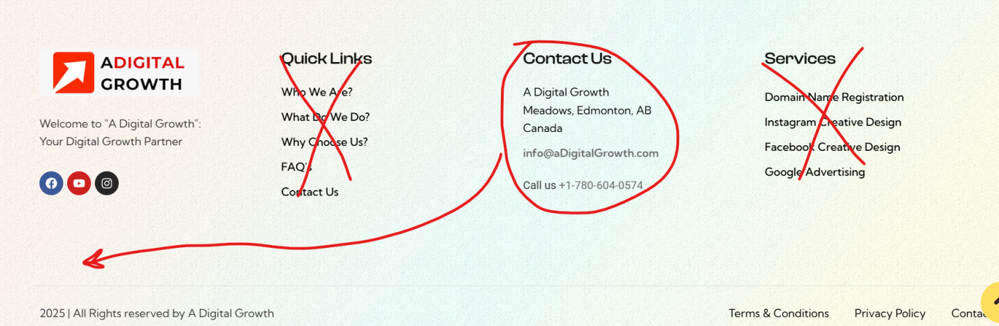(i) Delete Quick Link section  
(ii) Delete Services section  
(iii) Move Contact Us section below Social Links  
(iv) Now you have empty space. Make 4 sections. In top heder menu, you can see the link Package. It is having these 4 sections. Free Services, Power Tools, Web Solutions, Ad Campaign. Mention all those services here.

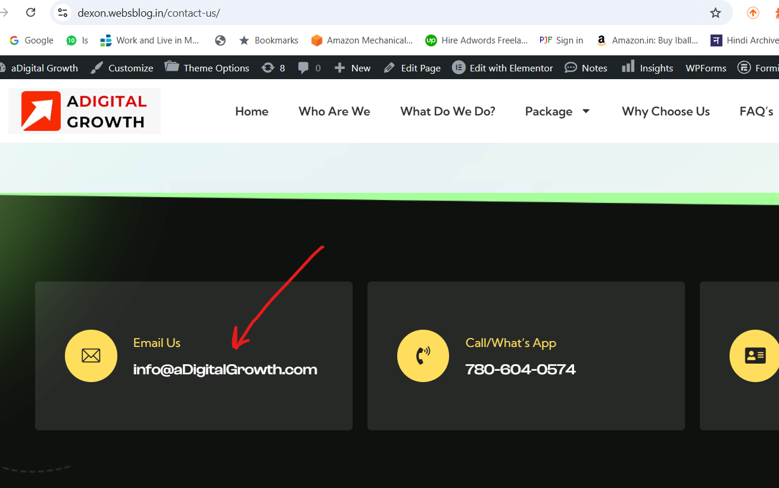

1. How to bring it to next line? What if I want that the bracket should start from next line? <br/>  
   
2. Many pages are not having Monthly and Yearly. It should be written there. Some pages it is written. At many pages, it is not written. Please ask your team to check all pages and correct it wherever it is missing.  
   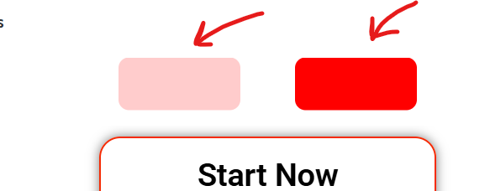
3. This line is in monthly plan.  
   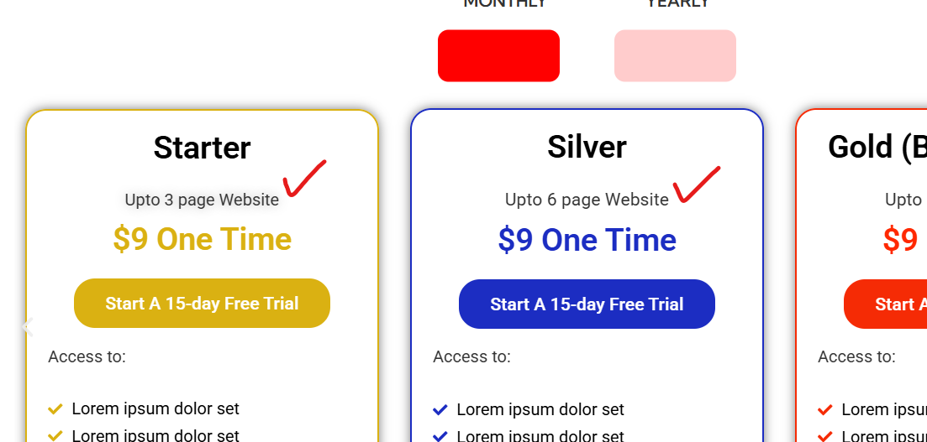  
   But wnen I go to yearly package, this line is not there.  
     
   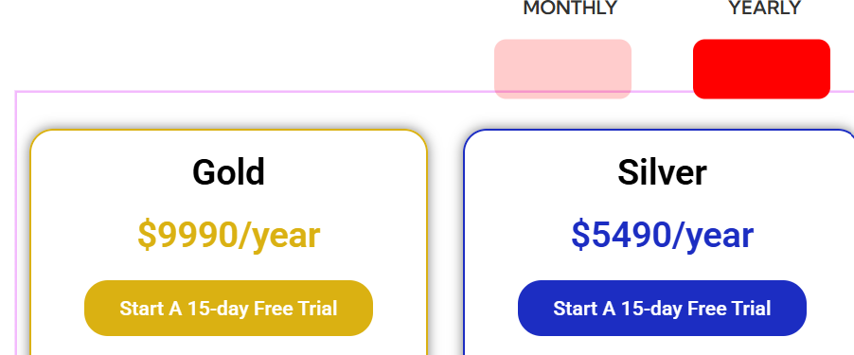  
   Please ask your developer to check all pages for this problem.
4. https://dexon.websblog.in/amazon-marketing-expand-to-the-usa-and-boost-your-sales/  
   First box (YELLOW Color) is bigger in size. done  
   