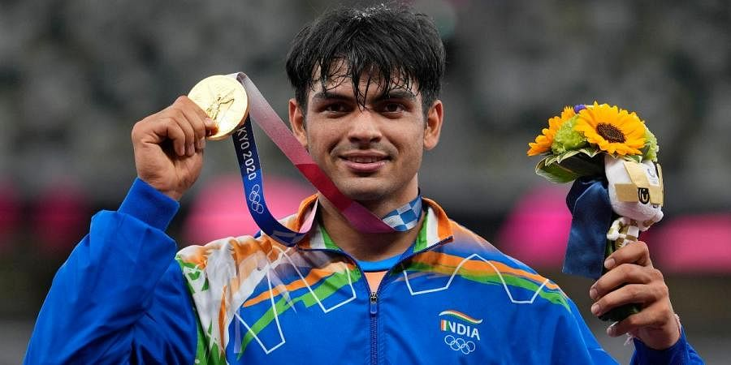

NEERAJ CHOPRA

Neeraj Chopra born on 24th December 1997.The nation won its first medal in track and field, which also happened to be the first gold in 13 years. It] the first medal in hockey in 41 years, the first silver in weightlifting, and the first boxing medal in 9 years. P V Sindhu became the first women in India’s history who won 2 Olympic medals. The contingent comprised the greatest number of debutants ending up on the podium, and the greatest number of medals ever won-total 7 medals.

Thankyou!

By Jaideep Manshani