**Step to execute this project**

**Installation requirement:-**

1) python 3.8.3

2) Install Anaconda 3 and set environment variable path.

3) Install OpenCV (cv2) using command prompt.

1. pip install opencv-python

After done installation, unzip gad.zip folder and use following instruction to run project.

1) Open command prompt and set location to unzip gad folder.

2) Then run gad.py file with image path name like "py gad.py --image LittleGirl.jpg"

Example 1:

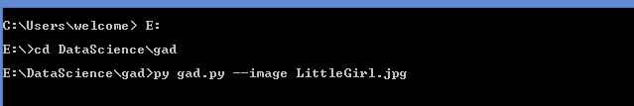

Output :-

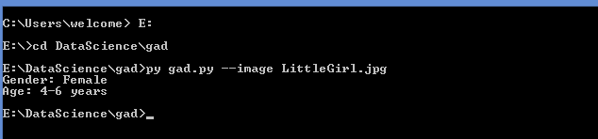

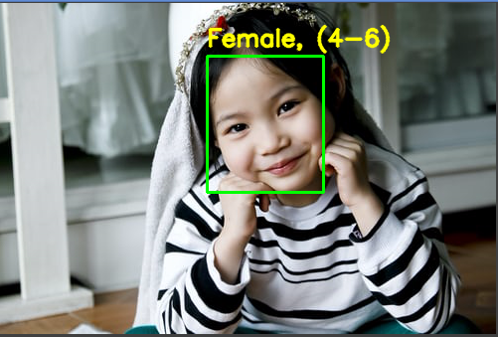

Example 2:-



Output 2:- 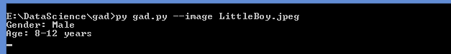

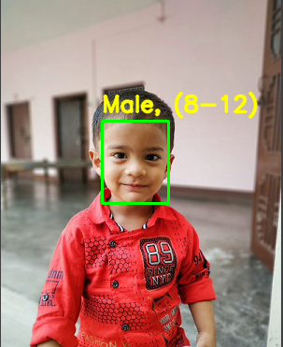

Example 3:-



Output:-



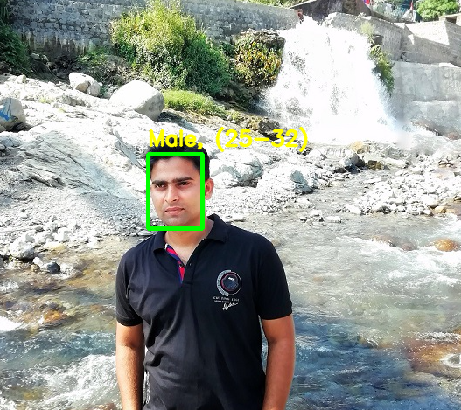

Example 4:-



Output:-

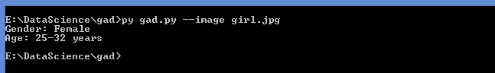

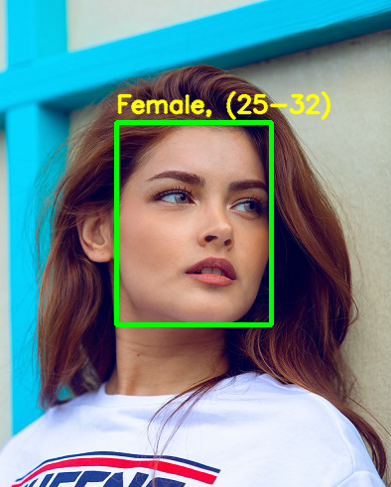

Example 5:-



Output :-

