drop table sample_business;

create table sample_business as

(select y.id as business_id,y.address,y.city,y.is_open,y.latitude,y.longitude,y.name,y.neighborhood,y.postal_code,

y.review_count,y.stars,y.state from business as y,

category as w where (y.id=w.business_id) and w.category = "Restaurants" limit 10000);

alter table sample_business add Primary key(business_id);

**LOAD** **DATA** **LOW_PRIORITY** **LOCAL** **INFILE** 'D:\\Intro to Big data\\restaurants.csv' **REPLACE** **INTO** **TABLE** `yelp_db`.`categoriestoimport` **FIELDS** **TERMINATED** **BY** ',' **OPTIONALLY** **ENCLOSED** **BY** '"' **ESCAPED** **BY** '"' **LINES** **TERMINATED** **BY** '\r\n' (`cat`);

*/* 214 rows imported in 0.047 seconds. */*

**SHOW** **WARNINGS**;

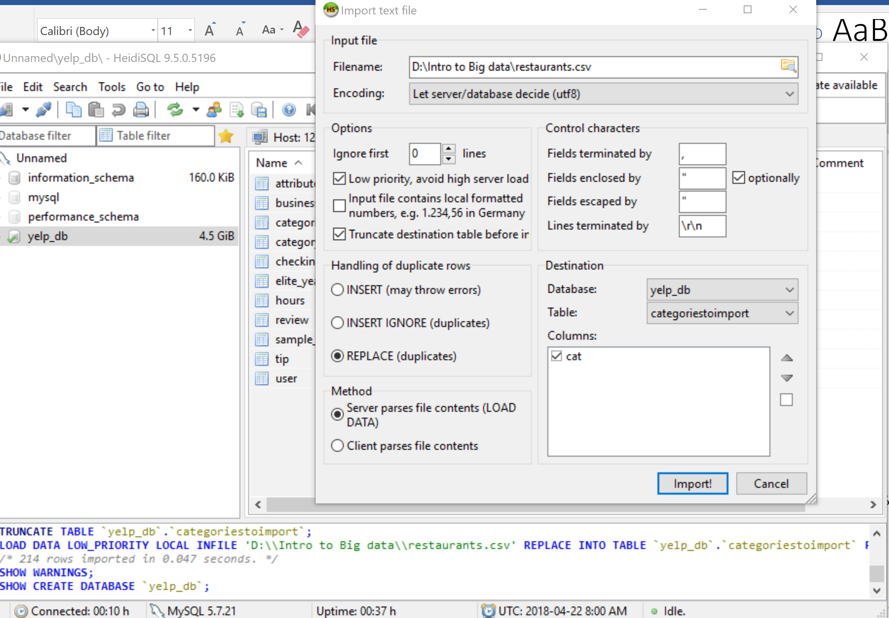

drop table sample_categories;

create table sample_categories as

(select c.business_id,c.category,c.id from category as c,categoriestoimport as x,sample_business as s where c.business_id =s.business_id and c.category=x.cat);

alter table sample_categories add Primary key (id);

alter table sample_categories ADD FOREIGN KEY (business_id) REFERENCES sample_business(business_id);



create table sample_review as

(select u.* from review as u, sample_business as s where u.business_id=s.business_id) limit 60000;

alter table sample_review add Primary key (id);

alter table sample_review ADD FOREIGN KEY (business_id) REFERENCES sample_business(business_id);

drop table sample_user;

create table sample_user as

(select distinct u.* from user as u, sample_review as s where u.id=s.user_id) ;

alter table sample_user add Primary key (id);

alter table sample_review ADD FOREIGN KEY (user_id) REFERENCES sample_user(id);

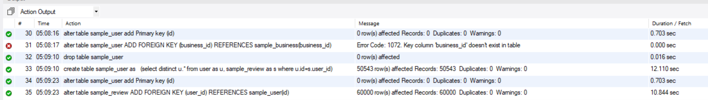

create table sample_tip as

(select u.* from tip as u, sample_business as s,sample_user as x where u.business_id=s.business_id and x.id=u.user_id) ;

alter table sample_tip add Primary key (id);

alter table sample_tip ADD FOREIGN KEY (business_id) REFERENCES sample_business(business_id);

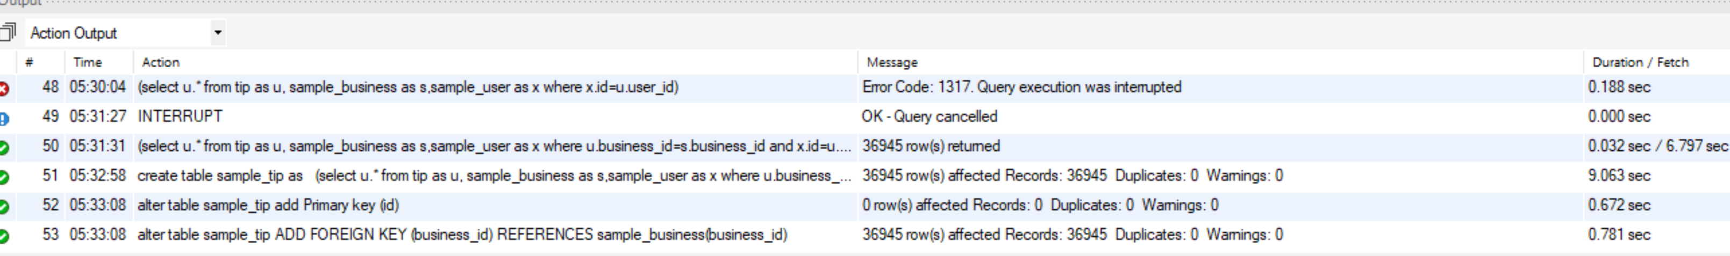

create table sample_checkin as

(select u.* from checkin as u, sample_business as s where u.business_id=s.business_id);

alter table sample_checkin add Primary key (id);

alter table sample_checkin ADD FOREIGN KEY (business_id) REFERENCES sample_business(business_id);



create table checkedin as

(SELECT

c.id,

c.business_id,

SUBSTRING_INDEX(date, '-', 1) AS day,

SUBSTRING_INDEX(date, '-', -1) AS time,

c.count

FROM checkin as c);

select time,count(*) from checkedin group by time order by count(*) desc;

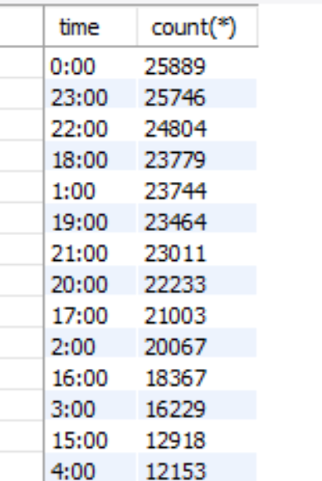

select day,count(*) from checkedin group by day order by count(*) desc;

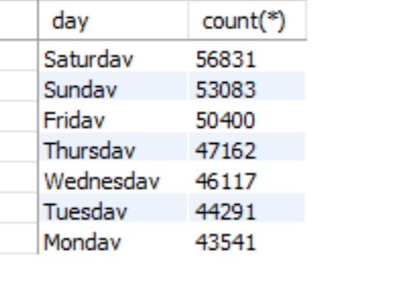

Example of finding busiest hours of a restaurant:

select day,count(*) from checkedin,business where checkedin.business_id=business.business_id and business.name="Pizza Hut" and business.city="North York" group by day order by count(*) desc;