Artefacts

1.new Homepage.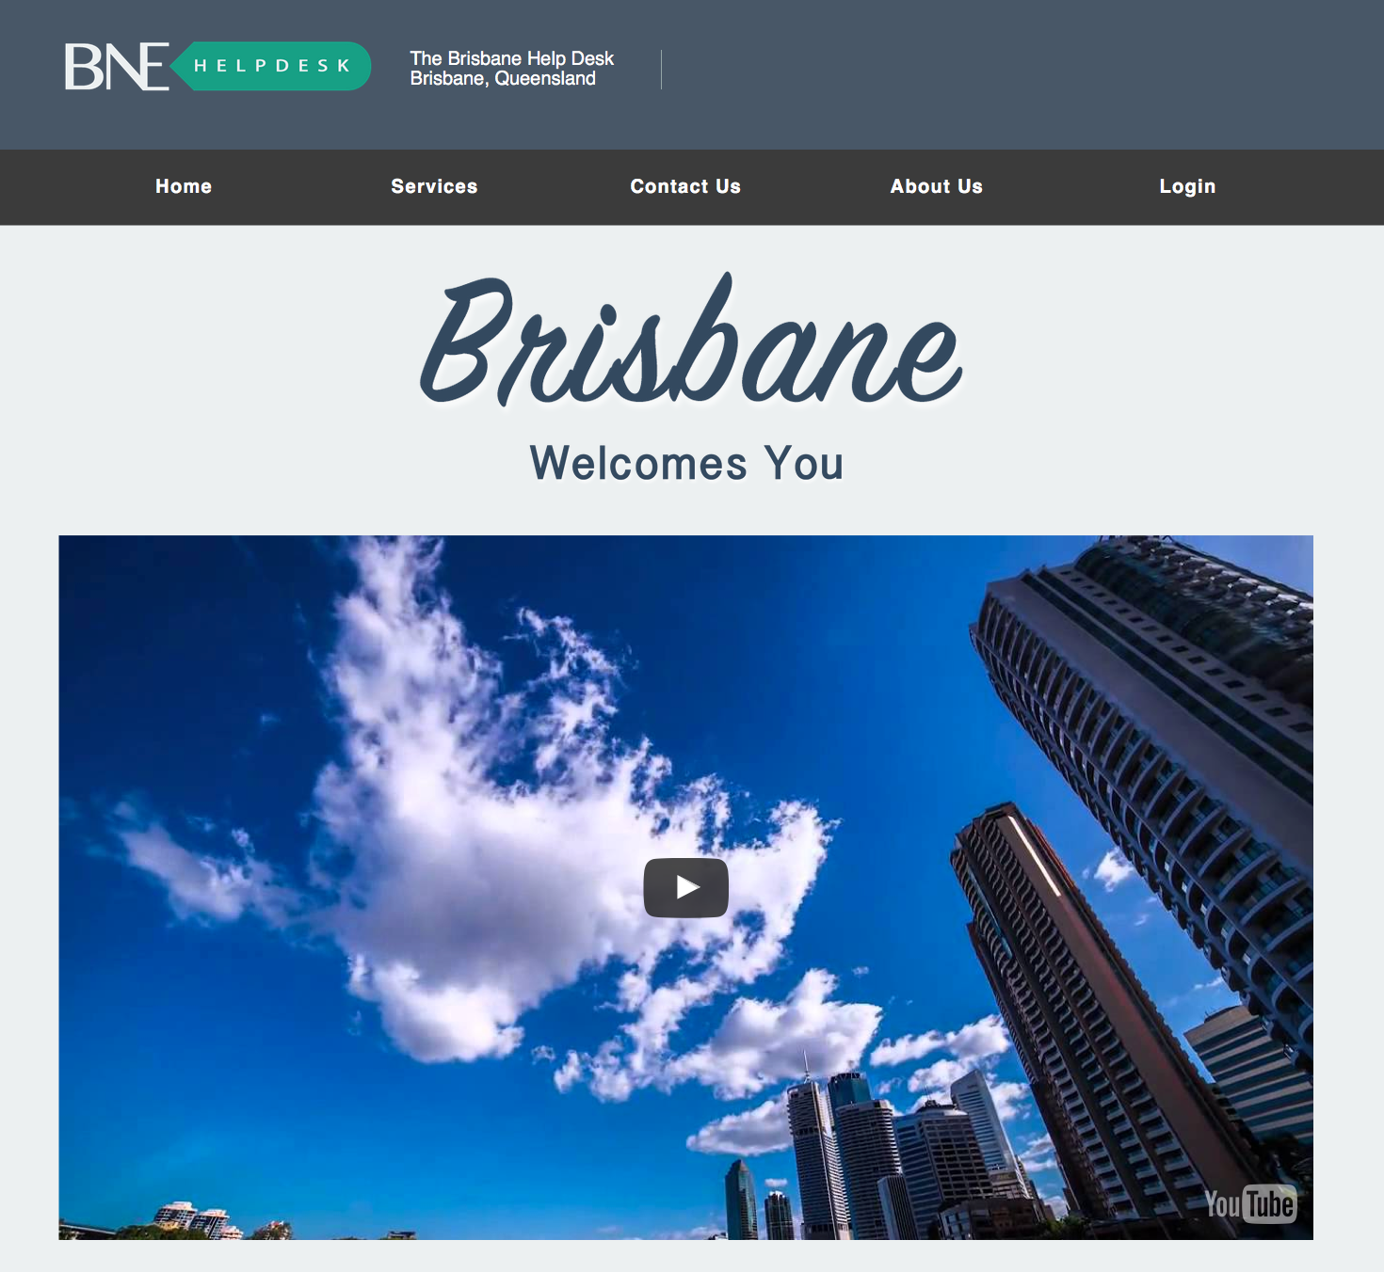

I designed a new homepage for the project. I added a welcome title to show that Brisbane help desk is willing to help those people in need. And I embed a youtube video which is the time lapse of Brisbane city view. It can make users feel comfortable and have a first insight of the the purpose of Brisbane help desk.

I used photoshop to create PNG files for the title and using youtube API to ember

Files involved: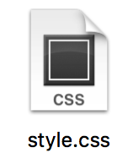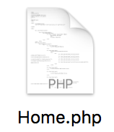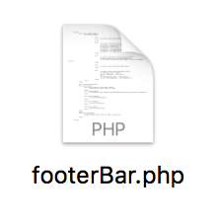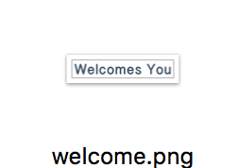



2. new designed about us page

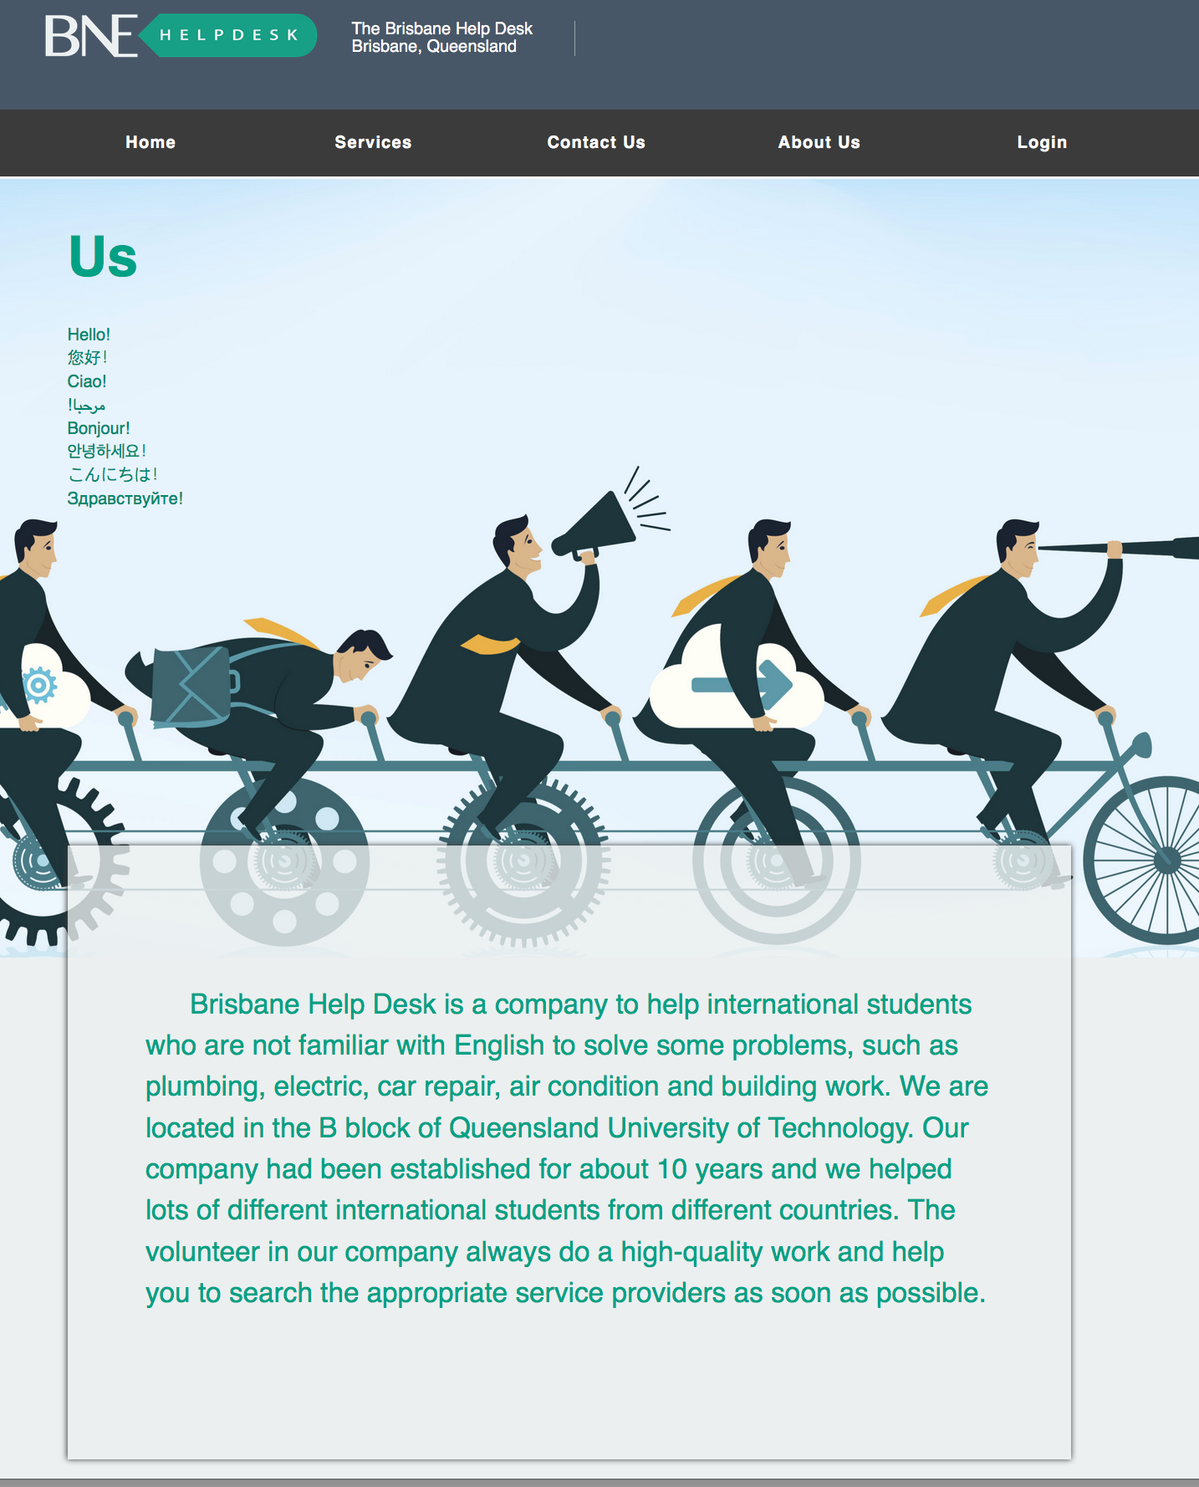

I replaced the old background at about us page and use a photo that can present hard-working stuffs working together. i showed that everyone in Brisbane help desk cooperate well and can deal with high pressure work due to satisfying teamwork. In addition, I add description of the company that the purpose of it and how they can offer users best service.

Files involved: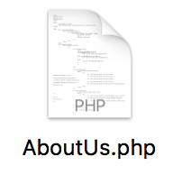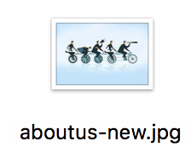

3. terms and conditions page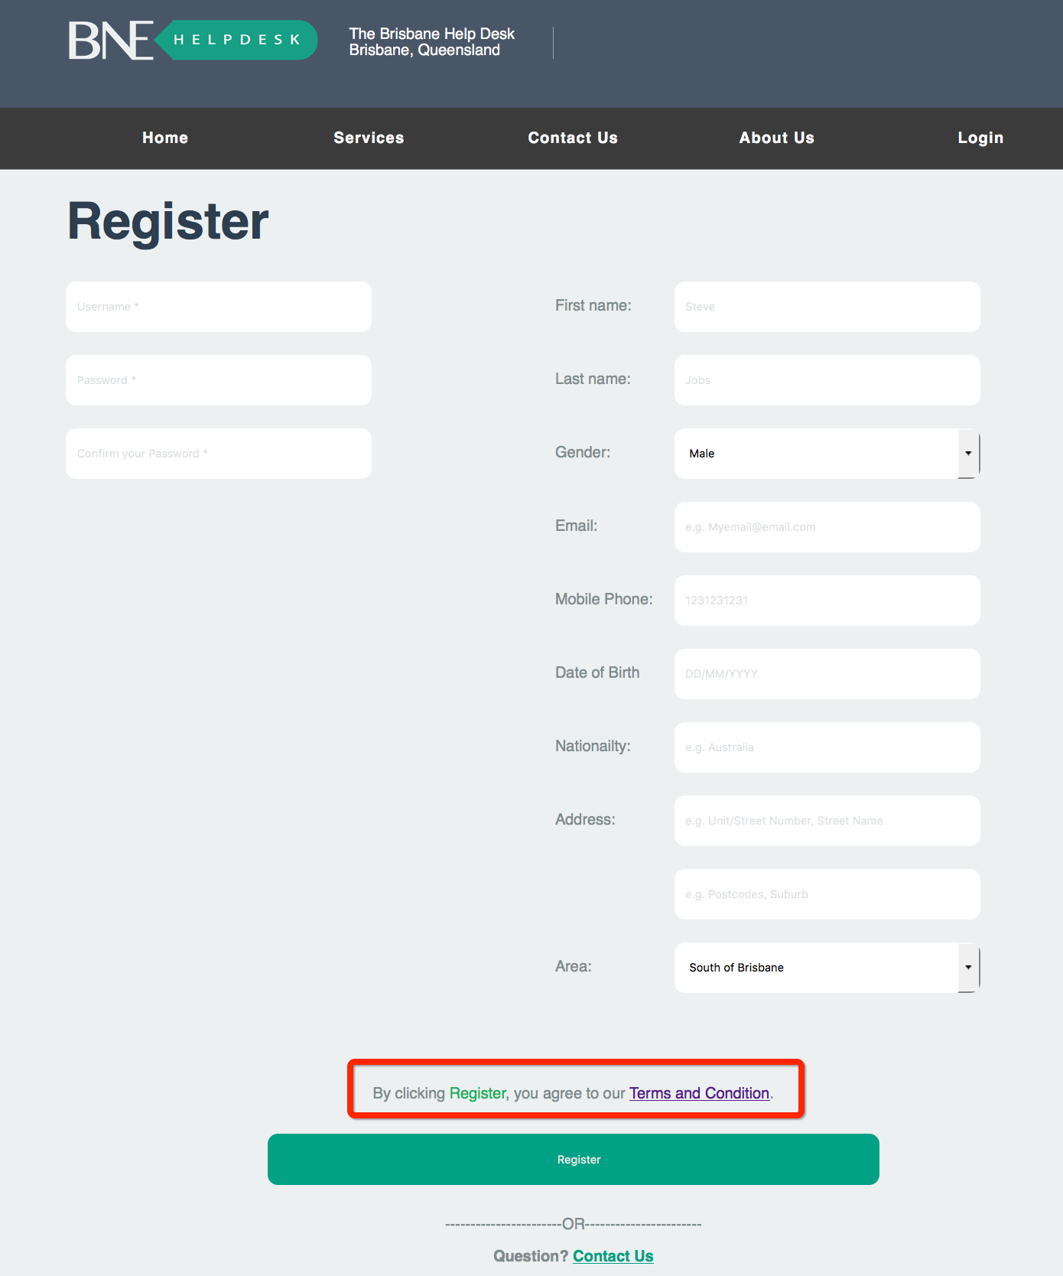

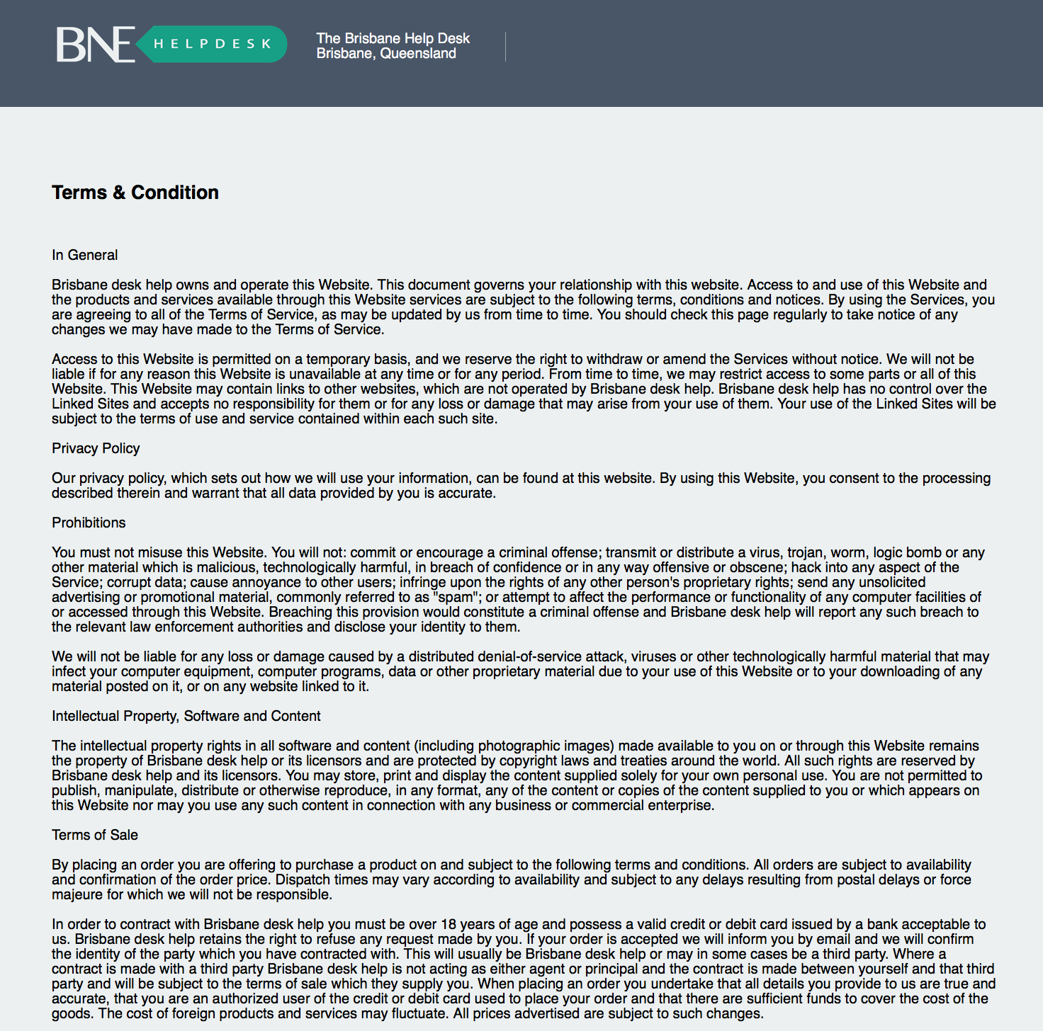

To make sure every user know their rights and limits when using our service, our team worked out a complete terms and conditions for users, users can check it easily when they are doing registration. In addition, when user clicks the summit button, system will treat as agreeing the terms and conditions.

Files involved: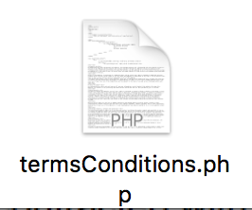

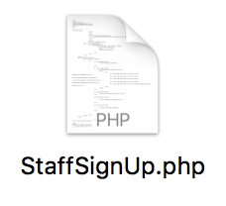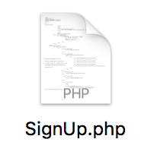

4. differential the user login and stuff login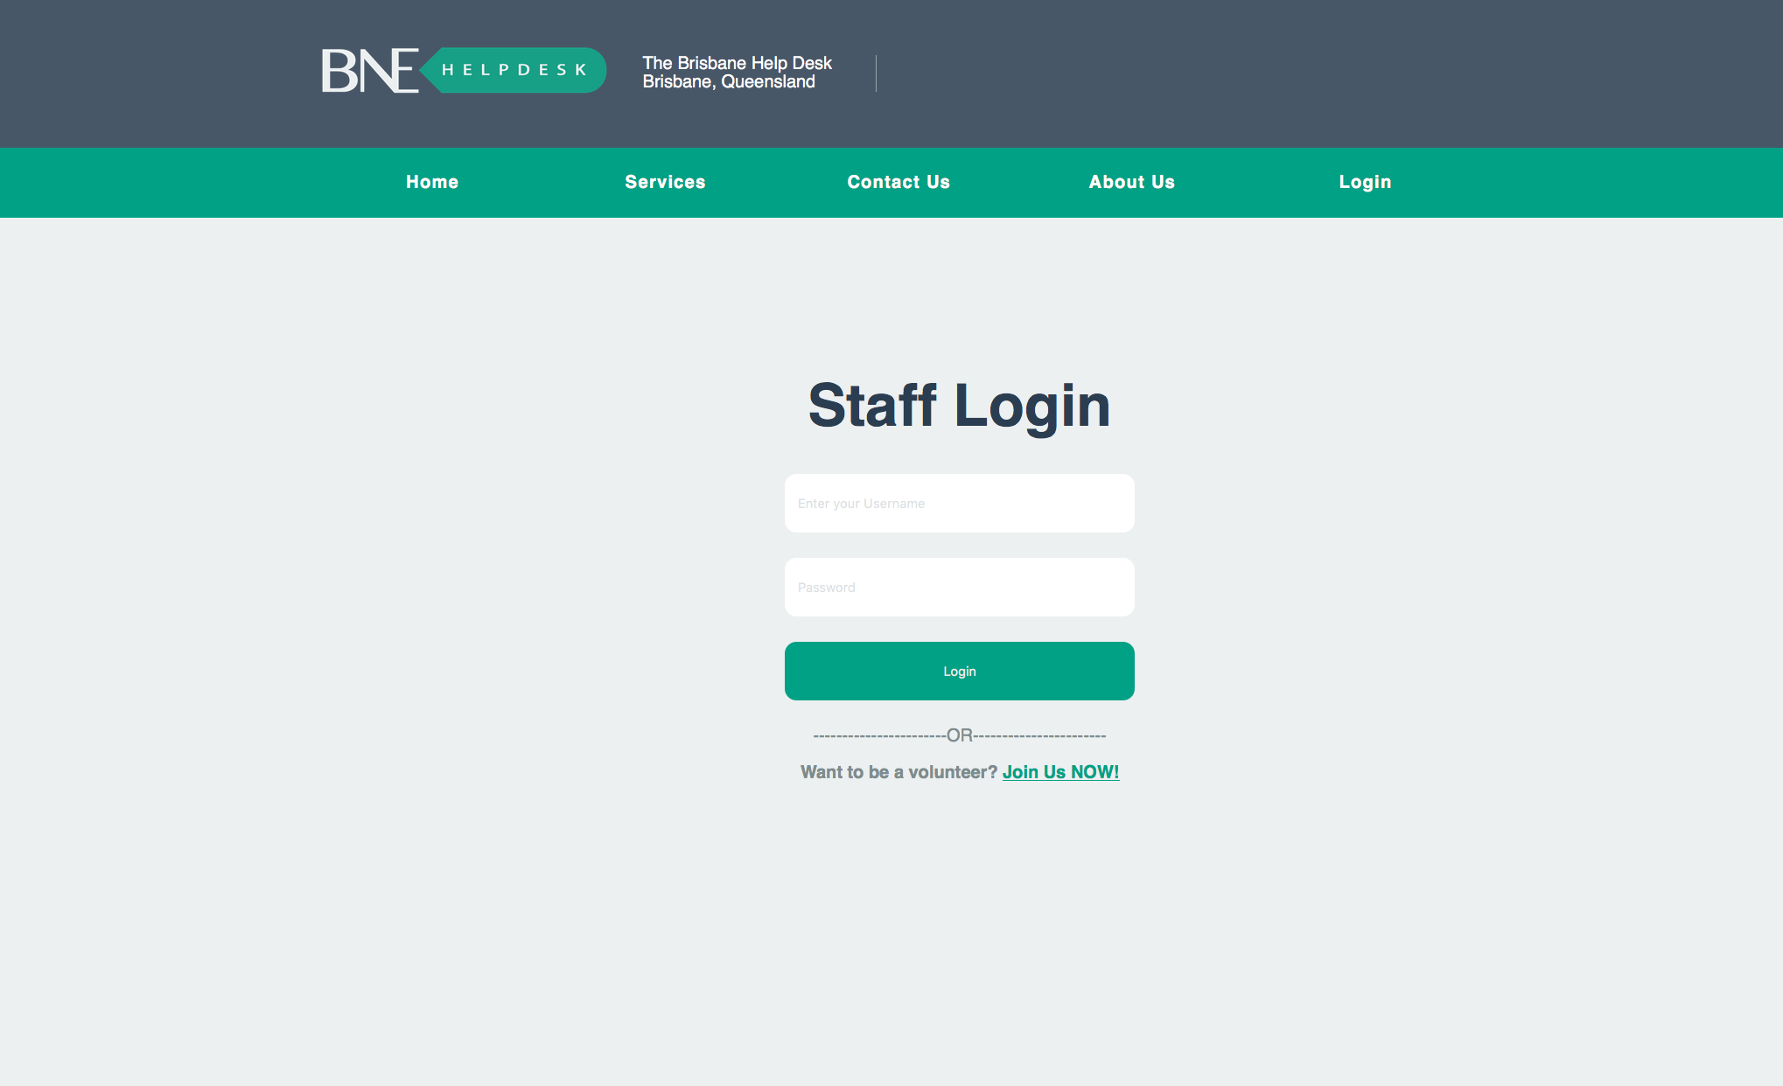

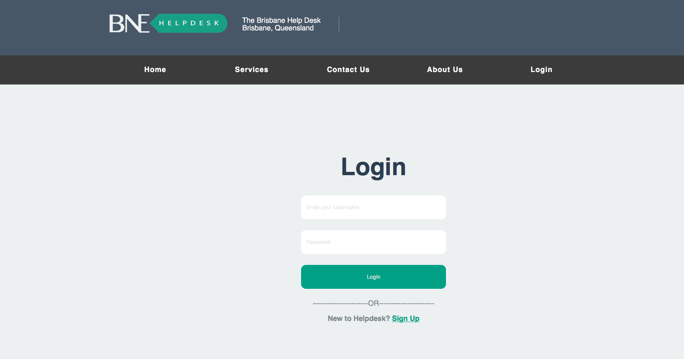

In the user story, to make sure user and stuff can easily know they are logging in the right account, we tried many scenario to illustrate the properties of the accounts, however we eventually chose a fast and direct way to present the if it is a user (normal) account. I change the color of navigation bar that staffs’ accounts now present a bright energetic green color, As long as its animation colors and hover colors

throughout change the css files, we can make the color change. the label for the navigations bar is <nav> and inside, classes that defined can modify the color of navigation bar. It used to be a PNG photo. Due to this issue, I use a pure css code to create the background color of the navigation bar.

Files involved: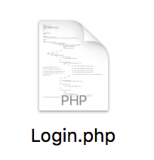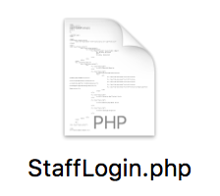

5. the test case

thought a series of test according to the release plan, I can make sure all the functions required can work properly. when in the last project, we learned how to test the project, as a result we conduct few test case sheet asking everyone in the project to test if the project functions are complete.

Files involved: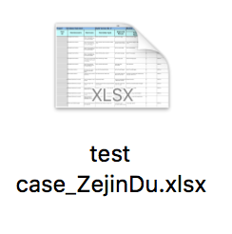

6. Others:

I helped teammates solving their few coding problems, for example, layout problems, css presentation problems, and some other visual bugs .I helped some teammates who are involved less coding parts to build their local host can update their files to be the latest version.