REPORT
on
Master Coding and Competitive Programming - Part-2
(Course Code: V23CSSE04)
B.TECH VI Semester (2023 - 2027 Batch )
Academic Year: 2025-26



SRI VASAVI ENGINEERING COLLEGE (Autonomous)
Pedatadepalli , Tadepalligudem - 534101
Department of Computer Science & Engineering (Accredited by NBA)

SRI VASAVI ENGINEERING COLLEGE (Autonomous)


PEDATADEPALLI, TADEPALLIGUDEM.

This is to certify Mr. Jaideep Vantipalli bearing Roll No. 23A81A0562 of CSE Branch of VI Semester submitted the Report on _____________________ as a part of Master Coding and Competitive Programming - Part-2 (Course Code: V23CSSE04) during the academic year 2025-2026.

Faculty In charge Head of the Department

Examiner1 Examiner2

Geeks For Geeks Profile :
https://www.geeksforgeeks.org/user/jaideepvantipalli/

LeetCode Profile :
https://leetcode.com/u/Jaideep_Vantipalli/


SI . NO | Topics | Page No.
1 | Programs on Binary Search | 5-9
2 | Programs on Sorting | 10-13
3 | Programs on TwoPointer | 14-18
4 | Programs on Sliding Window | 19-26
5 | Programs on Greedy | 27-34
6 | Programs on Dynamic programming | 35-43
7 | Programs on Linkedlist | 44-51
8 | Programs on Stack | 52-56
9 | Programs on Queue | 57-61
10 | Programs on Binary Search Tree | 62-69
System Design
11 | Case Study : Online Shopping Cart | 70-80
INDEX
1.Programs on BinarySearch.
1.1 First 1 in a Sorted Binary Array
Aim : Given a sorted array arr consisting of 0s and 1s. The task is to find the index (0-based indexing) of the first 1 in the given array.
class Solution {
public long firstIndex(int arr[]) {
int ans = -1;
int low =0;
int high = arr.length-1;
while(low<=high){
int mid = (low+high)/2;
if(arr[0] == 1){
return 0;
}
if(arr[mid] == 1 && arr[mid] > arr[mid-1]){
return mid;
}
else if(arr[mid] < 1){
low = mid +1;
}
else{
high = mid -1;
}
}
return ans;
}
}
Output :
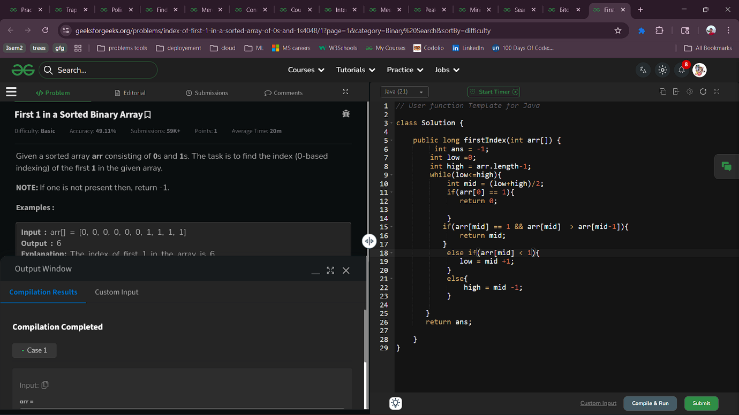
1.2 Bitonic Point
Aim : Given an array of integers arr[] that is first strictly increasing and then maybe strictly decreasing, find the bitonic point, that is the maximum element in the array.
Bitonic Point is a point before which elements are strictly increasing and after which elements are strictly decreasing.
Note: It is guaranteed that the array contains exactly one bitonic point
Code :
class Solution {
public int findMaximum(int[] arr) {
int low=0;
int high=arr.length-1;
while(low<=high){
int mid=(low+high)/2;
if(arr[mid]>arr[mid+1]&&arr[mid]>arr[mid-1])
return arr[mid];
else if(arr[mid]>arr[mid+1]) high=mid-1;
else low=mid+1;
}
return 0;
}
}
Output :
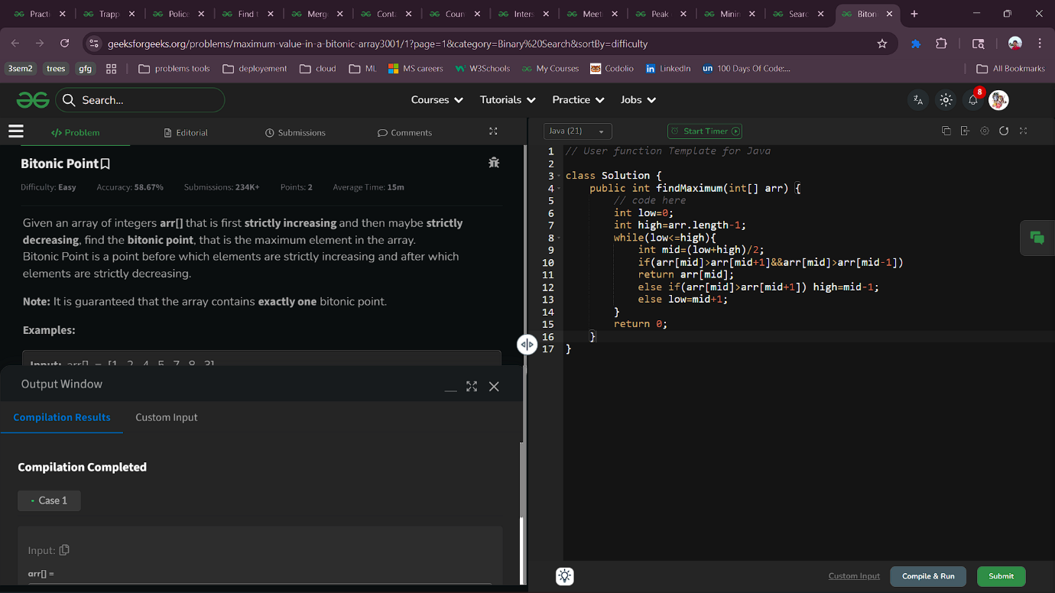

1.3 Search in a row-wise sorted matrix
Aim : Given a row-wise sorted 2D matrix mat[][] of size n x m and an integer x, find whether element x is present in the matrix.
Note: In a row-wise sorted matrix, each row is sorted in itself, i.e. for any i, j within bounds, mat[i][j] <= mat[i][j+1]
Code :
class Solution {
public boolean searchRowMatrix(int[][] mat, int x) {
int n = mat.length;
int m = mat[0].length;
for(int i=0;i<n;i++){
int low = 0,high = m-1;
while(low<=high){
int mid = (low+high)/2;
if(mat[i][mid]==x)
return true;
else if(mat[i][mid]<x)
low = mid+1;
else
high = mid-1;
}
}
return false;
}
}
Output :

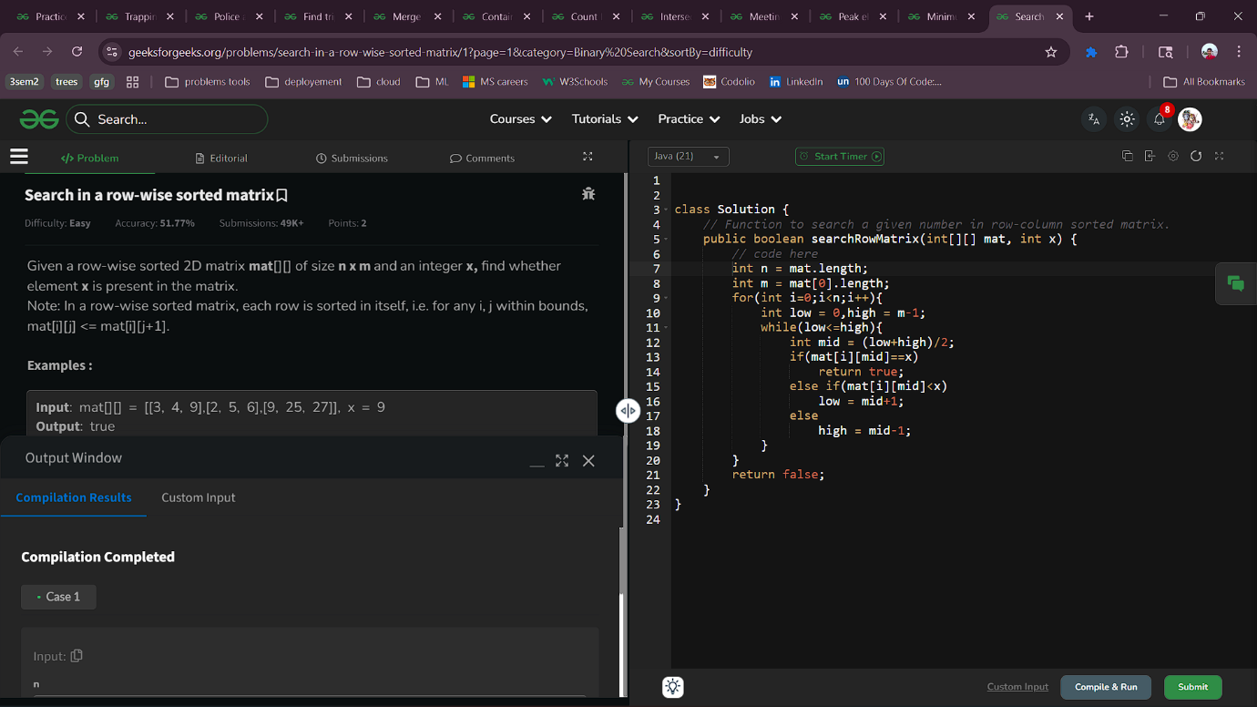
1.4 Minimum Number in a sorted rotated array
Aim : Given an array of distinct elements which was initially sorted. This array may be rotated at some unknown point. The task is to find the minimum element in the given sorted and rotated array.
Code :
class Solution {
static int minNumber(int arr[], int l, int h) {
// Your code here
while(l<h){
int mid=(l+h)/2;
if(arr[h]<arr[mid]) l=mid+1;
else h=mid;
}
return arr[l];
}
}
Output :

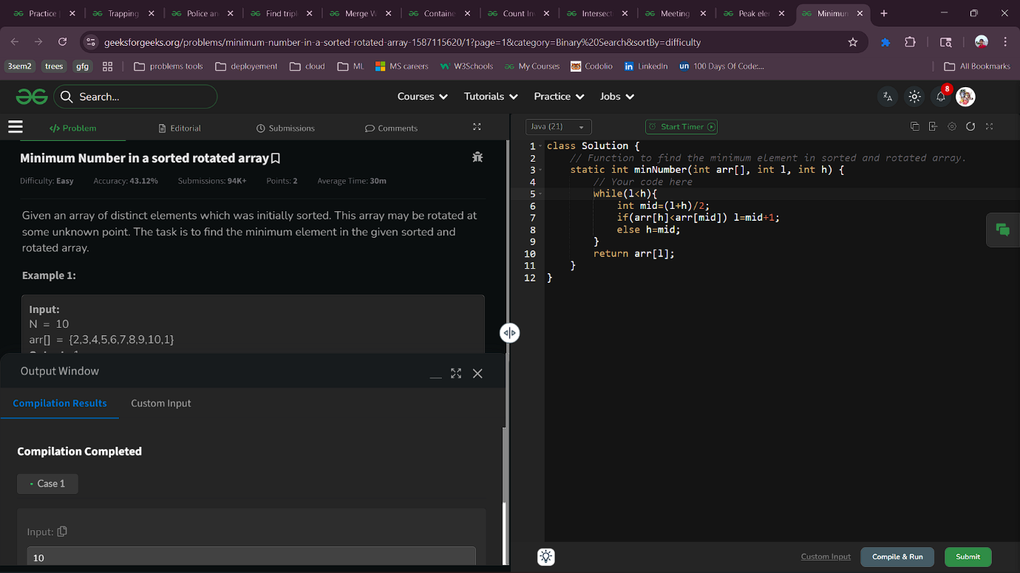

1.5 Peak element
Aim : Given You are given an array arr[] where no two adjacent elements are same, find the index of a peak element. An element is considered to be a peak if it is greater than its adjacent elements (if they exist).
If there are multiple peak elements, Return index of any one of them. The output will be "true" if the index returned by your function is correct; otherwise, it will be "false".
Note: Consider the element before the first element and the element after the last element to be negative infinity
Code :
class Solution {
public int peakElement(int[] arr) {
int n = arr.length;
if (n == 1) return 0;
if (arr[0] > arr[1]) return 0;
for (int i = 1; i < n - 1; i++) {
if (arr[i] > arr[i - 1] && arr[i] > arr[i + 1]) {
return i;
}
}
if (arr[n - 1] > arr[n - 2]) return n-1;
return -1;
}
}
Output :

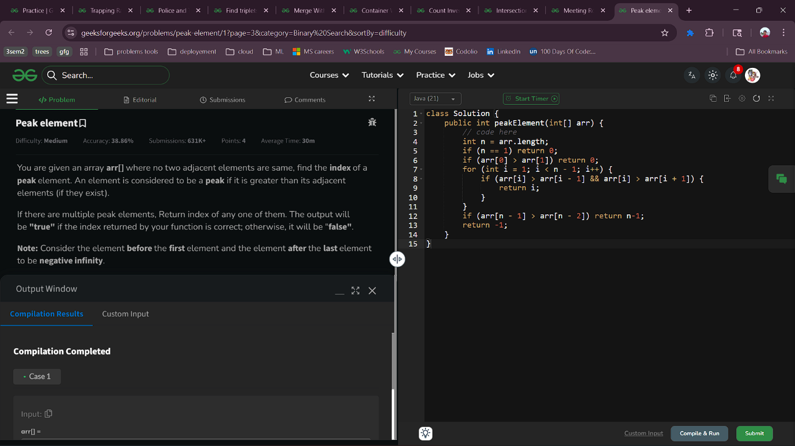
2.1 Meeting Rooms
Aim : Given a 2D array arr[][], where arr[i][0] is the starting time of i^{th} meeting and arr[i][1] is the ending time of i^{th} meeting, the task is to check if it is possible for a person to attend all the meetings such that he can attend only one meeting at a particular time.
Note: A person can attend a meeting if its starting time is greater than or equal to the previous meeting's ending time.
Code :
class Solution {
static boolean canAttend(int[][] arr) {
// code here
Arrays.sort(arr, (a, b) -> a[0] - b[0]);
for(int i=0;i<arr.length-1;i++){
if(arr[i][1]>arr[i+1][0])
return false;
}
return true;
}
}
Output :

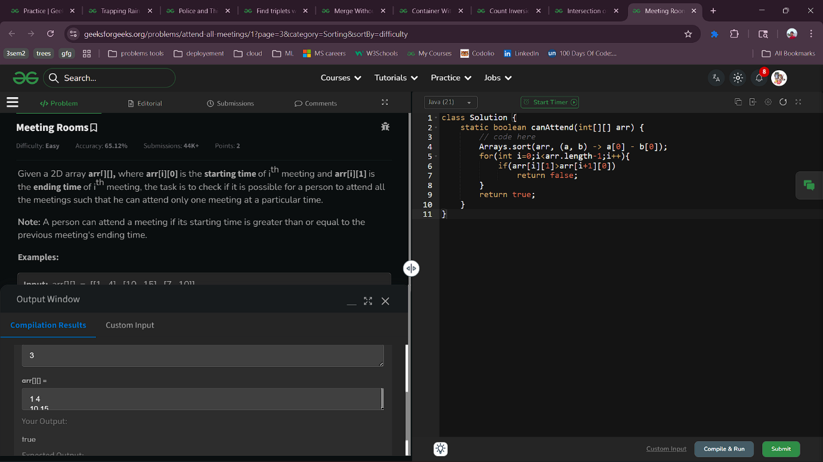

2.2 Intersection of two sorted arrays
Aim :Given two sorted arrays arr1[] and arr2[]. Your task is to return the intersection of both arrays.
Intersection of two arrays is said to be elements that are common in both arrays. The intersection should not count duplicate elements.
Note: If there is no intersection then return an empty array.
Code :
class Solution {
public ArrayList<Integer> intersection(int arr1[], int arr2[]) {
ArrayList<Integer> list =new ArrayList<>();
HashSet<Integer> set = new HashSet<>();
for(int num:arr1){
set.add(num);
}
for(int num: arr2){
if(set.contains(num)){
list.add(num);
set.remove(num);
}
}
return list;
}
}
Output ;

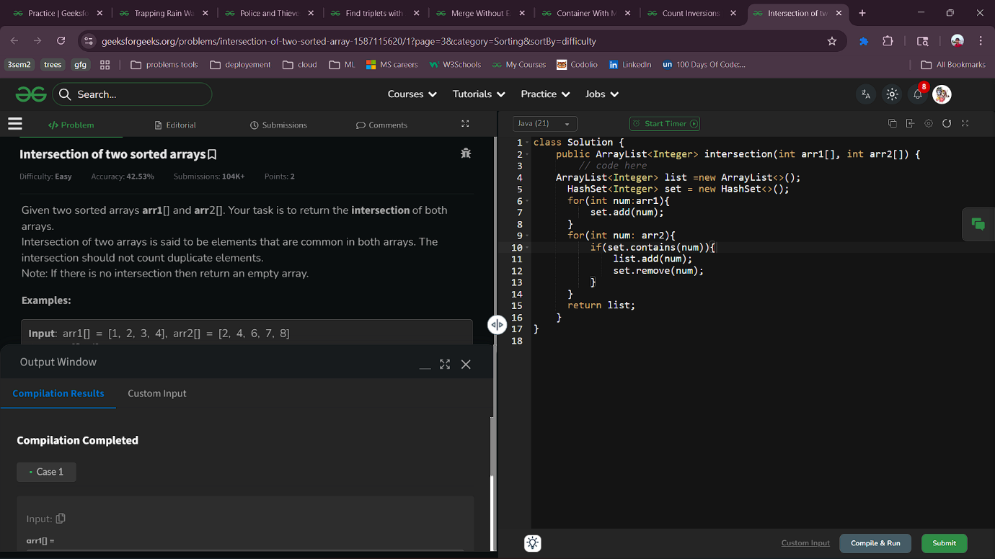
2.3 Count Inversions
Aim : Given an array of integers arr[]. You have to find the Inversion Count of the array.
Note : Inversion count is the number of pairs of elements (i, j) such that i < j and arr[i] > arr[j].
Code :
class Solution {
static int inversionCount(int arr[]) {
// Code Here
int invcount = 0;
invcount=mergeSort(arr,0,arr.length-1);
return invcount;

}
static int mergeSort(int[] arr, int left, int right) {
int count = 0;
if (left<right) {
int mid=left+(right-left)/2;
count += mergeSort(arr,left,mid);
count += mergeSort(arr,mid+1,right);
count += merge(arr,left,mid,right);
}
return count;
}
static int merge(int[] arr, int left, int mid, int right) {
int n1=mid-left+1;
int n2=right-mid;
int[] L = new int[n1];
int[] R = new int[n2];
for (int i = 0; i < n1; i++)
L[i] = arr[left + i];
for (int j = 0; j < n2; j++)
R[j] = arr[mid + 1 + j];
int i=0,j=0,k=left;
int invcount = 0;
while (i<n1&&j<n2) {
if (L[i]<=R[j]) {
arr[k++]=L[i++];
} else {
arr[k++]=R[j++];
invcount+=(n1-i);
}
}
while (i < n1)
arr[k++] = L[i++];

while (j < n2)
arr[k++] = R[j++];
return invcount;
}
}
Output :

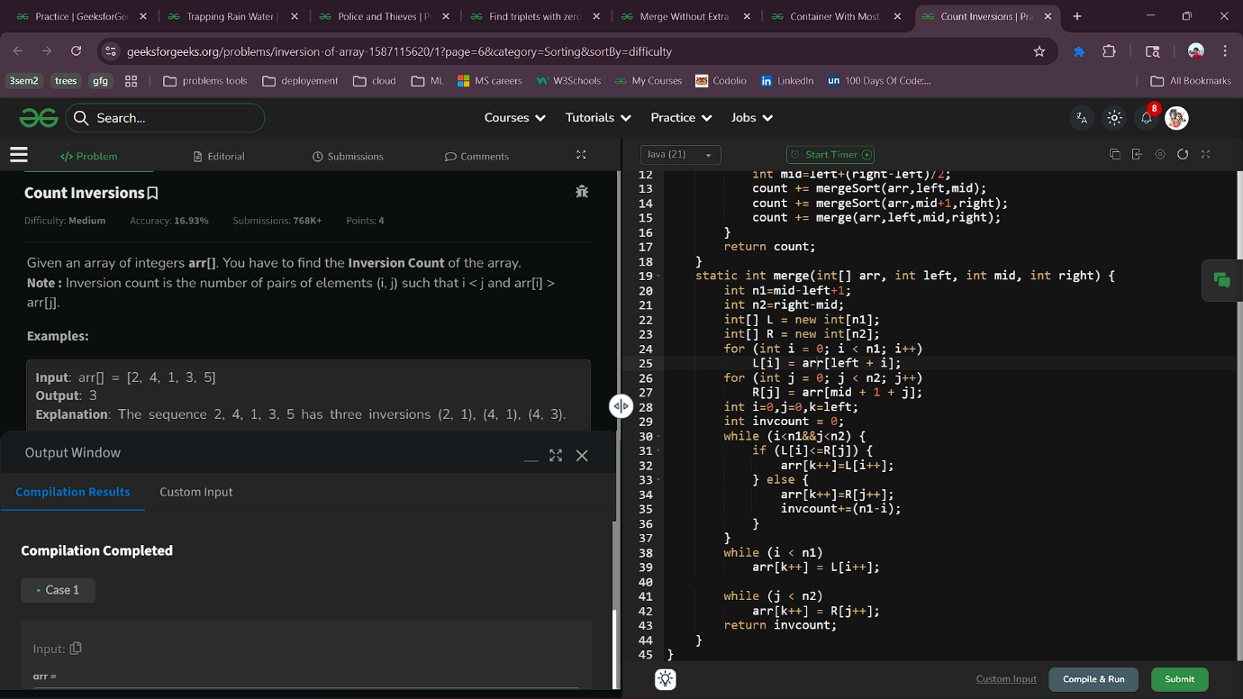

3.1 Container With Most Water
Aim : Given an array arr[] of non-negative integers, where each element arr[i] represents the height of the vertical lines, find the maximum amount of water that can be contained between any two lines, together with the x-axis.
Note: In the case of a single vertical line it will not be able to hold water
Code :
class Solution {
public int maxWater(int arr[]) {
// Code Here
int l=0,r=arr.length-1;
int maxwater=0;
while(l<=r){
maxwater=Math.max((r-l)*Math.min(arr[l],arr[r]),maxwater);
if(arr[l]<arr[r]) l++;
else r--;
}
return maxwater;
}
}
Output :

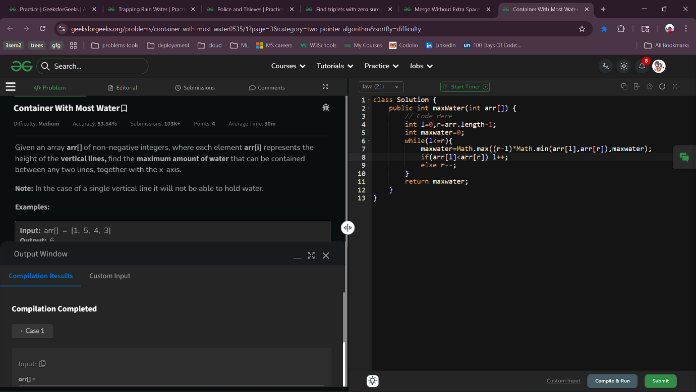

3.2 Merge Without Extra Space
Aim : Given two sorted arrays a[] and b[] of size n and m respectively, the task is to merge them in sorted order without using any extra space. Modify a[] so that it contains the first n elements and modify b[] so that it contains the last m elements.
Code :
class Solution {
public void mergeArrays(int a[], int b[]) {
// code here
int i=a.length-1;
int j=0;
while(i>=0 && j<b.length)
{
if(a[i]>b[j])
{
int temp=a[i];
a[i]=b[j];
b[j]=temp;
i--;
j++;
}
else j++;
}
Arrays.sort(a);
Arrays.sort(b);
}
}
Output :
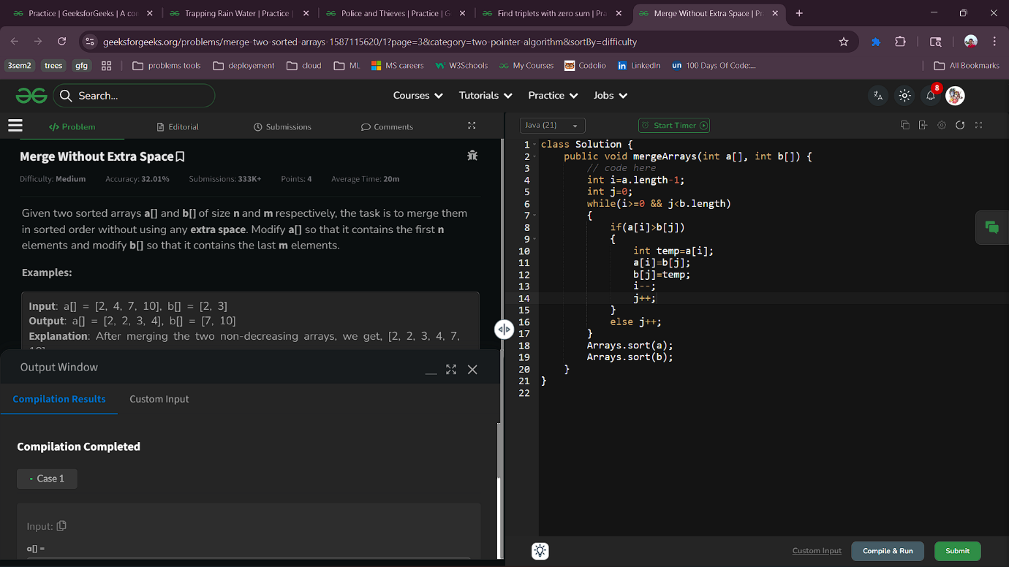
3.3 Find triplets with zero sum
Aim : Given an array arr[] of integers, determine whether it contains a triplet whose sum equals zero. Return true if such a triplet exists, otherwise, return false.
Code :
class Solution {
public boolean findTriplets(int[] arr) {
// code here.
Arrays.sort(arr);
int n=arr.length;
for (int i = 0;i<n;i++) {
int l=i+1;
int r=n-1;
while(l<r){
if (arr[i]+arr[l]+arr[r]==0){
return true;
} else if (arr[i]+arr[l]+arr[r]<0)
l++;
else
r--;
}
}
return false;
}
}
Output :
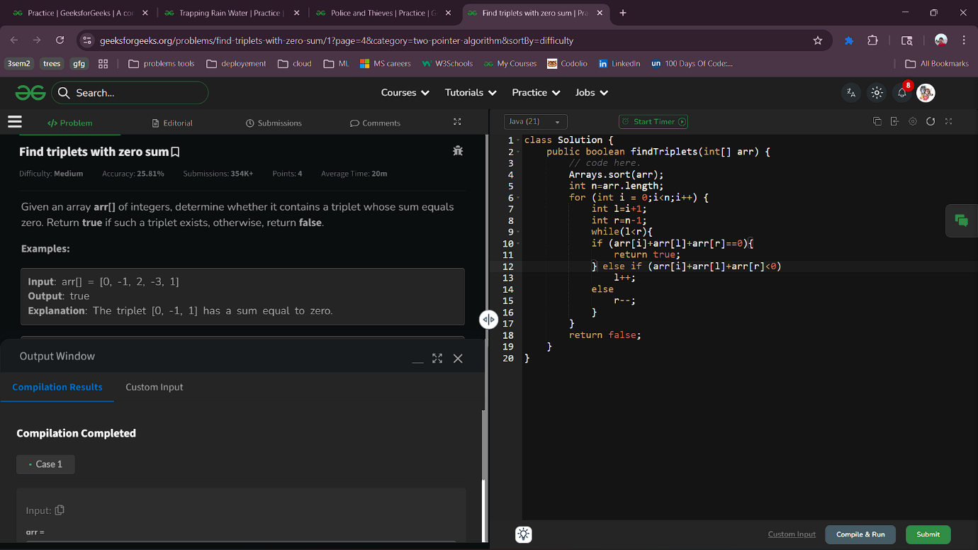
3.4 Police and Thieves
Aim: Given an array arr[], where each element contains either a 'P' for policeman or a 'T' for thief. Find the maximum number of thieves that can be caught by the police.
Keep in mind the following conditions :
- Each policeman can catch only one thief.
- A policeman cannot catch a thief who is more than k units away from him.
Code :
class Solution {
public int catchThieves(char[] arr, int k) {
Queue<Integer> police=new LinkedList<>();
Queue<Integer> thieve=new LinkedList<>();
int c=0;
for(int i=0;i<arr.length;i++){
if(arr[i]=='P') police.add(i);
else thieve.add(i);
while(!police.isEmpty() && !thieve.isEmpty()){
if(Math.abs(police.peek()-thieve.peek())<=k){
c++;
police.poll();
thieve.poll();
}else if(police.peek()<thieve.peek()) police.poll();
else thieve.poll();
}
}
return c;
}
}Output :
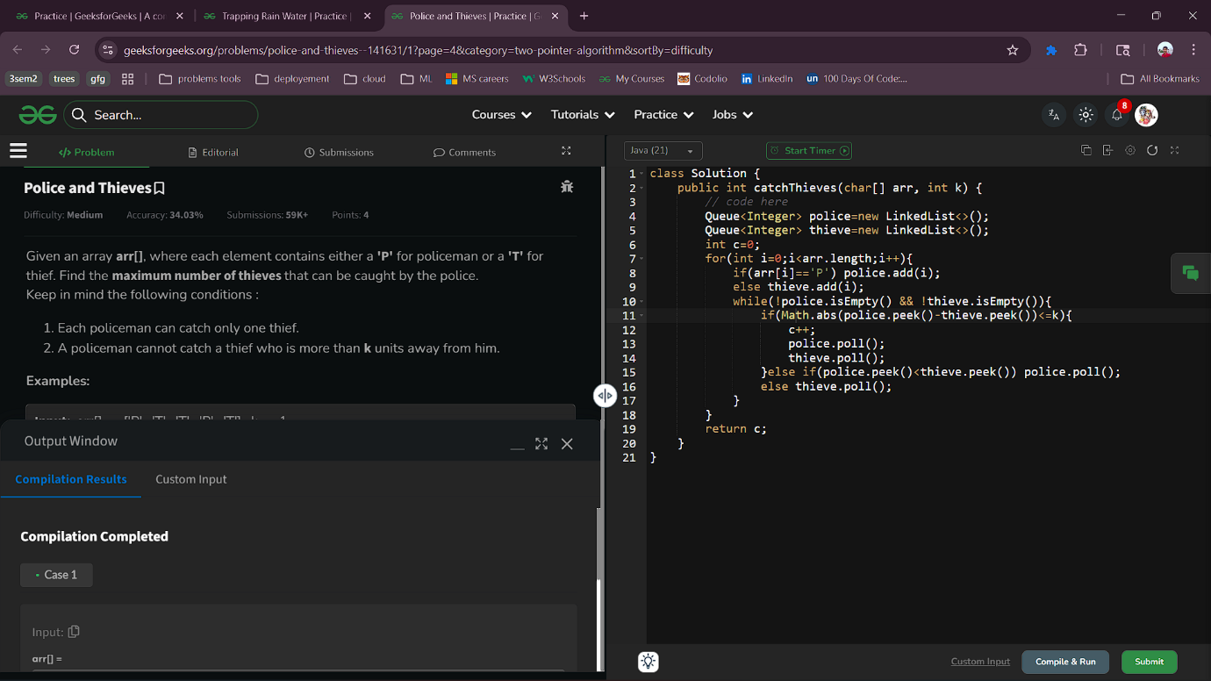
3.5 Trapping Rain Water
Aim : Given an array arr[] with non-negative integers representing the height of blocks. If the width of each block is 1, compute how much water can be trapped between the blocks during the rainy season.Code :
class Solution {
public int maxWater(int arr[]) {
int n=arr.length;
int l=0,r=n-1;
int lm=0,rm=0;
int water=0;
while(l<r){
if(arr[l]<arr[r]){
lm=Math.max(lm,arr[l]);
water+=lm-arr[l];
l++;
}
else{
rm=Math.max(rm,arr[r]);
water+=rm-arr[r];
r--;
}
}
return water;
}
}

Output :
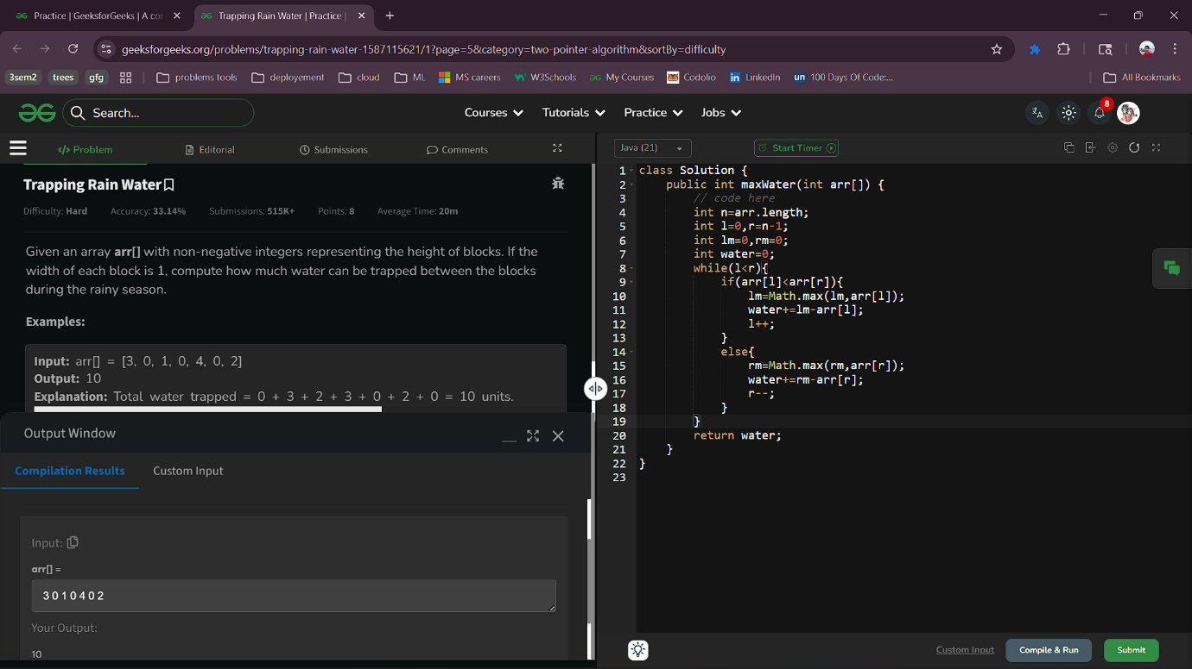
4.1 First negative in every window of size k
Aim : Given an array arr[] and a positive integer k, find the first negative integer for each and every window(contiguous subarray) of size k.
Note: If a window does not contain a negative integer, then return 0 for that window
class Solution {
static List<Integer> firstNegInt(int arr[], int k) {
Deque<Integer> dq = new LinkedList<>();
List<Integer> res = new ArrayList<>();
int n = arr.length;
for (int i = 0; i < k; i++)
if (arr[i] < 0) dq.addLast(i);
if (!dq.isEmpty())
res.add(arr[dq.peekFirst()]);
else
res.add(0);
for (int i = k; i < n; i++) {
if (arr[i] < 0)
dq.addLast(i);

while (!dq.isEmpty() && dq.peekFirst() < (i - k + 1))
dq.pollFirst();
if (!dq.isEmpty())
res.add(arr[dq.peekFirst()]);
else
res.add(0);
}
return res;
}
}Output : 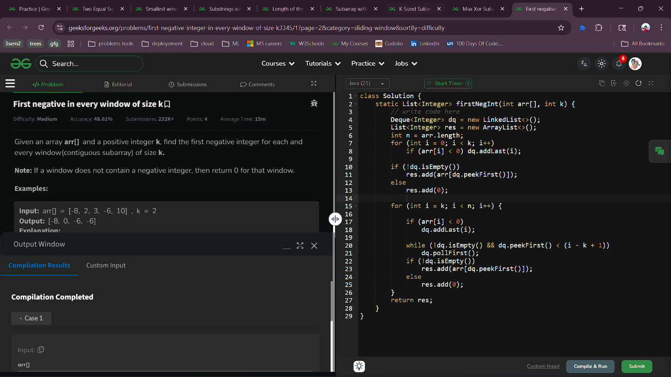
4.2 Max Xor Subarray of size K
Aim : Given an array of integers arr[] and a number k. Return the maximum xor of a subarray of size k.
Note: A subarray is a contiguous part of any given array.
class Solution {
public int maxSubarrayXOR(int[] arr, int k) {
// code here
int n = arr.length;
int currXor = 0;
for (int i = 0; i < k; i++) {
currXor ^= arr[i];
}

int maxXor = currXor;
for (int i = k; i < n; i++) {
currXor ^= arr[i];
currXor ^= arr[i - k];
maxXor = Math.max(maxXor, currXor);
}

return maxXor;
}
}
Output :
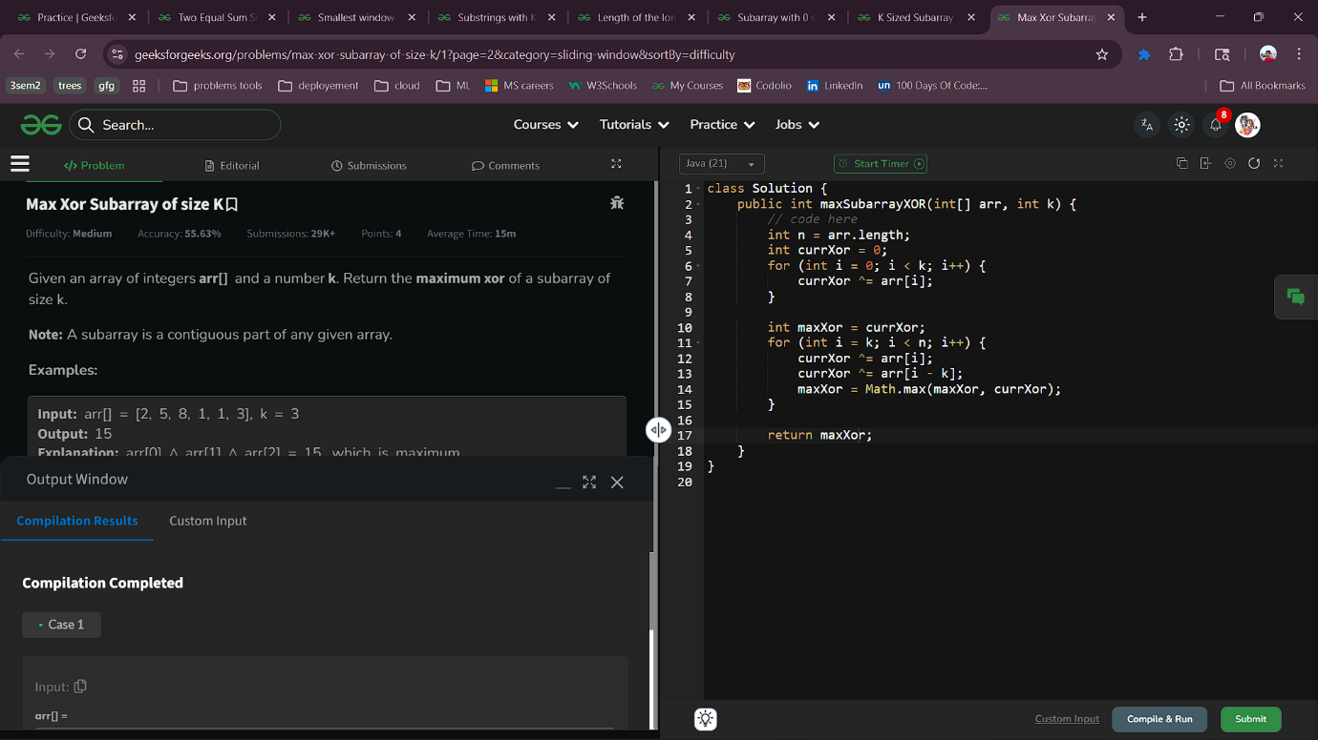

4.3 K Sized Subarray Maximum
Aim :Given Given an array arr[] of positive integers and an integer k. You have to find the maximum value for each contiguous subarray of size k. Return an array of maximum values corresponding to each contiguous subarray.
class Solution {
public ArrayList<Integer> maxOfSubarrays(int[] arr, int k) {
ArrayList<Integer> al=new ArrayList<>();
Deque<Integer> dq=new ArrayDeque<>();
for(int i=0;i<k;i++){
while(!dq.isEmpty() && arr[dq.peekLast()]<=arr[i] ){
dq.removeLast();
}
dq.add(i);
}
al.add(arr[dq.peekFirst()]);
for(int i=k;i<arr.length;i++){
while(!dq.isEmpty() && dq.peekFirst()<=i-k){
dq.removeFirst();
}
while(!dq.isEmpty() && arr[dq.peekLast()]<=arr[i]){
dq.removeLast();
}
dq.add(i);
al.add(arr[dq.peekFirst()]);
}
return al;
}}Output :
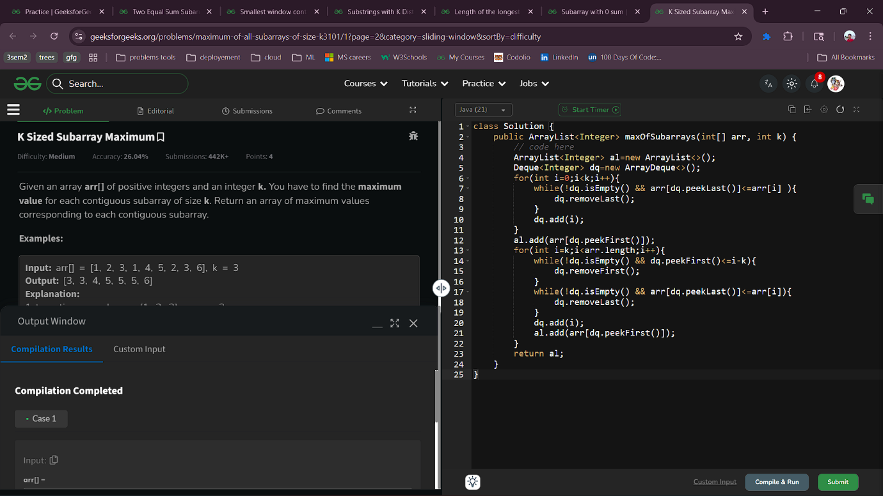

4.4 Subarray with 0 sum
Aim : Given an array of integers, arr[]. Find if there is a subarray (of size at least one) with 0 sum. Return true/false depending upon whether there is a subarray present with 0-sum or not.
class Solution {
// Function to check whether there is a subarray present with 0-sum or not.
static boolean findsum(int arr[]) {
// Your code here
HashSet<Integer> hs=new HashSet<>();
int psum=0;
for(int i=0;i<arr.length;i++){
psum+=arr[i];
if(psum==0 || hs.contains(psum)) return true;
hs.add(psum);
}
return false;
}
}Output :

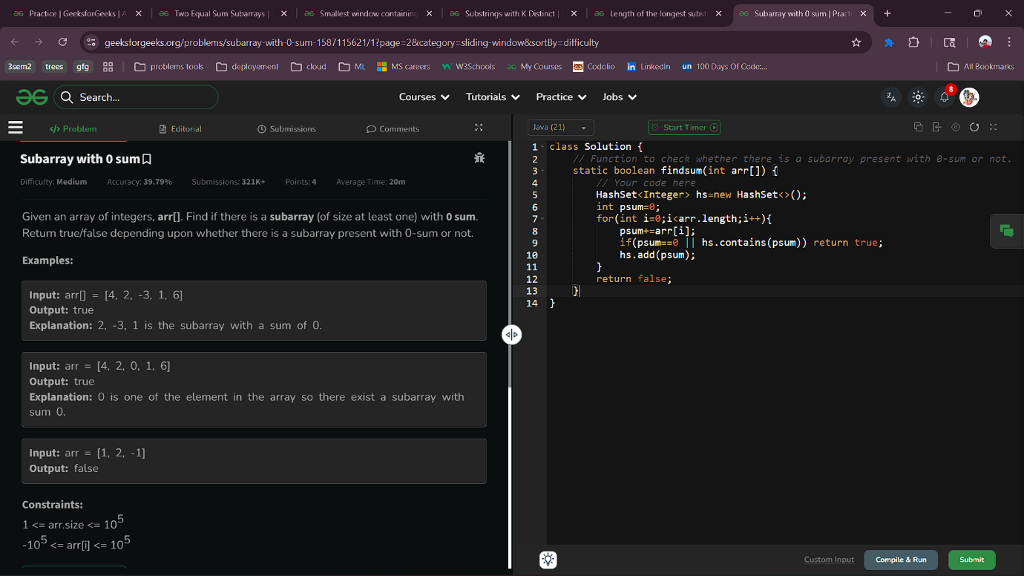

4.5 Length of the longest substring
Aim : You Given a string s, find the length of the longest substring without repeating characters.
class Solution {
int longestUniqueSubstring(String s) {
int l=0,n=s.length(),max=Integer.MIN_VALUE;
HashMap<Character,Integer> hm=new HashMap<>();
for(int r=0;r<n;r++){
char c = s.charAt(r);
if (hm.containsKey(c) && hm.get(c) >=l) {
l=hm.get(c)+1;
}
max=Math.max(max,r-l+1);
hm.put(c,r);
}
return max;
}
}
Output : 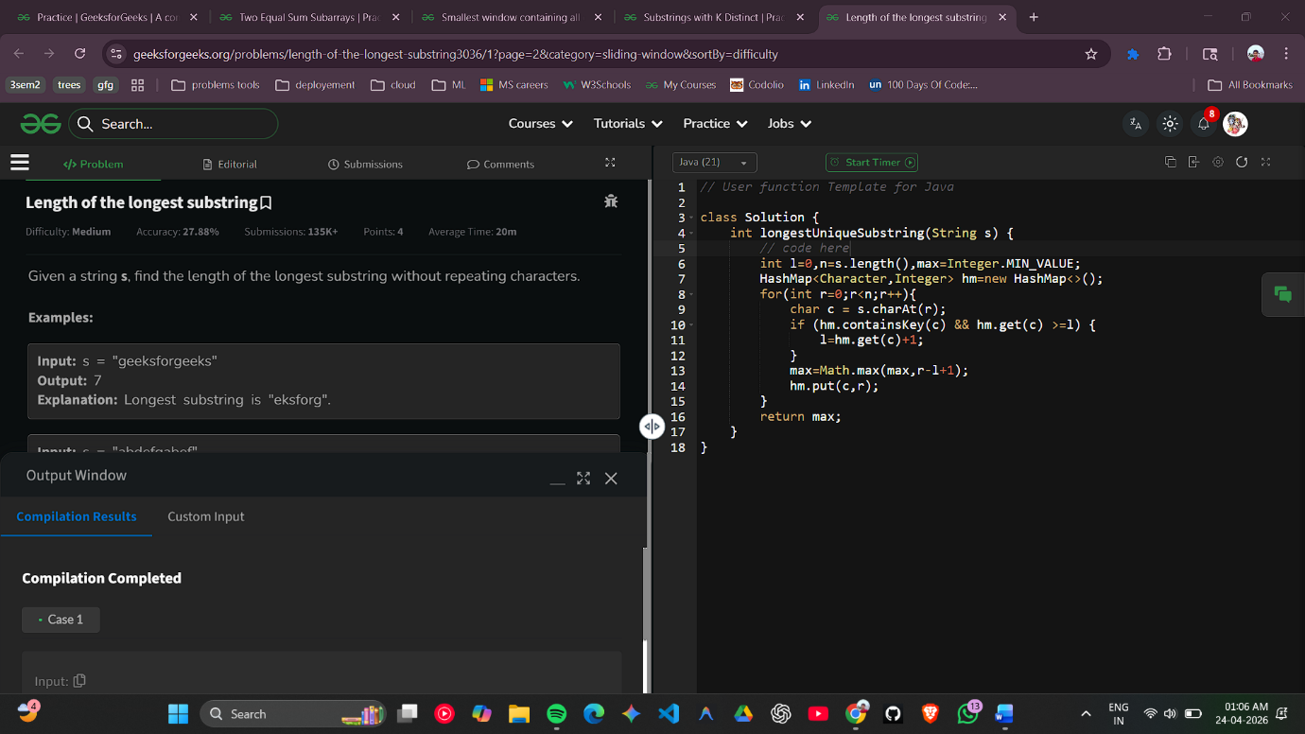

4.6 Substrings with K Distinct
Aim : You are given a string s consisting of lowercase characters and an integer k, You have to count all possible substrings that have exactly k distinct characters.
class Solution {
static int countSubstr(String s, int k) {
int n = s.length();
int ans = 0;
ans = count(s, k) - count(s, k - 1);
return ans;
}
static int count(String s, int k) {
int n = s.length();
int ans = 0;
int[] freq = new int[26];
int distinctCnt = 0;
int i = 0;
for (int j = 0; j < n; j++) {
freq[s.charAt(j) - 'a']++;
if (freq[s.charAt(j) - 'a'] == 1) distinctCnt++;
while (distinctCnt > k) {
freq[s.charAt(i) - 'a']--;
if (freq[s.charAt(i) - 'a'] == 0) distinctCnt--;
i++;
}
ans += j - i + 1;
}
return ans;
}
}Output :
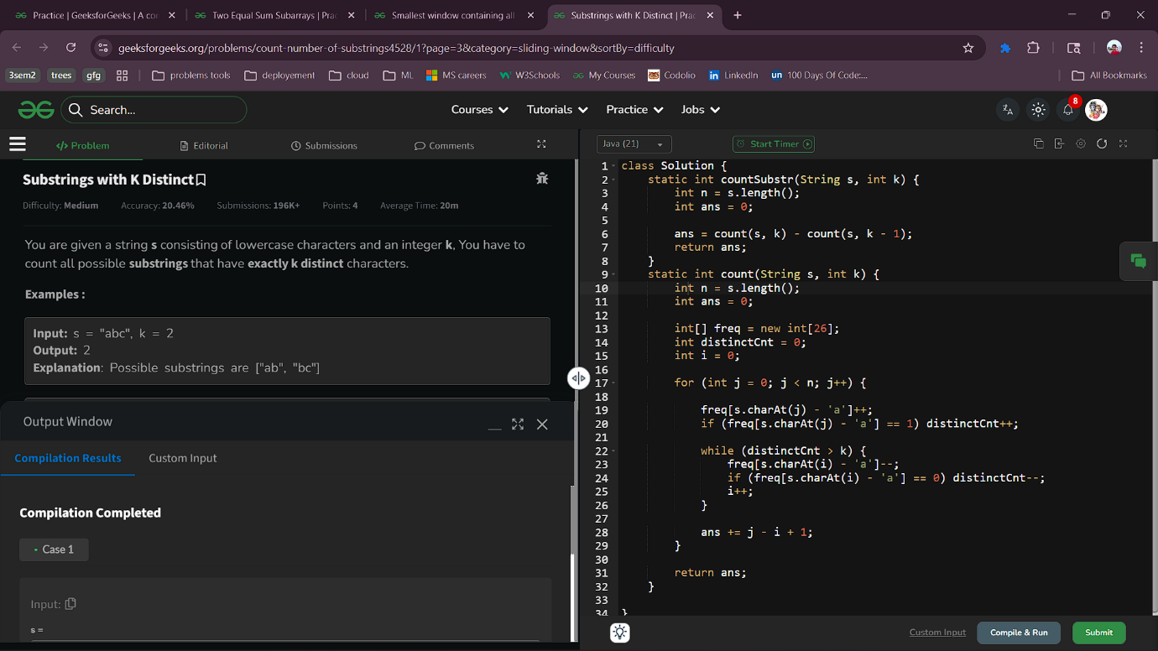
4.7 Smallest window containing all characters
Aim : Given two strings s and p. Find the smallest substring in s consisting of all the characters (including duplicates) of the string p. Return empty string in case no such substring is present.If there are multiple such substring of the same length found, return the one with the least starting index.
class Solution {
public static String minWindow(String s, String p) {
if (p.length() > s.length()) return "";
int[] freq = new int[256];
for (char c : p.toCharArray()) {
freq[c]++;
}
int left = 0, count = p.length();
int minLen = Integer.MAX_VALUE;
int start = 0;
for (int right = 0; right < s.length(); right++) {
if (freq[s.charAt(right)] > 0)
count--;
freq[s.charAt(right)]--;
while (count == 0) {
if (right - left + 1 < minLen) {
minLen = right - left + 1;
start = left;
}
freq[s.charAt(left)]++;
if (freq[s.charAt(left)] > 0)
count++;
left++;
}}
return minLen == Integer.MAX_VALUE ? "" : s.substring(start, start + minLen);
}
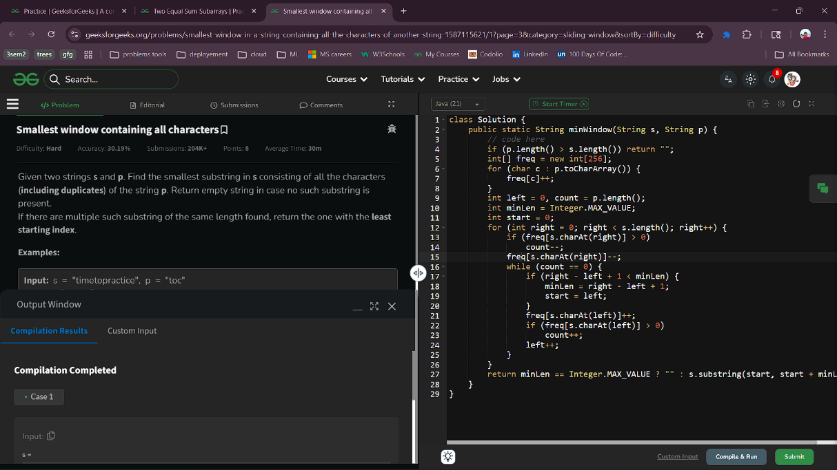
}Output :

4.8 Two Equal Sum Subarrays
Aim : Given an array of integers arr[], return true if it is possible to split it in two subarrays (without reordering the elements), such that the sum of the two subarrays are equal. If it is not possible then return false.
Code :
class Solution {
public boolean canSplit(int arr[]) {
// code here
int lsum=0,rsum=0;
for(int i=0;i<arr.length;i++) lsum+=arr[i];
for(int i=arr.length-1;i>=0;i--){
rsum+=arr[i];
lsum-=arr[i];
if(lsum==rsum) return true;
}
return false;
}
}
Output :

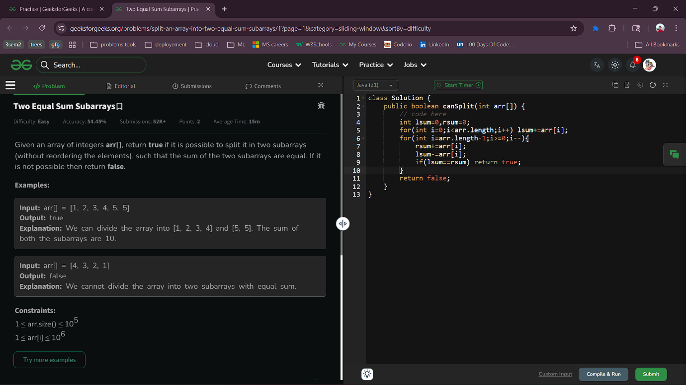
5.1 Minimum Platforms
Aim : Given arrival arr[] and departure dep[] times of trains on the same day, find the minimum number of platforms needed so that no train waits. A platform cannot serve two trains at the same time; if a train arrives before another departs, an extra platform is needed.
Note: Time intervals are in the 24-hour format (HHMM) , where the first two characters represent hour (between 00 to 23 ) and the last two characters represent minutes (this will be <= 59 and >= 0). Leading zeros for hours less than 10 are optional (e.g., 0900 is the same as 900).
class Solution {
public int minPlatform(int arr[], int dep[]) {
int ans=1;
Arrays.sort(arr);
Arrays.sort(dep);
int i=0,j=0,len=0;
while(i<arr.length){
if(arr[i]<=dep[j]){
len++;
i++;
}else{
len--;
j++;
}
ans=Math.max(len,ans);
}
return ans;
}
}Output ;
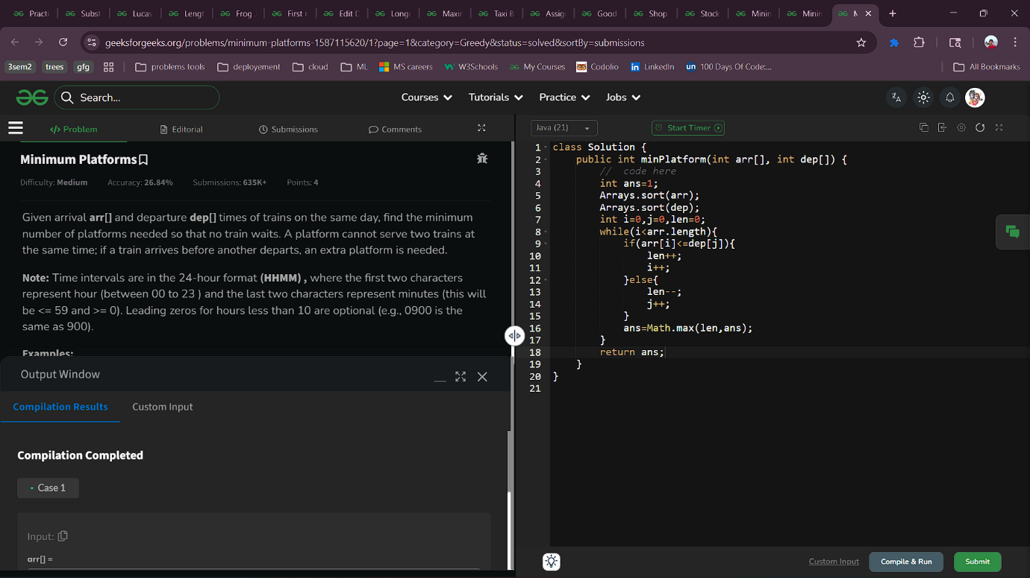

5.2 Minimum jumps
Aim : You are given an array arr[] of non-negative numbers. Each number tells you the maximum number of steps you can jump forward from that position.For example:
- If arr[i] = 3, you can jump to index i + 1, i + 2, or i + 3 from position i.
- If arr[i] = 0, you cannot jump forward from that position.
Your task is to find the minimum number of jumps needed to move from the first position in the array to the last position.
Note: Return -1 if you can't reach the end of the array.
class Solution {
static int minJumps(int[] arr) {
if(arr.length<=1) return 0;
if(arr[0]==0) return -1;
int jumps=0;
int n;
n=arr.length;
int i;
i=0;
while(i<n){
if(i==n-1){
return jumps;
}
if(arr[i]>0){
i+=arr[i];
jumps++;
}
}
return jumps;
}
}Output :
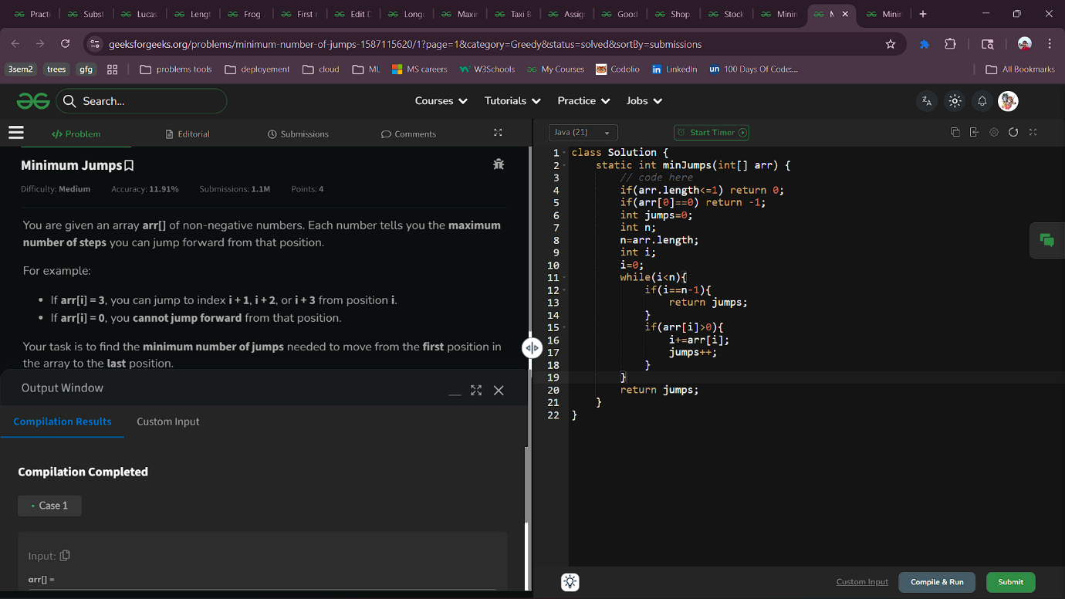
5.3 Minimum Operations
Given a number n. Find the minimum number of operations required to reach n starting from 0. You have two operations available:
- Double the number
- Add one to the number
class Solution {
public int minOperation(int n) {
// code here.
int ops=0;
while(n>0){
if(n%2==0){ n/=2; ops++;}
else{
n-=1;
ops++;
}
}
return ops;
}
}Output :
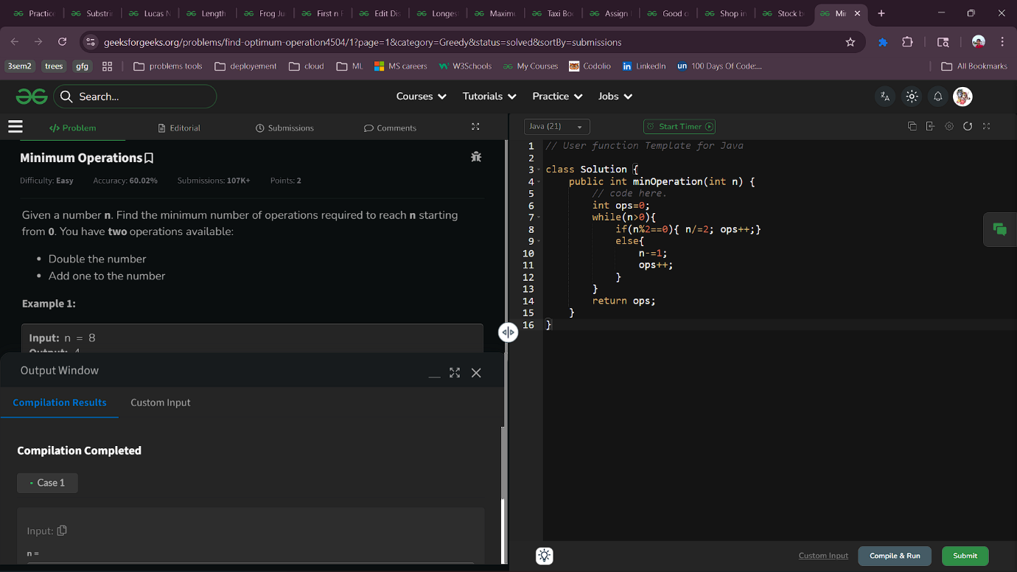

5.4 Stock buy and sell
Aim : Given an array arr[] denoting the cost of stock on each day, the task is to find the maximum total profit if we can buy and sell the stocks any number of times.
Note: We can only sell a stock which we have bought earlier and we cannot hold multiple stocks on any day.
class Solution {
int stockBuySell(int arr[]) {
// code here
int sum=0;
for(int i=1;i<arr.length;i++){
if(arr[i]>arr[i-1])
sum+=arr[i]-arr[i-1];
}
return sum;
}
}
Output :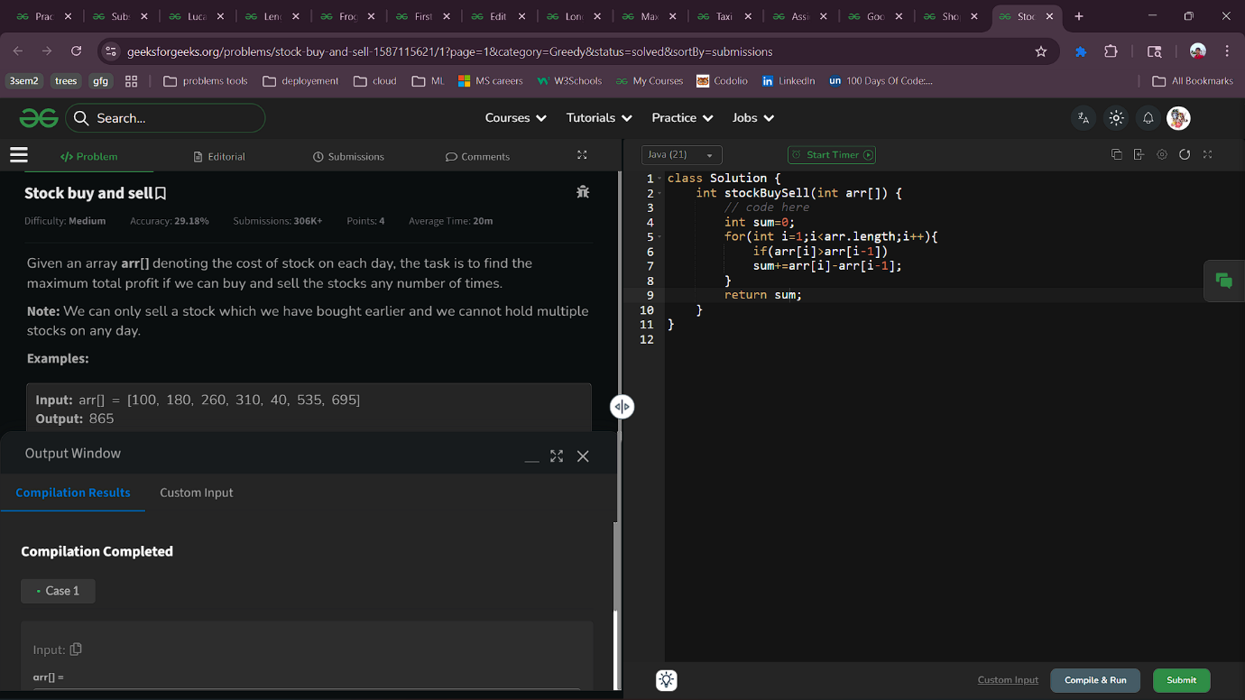

5.5 Shop in Candy Store
Aim : In a candy store, there are different types of candies available and prices[i] represent the price of i^{th} types of candies. You are now provided with an attractive offer.
For every candy you buy from the store, you can get up to k other different candies for free. Find the minimum and maximum amount of money needed to buy all the candies.
Note: In both cases, you must take the maximum number of free candies possible during each purchase.
class Solution {
public ArrayList<Integer> minMaxCandy(int[] prices, int k) {
Arrays.sort(prices);
int n=prices.length;
int mincost=0,maxcost=0;
for(int i=0;i<n;i++){
mincost+=prices[i];
n-=k;
}
int index=-1;
for(int i=prices.length-1;i>index;i--){
maxcost+=prices[i];
index+=k;
}
ArrayList<Integer> al=new ArrayList<>();
al.add(mincost);
al.add(maxcost);
return al;
}
}Output :

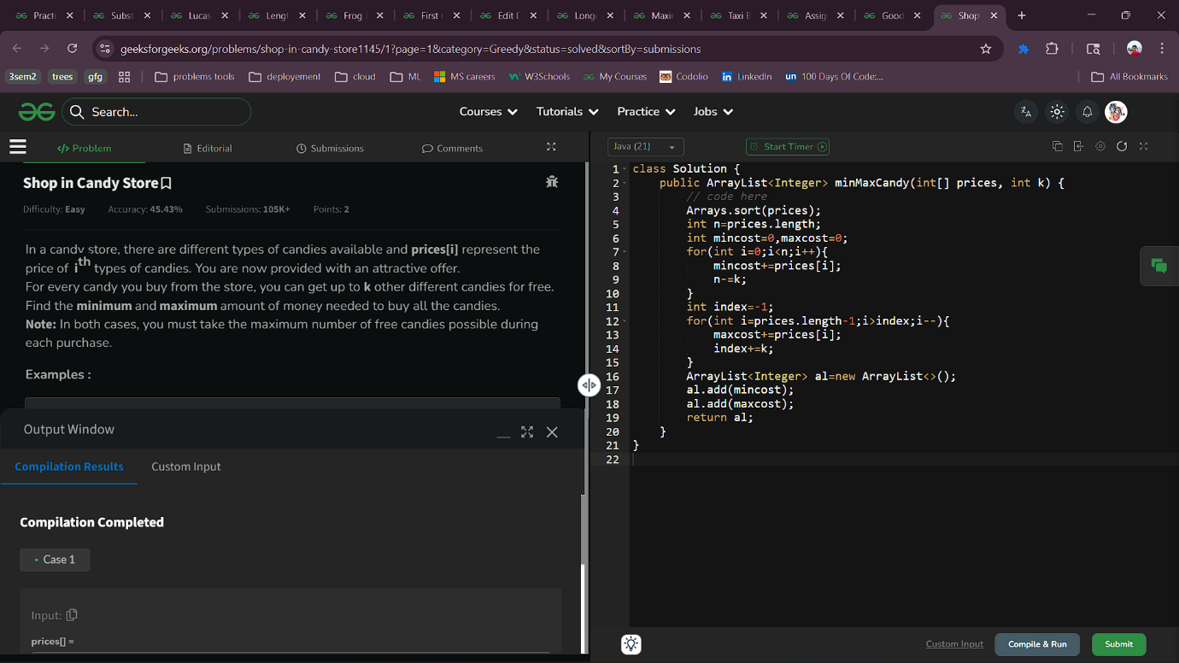
5.6 Good or Bad string
Aim : In this problem, a String S is composed of lowercase alphabets and wildcard characters i.e. '?'. Here, '?' can be replaced by any of the lowercase alphabets. Now you have to classify the given String on the basis of following rules:If there are more than 3 consonants together or more than 5 vowels together, the String is considered to be "BAD". A String is considered "GOOD" only if it is not “BAD”.NOTE: String is considered as "BAD" if the above condition is satisfied even once. Else it is "GOOD" and the task is to make the string "BAD".
class Solution {
static int isGoodorBad(String S) {
int v=0,c=0;
for(int i=0;i<S.length();i++){
char ch = S.charAt(i);
if(isVowel(ch)){
v++;
c=0;
}
else if(ch=='?'){
v++;
c++;
}
else{
v=0;
c++;
}
if(v>5||c>3)
return 0;
}
return 1;
}
static boolean isVowel(char ch){
return (ch == 'a' || ch == 'e' || ch == 'i' || ch == 'o' || ch == 'u');
}};Output :
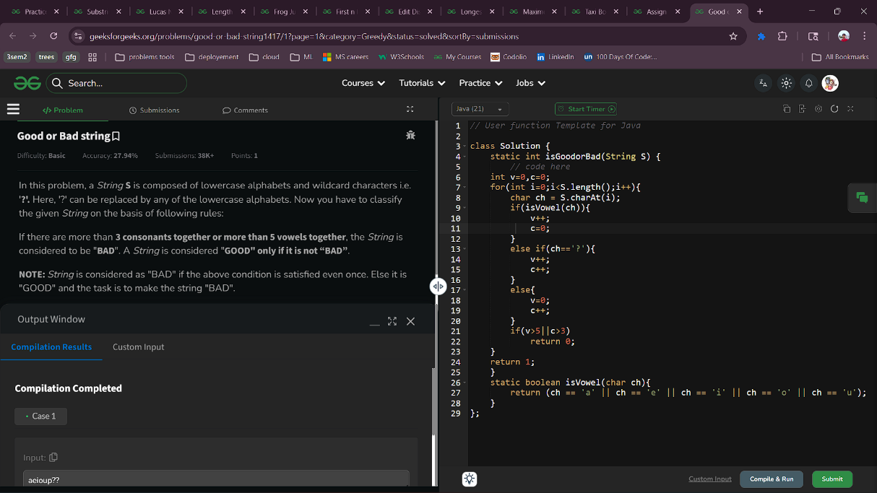
5.7 Assign Mice Holes
Aim : You are given two arrays mices[] and holes[] of the same size. The array mices[] represents the positions of the mice on a straight line, while the array holes[] represents the positions of the holes on the same line. Each hole can accommodate exactly one mouse. A mouse can either stay in its current position, move one step to the right, or move one step to the left, and each move takes one minute. The task is to assign each mouse to a distinct hole in such a way that the time taken by the last mouse to reach its hole is minimized.
class Solution {
public int assignHole(int[] mices, int[] holes) {
// code here
int max=Integer.MIN_VALUE;
Arrays.sort(mices);
Arrays.sort(holes);
for(int i=0;i<mices.length;i++){
max=Math.max(Math.abs(mices[i]-holes[i]),max);
}
return max;
}
};
Output :

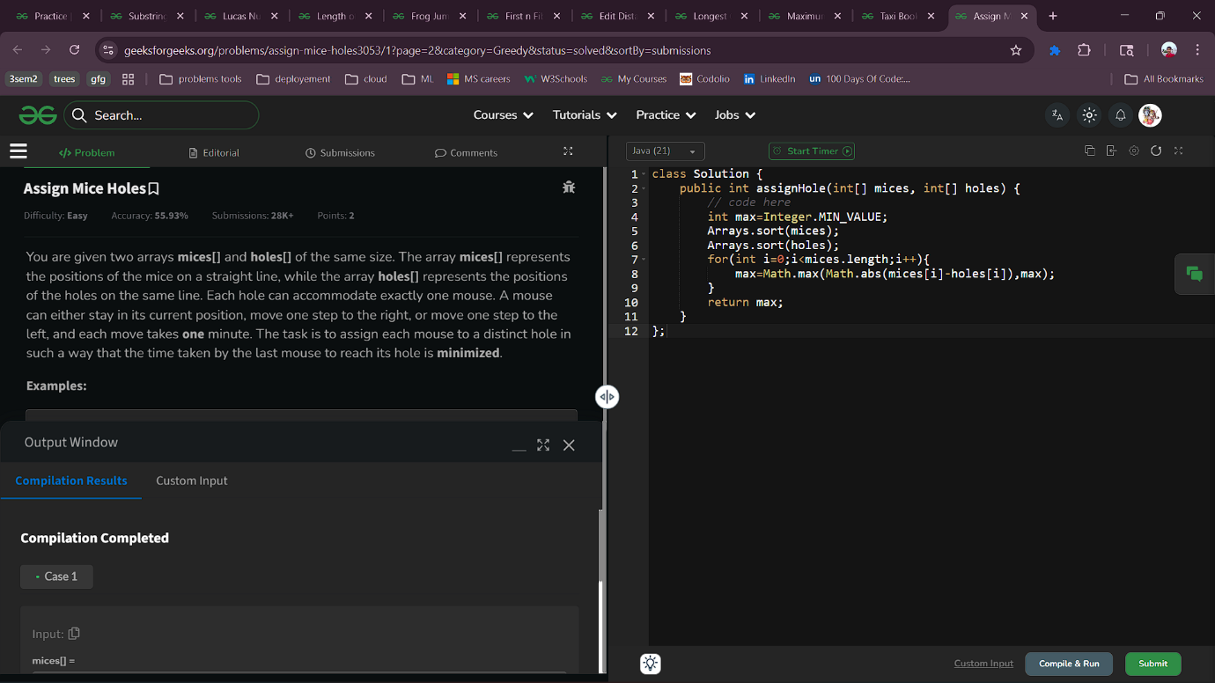

5.8 Taxi Booking
Aim : You are going to book a taxi. There are infinite number of points 1, 2, 3... on the X axis and your current position is cur. There are N Taxis near you, and the position of those taxis is given as an array pos. Where pos[i] denotes the position of the ith taxi. You are also given an array time. Where time[i] denotes the time taken by the ith taxi to cover 1 unit of distance. Your task is to find the minimum time to board a taxi.
class Solution {
public static int minimumTime(int N, int cur, int[] pos, int[] time) {
// code here
int min=Integer.MAX_VALUE;
for(int i=0;i<N;i++){
int currentTime=Math.abs(pos[i]-cur)*time[i];
if(currentTime<min){
min=currentTime;
}
}
return min;
}
}
Output :

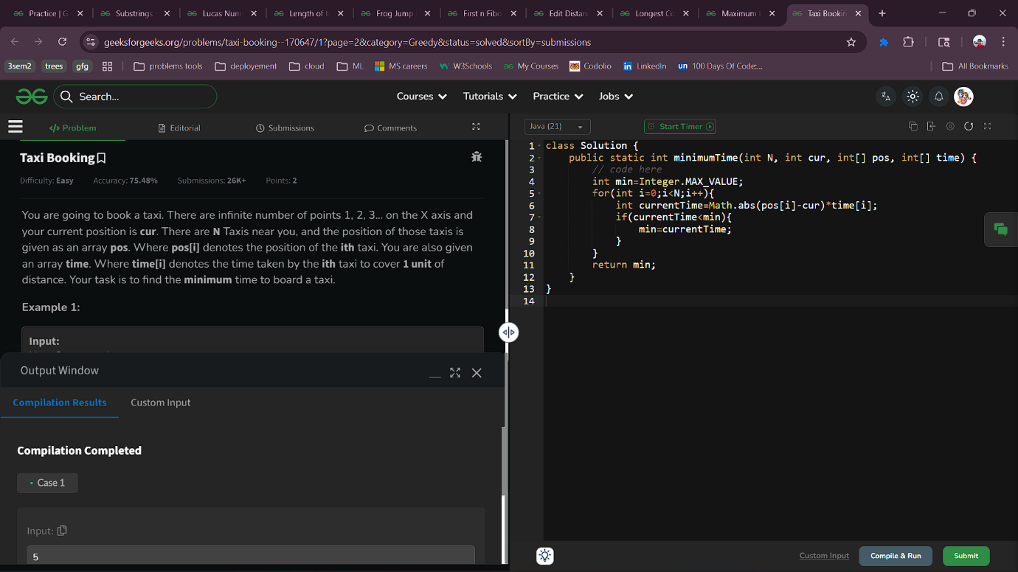

6.1 Maximum Product Subarray
Aim : Given an array arr[] that contains positive and negative integers (may contain 0 as well). Find the maximum product that we can get in a subarray of arr[].
Note: It is guaranteed that the answer fits in a 32-bit integer.
class Solution {
int maxProduct(int[] arr) {
// code here
int ans=Integer.MIN_VALUE,n=arr.length;
int left=1,right=1;
for(int i=0;i<n;i++){
if(left==0) left=1;
if(right==0) right=1;
left*=arr[i];
right*=arr[n-i-1];
ans=Math.max(ans,Math.max(left,right));
}
return ans;
}
}
Output :

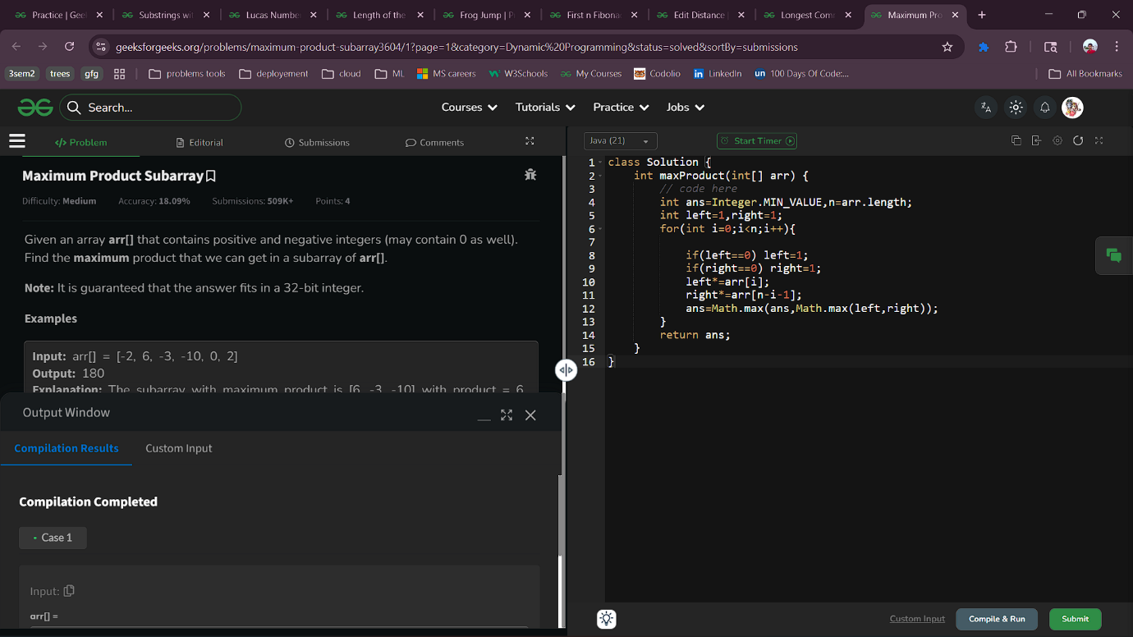

6.2 Longest Common Subsequence
Aim : Given two strings s1 and s2, return the length of their longest common subsequence (LCS). If there is no common subsequence, return 0.
A subsequence is a sequence that can be derived from the given string by deleting some or no elements without changing the order of the remaining elements. For example, "ABE" is a subsequence of "ABCDE".
class Solution {
static int lcs(String s1, String s2) {
// code here
int m=s1.length(),n=s2.length();
int dp[][]=new int [m+1][n+1];

for(int i=1;i<=m;i++){
for(int j=1;j<=n;j++){
if(s1.charAt(i-1)==s2.charAt(j-1)){
dp[i][j]=1+dp[i-1][j-1];
}else{
dp[i][j]=Math.max(dp[i-1][j],dp[i][j-1]);
}
}
}
return dp[m][n];
}
}
Output :

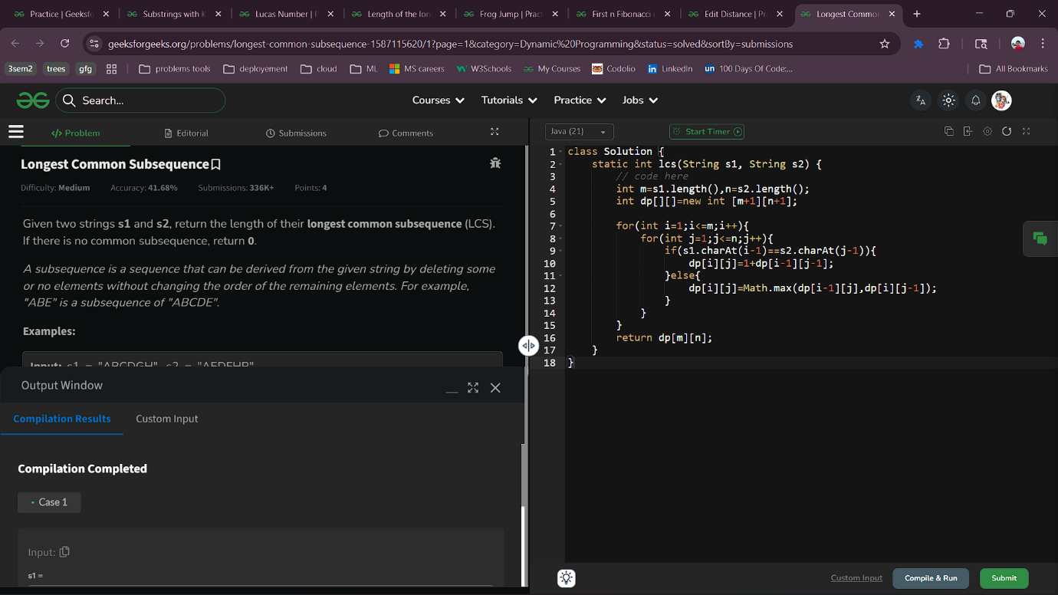

6.3 Edit Distance
Aim : Given two strings s1 and s2. Return the minimum number of operations required to convert s1 to s2.
The possible operations are permitted:
- Insert a character at any position of the string.
- Remove any character from the string.
- Replace any character from the string with any other character.
class Solution {
public int editDistance(String s1, String s2) {
int m=s1.length();
int n=s2.length();
int dp[][]=new int [m+1][n+1];
for(int i=1;i<=m;i++) dp[i][0]=i;
for(int j=1;j<=n;j++) dp[0][j]=j;
for(int i=1;i<=m;i++){
for(int j=1;j<=n;j++){
if(s1.charAt(i-1)==s2.charAt(j-1)){
dp[i][j]=dp[i-1][j-1];
}
else{
dp[i][j]=Math.min(dp[i-1][j-1],Math.min(dp[i-1][j],dp[i][j-1]))+1;
}
}
}
return dp[m][n];
}
}Output :

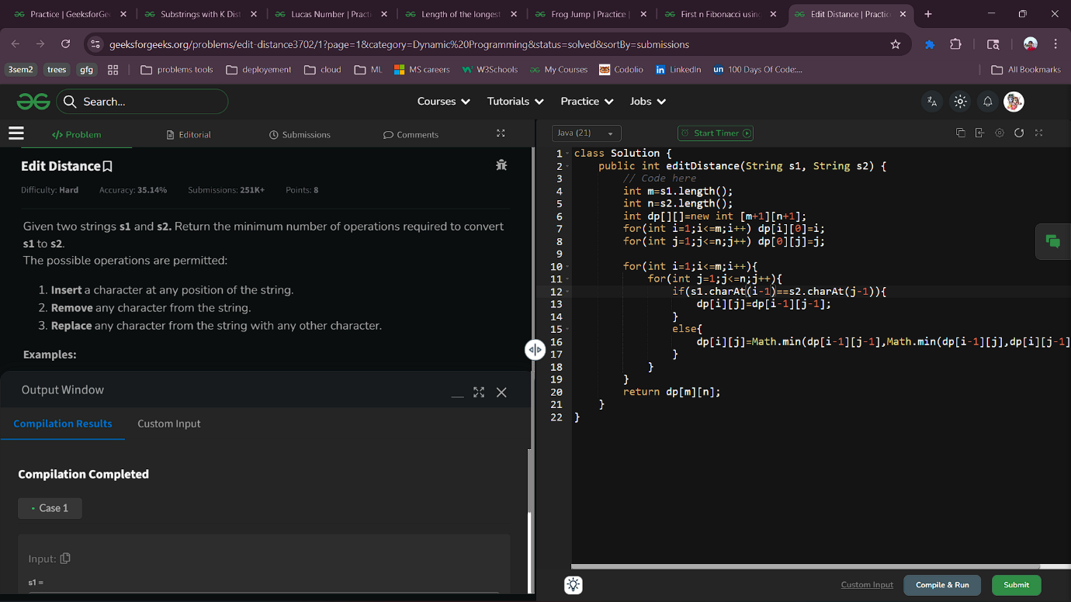

6.4 First n Fibonacci using DP
Aim : You are given an integer n, return the fibonacci series till the nth(0-based indexing) term. Since the terms can become very large return the terms modulo 10⁹+7.
class Solution {
int[] Series(int n) {
// code here
int arr[]=new int[n+1];
arr[0]=0;
arr[1]=1;
for(int i=2;i<=n;i++){
arr[i]=(arr[i-1]+arr[i-2])%1000000007;
}
return arr;
}
}Output :

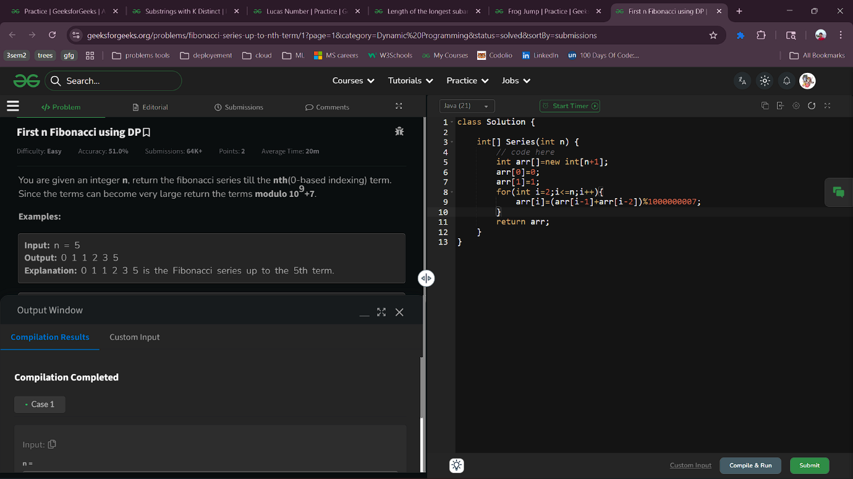

6.5 Frog Jump
Aim : Given an integer array height[] where height[i] represents the height of the i-th stair, a frog starts from the first stair and wants to reach the last stair. From any stair i, the frog has two options: it can either jump to the (i+1)th stair or the (i+2)th stair. The cost of a jump is the absolute difference in height between the two stairs. Determine the minimum total cost required for the frog to reach the last stair.
class Solution {
int minCost(int[] height) {
// code here
int n = height.length;
if (n == 1) return 0;

int prev2 = 0; // cost to reach i-2
int prev1 = Math.abs(height[1] - height[0]); // cost to reach i-1

for (int i = 2; i < n; i++) {
int jumpOne = prev1 + Math.abs(height[i] - height[i - 1]);
int jumpTwo = prev2 + Math.abs(height[i] - height[i - 2]);
int curr = Math.min(jumpOne, jumpTwo);
prev2 = prev1;
prev1 = curr;
}
return prev1;
}
}Output :

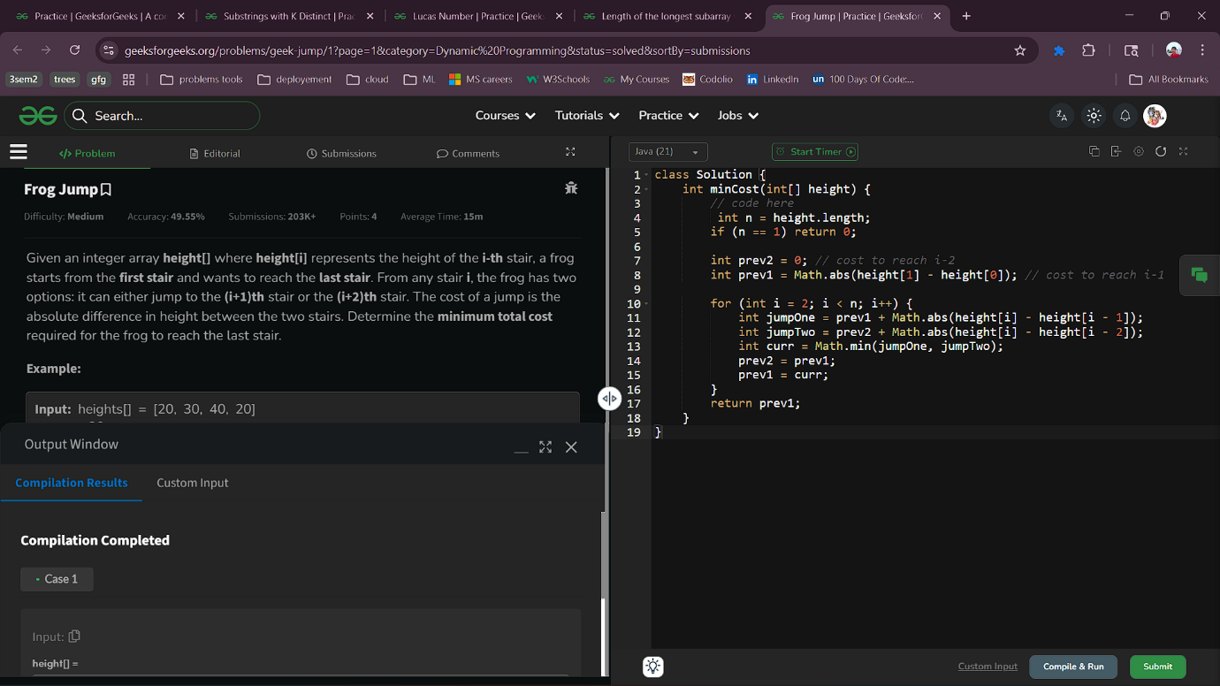

6.6 Length of the longest subarray with positive product
Aim : Given an array arr[] consisting of n integers, find the length of the longest subarray with positive (non zero) product.
// User function Template for Java

class Solution {
/* Function to return the length of the
longest subarray with ppositive product */
int maxLength(int arr[], int n) {
// code here
int Pos = 0;
int Neg = 0;
int res = 0;

for (int i = 0; i < n; i++)
{
if (arr[i] == 0)
{
Pos = Neg = 0;
}
else if (arr[i] > 0)
{
Pos += 1;

// If at least one element is
// present in the subarray with
// negative product
if (Neg != 0)
{
Neg += 1;
}
res = Math.max(res, Pos);
}
else
{
Pos = Pos + Neg;
Neg = Pos - Neg;
Pos = Pos - Neg;

// Increment the length of subarray
// with negative product
Neg += 1;
// If at least one element is present
// in the subarray with positive product
if (Pos != 0)
{
Pos += 1;
}
res = Math.max(res, Pos);
}
}
return res;
}
}Output :

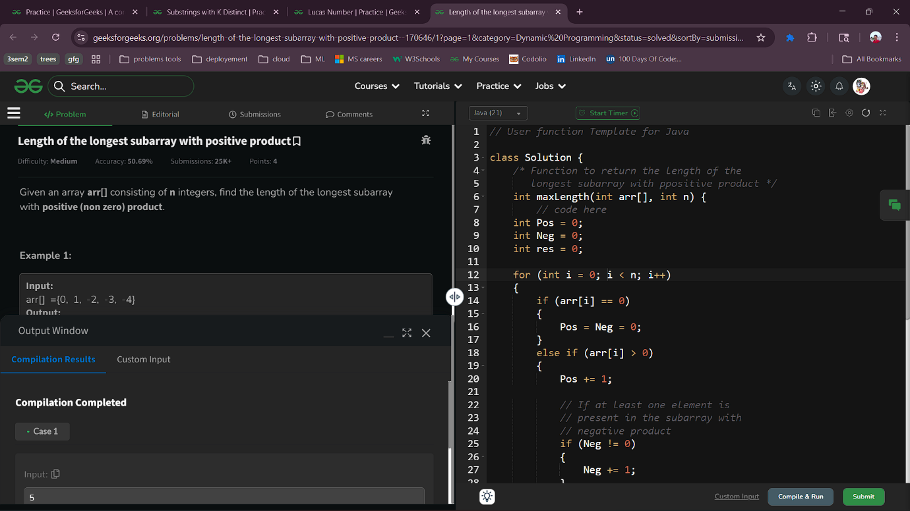

6.7 Lucas Number
Aim : A Lucas Number is a number which is represented by the following recurrence
L_{n} = L_{n-1} + L_{n-2} for n>1
L₀ = 2
L₁ = 1
Given a number n, find the n^{th} lucas number.
Note: Since the output may be very large calculate the answer modulus 10^9+7.
class Solution {
public long lucas(int n) {
// code here.
if(n<=1) return 2-n;
long l1=2,l2=1,res=0;
for(int i=2;i<=n;i++){
res=(l2+l1)%1000000007;
l1=l2;
l2=res;
}
return res;
}
};
Output :

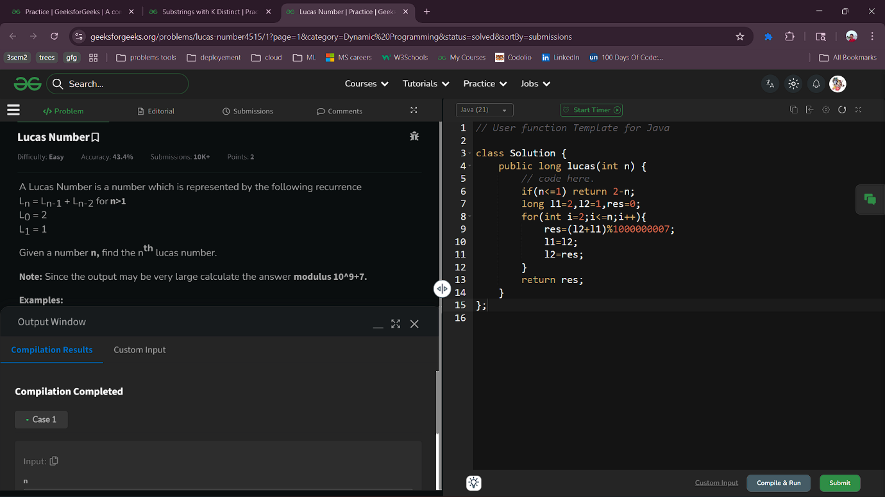

6.8 Substrings with K Distinct
Aim : You are given a string s consisting of lowercase characters and an integer k, You have to count all possible substrings that have exactly k distinct characters.
class Solution {
static int countSubstr(String s, int k) {
int n = s.length();
int ans = 0;
ans = count(s, k) - count(s, k - 1);
return ans;
}
static int count(String s, int k) {
int n = s.length();
int ans = 0;
int[] freq = new int[26];
int distinctCnt = 0;
int i = 0;
for (int j = 0; j < n; j++) {
freq[s.charAt(j) - 'a']++;
if (freq[s.charAt(j) - 'a'] == 1) distinctCnt++;
while (distinctCnt > k) {
freq[s.charAt(i) - 'a']--;
if (freq[s.charAt(i) - 'a'] == 0) distinctCnt--;
i++;
}
ans += j - i + 1;
}
return ans;
}
}Output :


7.1 Remove Duplicates from Sorted List
Aim : Given the head of a sorted linked list, delete all duplicates such that each element appears only once. Return the linked list sorted as well.
class Solution {
public ListNode deleteDuplicates(ListNode head) {
ListNode current = head;

while (current != null && current.next != null) {
if (current.val == current.next.val) {
current.next = current.next.next;
} else {
current = current.next;
}
}

return head;
}
}
Output ;

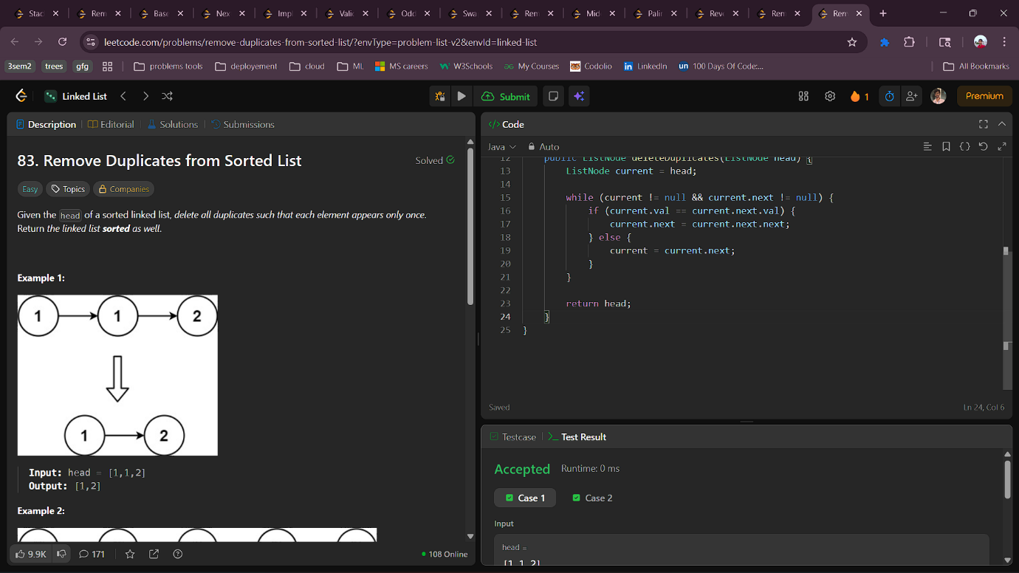

7.2 Remove Linked List Elements
Aim : Given the head of a linked list and an integer val, remove all the nodes of the linked list that has Node.val == val, and return the new head.
class Solution {
public ListNode removeElements(ListNode head, int val) {
ListNode temp=new ListNode(-1);
temp.next=head;
ListNode curr=head,prev=temp;
while(curr!=null){
if(curr.val==val){
prev.next=curr.next;
}else{
prev=prev.next;
}
curr=curr.next;
}
return temp.next;
}
}
Output :

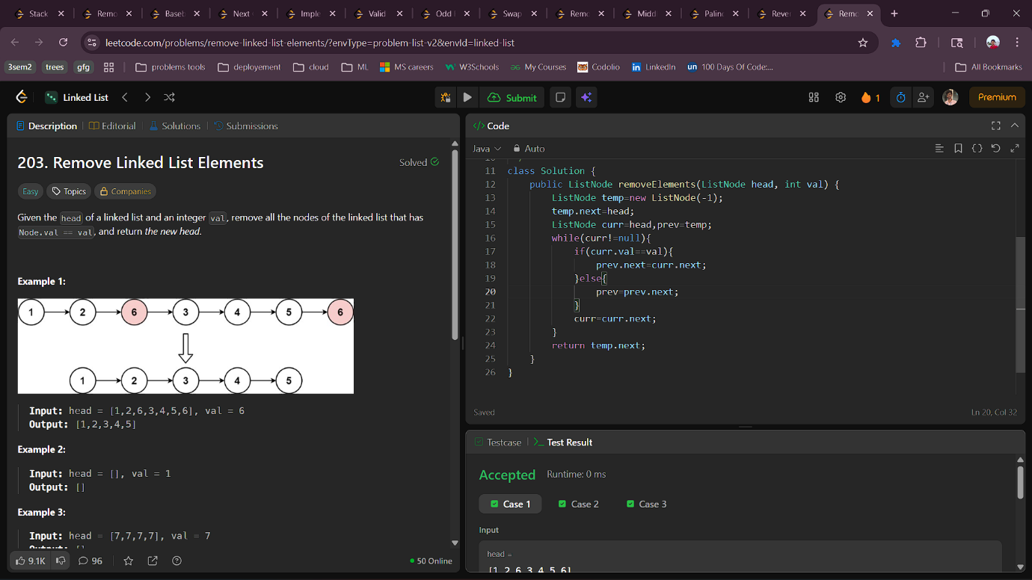

7.3 Reverse Linked List
Aim : Given the head of a singly linked list, reverse the list, and return the reversed list.
class Solution {
public ListNode reverseList(ListNode head) {
Stack<ListNode> st=new Stack<>();
ListNode temp=head;
while(temp!=null){
st.push(temp);
temp=temp.next;
}
if(!st.isEmpty()){
head=st.pop();
temp=head;
while(!st.isEmpty()){
temp.next=st.pop();
temp=temp.next;
}
temp.next=null;
}
return head;
}
}
Output :

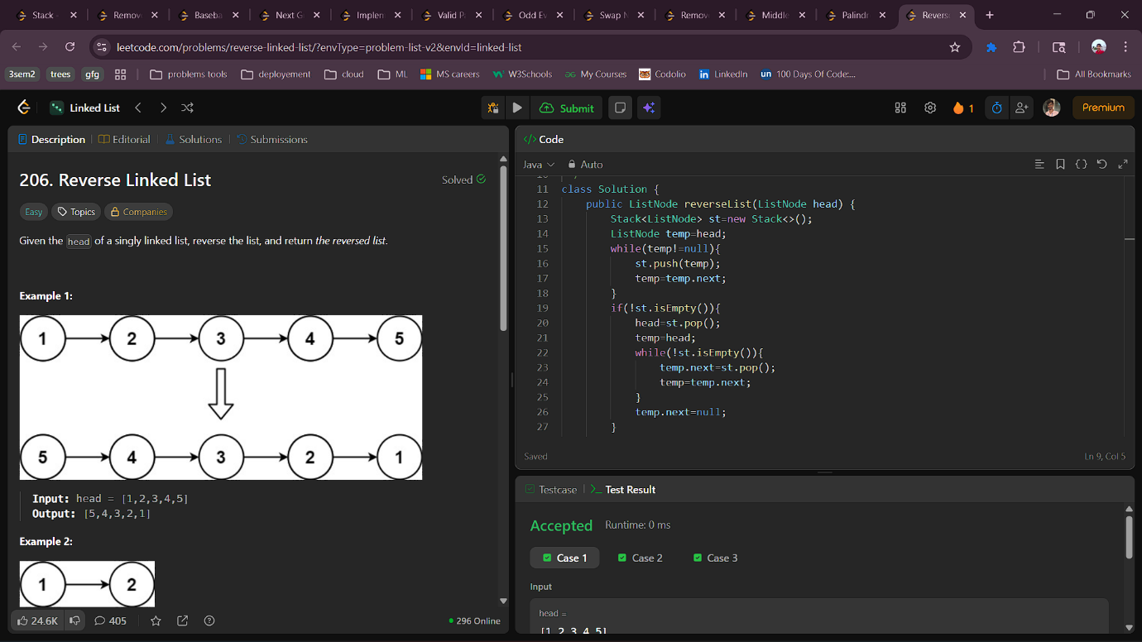

7.4 Palindrome Linked List
Aim : Given a matrix Grid[][] of size NxN. Calculate the absolute difference between the sums of its diagonals.
class Solution {
int diagonalSumDifference(int N, int[][] Grid) {
// code here
int diff=0;
for(int i=0;i<Grid.length;i++){
diff+=Grid[i][i];
diff-=Grid[i][Grid.length-i-1];
}
return Math.abs(diff);
}
}
Output :
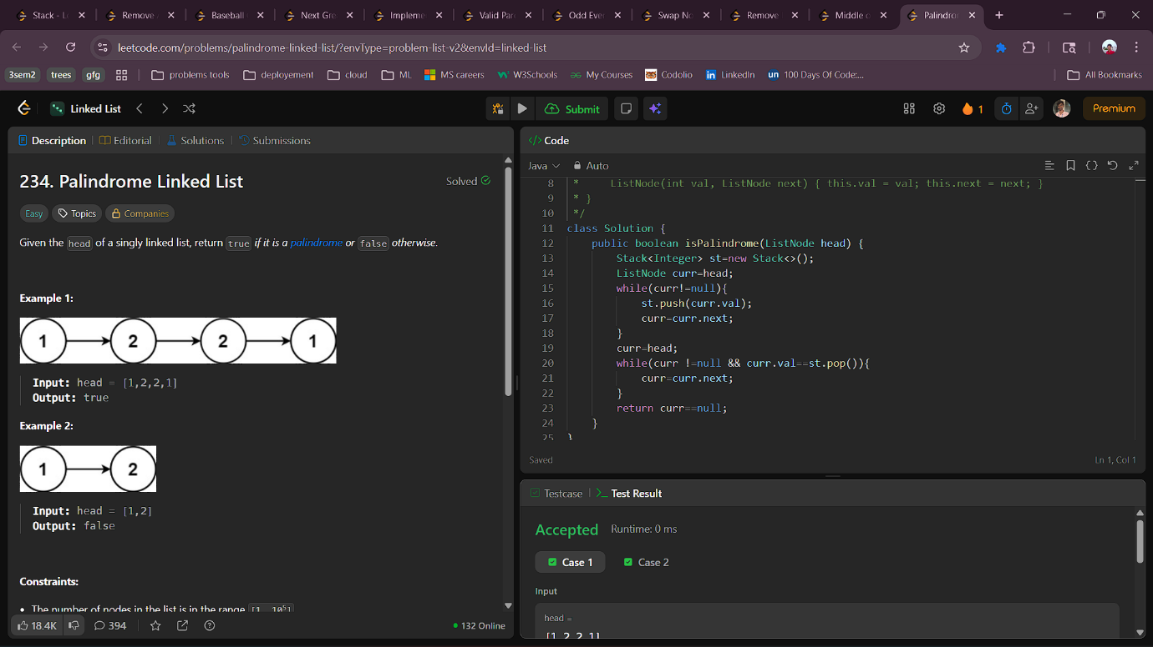

7.5 Middle of the Linked List
Aim : Given the head of a singly linked list, return the middle node of the linked list.
If there are two middle nodes, return the second middle node.
class Solution {
public ListNode middleNode(ListNode head) {
ListNode fp=head,sp=head;
while(fp!=null && fp.next!=null){
sp=sp.next;
fp=fp.next.next;
}
return sp;
}
}

Output :
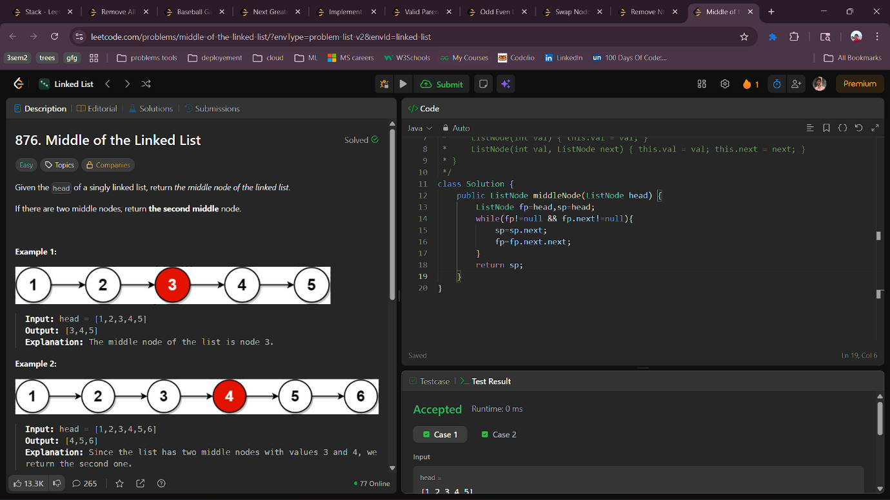

7.6 Remove Nth Node From End of List
Aim : Given an nxn matrix .In the given matrix, you have to find the boundary elements of the matrix.
class Solution {
public ListNode removeNthFromEnd(ListNode head, int n) {
if(head==null) return null;
ListNode sp=head,fp=head;
int i=1;
while(i++<=n){
fp=fp.next;
}
if(fp == null ) return head.next;
while(fp.next!=null){
fp=fp.next;
sp=sp.next;
}
if(sp.next!=null){
sp.next=sp.next.next;
}
return head;
}
}
Output :

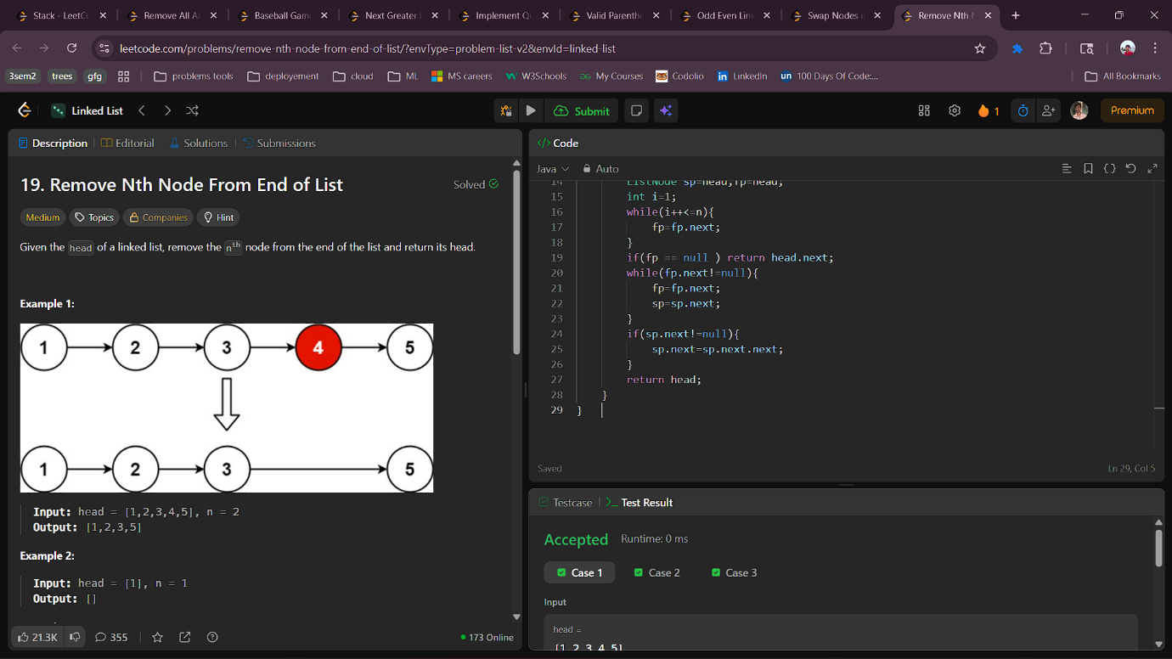

7.7 Swap Nodes in Pairs
Aim : Given a linked list, swap every two adjacent nodes and return its head. You must solve the problem without modifying the values in the list's nodes (i.e., only nodes themselves may be changed.)
class Solution {
public ListNode swapPairs(ListNode head) {
if(head==null || head.next==null) return head;
ListNode dummy=new ListNode(0);
dummy.next=head;
ListNode prev=dummy;
while(prev.next !=null && prev.next.next != null){
ListNode first=prev.next;
ListNode second=first.next;

first.next=second.next;
second.next=first;
prev.next=second;

prev=first;
}
head=dummy.next;
return head;
}
}
Output :
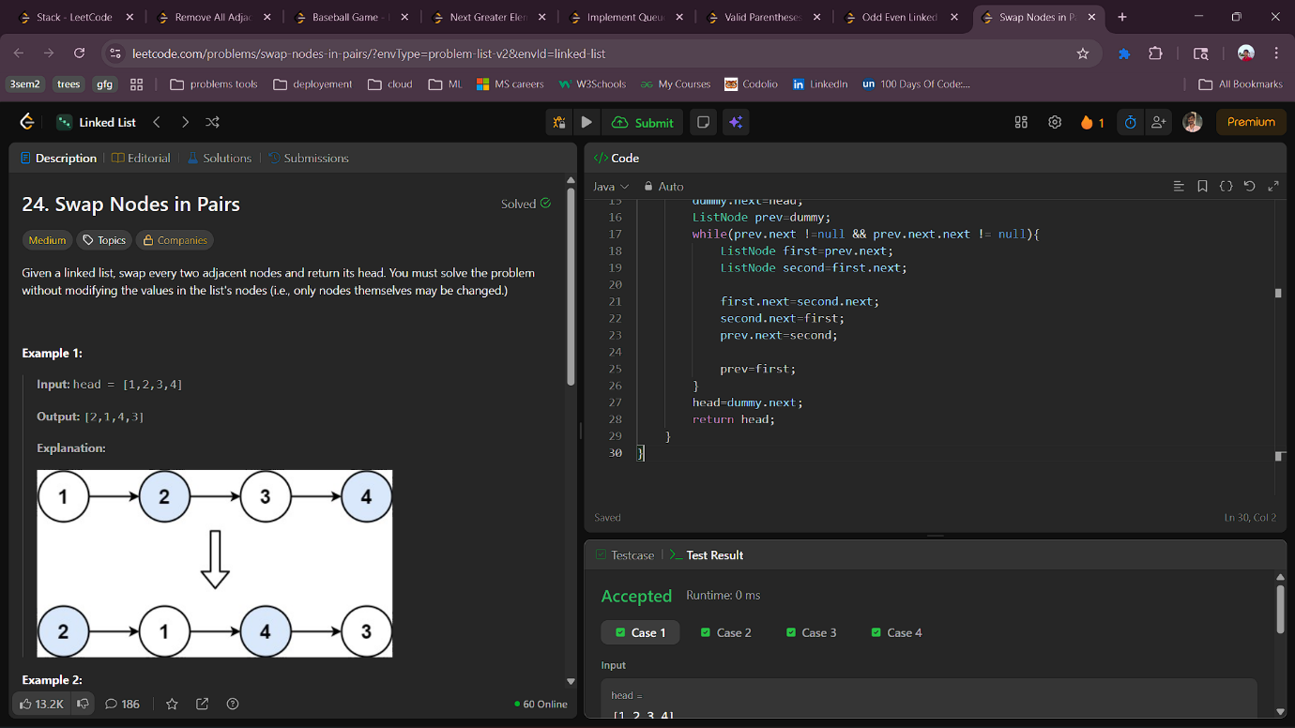

7.8 Odd Even Linked List
Aim : Given the head of a singly linked list, group all the nodes with odd indices together followed by the nodes with even indices, and return the reordered list.The first node is considered odd, and the second node is even, and so on.
Note that the relative order inside both the even and odd groups should remain as it was in the inputYou must solve the problem in O(1) extra space complexity and O(n) time complexity
class Solution {
public ListNode oddEvenList(ListNode head) {
if(head ==null || head.next==null) return head;
ListNode odd=head;
ListNode even=head.next;
ListNode evenhead=even;
while(even!=null && even.next!=null){
odd.next=even.next;
odd=odd.next;
even.next=even.next.next;
even=even.next;
}
odd.next=evenhead;
return head;
}
}
Output :

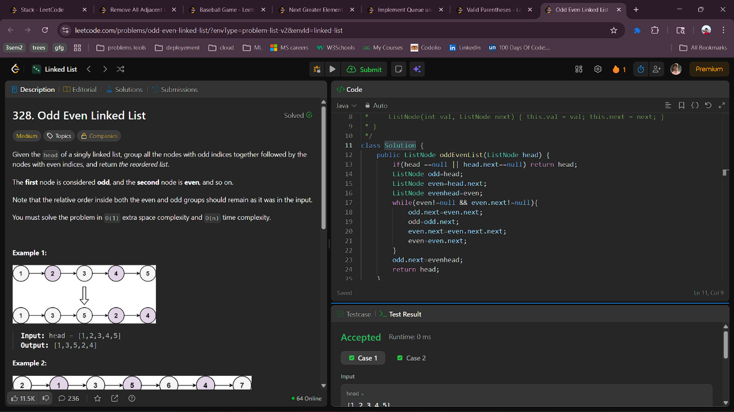
8.1 Valid Parentheses
Aim : Given a string s containing just the characters '(', ')', '{', '}', '[' and ']', determine if the input string is valid.
An input string is valid if:
- Open brackets must be closed by the same type of brackets.
- Open brackets must be closed in the correct order.
- Every close bracket has a corresponding open bracket of the same type.
class Solution {
public boolean isValid(String s) {
Stack<Character> stack = new Stack<>();
for (char ch : s.toCharArray()) {
if (ch == '(' || ch == '[' || ch == '{') {
stack.push(ch);
} else {
if (stack.isEmpty()) {
return false;
}
char top = stack.pop();
if (ch == ')' && top != '(') {
return false;
}
if (ch == ']' && top != '[') {
return false;
}
if (ch == '}' && top != '{') {
return false;
}
}
}
return stack.isEmpty();
}
}Output :
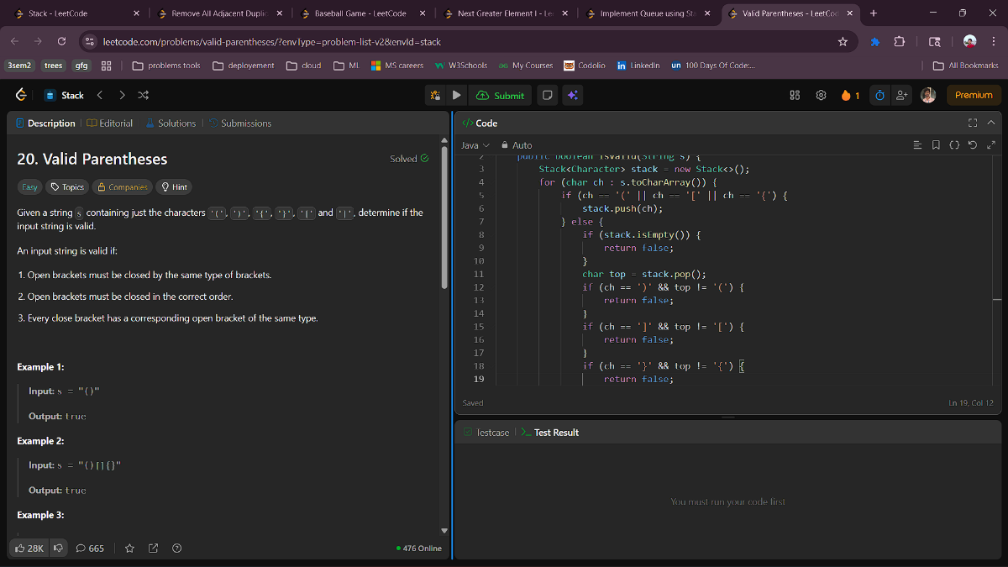
8.2 Implement Queue using Stacks
Aim : Implement a first in first out (FIFO) queue using only two stacks. The implemented queue should support all the functions of a normal queue (push, peek, pop, and empty).
Implement the MyQueue class:
- void push(int x) Pushes element x to the back of the queue.
- int pop() Removes the element from the front of the queue and returns it.
- int peek() Returns the element at the front of the queue.
- boolean empty() Returns true if the queue is empty, false otherwise.
class MyQueue {
Stack<Integer> s1;
public int peek() {
if(!s2.isEmpty()) return s2.peek();
return front;
}

public boolean empty() {
return s1.isEmpty() && s2.isEmpty();
}
}

Stack<Integer> s2;
public MyQueue() {
s1=new Stack<>();
s2=new Stack<>();
}
private int front;
public void push(int x) {
if(s1.isEmpty()) front=x;
s1.push(x);
}

public int pop() {
if(s2.isEmpty()){
while(!s1.isEmpty()) s2.push(s1.pop());
}
return s2.pop();
}
Output ;
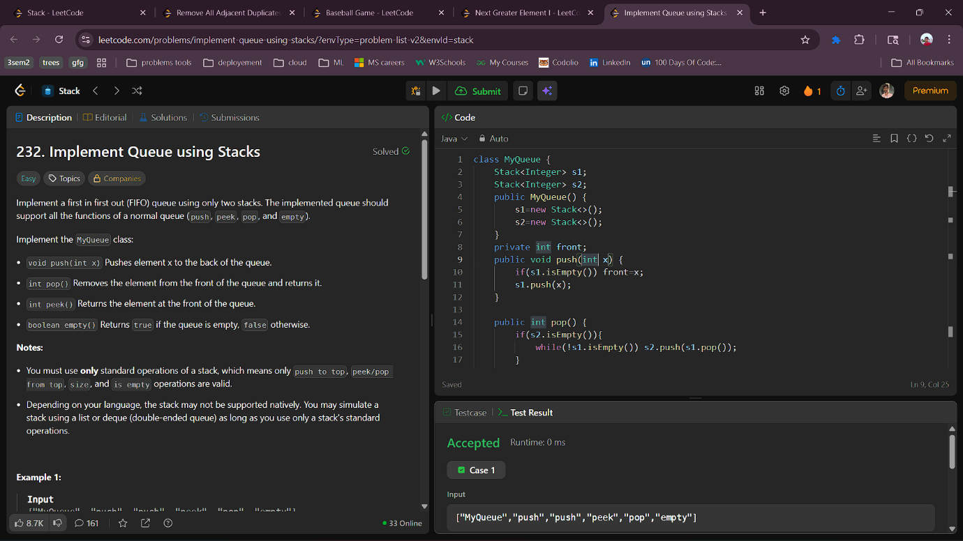
8.3 Next Greater Element I
Aim : The next greater element of some element x in an array is the first greater element that is to the right of x in the same array.
You are given two distinct 0-indexed integer arrays nums1 and nums2, where nums1 is a subset of nums2.
For each 0 <= i < nums1.length, find the index j such that nums1[i] == nums2[j] and determine the next greater element of nums2[j] in nums2. If there is no next greater element, then the answer for this query is -1..Return an array ans of length nums1.length such that ans[i] is the next greater element as described above.
class Solution {
public int[] nextGreaterElement(int[] nums1, int[] nums2) {
int[] nextGreater = new int[10001];
Stack<Integer> stack = new Stack<>();

for (int i = nums2.length - 1; i >= 0; i--) {
while (!stack.isEmpty() && stack.peek() <= nums2[i]) {
stack.pop();
}
nextGreater[nums2[i]] = stack.isEmpty() ? -1 : stack.peek();
stack.push(nums2[i]);
}

for (int i = 0; i < nums1.length; i++) {
nums1[i] = nextGreater[nums1[i]];
}

return nums1;
}
}Output :
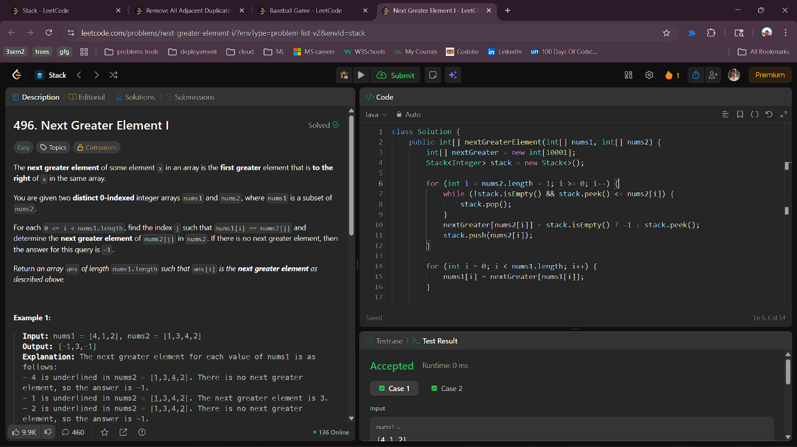
8.4 Baseball Game
Aim : You are keeping the scores for a baseball game with strange rules. At the beginning of the game, you start with an empty record.
You are given a list of strings operations, where operations[i] is the i^{th} operation you must apply to the record and is one of the following:
- An integer x.
  - Record a new score of x.
- '+'.
  - Record a new score that is the sum of the previous two scores.
- 'D'.
  - Record a new score that is the double of the previous score.
- 'C'.
  - Invalidate the previous score, removing it from the record.
Return the sum of all the scores on the record after applying all the operations.
class Solution {
public int calPoints(String[] operations) {
Stack<Integer> stack = new Stack();
for(String op : operations) {
if (op.equals("+")) {
int top = stack.pop();
int newtop = top + stack.peek();
stack.push(top);
stack.push(newtop);
} else if (op.equals("C")) {
stack.pop();
} else if (op.equals("D")) {
stack.push(2 * stack.peek());
} else {
stack.push(Integer.valueOf(op));
}
}
int ans = 0;
for(int score : stack) ans += score;
return ans;
}}Output :
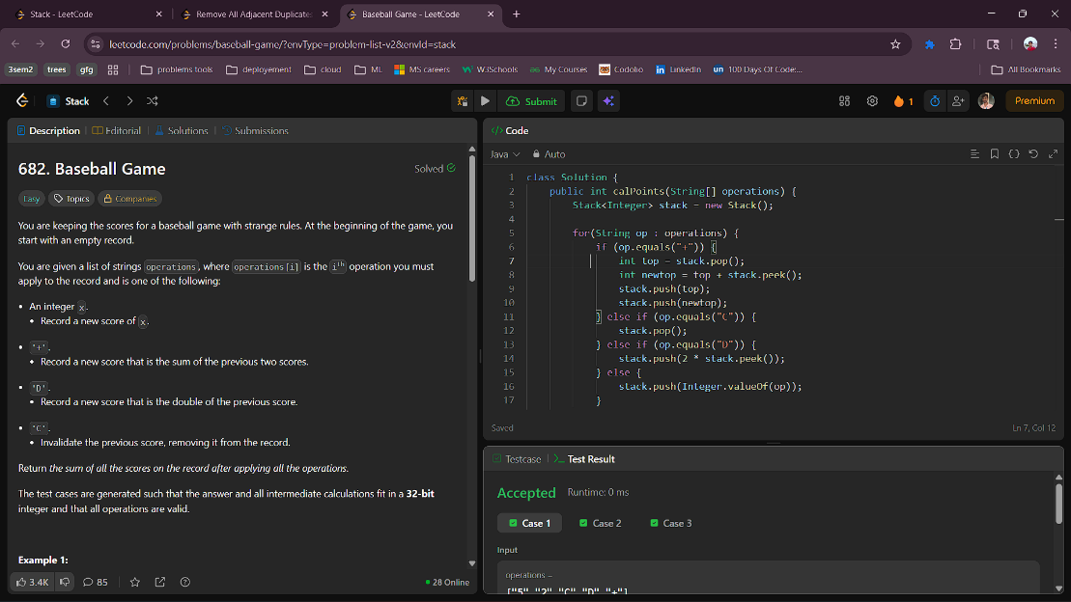
8.5 Remove All Adjacent Duplicates In String
Aim : You are given a string s consisting of lowercase English letters. A duplicate removal consists of choosing two adjacent and equal letters and removing them.
We repeatedly make duplicate removals on s until we no longer can.
Return the final string after all such duplicate removals have been made. It can be proven that the answer is unique.
class Solution {
public String removeDuplicates(String s) {
Stack<Character> st=new Stack<>();
for(int i=s.length()-1;i>=0;i--){
if(st.empty()) st.push(s.charAt(i));
else if(st.peek()==s.charAt(i)){
//st.push(s.charAt(i));
st.pop();
}
else st.push(s.charAt(i));
}
StringBuilder sb=new StringBuilder();
while(!st.empty()){
sb.append(st.pop());
}
return sb.toString();
}
}
Output :
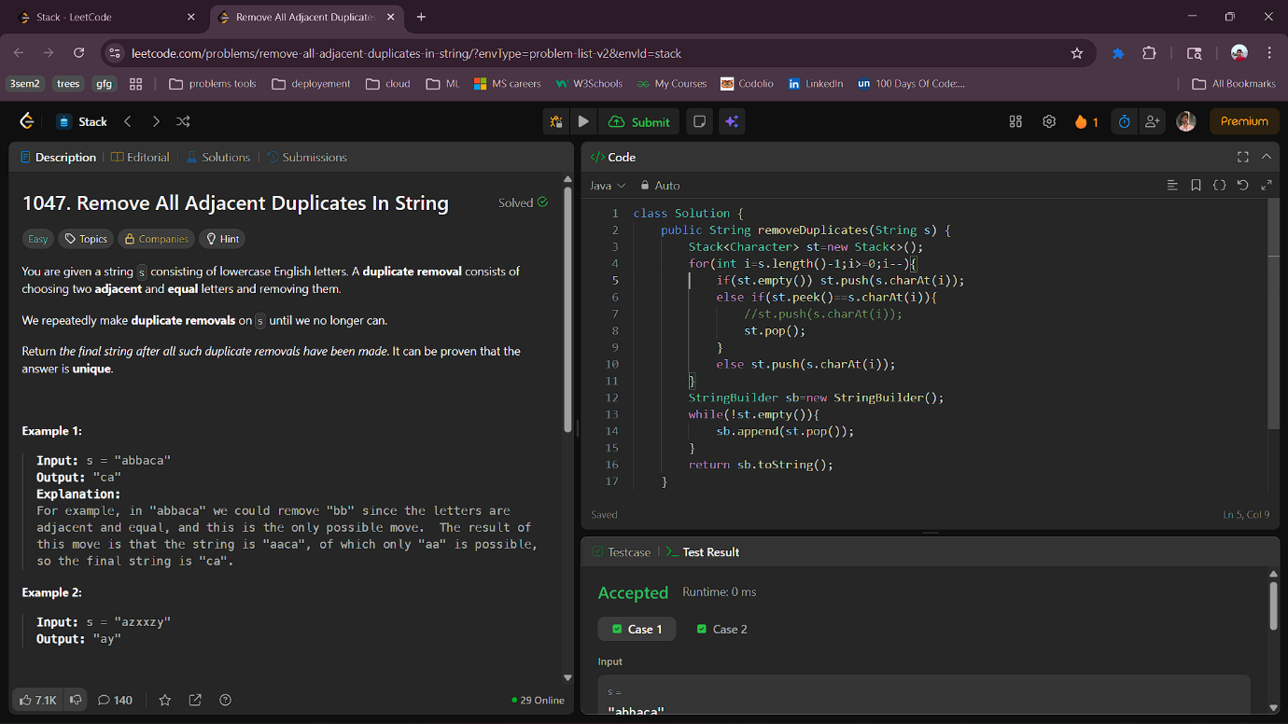

9.1 Implement Stack using Queues
Aim : Implement a last-in-first-out (LIFO) stack using only two queues. The implemented stack should support all the functions of a normal stack (push, top, pop, and empty).
Implement the MyStack class:
- void push(int x) Pushes element x to the top of the stack.
- int pop() Removes the element on the top of the stack and returns it.
- int top() Returns the element on the top of the stack.
- boolean empty() Returns true if the stack is empty, false otherwise.
class MyStack {
Queue<Integer> q;
public MyStack() {
public int top() {
if(q.isEmpty()) return -1;
return q.peek();
}

public boolean empty() {
return q.isEmpty();
}
}
q=new LinkedList<>();
}

public void push(int x) {
q.offer(x);
for(int i=1;i<q.size();i++) q.offer(q.poll());
}

public int pop() {
if(q.isEmpty()) return -1;
return q.poll();
}

Output :
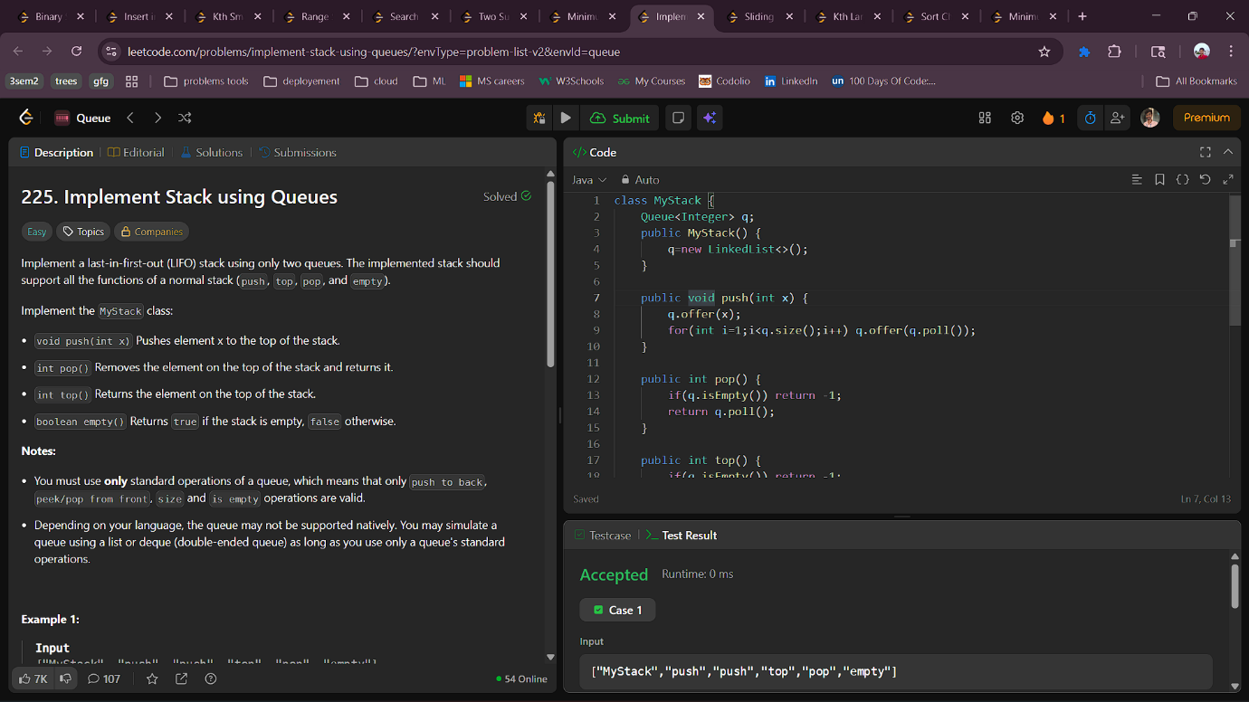
9.2 Sliding Window Maximum
Aim : You are given an array of integers nums, there is a sliding window of size k which is moving from the very left of the array to the very right. You can only see the k numbers in the window. Each time the sliding window moves right by one position.Return the max sliding window.
class Solution {
public int[] maxSlidingWindow(int[] a, int k) {
int n=a.length;
int res[]=new int[n-k+1];
Deque<Integer> dq=new LinkedList<>();
for(int i=0;i<k;i++){
while(!dq.isEmpty() && a[dq.peekLast()]<=a[i])
dq.removeLast();
dq.addLast(i);
}
res[0]=a[dq.peekFirst()];
for(int i=k;i<n;i++){
while(!dq.isEmpty() && dq.peekFirst()<=i-k)
dq.removeFirst();
while(!dq.isEmpty() && a[dq.peekLast()]<=a[i])
dq.removeLast();
dq.addLast(i);
res[i-k+1]=a[dq.peekFirst()];
}
return res;
}
}
Output ;
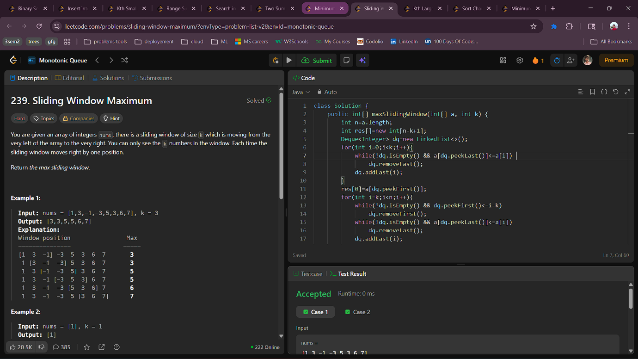

9.3 Kth Largest Element in an Array
Aim : Given an integer array nums and an integer k, return the k^{th} largest element in the array.
Note that it is the k^{th} largest element in the sorted order, not the k^{th} distinct element.
Can you solve it without sorting?

class Solution {
public int findKthLargest(int[] nums, int k) {
PriorityQueue<Integer> pq=new PriorityQueue<>();
for(int i:nums){
pq.add(i);
if(pq.size()>k)
pq.poll();
}
return pq.peek();
}
}
Output :

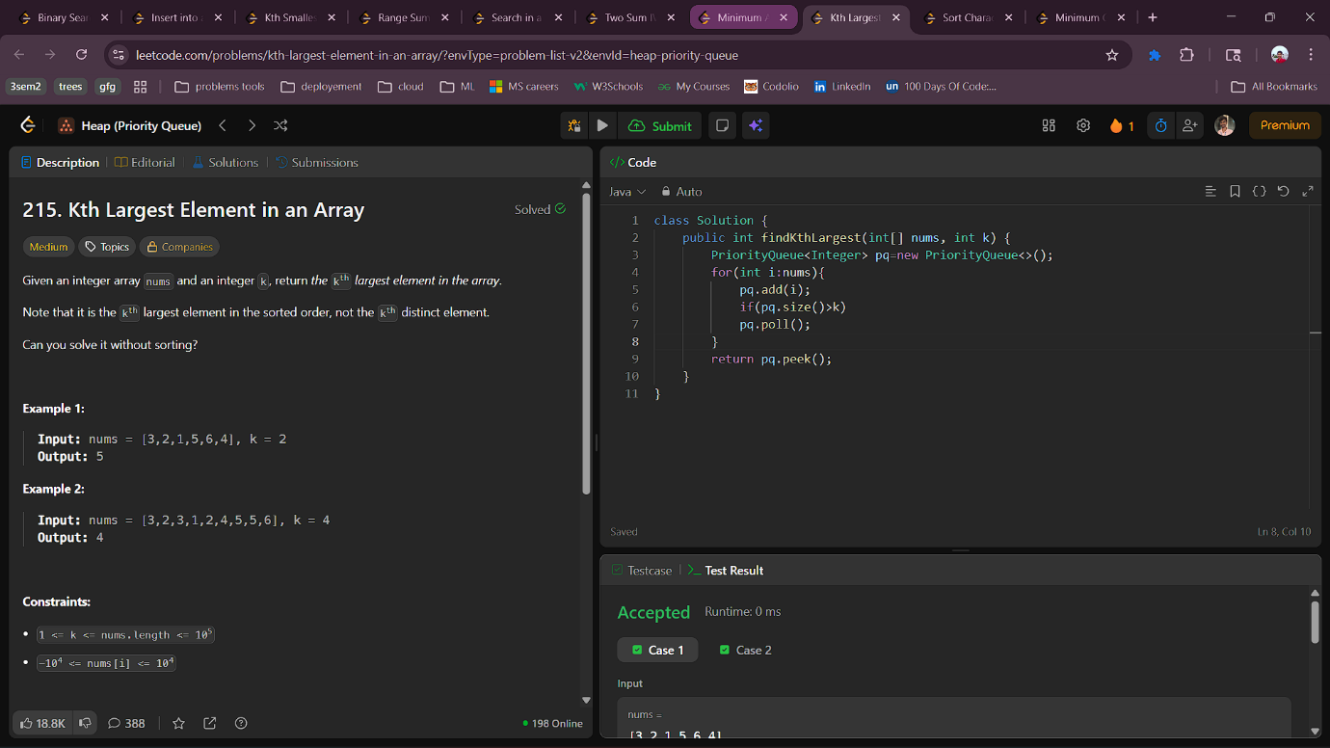

9.4 Sort Characters By Frequency
Aim : Given a string s, sort it in decreasing order based on the frequency of the characters. The frequency of a character is the number of times it appears in the string.
Return the sorted string. If there are multiple answers, return any of them.
class Solution {
public String frequencySort(String s) {
TreeMap<Character,Integer> tm=new TreeMap<>();
for(char ch:s.toCharArray()){
tm.put(ch,tm.getOrDefault(ch,0)+1);
}
PriorityQueue<Map.Entry<Character, Integer>> pq = new PriorityQueue<>(
(a, b) -> b.getValue() - a.getValue()
);

pq.addAll(tm.entrySet());

StringBuilder result = new StringBuilder();
while (!pq.isEmpty()) {
Map.Entry<Character, Integer> entry = pq.poll();
result.append(String.valueOf(entry.getKey()).repeat(entry.getValue()));
}

return result.toString();
}
}
Output :
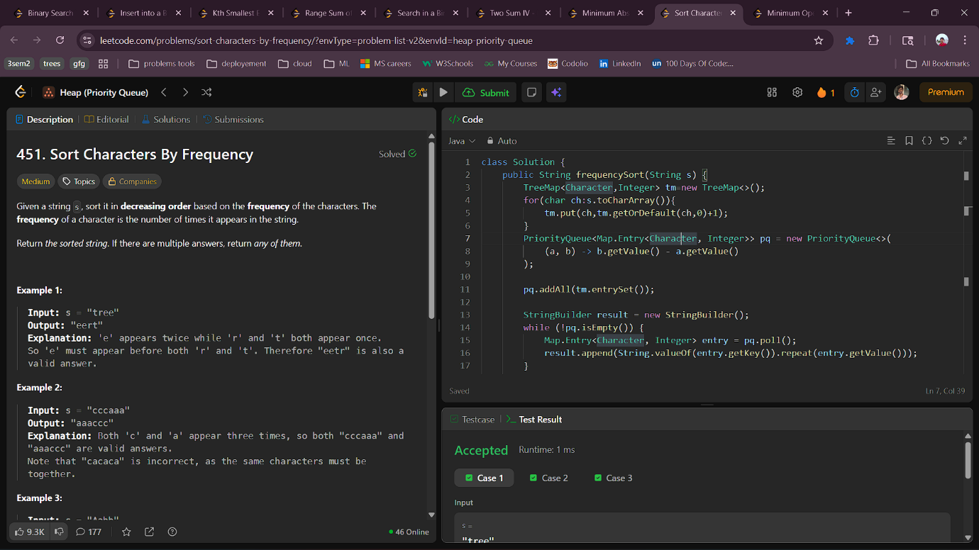

9.5 Minimum Operations to Make Binary Array Elements Equal to One I
Aim : You can do the following operation on the array any number of times (possibly zero):
- Choose any 3 consecutive elements from the array and flip all of them.
Flipping an element means changing its value from 0 to 1, and from 1 to 0.
Return the minimum number of operations required to make all elements in nums equal to 1. If it is impossible, return -1.
class Solution {
public int minOperations(int[] nums) {
int cnt=0;
for(int i=2;i<nums.length;i++){
if(nums[i-2]==0){
cnt++;
nums[i-2]=nums[i-2]^1;
nums[i-1]=nums[i-1]^1;
nums[i]=nums[i]^1;
}
}
int sum=0;
for(int i:nums) sum+=i;
if(sum==nums.length) return cnt;
return -1;
}
}
Output :

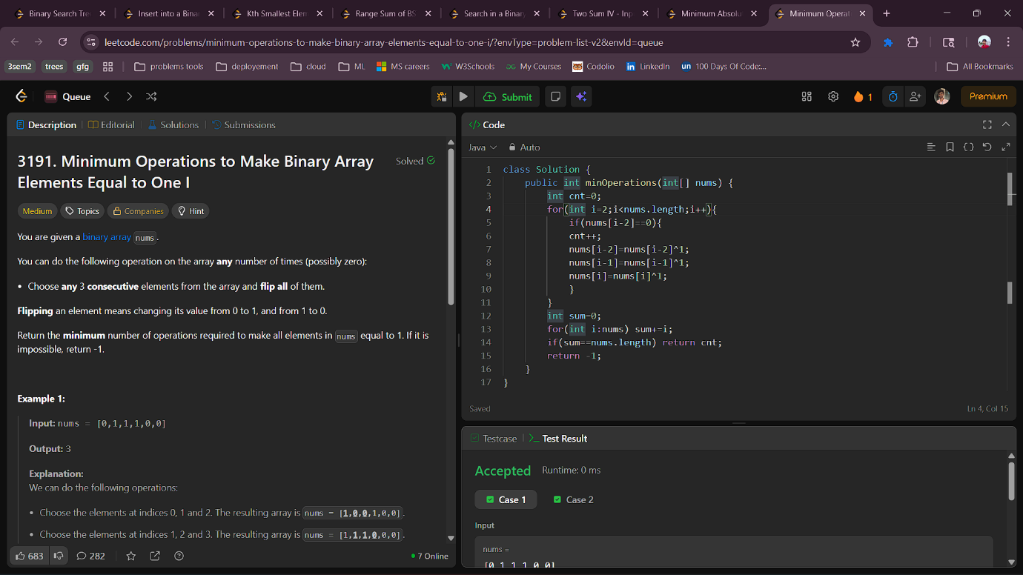
10.1 Insert into a Binary Search Tree
Aim : You are given the root node of a binary search tree (BST) and a value to insert into the tree. Return the root node of the BST after the insertion. It is guaranteed that the new value does not exist in the original BST.
Notice that there may exist multiple valid ways for the insertion, as long as the tree remains a BST after insertion. You can return any of them.
class Solution {
public TreeNode insertIntoBST(TreeNode root, int val) {
if(root == null ) return new TreeNode(val);
TreeNode curr = root;
while(true){
if(curr.val < val){
if(curr.right != null) curr = curr.right;
else {
curr.right = new TreeNode(val);
break;
}
}
else{
if(curr.left != null) curr = curr.left;
else{
curr.left = new TreeNode(val);
break;
}}}
return root;
}}
Output :
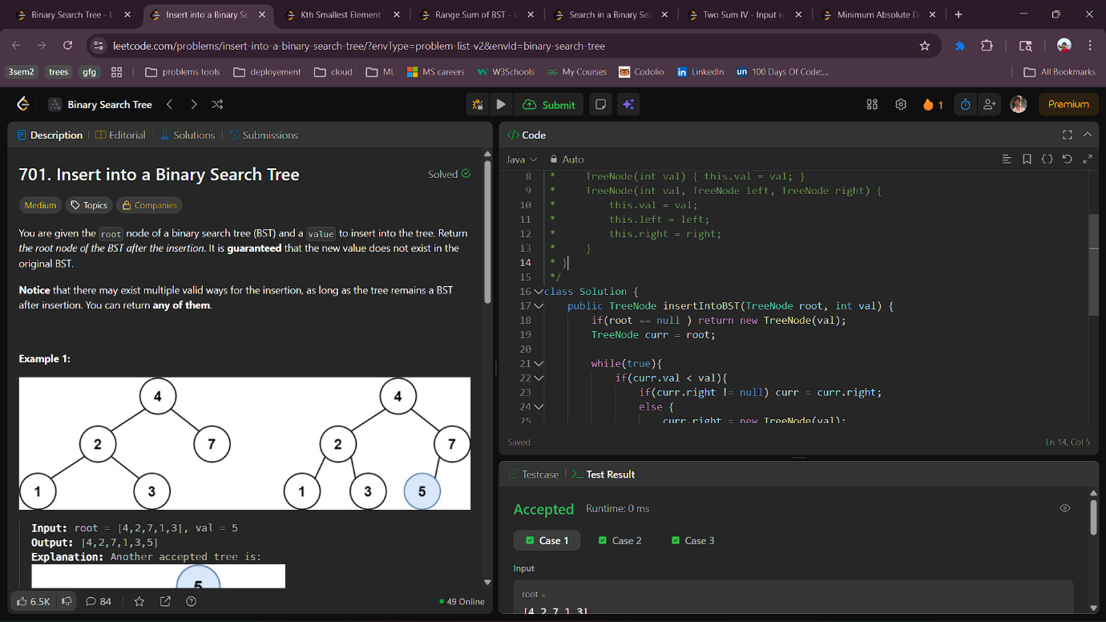

10.2 Kth Smallest Element in a BST
Aim : Given the root of a binary search tree, and an integer k, return the k^{th} smallest value (1-indexed) of all the values of the nodes in the tree.
class Solution {
int count = 0;
TreeNode result = null;

public int kthSmallest(TreeNode root, int k) {
helper(root, k);
return result.val;
}

private void helper(TreeNode node, int k) {
if (node == null) return;

helper(node.left, k); // Traverse left
count++; // Visit current
if (count == k) {
result = node;
return;
}
helper(node.right, k); // Traverse right
}
}
Output ;
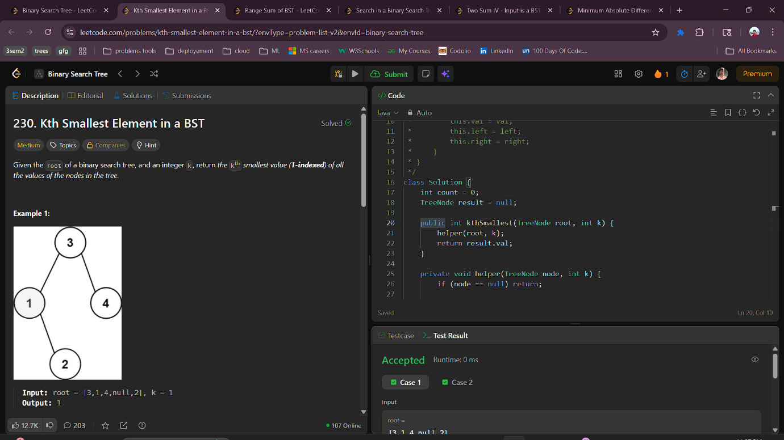

10.3 Range Sum of BST
Aim : Given the root node of a binary search tree and two integers low and high, return the sum of values of all nodes with a value in the inclusive range [low, high].
class Solution {
public int rangeSumBST(TreeNode root, int low, int high) {
if(root == null) return 0;
int currentval=(root.val >= low && root.val <=high)?root.val:0;
return currentval + rangeSumBST(root.left,low,high) + rangeSumBST(root.right,low,high);
}
}

Output :

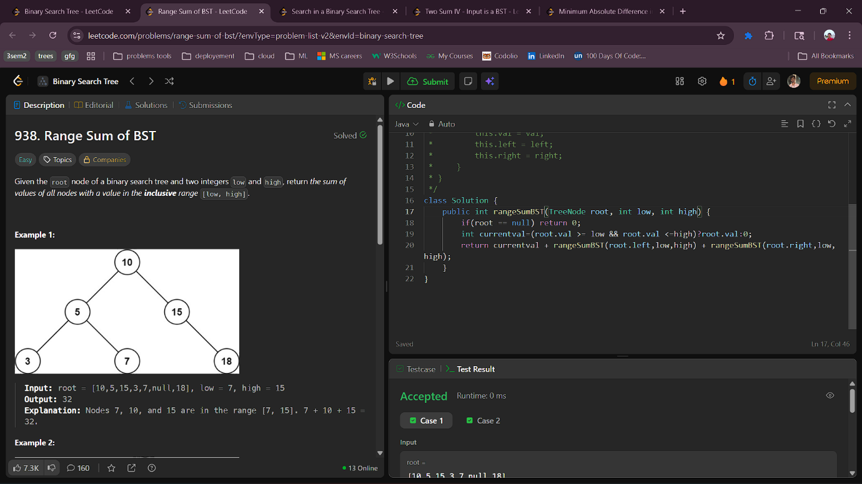

10.4 Search in a Binary Search Tree
Aim : You are given the root of a binary search tree (BST) and an integer val.
Find the node in the BST that the node's value equals val and return the subtree rooted with that node. If such a node does not exist, return null.
class Solution {
public TreeNode searchBST(TreeNode root, int val) {
if(root==null) return null;
while(root!=null && root.val!=val){
if(root.val<val) root=root.right;
else root=root.left;
}
return root;
}
}

Output :
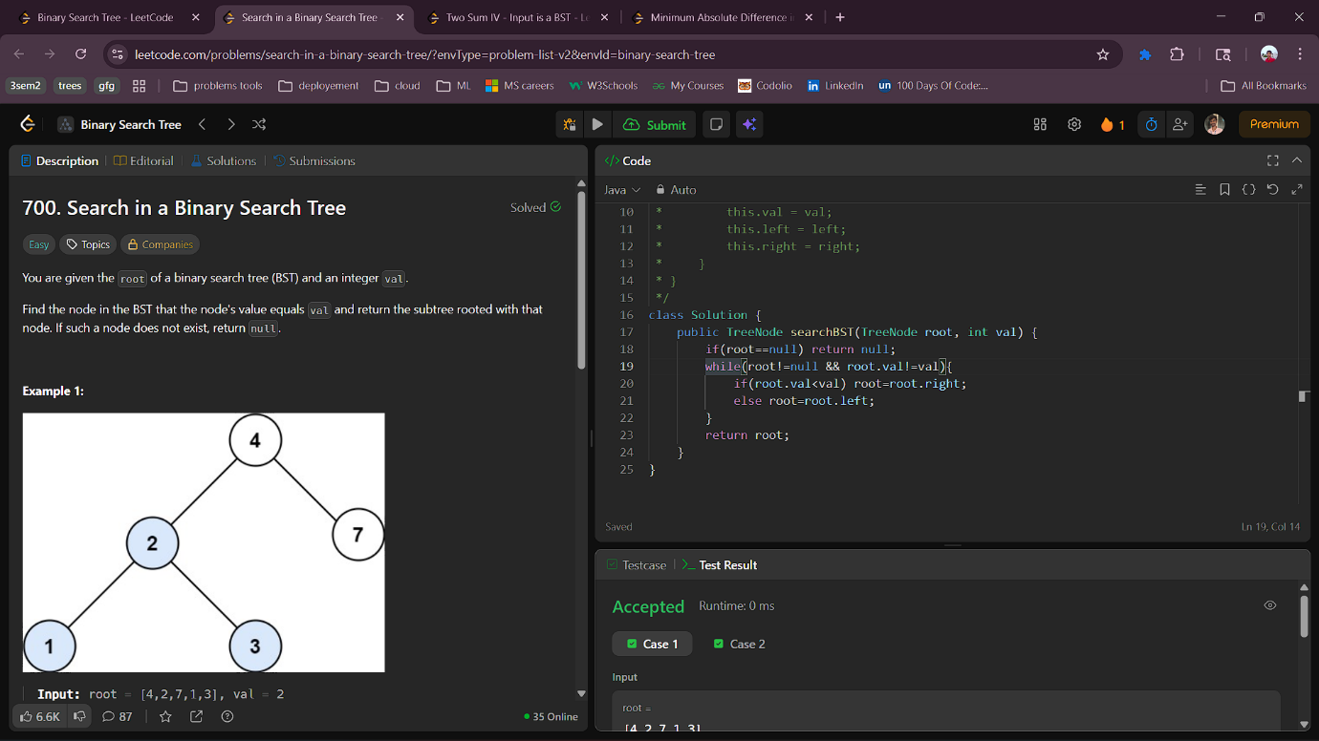

10.5 Two Sum IV - Input is a BST
Aim : Given the root of a binary search tree and an integer k, return true if there exist two elements in the BST such that their sum is equal to k, or false otherwise.
class Solution {
public boolean findTarget(TreeNode root, int target) {
ArrayList<Integer> al=new ArrayList<>();
getInorder(root,al);
int s=0;
int e=al.size()-1;
while(s<e){
if(al.get(s)+al.get(e)==target) return true;
else if(al.get(s)+al.get(e)< target) s++;
else e--;
}
return false;
}

private static void getInorder(TreeNode root,ArrayList<Integer> al){
if(root == null ) return;
getInorder(root.left,al);
al.add(root.val);
getInorder(root.right,al);
}
}
Output :

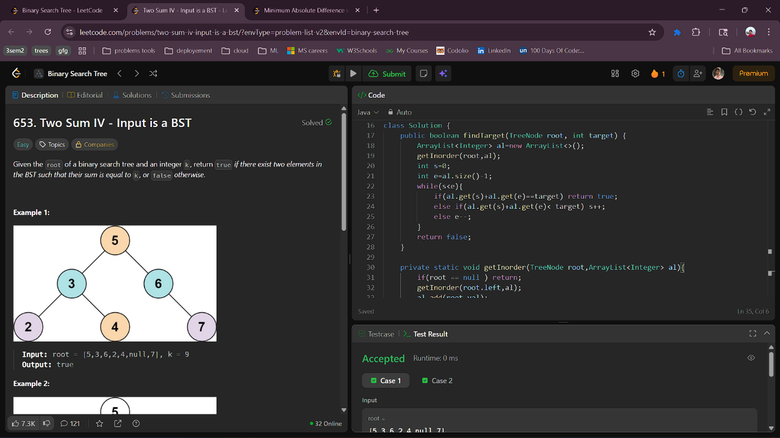
10.6 Minimum Absolute Difference in BST
Aim : Given the root of a Binary Search Tree (BST), return the minimum absolute difference between the values of any two different nodes in the tree.
class Solution {
public int getMinimumDifference(TreeNode root) {
ArrayList<Integer> al=new ArrayList<>();
inorder(root,al);
int min=Integer.MAX_VALUE;
for(int i=1;i<al.size();i++){
min=Math.min(min,Math.abs(al.get(i-1)-al.get(i)));
}
return min;
}
static void inorder(TreeNode root,ArrayList<Integer> al){
if(root == null ) return ;
inorder(root.left,al);
al.add(root.val);
inorder(root.right,al);
}
}
Output :

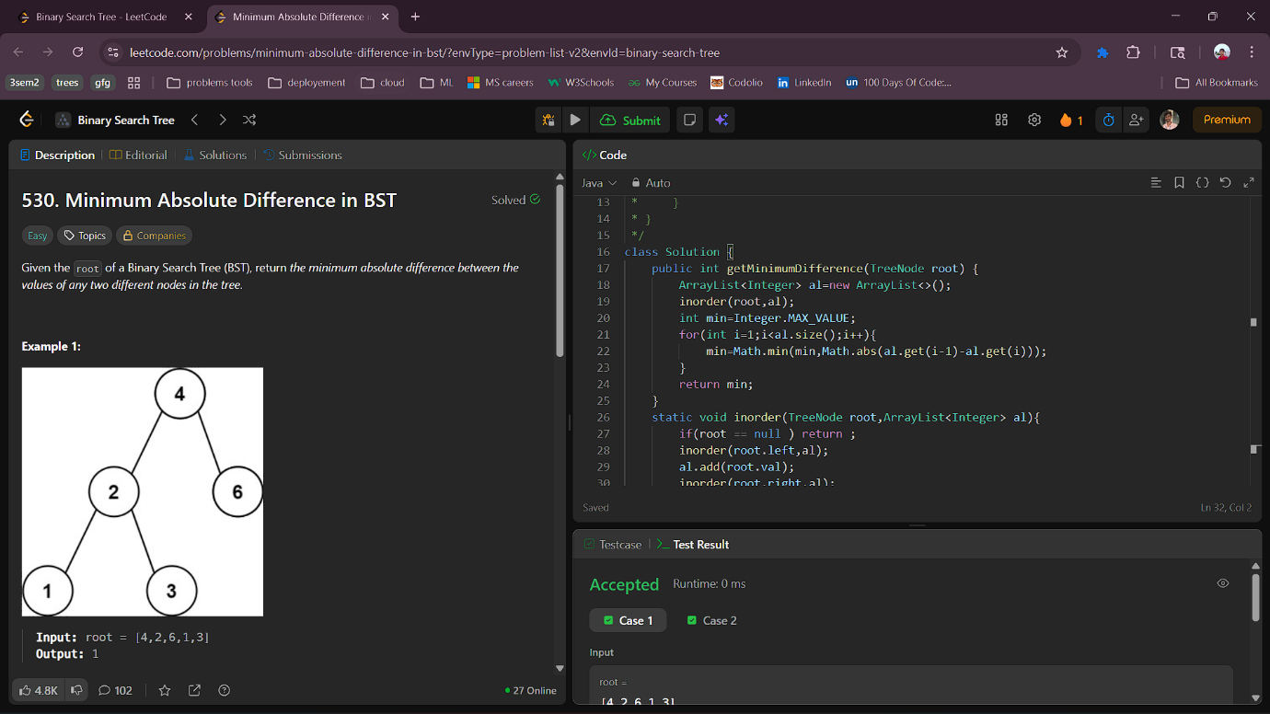

10.7 Ceil in BST
Aim : You are given a root binary search tree and an integer x . Your task is to find the Ceil of x in the tree.
Note: Ceil(x) is a number that is either equal to x or is immediately greater than x.
If Ceil could not be found, return -1.
class Solution {
int findCeil(Node root, int x) {
// code here
int ceil=-1;
while(root != null){
if(root.data==x){
ceil=root.data;
return ceil;
}
if(root.data>x){
ceil=root.data;
root=root.left;
}else if(root.data<x){
root=root.right;
}
}
return ceil;
}
}
Output :

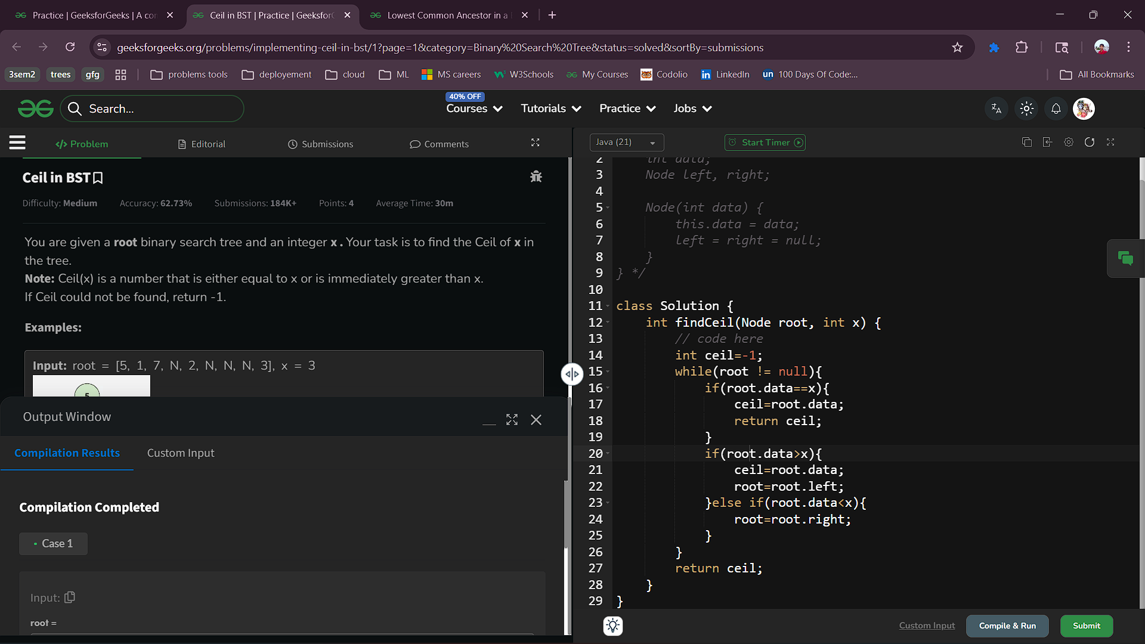

10.8 Lowest Common Ancestor in a BST
Aim : Given the root of a Binary Search Tree (with all values unique) and two nodes n1 and n2 (n1 != n2). You may assume that both nodes exist in the tree. Find the Lowest Common Ancestor (LCA) of the given two nodes in the BST.
Note: LCA between two nodes n1 and n2 is defined as the deepest node that has both n1 and n2 as descendants (where we allow a node to be a descendant of itself).
class Solution {
public Node LCA(Node root, Node n1, Node n2) {
// code here
if(root.data<n1.data && root.data<n2.data){
return LCA(root.right,n1,n2);
}else if(root.data>n1.data && root.data>n2.data){
return LCA(root.left,n1,n2);
}else{
return root;
}
}
}
Output :
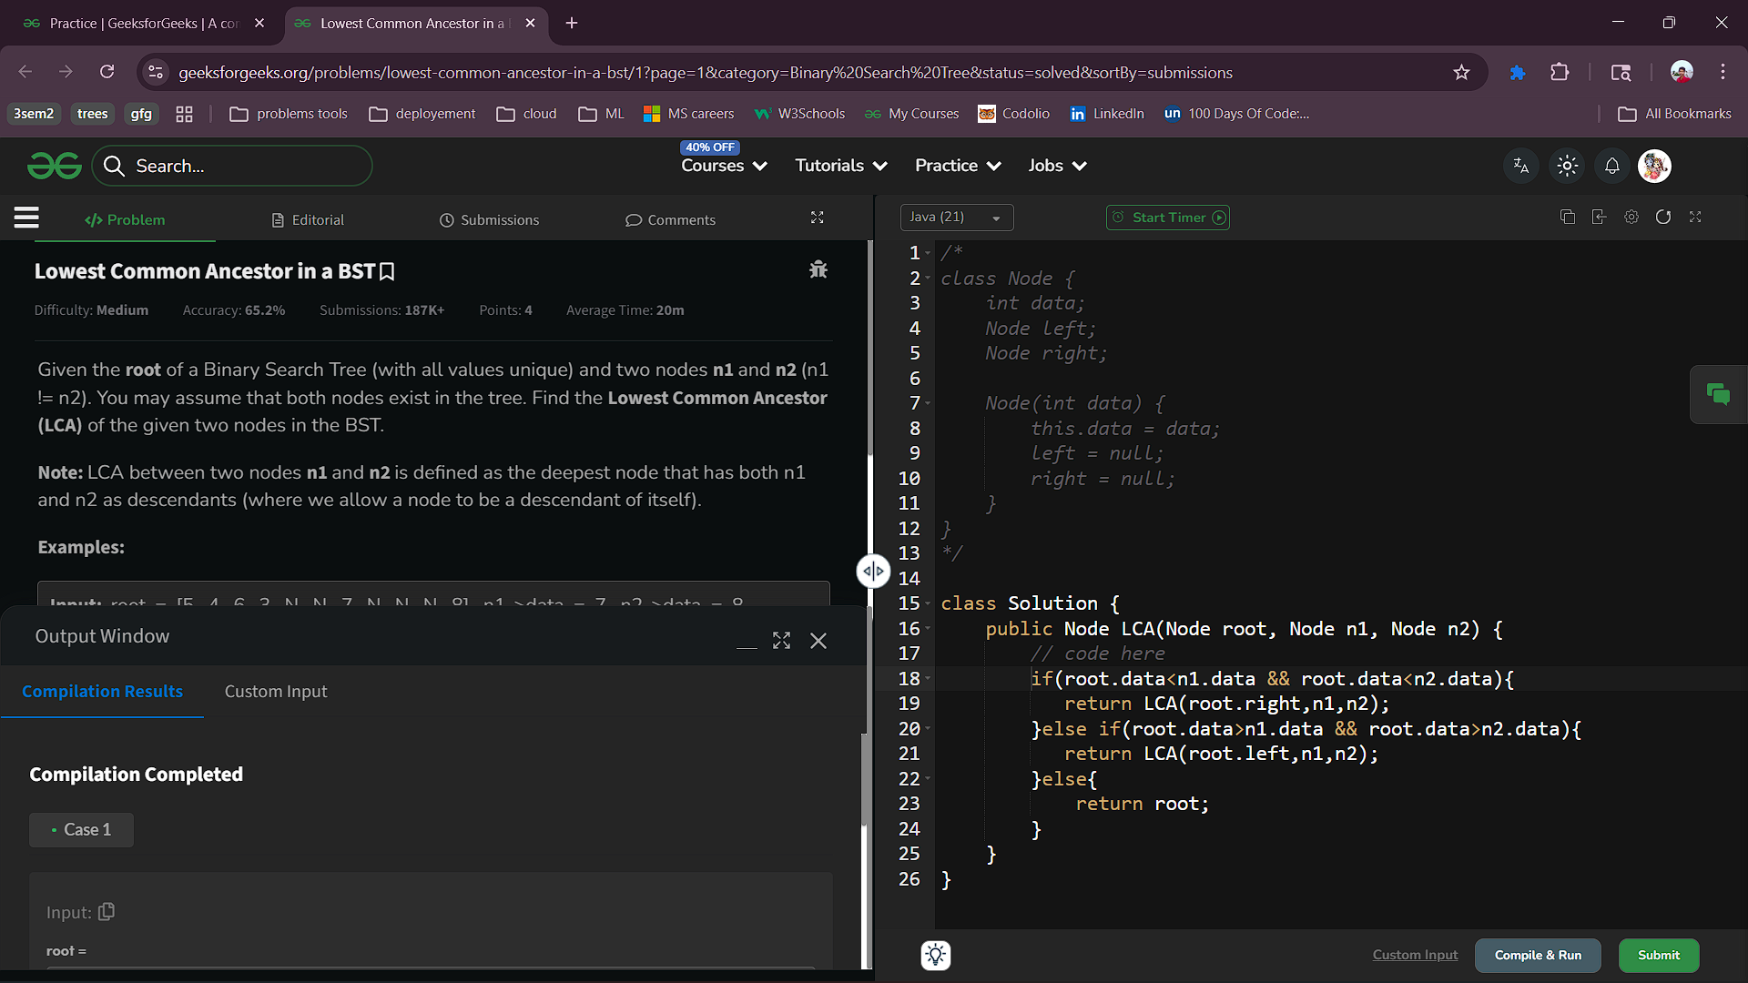

11 System Design : Online Shopping Cart
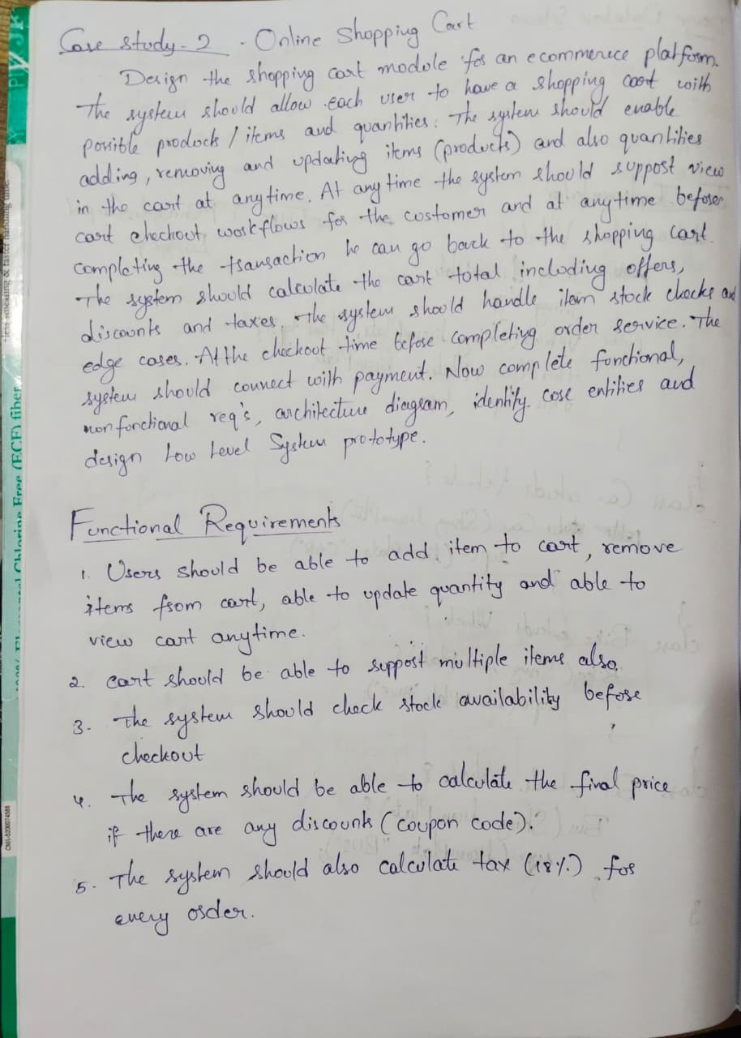
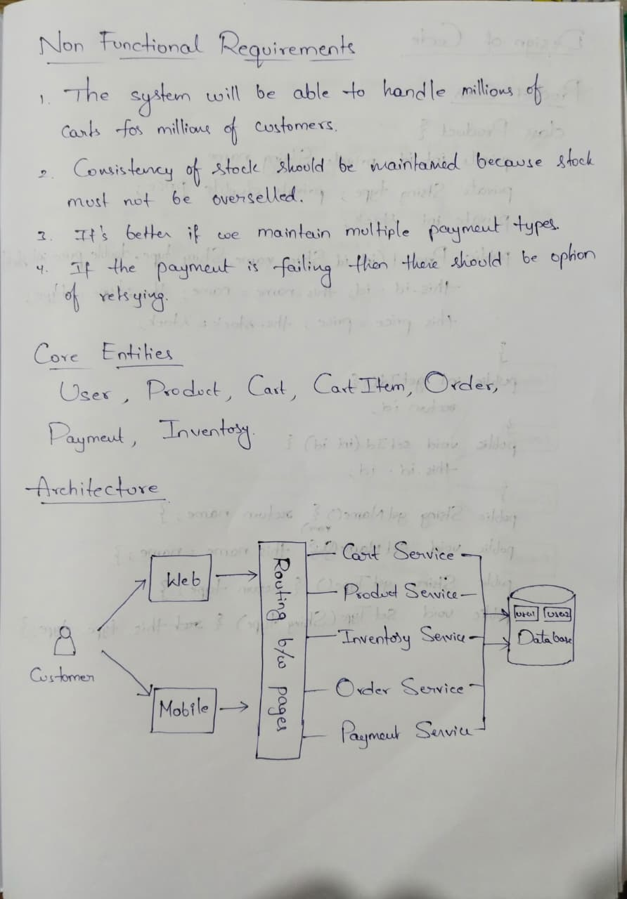
Prototype Code :
Product Class :
class Product {
private int id;
private String name;
private String type;
private double price;
private int stock;
public Product(int id, String name, String type, double price, int stock){
this.id = id;
this.name = name;
this.type = type;
this.price = price;
this.stock = stock;
}
public int getId() { return id; }
public void setId(int id) { this.id = id; }
public String getName() { return name; }
public void setName(String name) { this.name = name; }
public String getType() { return type; }
public void setType(String type) { this.type = type; }
public double getPrice() { return price; }
public void setPrice(double price) { this.price = price; }
public int getStock() { return stock; }
public void setStock(int stock) { this.stock = stock; }
}
CartItem Class :
class CartItem {
private Product product;
private int quantity;
public CartItem(Product product, int quantity) {
this.product = product;
this.quantity = quantity;
}
public Product getProduct() { return product; }
public void setProduct(Product product) { this.product = product; }
public int getQuantity() { return quantity; }
public void setQuantity(int quantity) { this.quantity = quantity; }
public double getTotalPrice() {
return product.getPrice() * quantity;
}
}
Cart Class:
import java.util.*;

class Cart {
private int userId;
private List<CartItem> items;
public Cart(int userId) {
this.userId = userId;
this.items = new ArrayList<>();
}
public int getUserId() { return userId; }
public void setUserId(int userId) { this.userId = userId; }
public List<CartItem> getItems() { return items; }
public void setItems(List<CartItem> items) { this.items = items; }
public void addItem(Product product, int quantity) {
for (CartItem item : items) {
if (item.getProduct().getId() == product.getId()) {
item.setQuantity(item.getQuantity() + quantity);
return;
}
}
items.add(new CartItem(product, quantity));
}
public void removeItem(int productId) {
items.removeIf(item -> item.getProduct().getId() == productId);
}
public void updateQuantity(int productId, int quantity) {
for (CartItem item : items) {
if (item.getProduct().getId() == productId) {
item.setQuantity(quantity);
}
}
}
public double calculateTotal() {
double total = 0;
for (CartItem item : items) {
total += item.getTotalPrice();
}
return total;
}
}

ProductSearch Class :
class ProductService {
private List<Product> products;
public ProductService(List<Product> products) {
this.products = products;
}
public List<Product> getProducts() {
return products;
}

public Product[] searchByName(String name) {
List<Product> result = new ArrayList<>();
for (Product p : products) {
if (p.getName().equalsIgnoreCase(name)) {
result.add(p);
}
}
return result.toArray(new Product[0]);
}
public Product[] searchByType(String type) {
List<Product> result = new ArrayList<>();
for (Product p : products) {
if (p.getType().equalsIgnoreCase(type)) {
result.add(p);
}
}
return result.toArray(new Product[0]);
}
public Product[] searchByNameAndType(String name, String type) {
List<Product> result = new ArrayList<>();
for (Product p : products) {
if (p.getName().equalsIgnoreCase(name) &&
p.getType().equalsIgnoreCase(type)) {
result.add(p);
}
}
return result.toArray(new Product[0]);
}
}
CheckoutService Class :
class CheckoutService {
public boolean validateStock(Cart cart) {
for (CartItem item : cart.getItems()) {
if (item.getQuantity() > item.getProduct().getStock()) {
return false;
}
}
return true;
}
public double applyDiscount(double total) {
if (total > 1000) return total * 0.9;
return total;
}
public double applyTax(double total) {
return total * 1.18;
}
public void checkout(Cart cart) {
if (!validateStock(cart)) {
System.out.println("Stock insufficient");
return;
}
double total = cart.calculateTotal();
total = applyDiscount(total);
total = applyTax(total);
Payment payment = new Payment(1, total);
payment.processPayment();
System.out.println("Payment Status: " + payment.getStatus());
}
}

