**How to convert PDF file to HTML using by pdf2htmlEX on Windows OS**

1. Go to [**pdf2htmlEX**](http://soft.rubypdf.com/software/pdf2htmlex-windows-verion)home page then click download the latest version.

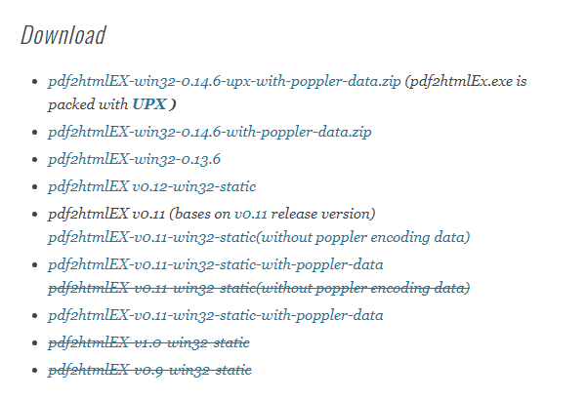

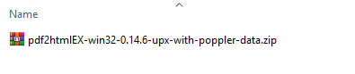

1. Extract zip files

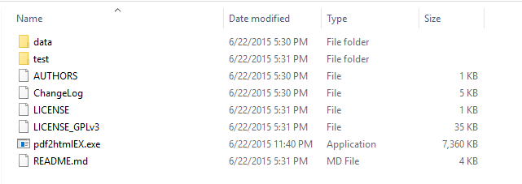

1. Go to “pdf2htmlEX” folder and then go to “data” folder.

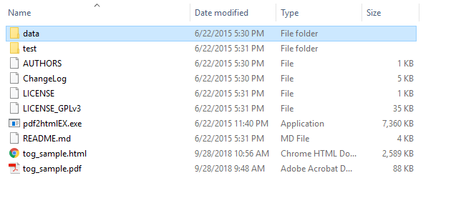

1. Create **formbuilder_pdf.css** and **formbuilder_pdf.js** files and then copy code below to the new files.

**Css code for formbuilder_pdf.css:**



**JS code for formbuilder_pdf.js:**



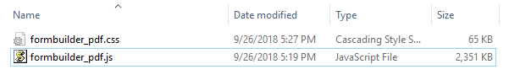

Follow these links to copy codes: rio-wap-fbd\stat\v1\src\forms\editor\v1\pdf2htmlEX\source

1. Open manifest file in “data” folder.

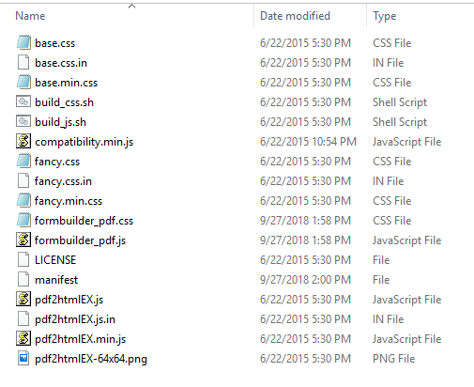

* Add **<div id=”pdf-form”></div>** tag before **<div class=”loading-indicator”></div>** and add files name behind the close tag “</body>”, save and close file.

**"""**

**@formbuilder_pdf.css**

**@formbuilder_pdf.js**

**"""**

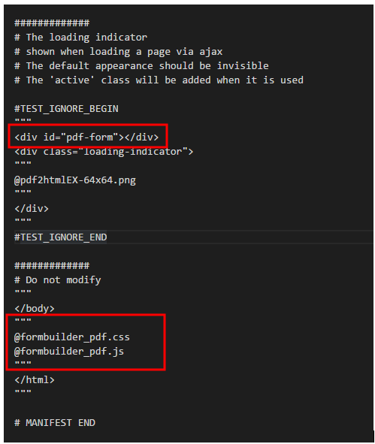

1. Go to “pdf2htmlEx” folder, press and hold the shift key, then press the right mouse button at the background of the Explorer window and click on “Open command window here”.

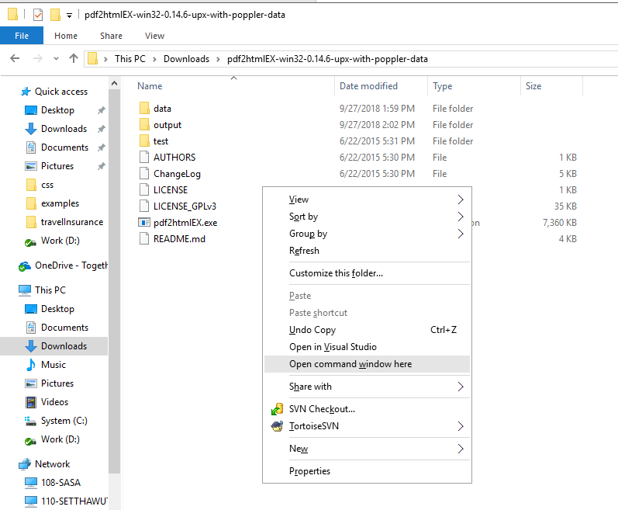

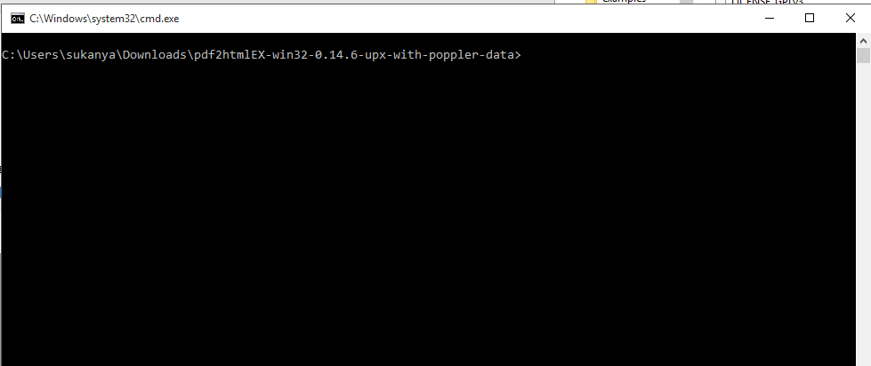

1. Use command pdf2htmlEX path/file.pdf outputpath/file.html

Example

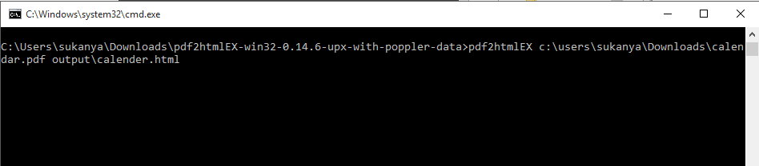

The finished file after being converted.

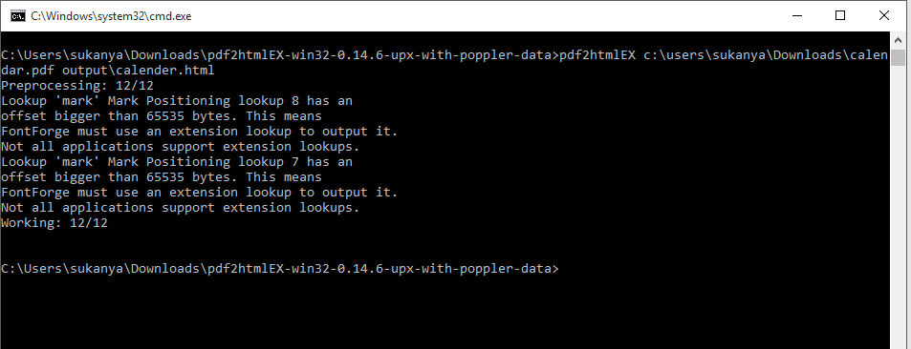

The html file shows up in the output path

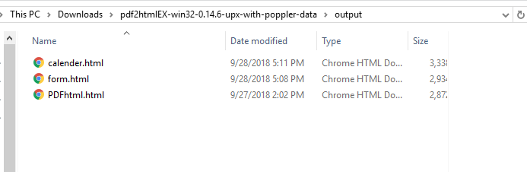

**How to use PDF html file in Formbuilder**

1. Open “Formbuilder” project and then change display as to “PDF”

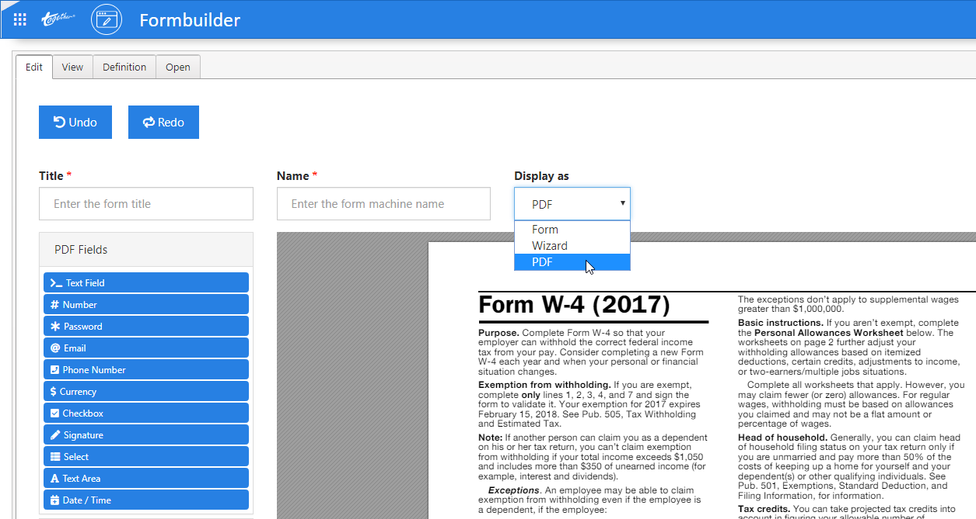

1. Click “Definition” tab
2. Look at “setting” object and then change the path of pdf html file at “src” object

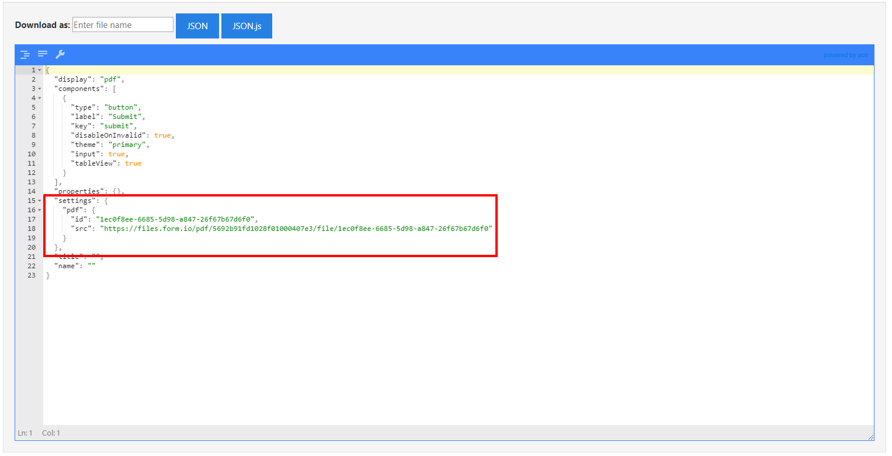

"settings": {

"pdf": {

"id": "1ec0f8ee-6685-5d98-a847-26f67b67d6f0",

"src": "<https://files.form.io/pdf/5692b91fd1028f01000407e3/file/1ec0f8ee-6685-5d98-a847-26f67b67d6f0>"

}

},

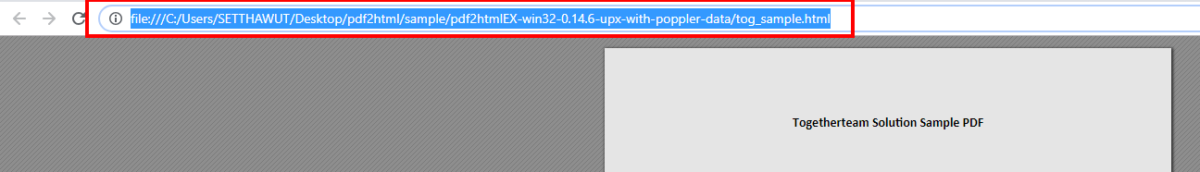

"settings": {

"pdf": {

"id": "1ec0f8ee-6685-5d98-a847-26f67b67d6f0",

"src": “[https://](https://files.form.io/pdf/5692b91fd1028f01000407e3/file/1ec0f8ee-6685-5d98-a847-26f67b67d6f0)your_part_to_folder/tog_sample"

}

},

**Note:**

Remove “.html” at the end of path before place it in the json code

**Example file:**

<http://fbd-pdf.azurewebsites.net/tog_sample.html>

1. After putting the path of PDF html, click on “Edit” tab. The PDF html file will be shown.

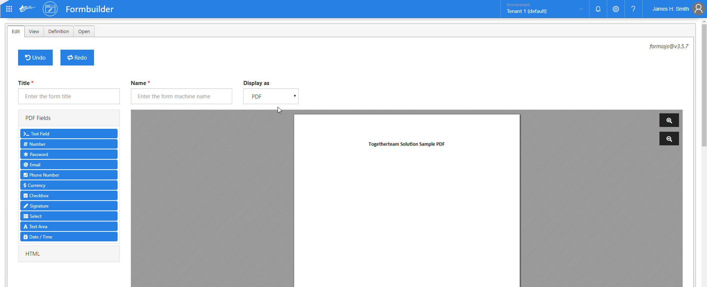

**How to convert PDF to HTML file using by pdf2htmlEX on MAC OS**

1. Open “Terminal” and then install **homebrew** first with command

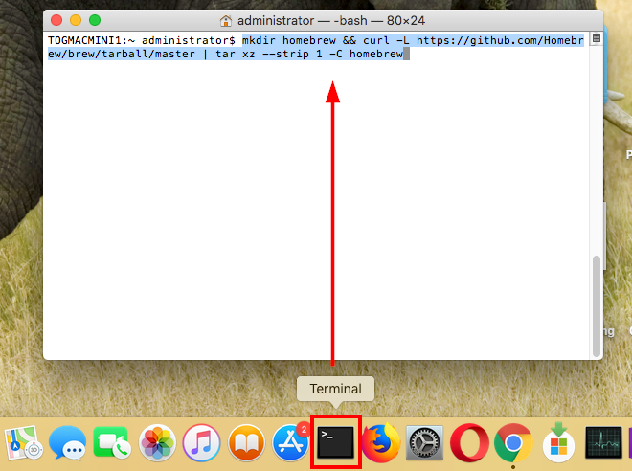mkdir homebrew **&&** curl -L <https://github.com/Homebrew/brew/tarball/master> | tar xz --strip 1 -C homebrew

2. Install **pdf2htmlEX** with command

brew install pdf2htmlEX

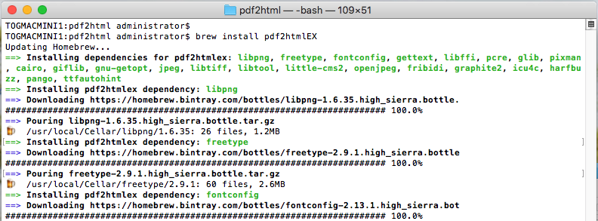

3. Press “**Command + Shift + G**” and then go to “usr/local/Cellar/pdf2htmlex/0.14.6_20/share/pdf2htmlEx” folder

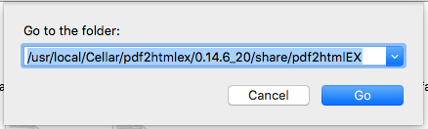

4. Open **manifest** file with text editor

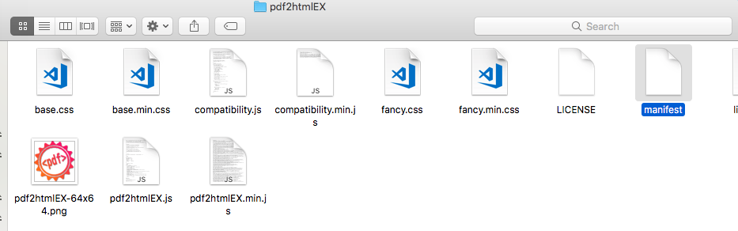

5. Add **<div id=”pdf-form”></div>** tag before **<div class=”loading-indicator”></div>** and add files name behind the close tag “</body>” then save and close file.

**"""**

**@formbuilder_pdf.css**

**@formbuilder_pdf.js**

**"""**

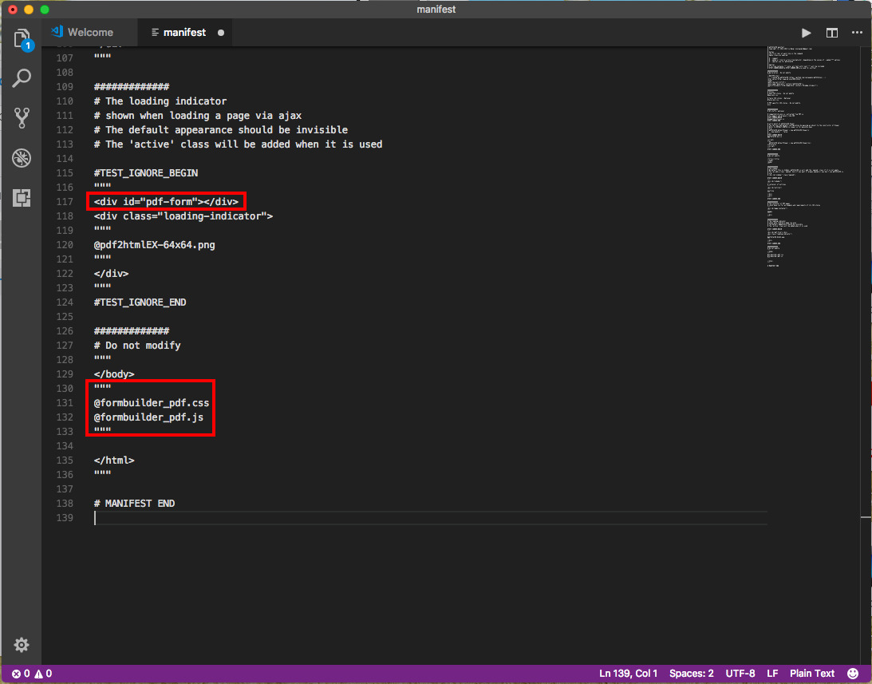

1. Create “formbuilder_pdf.css” and “formbuilder_pdf.js” files in “pdf2htmlEX” folder and then copy codes below to the new files

**Css code for formbuilder_pdf.css:**



**JS code for formbuilder_pdf.js:**



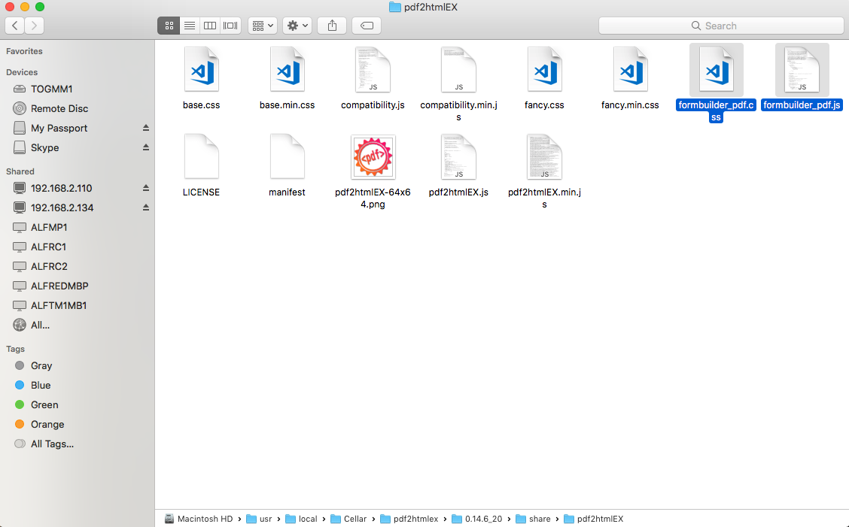

7. Open “**Terminal**” and go to “**pdf2htmlEX**” folder and then use command pdf2htmlEX path/file.pdf for converting

**Example**

pdf2htmlEX tog_sample_macos.pdf

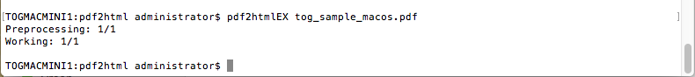

8. The PDF HTML file will be shown in this folder.

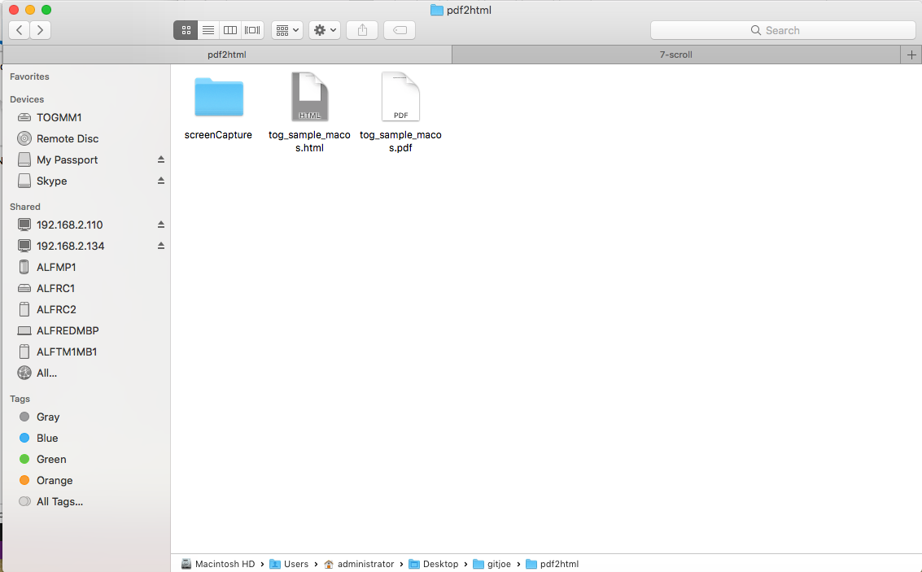

**How to use local html file in Formbuilder**

1. Open “Formbuilder” project and then change display as to “PDF”



1. Click “Definition” tab
2. Look at “setting” object and then change the path of pdf html file at “src” object

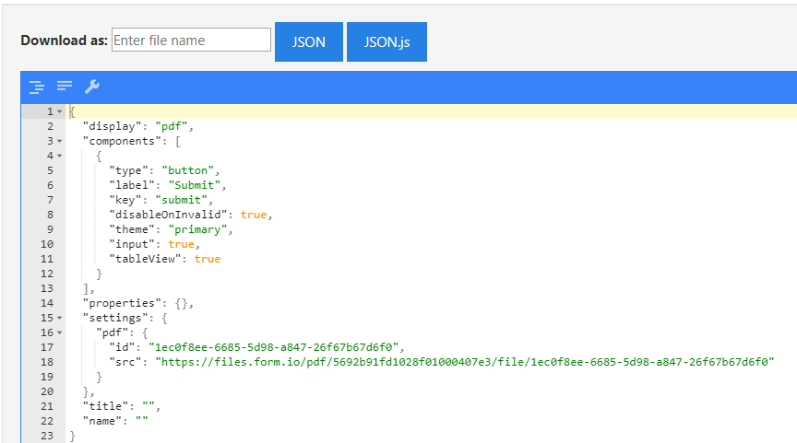

"settings": {

"pdf": {

"id": "1ec0f8ee-6685-5d98-a847-26f67b67d6f0",

"src": "<https://files.form.io/pdf/5692b91fd1028f01000407e3/file/1ec0f8ee-6685-5d98-a847-26f67b67d6f0>"

}

},

1. Putting the path from your machine

"settings": {

"pdf": {

"id": "1ec0f8ee-6685-5d98-a847-26f67b67d6f0",

"src": “**Path html file from your machine**"

}

},

**Note:**

Remove “.html” at the end of path before place it in the json code

**Example:**

<file:///C:/Users/sukanya/Downloads/pdf2htmlEX-win32-0.14.6-upx-with-poppler-data/output/calender>

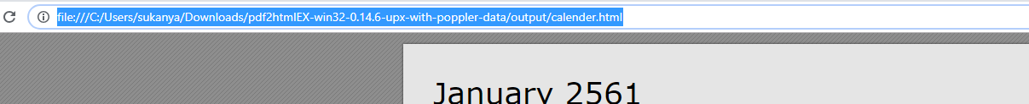

1. After putting the path of PDF html, click on “Edit” tab. The PDF html file will be shown.

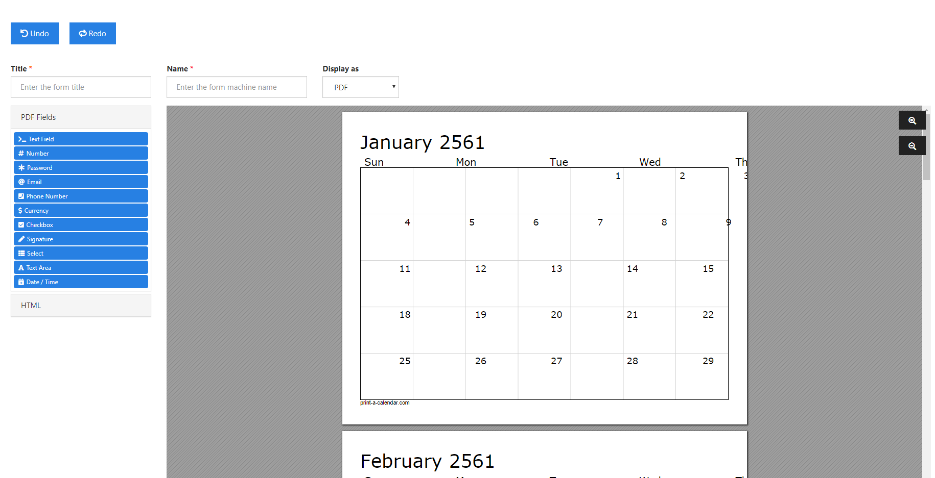

**How to use normal html file in Formbuilder**

1. Open sample.html file and then find keyword “content-area=”html””

Follow these links to copy sample.html file: rio-wap-fbd\stat\v1\src\forms\editor\v1\pdf2htmlEX\src

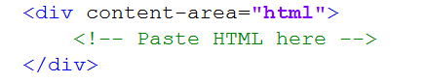

1. Copy html content to below of <div content-area=”html”> tag and then save file.

**Example:**

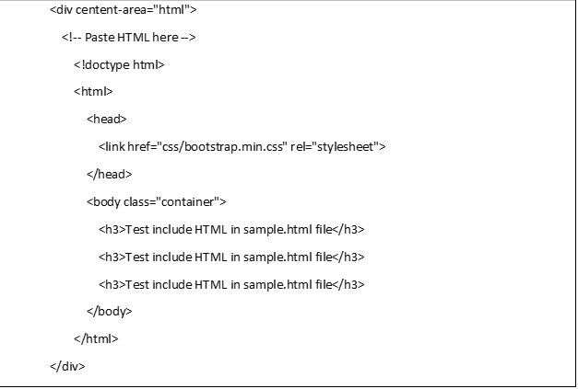

1. Open “Formbuilder” project and then change display as to “PDF”



1. Click “Definition” tab
2. Look at “setting” object and then change the path of pdf html file at “src” object



"settings": {

"pdf": {

"id": "1ec0f8ee-6685-5d98-a847-26f67b67d6f0",

"src": "<https://files.form.io/pdf/5692b91fd1028f01000407e3/file/1ec0f8ee-6685-5d98-a847-26f67b67d6f0>"

}

},

1. Putting the path of normal html file

"settings": {

"pdf": {

"id": "1ec0f8ee-6685-5d98-a847-26f67b67d6f0",

"src": “**Path of normal html file**"

}

},

**Note:**

Remove “.html” at the end of path before place it in the json code

**Example:**

<file:///C:/Users/sukanya/Downloads/pdf_data>

1. 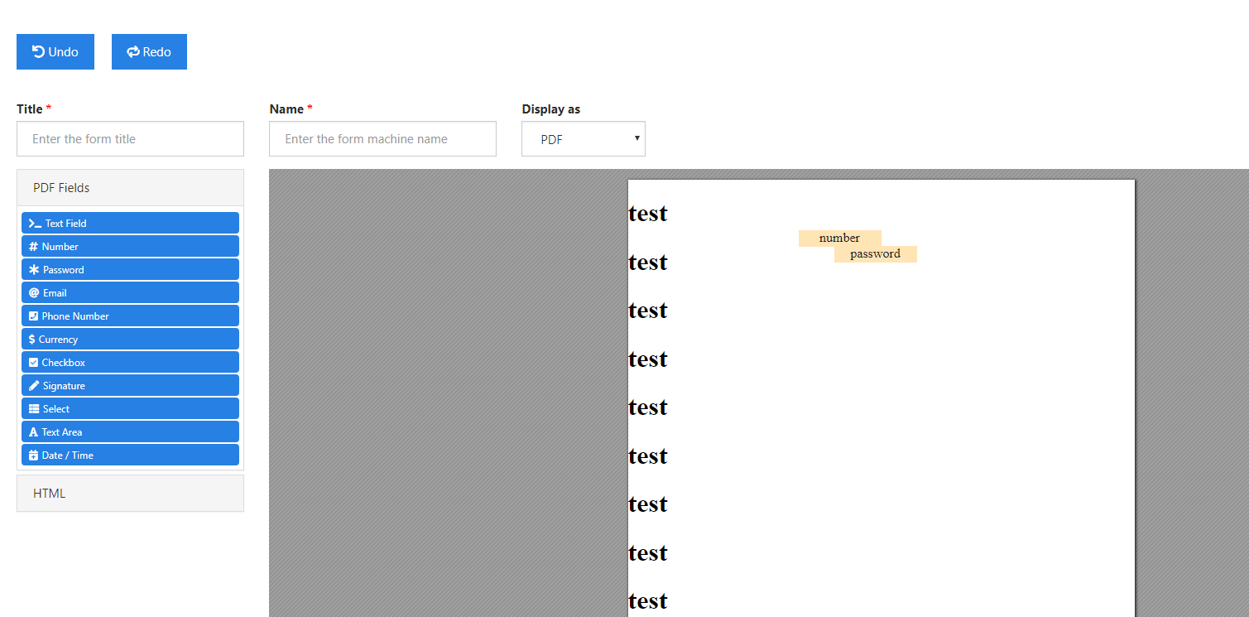After putting the path of PDF html, click on “Edit” tab. The normal html file will be shown.