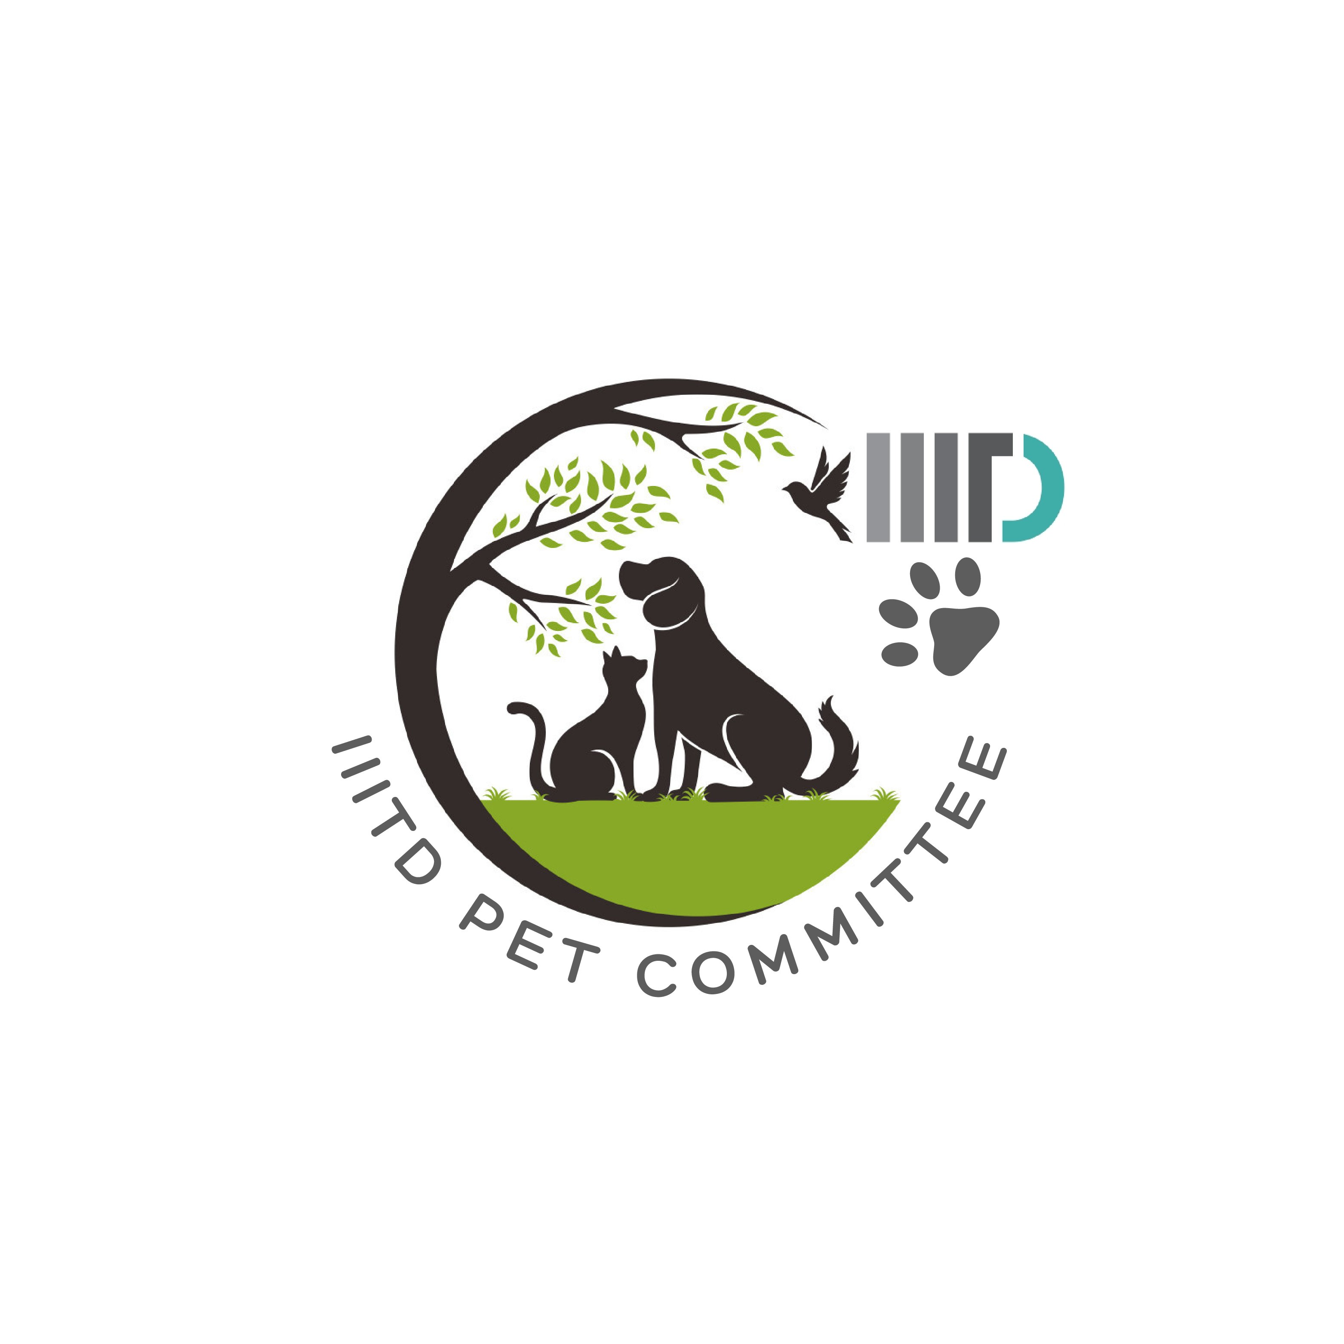 | IIITD PET COMMITTEE  Indraprastha Institute of Information Technology Delhi  Pet Adoption Application Form

Thank you for your interest in adopting a pet from the IIITD campus community. Please fill in all sections clearly. Incomplete forms may not be processed. Submitting this form does not guarantee adoption — the Pet Committee will review your application and contact you for further steps.
1. Applicant Information

Full Name:

Roll No. / Employee ID:
(if applicable)

Department / Programme:
(if applicable)

Mobile Number:

IIITD Email ID:

Hostel / Address:

Status at IIITD:
□ UG Student | □ PG Student | □ PhD Scholar | □ Faculty | □ Staff
□ Outside IIITD

Current Residence:
□ On-campus Hostel (not recommended) | □ On-campus Quarters | □ Off-campus (Delhi/NCR) | □ Off-campus (Delhi/NCR)

2. Pet Details

Pet's Name (if any):

Species:

Breed (if known):

Approximate Age:

Colour / Markings:

Gender:
□ Male | □ Female | □ Unknown

Spayed / Neutered:
□ Yes | □ No | □ Will do post-adoption | □ Unknown

3. Adoption Readiness

Have you owned / cared for a pet before?
□ Yes | □ No

If yes, briefly describe your previous pet experience:

Do you have other pets currently?
□ Yes — specify below | □ No

If yes, specify:

Are all household members aware of and agreeable to this adoption?
□ Yes | □ No | □ I live alone

Are you or any household member allergic to animals?
□ Yes | □ No | □ Not Sure

4. Care & Welfare Plan

Where will the pet primarily live?
□ Inside room/home | □ Designated campus area | □ Shared common space | □ Other

Who will be the primary caretaker when you are unavailable (exams, travel)?

Are you willing to cover veterinary expenses?
□ Yes | □ No | □ Need guidance on resources

Describe your plan for the pet's daily feeding, exercise, and healthcare:

5. Commitment & Agreement

□ I will provide adequate food, water, shelter, and veterinary care for the adopted pet.
□ I will not abandon, sell, or transfer the pet without prior written consent from the IIITD Pet Committee.
□ I will ensure the pet does not cause nuisance, harm, or distress to any campus community member.
□ I will comply with all IIITD campus rules and guidelines regarding pet ownership.
□ I understand that the Pet Committee reserves the right to revoke adoption if conditions of care are not met.
□ I will inform the Pet Committee of any change in my campus status, residence, or inability to care for the pet.

Applicant's Signature: | Date: | Place:

6. For Office Use Only

Application No. |  | Date Received:
Reviewed By: |  | Status:
Remarks:

IIITD Pet Committee • Indraprastha Institute of Information Technology Delhi • petcommittee@iiitd.ac.in | Submit completed forms to the Student Affairs Office or email a scanned copy.

