Implement a Generative Adversarial Network (GAN) to generate synthetic images or tabular data

Aim:
To implement a Generative Adversarial Network (GAN) using the MNIST dataset to learn the data distribution of handwritten digit images. To train the generator and discriminator models so that the generator can produce realistic synthetic digit images.
Dataset : MNIST
Step 1 – Import Required Libraries
import torch
import torch.nn as nn
import torchvision
import torchvision.transforms as transforms
import matplotlib.pyplot as plt
Step 2 – Load MNIST Dataset
transform = transforms.Compose([
transforms.ToTensor(),
transforms.Normalize((0.5,), (0.5,))
])
dataset = torchvision.datasets.MNIST(
root='./data',
train=True,
download=True,
transform=transform
)
dataloader = torch.utils.data.DataLoader(
dataset,
batch_size=64,
shuffle=True )
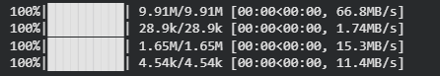
Step 3 – Create Generator Model
generator = nn.Sequential(
nn.Linear(100,256),
nn.ReLU(),
nn.Linear(256,512),
nn.ReLU(),
nn.Linear(512,1024),
nn.ReLU(),
nn.Linear(1024,784),
nn.Tanh()
)
Step 4 – Create Discriminator Model
discriminator = nn.Sequential(
nn.Linear(784,512),
nn.LeakyReLU(0.2),
nn.Linear(512,256),
nn.LeakyReLU(0.2),
nn.Linear(256,1),
nn.Sigmoid()
)
Step 5 – Define Loss Function
loss_function = nn.BCELoss()

Step 6 – Define Optimizers
optimizer_generator = torch.optim.Adam(
generator.parameters(),
lr=0.0002
)
optimizer_discriminator = torch.optim.Adam(
discriminator.parameters(),
lr=0.0002
)
Step 7 – Train the GAN
epochs = 10
for epoch in range(epochs):
for images,labels in dataloader:
real_images = images.view(-1,784)
real_labels = torch.ones(real_images.size(0),1)
fake_labels = torch.zeros(real_images.size(0),1)
outputs = discriminator(real_images)
loss_real = loss_function(outputs,real_labels)
noise = torch.randn(real_images.size(0),100)
fake_images = generator(noise)
outputs = discriminator(fake_images.detach())
loss_fake = loss_function(outputs,fake_labels)
loss_discriminator = loss_real + loss_fake
optimizer_discriminator.zero_grad()
loss_discriminator.backward()
optimizer_discriminator.step()
noise = torch.randn(real_images.size(0),100)
fake_images = generator(noise)
outputs = discriminator(fake_images)
loss_generator = loss_function(outputs,real_labels)
optimizer_generator.zero_grad()
loss_generator.backward()
optimizer_generator.step()

print("Epoch:",epoch,"Generator Loss:",loss_generator.item(),"Discriminator Loss:",loss_discriminator.item())
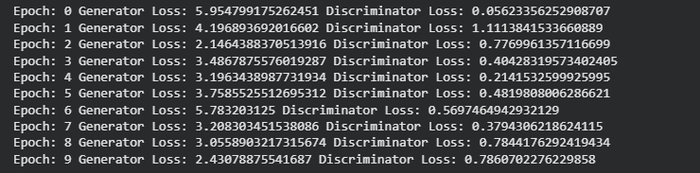
Step 8 – Generate Synthetic Images
noise = torch.randn(16,100)
generated_images = generator(noise)
generated_images = generated_images.view(16,28,28)
generated_images = generated_images.detach().numpy()
Step 9 – Display Generated Images
for i in range(16):
plt.subplot(4,4,i+1)
plt.imshow(generated_images[i],cmap='gray')
plt.axis('off')
plt.show()

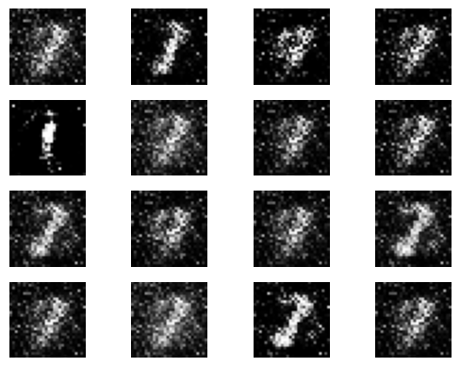

Result:
The GAN model was successfully trained on the MNIST dataset and generated synthetic handwritten digit images. The generated images resemble MNIST digit patterns, demonstrating that the model learned the underlying data distribution.

