**EXPT-1**

**HTML &amp; CSS**

**a) Create a web page to embed a map along with hot spot, frames &amp; links.**

**AIM:**

To create a web page to embed a map along with hot spot, frames &amp; links.

**CODE:**

<!DOCTYPE html>

<html lang="en">

<head>

<meta charset="UTF-8">

<meta name="viewport" content="width=device-width, initial-scale=1.0">

<title>Web Page with Map & Hotspots</title>

</head>

<body>

<h1>Interactive Web Page with Map, Hotspots, and Links</h1>

<!-- Google Map Embed -->

<iframe width="100%" height="300" src="https://www.google.com/maps/embed?v=3&output=embed"></iframe>

<!-- Image Map with Hotspots -->

<h2>Clickable Image Map</h2>

<img src="world-map.jpg" usemap="#worldmap" width="500" alt="World Map">

<map name="worldmap">

<area shape="rect" coords="50,50,100,100" href="https://www.google.com/maps/place/USA" alt="USA">

<area shape="circle" coords="200,200,50" href="https://www.google.com/maps/place/India" alt="India">

</map>

<!-- Navigation Links -->

<h2>Navigation</h2>

<ul>

<li><a href="https://www.google.com">Google</a></li>

<li><a href="https://www.wikipedia.org">Wikipedia</a></li>

</ul>

</body>

</html>

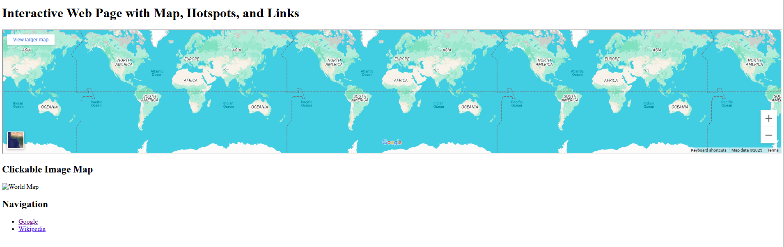

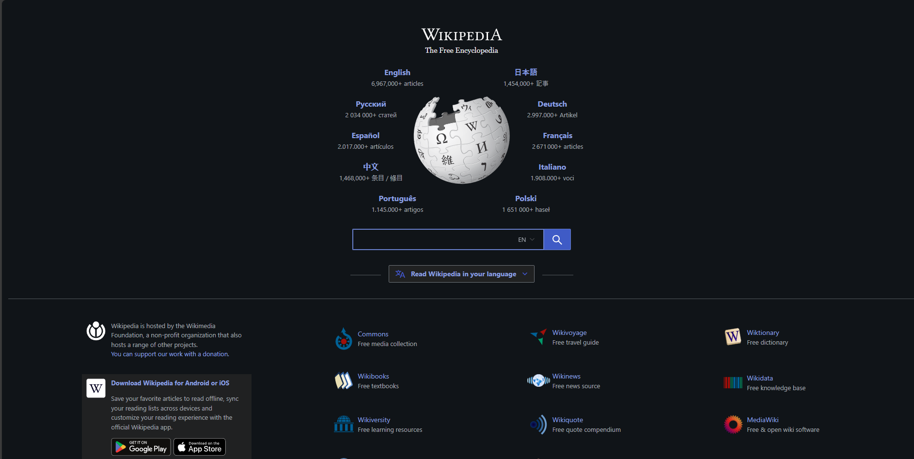

**RESULT:**

Thus the interactive web page has been created.

**b) Create a web page using an embedded, external and inline CSS file.**

**AIM:**

To create a web page using an embedded, external and inline CSS file.

**CODE:**

<!DOCTYPE html>

<html lang="en">

<head>

<meta charset="UTF-8">

<meta name="viewport" content="width=device-width, initial-scale=1.0">

<title>Web Page with CSS</title>

<!-- External CSS -->

<link rel="stylesheet" href="styles.css">

<!-- Embedded CSS -->

<style>

body {

font-family: Arial, sans-serif;

margin: 20px;

background-color: #f4f4f4;

}

.content {

padding: 20px;

background: white;

box-shadow: 2px 2px 10px rgba(0, 0, 0, 0.1);

}

</style>

</head>

<body>

<h1 style="color: blue; text-align: center;">Web Page with Different CSS Methods</h1> <!-- Inline CSS -->

<div class="content">

<p>This paragraph is styled using embedded CSS.</p>

<p class="external-css">This paragraph is styled using external CSS.</p>

</div>

</body>

</html>

External css:

.external-css {

color: red;

font-weight: bold;

}

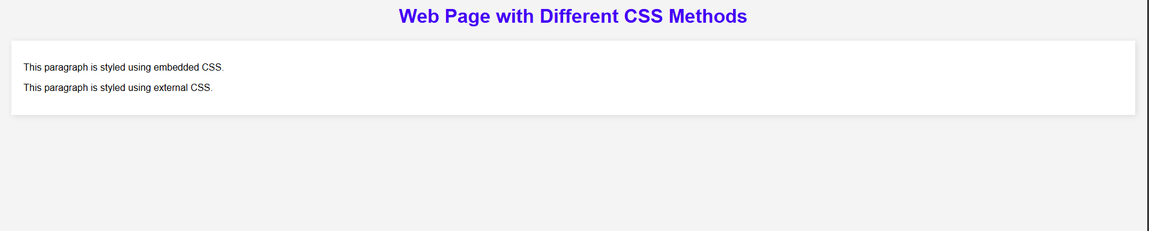

**RESULT:**

Thus the webpage has been created using internal and embedded css