**EXPT-2**

**Write JavaScript to validate the following fields of the Registration page.**

a) First Name (Name should contains alphabets and the length

Should not be less than 6 characters).

b) Password (Password should not be less than 6 characters length).

c) E-mail id (should not contain any invalid and must follow the standard pattern name@domain.com)

d) Mobile Number (Phone number should contain 10 digits only).

e) Last Name and Address (should not be Empty).

**AIM:**

To write a Javascript to validate the following fields of the registration page.

**CODE:**

<!DOCTYPE html>

<html lang="en">

<head>

<meta charset="UTF-8">

<meta name="viewport" content="width=device-width, initial-scale=1.0">

<title>Web Page with Map & CSS</title>

<link rel="stylesheet" href="styles.css">

<style>

body {

font-family: Arial, sans-serif;

margin: 20px;

background-color: #f4f4f4;

}

.container {

display: flex;

justify-content: space-between;

}

.map-container {

width: 60%;

}

.sidebar {

width: 35%;

padding: 10px;

background: #fff;

box-shadow: 2px 2px 10px rgba(0, 0, 0, 0.1);

}

.error {

color: red;

font-size: 14px;

}

</style>

<script>

function validateField(field, regex, errorMsg) {

let value = field.value.trim();

let errorSpan = document.getElementById(field.id + "Error");

if (!regex.test(value)) {

errorSpan.innerText = errorMsg;

return false;

} else {

errorSpan.innerText = "";

return true;

}

}

function validateForm() {

let isValid = true;

isValid &= validateField(document.getElementById("firstName"), /^[a-zA-Z]{6,}$/, "First name must have at least 6 letters.");

isValid &= validateField(document.getElementById("lastName"), /.+/, "Last name cannot be empty.");

isValid &= validateField(document.getElementById("password"), /^.{6,}$/, "Password must be at least 6 characters long.");

isValid &= validateField(document.getElementById("email"), /^[^\s@]+@[^\s@]+\.[^\s@]+$/, "Invalid email format.");

isValid &= validateField(document.getElementById("mobile"), /^\d{10}$/, "Mobile number must be 10 digits.");

isValid &= validateField(document.getElementById("address"), /.+/, "Address cannot be empty.");

return isValid;

}

window.onload = function() {

let fields = ["firstName", "lastName", "password", "email", "mobile", "address"];

fields.forEach(id => {

document.getElementById(id).oninput = () => validateForm();

});

};

</script>

</head>

<body>

<h1 style="color: blue; text-align: center;">Interactive Web Page with Map & CSS</h1>

<form onsubmit="return validateForm()">

<label>First Name: <input type="text" id="firstName"></label>

<span id="firstNameError" class="error"></span><br>

<label>Last Name: <input type="text" id="lastName"></label>

<span id="lastNameError" class="error"></span><br>

<label>Password: <input type="password" id="password"></label>

<span id="passwordError" class="error"></span><br>

<label>Email: <input type="email" id="email"></label>

<span id="emailError" class="error"></span><br>

<label>Mobile: <input type="text" id="mobile"></label>

<span id="mobileError" class="error"></span><br>

<label>Address: <textarea id="address"></textarea></label>

<span id="addressError" class="error"></span><br>

<button type="submit">Register</button>

</form>

</body>

</html>

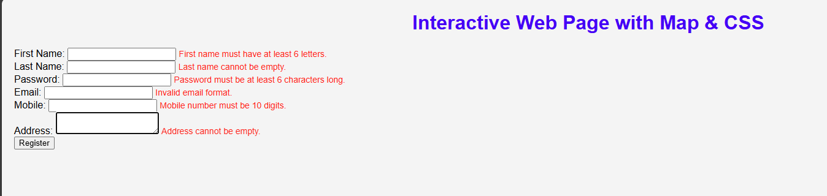

**RESULT:**

Thus the Javascript code has been scripted for the registration page