**DAILY ONLINE ACTIVITIES SUMMARY**

|  |  |  |  |  |  |  |  |  |
| --- | --- | --- | --- | --- | --- | --- | --- | --- |
| **Date:** | **20.06.20** | | | | | **Name:** | **Jaidithya y** | |
| **Sem & Sec** | **6th Sem ‘B’ Sec** | | | | | **USN:** | **4AL17CS118** | |
| **Online Test Summary** | | | | | | | | |
| **Subject** | | **C++ Programming** | | | | | | |
| **Max. Marks** | | **--** | | **Score** | | | **-** | |
| **Certification Course Summary** | | | | | | | | |
| **Course** | **Placement Training** | | | | | | | |
| **Certificate Provider** | | | **Ms. Ankita Shetty**  **Mr.Pradeep** | | **Duration** | | | **--** |
| **Coding Challenges** | | | | | | | | |
| **Problem Statement:1program** | | | | | | | | |
| **Status: Executed** | | | | | | | | |
| **Uploaded the report in GitHub** | | | | | **yes** | | | |
| **If yes Repository name** | | | | | **20-6-20** | | | |
| **Uploaded the report in slack** | | | | | **yes** | | | |

**C++ programming Session 1:**

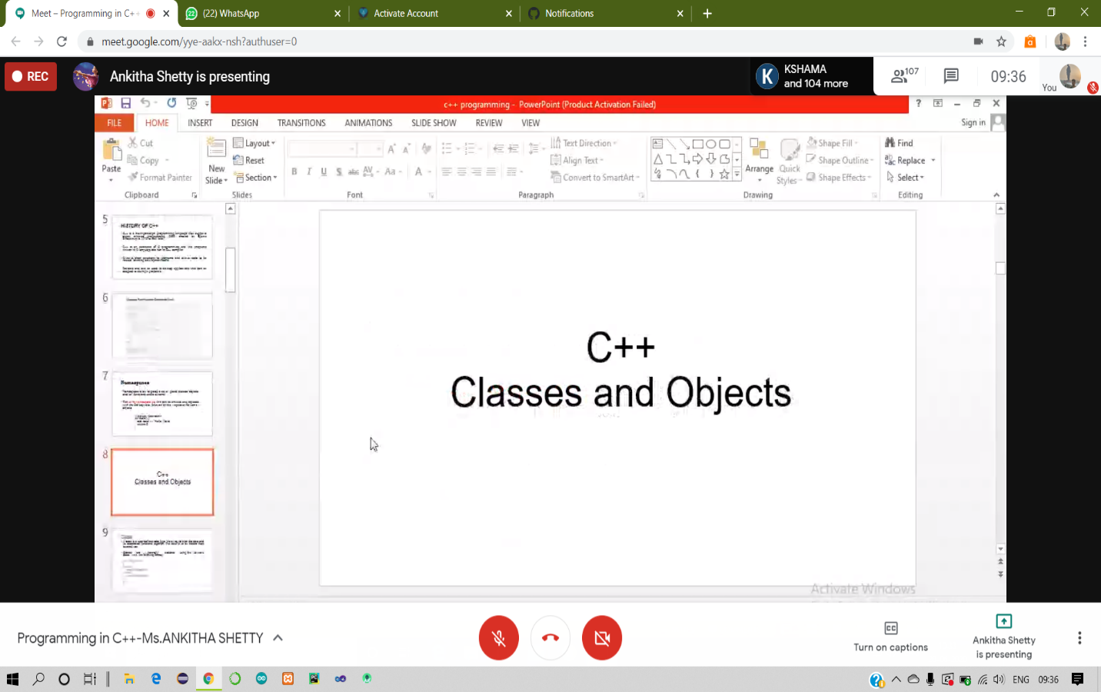

**C++ Programming Session 2**

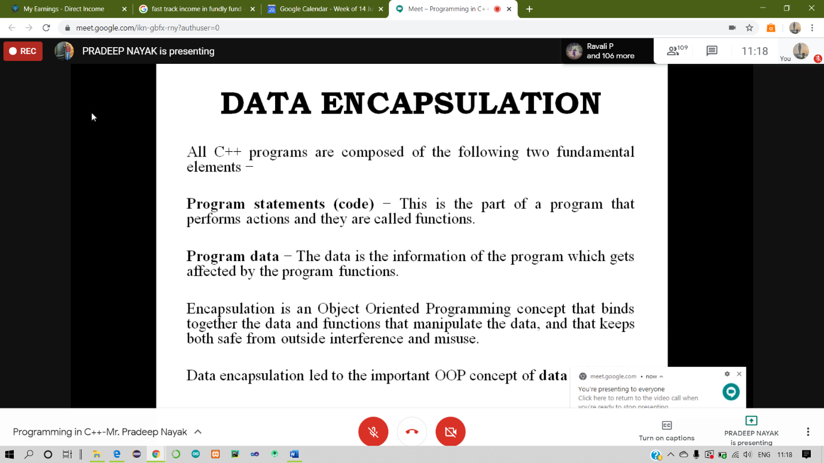

**Coding Challenges Details:**

**Program 1-**

