Sample Application in GitHub—jaig1/docker-demo, to illustrate spinnaker demo

This is a NodJS express application serving a simple HTML

Modify the index.js, push these changes to kubernetes through spinnaker

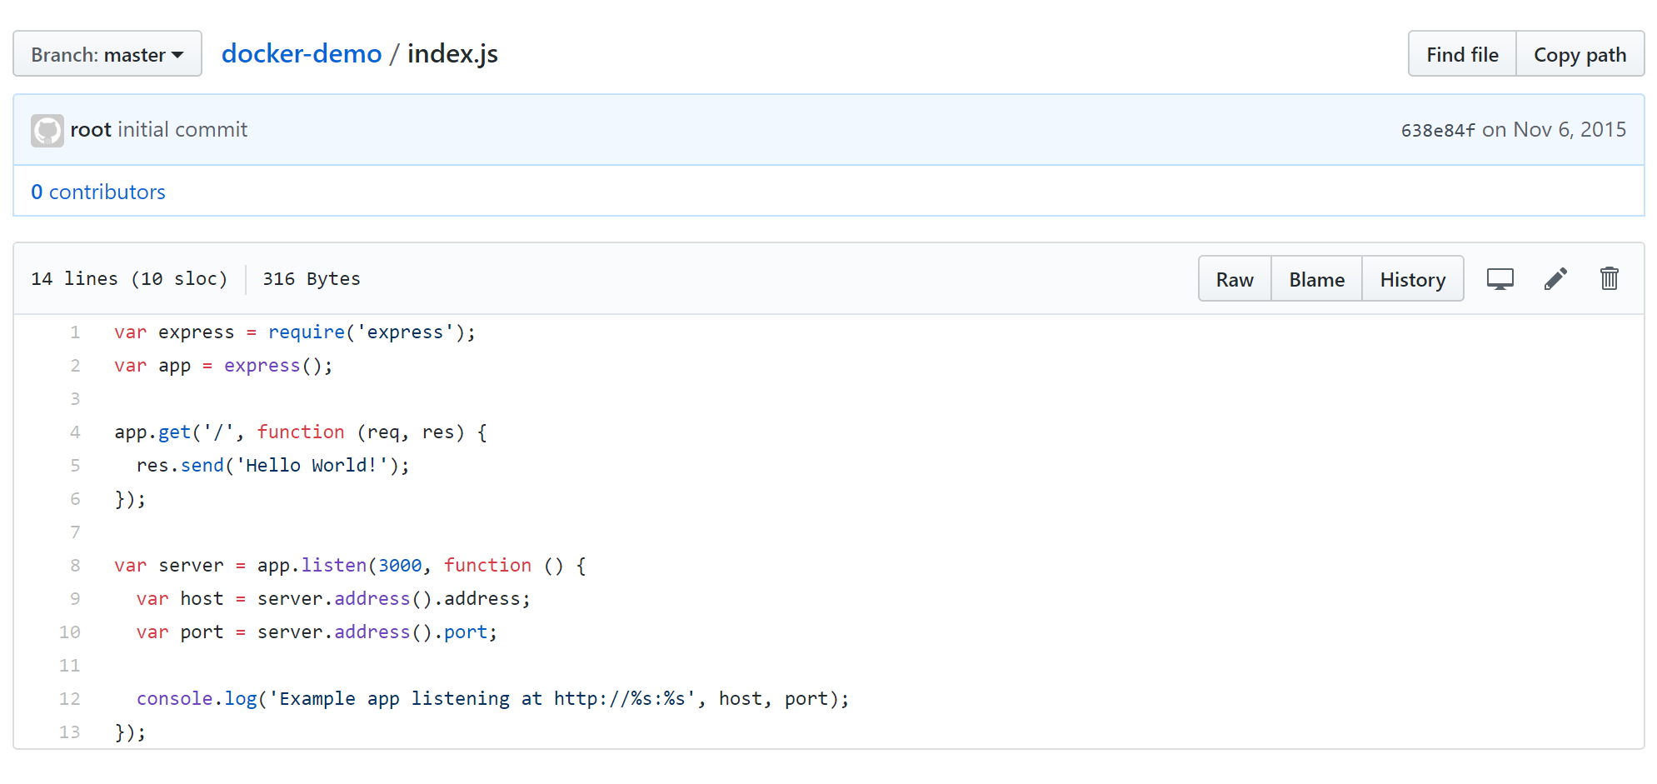

Here is the docker file that creates the runtime images, that spinnaker will deploy to kubernetes

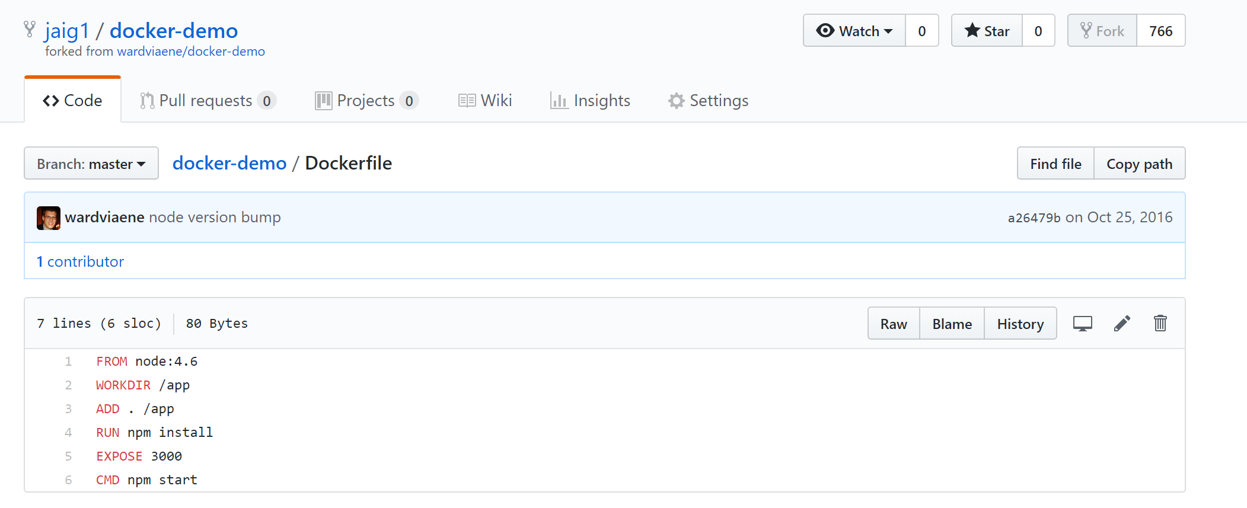

Here are steps to setup an Automated Image Build in Docker, as and when new tags are created on Github Source Repository jaig1/docker-demo

Link your GitHub account, through settings -> linked accounts & services

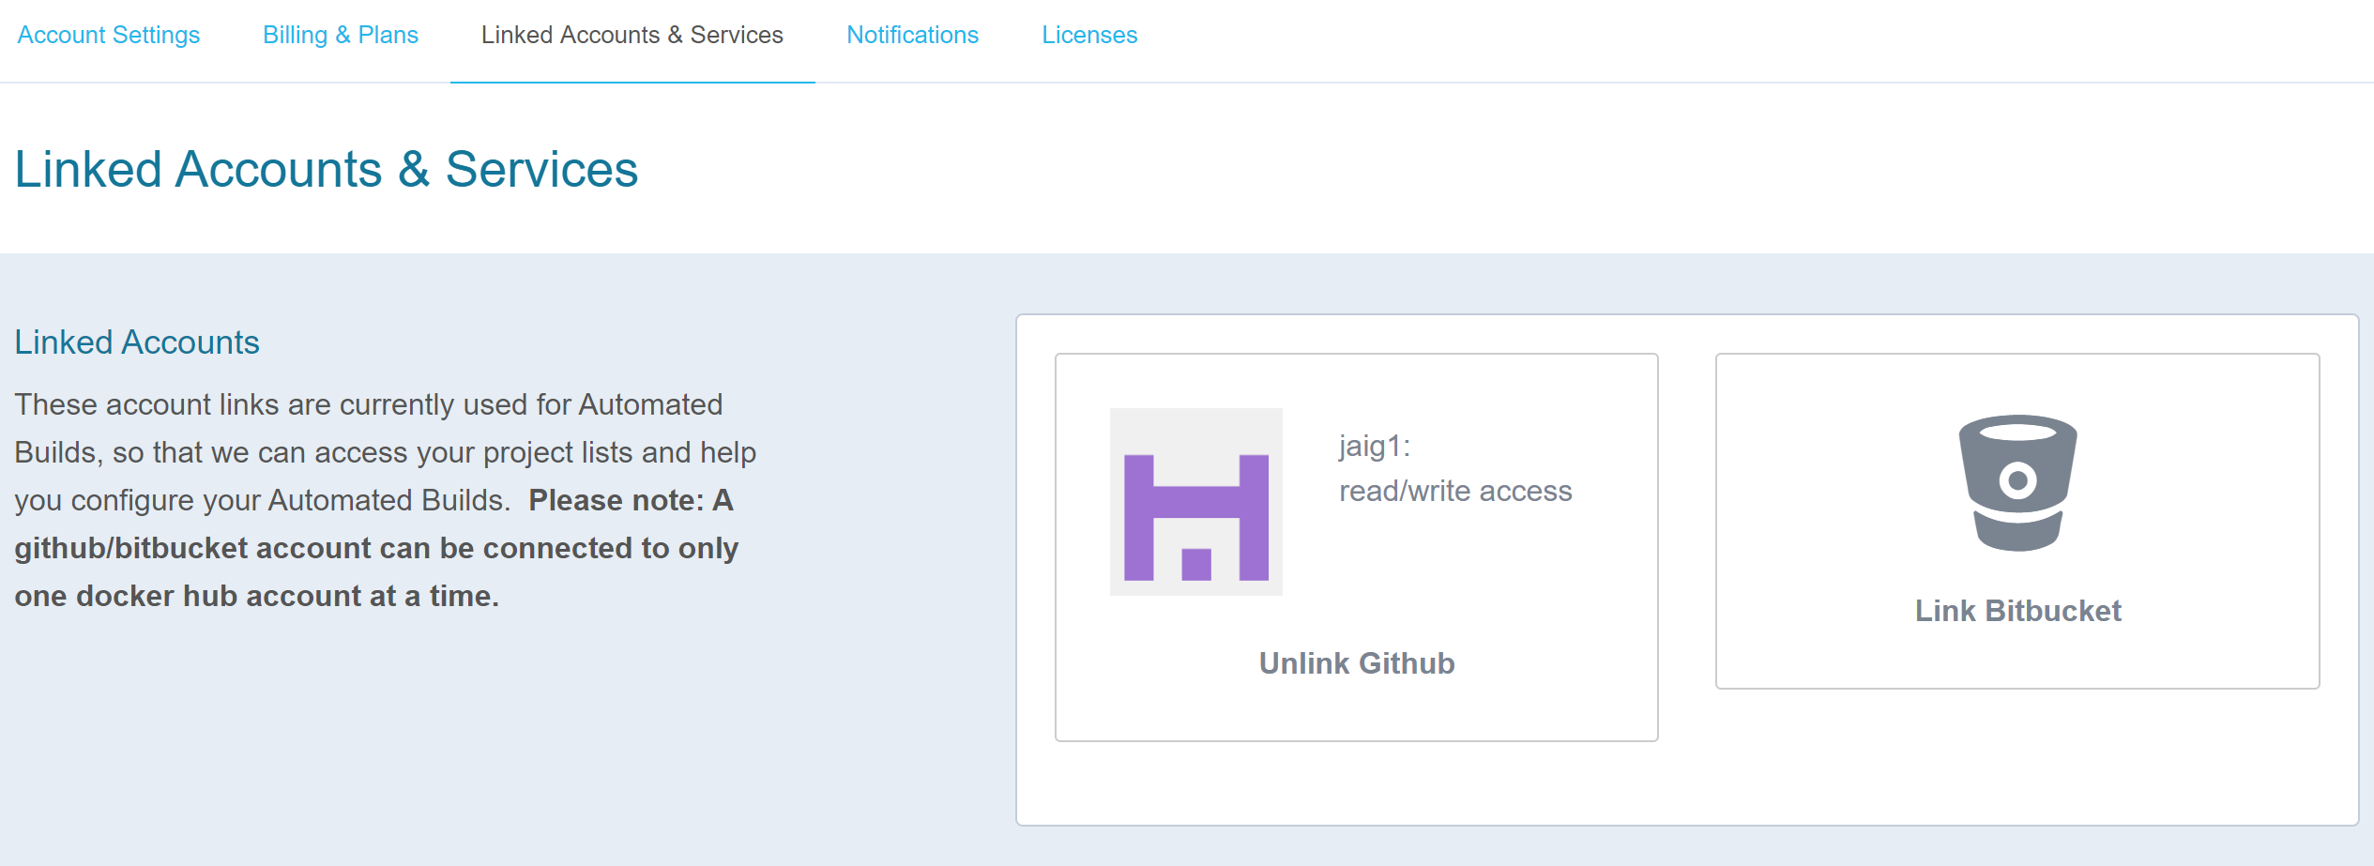

Create Automated Build

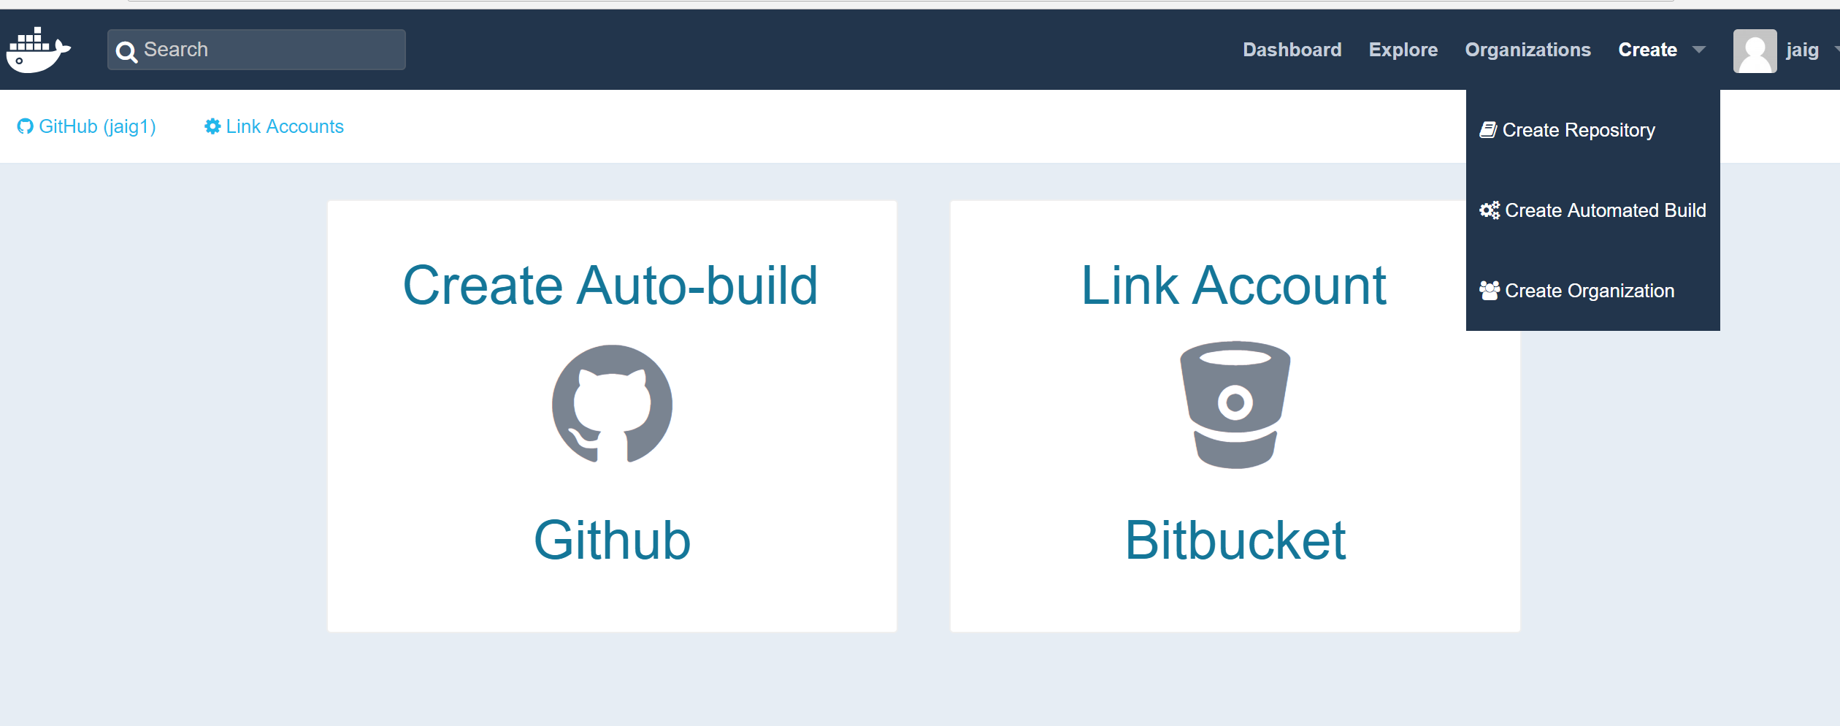

Select the ‘docker-demo’ repository

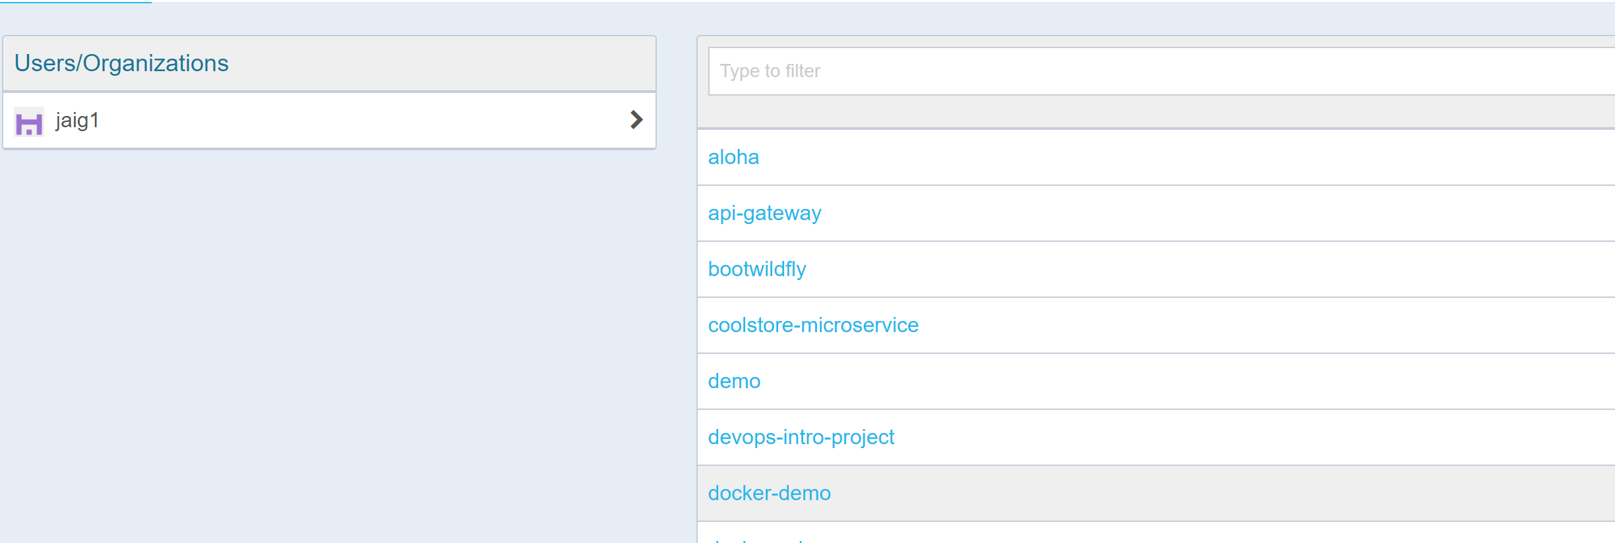

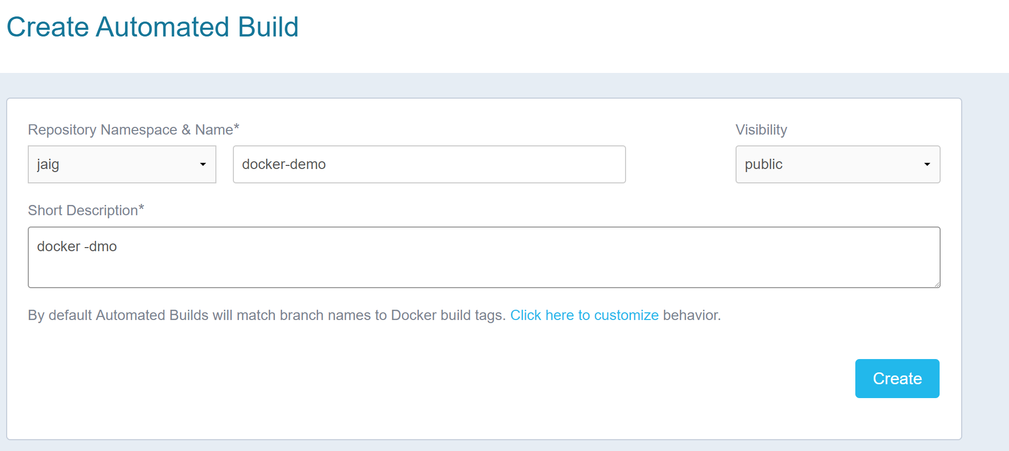

Trigger a manual build

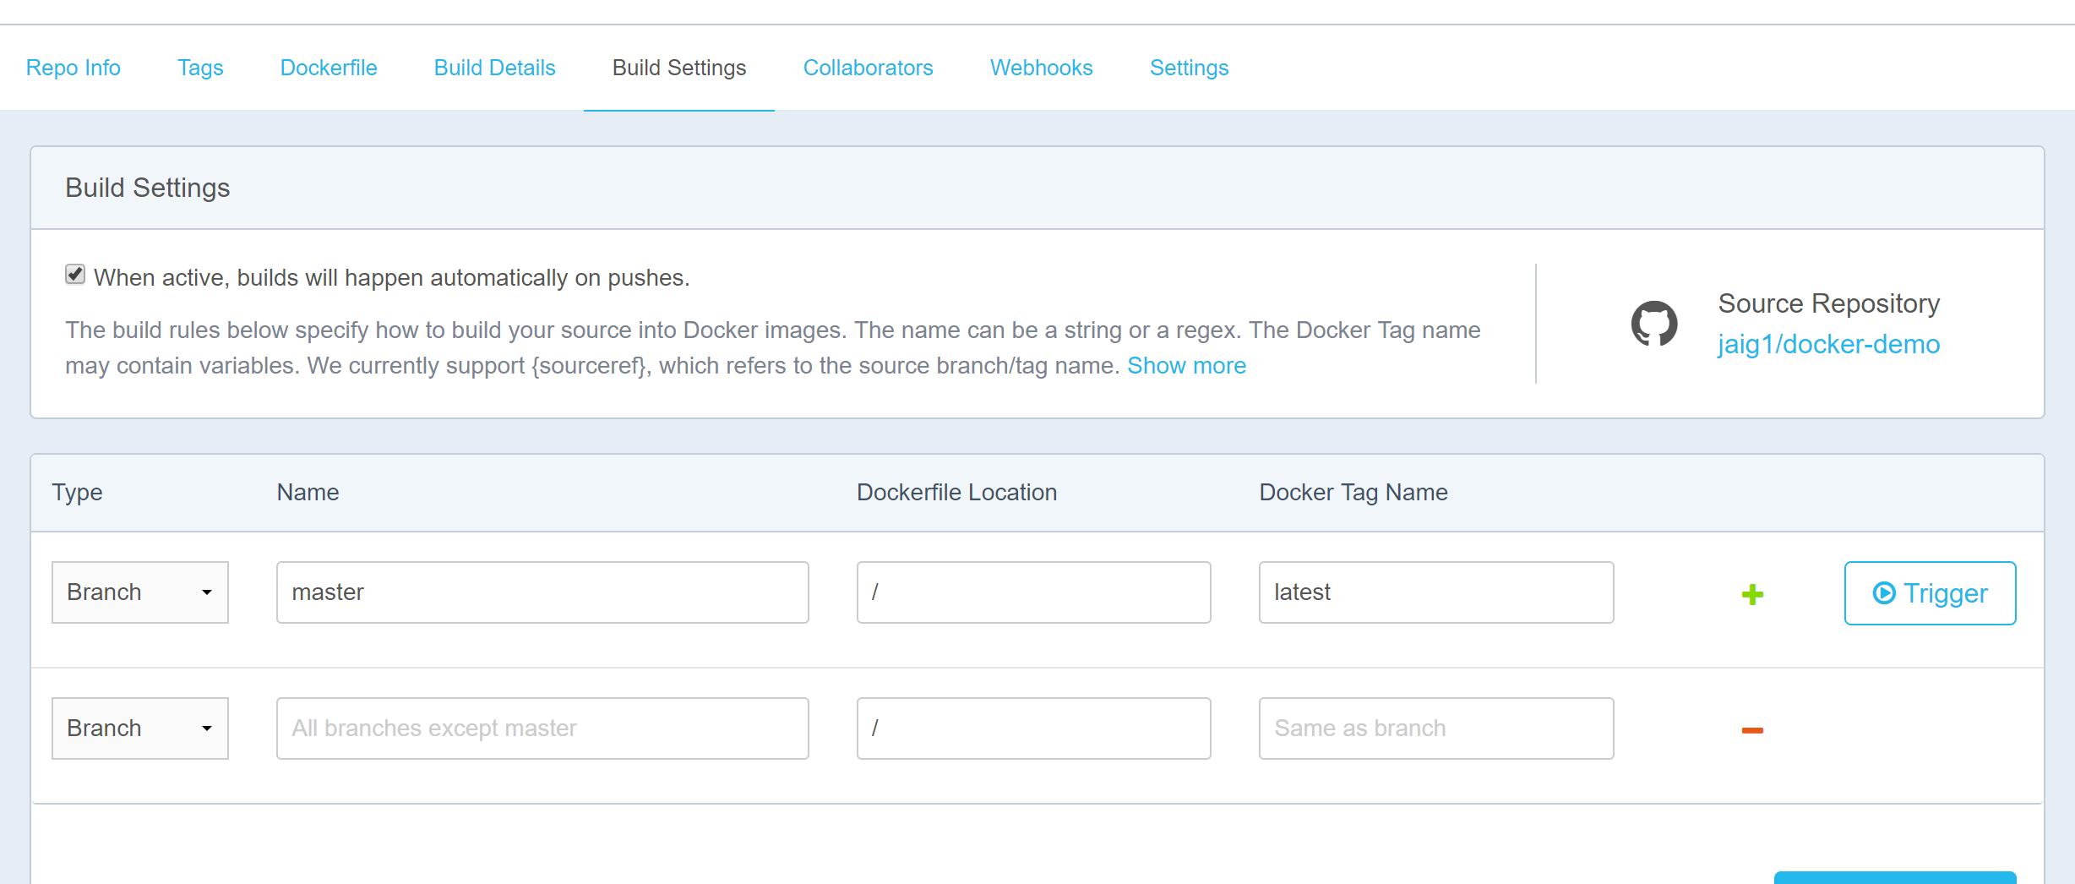

Check the Build Job Status

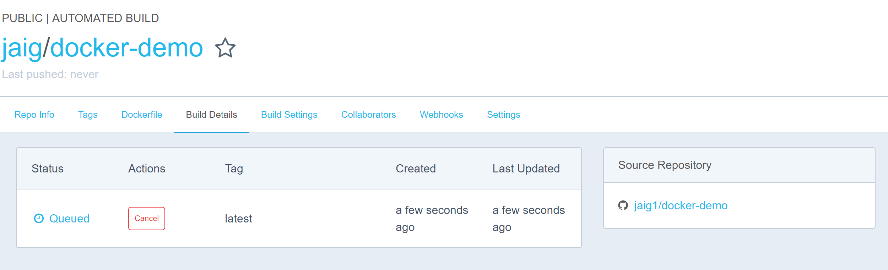

On Build completion. .confirm the image creation

