This document illustrates setup activities on Spinnaker, to illustrate deployment of sample ‘nodejs’ application to Kubernetes. The codebase for this application is available at jaig1/docker-demo in github. The automated image build is available at jaig/spinnaker-node-demo is available at Dockerhub

1. Create New Application for Nodejs app

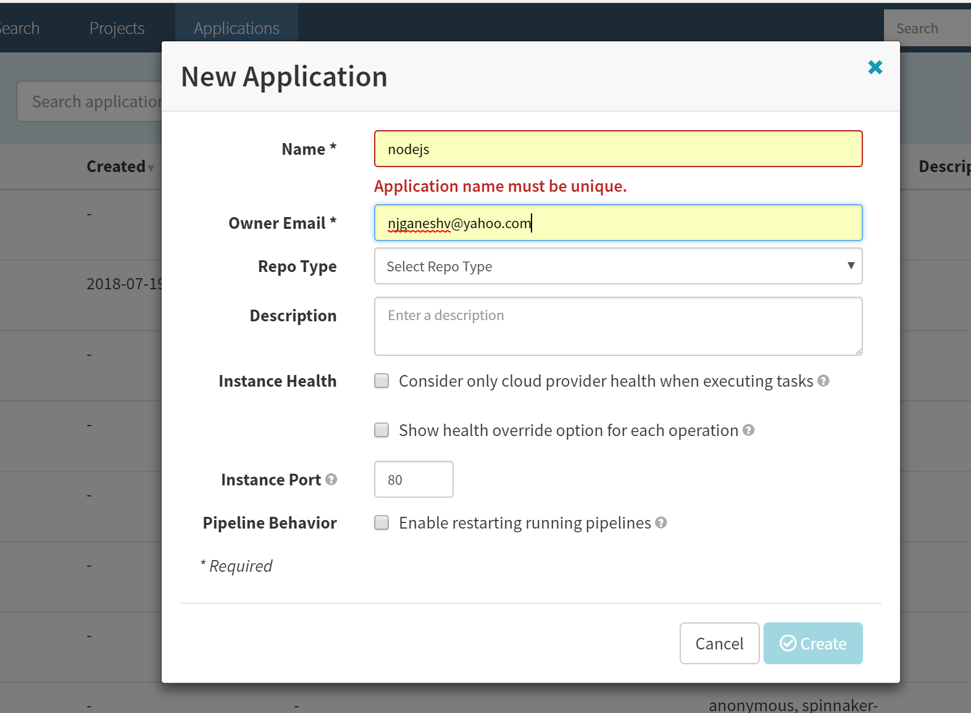

1. Setup the Load Balancer for ‘nodejs’ app

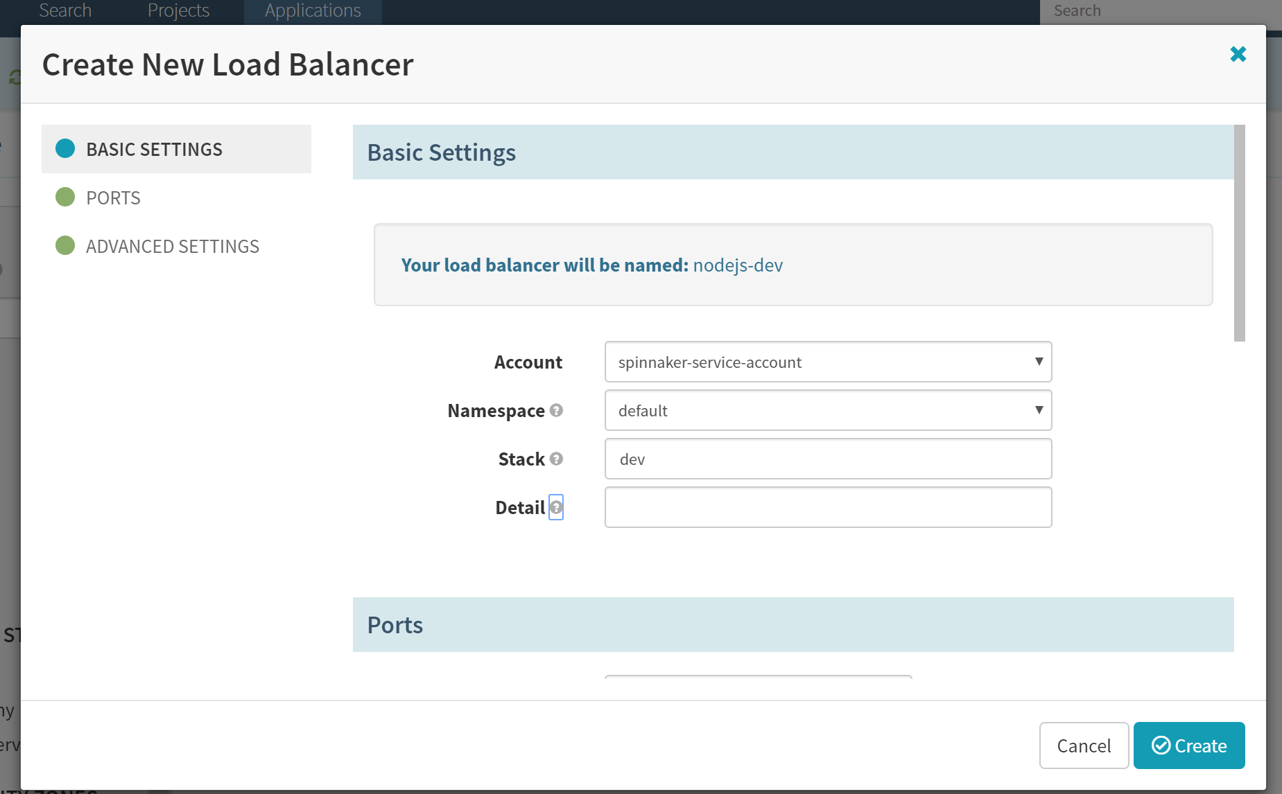

Configure the port

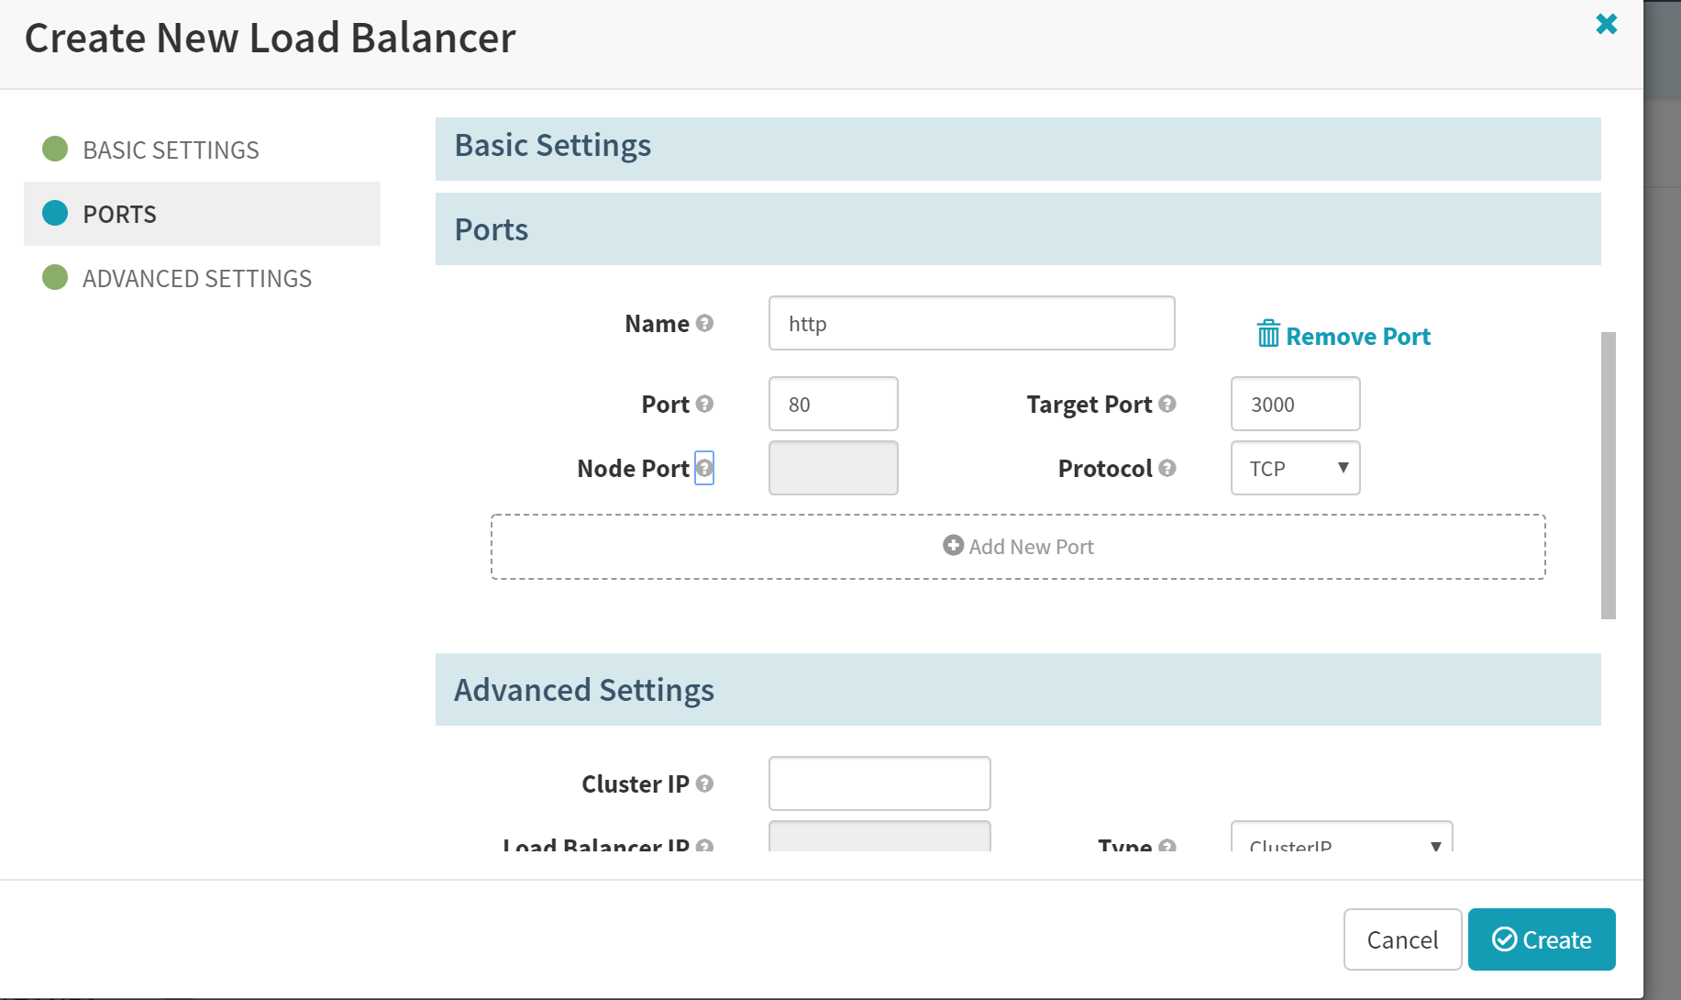

Select the ‘Load Balancer’ option

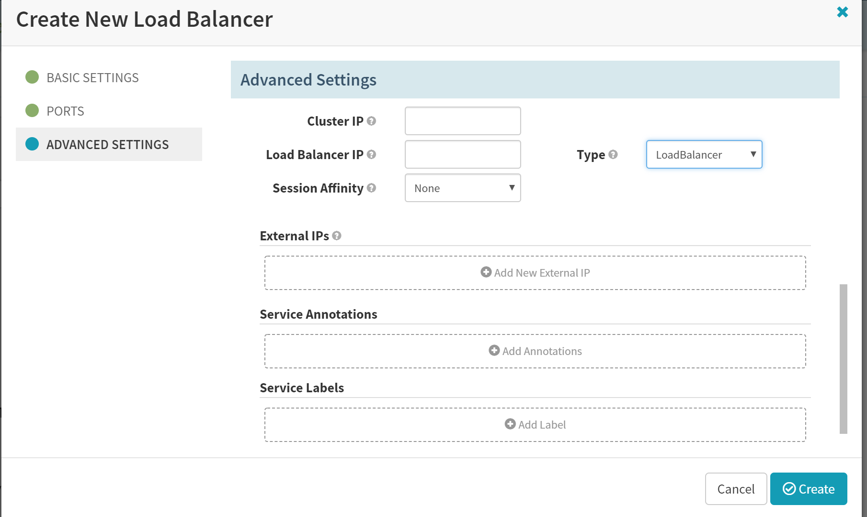

1. Create the server group for ‘nodejs’ app

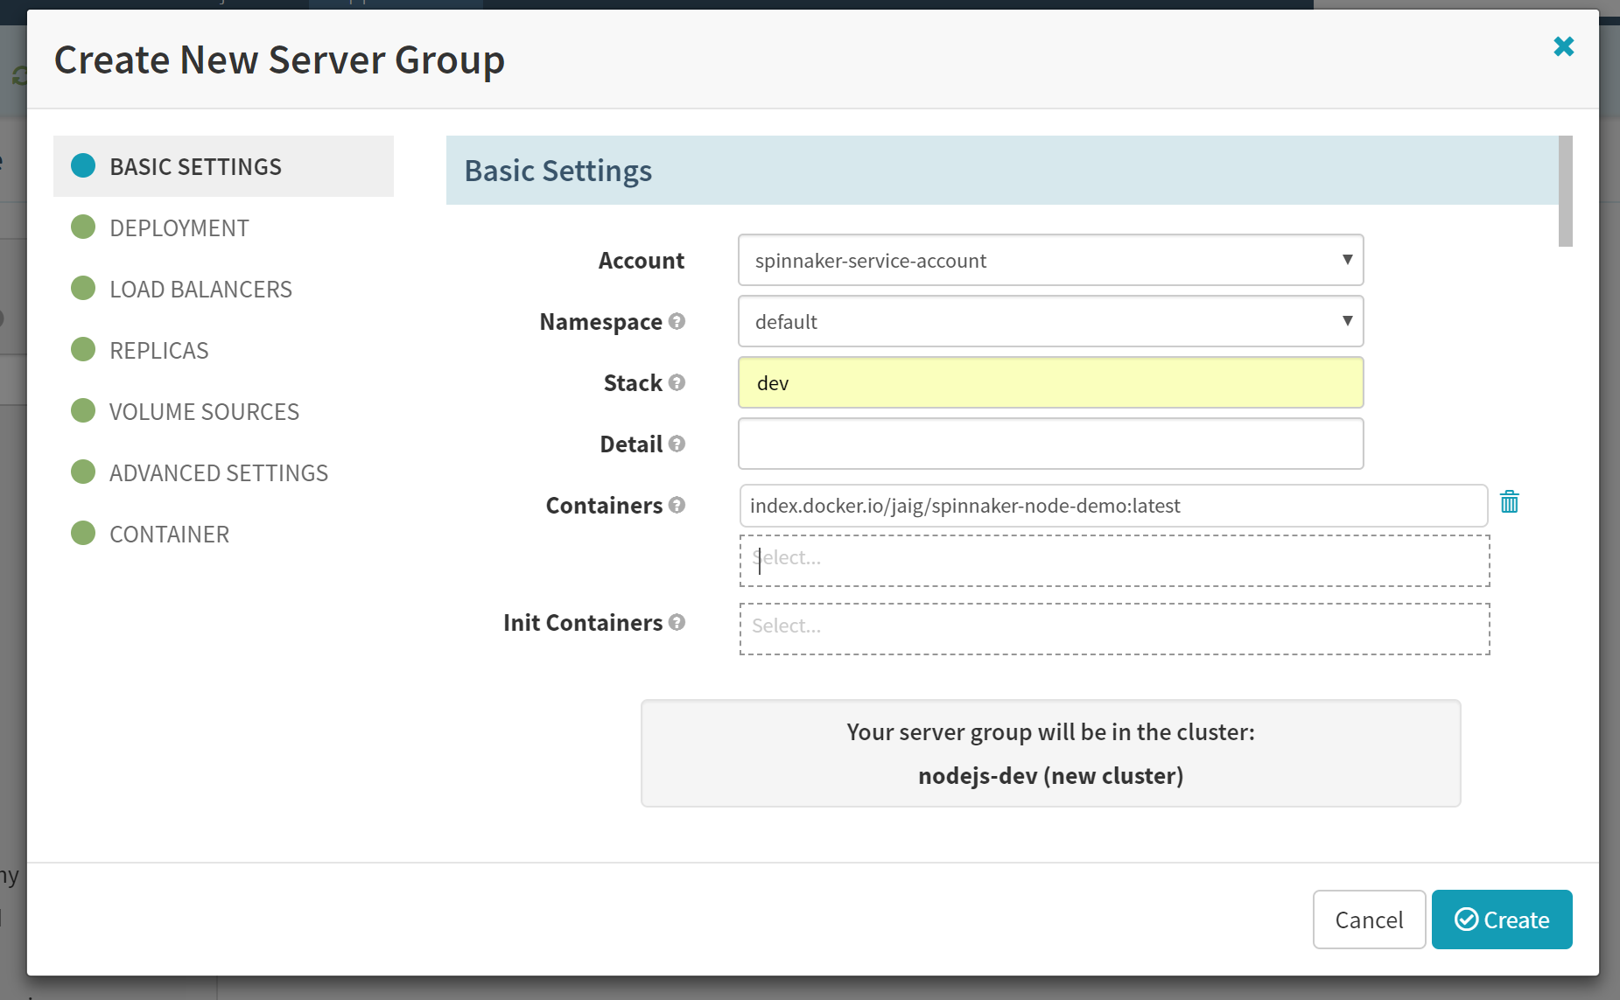

Select the LoadBalancer

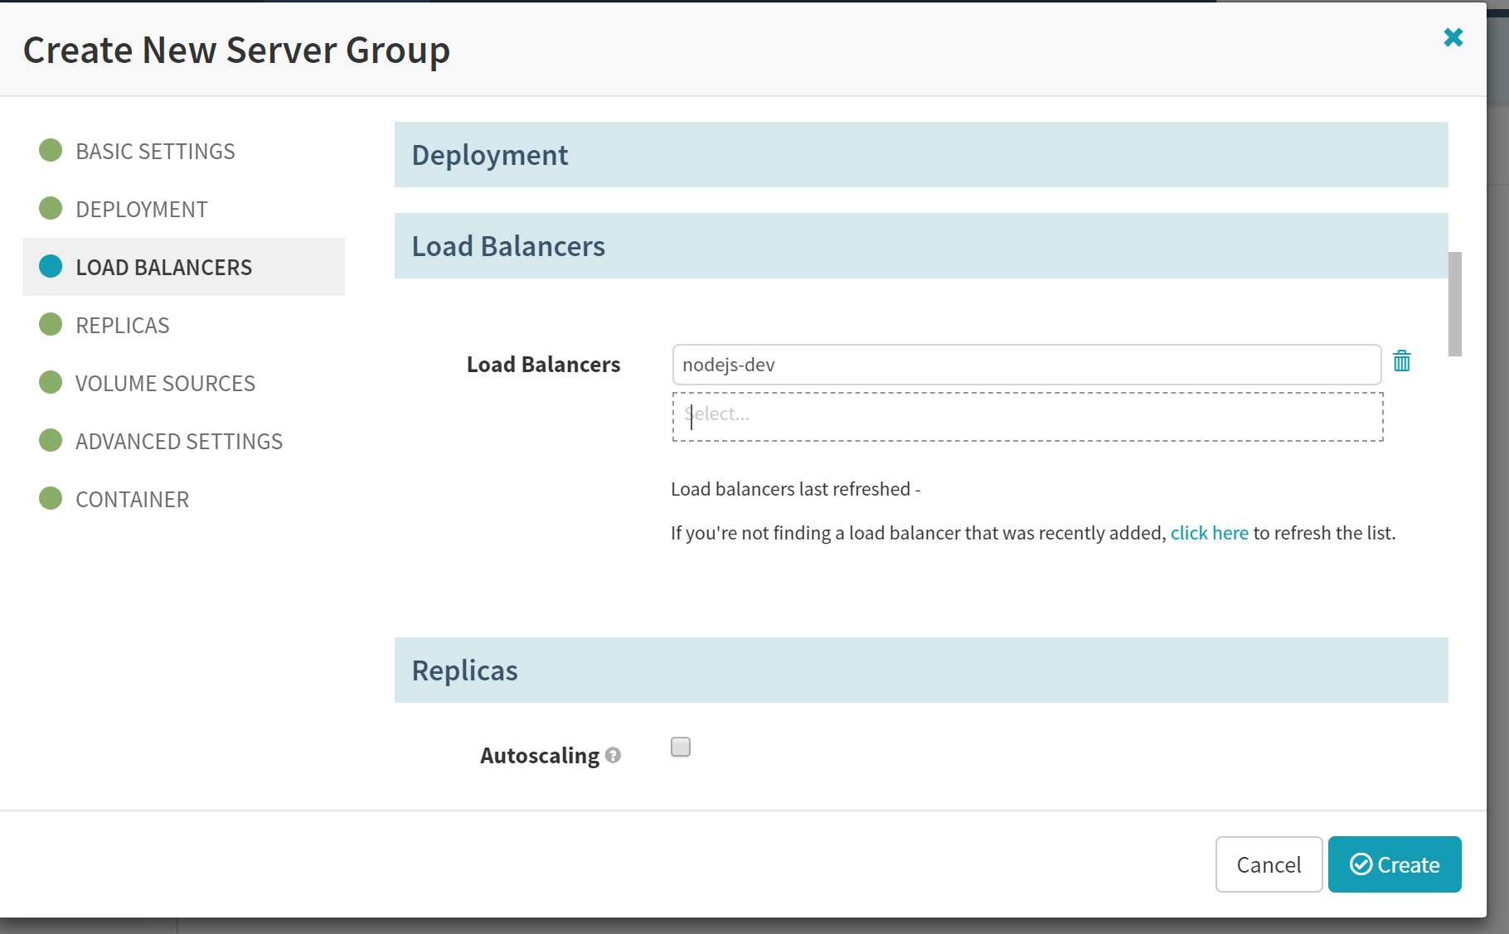

Set the container port value

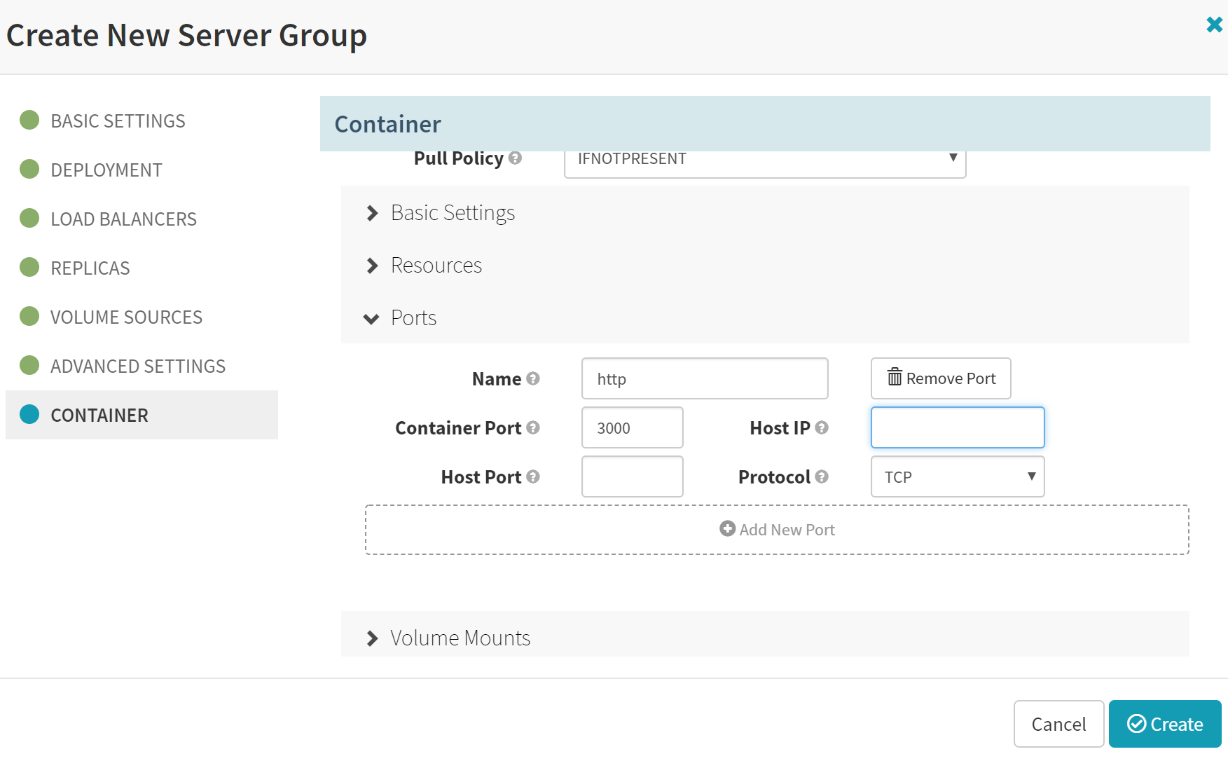

Confirm the deployment

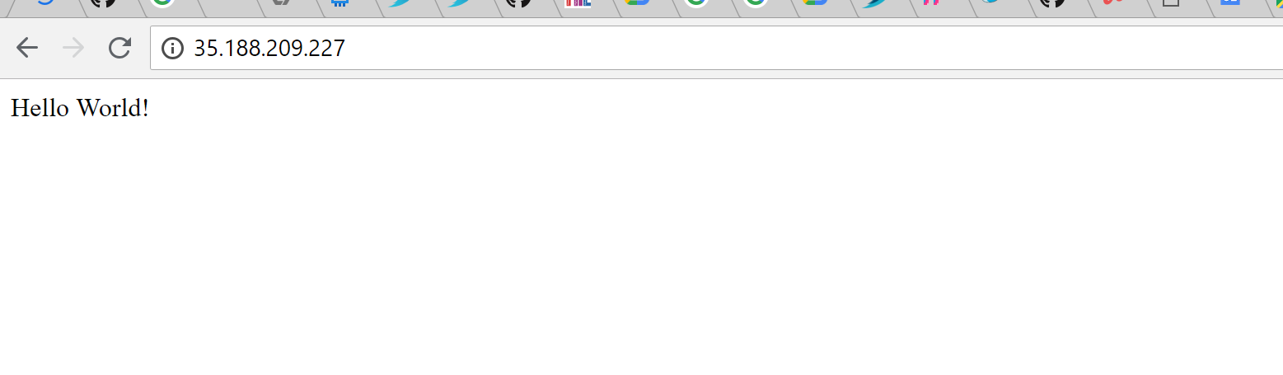

1. Create the pipeline for ‘nodejs’ app

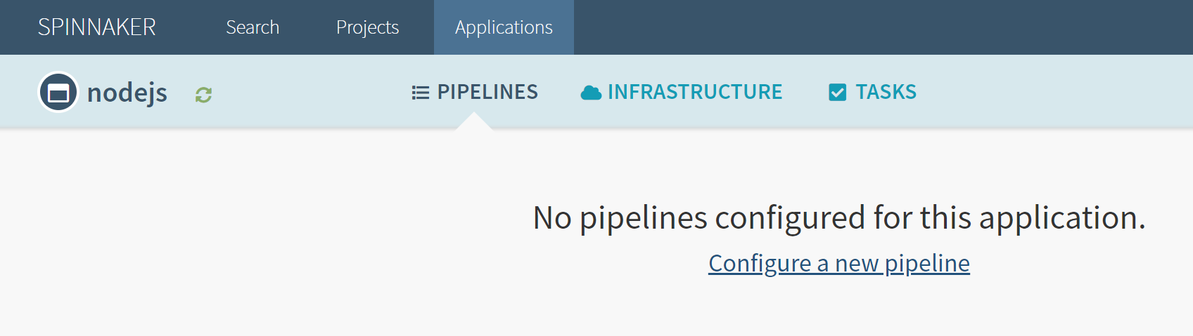

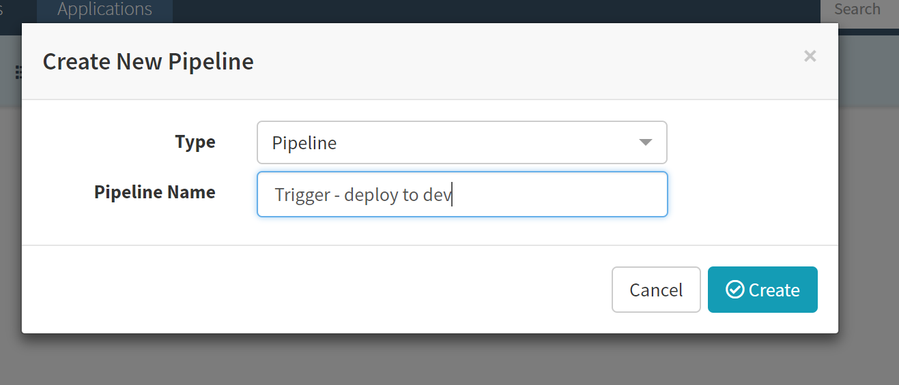

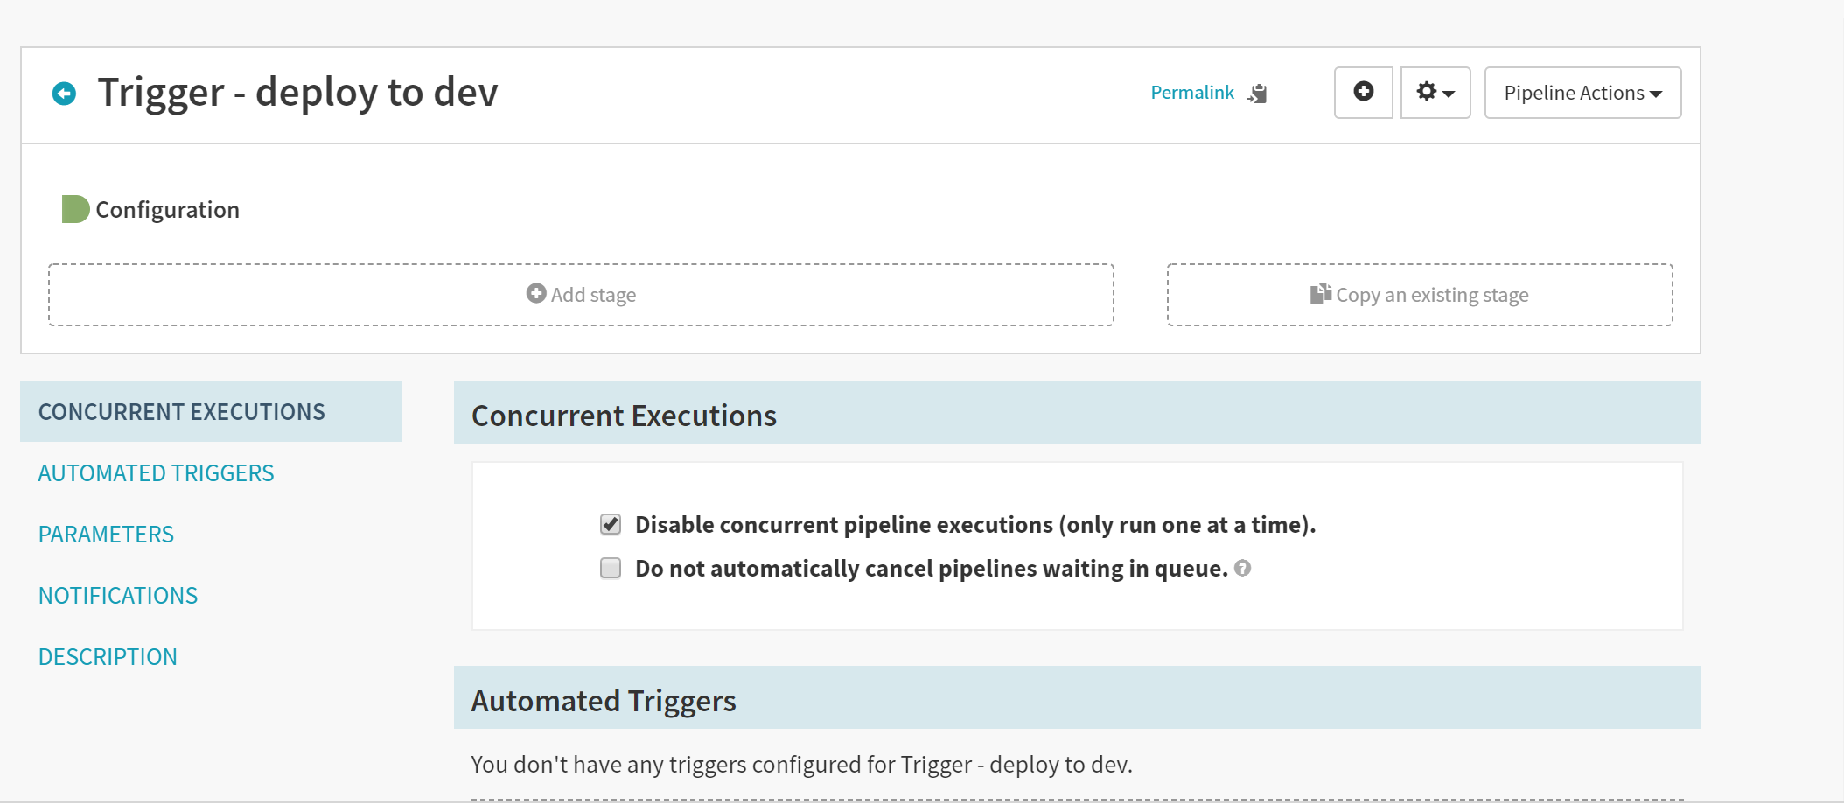

Add Stage for deploying new image of nodejs, from Docker hub

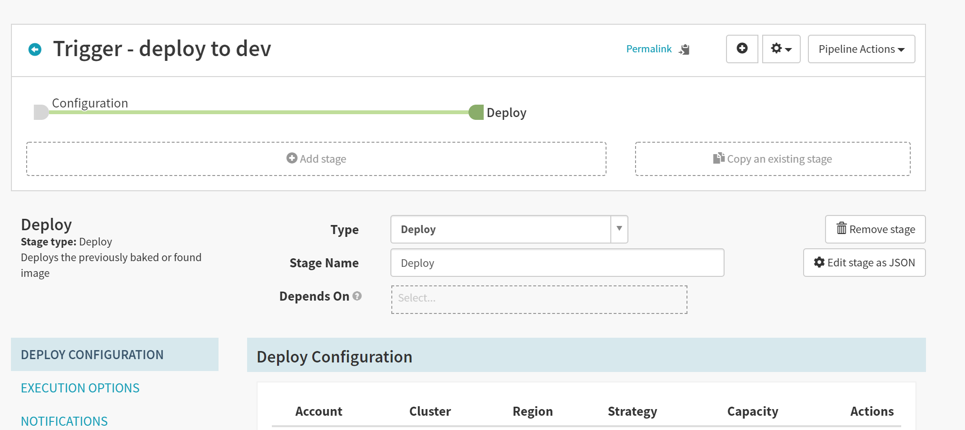

Add server group

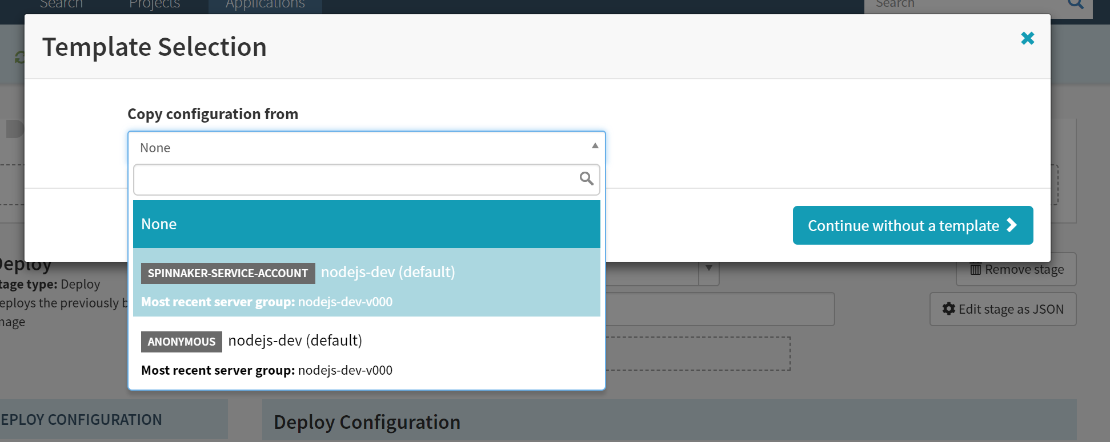

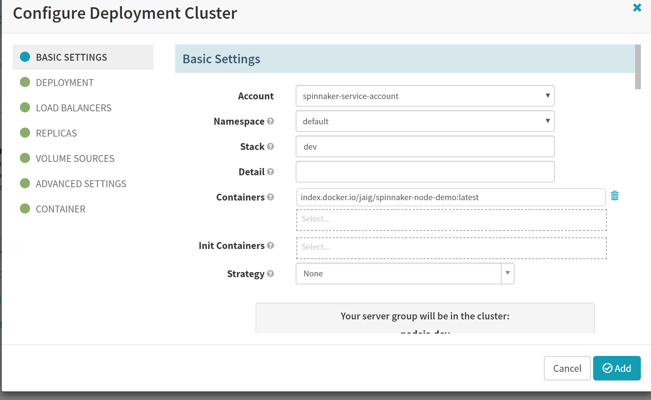

Confirm addition of ‘deploy’ stage

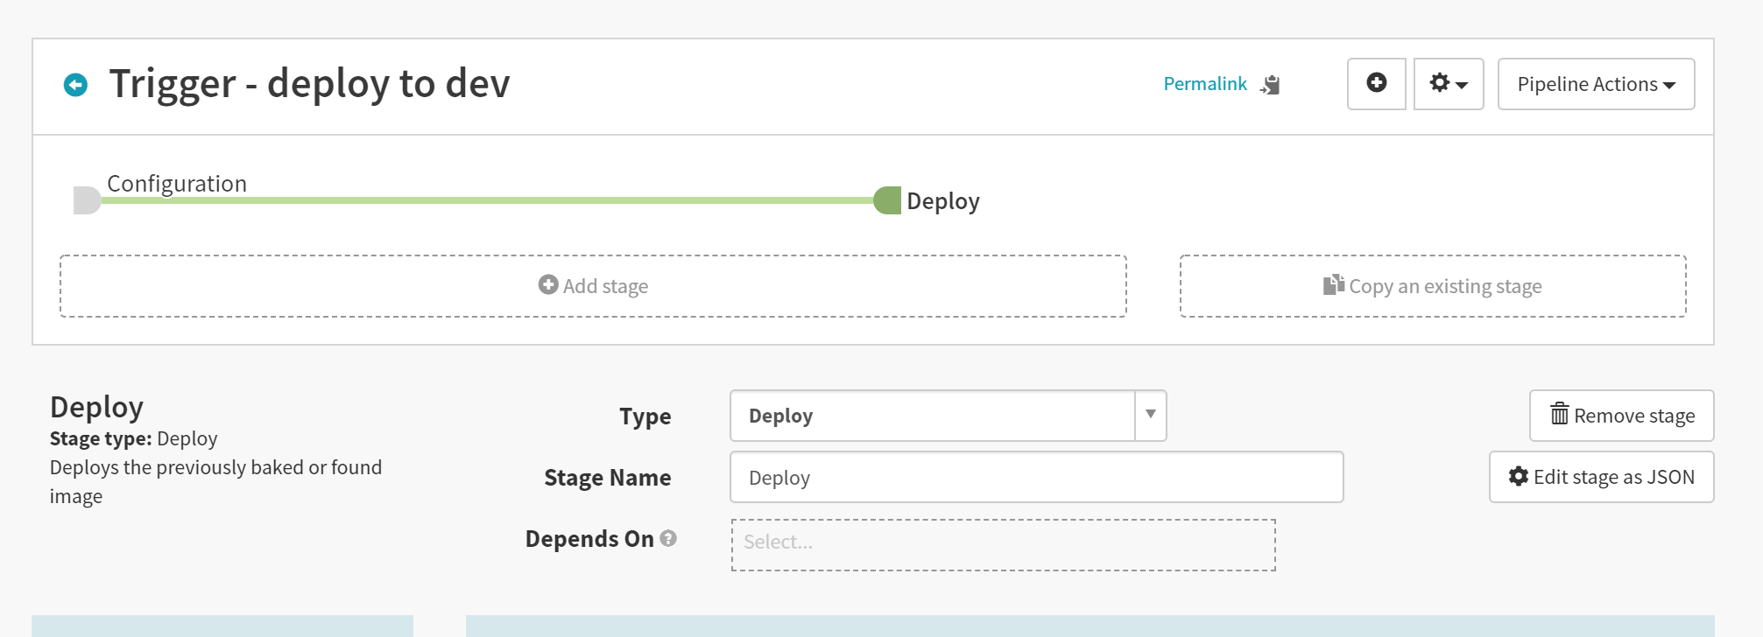

Add destroy ‘server-group’ as the next step in the pipeline

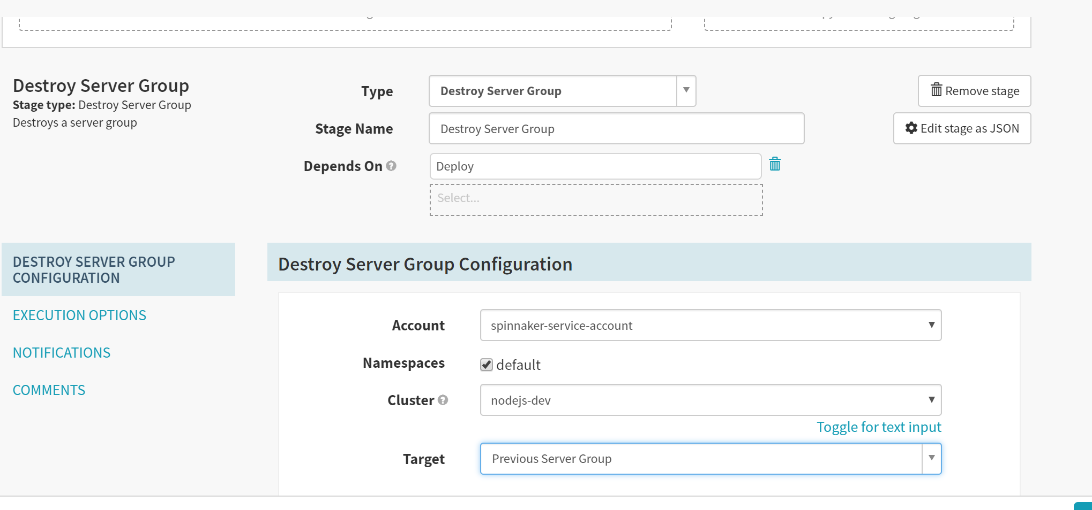

Confirm the pipeline setup…through an manual execution

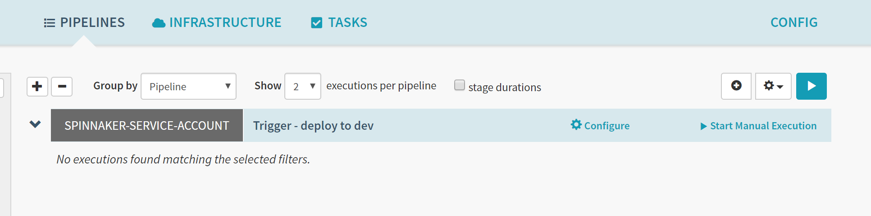

Make changes to nodejs app source repository jaig1/docker-demo

git clone https://github.com/jaig1/docker-demo.git

cd docker-demo

git branch

git branch -b v2.0.1

git checkout -b v2.0.1

git pull

vi index.js

git add .

git commit -m "chuma"

git commit -am "chuma"

git config --global user.email "njganeshv@gmail.com"

git config --global user.name "jaig1"

git commit -m "chuma"

git push --set-upstream origin v2.0.1