REAL TIME ELECTRICITY CONSUMPTION MONITOR USING IoT

A PROJECT REPORT
Submitted by
DHANASEKARAN E (922222104009)
HARISHBABU D (922222104014)
JAIGANESH R (922222104018)

In partial fulfilment for the award of the degree
of
BACHELOR OF ENGINEERING
in

COMPUTER SCIENCE AND ENGINEERING

THENI KAMMAVAR SANGAM COLLEGE OF TECHNOLOGY, KODUVILARPATTI, THENI-625534

ANNA UNIVERSITY:: CHENNAI 600 025
APRIL 2026

ANNA UNIVERSITY : CHENNAI 600 025

BONAFIDE CERTIFICATE

Certified that this project report “REAL TIME ELECTRICITY CONSUMPTION MONITOR USING IoT” is the bonfide work of,
DHANASEKARAN R (922222104009), HARISHBABU D (922222104014), JAIGANESH R (922222104018), who carried out the project work under my supervision.

SIGNATURE SIGNATURE

Mr.D.ANANTH Mr.D. RAJAPANDI

HEAD OF THE DEPARTMENT SUPERVISOR
 | Assistant Professor
Computer Science and Engineering | Information Technology
Theni Kammavar Sangam College of Technology, | Theni Kammavar Sangam College of  Technology
Theni - 625534. | Theni - 625534.

Submitted for the VIVA - VOCE Examination held on ____________

INTERNAL EXAMINER EXTERNAL EXAMINER

ABSTRACT

Electricity consumption monitoring plays a crucial role in efficient energy management in residential, commercial, and industrial environments. Traditional energy meters provide only cumulative readings and do not allow users to monitor real-time electricity usage. This lack of real-time monitoring makes it difficult for consumers to understand their energy consumption patterns and control unnecessary energy usage. With the advancement of Internet of Things (IoT) technologies, smart monitoring systems can be developed to track electricity consumption in real time. This project presents the design and implementation of a Real-Time Electricity Consumption Monitoring System using IoT. The system uses an ESP32 microcontroller and an ACS712 current sensor to measure the electrical current flowing through a load. The measured current is used to calculate power consumption using a predefined voltage value. The ESP32 processes the sensor data and sends it to the ThingSpeak cloud platform through Wi-Fi connectivity. A web-based dashboard is developed to display live energy parameters such as power consumption, voltage, and current. The system also estimates daily, monthly, and yearly energy usage based on the measured power values. The dashboard provides secure login access using an API key to ensure that only authorized users can access the monitoring interface. The proposed system offers a cost-effective and scalable solution for real-time energy monitoring. It allows users to track energy usage remotely, identify high energy consumption devices, and improve energy efficiency.

CHAPTER NO | TITLE | PAGE NO
 | ABSTRACT | i
 | LIST OF FIGURES | vi
 | LIST OF ABBREVIATIONS | vii
1 | INTRODUCTION | 1
 | 1.1 Internet of Things (IoT) | 1
 | 1.2 Energy Monitoring Systems | 2
 | 1.3 Components Used in the Project | 3
 | 1.3.1 ESP32 Microcontroller | 3
 | 1.3.2 ACS712 Current Sensor | 4
 | 1.3.3 ThingSpeak Cloud Platform | 4
 | 1.3.4 Web Dashboard | 5
 | 1.4 Objectives of the Project | 6
 | 1.5 Advantages of the Proposed System | 6
2 | LITERATURE SURVEY | 7
 | 2.1 Introduction | 7
 | 2.2 IoT Based Energy Monitoring Systems | 7
 | 2.3 Smart Metering Technologies | 8
 | 2.4 Cloud Based Energy Monitoring | 8
3 | SYSTEM METHODOLOGY | 9
 | 3.1 Introduction | 9
 | 3.2 System Architecture | 9
 | 3.3 Block Diagram of the System | 10
 | 3.4 Working Principle of the System | 12
 | 3.5 Data Acquisition Process | 13
 | 3.6 Data Processing | 13
 | 3.7 Data Transmission Using WiFi | 14
 | 3.8 Data Visualization | 14
 | 3.9 Security and Authentication | 15
 | 3.10 Summary | 15
4 | HARDWARE AND SOFTWARE IMPLEMENTATION | 16
 | 4.1 Introduction | 16
 | 4.2 Hardware Components | 16
 | 4.3 ESP32 Microcontroller | 17
 | 4.4 ACS712 Current Sensor | 18
 | 4.5 Power Supply | 18
 | 4.6 Circuit Design | 19
 | 4.7 Software Implementation | 20
 | 4.8 ThingSpeak Cloud Integration | 21
 | 4.9 Web DashBoard Implementaion | 22
 | 4.10 System Operation | 22
 | 4.11 Web dashboard design and implementation | 23
 | 4.11.1 Introduction | 23
 | 4.11.2 System architecture of the dashboard | 23
 | 4.11.3 Html structure of the dashboard | 24
 | 4.11.4 Authentication interface | 24
 | 4.11.5 Css design and user interface | 25
 | 4.11.6 Dashboard display components | 25
 | 4.11.7 Energy consumption estimation | 26
 | 4.11.8 Javascript data fetching | 27
 | 4.11.9 Real time data update | 27
 | 4.11.10 Logout function | 27
 | 4.11.11 Advantages of the dashboard | 28
 | 4.11.12 Summary | 29
5 | RESULTS AND DISCUSSION
 | 5.1 Introduction | 30
 | 5.2 Experimental Setup | 30
 | 5.3 Serial Monitor Output | 31
 | 5.4 ThingSpeak Cloud Data | 31
 | 5.5 Web Dashboard Output | 33
 | 5.6 System Performance Analysis | 33
 | 5.7 Advantages of the Proposed System | 34
 | 5.8 Limitations of the System | 34
 | 5.9 Summary | 34
6 | CONCLUSION AND FUTURE WORK | 35
 | 6.1 Conclusion | 35
 | 6.2 Future Enhancements | 35
 | REFERENCES | 36
 | APPENDIX A – Arduino Program Code | 37
 | APPENDIX B – Web Dashboard Source Code | 39

LIST OF FIGURES

FIGURE NO | TITLE | PAGE NO
Fig 3.1 | System Architecture | 10
Fig 3.2 | Block Diagram of the System | 11
Fig 4.1 | ESP32 (Microcontroller) | 17
Fig 4.2 | ACS712 Current Sensor | 18
Fig 4.3 | Circuit Diagram (Hardware Layout) | 19
Fig 4.4 | Arduino Program Sketch | 20
Fig 4.5 | Thinkspeak cloud | 21
Fig 4.6 | Web Dashboard Output | 29
Fig 5.1 | Thinkspeak Dashboard | 32

LIST OF ABBREVATIONS

IoT | Internet of Things
ESP32 | Espressif 32-bit Microcontroller
Wi-Fi | Wireless Fidelity
API | Application Programming Interface
HTTP | HyperText Transfer Protocol
HTML | HyperText Markup Language
CSS | Cascading Style Sheets
JS | JavaScript
ADC | Analog to Digital Converter
VREF | Reference Voltage
RMS | Root Mean Square
AC | Alternating Current
DC | Direct Current
kW | Kilowatt
kWh | Kilowatt-hour
IDE | Integrated Development Environment
MCU | Microcontroller Unit

CHAPTER 1

INTRODUCTION
Electricity is one of the most essential forms of energy used in modern society. It powers homes, industries, hospitals, communication systems, and various electronic devices that are part of everyday life. With the rapid growth of technology and increasing dependence on electrical appliances, electricity consumption has significantly increased worldwide. Efficient monitoring and management of electricity usage has therefore become an important requirement. The development of the Internet of Things (IoT) has opened new opportunities for intelligent monitoring systems. IoT refers to the network of interconnected physical devices that collect and exchange data through the internet. By integrating sensors, microcontrollers, and cloud platforms, IoT enables real-time monitoring and remote control of devices. This technology has been widely applied in smart homes, smart cities, healthcare monitoring, and energy management systems. In the context of energy monitoring, IoT can be used to measure electrical parameters such as current, voltage, and power consumption in real time. The main objective of this project is to design and implement a Real-Time Electricity Consumption Monitoring System using IoT technology. The system uses an ESP32 microcontroller and an ACS712 current sensor to measure the electrical current flowing through a load. The microcontroller processes the sensor data and calculates the corresponding power consumption. The measured data is then transmitted to the ThingSpeak cloud platform via Wi-Fi.
A web-based dashboard is developed to display real-time electricity usage data. The dashboard provides information such as current, voltage, and power consumption. Additionally, it estimates daily, monthly, and yearly energy consumption based on the measured power values. This feature helps users understand their energy usage patterns and take appropriate actions to reduce unnecessary consumption. The proposed system provides several advantages compared to conventional energy monitoring methods. It enables real-time monitoring, remote access, and improved energy awareness for users. The system is also cost-effective and easy to implement, making it suitable for residential and small-scale industrial applications. By implementing this IoT-based energy monitoring system, users can gain better control over their electricity consumption, reduce energy wastage, and promote efficient energy utilization.

1.1 INTERNET OF THINGS (IoT)
The Internet of Things (IoT) refers to a network of interconnected physical devices that are capable of collecting, processing, and exchanging data through the internet. These devices are embedded with sensors, software, and communication technologies that allow them to interact with each other and with centralized systems. IoT technology enables the automation and monitoring of various systems in real time, making it an important component in modern technological applications.
In recent years, IoT has gained significant attention due to its ability to transform traditional systems into intelligent and automated systems. IoT devices can gather real-time data from the environment, analyze it, and perform actions based on the collected information. This capability has made IoT a key technology in various fields such as healthcare, smart cities, industrial automation, agriculture, and energy management.
One of the most important applications of IoT is in the field of energy monitoring and management. Traditional energy systems rely on manual monitoring and periodic meter readings. However, IoT-based systems allow continuous monitoring of electricity consumption. By connecting sensors and microcontrollers to the internet, electrical parameters such as voltage, current, and power consumption can be measured and transmitted to cloud servers in real time.
The data collected through IoT devices can be analyzed using cloud computing platforms to generate useful insights. These insights help users understand their energy consumption patterns and identify areas where energy can be saved. IoT-based energy monitoring systems are particularly useful in smart homes and industries where energy efficiency is an important concern. Another major advantage of IoT technology is remote accessibility. Users can monitor and control devices from any location using web applications or mobile applications. This feature improves convenience and allows users to respond quickly to abnormal energy consumption or system faults.
IoT systems typically consist of several components, including sensors, microcontrollers, communication modules, cloud platforms, and user interfaces. Sensors are responsible for collecting data from the physical environment, while microcontrollers process the data and transmit it through communication networks such as Wi-Fi or Bluetooth. The data is then stored in cloud servers where it can be accessed and visualized by users.
In this project, IoT technology is used to monitor electricity consumption in real time. The system uses an ESP32 microcontroller and a current sensor to measure electrical parameters. The collected data is transmitted to a cloud platform called ThingSpeak, where it is stored and displayed through a web dashboard.
The integration of IoT technology in energy monitoring systems not only improves efficiency but also contributes to energy conservation and sustainable development. By providing real-time insights into electricity usage, IoT helps users make informed decisions about their energy consumption.

1.2 ENERGY MONITORING SYSTEMS
Energy monitoring systems are designed to measure and analyze electricity consumption in residential, commercial, and industrial environments. These systems provide detailed information about energy usage, allowing users to identify inefficient appliances, reduce energy waste, and optimize electricity consumption.
Traditional energy monitoring systems typically rely on mechanical or digital electricity meters installed by utility providers. These meters measure the total energy consumed over a specific period of time. While these meters provide accurate readings, they do not offer real-time insights into energy consumption. As a result, users are often unaware of their daily electricity usage patterns until they receive their monthly electricity bills.
Modern energy monitoring systems overcome these limitations by incorporating sensors, microcontrollers, and communication technologies. These systems continuously measure electrical parameters such as current, voltage, power, and energy consumption. The collected data is transmitted to cloud platforms where it can be analyzed and visualized through graphical interfaces. Real-time energy monitoring systems offer several benefits. They allow users to track electricity consumption instantly and identify devices that consume excessive power. By understanding energy usage patterns, users can take appropriate actions such as switching off unnecessary devices or replacing inefficient appliances with energy-efficient alternatives.
Energy monitoring systems are also important for industries where electricity consumption represents a significant portion of operational costs. Industrial facilities can use these systems to monitor equipment performance and detect abnormal energy usage that may indicate equipment malfunction or inefficiency.
Another advantage of energy monitoring systems is their ability to support energy conservation initiatives. The proposed real-time electricity monitoring system consists of several hardware and software components that work together to measure and display energy consumption. Each component plays an important role in ensuring accurate data collection and efficient communication with the cloud platform. Governments and organizations around the world are promoting energy efficiency to reduce environmental impact and minimize carbon emissions. Smart energy monitoring systems play a vital role in achieving these goals by encouraging responsible energy usage.IoT-based energy monitoring systems provide additional capabilities such as remote monitoring, data logging, and automated alerts. These features enable users to monitor energy consumption from anywhere and receive notifications if abnormal energy usage is detected.
In this project, an IoT-based energy monitoring system is developed to measure and display electricity consumption in real time. The system uses sensors to measure electrical parameters and transmits the data to a cloud platform for visualization and analysis.

1.3 COMPONENTS USED IN THE PROJECT
The proposed real-time electricity monitoring system consists of several hardware and software components that work together to measure and display energy consumption. Each component plays an important role in ensuring accurate data collection and efficient communication with the cloud platform.

1.3.1 ESP32 MICROCONTROLLER
The ESP32 is a powerful microcontroller developed by Espressif Systems. It is widely used in IoT applications due to its built-in Wi-Fi and Bluetooth capabilities. The ESP32 provides high processing performance, low power consumption, and multiple input/output interfaces. One of the main advantages of the ESP32 is its ability to connect directly to wireless networks. This feature allows the microcontroller to send data to cloud platforms without requiring additional communication modules.
The ESP32 also supports analog-to-digital conversion, which is essential for reading data from analog sensors such as the ACS712 current sensor.
In this project, the ESP32 is used to read current sensor data, calculate power consumption, and transmit the data to the ThingSpeak cloud platform.

1.3.2 ACS712 CURRENT SENSOR
The ACS712 is a Hall-effect based current sensor used to measure electrical current in circuits. It can measure both AC and DC currents and provides an analog voltage output proportional to the current flowing through the conductor. The sensor works by detecting the magnetic field generated by the current passing through a conductor.
This magnetic field is converted into an electrical signal which can be read by a microcontroller. The ACS712 sensor is widely used in energy monitoring applications due to its high accuracy and simple interface. In this project, the ACS712 sensor measures the current flowing through an electrical load. The analog signal generated by the sensor is read by the ESP32 microcontroller and used to calculate power consumption.

1.3.3 THINGSPEAK CLOUD PLATFORM
ThingSpeak is an IoT analytics platform that allows devices to send data to the cloud for storage and analysis. It provides features such as data visualization, real-time graphs, and data processing tools.
In this project, the ESP32 sends electricity consumption data to the ThingSpeak platform using Wi-Fi connectivity. The data is stored in the cloud and displayed through graphical charts, allowing users to monitor energy usage in real time. ThingSpeak also provides Application Programming Interfaces (APIs) that allow external applications to retrieve and display the stored data.

1.3.4 WEB DASHBOARD
A web dashboard is developed using HTML, CSS, and JavaScript to display real-time electricity consumption data. The dashboard retrieves data from the ThingSpeak platform using API keys and displays parameters such as power consumption, voltage, and current.
The dashboard also calculates estimated daily, monthly, and yearly energy usage based on the measured power values. This feature helps users understand long-term energy consumption patterns. The dashboard includes a login authentication system that ensures only authorized users can access the monitoring interface.

1.4 OBJECTIVES OF THE PROJECT
The main objectives of this project are as follows:
- To design and develop an IoT-based system for monitoring electricity consumption in real time.
- To measure electrical current using the ACS712 current sensor.
- To calculate power consumption using a microcontroller.
- To transmit electricity consumption data to a cloud platform using Wi-Fi connectivity.
- To develop a web dashboard that displays real-time electricity usage data.
- To estimate daily, monthly, and yearly electricity consumption.
- To provide users with insights into their energy usage patterns.

1.5 ADVANTAGES OF THE PROPOSED SYSTEM
The proposed IoT-based electricity monitoring system offers several advantages over traditional energy monitoring methods. One of the main advantages is real-time monitoring. Users can view electricity consumption instantly rather than waiting for monthly electricity bills. Another advantage is remote accessibility. Since the system uses internet connectivity, users can monitor their electricity usage from anywhere in the world using a web dashboard.The system also provides detailed insights into energy consumption patterns. By analyzing energy usage data, users can identify devices that consume excessive electricity and take corrective actions.
The proposed system is also cost-effective and easy to implement. It uses affordable components such as the ESP32 microcontroller and ACS712 sensor, making it suitable for residential and small-scale applications. Additionally, the system can be expanded in the future to include features such as smart home automation, energy alerts, and predictive energy analytics.

CHAPTER 2

LITERATURE SURVEY

2.1 INTRODUCTION
Energy monitoring and management have become important research areas due to the increasing demand for electricity and the need for efficient energy utilization. Researchers have developed various techniques and technologies to monitor electricity consumption and improve energy efficiency. Traditional energy monitoring systems were primarily based on mechanical meters that recorded cumulative energy usage. However, these systems lacked real-time monitoring capabilities and did not provide detailed insights into energy consumption patterns. With the advancement of Internet of Things (IoT) technology, modern energy monitoring systems have become more intelligent and efficient. IoT-based systems use sensors, microcontrollers, and cloud computing platforms to monitor electricity consumption in real time. These systems allow users to access energy usage data remotely and make informed decisions about energy management. In this chapter, various research works related to energy monitoring systems and IoT-based smart energy solutions are reviewed.

2.2 IoT BASED ENERGY MONITORING SYSTEMS
Several researchers have proposed IoT-based energy monitoring systems to improve energy efficiency and reduce electricity wastage. Some studies have focused on the development of smart meters that use wireless communication technologies to transmit energy consumption data to cloud platforms. These systems allow utility providers and consumers to monitor electricity usage in real time.
Other research works have explored the use of microcontrollers such as Arduino, Raspberry Pi, and ESP32 for energy monitoring applications. These devices can collect data from sensors and send it to cloud platforms for storage and analysis.
IoT-based energy monitoring systems offer several advantages such as remote monitoring, automated data logging, and real-time alerts. These features make them suitable for applications in smart homes, industrial automation, and smart grid systems.

2.3 SMART METERING TECHNOLOGIES
Smart metering technologies have been developed to replace traditional electricity meters. Smart meters are capable of measuring electricity consumption and transmitting the data to utility providers through communication networks. Unlike conventional meters, smart meters provide detailed information about electricity usage at different time intervals. This data can be used to analyze consumption patterns and optimize energy usage.
Smart meters also enable advanced features such as dynamic pricing, demand response programs, and automated billing systems. These features help utility providers manage electricity demand more effectively.
Many smart meter systems use wireless communication technologies such as ZigBee, Wi-Fi, and cellular networks to transmit data. Cloud computing platforms are often used to store and analyze the collected data.

2.4 CLOUD BASED ENERGY MONITORING
Cloud computing plays an important role in modern energy monitoring systems. Cloud platforms provide scalable storage and processing capabilities for large volumes of energy data.
By storing energy consumption data in the cloud, users can access their electricity usage information from any location. Cloud platforms also provide powerful data analysis tools that help identify energy consumption trends and anomalies.
Platforms such as ThingSpeak, AWS IoT, and Google Cloud IoT are commonly used in IoT-based energy monitoring systems. These platforms provide features such as data visualization, real-time dashboards, and data analytics. IoT-based systems use sensors, microcontrollers, and cloud computing platforms to monitor electricity consumption in real time. These systems allow users to access energy usage data remotely and make informed decisions about energy management. In this project, the ThingSpeak platform is used to store and visualize electricity consumption data collected from the ESP32 microcontroller.

CHAPTER 3

SYSTEM METHODOLOGY

3.1 INTRODUCTION
The system methodology describes the overall design and operation of the proposed Real-Time Electricity Consumption Monitoring System using IoT. This chapter explains how the system is structured, how data is collected from sensors, how the microcontroller processes the data, and how the information is transmitted to the cloud platform for visualization.
The proposed system is designed to continuously monitor electrical parameters such as current and power consumption. The system uses a current sensor to measure the electrical current flowing through an electrical load. The measured current value is processed by a microcontroller which calculates the corresponding power consumption. The microcontroller then sends the collected data to an IoT cloud platform using wireless communication. The cloud platform stores the data and displays it through graphical dashboards, allowing users to monitor electricity consumption remotely.
The system methodology involves several stages including data acquisition, signal processing, wireless communication, cloud data storage, and user interface visualization. Each stage plays an important role in ensuring the accuracy and reliability of the energy monitoring system.

3.2 SYSTEM ARCHITECTURE
The architecture of the proposed system consists of three major components:
- Data Acquisition Layer
- Processing and Communication Layer
- Cloud and User Interface Layer
These layers work together to collect, process, transmit, and display electricity consumption data.

Data Acquisition Layer
The data acquisition layer consists of sensors that measure electrical parameters. In this project, the ACS712 current sensor is used to measure the electrical current flowing through the load. The sensor generates an analog voltage signal that represents the measured current. The sensor continuously monitors the current and sends analog signals to the microcontroller. These signals represent the magnitude of the current passing through the electrical circuit.

Processing and Communication Layer
The processing layer consists of the ESP32 microcontroller which receives the analog signal from the current sensor. The microcontroller converts the analog signal into a digital value using its built-in analog-to-digital converter (ADC). The processed data includes parameters such as current, voltage, and power consumption. Once the data is processed, the ESP32 uses its built-in Wi-Fi module to transmit the data to the cloud platform.
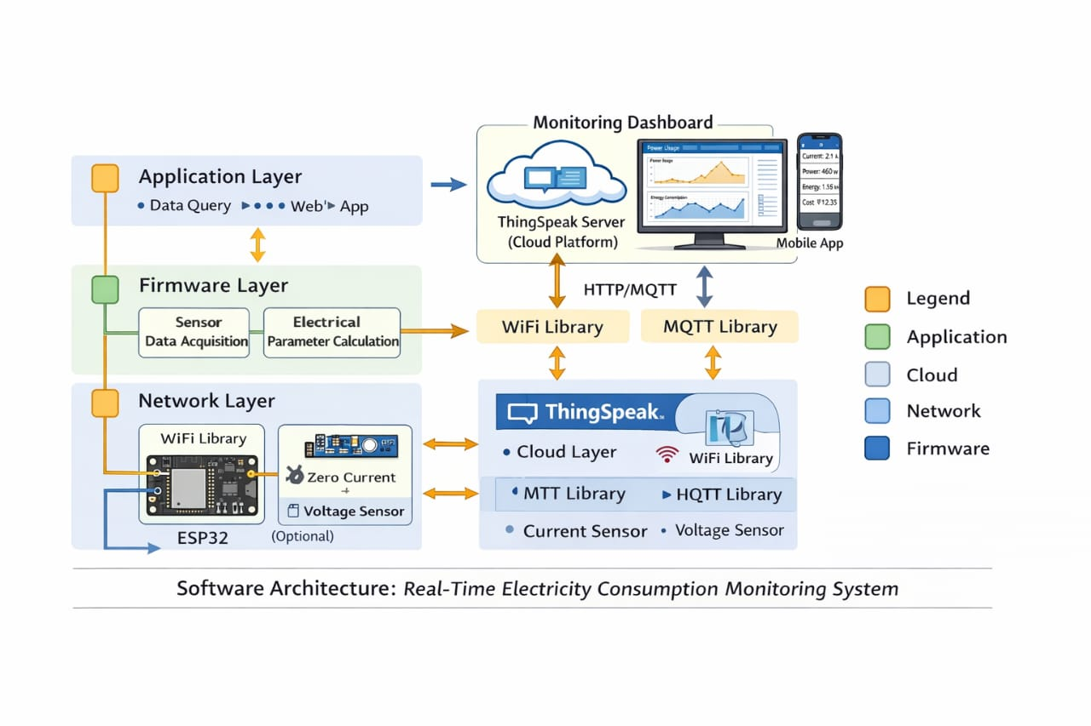
Figure 3.1 : System Architecture

Cloud and User Interface Layer
The cloud layer consists of the ThingSpeak IoT platform which stores the data received from the ESP32 microcontroller. ThingSpeak allows users to visualize data through graphs and dashboards.
The web dashboard retrieves data from the ThingSpeak server using API keys. The dashboard displays real-time electricity consumption values and calculates estimated daily, monthly, and yearly energy usage. This layered architecture ensures efficient data flow and enables real-time monitoring of electricity consumption.

3.3 BLOCK DIAGRAM OF THE SYSTEM
The block diagram represents the overall structure of the proposed energy monitoring system.
The main blocks of the system include:
- Power Supply
- Current Sensor (ACS712)
- ESP32 Microcontroller
- Wi-Fi Communication
- ThingSpeak Cloud Platform
- Web Dashboard Interface
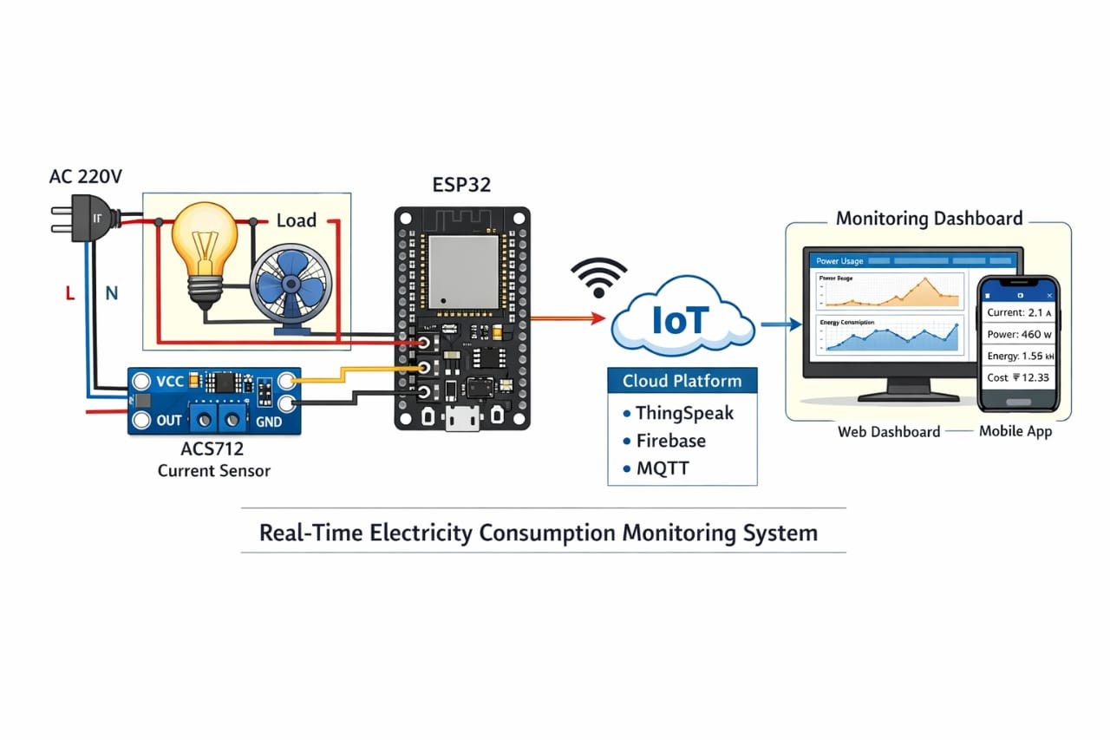 Figure 3.2: Block diagram of the system

The electrical load is connected to the current sensor which measures the current flowing through the circuit. The sensor outputs an analog voltage proportional to the measured current. This analog signal is fed into the ESP32 microcontroller for processing.
The microcontroller processes the sensor data and calculates power consumption. The processed data is transmitted to the ThingSpeak cloud server through Wi-Fi connectivity. The cloud server stores the data and provides visualization tools to display the information in graphical form. Users can access the data through a web dashboard that displays real-time electricity consumption information.

3.4 WORKING PRINCIPLE OF THE SYSTEM
The working principle of the proposed system is based on measuring electrical current and calculating power consumption using a microcontroller. The ACS712 current sensor is placed in series with the electrical load. When current flows through the load, it also flows through the sensor. The sensor detects the magnetic field generated by the flowing current and converts it into an analog voltage signal. The ESP32 microcontroller reads the analog signal from the sensor through its analog input pin. The microcontroller converts the analog voltage into a digital value using its internal analog-to-digital converter.
The digital value is then processed to determine the current flowing through the circuit. Using the measured current and a predefined voltage value (typically 230V for AC systems), the microcontroller calculates the power consumption using the following formula:
Power = Voltage × Current
The calculated power value represents the instantaneous electrical power consumed by the load.
The ESP32 microcontroller then connects to a Wi-Fi network and sends the measured parameters to the ThingSpeak cloud platform using HTTP requests. The data is stored in the cloud and can be visualized through graphs and charts. A web-based dashboard retrieves the data from the cloud server using API keys. The dashboard displays the power consumption along with calculated estimates of daily, monthly, and yearly energy usage. The system continuously repeats this process at regular intervals, allowing real-time monitoring of electricity consumption.

3.5 DATA ACQUISITION PROCESS
Data acquisition is the process of collecting sensor data from the physical environment. In this project, data acquisition involves measuring the electrical current flowing through an electrical load.
The ACS712 current sensor generates an analog voltage output corresponding to the current flowing through the conductor. The output voltage is proportional to the measured current and can be read by the microcontroller.
The ESP32 microcontroller periodically reads the sensor output using its analog input pin. The analog-to-digital converter converts the sensor voltage into a digital value that can be processed by the microcontroller. The sensor detects the magnetic field generated by the flowing current and converts it into an analog voltage signal. The ESP32 microcontroller reads the analog signal from the sensor through its analog input pin. The microcontroller then performs calibration and scaling operations to convert the digital value into a current measurement in amperes. This data acquisition process occurs continuously, ensuring that real-time electricity consumption data is collected and processed by the system.

3.6 DATA PROCESSING
After acquiring the sensor data, the microcontroller performs data processing to calculate meaningful electrical parameters. The analog voltage obtained from the current sensor is first converted into a current value using calibration constants. The microcontroller then calculates the electrical power consumed by the load.
The power calculation is based on the formula:
Power = Voltage × Current
In this project, the system assumes a constant supply voltage of approximately 230 volts. By multiplying the measured current with this voltage value, the system calculates the instantaneous power consumption in watts.
The calculated power value is then formatted into a data packet that can be transmitted to the cloud platform.

3.7 DATA TRANSMISSION USING WIFI
The ESP32 microcontroller has built-in Wi-Fi capabilities that allow it to connect to wireless networks. After processing the sensor data, the ESP32 establishes a connection with the Wi-Fi network.
Once connected to the network, the microcontroller sends the measured data to the ThingSpeak cloud platform using HTTP requests. The data is transmitted using a unique API key associated with the user's ThingSpeak channel.
The transmitted data typically includes:
- Current value
- Voltage value
- Power consumption value
ThingSpeak receives the data and stores it in a cloud database. The stored data can be accessed through web dashboards and graphical charts.

3.8 DATA VISUALIZATION
Data visualization is an important aspect of energy monitoring systems. It allows users to understand electricity consumption patterns through graphical representations. In this project, data visualization is achieved using the ThingSpeak cloud platform and a custom web dashboard.
ThingSpeak provides built-in graphing tools that display real-time data trends. The platform generates line graphs that show variations in current and power consumption over time.
In addition to the cloud platform, a web-based dashboard is developed using HTML, CSS, and JavaScript. The dashboard retrieves data from ThingSpeak using API keys and displays the values in an organized interface. The dashboard also calculates estimated energy usage for different time periods such as daily, monthly, and yearly consumption. These calculations help users understand long-term energy usage patterns.

3.9 SECURITY AND AUTHENTICATION
Security is an important consideration in IoT-based monitoring systems. Since the system transmits data over the internet, it is necessary to ensure that only authorized users can access the data. In this project, authentication is implemented using API keys provided by the ThingSpeak platform. The API key acts as a unique identifier that allows the ESP32 microcontroller to send data to the cloud server.
The web dashboard also requires authentication before displaying energy consumption data. This ensures that only authorized users can access the monitoring interface. Implementing proper security mechanisms helps protect user data and prevents unauthorized access to the monitoring system.

3.10 SUMMARY
This chapter described the system methodology of the proposed IoT-based electricity monitoring system. The architecture of the system includes sensor data acquisition, microcontroller-based data processing, wireless data transmission, cloud storage, and user interface visualization.
The ACS712 current sensor is used to measure electrical current, while the ESP32 microcontroller processes the sensor data and calculates power consumption. The processed data is transmitted to the ThingSpeak cloud platform using Wi-Fi connectivity. By implementing this IoT-based energy monitoring system, users can gain better control over their electricity consumption, reduce energy wastage, and promote efficient energy utilization.
The system provides real-time monitoring of electricity consumption and allows users to access the data through a web-based dashboard. The methodology described in this chapter forms the foundation for implementing the proposed energy monitoring system.

CHAPTER 4

HARDWARE AND SOFTWARE IMPLEMENTATION

4.1 INTRODUCTION
The implementation of the proposed Real-Time Electricity Consumption Monitoring System involves both hardware and software components. The hardware components are responsible for sensing and collecting electrical data, while the software components process the data and transmit it to the cloud platform for visualization.
The main hardware components used in this project include the ESP32 microcontroller, ACS712 current sensor, power supply module, and electrical load. These components work together to measure electrical current and calculate power consumption. The software implementation involves programming the ESP32 microcontroller using the Arduino development environment. The program reads the sensor data, performs necessary calculations, and sends the processed information to the ThingSpeak cloud platform using Wi-Fi connectivity.
In addition to the microcontroller program, a web dashboard is developed using HTML, CSS, and JavaScript. This dashboard retrieves data from the cloud platform and displays the electricity consumption in real time. This chapter explains the hardware components used in the system, the circuit design, the programming logic, and the integration of the IoT cloud platform.

4.2 HARDWARE COMPONENTS
The proposed electricity monitoring system uses several hardware components that enable the measurement and transmission of electrical parameters.
The main hardware components used in the project are:
• ESP32 Microcontroller
• ACS712 Current Sensor
• Power Supply Module
• Electrical Load
• Wi-Fi Network
Each component plays a specific role in the functioning of the energy monitoring system.

4.3 ESP32 MICROCONTROLLER
The ESP32 microcontroller is the main processing unit of the proposed system. It is a low-cost, high-performance microcontroller developed by Espressif Systems and widely used in Internet of Things applications. The ESP32 offers several advanced features that make it suitable for IoT-based projects. It includes built-in Wi-Fi and Bluetooth connectivity, which allows it to communicate with cloud platforms and other devices without requiring additional communication modules.
The ESP32 contains multiple input and output pins that allow it to interface with sensors, actuators, and other electronic components. It also includes an analog-to-digital converter (ADC) that can read analog signals from sensors such as the ACS712 current sensor.
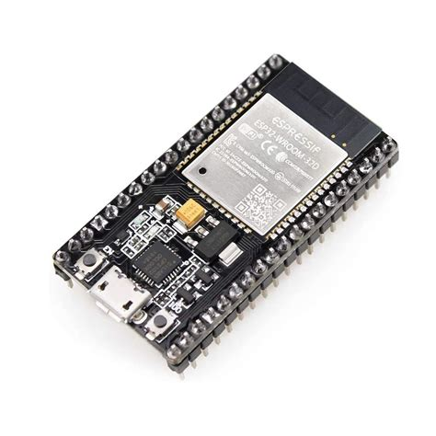 Figure 4.1:ESP32 Microcontroller
Some of the key features of the ESP32 microcontroller include:
• Dual-core processor with high processing speed
• Built-in Wi-Fi and Bluetooth communication
• Multiple analog and digital input/output pins
• Low power consumption
• Support for various communication protocols
• Compatibility with Arduino programming environment
In this project, the ESP32 performs several important tasks. It reads the analog signal from the ACS712 current sensor, processes the data to determine the current flowing through the load, calculates the corresponding power consumption, and transmits the measured data to the ThingSpeak cloud platform using Wi-Fi connectivity.
The ESP32 acts as the central controller of the system and coordinates all operations involved in data acquisition, processing, and communication.

4.4 ACS712 CURRENT SENSOR
The ACS712 is a Hall-effect based current sensor used for measuring electrical current in electronic circuits. It is capable of measuring both alternating current (AC) and direct current (DC).
The sensor works based on the Hall-effect principle. When current flows through a conductor, it generates a magnetic field around the conductor. The ACS712 sensor detects this magnetic field and converts it into a proportional voltage output.
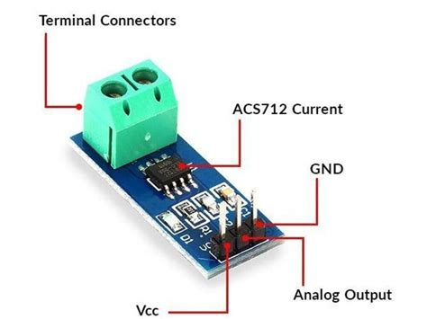 Figure 4.2:current sensor
This voltage output is an analog signal that can be read by a microcontroller using an analog input pin.
The ACS712 sensor offers several advantages that make it suitable for energy monitoring applications:
• High accuracy in current measurement
• Electrical isolation between sensing circuit and load circuit
• Ability to measure both AC and DC currents
• Compact size and easy interfacing with microcontrollers
• Low cost and wide availability
In this project, the ACS712 sensor is connected in series with the electrical load. When current flows through the load, it passes through the sensor and generates a voltage output proportional to the measured current. This output voltage is read by the ESP32 microcontroller and used to calculate the current value.

4.5 POWER SUPPLY
A stable power supply is required for the proper operation of the microcontroller and sensor components. The ESP32 typically operates at a voltage of 3.3V or 5V depending on the board configuration.
The power supply module converts the input electrical power into a regulated voltage suitable for the electronic components used in the system. A voltage regulator may be used to ensure a constant voltage supply. Providing a stable power supply is essential for accurate sensor readings and reliable system operation.

4.6 CIRCUIT DESIGN
The circuit design of the proposed energy monitoring system involves connecting the ACS712 current sensor to the ESP32 microcontroller. The current sensor is placed in series with the electrical load so that the current flowing through the load also flows through the sensor. The sensor output pin is connected to one of the analog input pins of the ESP32 microcontroller. The ESP32 reads the analog signal generated by the sensor and converts it into a digital value using its analog-to-digital converter.
The microcontroller is also connected to a Wi-Fi network, which allows it to transmit the measured data to the ThingSpeak cloud platform. The circuit design ensures that the sensor accurately measures the current flowing through the load while maintaining electrical isolation between the sensing circuit and the load circuit.
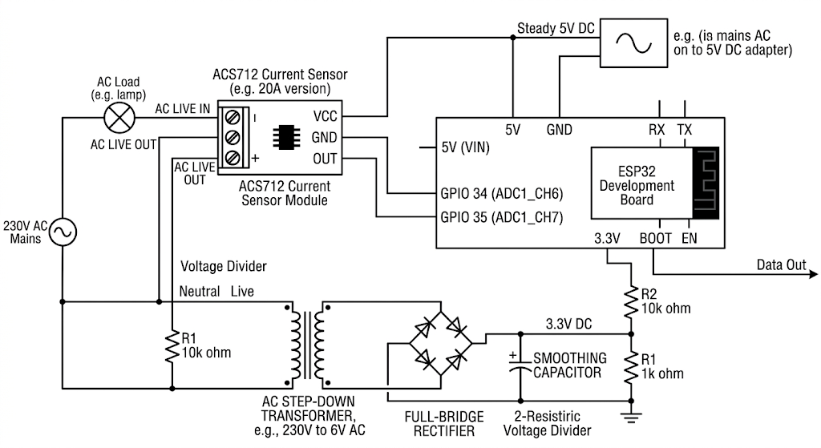 Figure 1
Figure 4.3 : circuit diagram

4.7 SOFTWARE IMPLEMENTATION
The software implementation of the system involves programming the ESP32 microcontroller using the Arduino development environment. The Arduino IDE provides a user-friendly interface for writing, compiling, and uploading programs to microcontrollers. It also provides libraries that simplify communication with sensors and cloud platforms.
The ESP32 program performs the following tasks:
- Initialize the microcontroller and configure the input/output pins.
- Establish a Wi-Fi connection with the available network.
- Read the analog signal from the ACS712 current sensor.
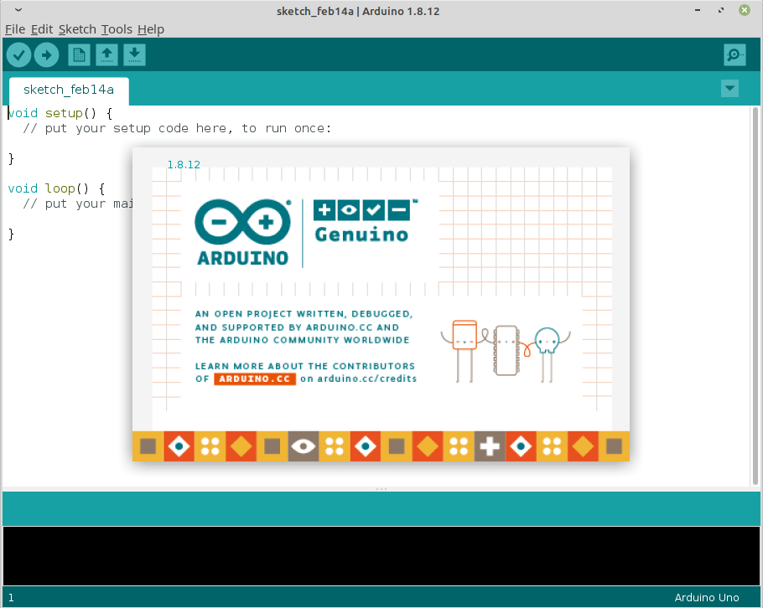 Figure 2
- Convert the analog signal into a current measurement.
- Calculate the power consumption using the measured current.
- Format the data and transmit it to the ThingSpeak cloud platform.
This continuous process allows the system to monitor electricity consumption in real time.
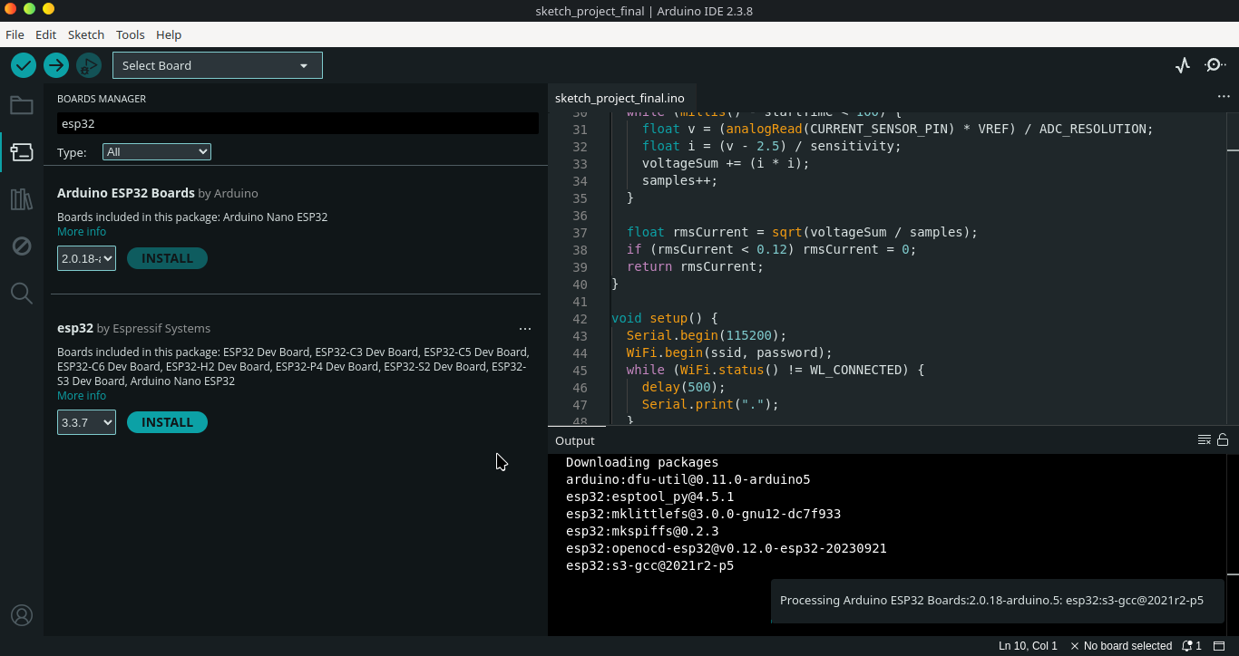 Figure 4.4. : Arduino sketch

4.8 THINGSPEAK CLOUD INTEGRATION
ThingSpeak is an IoT analytics platform used for collecting, storing, and analyzing data from connected devices. It provides an easy way to visualize sensor data using charts and graphs. In this project, the ESP32 microcontroller sends electricity consumption data to the ThingSpeak platform using HTTP requests. Each user creates a channel on ThingSpeak where the sensor data is stored. The channel includes fields for different parameters such as current, voltage, and power.
To send data to the channel, the ESP32 uses a unique API key provided by ThingSpeak. This API key ensures that the data is securely transmitted and stored in the correct channel.
Once the data is stored in the cloud, ThingSpeak automatically generates graphical charts that display variations in electricity consumption over time. These charts allow users to monitor their energy usage patterns and analyze changes in electricity consumption.

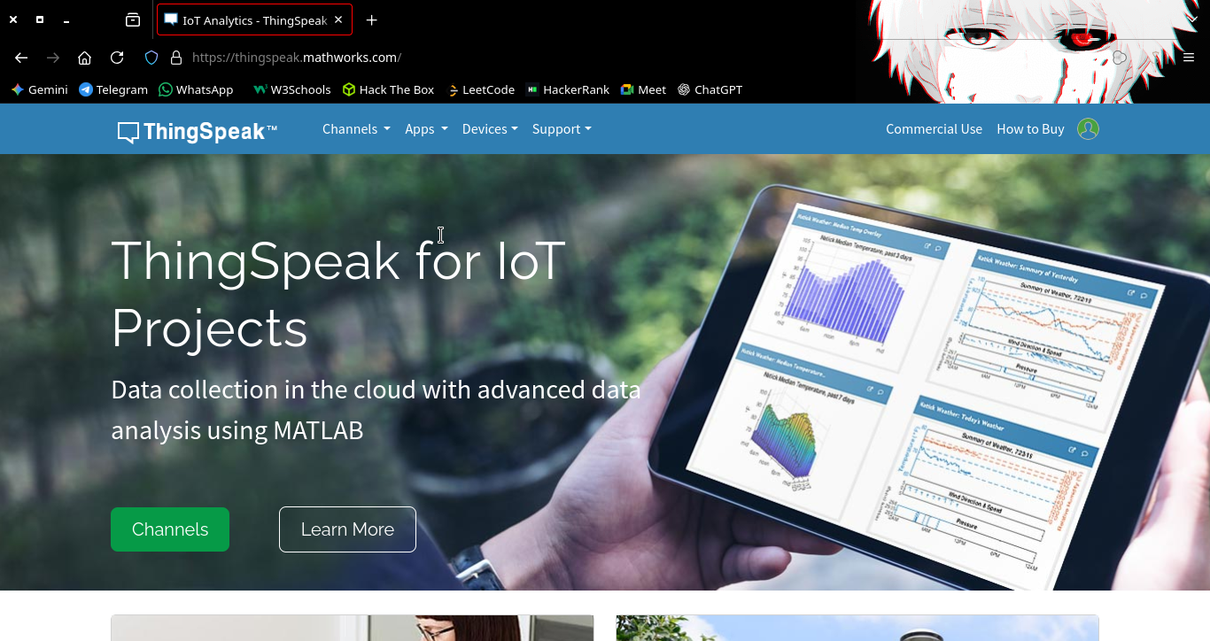
Figure 4.5 : Thinkspeak cloud
4.9 WEB DASHBOARD IMPLEMENTATION
A web dashboard is developed to display electricity consumption data in an easy-to-understand format. The dashboard is created using web technologies such as HTML, CSS, and JavaScript.
The dashboard retrieves data from the ThingSpeak platform using API requests. The retrieved data is then displayed as numerical values and graphical charts.
The web dashboard provides several features including:
• Real-time display of current electricity consumption
• Visualization of energy usage trends
• Calculation of daily, monthly, and yearly electricity consumption
• Secure login authentication for authorized access
The dashboard interface allows users to monitor electricity usage from any device connected to the internet.

4.10 SYSTEM OPERATION
The operation of the system begins when the ESP32 microcontroller is powered on. The microcontroller initializes the hardware components and establishes a connection with the Wi-Fi network. The ACS712 sensor continuously measures the electrical current flowing through the load. The analog output from the sensor is read by the ESP32 microcontroller.
The microcontroller processes the sensor data and calculates the power consumption using predefined voltage values. After calculating the power value, the ESP32 sends the data to the ThingSpeak cloud platform through the internet.
The web dashboard retrieves the stored data from ThingSpeak and displays it in real time. Users can view their electricity consumption through graphs and numerical displays.
The entire process repeats periodically, ensuring continuous monitoring of electricity usage.

4.11 WEB DASHBOARD DESIGN AND IMPLEMENTATION

4.11.1 INTRODUCTION
In addition to the hardware-based electricity monitoring system, a web-based dashboard was developed to display the electricity consumption data in real time. The dashboard provides a graphical interface through which users can monitor electrical parameters such as power consumption, voltage, and current. The dashboard retrieves sensor data from the cloud platform and presents it in a structured and user-friendly format. This allows users to easily understand their electricity consumption patterns and monitor energy usage remotely.
The web dashboard was developed using standard web technologies including HTML (HyperText Markup Language), CSS (Cascading Style Sheets), and JavaScript. These technologies enable the creation of dynamic and interactive web applications that can communicate with IoT cloud platforms.
The dashboard communicates with the ThingSpeak cloud server using HTTP requests and retrieves the latest sensor data using the ThingSpeak API. The web dashboard consists of several major components including the authentication interface, dashboard layout, energy display cards, energy estimation module, and logout functionality.

4.11.2 SYSTEM ARCHITECTURE OF THE DASHBOARD
The web dashboard operates as part of the IoT system architecture. The overall data flow between the hardware device, cloud platform, and dashboard is illustrated below.
- The ESP32 microcontroller collects current sensor data.
- The microcontroller calculates power consumption.
- The ESP32 sends the data to the ThingSpeak cloud platform.
- The web dashboard retrieves the stored data from the ThingSpeak server.
- The dashboard displays the data in real time to the user.
This architecture ensures that electricity consumption data can be accessed remotely from any device connected to the internet. The cloud platform acts as an intermediary storage system that allows both the microcontroller and the web dashboard to exchange information efficiently.

4.11.3 HTML STRUCTURE OF THE DASHBOARD
HTML is used to create the structural layout of the dashboard interface. It defines the elements that appear on the webpage such as input fields, buttons, cards, and text elements.
The dashboard page consists of two major sections:
- Authentication Interface
- Energy Monitoring Dashboard
The authentication interface ensures that only authorized users can access the energy monitoring data.
The dashboard section displays the electricity consumption information retrieved from the cloud server.
The HTML structure organizes these elements into containers and cards, which improves readability and user experience.

4.11.4 AUTHENTICATION INTERFACE
The authentication interface acts as a login system that protects access to the energy monitoring dashboard. The login system requires the user to enter a ThingSpeak Read API Key before accessing the dashboard.
The login page contains the following components:
• Title indicating device login
• Input field for entering the API key
• Access button
• Error message display
When the user enters the API key and presses the access button, the dashboard verifies whether the key is valid by sending a request to the ThingSpeak API. If the API key is correct, the user is granted access to the monitoring dashboard.
If the key is incorrect, the system displays an error message indicating that access is denied.
This authentication mechanism ensures that only authorized users can view the energy consumption data.

4.11.5 CSS DESIGN AND USER INTERFACE
CSS is used to design the visual appearance of the dashboard. It controls elements such as colors, fonts, layout, spacing, and animations.
The dashboard uses a modern dark-themed interface that improves readability and visual clarity.
The color scheme used in the dashboard includes:
• Dark background color for the main interface
• Light text color for readability
• Blue accent color for highlighting important values
The dashboard layout uses responsive grid design, which automatically adjusts the layout depending on the screen size. This allows the dashboard to work properly on devices such as laptops, tablets, and smartphones.
Each electrical parameter is displayed inside a card-style container that includes:
• Parameter name
• Measurement value
• Unit of measurement
The card layout improves visual organization and makes the data easier to interpret.

4.11.6 DASHBOARD DISPLAY COMPONENTS
The main dashboard interface displays several energy parameters retrieved from the ThingSpeak cloud platform.
The displayed parameters include:

Power Consumption
This value represents the electrical power consumed by the connected load. The power value is displayed in kilowatts (kW).
The power value is retrieved from Field 1 of the ThingSpeak channel.

Line Voltage
The voltage value represents the electrical supply voltage used in the system. In this project, the voltage is assumed to be approximately 230V.
The voltage value is retrieved from Field 2 of the ThingSpeak channel.

Current Measurement
The current value represents the electrical current flowing through the load. It is measured using the ACS712 current sensor.
The current value is retrieved from Field 3 of the ThingSpeak channel.
These three parameters form the core energy monitoring data displayed by the dashboard.

4.11.7 ENERGY CONSUMPTION ESTIMATION
In addition to displaying real-time electrical parameters, the dashboard also calculates estimated energy consumption values.
These estimates help users understand their electricity usage over longer periods.
The dashboard calculates the following estimates:

Daily Energy Consumption
Daily energy consumption is estimated using the formula:
Energy (kWh) = Power (kW) × 24 hours
This calculation estimates how much electricity will be consumed if the current power usage remains constant for an entire day.

Monthly Energy Consumption
Monthly energy usage is estimated by multiplying the daily consumption value by 30 days.
Monthly Energy = Power × 24 × 30
This estimate helps users predict their monthly electricity consumption.

Yearly Energy Consumption
Yearly energy usage is calculated using the formula:
Yearly Energy = Power × 24 × 365
This estimate provides an approximation of annual electricity consumption.
These projections allow users to better understand their energy usage and anticipate electricity costs.

4.11.8 JAVASCRIPT DATA FETCHING
JavaScript is used to retrieve sensor data from the ThingSpeak cloud platform.
The dashboard sends a request to the ThingSpeak API using the following URL format:

https://api.thingspeak.com/channels/{channelID}/feeds/last.json

This request retrieves the most recent sensor data stored in the ThingSpeak channel.
The JavaScript program then extracts the following values:
• Power value (Field 1)
• Voltage value (Field 2)
• Current value (Field 3)
The retrieved values are then displayed dynamically on the dashboard.

4.11.9 REAL TIME DATA UPDATE
To ensure continuous monitoring, the dashboard refreshes the data automatically at regular intervals. The system updates the displayed values every 15 seconds using a JavaScript timer function.
This periodic update ensures that users always see the latest electricity consumption data.
Automatic refresh eliminates the need for manual page reloads.

4.11.10 LOGOUT FUNCTION
The dashboard includes a logout option that allows users to exit the monitoring system. When the logout option is selected, the webpage reloads and returns to the authentication interface.
This feature provides an additional layer of security by preventing unauthorized users from accessing the dashboard after the session ends.

4.11.11 ADVANTAGES OF THE DASHBOARD
The developed web dashboard provides several advantages for electricity monitoring applications. One of the main advantages is real-time visualization of energy consumption. Users can instantly view electricity usage through an intuitive interface Another advantage is remote accessibility. Since the dashboard is web-based, users can monitor their energy consumption from any device connected to the internet. The dashboard also provides energy consumption projections, which help users understand long-term electricity usage patterns.
Additionally, the authentication system ensures that only authorized users can access the monitoring interface.

4.11.12 SUMMARY
The web dashboard plays a crucial role in the Real-Time Electricity Consumption Monitoring System. It provides a user-friendly interface that allows users to view electricity consumption data retrieved from the ThingSpeak cloud platform. The dashboard displays real-time power, voltage, and current values, along with estimated daily, monthly, and yearly energy usage. The system uses HTML, CSS, and JavaScript to create an interactive and visually appealing interface.
The integration of the web dashboard with the IoT-based energy monitoring system enables efficient remote monitoring and analysis of electricity consumption patterns.

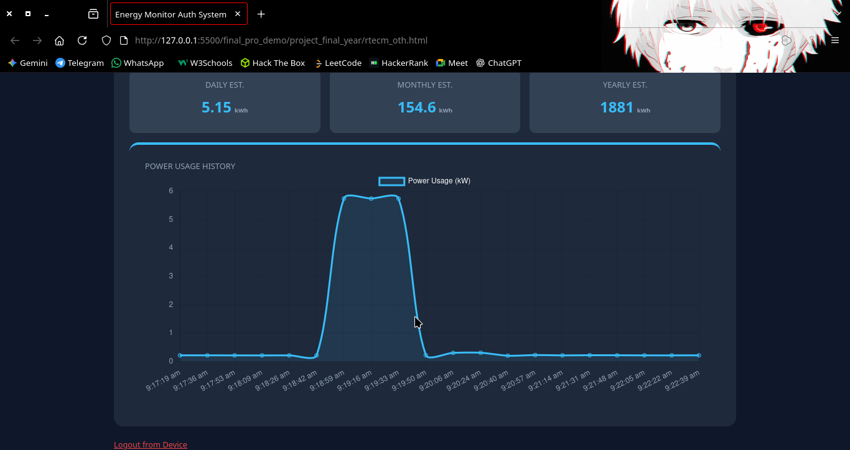
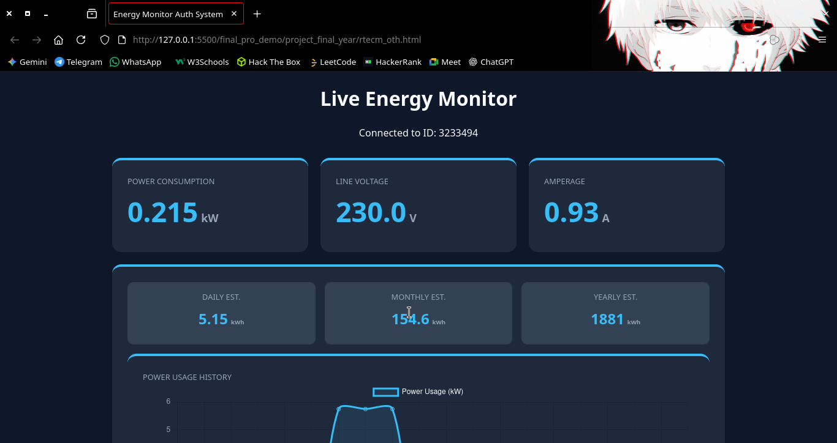
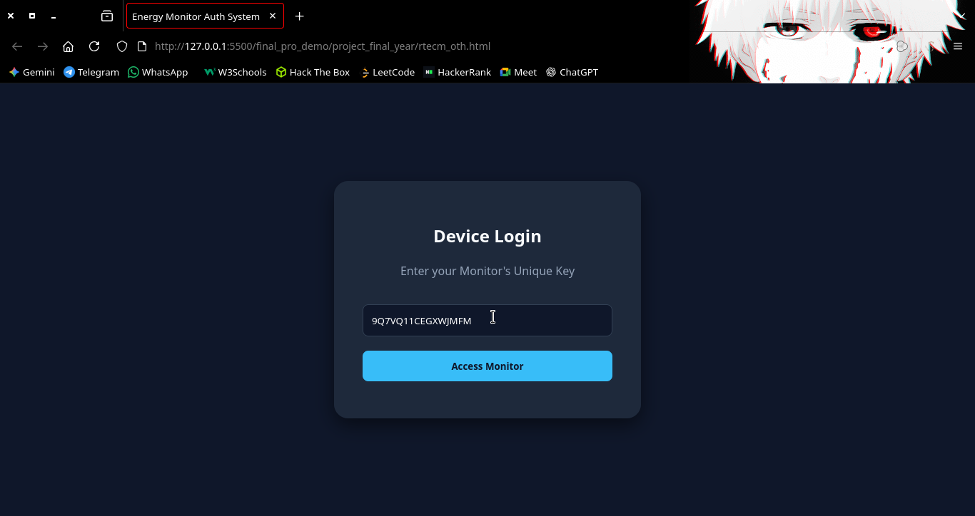
Fig 4.6 : Web Dashboard Output

CHAPTER 5

RESULTS AND DISCUSSION

5.1 INTRODUCTION
This chapter presents the results obtained from the implementation of the Real-Time Electricity Consumption Monitoring System using IoT. The performance of the system was evaluated by monitoring electrical parameters such as current and power consumption in real time. The collected data was transmitted to the cloud platform and displayed through graphical dashboards.
The objective of the experimental analysis was to verify the accuracy and reliability of the proposed energy monitoring system. Various tests were conducted to observe how the system measures electrical current, calculates power consumption, and transmits the data to the ThingSpeak cloud platform.
The system successfully monitored electricity consumption and displayed the data in real time through a web-based dashboard. The results obtained demonstrate the effectiveness of the proposed system in monitoring electrical energy usage.

5.2 EXPERIMENTAL SETUP
The experimental setup consists of the ESP32 microcontroller, ACS712 current sensor, electrical load, and a Wi-Fi network connection. The current sensor is connected in series with the load so that the current flowing through the load passes through the sensor.
The ESP32 microcontroller reads the analog signal from the current sensor and processes the data to calculate the current and power consumption values. The microcontroller then connects to the Wi-Fi network and transmits the measured values to the ThingSpeak cloud platform.
A web-based dashboard is used to display the real-time electricity consumption data retrieved from the cloud server. The dashboard shows parameters such as voltage, current, and power consumption. The experimental setup allows the system to continuously monitor electrical energy usage and provide real-time insights into electricity consumption patterns.

5.3 SERIAL MONITOR OUTPUT
During the testing phase, the Arduino Serial Monitor was used to verify the sensor readings and system performance. The ESP32 microcontroller prints the measured current and calculated power values to the serial monitor.
The serial monitor displays data in the following format:
Current: 0.45 A
Voltage: 230 V
Power: 103.5 W
These values update periodically as the system continues to measure the electrical current flowing through the load. The serial monitor output confirms that the ESP32 microcontroller successfully reads the sensor data and performs the necessary calculations for power consumption.
The serial monitor also helps in debugging and verifying the proper operation of the program during the development stage.

5.4 THINGSPEAK CLOUD DATA
The ThingSpeak platform is used to store and visualize the electricity consumption data transmitted by the ESP32 microcontroller. Each data transmission from the microcontroller updates the corresponding fields in the ThingSpeak channel.
The platform automatically generates graphical charts that display the variation of electrical parameters over time. These graphs allow users to observe trends in electricity consumption and analyze energy usage patterns.
The ThingSpeak charts typically include:
• Current vs Time
• Power vs Time
• Voltage vs Time
These graphical representations help users understand how electricity consumption changes during different time periods.
The cloud-based data storage ensures that the energy consumption data can be accessed from any location with internet connectivity.

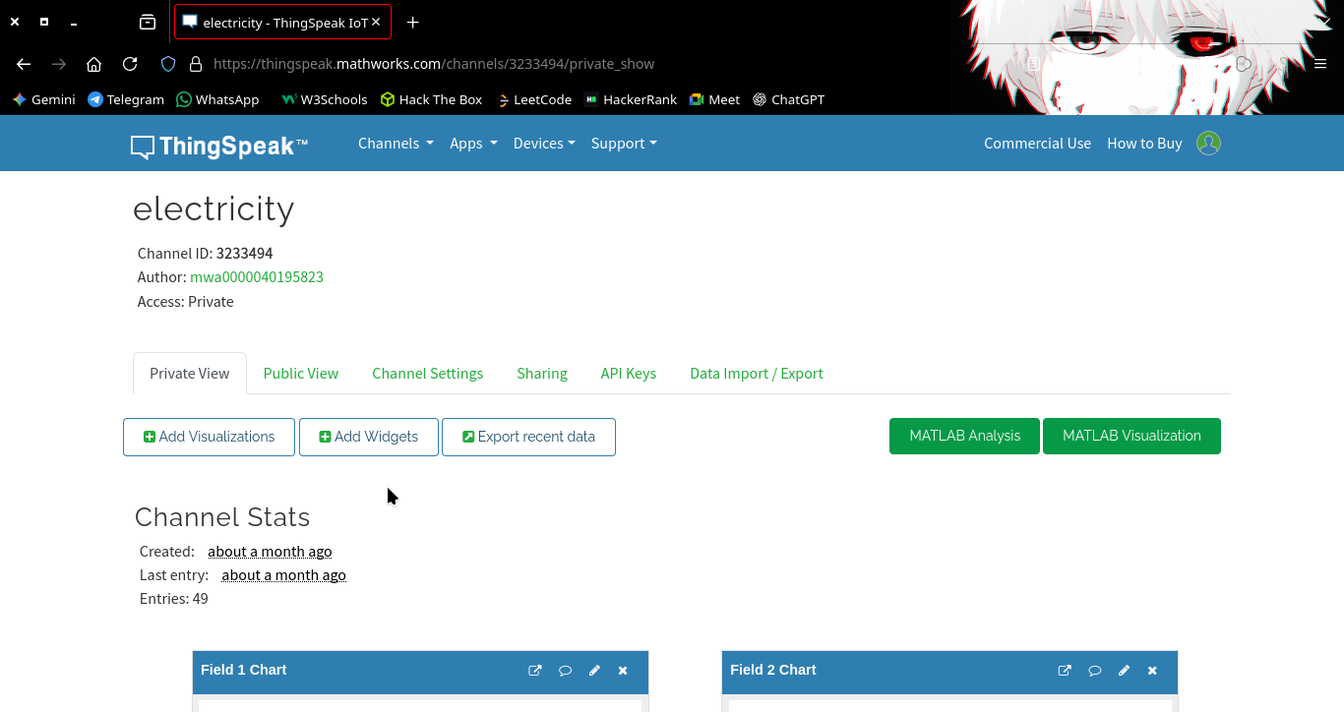

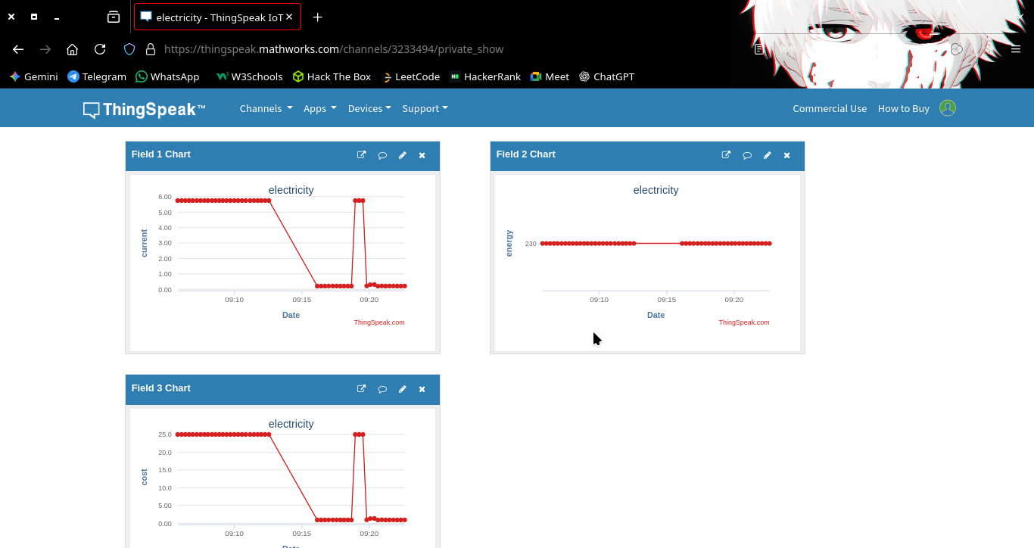

Figure5.1 : Thinkspeak Dashboard

5.5 .WEB DASHBOARD OUTPUT
A web-based dashboard was developed to provide an interactive interface for monitoring electricity consumption. The dashboard retrieves the stored data from the ThingSpeak cloud platform using API keys.
The dashboard displays several parameters including:
• Real-time current measurement
• Power consumption value
• Estimated daily electricity usage
• Estimated monthly electricity usage
• Estimated yearly electricity usage
The dashboard interface is designed to be simple and user-friendly. Users can log in to the dashboard and view the energy consumption information in real time. The dashboard also calculates long-term energy usage estimates based on the measured power values. These estimates help users understand their electricity consumption over extended periods of time.

5.6 SYSTEM PERFORMANCE ANALYSIS
The proposed system demonstrates reliable performance in monitoring electricity consumption. The ACS712 current sensor accurately measures the electrical current flowing through the load, and the ESP32 microcontroller successfully processes the sensor data. The Wi-Fi connectivity of the ESP32 allows seamless transmission of data to the ThingSpeak cloud platform. The data transmission process occurs at regular intervals, ensuring continuous monitoring of electricity usage.
The cloud platform provides reliable data storage and visualization capabilities. The generated graphs allow users to analyze energy consumption trends and identify periods of high electricity usage.
Overall, the system performs efficiently in real-time electricity monitoring and provides valuable insights into energy consumption patterns.

5.7 ADVANTAGES OF THE PROPOSED SYSTEM
The proposed IoT-based electricity monitoring system provides several advantages. One of the major advantages is real-time monitoring. Users can observe electricity consumption instantly instead of waiting for monthly electricity bills.
Another advantage is remote accessibility. Since the system uses internet connectivity, users can monitor their electricity usage from anywhere using a web dashboard. The system also promotes energy conservation by providing detailed information about energy consumption patterns. Users can identify appliances that consume excessive power and take steps to reduce unnecessary energy usage. Additionally, the system is cost-effective and easy to implement. The hardware components used in the project are affordable and widely available.

5.8 LIMITATIONS OF THE SYSTEM
Although the proposed system performs effectively, it has certain limitations. One limitation is the assumption of a constant voltage value when calculating power consumption. In real electrical systems, voltage may vary slightly, which can affect the accuracy of power calculations. Another limitation is that the system measures current using a single sensor, which may not capture the complete energy usage of complex electrical systems.
The system also depends on Wi-Fi connectivity for data transmission. If the internet connection is unavailable, the system cannot send data to the cloud platform. These limitations can be addressed in future improvements by incorporating additional sensors and advanced measurement techniques.

5.9 SUMMARY
This chapter presented the results obtained from the implementation of the IoT-based electricity monitoring system. The experimental results demonstrate that the system successfully measures electrical current, calculates power consumption, and transmits the data to the ThingSpeak cloud platform.
The web dashboard provides an effective interface for visualizing electricity consumption data. The results confirm that the proposed system is capable of monitoring electricity usage in real time and providing valuable insights into energy consumption patterns.

CHAPTER 6

CONCLUSION AND FUTURE WORK

6.1 CONCLUSION
The Real-Time Electricity Consumption Monitoring System using IoT was successfully designed and implemented in this project. The system utilizes an ESP32 microcontroller and ACS712 current sensor to measure electrical current and calculate power consumption. The ESP32 microcontroller processes the sensor data and transmits it to the ThingSpeak cloud platform using Wi-Fi connectivity. The collected data is stored in the cloud and displayed through graphical charts and a web-based dashboard.
The proposed system enables users to monitor electricity consumption in real time and analyze their energy usage patterns. This helps users identify inefficient appliances and reduce unnecessary electricity consumption. The system demonstrates how IoT technology can be effectively used for energy monitoring applications. By integrating sensors, microcontrollers, cloud platforms, and web interfaces, the system provides a cost-effective and efficient solution for monitoring electricity consumption.
The successful implementation of the proposed system highlights the potential of IoT-based technologies in improving energy management and promoting energy conservation.

6.2 FUTURE WORK
Although the proposed system provides an effective solution for real-time electricity monitoring, several improvements can be implemented in the future to enhance its functionality. One possible improvement is the integration of voltage sensors to measure voltage variations more accurately. This would allow the system to calculate power consumption with greater precision.
Another enhancement would be the development of a mobile application that allows users to monitor electricity consumption through smartphones. The system can also be extended to support multiple sensors for monitoring energy usage in different rooms or appliances within a building.

Advanced features such as automated alerts and notifications can be implemented to notify users when electricity consumption exceeds predefined limits. Machine learning techniques can also be applied to analyze historical energy consumption data and predict future energy usage patterns.
This helps users identify inefficient appliances and reduce unnecessary electricity consumption. The system demonstrates how IoT technology can be effectively used for energy monitoring applications. These improvements would make the system more powerful and suitable for large-scale energy management applications.

REFERENCES
You can include references like this:
- Arduino Official Documentation.
- Allegro Microsystems, ACS712 Current Sensor Datasheet.
- Espressif Systems, ESP32 Technical Reference Manual.
- Raj Kamal, Internet of Things: Architecture and Design Principles, McGraw Hill Education.
- ThingSpeak Documentation, IoT Analytics Platform.
- Vijay Madisetti and Arshdeep Bahga, Internet of Things: A Hands-On Approach, Universities Press.

APPENDIX A
ARDUINO PROGRAM CODE

// Real-Time Electricity Consumption Monitoring using ESP32
// Hardware: ESP32 + ACS712 Current Sensor
// Cloud Platform: ThingSpeak
#include <WiFi.h>
#include <ThingSpeak.h>
// Wi-Fi Credentials
const char* ssid = "YOUR_WIFI_NAME";
const char* password = "YOUR_WIFI_PASSWORD";
// ThingSpeak Configuration
unsigned long channelID = 3233494;
const char* writeAPIKey = "YOUR_WRITE_API_KEY";
WiFiClient client;
// Sensor Configuration
#define CURRENT_SENSOR_PIN 34
#define ADC_RESOLUTION 4095.0
#define VREF 3.3
float getSampledCurrent() {
float voltageSum = 0;
int samples = 0;
unsigned long startTime = millis();
while (millis() - startTime < 100) {
float voltage = (analogRead(CURRENT_SENSOR_PIN) * VREF) / ADC_RESOLUTION;
float current = (voltage - 2.5) / sensitivity;
voltageSum += current * current;
samples++;
}
float rmsCurrent = sqrt(voltageSum / samples);
return rmsCurrent;}
void setup() {
Serial.begin(115200);
WiFi.begin(ssid, password);
while (WiFi.status() != WL_CONNECTED) {
delay(500);
Serial.print(".");
}
Serial.println("\nWiFi Connected");
ThingSpeak.begin(client);
}
void loop() {
float current = getSampledCurrent();
float powerKW = (voltageAC * current) / 1000.0;
Serial.print("Current: ");
Serial.println(current);
Serial.print("Power (kW): ");
Serial.println(powerKW);
ThingSpeak.setField(1, powerKW);
ThingSpeak.setField(2, voltageAC);
ThingSpeak.setField(3, current);
ThingSpeak.writeFields(channelID, writeAPIKey);
delay(15000); // ThingSpeak update interval
}

APPENDIX B

WEB DASHBOARD CODE

<!DOCTYPE html>
<html>
<head>
<title>Energy Monitor</title>
<script src="https://cdn.jsdelivr.net/npm/chart.js"></script>
</head>
<body>
<h2>Electricity Monitoring</h2>
<p>Power: <span id="power">0</span> kW</p>
<canvas id="chart" width="400" height="200"></canvas>
<script>
let chart;
const channelID = "3233494";
const apiKey = "YOUR_READ_API_KEY";
function initChart(){
const ctx = document.getElementById('chart').getContext('2d');
chart = new Chart(ctx,{
type:'line',
data:{
labels:[],
datasets:[{
label:'Power',
data:[],
borderColor:'blue'
}]
}
});
}
async function getData(){
const res = await fetch(
`https://api.thingspeak.com/channels/${channelID}/feeds/last.json?api_key=${apiKey}`
);
const data = await res.json();
let power = parseFloat(data.field1) || 0;
document.getElementById("power").innerText = power;
chart.data.labels.push(new Date().toLocaleTimeString());
chart.data.datasets[0].data.push(power);
if(chart.data.labels.length > 10){
chart.data.labels.shift();
chart.data.datasets[0].data.shift();
}
chart.update();
}
initChart();
setInterval(getData, 15000);
</script>
</body>
</html>

