Predicting Accuracy of Players in the Cricket using Machine Learning

In this project you asked us to implement Hidden Markov Model (HMM) to predict cricket player accuracy in terms of performance. For batsman we have user various performance data like

‘player name’, 'runs_x', 'balls', 'strike_rate', 'fours', 'sixes', 'how_out', 'run_rate'

For ballers we have used input features like

'player name', 'run_conceded', 'maidens', 'wickets', 'overs', 'economy', 'wides', 'no_balls', 'fours', 'sixes', 'zeros', 'runs', 'over', 'run_rate'

So by using above input for batsman HMM will rank each player on scale 1 to 10 where best performer will get high rank and worst performer will get low rank or accuracy. Same will be happen for baller.

To train HMM algorithm we are using below dataset downloaded from KAGGLE

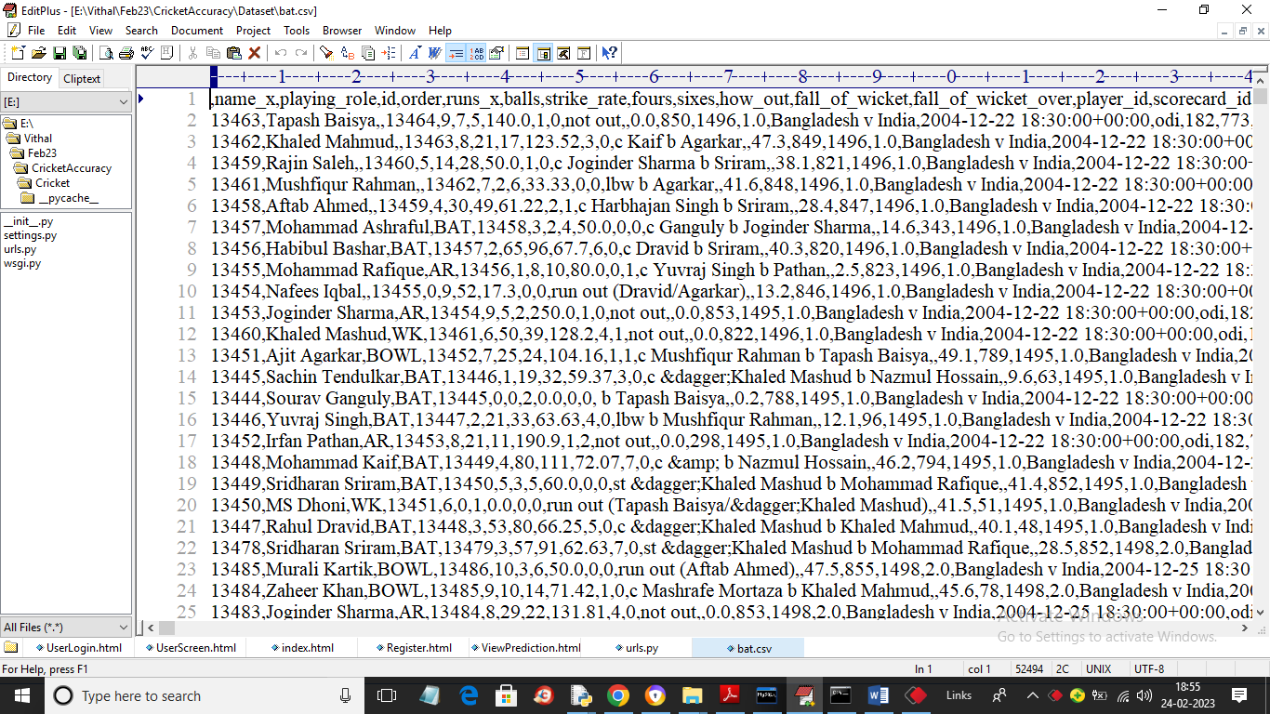

In above dataset screen first row contains dataset column names and remaining rows contains dataset values and you can download both baller and batsman dataset from below URL

<https://www.kaggle.com/datasets/akarshsinghh/cricket-player-performance-prediction>

So by using above Batsman and Ballers dataset we will train HMM model and after training either coach or captain can signup and login to system and then can predict top 15 ballers or batsman.

To run project first create database in MYSQL by copying content from DB.txt file and paste in MYSQL and then double click on ‘run.bat’ file to start python server and get below output

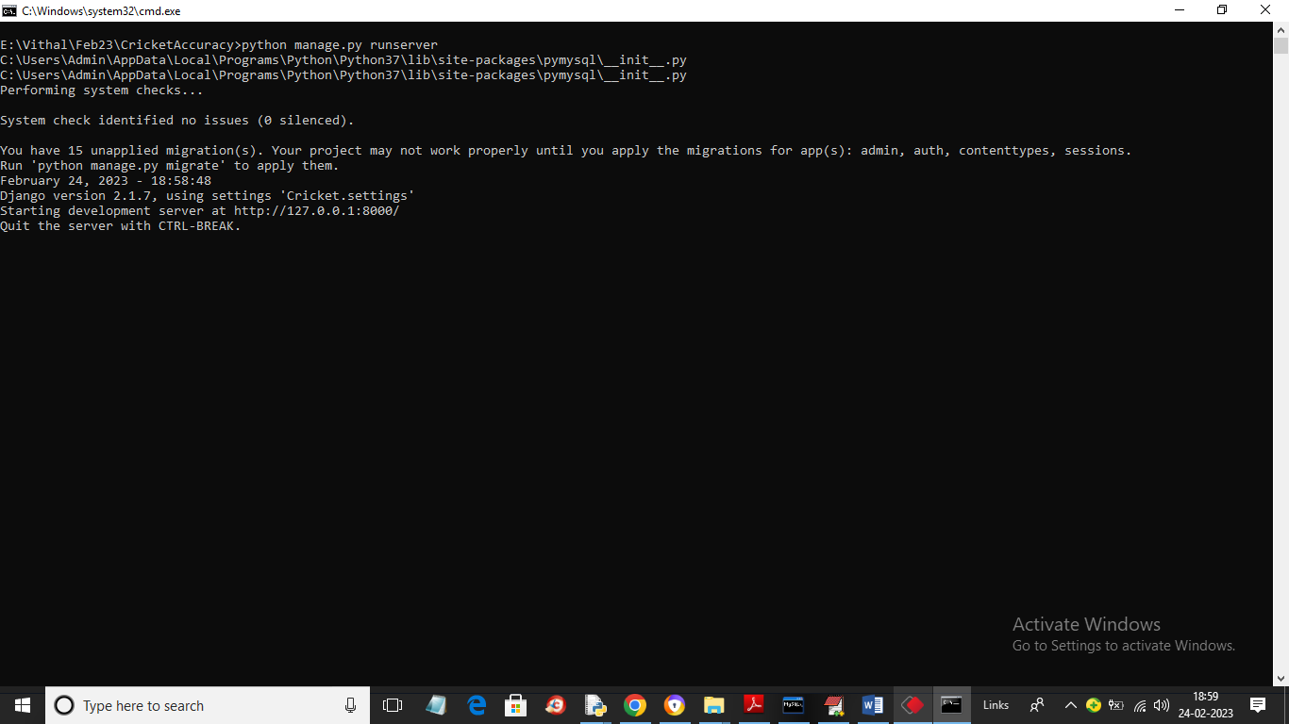

In above screen python server started and now open browser and enter URL as ‘http://127.0.0.1:8000/index.html’ and press enter key to get below page

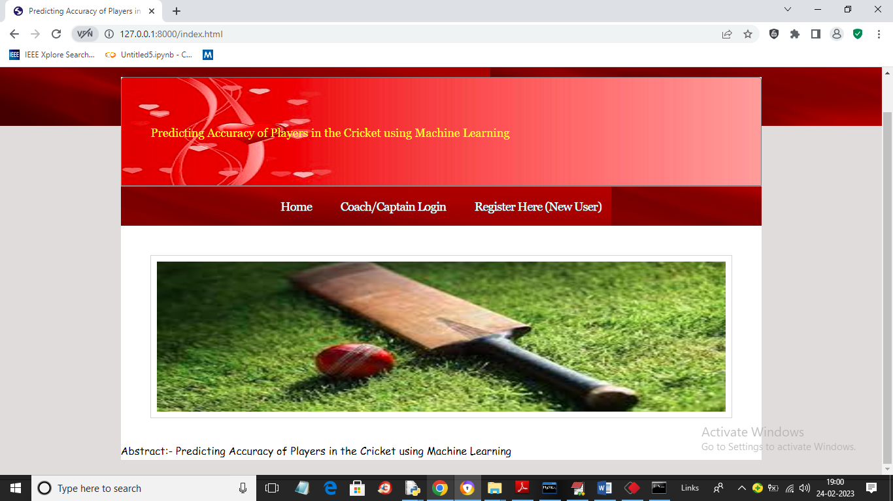

In above screen click on ‘Register Here’ link to signup user

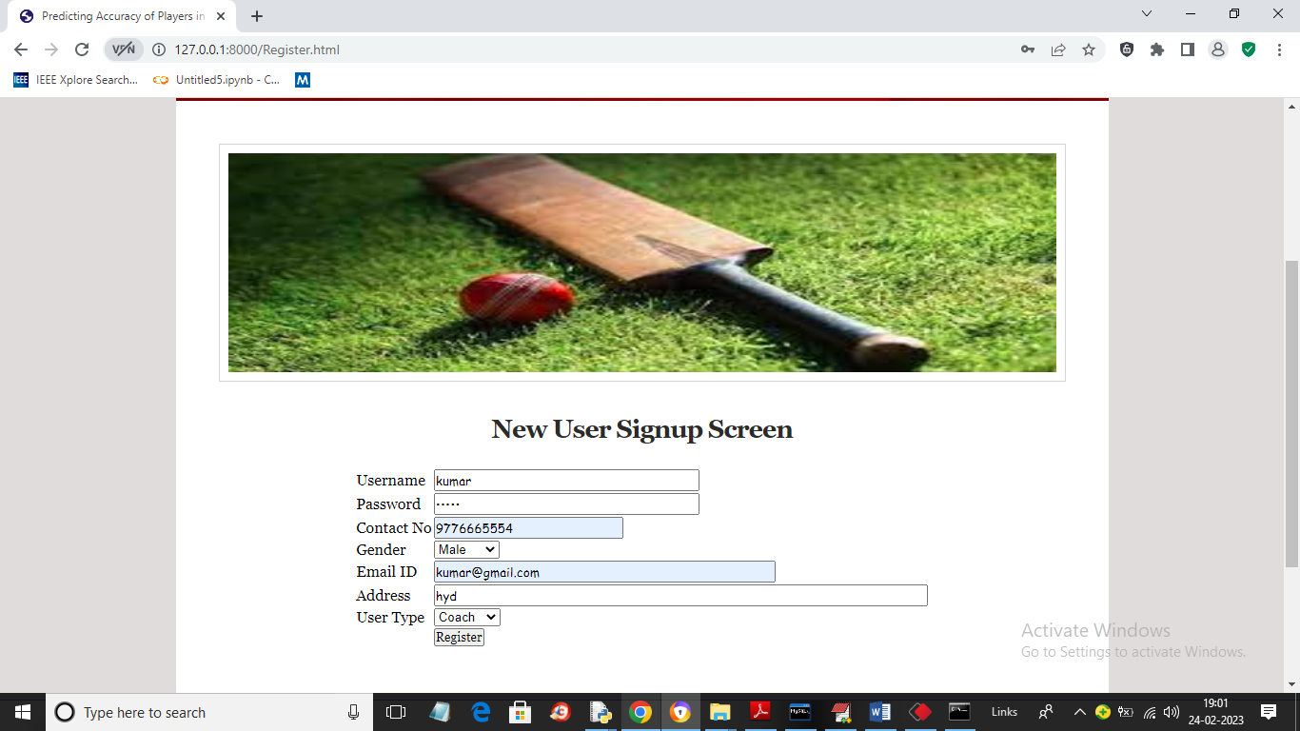

In above screen user is signing up and after pressing button will get below output

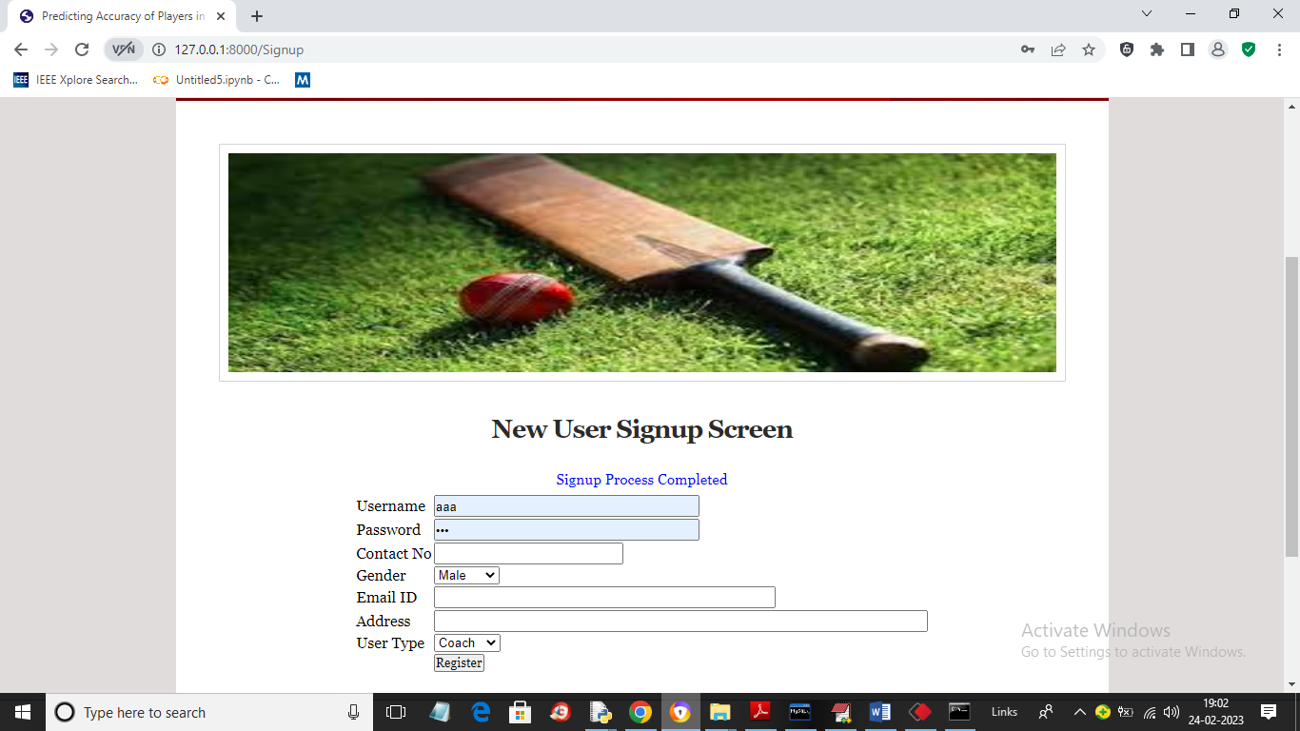

In above screen we can see ‘Signup Process Completed’ and now can click on ‘Coach/Captain Login’ link to get below login screen

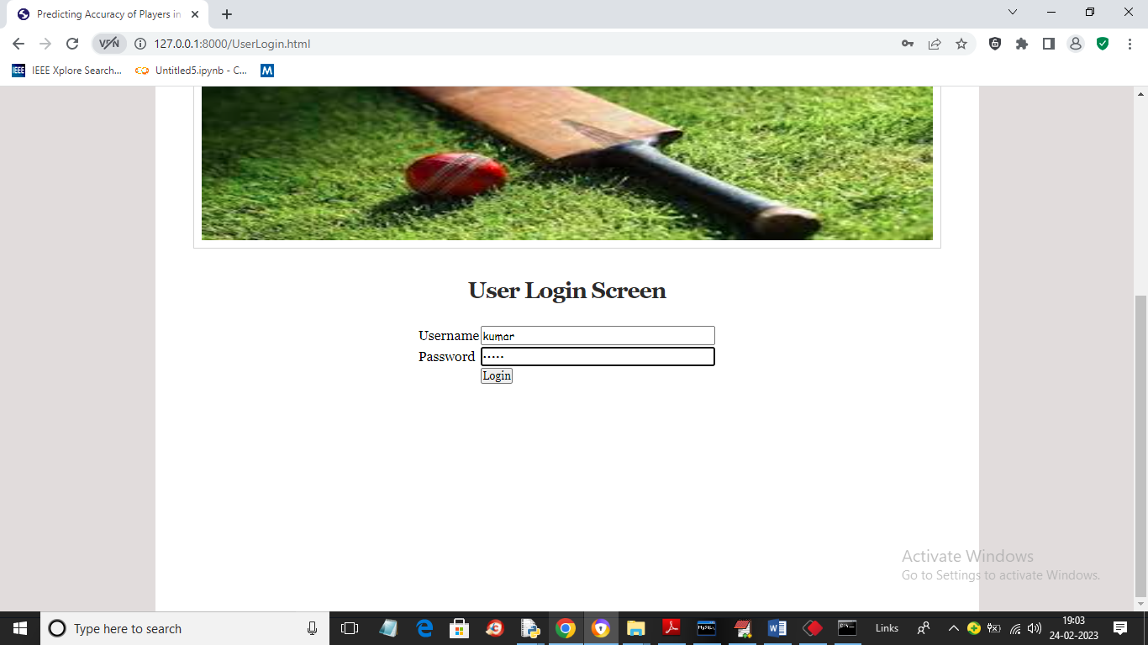

In above screen user is login and after login will get below page



In above screen we can see user is login as ‘Coach’ and now click on ‘Predict Top15 Batsman’ link to get below output

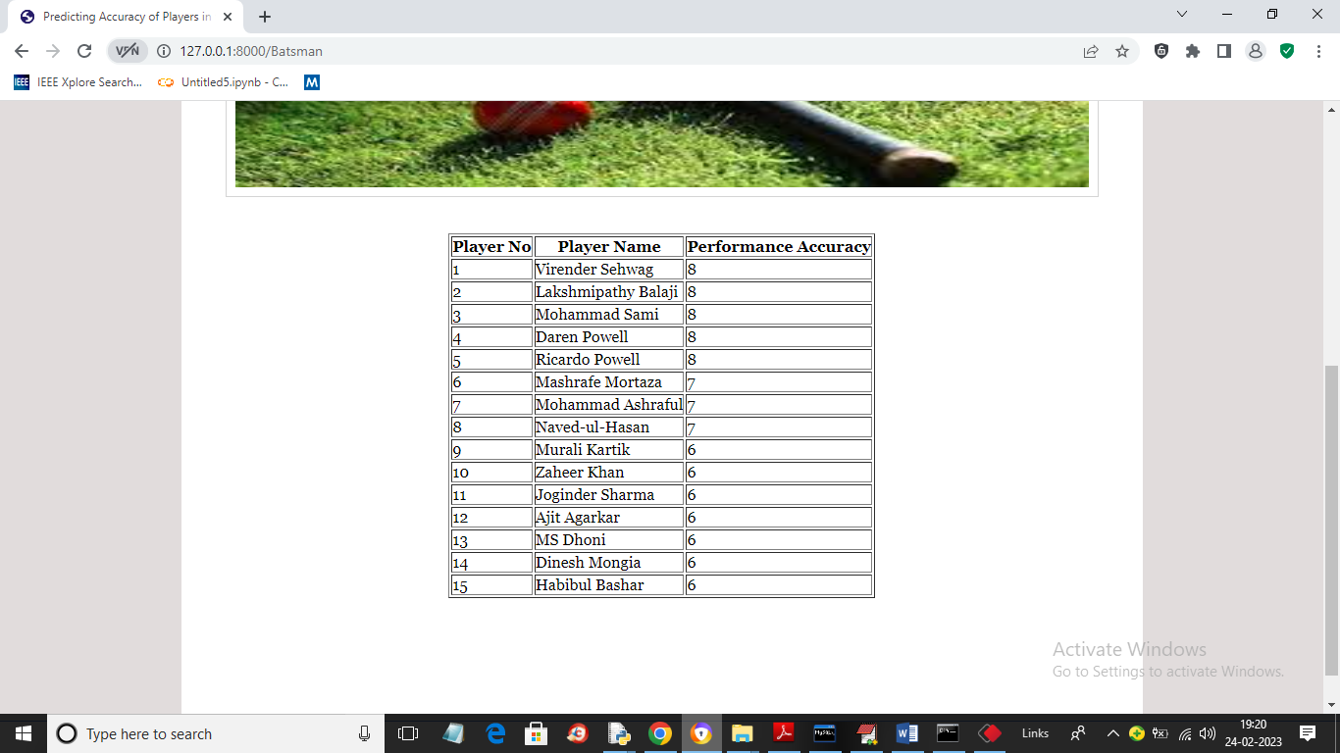

In above screen we can see the top performing players based on past performance and our dataset contains players from worldwide so will get other country player also. Similarly you can click on ‘Top15 Ballers’ link to get below output

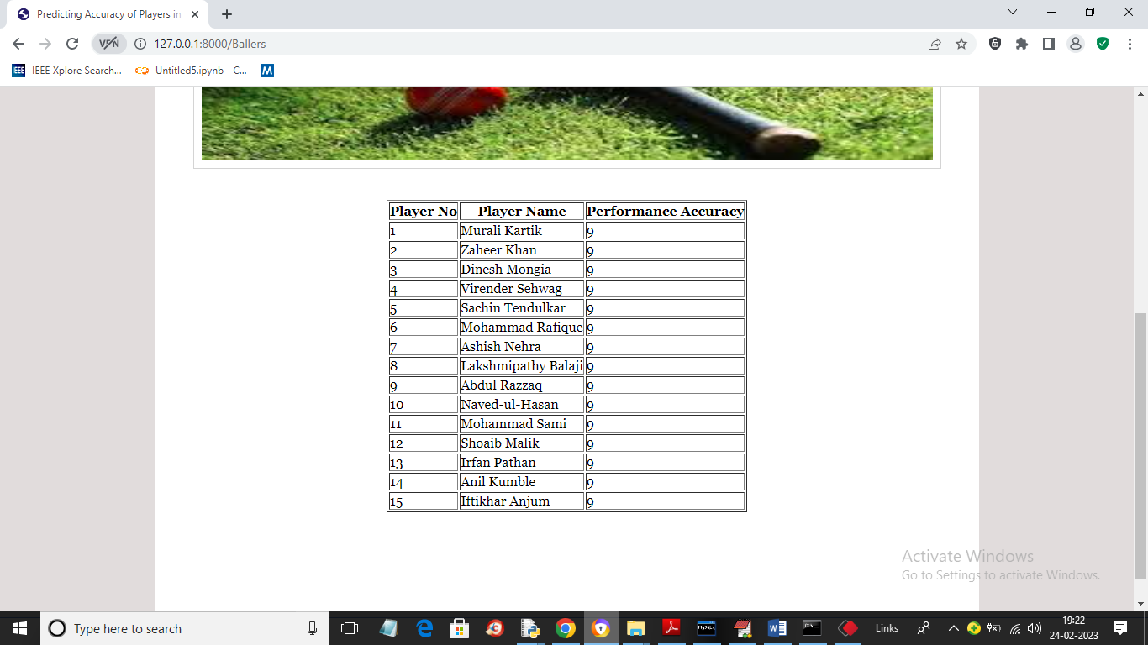

In above screen we can see list of top15 ballers and similarly you can click on any link to get prediction. In below screen you can see code for HMM training to rank each player between 1 to 10 scale based on their performance

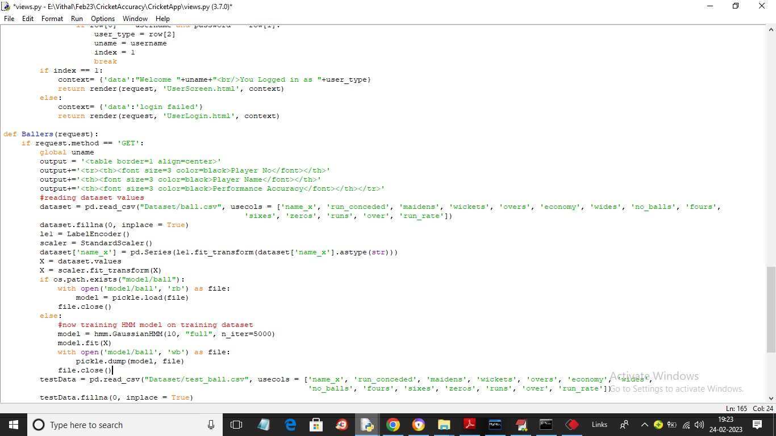

In above screen read red colour comments to know about HMM training