CICD:

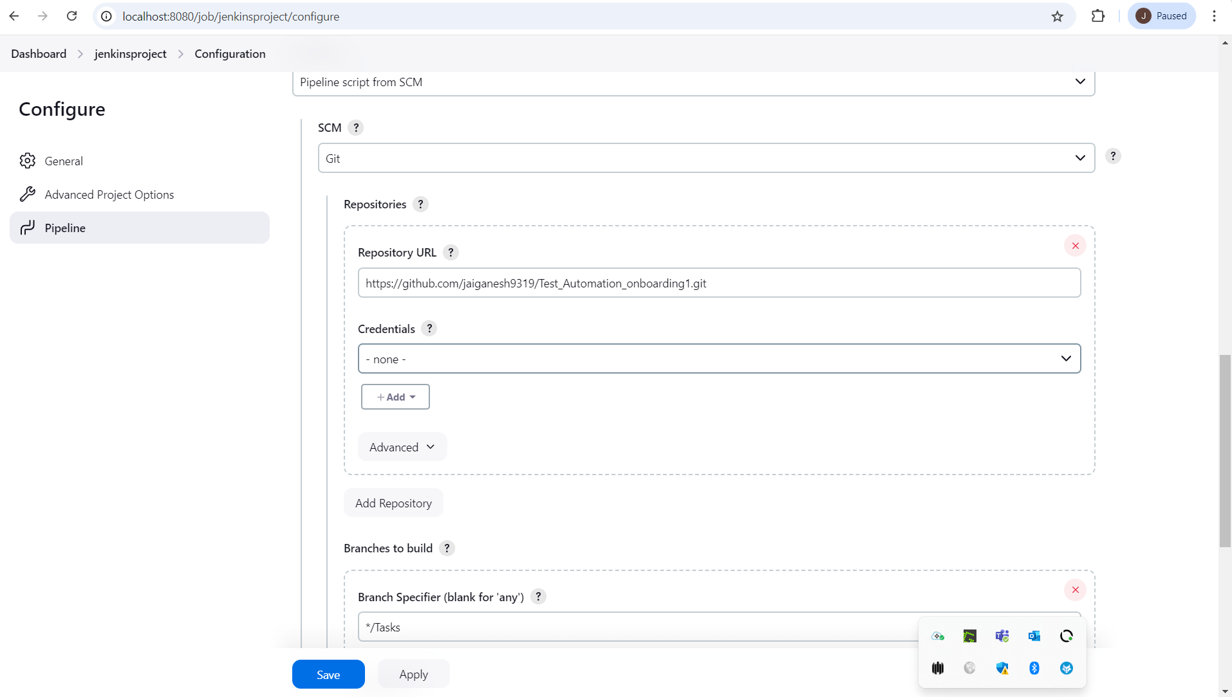

Declarative Pipeline:

