lOMoARcPSD|4663457



**JAVA PROJECT REPORT**

**Batch 2018-22**

**BROADCAST CHAT SERVER**

Prepared by: **Jai Gupta (18070122029)**

**Sahil Goel (18070122024)**

**What is Chat Server?**

CHAT SERVER is an online system developed for the group of members to communicate with each other over the internet. This system solves almost all the limitations of the conventional system. Both the students and teachers and the company are equally benefited by the proposed system. The system saves a lot of time and effort for both.we are introducing a new software called CHAT SERVER for chatting purpose.we can say thoroughly that this software is very useful for the [college. It](http://college.lt) is mainly designed for the college to reduce the communication gap between the different peoples in a college.

Chat server is a network based application which having two faces: one for the server side and one for the client. Our chat server has been developed with optimized technique to make fast and of less size. Even though, it’s a small application, but eligible to meet client side requirements. It’s having two page source code, one for the server and can be placed on any system which you want to make a server. For working as client side, you have to place the client code to other computer, which will act as client side. At the same time, there can be more than one client which can be handle by the TCP connection. In order to handle with networking concepts, we have used number of java built in features to have optimized codes like threading, networking console, Input and Output console, collections, streams and much more. Among all, it’s the application which can be run, using the concept of LAN and all clients need to be connected to server or use their dedicated IP address to receive and send messages through broadcasting central server.

**Definitions**

**User Account**

A user account is a location on a network server used to store a computer username, password, and other information. A user account allows or does not allow a user to connect to a network, another computer, or other share. Any network that has multiple users requires user accounts.

#### Entity relationship

An entity relationship model, also called an entity-relationship (ER) diagram, is a graphical representation of entities and their relationships to each other, typically used in computing in regard to the organization of data within databases or information systems.

**User case**

In software and systems engineering, a use case is a list of actions or event steps, typically defining the interactions between a role (known in the Unified Modeling Language as an actor) and a system, to achieve a goal. The actor can be a human or other external system.

**DFD**

A data flow diagram (DFD) is a graphical representation of the "flow" of data through an information system, modelling its process aspects. A DFD is often used as a preliminary step to create an overview of the system, which can later be elaborated.

**Project Scope**

Chat Server is an online instant messaging application that integrates user’s contacts from their phonebook

with the application and enables exchange of messages free of cost over the internet.

### Product Perspective

Chat Server does not work independently. It works together

with the internet and the operating system and its hardware services.

#### Communication interface

Chat Server communicate with its database systems via a communication network.

#### Software interface

The messages sent via the communication network are specific to the target other user's same software (Chat Server) on the other side.

**Hardware interface**

The software will run on the system with the help of its hardware.

#### User interfaces

#### User:

Once the application is installed, it sends a push invitation to connect and chat on Chat Server.

**Existing System:**

Earlier, the system was quite well and mostly hanged during login process through client side. Server was not able to provide quick information on logged users and take time to display currently login users. Among these, security was important section which were not given preference as all communications will be through server side, its need to have functionality of session and authentication with proper validation process. The client side was not able to identify and display proper message of errors. There was no provision of providing client users whether server is running or not. There was no provision of having private chats with other clients and even group chat facility.

**Proposed System:**

It’s the system which only not allow users to send messages from one clients to all clients but even facilitate to send private message and group chats with other clients. It’s the system, which provide clients the details of other clients with information like: name, logged in time, total duration and their message in public section. The server side will responsible to maintain users list, their messages, passwords and log details. It’s the application where the concept of data structure like linked list, array list has been used.

**Modules:**

1. Server Application: -It will act as a broadcasting server which will handle the sending and receiving of messages. It’s the part which have to deal with TCP/IP, port number and SSL techniques. Its predefined logic handles where to send messages, from where it has been received and what data has to carry.
2. Client Application: -Using the client panel, client can login to their account using their username and password. It’s the panel where message exchange process will take place and their representation medium among other clients.

**Architecture Diagram**

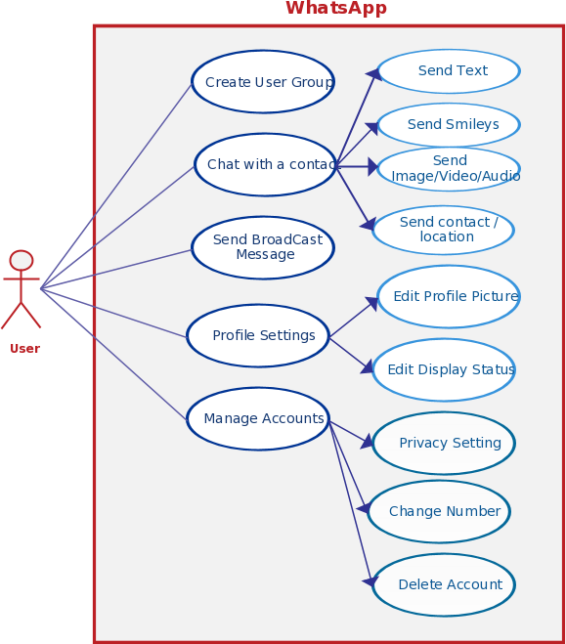

### Product Features

The Chat Server sends instant messages and data to the other users of Chat Server (e.g., pictures, messages, videos, documents), user

can communicate to the other user of Chat Server by calling them from Chat Server, can see their details of other clients with information like name, logged in time, total duration and their message in public section

### Operating Environment

The hardware, software and technology used should have following specifications:

* Ability to connect to the WIFI.
* Ability to exchange data over the network
* Keypad
* Processor with speed of 500 MHz
* Continuous power supply
* Ability to take input from user
* Device must have 512MB RAM or above

### Design and Implementation Constraints

* Create Chat Server account by entering and verifying Username

#### Lock Account

* If user failed to follow policies of Chat Server
* In case of spamming by 10 users
* Maintain Consecutive marked spam Counter
* Increment spam Counter
* For every consecutive spam, increment logic counter by 1.
* Deactivate the account as the spam number reaches 10 Functional Requirements

User must be able to register for the application through a valid User ID. On installing the application, user must be prompted to register their User-Id. If user skips this step, application should close. The User-ID will be the unique identifier of his/her account on Chat Server.

CODE DESIGN

The purpose of coding is to express the program logic in the best possible way and to the check it. The main reasons for coding are:

1. **Unique-Identification**. Each item in a system should be identified uniquely  
   and correctly.
2. **Efficient-storage**. Code is a concise representation it reduces data entry pme and improves reliability, Code as a key reduces storage space required for the data, Retrivel based on a key search is faster in a computer.

**Team Members Task and Responsibility**

**Jai Gupta**: Code and Implementation & Building the complete GUI for the application

**Sahil Goel**: Presentation, Information Gathering, Testing and Debugging the application

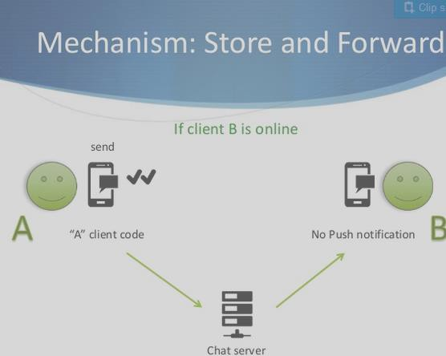

**Testing –**

The main objectives of testing are: -

Testing is a process of executing a program with the intent of finding an error. A good test case is one that has a high probability of finding an as yet undiscovered error. A successful test is one that uncovers as yet undiscovered error. The above objectives imply a dramatic change in view point. They move counter to the commonly held view that a successful test is one in which no errors are found. Our objective is to design tests that systematically uncover different classes of errors and do so with a minimum amount of time and effort.

**Data Flow Diagram**

CONTEXT LEVEL (0 LEVEL)

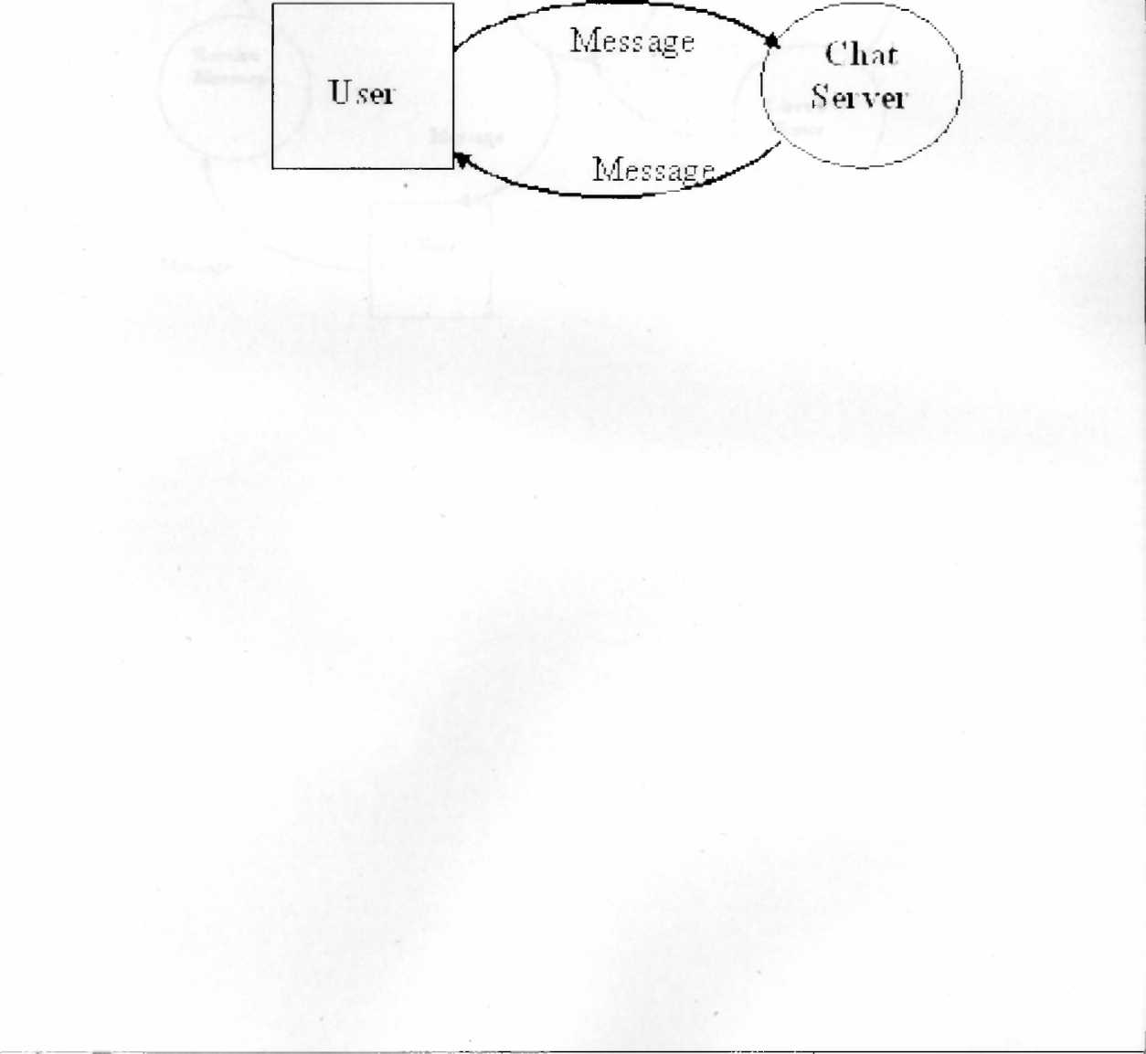

SCOPE FOR FUTURE ENHANCEMENTS –

On regarding the future enhancement, the application can be further expanded in accordance with the changing scenario in the web-based applications that need frequent changes in the changing environment and expansion of the organization. Since the change in technology and user needs arises frequently in certain short intervals of time, the application can be further upgraded to meet the requirements that may arise in the far or near future. With regarding to the needs that arises, more and more features can be included by adding it as separate modules and integrating it with the existing system.

## 

**Screenshots of your progress :**

**Current progress of the project – 100% completed and tested.**

1. **The Chat Window**

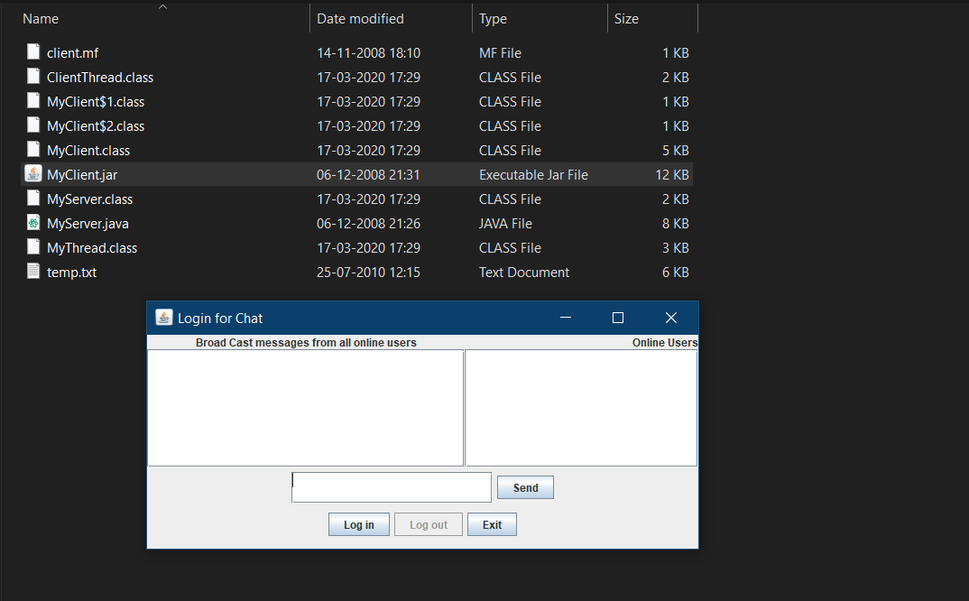

1. **The Login Input**

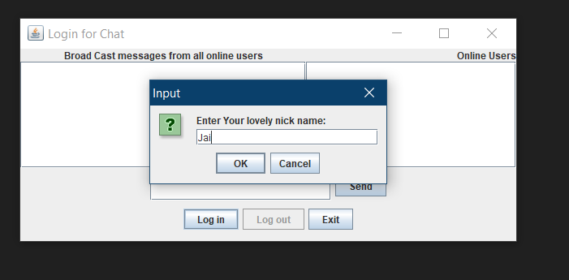

1. **The Login input for other users**

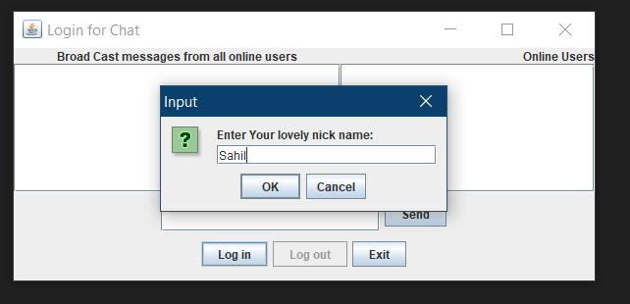

1. **Showing all the online users on right and chat screen on left**

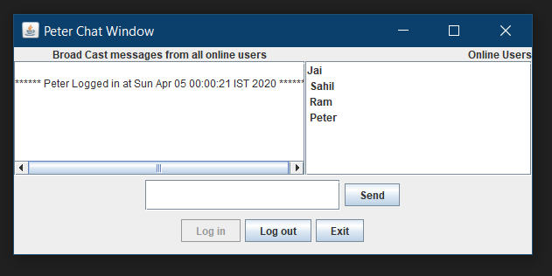

1. **Chat windows of every connected user**

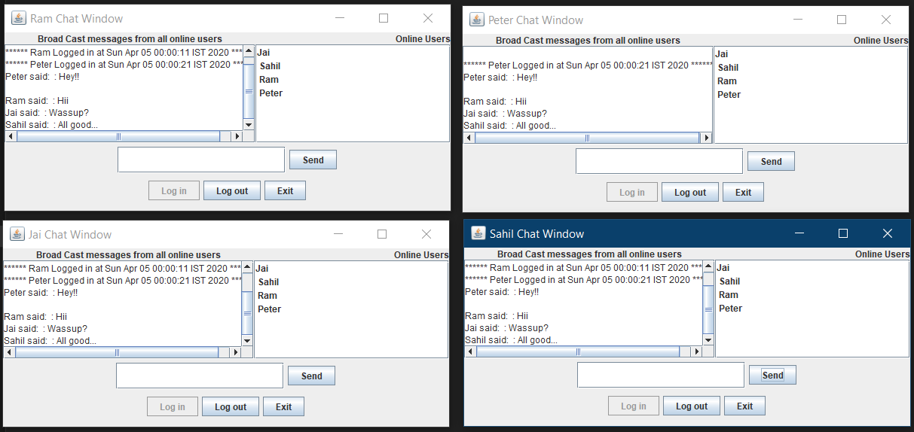

1. **The logout tab**

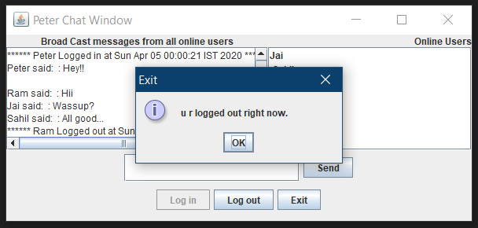

**CODE Snippets –**

1. **Closing of the Chat window**

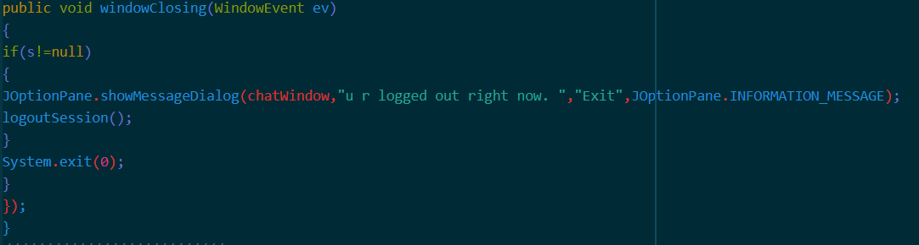

1. **Operations on the chat window**

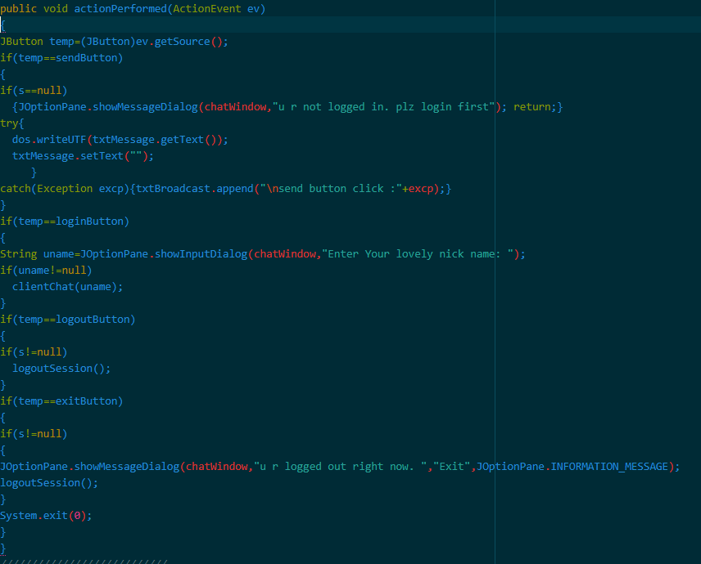

1. **clientChat method**

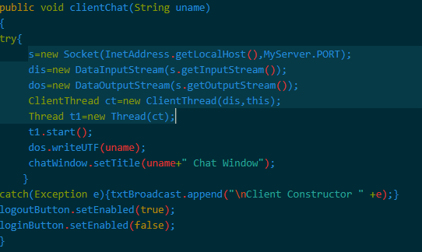

1. **Updating data**

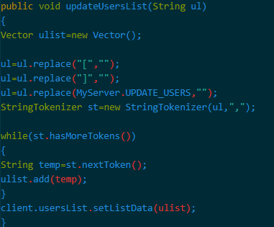

1. **Creating GUI for the application**

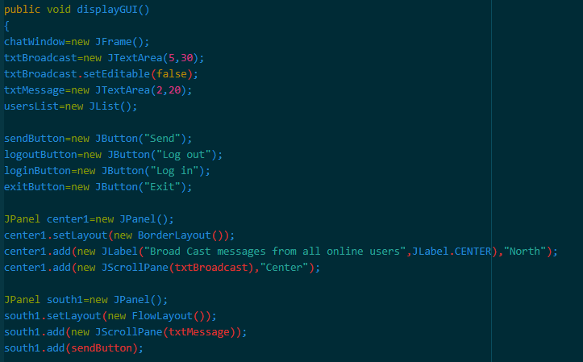

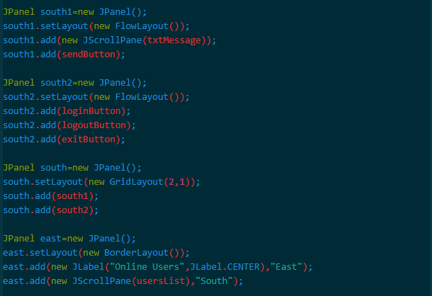

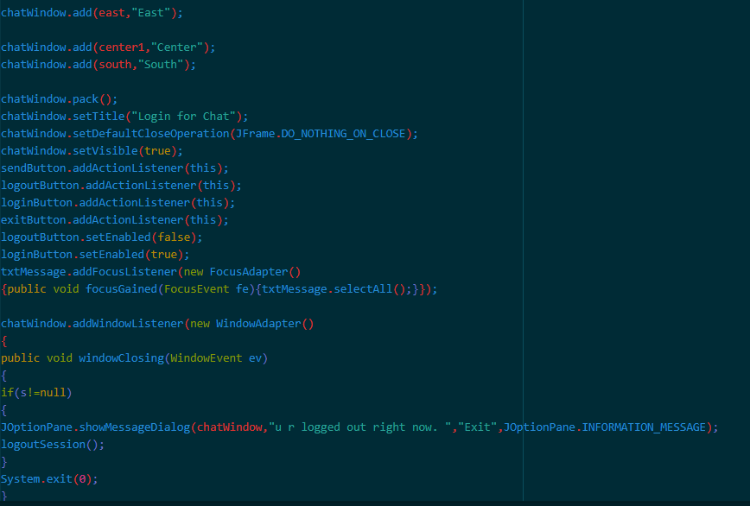

1. **Creating a MyServer class**

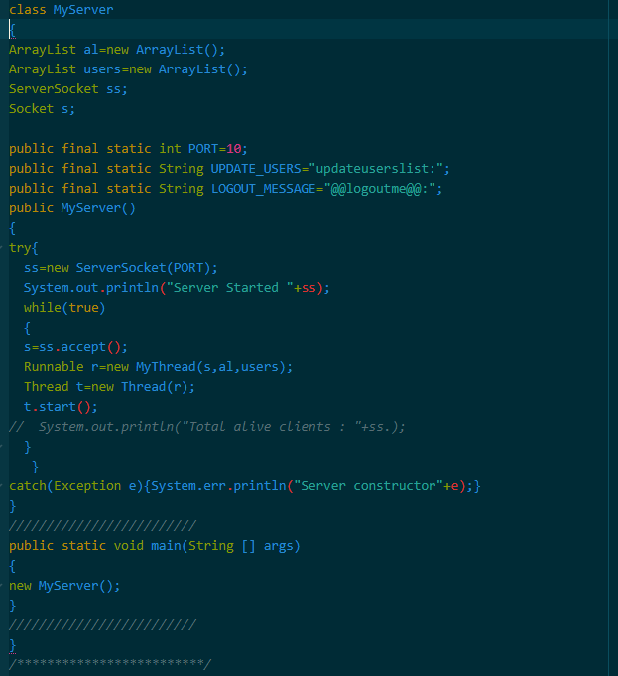

**// Above images are only the part of code. It doesn’t consists of each and every methods used in building the**

**application. //**