SCHOOL OF TECHNOLOGY | 

DATABASE MANAGEMENT SYSTEMS
PROJECT-BASED LEARNING (PBL) REPORT
Small Database Application Development using Java / Python

PROJECT TITLE
Design and Implementation of a Database Management System for Library Circulation and Digital Resource Management

Program | AI/ML
Section | AI/ML RHINOS
Faculty | Miss Sahiti
Date of Submission | 15/10/2026
Academic Year | 2026 – 27

Submitted by
Roll Number | Student Name | Mobile | Email ID
25WU0102103 | Jai Havish Sannapareddy | [Enter mobile] | [Enter email]

ACKNOWLEDGEMENT
I express my sincere gratitude to Woxsen University, School of Technology, for providing me with the opportunity to undertake this Project-Based Learning (PBL) activity as part of the Database Management Systems (DBMS) course.
I thank my course faculty, Miss Sahiti, for the guidance, suggestions, and support throughout the design and development of this project. The guidance helped me understand the practical application of database concepts such as ER modelling, relational schema design, normalization, SQL, constraints, queries, and database application development.
This PBL activity has strengthened my understanding of DBMS concepts and provided valuable experience in applying them to a real-world problem.

UNDERTAKING
I hereby declare that the project entitled “Design and Implementation of a Database Management System for Library Circulation and Digital Resource Management”, submitted as part of the Project-Based Learning activity for the Database Management Systems (DBMS) course, is my individual work carried out under the guidance of the course faculty.
I undertake that the project report, database design, SQL scripts, application source code, results, and supporting materials submitted by me have been prepared for academic purposes. Wherever information, ideas, tools, datasets, or other resources have been referred to, appropriate acknowledgement has been provided.
I further undertake that I am responsible for the correctness and authenticity of the work submitted and that I have followed the academic and project guidelines prescribed by the University.

 |  |  |  | Signature
Date | : |  | Name: Jai Havish Sannapareddy
Place | : |  | Roll Number: 25WU0102103
 |  |  | Program: AI/ML

TABLE OF CONTENTS
Contents | Page No.
Abstract | 8
LIST OF TABLES | 5
LIST OF FIGURES | 6
LIST OF ACRONYMS | 7
1. PROBLEM STATEMENT, SOLUTION STRATEGY AND ER DIAGRAM | 9
1.1 Problem Statement | 9
1.2 Objectives | 9
1.3 Scope and Assumptions | 10
1.4 Proposed Solution Strategy | 10
1.5 Functional Requirements | 10
1.6 Entity-Relationship Diagram (ERD) | 11
1.7 Entity and Relationship Summary | 12
2. LOGICAL DATABASE DESIGN | 13
2.1 Relational Schema | 13
2.2 Keys and Integrity Constraints | 13
2.3 Functional Dependencies | 15
2.4 Normalization up to Third Normal Form (3NF) | 16
2.5 Data Dictionary | 17
2.6 Implementation of Logical Design: DDL and Sample Data | 19
3. APPLICATION DEVELOPMENT USING LOGICAL DATABASE DESIGN | 22
3.1 Application Overview | 22
3.2 Development Environment and Database Connectivity | 22
3.3 Application Modules and Database Mapping | 22
3.4 CRUD Operations | 23
3.5 Business Rules, Validation and Error Handling | 23
3.6 Reports and Database Operations | 24
3.7 Application Screens | 24
3.8 Testing and Results | 30
4. CONCLUSION | 32
4.1 Limitations and Future Enhancements | 32
5. REFERENCES | 33
6. APPENDICES | 34

LIST OF TABLES
Table No. | Table Title | Page No.
Table 1 | Scope and Assumptions | 10
Table 2 | Proposed Solution Strategy | 10
Table 3 | Functional Requirements | 10
Table 4 | Entity and Relationship Summary | 12
Table 5 | Relational Schema | 13
Table 6 | Keys and Integrity Constraints | 13
Table 7 | Normalization Status up to 3NF | 16
Table 8 | Data Dictionary | 17
Table 9 | Database Implementation Environment | 19
Table 10 | Application Development Environment | 22
Table 11 | Application Module-to-Database Mapping | 22
Table 12 | CRUD Operations | 23
Table 13 | Business Rules, Validation and Error Handling | 23
Table 14 | Reports and Database Operations | 24
Table 15 | Test Cases | 30

LIST OF FIGURES
Figure No. | Figure Title | Page No.
Figure 1 | Entity-Relationship Diagram of the Proposed System | 11
Figure 2 | Dashboard with key figures, overdue copies and popular books | 25
Figure 3 | Catalogue search for “database” | 25
Figure 4 | Member list with borrowing history of the selected member | 26
Figure 5 | Issuing a book to a member (status bar shows the due date) | 26
Figure 6 | Returning an overdue book creates a fine | 27
Figure 7 | Reservation queue for Wings of Fire | 27
Figure 8 | Unpaid fines, including the fine created by the return | 28
Figure 9 | Report: overdue copies with fine so far | 28
Figure 10 | Report: fine collection by month | 29
Figure 11 | Digital resources and usage | 29

LIST OF ACRONYMS
Acronym | Expansion
3NF | Third Normal Form
BCNF | Boyce-Codd Normal Form
CRUD | Create, Read, Update, Delete
CSV | Comma-Separated Values
DBMS | Database Management System
DDL | Data Definition Language
ER | Entity-Relationship
ERD | Entity-Relationship Diagram
FK | Foreign Key
ISBN | International Standard Book Number
PBL | Project-Based Learning
PK | Primary Key
SQL | Structured Query Language

ABSTRACT
Many college libraries still track books in paper registers or loose spreadsheets. In such a setup it is hard to know which copy is on the shelf, who is keeping a book past its due date, or how much fine a member owes. This project builds a relational database and a small desktop application to remove those problems. The aim was to design a database for a library that handles books, digital resources, members, issues, returns, reservations and fines, and to put a simple front end on it. The design started from an ER model with fifteen entities, which was converted into a relational schema in Third Normal Form and built in MySQL 8.0 with keys and UNIQUE, NOT NULL, CHECK and DEFAULT constraints. The front end is written in Python with Tkinter. It supports catalogue maintenance, member registration, issue, return, reservation, fine payment, search and seven reports. Rules such as one active issue per copy are enforced by the database itself, and multi-step actions run inside transactions. Forty automated tests, valid and invalid cases, pass on the final system. The result is a tested library system that a small library could use for daily circulation.

KEYWORDS
Keywords: Library Management, Relational Database, ER Diagram, Normalization, MySQL, Python

CHAPTER 1

PROBLEM STATEMENT, SOLUTION STRATEGY AND ER DIAGRAM

1.1 Problem Statement
A small library keeps three kinds of things: books, the people who borrow them, and the record of who borrowed what. When this record lives in a register, simple questions become slow to answer. A librarian has to flip through pages to find out whether a title is on the shelf. Overdue books are noticed only when someone happens to look at the due dates. Fines are worked out by hand, so mistakes and arguments are common. When a popular book is out, there is no fair way to remember who asked for it first.
The library staff, the members and the administrators are all affected. Staff lose time on routine lookups. Members do not know when a book will be free. Administrators cannot easily see which books are popular or how much fine money is pending. Digital resources such as e-books and journals make it worse, because their use is not recorded anywhere. A shared database that checks every entry and a simple application on top of it will replace the registers and give the same answer to everybody.

1.2 Objectives
- Design an ER model and a normalised relational schema (up to 3NF) for books, editions, copies, members, issues, reservations, fines and digital resources.
- Implement the schema in MySQL with keys and constraints that enforce rules such as unique ISBN and accession numbers, one active issue per copy and non-negative fines.
- Develop a Python application that performs catalogue maintenance, member registration, issue, return, reservation, fine collection and search.
- Generate circulation reports (available titles, overdue copies, member history, popular books, reservations and fine collection) using joins, aggregates, nested queries and views.
- Validate the system with positive and negative test cases and show that transactions leave no half-finished data.

1.3 Scope and Assumptions
Table 1 states what the project covers and what it leaves out.
Table 1. Scope and Assumptions
Item | Description
In Scope | Catalogue of titles, editions, authors, publishers and categories; physical copies with accession numbers; member registration for three member types; issue, return and renewal; reservation queue; fine calculation and payment; digital resource access log; search; seven reports; desktop application for library staff.
Out of Scope / Exclusions | Member self-service login, online payment, barcode scanners, e-mail or SMS reminders, lost-book charges, fine waivers, purchase and acquisition of new stock, and storing the digital files themselves.
Assumptions | The librarian operates the program on behalf of members at the desk. One library branch only. Loan period and fine rate depend on member type (Student 14 days at Rs 2 per day, Faculty 30 days at Rs 1, Public 7 days at Rs 5). A member with more than Rs 50 unpaid fine cannot borrow. Fine is charged when the book is returned.

1.4 Proposed Solution Strategy
The solution keeps all rules in one place. The database refuses data that breaks a rule, and the application adds the rules that need several rows to be checked together. Table 2 summarises the approach. The relational model [1] is used for the data, so every fact is stored once.
Table 2. Proposed Solution Strategy
Solution Element | Project-Specific Description
Primary Users / Roles | Librarian (daily circulation and catalogue work); Administrator (reports and policy); Member (student, faculty or public, served at the desk).
Major Application Modules | Dashboard, Catalogue, Members, Issue & Return, Reservations, Fines, Digital Resources, Reports.
Proposed Workflow | A member is registered once. The librarian issues a copy by picking the member and the copy. On return the system closes the loan, adds a fine if the book is late, and either puts the copy back on the shelf or holds it for the first member in the reservation queue.
Important Business Rules | Unique ISBN and accession number; one active issue per copy; return date not before issue date; book limit by member type; reservation queue served in order; fines never negative and never over-paid.
Expected Reports / Outputs | Available titles, overdue copies with fine so far, member borrowing history, popular books, reservation queue, fine collection by month, digital resource usage.

1.5 Functional Requirements
The main functions the system must provide are listed in Table 3.
Table 3. Functional Requirements
Req. ID | Functional Requirement | Remarks / Priority
FR-01 | Add and search titles, editions, authors, publishers and categories | High
FR-02 | Add physical copies with a unique accession number and withdraw copies without losing history | High
FR-03 | Register members with type, card number, e-mail, phone and expiry date | High
FR-04 | Issue a copy to a member after checking membership, book limit, fines and copy status | High
FR-05 | Return a copy, close the loan and calculate the fine for late return | High
FR-06 | Renew a loan when it is not overdue and nobody is waiting | Medium
FR-07 | Reserve a title that has no copy on the shelf and keep a fair queue | High
FR-08 | Hold a returned copy for the first person in the queue | High
FR-09 | Show fines per member and record full or part payment | High
FR-10 | Record use of digital resources and refuse use after the licence ends | Medium
FR-11 | Search the catalogue by title, author, category or ISBN | High
FR-12 | Produce circulation reports and save them as CSV | Medium

1.6 Entity-Relationship Diagram (ERD)
The approved ER diagram is shown in Figure 1 [2]. It has fifteen entities. The cardinality of each relationship is written next to the lines. PK marks a primary key and FK a foreign key.
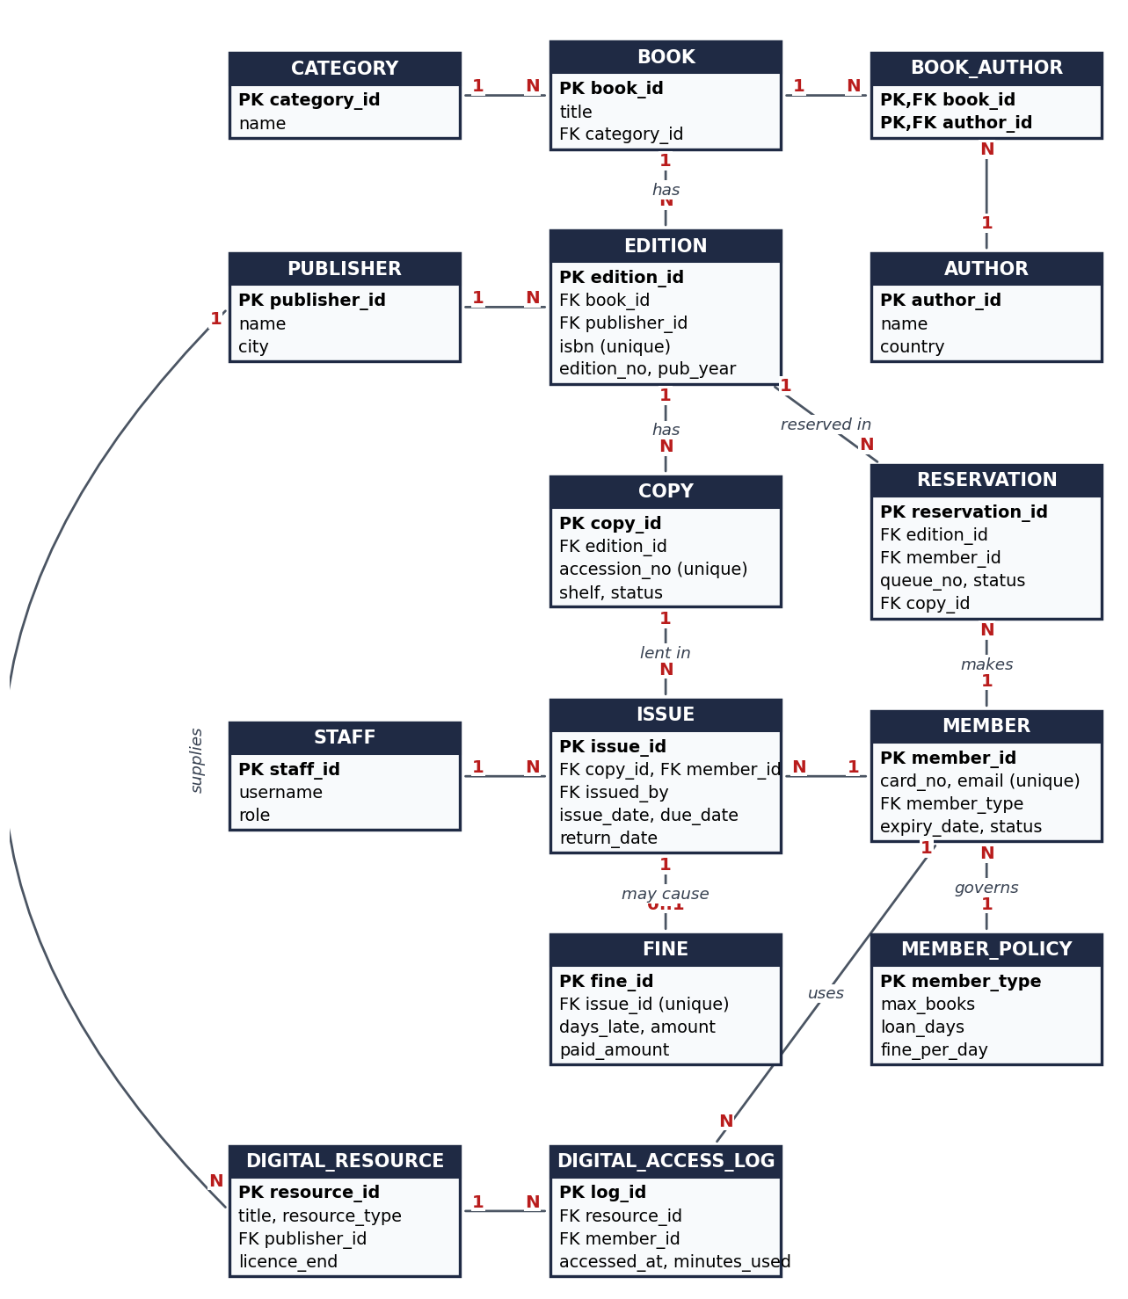
Figure 1. Entity-Relationship Diagram of the Proposed System
A title (BOOK) is separate from its EDITION and from each physical COPY. This avoids repeating the title and publisher on every copy row, and it lets the library own several editions of the same title.

1.7 Entity and Relationship Summary
Table 4 summarises the entities and their relationships.
Table 4. Entity and Relationship Summary
Entity / Relationship | Major Attributes / Cardinality | Purpose / Rule
PUBLISHER | publisher_id, name, city. 1 publisher : N editions | Who publishes an edition; also supplies digital resources
AUTHOR | author_id, name, country. M:N with BOOK | People who write the titles
CATEGORY | category_id, name. 1 category : N books | Subject grouping used in search
BOOK | book_id, title, category_id. 1 book : N editions | One row per title
BOOK_AUTHOR | book_id, author_id (composite key) | Resolves the many-to-many link between books and authors
EDITION | edition_id, isbn, edition_no, pub_year, pages. 1 edition : N copies | One row per printed edition; ISBN is unique
COPY | copy_id, accession_no, shelf, status. 1 copy : N issues over time | Physical item; status is AVAILABLE, ISSUED, ON_HOLD, LOST or WITHDRAWN
MEMBER_POLICY | member_type, max_books, loan_days, fine_per_day. 1 type : N members | Loan rules that depend only on member type
MEMBER | member_id, card_no, name, email, phone, expiry_date, status | A registered library user
STAFF | staff_id, username, role. 1 staff : N issues | Librarian or admin who records the issue
ISSUE | issue_id, issue_date, due_date, return_date. 1 issue : 0..1 fine | One loan of one copy to one member
RESERVATION | reservation_id, queue_no, status, copy_id. N per edition | A member's place in the waiting line for a title
FINE | fine_id, days_late, amount, paid_amount | Charge for a late return, linked to the issue
DIGITAL_RESOURCE | resource_id, title, resource_type, url, licence_end | E-book, journal, video or database the library subscribes to
DIGITAL_ACCESS_LOG | log_id, accessed_at, minutes_used. Links MEMBER and DIGITAL_RESOURCE (M:N) | Records each use of a digital resource

CHAPTER 2

LOGICAL DATABASE DESIGN

2.1 Relational Schema
The ER model was converted into the 15 relations in Table 5. Each entity became a table, and the many-to-many links became tables of their own (BOOK_AUTHOR and DIGITAL_ACCESS_LOG).
Table 5. Relational Schema
S.No. | Table Name | Purpose
1 | publisher | Publishers of editions and digital resources
2 | author | Authors of titles
3 | category | Subject categories
4 | member_policy | Loan days, book limit and fine rate for each member type
5 | staff | Library staff who operate the system
6 | book | Titles
7 | book_author | Links titles to their authors
8 | edition | Printed editions with ISBN
9 | copy | Physical copies with accession number and status
10 | member | Library members
11 | issue | Loans of copies to members
12 | reservation | Reservation queue for editions
13 | fine | Fines raised on late returns
14 | digital_resource | Digital resources and licence end dates
15 | digital_access_log | Use of digital resources by members

2.2 Keys and Integrity Constraints
Table 6 lists the keys and constraints. Every foreign key points to a parent table, so no row can refer to something that does not exist.
Table 6. Keys and Integrity Constraints
digital_access_log | Key / Constraint | Attribute(s) | Business Rule Enforced
 | Primary Key | publisher_id | Identifies a publisher
 | Unique / Not Null | name | No duplicate publisher names
 | Primary Key / Not Null | author_id / name | Every author has a name
 | Primary Key / Unique | category_id / name | No duplicate categories
 | Primary Key | member_type | One rule set per type
 | Check | max_books > 0, loan_days > 0, fine_per_day >= 0 | Rules must be sensible
 | Primary Key / Foreign Key | book_id / category_id | Each title belongs to a category
 | Composite Primary Key | book_id, author_id | A pair appears only once
 | Foreign Key | book_id (ON DELETE CASCADE), author_id | No link without both parents
 | Primary Key / Unique | edition_id / isbn | ISBN is unique
 | Unique | book_id, publisher_id, edition_no | Same edition cannot be added twice
 | Foreign Key | book_id, publisher_id | Edition needs a title and a publisher
 | Check | isbn REGEXP '^[0-9]{13}$'; edition_no > 0; pub_year 1450-2100; pages > 0 | Valid ISBN and dates
 | Primary Key / Unique | copy_id / accession_no | Accession number is unique
 | Foreign Key | edition_id | A copy belongs to an edition
 | Default / Not Null | status = 'AVAILABLE'; added_on = today | New copies start on the shelf
 | Primary Key / Unique | member_id / card_no, email | No duplicate card or e-mail
 | Foreign Key | member_type | Type must exist in member_policy
 | Check | expiry_date > joined_on; email LIKE '%_@_%._%' | Valid dates and e-mail
 | Default | member_type = 'STUDENT'; status = 'ACTIVE' | Common case needs no input
 | Primary Key / Foreign Key | issue_id / copy_id, member_id, issued_by | Loan links copy, member and staff
 | Unique (generated column) | active_copy_id = IF(return_date IS NULL, copy_id, NULL) | One active issue per copy
 | Check | due_date > issue_date; return_date IS NULL OR return_date >= issue_date | Valid issue and return dates
 | Primary Key / Foreign Key | reservation_id / edition_id, member_id, copy_id | Reservation links edition and member
 | Unique (generated columns) | (edition_id, live_queue_no); (edition_id, live_member_id) | Queue order is unique; one live reservation per member per title
 | Check | queue_no > 0; status <> 'READY' OR copy_id IS NOT NULL | A ready reservation always has a copy
 | Primary Key / Unique | fine_id / issue_id | At most one fine per loan
 | Check | days_late >= 0; amount >= 0; paid_amount >= 0; paid_amount <= amount | Non-negative and never over-paid
 | Primary Key / Check by ENUM | resource_id / resource_type | Only EBOOK, JOURNAL, VIDEO or DATABASE
 | Primary Key / Foreign Key | log_id / resource_id, member_id | Each use is tied to a member and a resource
 | Check / Default | minutes_used >= 0; accessed_at = now | No negative time

Referential actions: foreign keys use the default RESTRICT, so a title, member or copy that has history cannot be deleted. Only book_author uses ON DELETE CASCADE. The program withdraws copies and cancels reservations by changing status instead of deleting rows.

2.3 Functional Dependencies
The important functional dependencies are given below. Each determinant on the left is a candidate key of its table, so the design also satisfies Boyce-Codd Normal Form.
- publisher: publisher_id → name, city; name → publisher_id
- author: author_id → name, country
- category: category_id → name; name → category_id
- member_policy: member_type → max_books, loan_days, fine_per_day
- book: book_id → title, category_id
- edition: edition_id → book_id, publisher_id, isbn, edition_no, pub_year, pages; isbn → edition_id; (book_id, publisher_id, edition_no) → edition_id
- copy: copy_id → edition_id, accession_no, shelf, status, added_on; accession_no → copy_id
- member: member_id → card_no, full_name, email, phone, member_type, joined_on, expiry_date, status; card_no → member_id; email → member_id
- issue: issue_id → copy_id, member_id, issued_by, issue_date, due_date, return_date
- reservation: reservation_id → edition_id, member_id, queue_no, reserved_on, status, copy_id, ready_on
- fine: fine_id → issue_id, days_late, amount, paid_amount, assessed_on, paid_on; issue_id → fine_id
- digital_resource: resource_id → title, resource_type, publisher_id, url, licence_end
- digital_access_log: log_id → resource_id, member_id, accessed_at, minutes_used

2.4 Normalization
Normalization was done on the single sheet a librarian would keep by hand, with one wide row for every loan. Table 7 shows that every final relation satisfies each normal form [3], [4].
Table 7. Normalization Status up to 3NF
Relation Name | 1NF | 2NF | 3NF | BCNF | Remarks / Decomposition
publisher | Yes | Yes | Yes | Yes | Already in 3NF
author | Yes | Yes | Yes | Yes | Already in 3NF
category | Yes | Yes | Yes | Yes | Already in 3NF
member_policy | Yes | Yes | Yes | Yes | Split from MEMBER (type → loan rules)
staff | Yes | Yes | Yes | Yes | Already in 3NF
book | Yes | Yes | Yes | Yes | Split from the loan sheet (title, category)
book_author | Yes | Yes | Yes | Yes | Created to remove author list (1NF)
edition | Yes | Yes | Yes | Yes | ISBN, year, publisher moved out of COPY
copy | Yes | Yes | Yes | Yes | Physical item only; no title data
member | Yes | Yes | Yes | Yes | Person data separated from loan data
issue | Yes | Yes | Yes | Yes | Only loan facts remain
reservation | Yes | Yes | Yes | Yes | Queue facts only
fine | Yes | Yes | Yes | Yes | Member found through ISSUE, so not repeated
digital_resource | Yes | Yes | Yes | Yes | Already in 3NF
digital_access_log | Yes | Yes | Yes | Yes | Link table for M:N use

1NF: The sheet stored a list of authors in one cell. Authors were moved to their own table and linked through BOOK_AUTHOR, so every cell holds one value and every table has a primary key.
2NF: Member name depended only on the card number and title depended only on the copy, not on the whole loan. These facts moved to MEMBER, COPY, EDITION and BOOK, so ISSUE keeps only facts about the loan.
3NF: member_type determined max_books, loan_days and fine_per_day, so these went to MEMBER_POLICY. Category and publisher details were separated in the same way. FINE does not store member_id, because issue_id already gives the member.
Two columns look like repeated data but are not. reservation.copy_id is filled only while a copy is being held for that reservation. issue.active_copy_id and the live_* columns of RESERVATION are generated by MySQL for constraints, and nobody types them in.

2.5 Data Dictionary
Table 8 is the data dictionary. It was generated from the live database, so the data types and keys match what MySQL actually holds.
Table 8. Data Dictionary
Table | Attribute | Data Type | Key / Constraint | Description
publisher | publisher_id | INT | PK, AUTO_INCREMENT | Unique publisher number
 | name | VARCHAR(100) | UNIQUE, NOT NULL | Publisher name
 | city | VARCHAR(60) |  | City of the publisher
author | author_id | INT | PK, AUTO_INCREMENT | Unique author number
 | name | VARCHAR(100) | NOT NULL | Author's full name
 | country | VARCHAR(60) |  | Author's country
category | category_id | INT | PK, AUTO_INCREMENT | Unique category number
 | name | VARCHAR(60) | UNIQUE, NOT NULL | Category name
member_policy | member_type | VARCHAR(10) | PK | Member type: STUDENT, FACULTY or PUBLIC
 | max_books | TINYINT | NOT NULL | Most books held at one time
 | loan_days | TINYINT | NOT NULL | Days a book may be kept
 | fine_per_day | DECIMAL(5,2) | NOT NULL, DEFAULT 2.00 | Fine for each late day (Rs)
staff | staff_id | INT | PK, AUTO_INCREMENT | Unique staff number
 | username | VARCHAR(30) | UNIQUE, NOT NULL | Login name
 | full_name | VARCHAR(80) | NOT NULL | Staff member's name
 | role | ENUM | NOT NULL, DEFAULT LIBRARIAN | LIBRARIAN or ADMIN
book | book_id | INT | PK, AUTO_INCREMENT | Unique title number
 | title | VARCHAR(200) | NOT NULL | Title of the book
 | category_id | INT | FK, NOT NULL | Category of the title
book_author | book_id | INT | PK, FK | Title
 | author_id | INT | PK, FK | Author of that title
edition | edition_id | INT | PK, AUTO_INCREMENT | Unique edition number
 | book_id | INT | FK, NOT NULL | Title this edition belongs to
 | publisher_id | INT | FK, NOT NULL | Publisher of the edition
 | isbn | CHAR(13) | UNIQUE, NOT NULL | 13-digit ISBN
 | edition_no | TINYINT | NOT NULL, DEFAULT 1 | Edition number
 | pub_year | SMALLINT | NOT NULL | Year of publication
 | pages | SMALLINT |  | Number of pages
copy | copy_id | INT | PK, AUTO_INCREMENT | Unique copy number
 | edition_id | INT | FK, NOT NULL | Edition this copy belongs to
 | accession_no | VARCHAR(15) | UNIQUE, NOT NULL | Library's own number for the copy
 | shelf | VARCHAR(20) |  | Shelf location
 | status | ENUM | NOT NULL, DEFAULT AVAILABLE | Where the copy is now (AVAILABLE, ISSUED, ON_HOLD, LOST, WITHDRAWN)
 | added_on | DATE | GENERATED | Date the copy was added
member | member_id | INT | PK, AUTO_INCREMENT | Unique member number
 | card_no | VARCHAR(12) | UNIQUE, NOT NULL | Library card number
 | full_name | VARCHAR(100) | NOT NULL | Member's name
 | email | VARCHAR(120) | UNIQUE, NOT NULL | E-mail address
 | phone | VARCHAR(15) |  | Phone number
 | member_type | VARCHAR(10) | FK, NOT NULL, DEFAULT STUDENT | Type; decides loan rules
 | joined_on | DATE | GENERATED | Date of joining
 | expiry_date | DATE | NOT NULL | Date membership ends
 | status | ENUM | NOT NULL, DEFAULT ACTIVE | ACTIVE, SUSPENDED or EXPIRED
issue | issue_id | INT | PK, AUTO_INCREMENT | Unique loan number
 | copy_id | INT | FK, NOT NULL | Copy lent
 | member_id | INT | FK, NOT NULL | Borrower
 | issued_by | INT | FK | Staff member who issued it
 | issue_date | DATE | NOT NULL | Date of issue
 | due_date | DATE | NOT NULL | Date due back
 | return_date | DATE |  | Date returned; NULL while on loan
 | active_copy_id | INT | UNIQUE, GENERATED | Generated: copy_id while on loan, else NULL
reservation | reservation_id | INT | PK, AUTO_INCREMENT | Unique reservation number
 | edition_id | INT | FK, NOT NULL | Title reserved
 | member_id | INT | FK, NOT NULL | Member waiting
 | queue_no | INT | NOT NULL | Place in line; keeps counting up
 | reserved_on | DATETIME | GENERATED | Date and time of reservation
 | status | ENUM | NOT NULL, DEFAULT WAITING | WAITING, READY, FULFILLED, CANCELLED or EXPIRED
 | copy_id | INT | FK | Copy held for the member once READY
 | ready_on | DATE |  | Date the copy was set aside
 | live_queue_no | INT | GENERATED | Generated: queue_no while reservation is live
 | live_member_id | INT | GENERATED | Generated: member_id while reservation is live
fine | fine_id | INT | PK, AUTO_INCREMENT | Unique fine number
 | issue_id | INT | FK, UNIQUE, NOT NULL | Late loan the fine belongs to
 | days_late | SMALLINT | NOT NULL | Days past the due date
 | amount | DECIMAL(8,2) | NOT NULL, DEFAULT 0.00 | Fine amount in rupees
 | paid_amount | DECIMAL(8,2) | NOT NULL, DEFAULT 0.00 | Amount paid so far
 | assessed_on | DATE | GENERATED | Date fine was raised
 | paid_on | DATE |  | Date of latest payment
digital_resource | resource_id | INT | PK, AUTO_INCREMENT | Unique resource number
 | title | VARCHAR(200) | NOT NULL | Title of the resource
 | resource_type | ENUM | NOT NULL | EBOOK, JOURNAL, VIDEO or DATABASE
 | publisher_id | INT | FK | Supplier or publisher
 | url | VARCHAR(255) | NOT NULL | Address of the resource
 | licence_end | DATE |  | Date the licence ends
digital_access_log | log_id | INT | PK, AUTO_INCREMENT | Unique log number
 | resource_id | INT | FK, NOT NULL | Resource used
 | member_id | INT | FK, NOT NULL | Member who used it
 | accessed_at | DATETIME | GENERATED | Date and time of use
 | minutes_used | SMALLINT | NOT NULL, DEFAULT 0 | Minutes spent

2.6 Implementation of Logical Design: DDL and Sample Data
The database was built in MySQL [5]. The complete script is in Appendix A. Three representative CREATE TABLE statements follow: the ISSUE table, which enforces one active issue per copy, the RESERVATION table, which keeps the queue in order, and the FINE table.
Table 9. Database Implementation Environment
Item | Details
DBMS | MySQL
DBMS Version | 8.0.46
Number of Tables | 15 tables and 6 views
Sample Data | About 210 rows: 15 titles, 16 editions, 36 copies, 12 members, 34 loans, 7 fines, 5 reservations, 6 digital resources and 24 access records
The statements below show the three most important tables. The remaining tables follow the same style.
CREATE TABLE issue (
issue_id INT AUTO_INCREMENT PRIMARY KEY,
copy_id INT NOT NULL,
member_id INT NOT NULL,
issued_by INT,
issue_date DATE NOT NULL,
due_date DATE NOT NULL,
return_date DATE NULL,
active_copy_id INT GENERATED ALWAYS AS (IF(return_date IS NULL, copy_id, NULL)) STORED,
UNIQUE (active_copy_id),
FOREIGN KEY (copy_id) REFERENCES copy(copy_id),
FOREIGN KEY (member_id) REFERENCES member(member_id),
FOREIGN KEY (issued_by) REFERENCES staff(staff_id),
CHECK (due_date > issue_date),
CHECK (return_date IS NULL OR return_date >= issue_date)
);

CREATE TABLE reservation (
reservation_id INT AUTO_INCREMENT PRIMARY KEY,
edition_id INT NOT NULL,
member_id INT NOT NULL,
queue_no INT NOT NULL CHECK (queue_no > 0),
reserved_on DATETIME NOT NULL DEFAULT CURRENT_TIMESTAMP,
status ENUM('WAITING','READY','FULFILLED','CANCELLED','EXPIRED')
NOT NULL DEFAULT 'WAITING',
copy_id INT NULL,
ready_on DATE NULL,
live_queue_no INT GENERATED ALWAYS AS
(IF(status IN ('WAITING','READY'), queue_no, NULL)) STORED,
live_member_id INT GENERATED ALWAYS AS
(IF(status IN ('WAITING','READY'), member_id, NULL)) STORED,
UNIQUE (edition_id, live_queue_no),
UNIQUE (edition_id, live_member_id),
FOREIGN KEY (edition_id) REFERENCES edition(edition_id),
FOREIGN KEY (member_id) REFERENCES member(member_id),
FOREIGN KEY (copy_id) REFERENCES copy(copy_id),
CHECK (status <> 'READY' OR copy_id IS NOT NULL)
);

CREATE TABLE fine (
fine_id INT AUTO_INCREMENT PRIMARY KEY,
issue_id INT NOT NULL UNIQUE,
days_late SMALLINT NOT NULL CHECK (days_late >= 0),
amount DECIMAL(8,2) NOT NULL DEFAULT 0 CHECK (amount >= 0),
paid_amount DECIMAL(8,2) NOT NULL DEFAULT 0 CHECK (paid_amount >= 0),
assessed_on DATE NOT NULL DEFAULT (CURRENT_DATE),
paid_on DATE NULL,
FOREIGN KEY (issue_id) REFERENCES issue(issue_id),
CHECK (paid_amount <= amount)
);

The sample data gives each table realistic rows. Dates are written as an offset from the current date, so the overdue and fine reports always have records to show. Row counts after loading the script are:
table rows
--------------------------
publisher 6
author 18
category 6
member_policy 3
staff 3
book 15
book_author 19
edition 16
copy 36
member 12
issue 34
reservation 5
fine 7
digital_resource 6
digital_access_log 24

Sample rows from the member and copy tables:
card_no full_name member_type expiry_date status
LIB2025001 Aarav Sharma STUDENT +300 days ACTIVE
LIB2024101 Dr. Neha Kapoor FACULTY +800 days ACTIVE
LIB2025201 Manoj Kulkarni PUBLIC +165 days ACTIVE
LIB2023015 Ishaan Joshi STUDENT -30 days EXPIRED

accession_no edition shelf status
ACC-0001 1 CS-A1 ISSUED
ACC-0002 1 CS-A1 AVAILABLE
ACC-0029 13 HI-E2 ON_HOLD

CHAPTER 3

APPLICATION DEVELOPMENT USING LOGICAL DATABASE DESIGN

3.1 Application Overview
The application is a desktop program for library staff. It opens on a dashboard that shows the key numbers, and a side menu leads to eight screens: Dashboard, Catalogue, Members, Issue & Return, Reservations, Fines, Digital and Reports. Nothing on the screens is typed in advance. Every list, drop-down and figure is read from the MySQL database when the screen opens, and every button writes back to it. All circulation rules live in one Python module, library.py, so the screens, the tests and any future interface use exactly the same checks.

3.2 Development Environment and Database Connectivity
The program connects through MySQL Connector/Python [7], with the host, user, password and database name read from environment variables. If the password is wrong the program asks for it. The interface uses Tkinter [6]. Table 10 gives the environment.
Table 10. Application Development Environment
Item | Details
Programming Language | Python 3.13
DBMS | MySQL 8.0
IDE / Framework / GUI Toolkit | Tkinter with ttk (standard library); unittest for tests
Database Connector / Driver | mysql-connector-python
Operating Environment | Windows 11
Repository Link | Project folder submitted with this report (see Appendix B). Not published online.

3.3 Application Modules and Database Mapping
Table 11 shows which tables each screen reads or changes.
Table 11. Application Module-to-Database Mapping
Module / Screen | Purpose | Tables Used | Main Operations
Dashboard | Show key numbers, overdue list and popular books | copy, issue, member, book, reservation, fine, digital_access_log, v_overdue_copies, v_popular_books | SELECT, COUNT, SUM
Catalogue | Search titles; add a book, add a copy, withdraw a copy | book, author, book_author, edition, publisher, category, copy | INSERT, SELECT, UPDATE (status)
Members | Register, search and show borrowing history | member, member_policy, v_member_history | INSERT, SELECT
Issue & Return | Issue, return and renew; fine at return | member, member_policy, copy, issue, fine, reservation | Transaction: INSERT, UPDATE
Reservations | Reserve, cancel and view the queue | reservation, edition, copy, member, v_reservation_queue | INSERT, UPDATE, SELECT
Fines | List fines and take payment | fine, issue, member, copy, edition, book | SELECT, UPDATE
Digital | Log access and show usage | digital_resource, digital_access_log, member | INSERT, SELECT, GROUP BY
Reports | Run seven reports and save CSV | Views and joins on all main tables | SELECT, JOIN, aggregate

3.4 CRUD Operations
Table 12 shows how the four basic operations appear in the application. The program never deletes loan history; it changes a status instead.
Table 12. CRUD Operations
Operation | Application Feature / Screen | Table(s) Affected | Evidence
Create | Add book, add copy, register member, issue book, reserve title, log digital access | book, author, edition, copy, member, issue, reservation, digital_access_log | Figures 5 and 7
Read / Search | Catalogue search, member history, dashboard, reports, fines list | All main tables and views | Figures 2, 3, 4, 9, 10
Update | Return book (sets return date and copy status, adds fine); renew; pay fine; promote reservation | issue, copy, fine, reservation | Figures 6 and 8
Delete / Controlled Removal | Withdraw copy (status WITHDRAWN); cancel reservation (status CANCELLED). No row is deleted, so history stays | copy, reservation | Figure 7 (Cancel selected)

3.5 Business Rules, Validation and Error Handling
Input is checked in Python before it reaches the database, and the database checks it again with its own constraints. All SQL uses parameter placeholders, so typed text can never become part of a query. Every action that changes more than one table runs in one transaction. If any step fails, the whole action is rolled back. Table 13 lists the main rules.
Table 13. Business Rules, Validation and Error Handling
Rule / Validation | How Implemented | Evidence / Message
ISBN has 13 digits | check_isbn() in Python and CHECK with REGEXP in the table | “ISBN must have exactly 13 digits.” (TC12)
ISBN and accession number are unique | Pre-check plus UNIQUE constraint | “This ISBN is already in the catalogue.” (TC11)
E-mail and phone are valid | Regular-expression checks; CHECK on e-mail column | “Email address is not valid.” (TC13)
Member must be active and not expired | Status and expiry date checked before issue or reserve | “Membership is expired.” (TC04)
Book limit by member type | Active loans counted and compared with member_policy.max_books | “Limit reached: Student members can hold 3 books.” (TC02)
Copy must be free | Row locked with SELECT … FOR UPDATE, then status checked | “This copy is not available (status: ISSUED).” (TC03)
One active issue per copy | UNIQUE index on generated column active_copy_id | Error 1062 Duplicate entry for key 'issue.active_copy_id' (TC16)
Held copy only for the right member | Reservation with status READY must match the member | “This copy is kept aside for another member.” (TC10)
Fine is correct and never negative or over-paid | days late × fine_per_day; CHECK constraints; payment compared with balance | “Amount is more than the balance of Rs 25.00.” (TC14); error 3819 (TC17)
Digital licence must be valid | licence_end compared with today | “The licence for this resource has ended.” (TC15)
All-or-nothing actions | Transaction wrapper commits on success and rolls back on any error | Copy stays AVAILABLE after refused issue (TC02)
No SQL injection | Parameterised queries (%s placeholders) everywhere | User text is never joined into SQL

3.6 Reports and Database Operations
The reports in Table 14 are run from the Reports screen and can be saved as CSV.
Table 14. Reports and Database Operations
Report / Operation | SQL / Database Concept Used | Application Output
Available titles | View v_available_titles: JOIN, GROUP_CONCAT, COUNT(DISTINCT) | Title, edition, authors, copies on the shelf
Overdue copies | View v_overdue_copies: JOIN, DATEDIFF, arithmetic with fine_per_day | Copy, member, days overdue, fine so far (Figure 9)
Member history | View v_member_history: JOIN, LEFT JOIN, CASE | All loans of a member with status and fine (Figure 4)
Popular books | View v_popular_books: COUNT, GROUP BY, ORDER BY, LIMIT | Top titles by number of issues
Reservation queue | View v_reservation_queue: ROW_NUMBER() OVER (PARTITION BY …) | Position in line per title (Figure 7)
Fine collection by month | View v_fine_summary: SUM, GROUP BY DATE_FORMAT | Fined, collected and pending per month (Figure 10)
Books currently on loan | Multi-table JOIN with WHERE return_date IS NULL | Copy, member, issue and due dates
Digital resource usage | LEFT JOIN, GROUP BY, COALESCE | Visits and minutes per resource (Figure 11)
Titles never issued (SQL file) | Nested query: NOT IN (subquery) | List of unused titles
Unpaid fines above average (SQL file) | Subquery inside HAVING | Members owing more than the average unpaid fine

3.7 Application Screens
Figures 2 to 11 show the application running on the sample data. They cover search, data entry, a transaction, a rejected action and several reports.
The dashboard in Figure 2 is the first screen. Its numbers are counted live from the database.
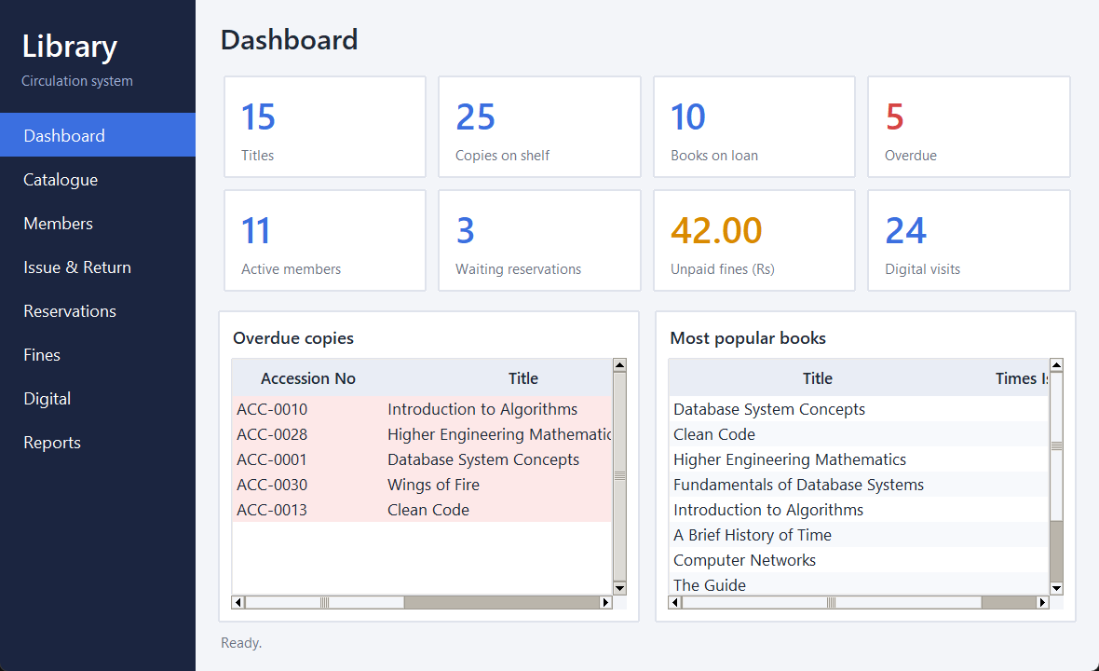
Figure 2. Dashboard with key figures, overdue copies and popular books
Figure 3 shows the catalogue after typing a search word. Rows are filtered as the user types.
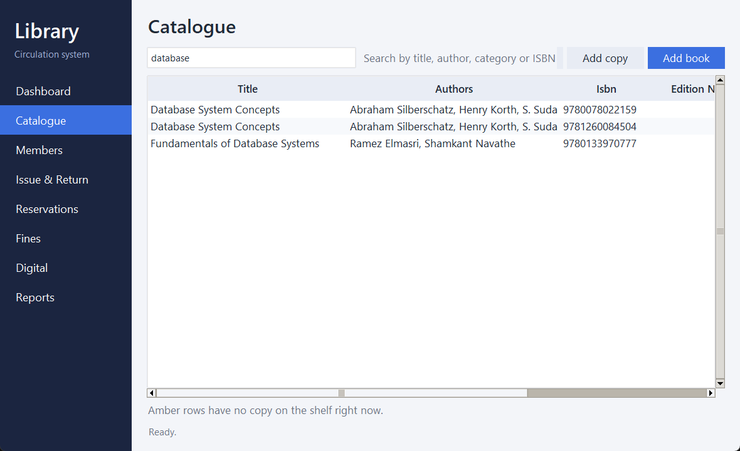
Figure 3. Catalogue search for “database”
Figure 4 shows the member list. Clicking a member shows that member's loans below. Red rows are overdue or expired.
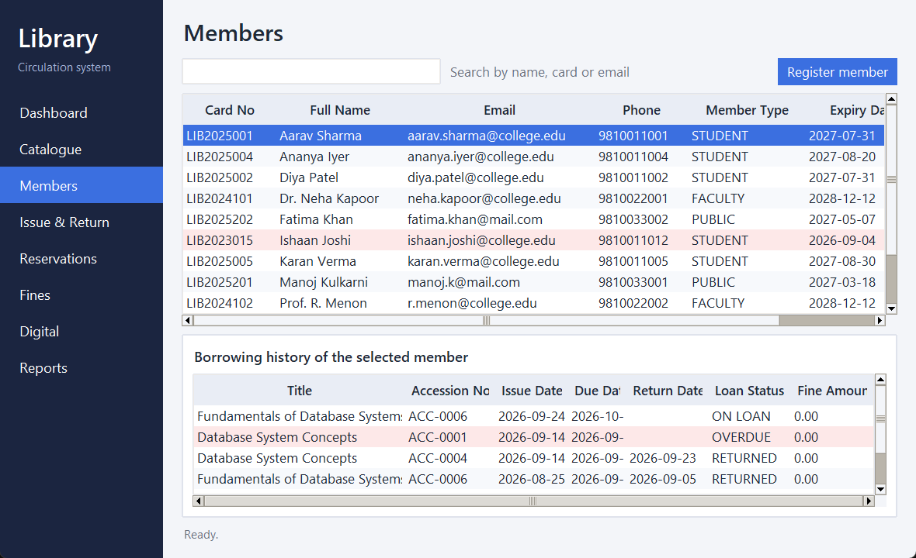
Figure 4. Member list with borrowing history of the selected member
Figure 5 shows a data-entry transaction. A copy was issued to a student, and the status bar reports the due date.
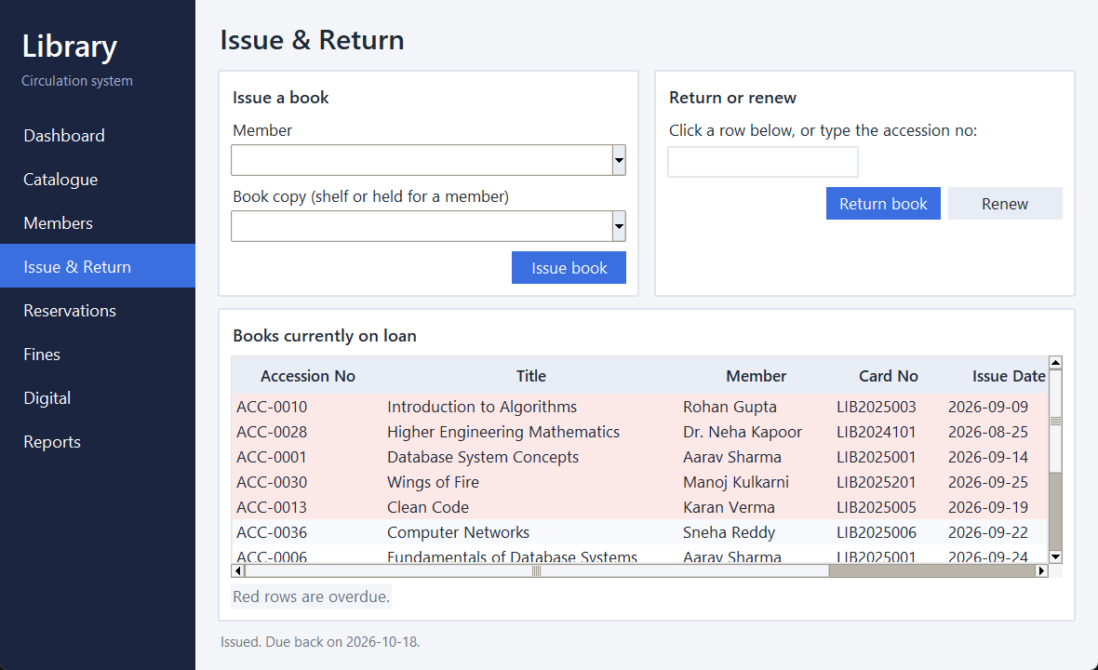
Figure 5. Issuing a book to a member (status bar shows the due date)
Figure 6 shows the return of an overdue copy. The status bar shows the fine, and the loan list no longer holds the copy.
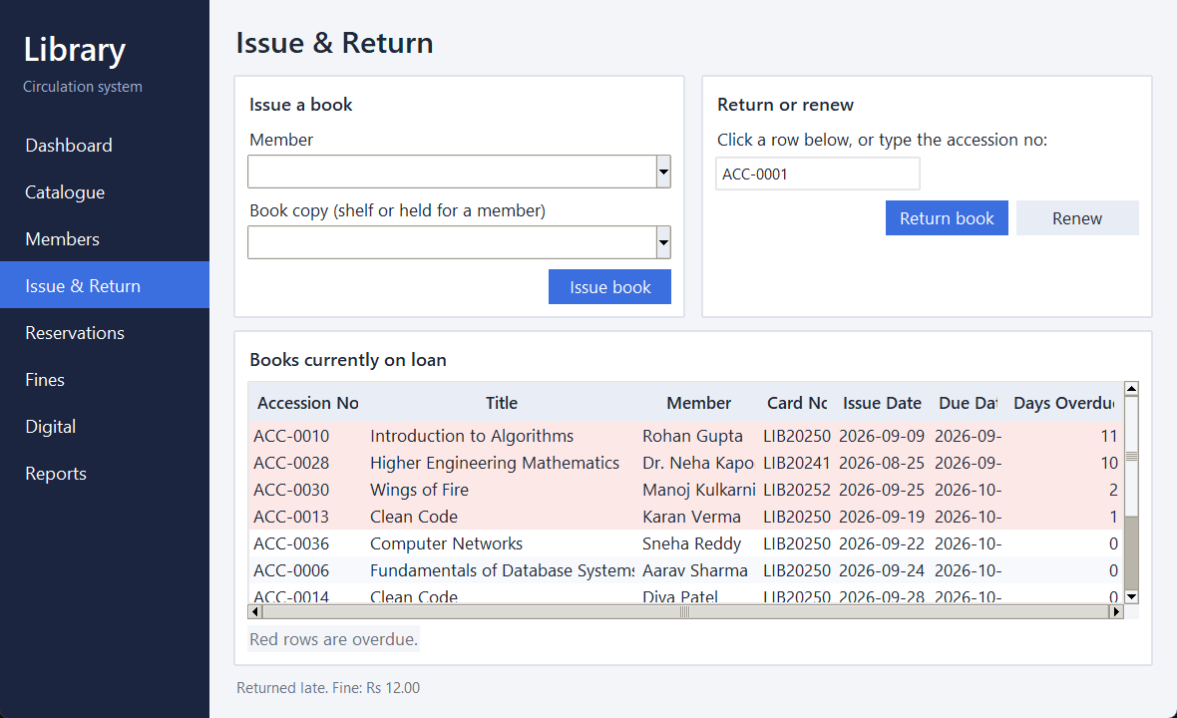
Figure 6. Returning an overdue book creates a fine
Figure 7 shows the queue. READY means a copy is being held for that member.
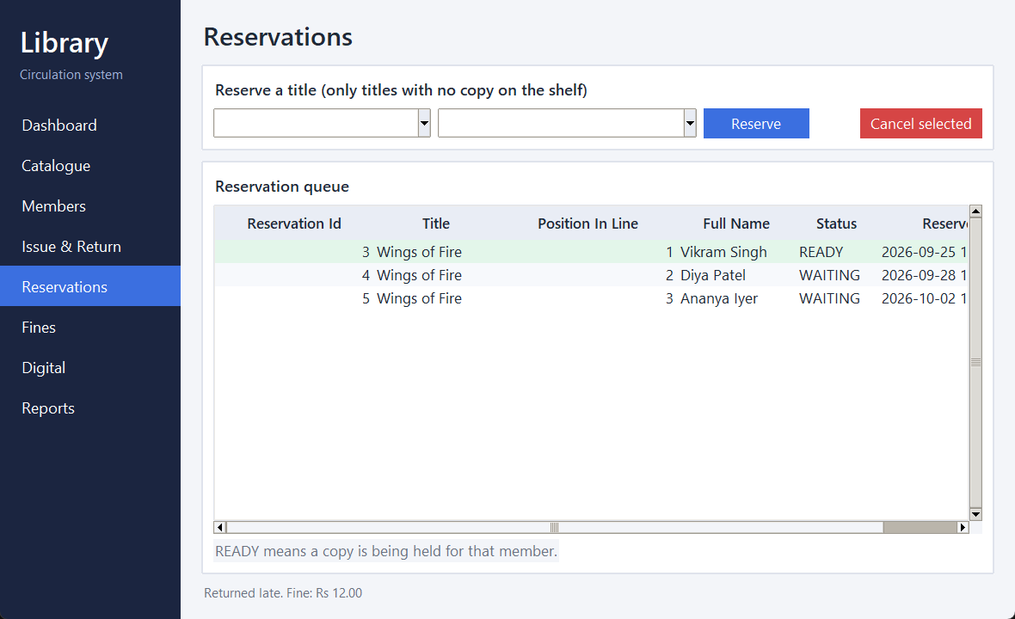
Figure 7. Reservation queue for Wings of Fire
Figure 8 lists unpaid fines. Clicking a row fills in the balance for payment.
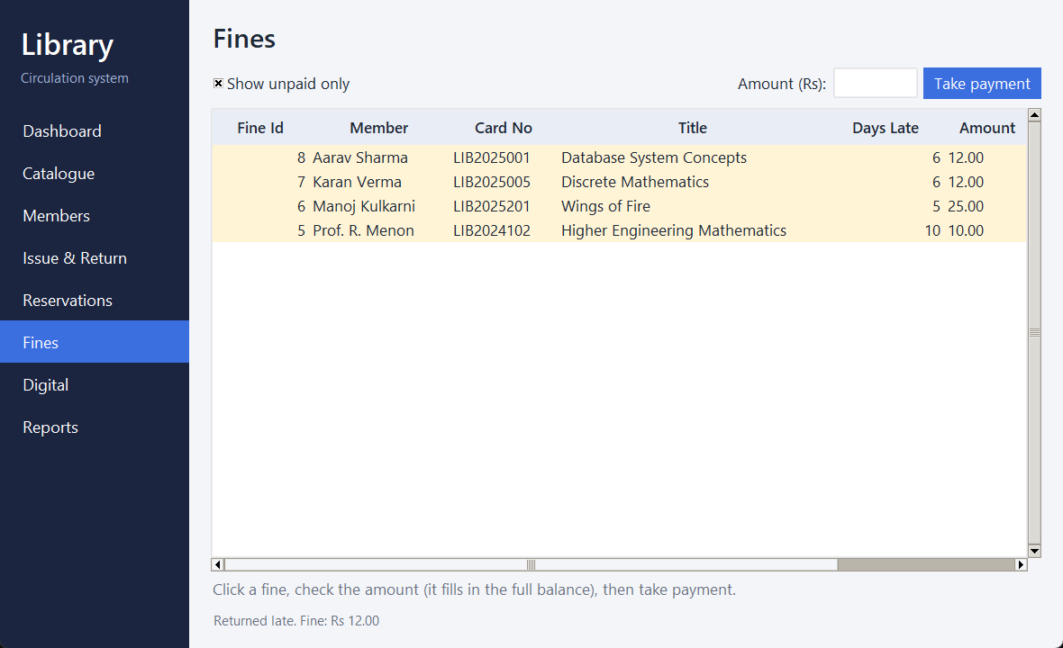
Figure 8. Unpaid fines, including the fine created by the return
Figure 9 is the overdue report with fine so far.
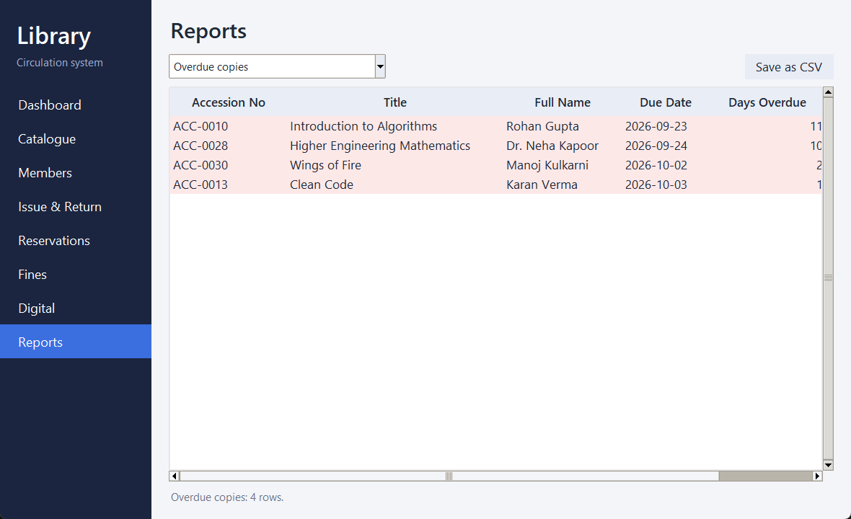
Figure 9. Report: overdue copies with fine so far
Figure 10 shows fines raised, collected and still pending for each month.
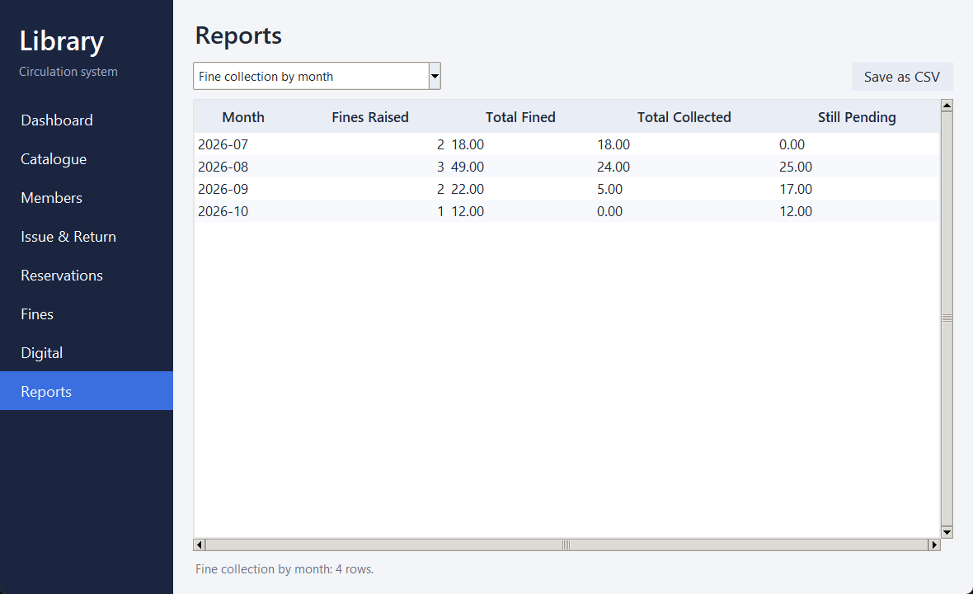
Figure 10. Report: fine collection by month
Figure 11 shows digital resource usage and the form for recording access.
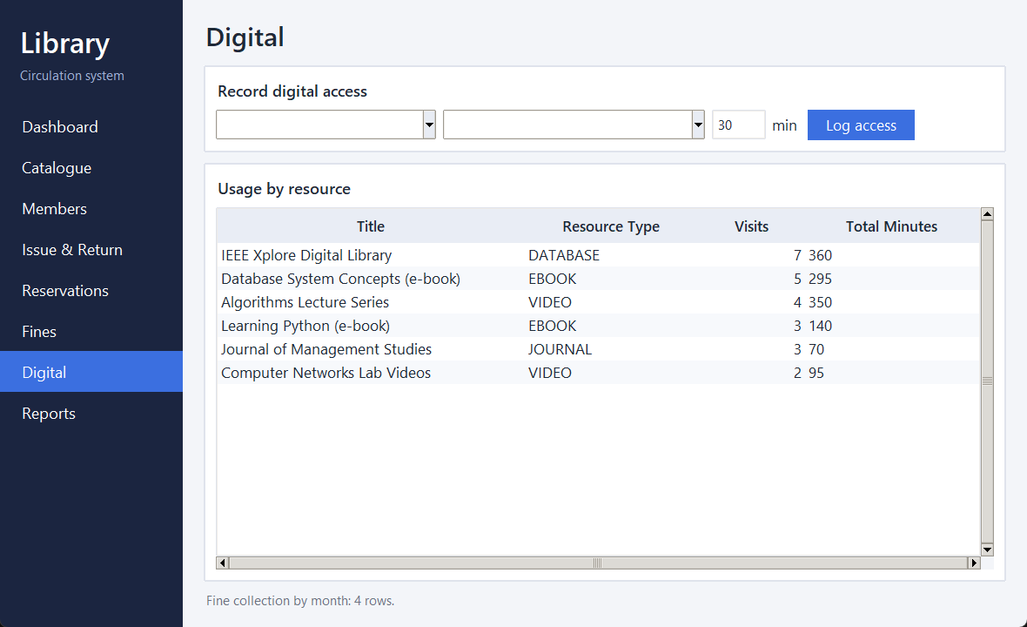
Figure 11. Digital resources and usage
3.8 Testing and Results
Table 15 lists the test cases. The expected result was written before the test was run, and the actual result is the real message or value the program produced on a freshly loaded database. The same checks, and more, are repeated in the automated test file tests/test_library.py.
Table 15. Test Cases
Test ID | Feature | Input / Action | Expected Result | Actual Result | Status
TC-01 | Issue (positive) | Issue ACC-0002 to student LIB2025007 | Loan created; due date = today + 14 days | Issued; due date 2026-10-18 (14 days). Copy became ISSUED | Pass
TC-02 | Book limit (negative) | Issue a 4th book to the same student | Refused with limit message; nothing saved | “Limit reached: Student members can hold 3 books.” Copy ACC-0005 stayed AVAILABLE | Pass
TC-03 | Copy already out (negative) | Issue ACC-0001, which is already on loan | Refused | “This copy is not available (status: ISSUED).” | Pass
TC-04 | Expired member (negative) | Issue a copy to expired member LIB2023015 | Refused | “Membership is expired.” | Pass
TC-05 | Late return (positive) | Return ACC-0001, 6 days overdue, student rate Rs 2 | Fine of Rs 12 | Fine Rs 12.00 created for 6 days late | Pass
TC-06 | On-time return | Return ACC-0002 the same day | No fine; copy back on shelf | Fine 0.00; copy AVAILABLE; no row added to fine | Pass
TC-07 | Return not on loan (negative) | Return ACC-0008, which is on the shelf | Refused | “That copy is not out on loan.” | Pass
TC-08 | Reserve while copy on shelf (negative) | Reserve Database System Concepts (copies available) | Refused | “A copy is on the shelf. Issue it directly instead of reserving.” | Pass
TC-09 | Queue promotion | Issue last copy of Clean Code, reserve, then return another copy | Returned copy held for first in line | Reservation became READY with copy 13; copy status ON_HOLD | Pass
TC-10 | Held copy for another member (negative) | Another member tries to issue held copy ACC-0029 | Refused | “This copy is kept aside for another member.” | Pass
TC-11 | Duplicate ISBN (negative) | Add a book with an ISBN already in the catalogue | Refused | “This ISBN is already in the catalogue.” | Pass
TC-12 | Invalid ISBN (negative) | Add a book with ISBN 12345 | Refused | “ISBN must have exactly 13 digits.” | Pass
TC-13 | Invalid e-mail (negative) | Register member with e-mail “not-an-email” | Refused | “Email address is not valid.” | Pass
TC-14 | Fine payment | Pay Rs 100 on a Rs 25 fine, then pay Rs 10 | First refused; second accepted with balance Rs 15 | “Amount is more than the balance of Rs 25.00.” then balance Rs 15.00 | Pass
TC-15 | Expired licence (negative) | Log use of a resource whose licence ended | Refused | “The licence for this resource has ended.” | Pass
TC-16 | Database rule: one active issue per copy | Insert a second active issue for copy 10 directly in SQL | MySQL rejects it | Error 1062: Duplicate entry '10' for key 'issue.active_copy_id' | Pass
TC-17 | Database rule: negative fine | Insert a fine of -5 directly in SQL | MySQL rejects it | Error 3819: Check constraint 'fine_chk_2' is violated | Pass

All 17 test cases behaved as expected. Forty automated unit tests also pass on MySQL 8.0 (the full set covers input checks, catalogue, issue, return, renewal, reservation, fines, digital access and reports).
The tests show that the application uses the designed database and that the important rules are enforced twice: once in the program, with a clear message for the user, and once in the database. TC16 and TC17 bypass the program and try to break the database directly, and MySQL rejects both. The failed fourth issue in TC02 left the copy untouched, which shows the rollback works.
Two defects were found and fixed during testing. The search screen counted copies twice for titles with two authors, and a failed CHECK constraint reached the user as a raw database error. The screens themselves were checked by hand and by building every page against the database, not by automated clicking.
CHAPTER 4
CONCLUSION

This project set out to replace the paper registers of a library with a reliable database. An ER model with fifteen entities was designed and converted into a relational schema in Third Normal Form. The schema was built in MySQL with keys and constraints that enforce rules such as unique ISBN and accession numbers, one active issue per copy, valid dates, queue order and non-negative fines. Realistic sample data, twenty SQL queries and six views were prepared.
On top of the database, a Python desktop application covers the daily work of a library: catalogue maintenance, member registration, issue, return, renewal, reservation, fine payment, search and reports. The most useful lesson was that rules are safest when the database enforces them, because the program can then be changed without risking bad data. Working with transactions also showed why a multi-step action such as a return, which closes a loan, adds a fine and moves a copy to the next reader, must either finish completely or not happen at all.

4.1 Limitations and Future Enhancements
- Members cannot log in. A web version with member accounts would let them search, reserve and renew by themselves.
- Fines are raised only when a book is returned. A daily job could update the amount for books still out and send reminders.
- A reserved copy stays on hold with no time limit. A real library would expire the hold after a few days.
- Lost-book charges, fine waivers and stock purchase are not handled.
- The program connects with one database user. Separate users with limited rights for librarian and admin would improve security.
- The screens are not covered by automated GUI tests.

REFERENCES
- E. F. Codd, “A relational model of data for large shared data banks,” Commun. ACM, vol. 13, no. 6, pp. 377–387, Jun. 1970, doi: 10.1145/362384.362685.
- P. P.-S. Chen, “The entity-relationship model—toward a unified view of data,” ACM Trans. Database Syst., vol. 1, no. 1, pp. 9–36, Mar. 1976, doi: 10.1145/320434.320440.
- A. Silberschatz, H. F. Korth, and S. Sudarshan, Database System Concepts, 7th ed. New York, NY, USA: McGraw-Hill, 2019.
- R. Elmasri and S. B. Navathe, Fundamentals of Database Systems, 7th ed. Hoboken, NJ, USA: Pearson, 2016.
- Oracle Corporation, MySQL 8.0 Reference Manual. Accessed: Oct. 4, 2026. [Online]. Available: https://dev.mysql.com/doc/refman/8.0/en/
- Python Software Foundation, “tkinter — Python interface to Tcl/Tk,” Python 3 Documentation. Accessed: Oct. 4, 2026. [Online]. Available: https://docs.python.org/3/library/tkinter.html
- Oracle Corporation, MySQL Connector/Python Developer Guide. Accessed: Oct. 4, 2026. [Online]. Available: https://dev.mysql.com/doc/connector-python/en/

APPENDICES

APPENDIX A - COMPLETE DATABASE SCRIPT
The complete database script is submitted as four files in the sql folder of the project:
- sql/01_schema.sql: DROP/CREATE DATABASE, all 15 tables, constraints and indexes
- sql/02_sample_data.sql: Sample data for every table
- sql/03_views.sql: Six views used by reports and screens
- sql/04_queries.sql: Twenty queries: joins, aggregates, nested queries, views, EXPLAIN
Run them in the order shown. The first script drops and rebuilds the database named library_db.

APPENDIX B - APPLICATION SOURCE CODE
The application source code and the automated tests are in the project folder submitted with this report:
- app/library.py: Database layer: connection, validation, transactions and all circulation rules
- app/app.py: Tkinter desktop application with eight screens
- tests/test_library.py: Forty automated tests (python -m unittest discover -s tests -v)
To run: load the SQL files, then start the program with python app/app.py from the project folder.

APPENDIX C - ADDITIONAL TEST DATA AND OUTPUTS
Two of the six views, as an example of how reports are built. The remaining views and the twenty queries are in the SQL files named in Appendix A.
-- Copies that are past their due date and not yet back
CREATE OR REPLACE VIEW v_overdue_copies AS
SELECT i.issue_id, cp.accession_no, b.title, m.card_no, m.full_name, m.email,
i.issue_date, i.due_date,
DATEDIFF(CURDATE(), i.due_date) AS days_overdue,
DATEDIFF(CURDATE(), i.due_date) * mp.fine_per_day AS fine_so_far
FROM issue i
JOIN copy cp ON cp.copy_id = i.copy_id
JOIN edition e ON e.edition_id = cp.edition_id
JOIN book b ON b.book_id = e.book_id
JOIN member m ON m.member_id = i.member_id
JOIN member_policy mp ON mp.member_type = m.member_type
WHERE i.return_date IS NULL AND i.due_date < CURDATE();

-- Waiting list, in queue order
CREATE OR REPLACE VIEW v_reservation_queue AS
SELECT r.reservation_id, b.title, e.edition_id, r.queue_no, m.full_name,
r.status, r.reserved_on,
ROW_NUMBER() OVER (PARTITION BY r.edition_id ORDER BY r.queue_no) AS position_in_line
FROM reservation r
JOIN edition e ON e.edition_id = r.edition_id
JOIN book b ON b.book_id = e.book_id
JOIN member m ON m.member_id = r.member_id
WHERE r.status IN ('WAITING','READY');

