TVClock – Networking design

How information is transferred between the client and the server application.

Data types
RequestType [Enum]
- Get // Client only – Obtain data from server
- Post // Client only– Update data to server
- Update // Server only – Updates client data

DataAction [Enum]
- Add // Add data to list
- Edit // Edit data in list
- Delete // Delete data in list

Packet [Class]
- RequestType requestType // One of the possible RequestType
- bool isResponse // Is response to acknowledge receiving a packet
- bool isServer // Sender is the server or not
- string data (Nullable) // Data serialized in JSON
- string[] dataIdentifiers // Identifiers for the data string
- long timestamp // UNIX timestamp of packet sending time
- long id // Incrementing id to identify received packet origin

DataActionPacket [Class]
- DataAction dataAction // One of the possible DataAction
- string hash // Hash of the data being referred to
- string data (Nullable) // Data serialized in JSON

Data exchange scenarios
Client startup
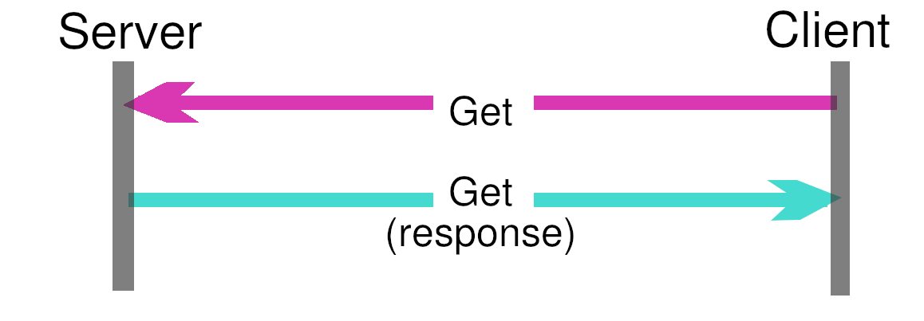
The client sends a get request to the server, along with an array of dataIdentifiers for the data it wishes to get.

The server sends a response back with the same request, the data is serialized as a JSON string in the packet.

The response get packet is differentiated from other packets as it has the same id as the packet sent out.

Client data modified
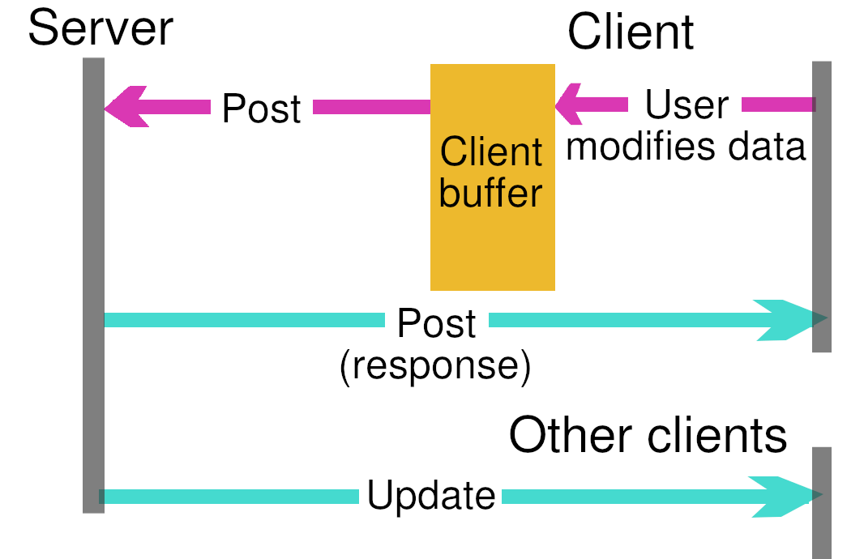
To support offline networking, client data can be modified with DataActionPackets using the 3 DataActions. DataActionPackets are stored as JSON in the string data property of the Packet.

A hash is used within the DataActionPacket to refer to the data being modified

The hash is generated from the Unix timestamp of when the item is created and the JSON string of the item, the hash is only generated when the item is first created.

Because the Unix creation timestamp is part of the hash, it removes the possibility of refering to the wrong item. Allowing a client to refer to an item without a risk of conflict.

When client data is modified by the user, DataActionPackets are buffered and sent when client reconnects or connects to the server. The actions are then forwarded by the server to other connected clients so their data matches the server’s.

