Data Management and Accounting Analysis

**PROJECT SYNOPSIS**

OF MINI PROJECT

**BACHELOR OF TECHNOLOGY**

Branch – CSE (Data Science)

SUBMITTED BY ADITYA RAJ (2101331540008)

AJENDRA RAI (2101331540012) DHAIRYA KUMAR SINGH (2101331540036)

Batch – 2022-23



**NOIDA INSTITUTE OF ENGINEERING AND TECHNOLOGY (NIET)**

**GREATER NOIDA, INDIA**

**Title:** Data Management and Accounting Analysis

# Objective:

The objective of the project is to create a segment of banking website that allows user to create, modify and delete their account and admin can manage users account details and can access user transaction details.

# Features:

The website will have the following features:

* User registration and login: The website will allow users to create new accounts by providing their personal information and a username and password. Users will be able to log in to their accounts securely.
* Account management: Once logged in, users will be able to view their account information, including their balance and transaction history. They will also be able to update their personal information, such as their address, phone number, etc.
* Account opening: Users will be able to open new accounts, such as saving or current account as per need, directly from the website.
* Admin login and accessibilities: In admin’s login section, after login, admin can access all customer details and able to modify or delete any user account. Admin is also able to see all transaction details of required user. The regular customers are not able to logged in or create new admin account.

# Feasibility Study:

A feasibility study is a critical component of any project. It helps in determining whether the project is practical, achievable, and viable within the given constraints. In this case, we will conduct a feasibility study for a mini-project involving the development of a Data Management and Accounting Analysis form account opening to maintaining database of user details and their transactions.

Technical Feasibility: Technical feasibility is a standard practice for companies to conduct feasibility studies before commencing work on a project. Businesses undertake a technical feasibility study to assess the practicality and viability of a product or service before launching it. To develop a banking website, technical expertise is required in web development, database management, and cyber security. The website must be able to handle large amount of data, and the database must be secure from any unauthorized access. It will be feasible if the required technical expertise is available.

Economic Feasibility: The cost of developing a banking website can be high, considering the technical expertise required and the resources needed for development. The development costs should be compared with the potential benefits to ensure that the project is economically feasible.

Operational Feasibility: It refers to the ability of a project or business venture to generate enough revenue to cover its costs and provide a reasonable return on investment. It involves analyzing the costs and benefits of a project, including the costs of materials, labor, and equipment, as well as the projected revenue from sales or other sources of income. The banking website should be user-friendly, easy to navigate, and provide all the required information to the customers. The website should be easy to use. The website should also be able to handle a large volume of users without any downtime.

Legal and Ethical Feasibility: It is the measure of the practicality of a specific technical solution and the availability of technical resource and expertise. The banking website should comply with all the legal and ethical requirements. It should comply with data protection laws, and the website should have proper security measures to prevent unauthorized access to the customer's data.

Conclusion: In conclusion, the feasibility study shows that the development of a banking website for account opening page insertion, modification and deletion is feasible. The technical expertise can be acquired, and the cost-benefit analysis shows that the project is economically viable. Operational feasibility can be ensured by making the website user-friendly and secure, and the website should comply with all the legal and ethical requirements.

# Methodology:

The project management methodology is essential in companies today because the projects needs much tighter incorporation and innovativeness than previous years, this demands the use of more resourceful means to test, design, build and deploy products and services. The following methodology or steps can be followed for the development of a banking website for account opening page:

* Requirement Analysis:

Requirement analysis is significant and essential activity after elicitation. We analyze, refine, and scrutinize the gathered requirements to make consistent and unambiguous requirements. In this step, the requirements for the banking website should be identified. This includes the features and functionalities required for the website, such as user account creation, login, account opening, account and deletion. It is essential to identify the user requirements and expectations.

* System Design:

System design is the **process of defining the architecture, interfaces, and data for a system** that satisfies specific requirements. System design meets the needs of your business or organization through coherent and efficient systems. In this step, the system design for the banking website should be created. The design should include the database design, UI design, and system architecture. The database design should include the table structure, data types, and relationships. The UI design should be user-friendly and easy to navigate.

* Development:

After the system design is created, the development of the banking website can be started. The development can be done using various web development technologies such as HTML, CSS and backend technology like Django (Python-based web framework). The website should be developed according to the design.

* Testing:

Software testing is the process of evaluating and verifying that a software product or application does what it is supposed to do. The benefits of testing include preventing bugs, reducing development costs and improving performance. Once the development of the website is completed, it is essential to test the website to ensure that it is free from any bugs or errors. Testing can be done using various testing techniques such as functional testing, performance testing, security testing, and user acceptance testing.

* Deployment:

After the testing is completed, the website can be deployed to the production environment. It is essential to ensure that the deployment process is smooth and all the necessary configurations are done correctly.

* Maintenance:

After the deployment of the website, it is essential to maintain the website regularly to ensure that it is running smoothly and is up-to-date with the latest security patches and updates. Regular maintenance will help to avoid any downtime or security breaches.

* Conclusion:

By following these steps, a banking website for account opening page insertion and deletion can be developed. It is essential to ensure that the website is user-friendly, secure, and compliant with all the legal and ethical requirements. Regular maintenance and updates will l help in keeping the website up-to-date and secure.

# Technologies:

The website will be built using the Django framework, which provides a robust and secure platform for developing web applications. The front- end of the website will be built using HTML, CSS, while the back-end will be written in Python.

Django is a high-level Python web framework that enables rapid development of secure and maintainable websites. Built by experienced developers, Django takes care of much of the hassle of web development, so you can focus on writing your app without needing to reinvent the wheel. It is free and open source, has a thriving and active community, great documentation, and many options for free and paid-for support.

The Hyper Text Markup Language or HTML is the standard [markup language](https://en.wikipedia.org/wiki/Markup_language) for documents designed to be displayed in a [web browser](https://en.wikipedia.org/wiki/Web_browser). It is often assisted by technologies such as [Cascading Style Sheets](https://en.wikipedia.org/wiki/Cascading_Style_Sheets) (CSS) and [scripting languages](https://en.wikipedia.org/wiki/Scripting_language) such as [JavaScript](https://en.wikipedia.org/wiki/JavaScript).

[Web browsers](https://en.wikipedia.org/wiki/Web_browser) receive HTML documents from a [web server](https://en.wikipedia.org/wiki/Web_server) or from local storage and [render](https://en.wikipedia.org/wiki/Browser_engine) the documents into multimedia web pages. HTML describes the structure of a [web page](https://en.wikipedia.org/wiki/Web_page) [semantically](https://en.wikipedia.org/wiki/Semantic_Web) and originally included cues for its appearance.

CSS can be used for very basic document text styling — for example, for changing the [color](https://developer.mozilla.org/en-US/docs/Web/CSS/color_value) and [size](https://developer.mozilla.org/en-US/docs/Web/CSS/font-size) of headings and links. It can be used to create a layout — for example, [turning a single column of text into a layout](https://developer.mozilla.org/en-US/docs/Web/CSS/Layout_cookbook/Column_layouts) with a main content area and a sidebar for related information. It can even be used for effects such as [animation](https://developer.mozilla.org/en-US/docs/Web/CSS/CSS_Animations). Have a look at the links in this paragraph for specific examples.

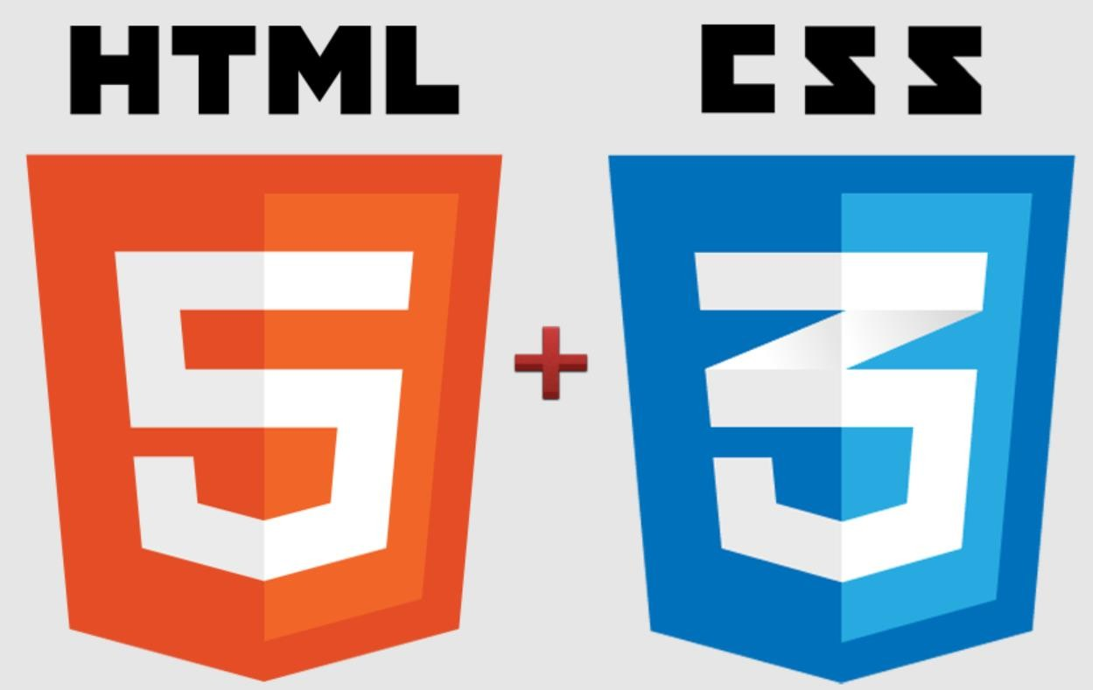

# CONCLUSION

In conclusion, the development of a banking website for account opening page (with features of insertion and deletion) is feasible and can be done by following a step-by-step methodology. The website should be user-friendly, secure, and comply with all legal and ethical requirements. The development process should include requirement analysis, system design, development, testing, deployment, and maintenance. Regular maintenance and updates will help to ensure that the website is up-to-date and secure. The database design should include the table structure, data types, and relationships. The UI design should be user-friendly and easy to navigate. Overall, the banking website will provide convenience to customers and improve the efficiency of the banking system by allowing account opening and deletion to be done online

# BIBLIOGRAPHY

[**www.youtube.com**](http://www.youtube.com/)