ZEBRON
Zebron Learning
User, administrator and developer manual

Courses · Test Center · Virtual Classroom · Certifications · Polls · Dashboards
Edition: November 2026 (Knowledge Center edition 31)
Audience: learners, organization staff and managers, Zebron platform administrators, and the developers who maintain Zebron
Source of truth: the code in the zebron repository and the Knowledge Center articles it publishes

Contents

If the page numbers above are empty, right-click the table and choose Update Field (Word fills them in when the document is opened).

1. About this manual
Zebron Learning is the learning side of the Zebron platform. It brings together three capabilities that an organization can switch on separately: Courses (lessons, quick checks, final exams and certificates), the Test Center (question banks for practice and graded exams) and the Virtual Classroom (scheduled live sessions with an instructor). Around them sit certifications, course assignments, team progress, live polls and the shared dashboards.
The manual is written for four groups of readers:
Reader | Read these parts
Learners (every member, and anyone using Zebron’s public courses) | Parts 2, 3 and 4
Organization staff and managers (authors, reviewers, instructors) | Parts 2–5
Organization admins and owners, Zebron platform administrators | Parts 2–6
Developers and maintainers | Everything, especially Parts 7–12

Two kinds of content
- Zebron (platform) content is written by Zebron’s platform administrators and is open to everyone: Zebron courses at /courses and public quizzes at /test-center. In the data it has scope: platform and organizationId: null.
- Organization content belongs to one organization (a school, company or group) and is visible only to its members, at /partner/org/<organization id>/…. Each organization writes its own courses, quizzes and live sessions, and can also offer Zebron’s.

Words used in this manual
Term | Meaning
Course | A learning course: modules of lessons, each lesson made of blocks and usually ending with a quick check; optionally a final exam and a certificate.
Quiz | A Test Center question bank, grouped into topics. (Older screens and data called it a “course”.)
Program | A group of quizzes and courses, such as a bootcamp. Courses in a program are shown in step order.
Quick check | A question at the end of a lesson section; the right answer unlocks Complete and continue.
Final exam | A server-graded exam at the end of a course, drawn from a Test Center quiz. Passing it issues a certificate.
Certification | An ordered path of courses that ends in a certification exam and a credential valid for 3 years.
Exam-only quiz | A quiz whose questions are never sent to learners’ browsers; it can only be taken as a server-graded exam.
Assignment | A manager asking people to take a course or one lesson, optionally by a due date.
Entitlement | An application switched on for an organization (for example courses, test-center, virtual-classroom).

2. Getting access

2.1 Signing in
- Zebron uses Firebase Authentication: email and password, or Sign in with Google.
- Anyone can browse the Zebron course catalog without signing in. Starting a course, saving progress, taking quizzes and exams, and joining live sessions need a signed-in account.
- Add your first and last name in Profile (an amber reminder shows until you do): certificates use your name.

2.2 Joining an organization
- An organization manager (or above) invites you from Administration; you receive an email invitation.
- Open the invitation link, sign in or create an account, and accept. Your membership is created with the role you were invited to.
- Your organization’s dashboard opens at /partner/org/<organization id>/dashboard. Its Learning card (and the Courses, Test Center and Virtual Classroom entries in the app menu) lead to the learning pages.
Note: Each person has exactly one role in each organization they belong to. Roles can only be changed by someone with a higher role (see Part 3).

2.3 Where everything lives
What | Zebron (public) | Your organization
Courses: My learning, Catalog, Certificates | /courses | /partner/org/:id/courses
Certifications | /courses/certifications | /partner/org/:id/courses/certifications
A course, a lesson, the exam, the certificate | /courses/:courseId (…/lessons/:lessonId, /summary, /exam, /certificate) | same under /partner/org/:id/courses
Manage courses (course builder) | /courses/manage | /partner/org/:id/courses/manage
Test Center quiz library and practice | /test-center/quizzes | /partner/org/:id/learn/test-center
Test Center management | /admin/test-center (platform admins) | /partner/org/:id/test-center (staff+)
Virtual Classroom (live sessions) | — | /partner/org/:id/live
Learning administration | — | /partner/org/:id/learning/manage (staff+)
Team progress | — | /partner/org/:id/learning/progress (managers+)
Dashboards | — | /partner/org/:id/dashboards
Check a certificate | /verify and /verify/:code (public, no sign-in)

The old Learning Lab address (/learning) opens Courses. On phones, the Certificates, Test Center, Live sessions and Manage courses tabs move into the ⋮ menu at the right of the tabs.

3. Roles and access control
Access is decided twice: the app hides what you can’t use (route guards and the permission map), and the database rules refuse anything you aren’t allowed to read or write, whatever the browser sends. Anything sensitive (exams, certificates, team progress, votes) runs in Cloud Functions that check the role again on the server.
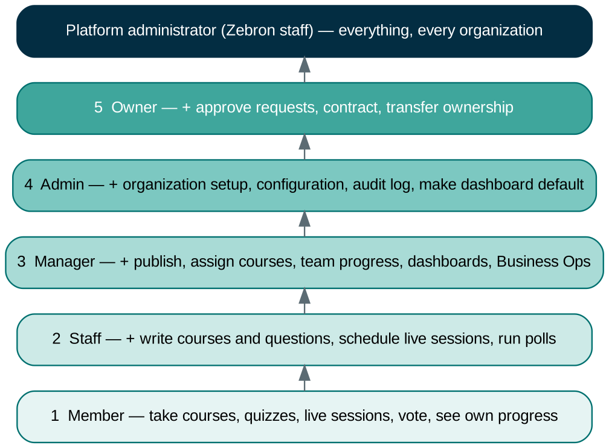
Figure 1. The organization role ladder. Each role includes everything below it.

3.1 Platform role and organization roles
- Platform administrator (Zebron staff): platformRole: "platform-admin" on users/{uid}. Full access to every organization and to Zebron’s own content. Their dashboard badge says Platform Admin.
- Organization roles, stored in organizationMemberships/{uid}_{orgId} with role and active: org_member (1) < org_staff (2) < org_manager (3) < org_admin (4) < org_owner (5).
- Managers and above manage people strictly below their own role, only to roles below their own, and never themselves.
- Roles are copied onto the sign-in token (custom claims zv, zpa, zorg), so most checks don’t need a database read. A role missing from the token falls back to the membership document; a removed role can keep working for up to an hour (token lifetime).

3.2 What each role can do in Learning
Action | Member | Staff | Manager | Admin / Owner | Platform admin
Take published courses, quick checks, final exams | ✓ | ✓ | ✓ | ✓ | ✓ (can skip lessons)
Practise quizzes; take Test Center exams | ✓ | ✓ | ✓ | ✓ | ✓
Register for and join live sessions; vote in polls | ✓ | ✓ | ✓ | ✓ | ✓
See own progress, assignments, certificates | ✓ | ✓ | ✓ | ✓ | ✓
Write organization courses; submit for review |  | ✓ | ✓ | ✓ | ✓
Publish, unpublish, delete organization courses |  |  | ✓ | ✓ | ✓
Write Test Center questions; submit for review |  | ✓ | ✓ | ✓ | ✓
Create programs, quizzes, topics; publish and import questions |  |  | ✓ | ✓ | ✓
Schedule live sessions, mark attendance, run live polls |  | ✓ | ✓ | ✓ | ✓
Assign courses; Team progress |  |  | ✓ | ✓ | ✓
Read other people’s Test Center results (Learners page) |  |  |  | ✓ | ✓
Create and edit dashboards; org-wide learning figures |  |  | ✓ | ✓ | ✓
Make a dashboard the organization default |  |  |  | ✓ | ✓
Write Zebron courses, quizzes, certifications |  |  |  |  | ✓

3.3 The permission map (developers)
PARTNER_PERMISSIONS in src/app/core/services/partner-access.service.ts is the single place that names a permission and its minimum role. Route guards use minimumOrganizationRole, components call PartnerAccessService.can(), and firestore.rules enforces the same ladder.
Permission | Minimum role | Used for
applications.view | org_member | Open every provisioned application
testCenter.settings | org_staff | Gear on the Test Center card (management)
knowledge.manage | org_staff | Knowledge Center articles
dashboards.manage | org_manager | Create, edit, delete dashboards
learning.insights | org_manager | Org-wide learning figures (same data as Team progress)
members.manage / administration.access | org_manager | Invite people, change roles, Administration page
community.moderate | org_manager | Moderate the organization community (and its polls)
business.manage | org_manager | Business Operations (not part of Learning)
audit.view, organization.configure, applications.request | org_admin | Audit log, configuration, request applications
applications.approve, partnership.terminate | org_owner | Approve requests, end the contract

3.4 Applications (entitlements)
Learning is a parent application with three capabilities, each provisioned separately under organizations/{id}/applications/{appId} with status: "active":
Capability | appId | Pages it unlocks
Courses | courses | Organization courses, assignments, Team progress, learning dashboards
Test Center | test-center | Quiz library, practice, exams, Test Center management, learner results
Virtual Classroom | virtual-classroom | Live sessions, registrations, attendance, live polls

The Learning card is shown while any capability is active. Organizations request capabilities when applying, or later from the Contract page (Learning → Add more); the owner approves.

4. Guide for learners
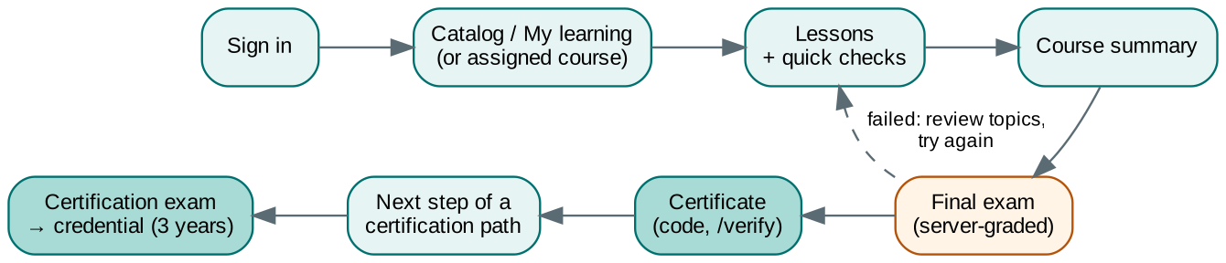
Figure 2. A learner’s path through a course, its final exam and a certification.

4.1 Courses: My learning, Catalog and Certificates
Tab | What it shows
My learning | Assigned to you (with Required, due date and Overdue in red); a Continue card for the course you used last; your week; courses in progress; recommendations
Catalog | Every published course. Programs first (in step order, with your progress and Start/Continue), then More courses. Filter by topic or search by name or skill
Certificates | Every course you have completed with a certificate
Certifications | Each certification path with its steps and your status

In an organization you see your organization’s courses first, then Zebron’s.

Your week
- Week streak: weeks in a row with at least one completed lesson; the dots show the days you learned this week.
- Minutes this week against a 60-minute goal; Completed courses and Skills earned.

4.2 Taking a lesson
- Open a course and press Start course (or Resume).
- Each lesson is split into numbered sections. Read the text, watch the video, listen to the audio or page through the slides; they play inside the lesson. Links from other sites open in a new tab.
- Answer each quick check. A wrong answer just asks you to try again; Complete and continue unlocks with the right one. Only your first answer counts towards your score.
- Your progress is saved when you continue, and the next unfinished lesson opens. The outline (wider screens) shows what is done.

4.3 Final exam and certificate
- After the last lesson the course summary opens: lessons done, time spent, your first-try quick check score and what you learned.
- If the course has a final exam, press Take test. The rules show first (questions, pass mark, time limit, attempts); then one question at a time with a question map and, when set, a timer that submits by itself.
- The exam is graded on Zebron’s server. You see your score and the topics to review, never the right answers.
- A certificate needs a passed final exam. It shows your name, the date, your score, the skills and a code such as ZB-7Q4K-M2XP. Print or save as PDF, or Add to LinkedIn.
- Anyone, an employer for example, can check a code at /verify.

4.4 Certifications
A certification is an ordered path of courses ending in a certification exam. Zebron offers the Zebron Certified Cybersecurity Associate (8 Cybersecurity Program courses; prepares for CompTIA Security+ and ISC2 CC) and the Zebron Certified ServiceNow Administrator (8 courses; prepares for ServiceNow CSA). Exam-preparation paths for vendor exams (CompTIA Security+, ServiceNow CSA) are listed under External Professional Certifications.
- Start the certification on its page. Courses you already passed in order count at once.
- Courses go in order and can’t be skipped: a course’s final exam won’t start until the step before is passed. A course passed out of order is retaken when its step comes up.
- The certification exam opens when every course is done: 40 questions (5 per course), 75% to pass, 60 minutes.
- 3 attempts, then a 7-day wait before 3 more. The credential is valid for 3 years; Renew appears when it expires.

4.5 Test Center: practice and exams
Open the Test Center from your organization dashboard (arrow on the Test Center card) or /test-center/quizzes for Zebron’s public quizzes. The Quiz Library has search, difficulty, status and category filters, cards or a compact list, and favorites (star).
- Open a quiz and tick the topics you want (or Select all).
- Choose the number of questions (10, 20, 50, 100 or All), difficulty and test mode.
- Practice: instant feedback after each answer, with the explanation; the first answer counts.
- Exam: no feedback until the end; skip questions and flag them for review. Exams are graded and recorded by Zebron’s server. Exam-only quizzes offer only this mode and don’t reveal the right answers afterwards.
- The results page shows a score ring, a bar per topic, Practise your weak topics (topics under 70%) and Review your answers.
Answer type | You do | Notes
Multiple choice | Pick one answer | Keys A–F or 1–6
True / False | Pick true or false
Multiple answers | Tick every right answer | Exactly the right set is needed
Short answer | Type a word or phrase | Capitals, accents and extra spaces are ignored
Number | Type a number | Within the allowed margin
Put in order | Arrange the steps | Shown shuffled

4.6 Live sessions (Virtual Classroom)
- Find sessions in the Live sessions tab of Courses, the Live sessions card on the Test Center home, or the Learning card on your dashboard (it shows the next session, or Live now).
- Register (or Cancel registration); full sessions say so. Add to calendar downloads a calendar file with the link.
- Join appears 15 minutes before the start and stays until 30 minutes after the end. The meeting runs in the tool the instructor chose (Jitsi, Google Meet, Zoom, Teams…).
- During the session a Live polls section shows on the session card: vote, and see the totals when the host shares them. Votes are private: nobody sees who picked what.
- Past sessions show Watch the recording when one is added.

4.7 Assignments
When a manager assigns you a course or a lesson, it appears in My learning → Assigned to you with Required, the due date and Overdue once the date passes. A whole course is done when every lesson is done and, if it has a final exam, the exam is passed; a single lesson is done when that lesson is. Assignments send no emails.

4.8 Dashboards
Your organization’s Dashboards page (next to Your Workspace on the partner dashboard) shows the dashboards meant for your role. Members typically see their own assignments, courses in progress, upcoming live sessions and live polls; team-wide figures show only to managers and above.

5. Guide for staff, managers and instructors

5.1 Learning administration
The gear on the dashboard’s Learning card opens Learning administration (/partner/org/:id/learning/manage, staff and above): a card for each active capability with counts (published, draft and in-review courses; quizzes and published questions; upcoming sessions) and links to Manage courses, New course, Test Center settings, Questions, Learner results, Team progress and the Virtual Classroom.

5.2 Building a course
- Manage courses → New course. It starts with one module and one lesson.
- Course details: title, one-line summary, About this course, Program and Step (pick from your Test Center programs), Topic (catalog category; suggestions from existing topics), level, outcomes (one per line), skills (comma-separated), cover colour, and Final exam and certificate.
- Outline: rename modules, Add lesson, Add module, reorder with the arrows.
- Lesson: title, minutes, then blocks. Save draft (or Ctrl+S); leaving with unsaved changes asks first.
- Preview shows the saved course as a learner sees it. The Before you publish list shows what is missing.
Block | Use it for
Text | The lesson itself: bold, italic, headings, lists, links and tables
Video | YouTube, Vimeo, Loom, Google Drive, Microsoft Stream (Embed link) or .mp4/.webm; optional start time and caption
Audio | SoundCloud, Spotify, or .mp3/.m4a
PDF or slides | Google Slides, Docs, Sheets, or a PDF in Google Drive
Image | An https image with a description for screen readers
Tip | A highlighted tip
Quick check | A question with 2–6 answers; mark the right one and explain why

Note: Sharing settings still apply: a Google Drive file or Slides deck must be shared so learners can open it (for example “Anyone with the link”). Other links show a button that opens them in a new tab.

5.3 Review and publishing (organization courses)
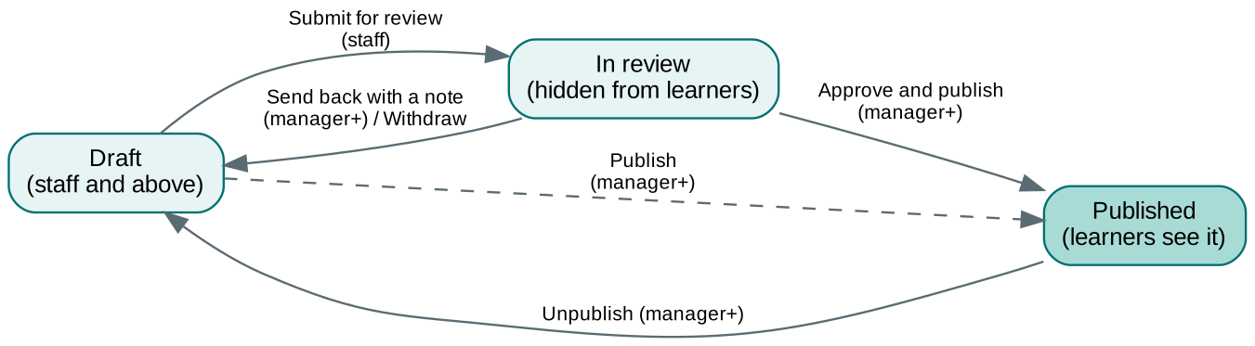
Figure 3. Course review workflow.
- Staff write and Submit for review; managers see Waiting for your review and a number on the Learning card’s gear.
- A manager presses Approve and publish or Send back with a note the author sees. A submitted course can be taken back with Withdraw from review.
- Staff can’t change a published course. A published course is live: Save changes reaches learners at once. ⋮ → Unpublish moves it back to draft; ⋮ → Delete course removes it for good.
- Zebron courses are written by platform administrators at /courses/manage.

5.4 Final exams
In Course details → Final exam and certificate, switch the exam on and choose a Test Center quiz (your organization’s or Zebron’s), then the number of questions, pass mark, time limit and attempts. Questions are drawn at random from the quiz’s published questions and graded on the server. Use an Exam only quiz for final exams so its answers never reach learners’ browsers.

5.5 Assigning courses and Team progress (managers)
- Manage courses → Assign next to a published course.
- Choose the whole course or one lesson (a lesson has no exam or certificate), an optional due date and note, and Required if mandatory.
- Tick the people (search or Select all) and Assign to …. Assigning again updates the due date and note; the bin removes an assignment.
Team progress (/partner/org/:id/learning/progress) has an Assignments tab (status Not started, In progress, Completed, Overdue; filters and search) and a People tab (courses started and completed, certificates, assignments done, last activity). Download CSV saves the current tab. It covers the organization’s own courses only; learners’ progress stays private otherwise.

5.6 Managing the Test Center
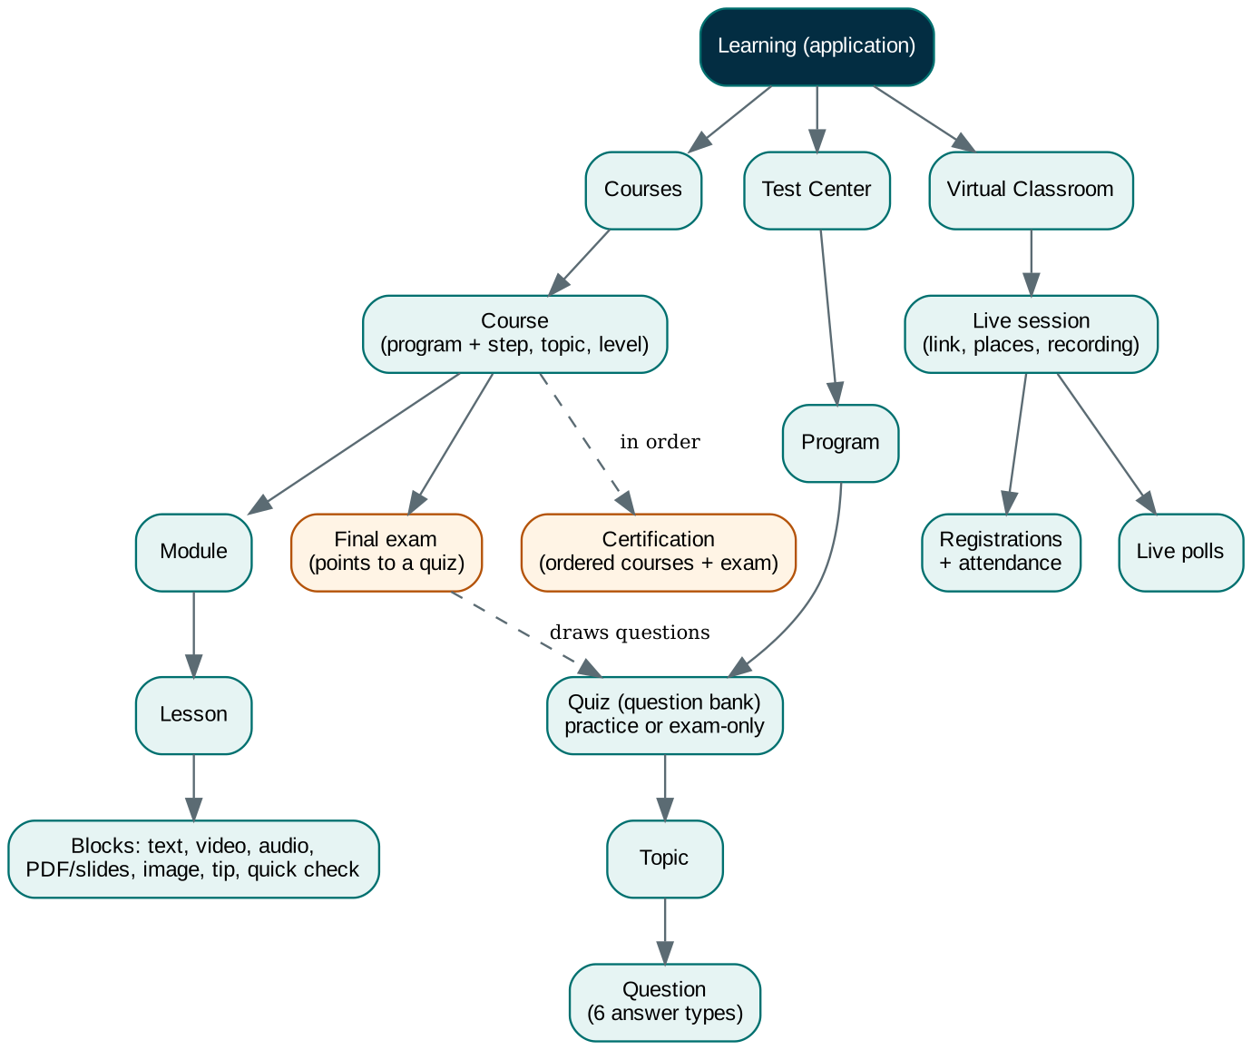
Figure 4. How Learning content is organised.
Open the Test Center with the gear on its dashboard card. The Structure section shows the tree Program → Quiz → Topic, with New program, + Quiz, + Topic, ✎ edit, ↑↓ topic order, Show inactive and Expand all.
Who | Can do
Staff | Write questions and submit them for review
Managers and above | Create programs, quizzes and topics; review and publish questions; import question files; see learner results
Members | See only published questions, in the learner view

Writing questions
- Open Questions, pick the quiz and topic (managers can add a topic with + New topic).
- Choose the answer type, mark the right answer, add an explanation (shown after answering) and an optional hint.
- Set difficulty and tags, then submit for review or publish.

Importing questions
Managers: Test Center → Import. CSV (Excel: Save As → CSV UTF-8) or JSON, up to 2,000 questions and 5 MB. Columns: program, course (or quiz), topic, question, type (multiple-choice or true-false), option_a…option_f, correct_answer (letter or exact text), explanation, hint, difficulty, tags, and an optional stable id so re-imports update instead of duplicating. A review step shows what is new, updated or skipped (with line numbers) before anything is saved.

Exam-only quizzes
- Tick Exam only on a quiz (organization Test Center or Zebron’s admin Test Center) for final exams and certifications.
- Learners can’t practise it or read its questions; in the Test Center it offers only Exam mode, and course final exams can use it.
- Results show the score and topic breakdown but not the right answers. Managers still see and edit every question.

Using Zebron quizzes
Zebron publishes quizzes every organization can use. In Structure, edit one of your programs, tick quizzes under Zebron quizzes in this program and save. They appear in your learners’ Quiz Library marked Zebron; you can’t edit them.

Learner results
Test Center → Learners lists your members with their assessment count, average score and last activity; each learner page shows their results by quiz. Practice results, Test Center exams and course final exams all appear there. The page opens for staff and above, but the rules let only admins and owners read other people’s results (see Part 13).

5.7 Running live sessions
- Learning → gear → Virtual Classroom, or the Live sessions tab. Schedule session: title, description, start (your time zone), length, instructor and places (0 = no limit).
- Meeting link: Create a Jitsi link (free, no learner account), open Google Meet / Zoom / Teams to create one with your own account and paste it back, or paste any link.
- Before or during the session, ⋮ → Polls: Save for later (draft) or Open now. Show results to everyone shares totals; Close poll, Reopen, Delete.
- Afterwards: ⋮ → Registrations and attendance (tick who attended), Edit / add recording, Cancel session (kept as cancelled) or Delete.
Note: Zebron doesn’t host video: the meeting runs in the tool you chose, so there is no extra cost.

5.8 Dashboards for learning
Managers create dashboards from templates (Organization overview, Learning, Business overview, Blank), add up to 12 widgets, and choose who can see and edit them. Learning widgets include course completion %, active learners (7 days), overdue assignments, certificates, bar charts of completions per week, assignments by status and completions by course, the viewer’s own assignments and courses in progress, upcoming live sessions and live polls. Team-wide figures are refreshed nightly (02:45 ET) and on request from ⋮ → Refresh learning figures (at most every 10 minutes). Admins and owners can make the Organization overview dashboard the default; it then replaces the app cards under Your Workspace.

6. Guide for Zebron platform administrators
- Zebron courses: /courses/manage (or Courses on the admin dashboard). Same builder as organizations, without the review step.
- Zebron Test Center: /admin/test-center manages Zebron programs, quizzes, topics and questions (scope platform). Create from courses creates a program for each course Program name. Making a Zebron quiz inactive hides it from every organization.
- Zebron questions: /admin/test-center/questions edits and imports questions for Zebron quizzes only.
- Certifications and programs are written by seed scripts (see Part 11). Organizations will be able to define their own certifications; the data and rules are ready, the editor screen is not built yet.
- Platform administrators can open any organization’s learning pages to help, and can try a course’s final exam without finishing the lessons.

7. Architecture and infrastructure
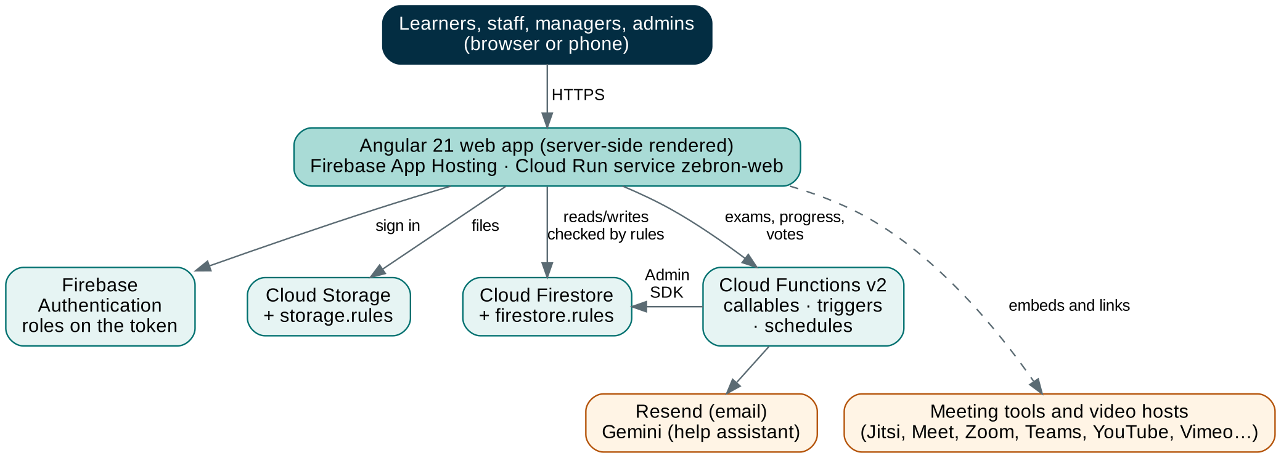
Figure 5. How Zebron is put together.
Layer | Technology | Notes
Web app | Angular 21 (standalone components, signals, OnPush), Angular Material, Tailwind CSS v4 | Server-side rendering; French and English (core/i18n)
Hosting | Firebase App Hosting (Cloud Run service zebron-web) | Push to master deploys the website; up to 20 instances
Database | Cloud Firestore (nam5) with firestore.rules and firestore.indexes.json | Browser reads/writes are checked by rules
Files | Cloud Storage with storage.rules
Server code | Cloud Functions v2, Node, firebase-admin, region us-central1 | Callables, triggers and schedules; 10 instances each
Sign-in | Firebase Authentication: email/password and Google | Roles on the token (custom claims)
Email / AI | Resend (outbound and inbound), Gemini (help assistant) | Secrets RESEND_API_KEY, GEMINI_API_KEY
Tests | Vitest; Firestore emulator on port 8080 | Unit, rules and integration tests in tests/

7.1 Design principles
- Rules first. The browser talks to Firestore directly for most things; firestore.rules is the security boundary, written so list queries can be proven from their filters.
- Server for anything that must be trusted: exam grading, certificates, certification progress, team progress across members, vote counting.
- Keep cost low: summaries instead of reading every document (dashboard stats), count queries, load on scroll, no video hosting, no email for assignments, one document of totals per poll.
- Zebron and organization content share one model, separated by scope and organizationId.

7.2 How an exam works
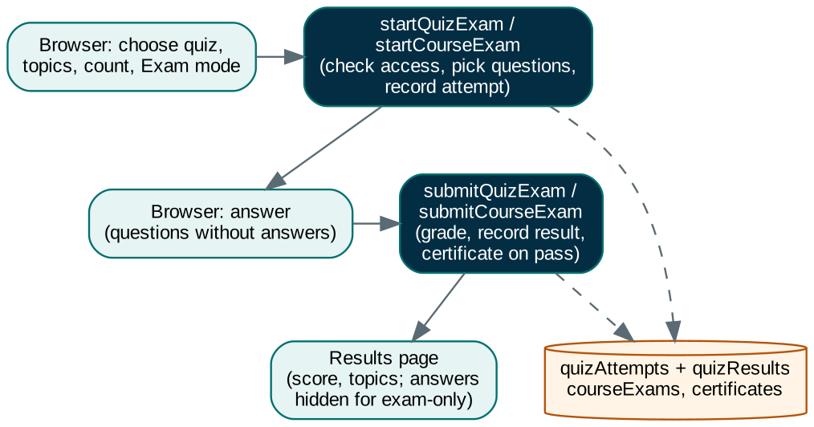
Figure 6. Server-graded exams (Test Center exam mode, course final exams).
Practice stays in the browser. Exams, from the Test Center or at the end of a course, are started and submitted through Cloud Functions that share one grading routine (isAnswerCorrect). The browser never receives the answers during an exam, and browsers may save only practice results.

8. Data model

8.1 Courses
Path | Contents | Written by
courses/{courseId} | Zebron course: details, outline modules[{id,title,lessons[{id,title,minutes,hasCheck}]}], status, program, programOrder, topic, finalExam | Platform admins
organizations/{orgId}/courses/{courseId} | Organization course (same shape, plus review status) | Staff write; managers publish
…/courses/{courseId}/lessons/{lessonId} | title, moduleId, order, minutes, blocks | Same as the course
users/{uid}/courseProgress/{progressId} | completedLessonIds, percent, status, checkScores, activity, certificateCode. progressId = courseId (Zebron) or <orgId>__<courseId> | The learner only
users/{uid}/courseExams/{progressId} (+ attempts) | Exam attempts, best score, passed, certificate code | Functions only
certificates/{code} | Public certificate record (get by code, never list) | Functions only
organizations/{orgId}/courseAssignments/{uid}__{courseId|lessonId} | userId, courseId, lessonId, dueAt, required, note, assignedBy | Managers
certifications/{id}, organizations/{orgId}/certifications/{id} | Certification definitions: courses in order, exam rules, validity | Seed scripts / managers
users/{uid}/certifications/{key} (+ attempts) | Enrollment: courseKeys, stepPasses, exam state, credential | Functions only

8.2 Test Center
Path | Contents
testPrograms/{id} | Programs; organization programs may list platformQuizIds (linked Zebron quizzes)
quizzes/{quizId} | Question bank: organizationId, scope, accessType, programId, name, slug, type, active, examOnly, questionCount
quizTopics/{topicId} | Topic of a quiz: quizId, name, sortOrder, active, questionCount
quizQuestions/{questionId} | quizId, topicId, type, options, correctAnswer (and correctAnswers, acceptedAnswers, numericAnswer/numericTolerance, correctOrder), explanation, hint, difficulty, tags, status (draft → published)
quizAttempts/{id} | One attempt: userId, quizId, questionIds, mode (practice or exam), status, score, source (test-center or course)
quizResults/{id} | The result: score, topicPerformance, questionResults, mode, source, examOnly

8.3 Virtual Classroom, polls and dashboards
Path | Contents
organizations/{orgId}/liveSessions/{sessionId} | Title, start, length, instructor, places, meeting link, recording, status
…/liveSessions/{sessionId}/registrations/{uid} | Registration and attendance
polls/{pollId} (+ results/summary, votes/{uid}) | Shared polls (community and live): question, options, status, resultsVisibility; totals; each person’s own vote
organizations/{orgId}/dashboards/{id} | Dashboard layout only (widgets, viewMinRank, editMinRank)
organizations/{orgId}/stats/learning | Nightly learning summary: members, completion %, active learners, certificates, assignments, completions by week and by course

9. Security rules
Data | Read | Write
Published Zebron courses | Anyone (lessons: signed in) | Platform admins
Organization courses | Members (published); staff and above (all) | Staff draft; managers publish (isValidCourse, isValidCourseLesson)
Course progress | Owner; platform admins | Owner only (isValidCourseProgress)
Course exams, certificates, certification enrollments | Owner (certificates: anyone by code) | Cloud Functions only
Assignments | Learner (own); staff and above (all) | Managers (id must match the fields)
Quizzes, topics | Public Zebron quizzes: signed in; organization: Test Center members | Platform admins (Zebron); managers (organization)
Questions | Published only, and not of exam-only quizzes (quizAllowsBrowserAnswers); Test Center managers read all | Staff draft and submit; managers publish
Attempts and results | Own; organization admins (organization); own Zebron records | Browsers: practice only; exams by functions
Live sessions | Members of an organization with Virtual Classroom | Staff and above
Polls | Whoever sees where the poll lives; totals by visibility setting | Runner updates status only; votes via castPollVote
Dashboards; stats | By viewMinRank; stats: managers and above | By editMinRank; stats: functions only

Developer note: Rules have a limit of 1,000 evaluated expressions per request. Put cheap checks first, guard every get() with exists(), and run the rules tests after each change.

10. Cloud Functions
Function | Type | What it does
startCourseExam / submitCourseExam | Callable | Course final exams: access, every lesson done, certification order; grade, certificate on first pass, Test Center history
startQuizExam / submitQuizExam | Callable | Test Center exam mode: pick questions without answers; grade and record the result
enrollInCertification, startCertificationExam, submitCertificationExam | Callable | Certification paths, exams, cooldown and credentials (also exam-prep readiness)
getTeamLearningProgress | Callable | Team progress for managers (members, assignments, progress of the organization’s courses)
registerForLiveSession | Callable | Register for a live session with places checked
castPollVote | Callable | Cast or change a vote and keep the totals, in one transaction
refreshOrganizationStats / refreshDashboardStatsNightly | Callable / schedule 02:45 ET | Dashboard summaries (stats/learning, stats/business)
auditQuizChanges, auditQuizTopicChanges, auditQuizQuestionChanges, auditTestProgramChanges | Triggers | Organization audit log entries
syncClaimsOnUserWrite, syncClaimsOnMembershipWrite, syncMyClaims | Triggers / callable | Roles on the sign-in token

11. Code map
Folder or file | What is in it
src/app/core/services | auth, firebase-config, partner-access (permission map), claims sync, application registry
src/app/core/guards | authGuard, adminGuard, partnerOrganizationGuard, partnerRoleGuard, applicationAccessGuard
src/app/features/courses | course.model (media resolver, progress helpers), course.service, course.store; pages my-learning, course-catalog, course-page, lesson-player, course-summary, course-exam, certificate pages, certification pages; builder/ (course-manage, course-builder, block-editor)
src/app/features/test-center | models (quiz, question, result, question-answers), services (quiz, topic, question, result, import, learners), store/test.store (practice and server exams), pages (quiz-list, quiz-details, test-practice, test-results, learners)
src/app/features/partner/test-center | Organization Test Center management (Structure, quizzes, topics, import)
src/app/features/partner/learning | learning-admin (Learning administration), team-progress
src/app/features/live | live-sessions page and service, live-polls widget, dashboard sources
src/app/shared/polls, shared/dashboards | Shared polls and the shared dashboard engine
functions/src | course-exams.ts, quiz-exams.ts, certifications.ts, learning-progress.ts, live-sessions.ts, polls.ts, dashboard-stats.ts, …
scripts/ | Seed scripts: seed-courses, seed-cybersecurity-program, seed-servicenow-program, seed-securityplus-prep, seed-servicenow-csa-prep; shared engines in scripts/lib
tests/ | unit, firestore (rules) and integration tests

11.1 Conventions
- Standalone components with signals; Tailwind with ! for important overrides; grid-cols-1, min-w-0 and [overflow-wrap:anywhere] so phone layouts never scroll sideways; 16px inputs on iOS.
- Angular templates: write an apostrophe inside a single-quoted template string as \u0027; class bindings with [ or ! go through ngClass.
- Embedded players are allowed in src/server.ts (frame-src). Add a host there when the media resolver learns a new player.
- Grading exists in the browser (practice, models/question-answers.ts) and on the server (course-exams.ts). Keep them in step.

11.2 Seed scripts
export GOOGLE_APPLICATION_CREDENTIALS="C:/path/to/service-account.json"
# validate the content only, without Firebase
node scripts/seed-cybersecurity-program.mjs --check
# dry run (prints what would change)
node scripts/seed-cybersecurity-program.mjs
# write what does not exist yet
node scripts/seed-cybersecurity-program.mjs --apply
# replace this program’s content (learner progress is kept)
node scripts/seed-cybersecurity-program.mjs --apply --overwrite

12. Testing, deployment and operations

12.1 Tests
# rules tests
firebase emulators:exec --only firestore "npx vitest run tests/firestore"
# everything (unit, rules and integration)
firebase emulators:exec --only firestore "npx vitest run"
# unit tests only (no emulator)
npx vitest run tests/unit
Integration tests use the project zebron-test (vitest.config.ts sets GCLOUD_PROJECT and FIRESTORE_EMULATOR_HOST). Run only one emulator at a time; two runs on the same emulator clear each other’s data.

12.2 Deploying
npm run build
npm --prefix functions run build
# Windows cmd: set … Git Bash: export …
export FUNCTIONS_DISCOVERY_TIMEOUT=60
# all functions, or only some: functions:name1,functions:name2
firebase deploy --only functions
firebase deploy --only firestore:rules,firestore:indexes,storage
# the website deploys from master (App Hosting)
git push
- Deploy functions before rules when new rules depend on new functions (for example, exams).
- A failed functions analysis cancels the whole deploy; deploy rules on their own.
- When the CLI offers to delete functions or indexes that exist only online, answer No unless you removed them on purpose.
- After changing guide articles, push and run the import at /admin/knowledge/import-guide.
- The local app (localhost:4200) uses the live Firebase project: new rules and functions must be deployed before they work locally.

12.3 Troubleshooting
Symptom | Likely cause and fix
“Missing or insufficient permissions” after a new feature | Its rules aren’t deployed yet. Deploy firestore:rules.
A member is sent back from the Test Center | Management needs staff or above; members use the arrow (learner view).
A new role doesn’t work yet | The token refreshes within seconds; otherwise sign out and back in.
A removed role still works | Tokens last up to an hour; disable the account in Firebase Authentication for immediate removal.
Exam won’t start | startQuizExam/startCourseExam not deployed, no published questions for the chosen topics, or (course) lessons not finished / earlier certification step not passed.
Exam-only quiz shows no live question counts | Expected: counts come from the cached topic numbers.
Embedded video doesn’t play | The link isn’t a supported player or the file isn’t shared; the host may also need adding to frame-src.
Dashboard figures say “after tonight’s update” | No summary yet: ⋮ → Refresh learning figures (managers), or wait for 02:45 ET.

12.4 Cost and scaling
- Dashboards read one summary document per app instead of every record; most lists use count queries or small pages.
- Instance caps: functions 10 each, website 20. Set budget alerts at 50%, 90% and 100%.
- Known limits to address before very large organizations: member directory loads everyone; search runs in the browser; poll totals live in one document; Team progress reads each member’s progress.

13. Known gaps and roadmap
Area | Status | Next step
Learning paths and prerequisites | Certification paths enforce order; general prerequisites not built | Generalise certification paths into learning paths with prerequisites
Coursework and grading | Not built (submissions, rubrics, gradebook) | Per-course instructor role, submissions with files, rubrics, feedback, gradebook
Organization certifications | Data and rules ready | Editor screen
Reporting exports | Team progress CSV exists | Exports from dashboards and Test Center results
Video | Embedded from external hosts | Uploads, watch-to-continue, chapters, transcripts
Shared grading code | Duplicated in browser and server | A shared package used by both
Test Center Learners page | Opens for staff and above; rules let only admins and owners read others’ results | Align the two: open the results to managers in the rules, or raise the page to admins
SCORM / LTI | Not built | When a customer needs it
AI | Help assistant exists | AI question generation in the Test Center

Appendix A. Glossary
Term | Meaning
Platform admin | Zebron staff with full access to every organization
Organization / partner | A school, company or group on Zebron with its own members, applications and data
Role | member, staff, manager, admin or owner within an organization
Entitlement | An application switched on for an organization
Linked Zebron quiz | A Zebron quiz an organization added to one of its programs
Week streak | Weeks in a row with at least one completed lesson
Poll | A question with 2–10 answers on a community post or in a live session; only totals are shown
Widget | One card on a dashboard (key figure, list, progress, bar chart, live polls…)
Custom claims | Values on the sign-in token; Zebron stores roles there
Callable function | A Cloud Function the app calls; it checks roles on the server

The Knowledge Center (in the app) holds the latest version of each topic, including the developer reference articles named in this manual.

