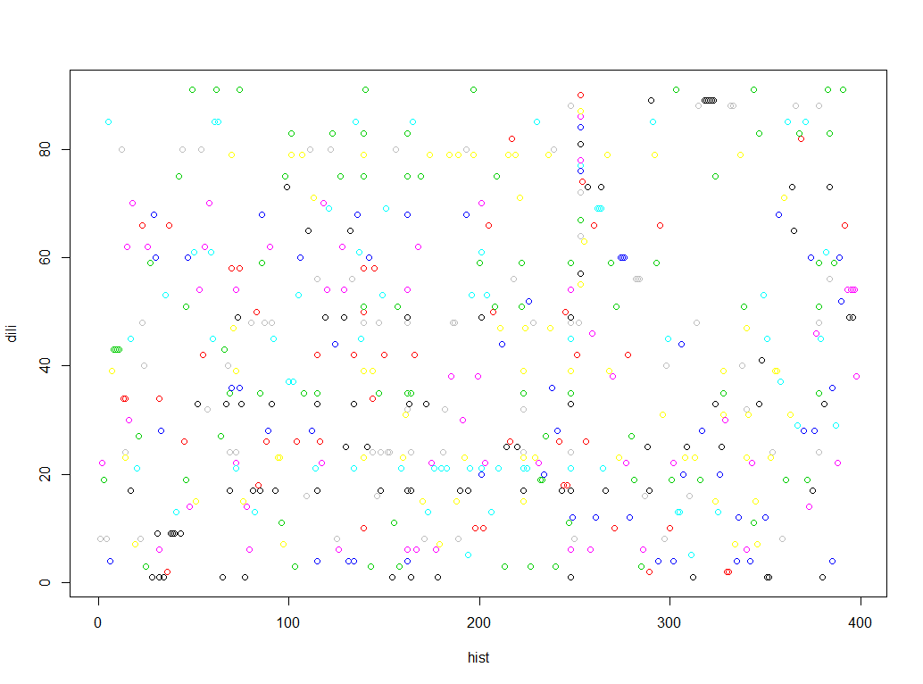

o

08

400

3OO

200

1OO

**hist**