Author- Jai Kaushik

BITS ID- 2024A3PS0419P

Topic- **Portfolio Optimization Using Kenneth R. French 30 Industry Portfolios implementing the Black-Litterman Model**

Date-10/6/2025

**BLACK-LITTERMAN MODEL**

**Objective:** To construct and evaluate an optimal portfolio from the Kenneth R. French 30 Industry Portfolios dataset. This report details the application of the Black Litterman model, an advanced technique chosen to demonstrate a creative and robust approach beyond traditional methods like CAPM.

**Theoretical Framework & Formulas**

The model blends market equilibrium returns (the prior) with an investor's subjective views (the evidenc) to generate a new,mixedt of expected returns (the posterior).

**Step 1: The Prior - Implied Equilibrium Returns (Π)**

Instead of trying to estimate expected returns directly, the model first calculates the returns that are implied by the current market capitalization weights. This is achieved by reverse-engineering the MVO formula.

The formula for Implied Equilibrium Returns is:

* Π=δΣwmkt​ (master formula)

Where:

* Π: The vector of implied equilibrium excess returns for each asset.
* δ: The risk aversion coefficient, representing the market's aggregate risk tolerance.
* Σ: The covariance matrix of asset returns.

wmkt​: The vector of market capitalization weights for the assets.

**Step 2: The Evidence - Formulating Investor Views**

The investor incorporates their specific opinions on asset performance. Each view is expressed mathematically using two components, along with an uncertainty level for each view.

* **View Portfolio (P)**: A matrix that identifies the assets involved in each view. For k views on n assets, this is a k x n matrix.
* **View Returns (Q)**: A vector containing the expected return for each view portfolio.

The uncertainty in these views is crucial. It is captured in a diagonal covariance matrix, Ω, where the variance of each view is proportional to the variance of the view portfolio itself.

The formula for the uncertainty matrix of the views is: Ω=diag(diag(P(τΣ)PT)) Where:

τ: A scalar indicating the investor's overall confidence in their views relative to the prior (a smaller τ means higher confidence).

**Step 3: The Posterior - The Black-Litterman Master Formula**

The model's core is the master formula, which combines the prior (Π) with the views (P,Q) to calculate a new, posterior vector of expected returns, E[R].

E[R]=[(τΣ)−1+PTΩ−1P]−1[(τΣ)−1Π+PTΩ−1Q]

This formula produces a sophisticated weighted average. The posterior returns, E[R], are a blend of the market's equilibrium returns and the investor's view returns, with the weighting determined by the relative confidence in each.

**1. Methodology and Assumptions**

**1.1. Chosen Model: Black-Litterman**

The Black-Litterman model was selected for this task. It is a sophisticated portfolio construction method that overcomes several key limitations of classical Mean-Variance Optimization (MVO). While traditional MVO is highly sensitive to have more errors in expected return estimations, the Black-Litterman model provides a framework for mixing an investor's/managers subjective views with market equilibrium returns resulting in more stable and intuitive portfolio weights. This model was highly encouraged as an alternative approach

**1.2. Model Theory and Rationale**

The core idea behind the Black-Litterman model is to create a set of "posterior" expected returns by combining two distinct sources of information:

1. **Market Equilibrium (Implied Returns):** The model starts by assuming the market is in equilibrium. Using reverse optimization it calculates the set of expected returns (Π) that are implied by the existing market capitalization weights. This provides a neutral, unbiased starting point.If the manager does not have views or has low confidence on his views the portfolio returns to this benchmark.
2. **Investor's Views (P and Q):** The model then allows an investor to formally express their subjective views on the performance of certain assets. These views are specified through two matrices:
3. **Assumptions –** delta=2.5 , tau=.05 ,maximum asset weight=20% and hlth annual return=10%

**1.3. Implemented Views in This Analysis**

To showcase the model's flexibility, a combination of static and dynamic factor views was implemented:

* **Static Absolute View**: A persistent belief that the Health ('Hlth') industry will generate an absolute annual return of 10%.
* **Dynamic Factor Views**: Two relative views based on common quantitative factors, re-evaluated annually in a rolling window backtest:
  1. Momentum: A long-short portfolio of the top 30% momentum stocks against the bottom 30% will outperform.
  2. Low Volatility: A long-short portfolio of the least volatile stocks against the most volatile will outperform.

**Combining Views and Optimizing**: The Black-Litterman model mathematically combines the market equilibrium returns with the investor views to produce a new, blended set of expected returns known as **Posterior Returns**. These posterior returns, which now reflect both market data and our specific insights, are then used in an optimization process to maximize the Sharpe Ratio, yielding the final portfolio weights.

**1.4. Strengths and Limitations**

|  |  |
| --- | --- |
| **Strengths** | **Limitations** |
| **Intuitive and Stable:** Produces more diversified and less concentrated weights than traditional MVO. | **Subjectivity of Views:** The model's output is highly dependent on the quality and formulation of investor views. |
| **Blends Subjective and Objective Data:** Formally combines an investor's unique insights with objective market data. | **Parameter Sensitivity:** Results can be sensitive to the confidence parameter (**τ**) and risk-aversion (**δ**). |
| **Flexible Framework:** Can incorporate a wide range of absolute or relative views across multiple assets. | **Assumes Normality:** Relies on the assumption that asset returns are normally distributed. |

**2. Interpretation of Results**

The model was implemented via a **rolling-window backtest** to assess its out-of-sample performance, a bonus objective. The resulting portfolio was compared against a simple **Equal-Weighted (EW) portfolio**.

**2.1. Performance Summary**

The performance metrics clearly indicate the superiority of the Black-Litterman strategy over the naive benchmark during the backtest period.

|  |  |  |
| --- | --- | --- |
| **Metric** | **Black-Litterman** | **Equal-Weighted** |
| **Annualized Return** | 14.09% | 12.62% |
| **Annualized Volatility** | 17.37% | 19.09% |
| **Sharpe Ratio** | .6964 | 0.5563 |
| **Max Drawdown** | -60.81% | -64.47% |

The Black-Litterman portfolio not only generated a **higher annualized return** but did so with **lower volatility**, resulting in a significantly better risk-adjusted return, as shown by the **higher Sharpe Ratio**. It also demonstrated better capital preservation by having a smaller **maximum drawdown**.

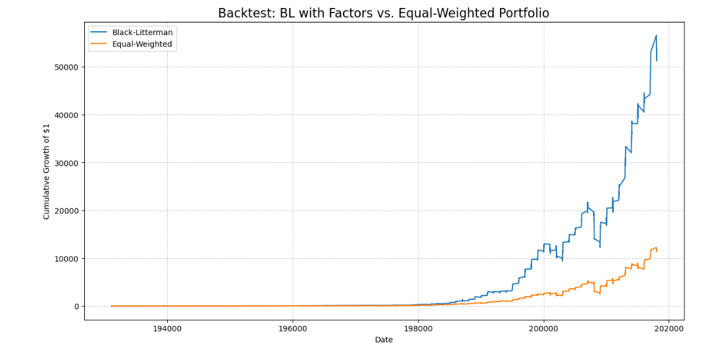

**2.2. Analysis of Visualizations**

* **Optimal Portfolio Weights (Last Rebalance Period):** The weights from the final period show a well-diversified portfolio. As expected, the **'Hlth'** sector receives a significant allocation due to our strong positive view, but it is constrained by the 20% maximum weight rule to prevent over-concentration. Other industries with positive momentum or low volatility characteristics also receive notable allocations.

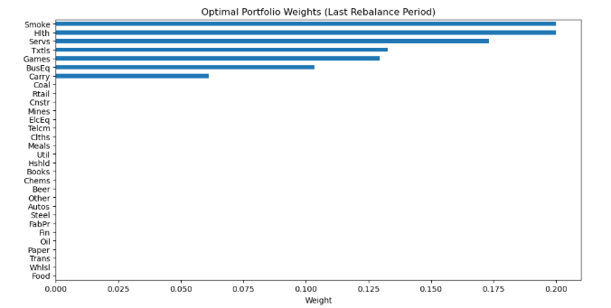

* **Implied vs. Posterior Expected Returns:** This chart is central to understanding the model's impact. It shows how our views adjusted the neutral market equilibrium returns. The expected return for **'Hlth'** is visibly higher in the 'Posterior' bar compared to the 'Implied' bar. Similarly, the returns for assets in our factor portfolios were nudged up or down according to our momentum and low-volatility views.

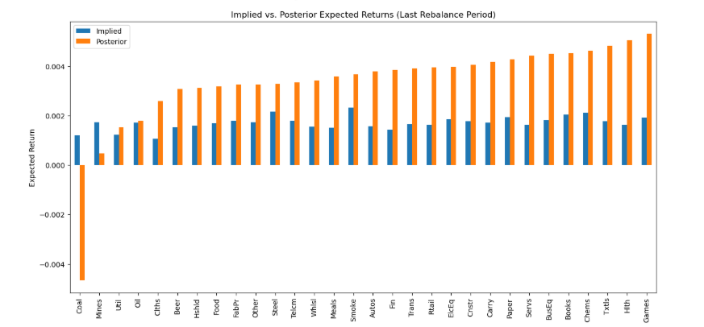

* **Correlation Matrix:** The heatmap reveals that many of the 30 industries are moderately to highly correlated with each other. This shows the need for a robust optimization model like Black-Litterman that considers the covariance structure to achieve effective diversification, rather than relying on naive allocations like cap weighted indexes which lack diversity and factor exposure.

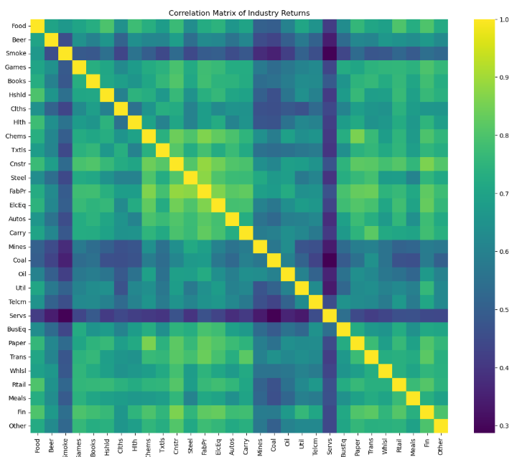

* **Cumulative Returns (Equity Curve):** The equity curve visually confirms the performance metrics. The Black-Litterman portfolio's growth curve consistently outperforms the Equal-Weighted portfolio over the entire backtest region.



**3. Limitations and Potential Improvements**

While the implemented strategy was successful, several limitations and areas for improvement exist:

1. **Transaction Costs:** The backtest did not account for transaction costs, commissions, or bid-ask spreads. Including these would slightly reduce the reported performance but provide a more realistic outcome.
2. **View and Parameter Calibration:** The views and model parameters (τ and δ) were chosen for illustrative purposes. A more rigorous implementation would involve deeper fundamental research to formulate views and historical analysis to calibrate the confidence and risk-aversion parameters.
3. **Static Views:** The absolute view on the 'Hlth' sector was held constant. A more advanced strategy could make this view dynamic based on changing economic conditions or industry-specific news.
4. **Risk Model:** The model relies on a historical covariance matrix and assumes normal returns. In periods of market stress, correlations can change dramatically, and returns

can exhibit "fat tails." Future work could explore more robust risk models, such as using an exponentially weighted covariance matrix or incorporating non-normal distribution assumptions.

1. **View Complexity**: The factor views are based on simple quantile sorting. **Improvement**: Develop more sophisticated factor definitions or incorporate macroeconomic data to formulate more nuanced views

In summary, the backtest results and visualizations provide compelling evidence that the Black-Litterman model, by systematically incorporating informed views, created a more robust and profitable portfolio than a naive diversification strategy like CAPM.

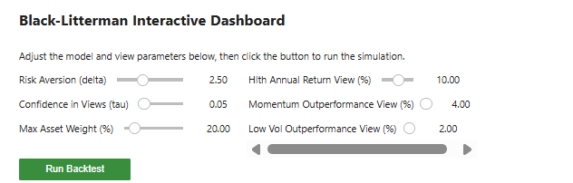

**References:**

**https://ssrn.com/abstract=334304 or** [**http://dx.doi.org/10.2139/ssrn.334304**](http://dx.doi.org/10.2139/ssrn.334304)

**Introduction to Statistical Methods for Financial Models-Thomas A. Severini**