Full Itinerary Customisation

Overview
This document describes the Full Itinerary Customisation experience: how a user builds and customises their own Itinerary inside the app, and what happens for destinations we do not yet auto generate Itineraries.
The idea: Let customers self-serve the routine parts of planning (destination, travellers, nights, route, activities, hotels and day plans) so the sales and ops teams spend less time on back-and-forth, while for the countries where this is not supported still reaches the team as a lead.
There are four entry flows into the same core wizard. They are described one by one, after the shared building blocks.

Where it applies
Current scope for Itinerary generation and customisation is for three destinations only- Vietnam, Bali & Thailand. Every other destination becomes a lead.
Destination | What happens
Thailand, Bali, Vietnam | A full itinerary can be generated and can be customised in the app by the users
All other destinations | Lead only. No itinerary is generated & no customisation supported. On submitting the lead generation form the user lands on the My Plans section with a message that we have received the request and a travel consultant will reach out, plus an option to call the team.

Key concepts
- The wizard. One shared, step-by-step flow: Destination, Travellers, Nights, Route, Activities, then OTP verification (if not done by the user already) . Different flows enter it at different points.
- Dependencies. Some screens are built from earlier choices. Route options are built for the chosen number of nights. Activities and day plans are built for the chosen route and number of travellers.
- Local draft vs created itinerary. While the user edits, changes are saved only on their device. No itinerary version is generated and nothing is visible to the travel consultant until the user taps Create Itinerary.
- Versions. Creating an itinerary assigns it a version (V1, V2, and so on). Versions are visible to the travel consultant. A user can keep editing to produce further versions.
- OTP. A new user verifies their mobile number once, at the end of the flow, just before the itinerary is created. If already verified, this step is skipped.

The wizard screens (shared across flows)
These are the core screens. Each flow reuses them; the flow sections later only call out what is different.

Destination
A scannable list of destinations. Each row shows the destination photo, name, its visa status (for example Visa on arrival, E-Visa, Visa-free), and a Trending tag where relevant. Tapping a row selects it and moves ahead.
- Edge case: only Thailand, Bali and Vietnam continue into the itinerary builder. Any other destination routes the user to lead generation (see section 5.2).
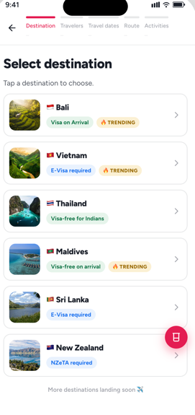

Travellers
The user tells us who is travelling. 30 Sundays is couples-first, so the default is 2 adults.
- Larger groups are chosen from an adults selector (4 or more).
- Edge case: Solo traveller, odd numbers of adults and children are not allowed and the screen explains this on their respective selections
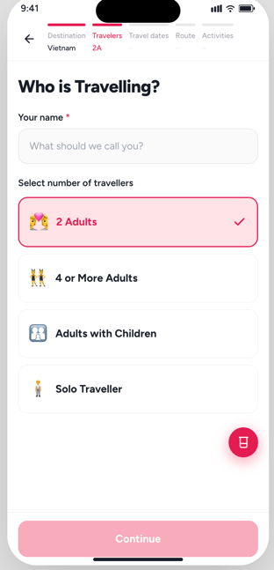

Nights
The user picks their travel dates and the number of nights. We recommend a sensible minimum per destination.
- Edge case: if the user picks fewer than the recommended nights, we still let them continue, but show a gentle nudge to add a couple more nights.
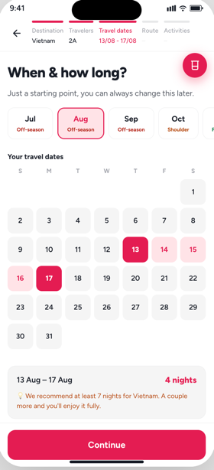

Route
Depends on Nights & Destination. The route step offers regions to explore and a set of recommended routes built for the chosen number of nights and destination. The user picks the route that suits them.
Edge cases:
- If the Cities selection chips goes beyond two lines then view more and view less option to be provided
- If a lot of cities are selected for the selected number of nights then we show a message to select less number of spots
- If the user has selected lesser number of nights than the recommended then we show a nudge and option to increase nights

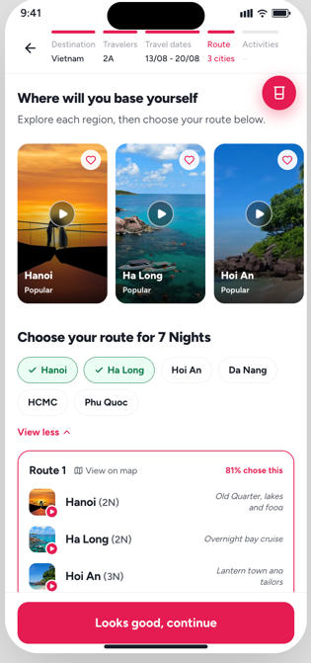

Activities
Depends on Destination, Route and Travellers. Day plans and activities are built for the chosen route and party. The user can keep the recommendation or adjust it.
Note: Activities is part of Flow 1 and Flow 3, but is skipped in Flow 4 (see that section).
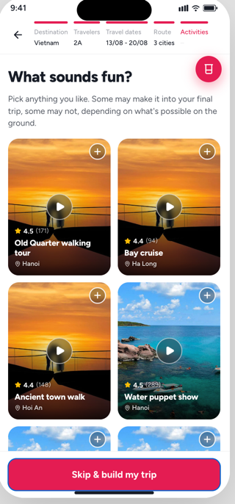

OTP verification
Shown at the end of the flow for users who have not verified their mobile number yet, just before the itinerary is created. For verified users it won’t come.

What the user gets

Itinerary screen (Thailand, Bali, Vietnam)
The generated itinerary, with hotels and day plans for each day. Flight details are not shown on this screen. From here the user can review, customise, and create the itinerary.

Lead generated (all other destinations)
On tap plan my trip and if the selected destination is not Vietnam, Thailand or Bali then the user will be taken to the lead generation existing form after that OTP. Verification will be done. After OTP verification The user lands on My Plans with a confirmation that the request is received and a travel consultant will reach out, plus an option to call the team.

Flow 1 - Plan my journey from the home page
Summary: the full build, start to finish, from the home page.
Steps:
- On the home page, the user taps the Plan my journey CTA.
- Destination selection screen opens. The user chooses a destination.
- The user moves through Travellers, then Nights, then Route, then Activities if the country selected is Vietnam or Thailand or Bali. OTP verification runs here if the user has not verified already.
- If the destination selected is not Vietnam, Thailand or Bali then user will be taken to the lead generation form after that OTP verification will be done

Outcome. For Thailand, Bali and Vietnam, the user lands on the Itinerary screen with hotels and day plans (no flight details). For every other destination, only a lead is created and the user lands on My Plans with the request-received message and a Call the team option.
Edge cases and dependencies
Route depends on the number of nights; Activities depends on the route and travellers.
Travellers: couples only, odd adults blocked, children not supported.
Nights below the recommended minimum: allowed, with a nudge.
Only Thailand, Bali and Vietnam produce an itinerary; all others become a lead.

Flow 2 - Editing an itinerary (Only allowed for Vietnam, Bali & Thailand)
Summary: the user changes an itinerary they already have.
Steps:
- On the Itinerary screen, the user taps the edit icon.
- A bottom sheet appears listing the fields that can be edited: Destination, Travellers, Nights and Route. The user picks the field to change.
- The user edits the chosen field and every field that comes after it, in order (for example, editing Nights then leads through Route).
- The user can also change day plans and hotels directly on the itinerary.
- Until the user taps Create Itinerary, all changes stay on their device only. No version is generated and nothing is visible to the travel consultant (Itinerary Builder).
- On Create Itinerary, a version is assigned and it becomes visible to the travel consultant.
- The user can edit again and repeat the same process to make further versions.
How saving and versions work
Draft: changes are local to the device, not a version, not visible to the consultant.
Created: tapping Create Itinerary assigns a version (V1, V2, ...) and shares it with the consultant.
Re-editing a created version starts a fresh draft on top of it.

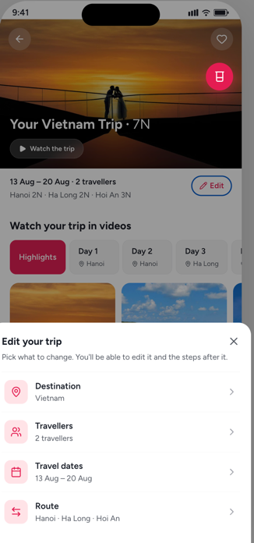

Flow 3 - Plan my trip from a destination page
Summary: the user has already picked a destination, so the wizard skips the destination step.
Steps:
The user chooses a destination, then taps Plan my trip.
The wizard opens on the Travellers screen, because the destination is already selected (and shown as fixed).
From here the experience is the same as Flow 2 onwards (Nights, Route, Activities, edit, create).

Edge case: for destinations other than Bali, Vietnam and Thailand, tapping Plan my trip opens the existing lead-generation page instead of the wizard.

Flow 4 - From a ready-made itinerary
Summary: the user taps on a ready-made itinerary on the destination page and then taps on Plan my trip on the itinerary screen.
Steps:
- On the Destination page, the user opens a ready-made itinerary and taps Add travel dates, Add travellers, or Plan my trip.
- The wizard opens on the Travellers screen.
- The user selects Travellers, Nights and Route. Activities is not part of this flow (the ready-made itinerary already has its day plans).

Edge case: if the destination is not Vietnam, Bali or Thailand, tapping any of these opens the lead-generation page instead.

Events:
Event Name | Type | Screen | Trigger | Key metadata
hero_plan_my_trip_tapped | CTA Tap | Home | Taps "Plan my trip" on home hero | cust id, leadstatus
bottomcard_plan_my_trip_tapped | CTA Tap | Home | Taps "Plan my trip" on home bottom card | cust id, leadstatus
destination_plan_my_trip_tapped | CTA Tap | Destination page | Taps "Plan my trip" | destination, is_wizard_eligible, entry_point=destination_page, cust id, leadstatus
itinerary_preview_viewed | Screen View | Readymade itinerary preview | Opens a readymade itinerary | itinerary_id, destination, is_wizard_eligible, entry_point=destination_page, cust id, leadstatus
add_travel_dates_tapped | CTA Tap | Readymade preview | Taps "Add travel dates" | itinerary_id, destination, is_wizard_eligible, entry_point=readymade_itinerary, cust id, leadstatus
add_travellers_tapped | CTA Tap | Readymade preview | Taps "Add travellers" | itinerary_id, destination, is_wizard_eligible, entry_point=readymade_itinerary, cust id, leadstatus
preview_plan_my_trip_tapped | CTA Tap | Readymade preview | Taps "Plan my trip" | itinerary_id, destination, is_wizard_eligible, entry_point=readymade_itinerary, cust id, leadstatus
select_destination_viewed | Screen View | Select destination | Page loads | entry_point, destinations_shown
destination_selected | CTA Tap / Funnel Step | Select destination | Taps a destination row | destination, is_wizard_eligible, position, is_trending, visa_type
destination_routed_to_wizard | Funnel Step | Select destination | TVB country chosen | destination
destination_routed_to_lead | Funnel Step | Select destination | Non-TVB country chosen | destination
travellers_viewed | Screen View | Travellers | Step loads | destination, entry_point, mode (create/edit), skip_activities
traveller_name_entered | Action | Travellers | Name field filled (fire once, no PII value) | destination, has_name=true
traveller_type_selected | CTA Tap | Travellers | Picks a traveller card | destination, traveller_type, adults_count
travellers_group_odd_blocked | Impression | Travellers | Odd adult count (couples-only) | adults_count
travellers_kids_not_supported | Impression | Travellers | "Adults with children" chosen | -
travellers_solo_not_supported | Impression | Travellers | "Solo traveller" chosen | -
travellers_continue_tapped | CTA Tap / Funnel Step | Travellers | Continue | destination, travellers, traveller_type
travel_dates_viewed | Screen View | Travel dates | Step loads | destination
travel_dates_selected | Action | Travel dates | Start + return chosen | destination, start_date, nights
nights_below_recommended_shown | Impression | Travel dates | Nights < recommended | destination, selected_nights, recommended_min_nights
travel_dates_continue_tapped | CTA Tap / Funnel Step | Travel dates | Continue | destination, nights, start_date
route_viewed | Screen View | Route | Step loads | destination, nights
region_explored | CTA Tap | Route | Plays a region video / opens region | destination, region
route_below_recommended_shown | Impression | Route | Nights below recommendation | destination, nights, recommended_min_nights
route_nights_adjusted | Action | Route | Uses the +/- nights stepper | destination, from_nights, to_nights
route_selected | Action | Route | Picks a route card | destination, route_id, cities, nights, chosen_pct
route_continue_tapped | CTA Tap / Funnel Step | Route | Continue (or "Create itinerary" in readymade flow) | destination, route, skip_activities
activities_viewed | Screen View | Activities | Step loads (skipped in Flow 4 / edit) | destination, route
activity_toggled | Action | Activities | Add/remove an activity | destination, city, activity_id, added
create_itinerary_tapped | CTA Tap / Funnel Step | Activities (or Route in skip flow) | "Create my itinerary" | destination, nights, travellers, activities_count
otp_viewed | Screen View | OTP verification | Gate opens | trigger (itinerary_create/lead_submit), destination
otp_requested | CTA Tap | OTP | "Send OTP" | phone_country
otp_verified | Funnel Step | OTP | Correct OTP | -
otp_failed | Error | OTP | Wrong OTP | reason
otp_skipped | CTA Tap | OTP | Skip (where allowed) | -
itinerary_generation_started | Impression | Building loader | Generation begins | destination, nights, travellers
itinerary_created | Funnel Step (Conversion) | Itinerary | Itinerary generated (TVB) | deal_id, version_id, version_number, destination, nights, travellers, total_amount
itinerary_viewed | Screen View | Itinerary | Screen loads | deal_id, version_id, destination, has_flights=false, is_draft
cost_breakdown_info_tapped | CTA Tap | Itinerary | Taps (i) beside total | deal_id, version_id
edit_trip_tapped | CTA Tap | Itinerary | Taps Edit icon | deal_id, version_id, flow=flow2_edit
edit_trip_sheet_viewed | Screen View | Edit your trip (sheet) | Sheet opens | deal_id, version_id
edit_field_selected | CTA Tap | Edit sheet | Picks a field | field (destination/travellers/dates/route), deal_id, version_id
edit_wizard_viewed | Screen View | Wizard (edit mode) | Lands at chosen field | entry_field, deal_id, version_id
edit_save_changes_tapped | CTA Tap / Funnel Step | Wizard (edit, Route step) | "Save changes" | deal_id, version_id
save_as_draft_tapped | CTA Tap | Itinerary (leave guard) | Leaves with unsaved edits | deal_id, version_id, changes_count
create_itinerary_from_edit_tapped | CTA Tap / Funnel Step | Itinerary | "Create Itinerary" after edits | deal_id, version_id, changes_count
itinerary_version_created | Funnel Step (Conversion) | Itinerary | New version generated + visible to consultant | deal_id, new_version_id, version_number, total_amount, changed_components
lead_form_viewed | Screen View | Lead form | Form opens | prefilled_destination, entry_point
lead_form_field_edited | Action | Lead form | Edits a field | field (name/adults/children/destinations/start_date/nights)
lead_children_selected | Impression | Lead form | Chooses "children: yes" (not catered) | -
lead_form_submitted | CTA Tap / Funnel Step | Lead form | "Explore Itineraries" | destinations, adults, children, start_date, nights, sales_request
lead_generated | Funnel Step (Conversion) | Curating | Lead created after OTP | destinations, sales_request=true, lead_status
lead_confirmation_viewed | Screen View | My Plans (request received) | Lands post-lead | destinations
call_consultant_tapped | CTA Tap | My Plans (request received) | "Call travel consultant" | -
continue_editing_tapped | CTA Tap | My Plans | On a draft card | deal_id, version_id

