Name- Jai Kumar

Email- [jaikii@iiserb.ac.in](mailto:jaikii@iiserb.ac.in)

**Answer 1:**

* Following is the PCA plot after removing ‘*NA’* values out *histology_type_other*.
* Link for *phantasus* online tool is [here](https://genome.ifmo.ru/phantasus/?session=x066fd8eb8adc1f).

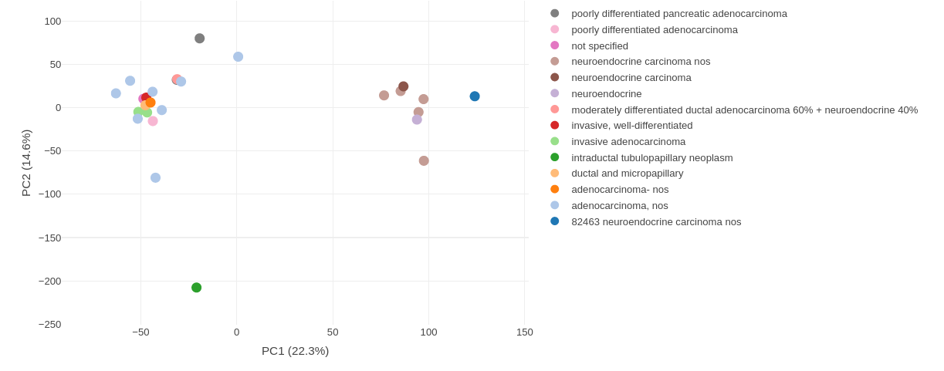

**It can be seen that Exocrine (adenocarcinoma) tumors and Neuroendocrine tumors can be separated from the plot, As they are clustered separately.**

**Answer 2:**

* It is done on R-studio after installing GSVA packing. GSVA score taken is from (-1,1).
* The link of the R-file is [here](https://rstudio.cloud/project/822044)

The GSVA scoring plots are: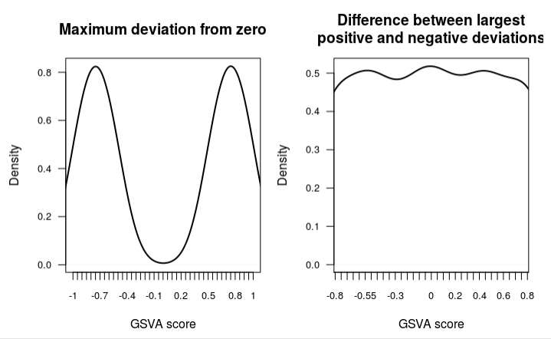

**It can be seen from the graph that the difference between the positive and negative deviations are very small. That implies GSVA score can’t segregate the samples into subtypes.**

**Answer-3**

The project is hosted on GitHub but can’t be seen because it is private.

**https://github.com/jaikii/Elucidata.git**