Solution Specification Document
<VR Chennai>

Contents
A. Scope 3
B. General Information 4
C. Deployment of POS Patrol | Integra 6
1. Approach 6
2. Data Parameters 7
A) Transaction details [Retail, F&B & Forex] 7
B) Transaction details [Lounge] 9
C) Item details 11
D) Payment details 12
E) Data Access Credentials 13
3. Integration Architecture | POS Patrol - Integra 14
A) Check List for POSpatrol | Integra 14
D. Deployment of POS Patrol | Print 14
1. Integration Architecture | POS Patrol – Print 15
A) Check List for POSpatrol | Print 17
E. Project Coordinates 17
F. Next Steps 19
G. Sign Off 20

Scope

VR Chennai in its vision of becoming the world’s leading shopping center company is moving towards digital transformation and has chosen Pathfinder as its preferred vendor to implement Retail Contract Management System (RCMS)

This system will help VR Chennai to establish transparency with concessionaires and provide intelligence for overall operational efficiency.

As part of the RCMS, Pathfinder will implement an automated solution capturing Sales data which will be implemented. The information required to develop the interface is detailed in this document.

We’d appreciate your cooperation to make this engagement successful

The Objectives of the solution are as follows:
- Design, develop & deploy POS PATROL – Integra & Print to capture sales data on a real-time basis or at agreed frequency
- During this process, Concessionaire shall extend the fullest cooperation and support to ‘PATHFINDER’ to achieve this Goal
- The developed agent will be tested at concessionaire’s test environment, deployed at production environment and monitored for a period of 30 days for consistency & accuracy of data
We are confident this activity will greatly help our mutual interests, we look forward to your cooperation and support with VR Mall and PATHFINDER.

General Information

Organization Name
List Brand(s) owned or franchised
Locations at various Malls along with number of tills at each site
Engagement Coordinates
Business Contact
Engagement Coordinates
Technical Contact
Is internet connectivity available at the outlet? Yes/No
Name of POS Software & Version in use

Are you considering to upgrade or replace your current POS systems?  If Yes, detail new POS system and by when is this change expected? | -
Is the POS software managed in house or contracted to a vendor?  If Contracted, please share coordinates | -
Database Specification  (Oracle / MS SQL / MySQL / MS Access / Proprietary) | -
Operating System Platform - Windows / Linux | -
If Windows, Production / Deployment environment 32 / 64bit
POS application type - Desktop / Web based | -
Database Storage - POS / Central | -
Database Availability  (On premise / Off Premise - Head Office / Data Centre) | -
Database structure to identify different brands, locations & tills within the same property | -
Do you allow multi-currency transactions at POS?  If Yes, please specify how the exchange rate is handled? | -

Deployment of POS Patrol | Integra

Approach
- In this approach, agreed data parameters are extracted directly from the store’s production database
- On Premise Database
  - Provide Direct access to production database table & field information (or)
  - Provide Database views of agreed data parameters with read only access at local production environment (or)
  - Share API documentation to access agreed data parameters with read only access.
- Off Premise Database (Subject to approval by Mall Commercial & IT)
  - If the database is hosted outside the Mall premise at the head office or data center:
    - Provide Direct access to production database table & field information (or)
    - Provide Database views of agreed data parameters with read only access at production environment (or)
    - Share API documentation to access agreed data parameters with read only access.
    - Provide a WEB Service of agreed data parameters
- Once the inputs are shared, a service based utility will be developed exclusively for the brand by PATHFINDER and deployed at the store till or head office / data center which will automatically extracts data at agreed intervals, encrypts and pushes the file over a secure connection to the data staging server over local LAN or Internet for reporting.

Data Parameters

Transaction details [Retail & F&B]

Data Name | Mandatory | Description | Table & Field Name | Join Table & Field Name | Comments
LOCATION_CODE | Yes | Branch/POS ID of the store or with default value 01
TERMINAL_ID | Yes | Terminal ID of the POS till or with default value 01
SHIFT_NO | Yes | Shift of the day or with default value 01
RCPT_NUM | Yes | Is the receipt number of this transaction
RCPT_DT | Yes | Receipt date in YYYYMMDD format
BUSINESS_DT | Yes | Business date in YYYYMMDD format
RCPT_TM | Yes | Receipt time in HHMMSS, 24-hour System Time
INV_AMT | Yes | Is the receipt total amount
TAX_AMT | Yes | Is the total tax collected
RET_AMT | Yes | Is the total Return amount

Data Name | Mandatory | Description | Table & Field Name | Join Table & Field Name | Comments
CUST_NAME | No | Is the Customer Name
CUST_GEN | No | M - Male, F – Female
CUST_NATION | No | Nationality of the customer
CUST_EMAIL | No | Email address of the customer
CUST_CONT | No | Customer Contact number
CUST_PAX_TYPE | No | Is the Type of Passenger - A - Arrival, D - Departure, S - Transit, T – Transfer & O - Others
CUST_PP_NO | No | Is the passport number of the customer
CUST_BP | No | Boarding Pass Number
CUST_FL_NO | No | Is the Flight number of the customer
CUST_FL_CLASS | No | Is the Passenger flight boarding Class
CUST_ORIGIN | No | Is the Passenger Origin
CUST_DESTINATION | No | Is the Passenger Destination
CUST_BR_GATE_NO | No | Is the Passenger flight boarding Gate
CUST_PNR_NO | No | Is the Passenger Name Record
VOUCH_CODE | No | Is the Passenger Voucher/Coupon/Promo Code
TRAN_STATUS | Yes | Is the Type of Transaction. SALES or RETURN
OP_CUR | No | Operational currency code. INR, USD, CNY etc.
BC_EXCH | No | Is the Exchange rate of Operational currency

Payment details

Data Name | Mandatory | Description | Table & Field Name | Join Table & Field Name | Comments
PAYMENT_NAME | Yes | Is the name of payment mode. CASH , CC, CHEQUE & OTHERS
CURRENCY_CODE | Yes | Tendered currency. INR, USD, CNY etc.
EXCHANGE_RATE | Yes | Is the Exchange rate of Tendered currency
TENDER_AMOUNT | Yes | Is the amount of tendered
OP_CUR | Yes | Operational currency code. INR, USD, CNY etc.
BC_EXCH | Yes | Is the Exchange rate of Operational currency code
PAYMENT_STATUS | Yes | Is the Type of Transaction. SALES or RETURN

* The above table to be filled by the Concessionaire’s IT Database Administrator:

Data Access Credentials

Database credentials

Host Address/Server Name | DB Name | User Name | Password

If applicable, below details are required to be filled

DB file folder -
Port Number -
Mention Company Name as in Database -
Mention Financial Year as in Database -
Parameter for Store Procedure -

* Above table applicable for Database View and Stored procedure also.

Web Service / API credentials

URL | User Name | Password | Methods | Parameters | Return Type | Access Token/Key

Sales data in API as dataset, XML or Json format: API must contain Transaction, Payment & item detail. With static IP in URL which can be accessible from anywhere and date parameter from & to.

Integration Architecture | POS Patrol - Integra
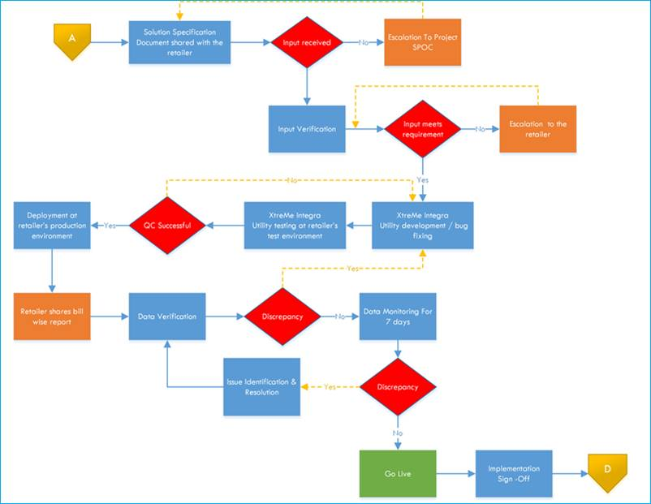

A) Check List for POSpatrol | Integra

Description | Status
OS Compatibility (Platform, Version) | YES
Administrator Access | YES
Network Connectivity | YES
Port access enabled | YES
AV & Firewall exceptions | YES
Permits USB port access for (Installation) | YES

Deployment of POS Patrol | Print

Name & Specification of POS Software used
Operating System Platform
(Windows / Linux)
If Windows, Production / Deployment environment 32 / 64bit
POS application type (Desktop / Web based)
Number of brands, locations & tills
Do you allow multi-currency transactions at POS?
Detail the IT setup at the property
(Environment, Configuration, OS, Network & Security)
Detail POS Printer setup viz. USB / LPT / COM / Network
Is the printing of receipts from the application routed through OPOS or standard windows driver?
Share receipt formats of all transactions done at the till viz. Sales, Return, Exchange, VOID/Cancellation in PDF format

Integration Architecture | POS Patrol – Print

- Insert Integration Architecture Diagram & Documentation (to be filled by CO @ Pathfinder)

A) Check List for POSpatrol | PRINT

Description | Status
Provide replication of live setup for testing
Administrator access to POS till for implementation

Next Steps
- Fill in the Solution Specification Document, submission to Pathfinder
- Develop the data base views/ API / Web Service consisting of data mentioned in Section C, Point #2

- Connect with VR Mall or Pathfinder for any clarifications

Sign Off

Portfolio Name
Project Name
Project Code
Tenant Name
Outlet Name | Location| Landmark

This acknowledge that the Project and Concessionaire SPOC had reviewed the services delivered by Pathfinder as per obligations outlined in the Solution Specification Document used during the project.

Project SPOC Name and Signature | Concessionaire SPOC Name and Signature | Pathfinder SPOC Name and Signature
*Signature with date is mandatory

