

External PHY Failover

Proposal

|  |  |
| --- | --- |
| **Title** | **External PHY Abstraction Interface** |
| **Authors** | **Broadcom** |
| **Status** | **Draft** |
| **Type** |  |
| **Created** | **8/31/2020** |
| **SAI-Version** | **0.1** |

**Contents**

List of Changes i

1 Overview 1

2 Proposal 1

2.1 Failover Configuration on PHY 2

2.2 New attributes 2

2.3 Changes to saiport.h 2

2.4 Changes to saiswitch.h 3

3 Configuration Example 4

# List of Changes

|  |  |  |  |
| --- | --- | --- | --- |
| Version | Changes | Name | Date |
| 0.1 | Proposal for PAI Failover |  | 8/31/2020 |

License

© 2014 Microsoft Corporation, Dell Inc., Facebook, Inc, Broadcom Corporation, Intel Corporation, Mellanox Technologies Ltd.

As of September 9, 2014, the following persons or entities have made this Specification available under the Open Web Foundation Final Specification Agreement (OWFa 1.0), which is available at <http://www.openwebfoundation.org/legal/the-owf-1-0-agreements/owfa-1-0>

Microsoft Corporation, Dell Inc., Facebook, Inc, Intel Corporation, Mellanox Technologies Ltd.

You can review the signed copies of the Open Web Foundation Agreement Version 1.0 for this Specification at <http://opencompute.org/licensing/>, which may also include additional parties to those listed above.

Your use of this Specification may be subject to other third party rights. THIS SPECIFICATION IS PROVIDED "AS IS." The contributors expressly disclaim any warranties (express, implied, or otherwise), including implied warranties of merchantability, noninfringement, fitness for a particular purpose, or title, related to the Specification. The entire risk as to implementing or otherwise using the Specification is assumed by the Specification implementer and user. IN NO EVENT WILL ANY PARTY BE LIABLE TO ANY OTHER PARTY FOR LOST PROFITS OR ANY FORM OF INDIRECT, SPECIAL, INCIDENTAL, OR CONSEQUENTIAL DAMAGES OF ANY CHARACTER FROM ANY CAUSES OF ACTION OF ANY KIND WITH RESPECT TO THIS SPECIFICATION OR ITS GOVERNING AGREEMENT, WHETHER BASED ON BREACH OF CONTRACT, TORT (INCLUDING NEGLIGENCE), OR OTHERWISE, AND WHETHER OR NOT THE OTHER PARTY HAS BEEN ADVISED OF THE POSSIBILITY OF SUCH DAMAGE.

THE FOLLOWING IS A LIST OF MERELY REFERENCED TECHNOLOGY: Microprocessor technology, semiconductor manufacturing technology, operating system technology (including without limitation networking operating system technology), emulation technology, graphics technology, video technology, integrated circuit packaging technology and the like, compiler technologies, object oriented technology, optical/RF communications technology including chip I/O and driver technology, bus technology, memory chip technology (including, without limitation, NAND memory, NOR memory, resistive RAM (RRAM), seek scan probe (SSP) memory, nonvolatile memory (including without limitation, memory based on chalcogenide materials, phase change memory (PCM), one or more stacked layers of memory cells, embedded PCM memories, non-volatile cache memory, solid state drives, SRAM, embedded DRAM, ferro-electric memory, and polymer memory)) and/or health-related and medical technology. IMPLEMENTATION OF THESE TECHNOLOGIES MAY BE SUBJECT TO THEIR OWN LEGAL TERMS.

# Overview

The purpose of this document is to describe PHY failover (FO) functionality and interface to manage failover functionality of the PHY. PHY is the connector between MAC (SerDes) and physical medium such as optical fiber or copper transceivers. PHY failover feature uses two physical port configurations: primary and secondary. This can be enabled on system/host or line/client side of a port. It provides the ability to switch from primary port to secondary port or vice versa without losing data/link.

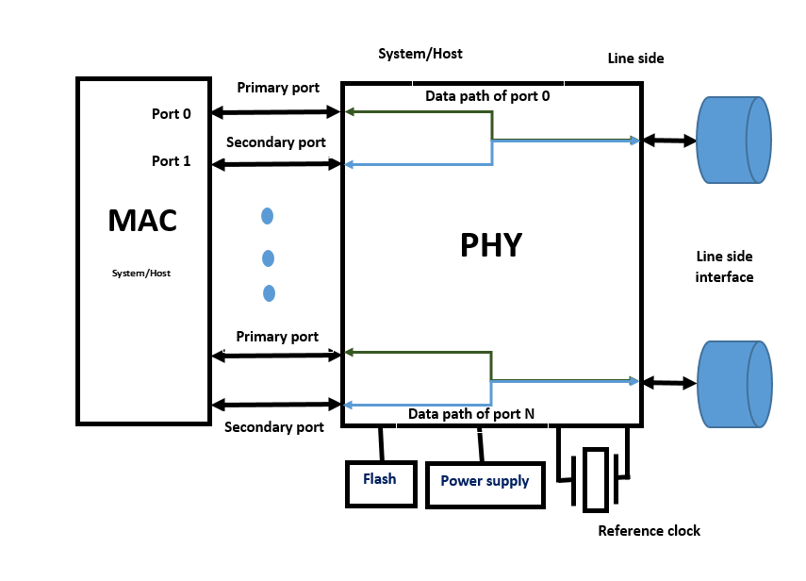

In the above multi-port configuration, failover mode is configured on the system side of external PHY. Primary and secondary ports are physical connections between MAC and PHY. The FO configuration uses primary and secondary port connections on selected side (system side or line side).

The PHY failover mode enables a port to broadcast data on both primary and secondary ports. The MAC would be configured to receive the data on either primary or secondary ports. PHY failover active ingress port can be configured as either primary or secondary port. When the link between MAC and PHY goes down on primary port, user can switch to secondary port.

## Failover Configuration on PHY

Failover configuration can be configured on all ports of the PHY. Failover ports can operate in either hitless (the ability to switch over port without losing link) or non-hitless mode. Failover feature supports global, per port or pin-based configurations.

## Additions to saiport.h

/**

* @brief Attribute data for #SAI_PORT_CONNECTOR_ATTR_FAILOVER_MODE

* Used for Failover mode configuration on port

*/

typedef enum _sai_port_connector_failover_mode_e

{

/** Failover mode disable */

SAI_PORT_CONNECTOR_FAILOVER_MODE_DISABLE,

/** Configure Failover mode on primary port */

SAI_PORT_CONNECTOR_FAILOVER_MODE_PRIMARY,

/** Configure Failover mode on secondary port */

SAI_PORT_CONNECTOR_FAILOVER_MODE_SECONDARY

} sai_port_connector_failover_mode_t;

/**

* @brief Configure the failover mode on port

*

* @type sai_port_connector_failover_mode_t

* @flags CREATE_AND_SET

* @default SAI_PORT_CONNECTOR_FAILOVER_MODE_DISABLE

*/

SAI_PORT_CONNECTOR_ATTR_FAILOVER_MODE,

/**

* @brief System Side Port ID

*

* @type sai_object_id_t

* @flags CREATE_ONLY

* @objects SAI_OBJECT_TYPE_PORT

*/

SAI_PORT_CONNECTOR_ATTR_SYSTEM_SIDE_FAILOVER_PORT_ID,

/**

* @brief Line Side Port ID

*

* @type sai_object_id_t

* @flags CREATE_ONLY

* @objects SAI_OBJECT_TYPE_PORT

*/

SAI_PORT_CONNECTOR_ATTR_LINE_SIDE_FAILOVER_PORT_ID,

## Additions to saiswitch.h

/**

* @brief Attribute data for #SAI_SWITCH_ATTR_FAILOVER_CONFIG_MODE

* Used for Failover configuration mode

* In case of primary port failure, hitless enables the switch over to secondary

* port without losing link. It allows uninterrupted data transmission

*/

typedef enum _sai_switch_failover_config_mode_t

{

/** Ports are configured but do not operate in hitless mode with global switching context */

SAI_SWITCH_FAILOVER_CONFIG_MODE_NO_HITLESS_GLOBAL,

/** Ports are configured but do not operate in hitless mode with per port switching context */

SAI_SWITCH_FAILOVER_CONFIG_MODE_NO_HITLESS_PER_PORT,

/** Ports are configured but do not operate in hitless mode with pin based switching context */

SAI_SWITCH_FAILOVER_CONFIG_MODE_NO_HITLESS_PIN_BASED,

/** Ports are configured and operate in hitless mode with global switching context */

SAI_SWITCH_FAILOVER_CONFIG_MODE_HITLESS_GLOBAL,

/** Ports are configured and operate in hitless mode with per port switching context */

SAI_SWITCH_FAILOVER_CONFIG_MODE_HITLESS_PER_PORT,

/** Ports are configured and operate in hitless mode with pin based switching context */

SAI_SWITCH_FAILOVER_CONFIG_MODE_HITLESS_PIN_BASED

} sai_switch_failover_config_mode_t;

/**

* @brief Failover configuration mode

*

* @type sai_switch_failover_config_mode_t

* @flags CREATE_AND_SET

* @default SAI_SWITCH_FAILOVER_CONFIG_MODE_NO_HITLESS_GLOBAL

*/

SAI_SWITCH_ATTR_FAILOVER_CONFIG_MODE,

# Configuration Example

Following example shows how to setup failover configuration on a system side port. In this example a 16 lane PHY is used.

/* Create System side, Line side, and System Side Failover ports */

sys_attr[0].value.u32list.list = sys_lane_list;

line_attr[0].value.u32list.list = line_lane_list;

failover_attr[0].value.u32list.list = failover_lane_list;

line_attr[1].id = sys_attr[1].id = SAI_PORT_ATTR_SPEED;

line_attr[1].value.u32= sys_attr[1].value.u32 = 100000;

line_attr[2].id = sys_attr[2].id = SAI_PORT_ATTR_INTERFACE_TYPE;

line_attr[2].value.u32 = sys_attr[2].value.u32 = SAI_PORT_INTERFACE_TYPE_KR;

line_attr[3].id = sys_attr[3].id = SAI_PORT_ATTR_FEC_MODE;

line_attr[3].value.u32 = sys_attr[3].value.u32 = SAI_PORT_FEC_MODE_RS;

line_attr[4].id = sys_attr[4].id = SAI_PORT_ATTR_LINK_TRAINING_ENABLE;

line_attr[4].value.booldata = sys_attr[4].value.booldata = 1;

line_attr[5].id = sys_attr[5].id = SAI_PORT_ATTR_ADMIN_STATE;

line_attr[5].value.booldata = sys_attr[5].value.booldata = 1;

for (phy_index = 0; phy_index < PAI_MAX_PHY; phy_index ++) {

for (index = 0; index < 2; index ++) {

line_lane_list[index] = (phy_index*16)+ port_index + index;

sys_lane_list[index] = (phy_index*16)+16 + port_index + index;

failover_lane_list[index] = (phy_index*16)+20 + port_index + index;

}

rv = pai_port_apis_ptr->create_port(&sys_port_id[phy_index][port_index],

switch_id[phy_index], COUNTOF(sys_attr), sys_attr);

if (SAI_STATUS_SUCCESS != rv) {

printf("System side port creation failed with error:%d\n", rv);

return rv;

}

rv = pai_port_apis_ptr->create_port(&fail_over_port_id[phy_index][port_index],

switch_id[phy_index], COUNTOF(fail_over_attr), fail_over_attr);

if (SAI_STATUS_SUCCESS != rv) {

printf("System side failover port creation failed with error:%d\n", rv);

return rv;

}

rv = pai_port_apis_ptr->create_port(&line_port_id[phy_index][port_index],

switch_id[phy_index], COUNTOF(line_attr), line_attr);

if (SAI_STATUS_SUCCESS != rv) {

printf("Line side port creation failed with error:%d\n", rv);

return rv;

}

/* Populate failover port IDs */

port_conn[0].id = SAI_PORT_CONNECTOR_ATTR_SYSTEM_SIDE_PORT_ID;

port_conn[0].value.oid = sys_port_id[phy_index][port_index];

port_conn[1].id = SAI_PORT_CONNECTOR_ATTR_LINE_SIDE_PORT_ID;

port_conn[1].value.oid = line_port_id[phy_index][port_index];

port_conn[2].id = SAI_PORT_CONNECTOR_ATTR_SYSTEM_SIDE_FAILOVER_PORT_ID;

port_conn[2].value.oid = fail_over_port_id[phy_index][port_index];

port_conn[3].id = SAI_PORT_CONNECTOR_ATTR_FAILOVER_MODE;

port_conn[3].value.u32 = SAI_PORT_CONNECTOR_FAILOVER_MODE_PRIMARY;

rv = pai_port_apis_ptr->create_port_connector(&port_conn_id[phy_index][port_index],

switch_id[phy_index], COUNTOF(port_conn), port_conn);

if (SAI_STATUS_SUCCESS != rv) {

printf("Port connector creation failed with error: %d\n", rv);

return rv;

}

printf("Port connector: 0x%lx.\n", port_conn_id[phy_index][port_index]);

}

/* Get current state of failover mode */

for (port_index = 0; port_index < 1; port_index ++) {

for (phy_index = 0; phy_index < PAI_MAX_PHY; phy_index ++) {

attr_count = 1;

memset(&port_conn_attr_get, 0, sizeof(port_conn_attr_get));

port_conn_attr_get[0].id = SAI_PORT_CONNECTOR_ATTR_FAILOVER_MODE;

rv = pai_port_apis_ptr->get_port_connector_attribute(

sys_port_id[phy_index][port_index], attr_count, port_conn_attr_get);

if (SAI_STATUS_SUCCESS != rv) {

printf("Get port connector attribute failed with error: %d\n", rv);

return rv;

}

printf("PAI Port Connector failover mode get attribute values :%d\n",

port_conn_attr_get[0].value.u32);

}

}

/* Configure primary failover port */

for (port_index = 0; port_index < 1; port_index ++) {

for (phy_index = 0; phy_index < PAI_MAX_PHY; phy_index ++) {

port_conn_attr_set.id = SAI_PORT_CONNECTOR_ATTR_FAILOVER_MODE;

port_conn_attr_set.value.u32 = SAI_PORT_CONNECTOR_FAILOVER_MODE_PRIMARY;

rv = pai_port_apis_ptr->set_port_connector_attribute(

sys_port_id[phy_index][port_index], &port_conn_attr_set);

if (SAI_STATUS_SUCCESS != rv) {

printf("Set Port Connector Attribute failed with error: %d\n", rv);

return rv;

}

}

}

/* Failover switch attribute configuration applicable for all ports on PHY (Global and no hitless) */

if (pai_switch_apis_ptr->set_switch_attribute) {

sai_attribute_t sai_set_attr;

sai_set_attr.id = SAI_SWITCH_ATTR_FAILOVER_CONFIG_MODE;

sai_set_attr.value.u32 = SAI_SWITCH_FAILOVER_CONFIG_MODE_NO_HITLESS_GLOBAL;

rv = pai_switch_apis_ptr->set_switch_attribute(switch_id[0], &sai_set_attr);

if (SAI_STATUS_SUCCESS != rv) {

printf("Set switch attribute failed: Error: %d\n", rv);

return rv;

}

}

if (pai_switch_apis_ptr->get_switch_attribute) {

for (switch_index = 0;switch_index < PAI_MAX_PHY; switch_index ++) {

sai_get_attr.id = SAI_SWITCH_ATTR_FAILOVER_CONFIG_MODE;

rv = pai_switch_apis_ptr->get_switch_attribute(switch_id[switch_index],

attr_count, &sai_get_attr);

if (SAI_STATUS_SUCCESS != rv) {

printf("Get switch attribute failed: Error: %d\n", rv);

return rv;

}

printf("failover config mode: %d\n", sai_get_attr.value.u32);

}

}