Task 1. Check file and directory details

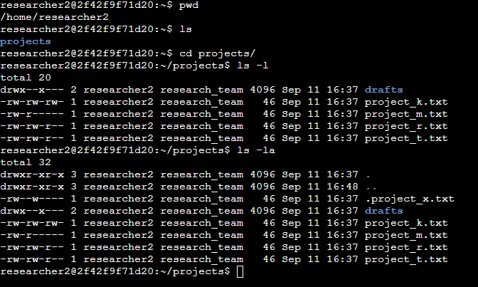

Task 2. Change file permissions

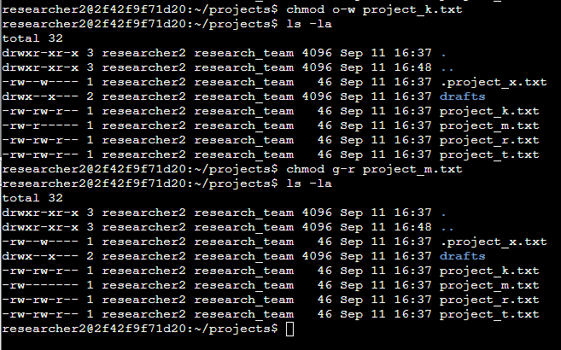

Task 3. Change file permissions on a hidden file

Task 4. Change directory permissions

Task 1. Check file and directory details

|  |
| --- |
| researcher2@2f42f9f71d20:~$ pwd  /home/researcher2  researcher2@2f42f9f71d20:~$ ls  projects  researcher2@2f42f9f71d20:~$ cd projects/  researcher2@2f42f9f71d20:~/projects$ ls -l  total 20  drwx--x--- 2 researcher2 research_team 4096 Sep 11 16:37 drafts  -rw-rw-rw- 1 researcher2 research_team 46 Sep 11 16:37 project_k.txt  -rw-r----- 1 researcher2 research_team 46 Sep 11 16:37 project_m.txt  -rw-rw-r-- 1 researcher2 research_team 46 Sep 11 16:37 project_r.txt  -rw-rw-r-- 1 researcher2 research_team 46 Sep 11 16:37 project_t.txt  researcher2@2f42f9f71d20:~/projects$ ls -la  total 32  drwxr-xr-x 3 researcher2 research_team 4096 Sep 11 16:37 .  drwxr-xr-x 3 researcher2 research_team 4096 Sep 11 16:48 ..  -rw--w---- 1 researcher2 research_team 46 Sep 11 16:37 .project_x.txt  drwx--x--- 2 researcher2 research_team 4096 Sep 11 16:37 drafts  -rw-rw-rw- 1 researcher2 research_team 46 Sep 11 16:37 project_k.txt  -rw-r----- 1 researcher2 research_team 46 Sep 11 16:37 project_m.txt  -rw-rw-r-- 1 researcher2 research_team 46 Sep 11 16:37 project_r.txt  -rw-rw-r-- 1 researcher2 research_team 46 Sep 11 16:37 project_t.txt  researcher2@2f42f9f71d20:~/projects$ |

Task 2. Change file permissions

|  |
| --- |
| researcher2@2f42f9f71d20:~/projects$ chmod o-w project_k.txt  researcher2@2f42f9f71d20:~/projects$ ls -la  total 32  drwxr-xr-x 3 researcher2 research_team 4096 Sep 11 16:37 .  drwxr-xr-x 3 researcher2 research_team 4096 Sep 11 16:48 ..  -rw--w---- 1 researcher2 research_team 46 Sep 11 16:37 .project_x.txt  drwx--x--- 2 researcher2 research_team 4096 Sep 11 16:37 drafts  -rw-rw-r-- 1 researcher2 research_team 46 Sep 11 16:37 project_k.txt  -rw-r----- 1 researcher2 research_team 46 Sep 11 16:37 project_m.txt  -rw-rw-r-- 1 researcher2 research_team 46 Sep 11 16:37 project_r.txt  -rw-rw-r-- 1 researcher2 research_team 46 Sep 11 16:37 project_t.txt  researcher2@2f42f9f71d20:~/projects$ chmod g-r project_m.txt  researcher2@2f42f9f71d20:~/projects$ ls -la  total 32  drwxr-xr-x 3 researcher2 research_team 4096 Sep 11 16:37 .  drwxr-xr-x 3 researcher2 research_team 4096 Sep 11 16:48 ..  -rw--w---- 1 researcher2 research_team 46 Sep 11 16:37 .project_x.txt  drwx--x--- 2 researcher2 research_team 4096 Sep 11 16:37 drafts  -rw-rw-r-- 1 researcher2 research_team 46 Sep 11 16:37 project_k.txt  -rw------- 1 researcher2 research_team 46 Sep 11 16:37 project_m.txt  -rw-rw-r-- 1 researcher2 research_team 46 Sep 11 16:37 project_r.txt  -rw-rw-r-- 1 researcher2 research_team 46 Sep 11 16:37 project_t.txt  researcher2@2f42f9f71d20:~/projects$ |

Task 3. Change file permissions on a hidden file

|  |
| --- |
| researcher2@2f42f9f71d20:~/projects$ chmod u-w,g=r .project_x.txt  researcher2@2f42f9f71d20:~/projects$ ls -l  total 20  drwx--x--- 2 researcher2 research_team 4096 Sep 11 16:37 drafts  -rw-rw-r-- 1 researcher2 research_team 46 Sep 11 16:37 project_k.txt  -rw------- 1 researcher2 research_team 46 Sep 11 16:37 project_m.txt  -rw-rw-r-- 1 researcher2 research_team 46 Sep 11 16:37 project_r.txt  -rw-rw-r-- 1 researcher2 research_team 46 Sep 11 16:37 project_t.txt  researcher2@2f42f9f71d20:~/projects$ ls -la  total 32  drwxr-xr-x 3 researcher2 research_team 4096 Sep 11 16:37 .  drwxr-xr-x 3 researcher2 research_team 4096 Sep 11 16:48 ..  -r--r----- 1 researcher2 research_team 46 Sep 11 16:37 .project_x.txt  drwx--x--- 2 researcher2 research_team 4096 Sep 11 16:37 drafts  -rw-rw-r-- 1 researcher2 research_team 46 Sep 11 16:37 project_k.txt  -rw------- 1 researcher2 research_team 46 Sep 11 16:37 project_m.txt  -rw-rw-r-- 1 researcher2 research_team 46 Sep 11 16:37 project_r.txt  -rw-rw-r-- 1 researcher2 research_team 46 Sep 11 16:37 project_t.txt  researcher2@2f42f9f71d20:~/projects$ |

Task 4. Change directory permissions

|  |
| --- |
| researcher2@2f42f9f71d20:~/projects$ ls -l  total 20  drwx--x--- 2 researcher2 research_team 4096 Sep 11 16:37 drafts  -rw-rw-r-- 1 researcher2 research_team 46 Sep 11 16:37 project_k.txt  -rw------- 1 researcher2 research_team 46 Sep 11 16:37 project_m.txt  -rw-rw-r-- 1 researcher2 research_team 46 Sep 11 16:37 project_r.txt  -rw-rw-r-- 1 researcher2 research_team 46 Sep 11 16:37 project_t.txt  researcher2@2f42f9f71d20:~/projects$ chmod g-x drafts  researcher2@2f42f9f71d20:~/projects$ ls -l  total 20  drwx------ 2 researcher2 research_team 4096 Sep 11 16:37 drafts  -rw-rw-r-- 1 researcher2 research_team 46 Sep 11 16:37 project_k.txt  -rw------- 1 researcher2 research_team 46 Sep 11 16:37 project_m.txt  -rw-rw-r-- 1 researcher2 research_team 46 Sep 11 16:37 project_r.txt  -rw-rw-r-- 1 researcher2 research_team 46 Sep 11 16:37 project_t.txt  researcher2@2f42f9f71d20:~/projects$ |