Part 1: Introduction to Python



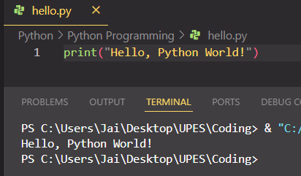

Part 2: Basic Python Syntax

1. String Operations

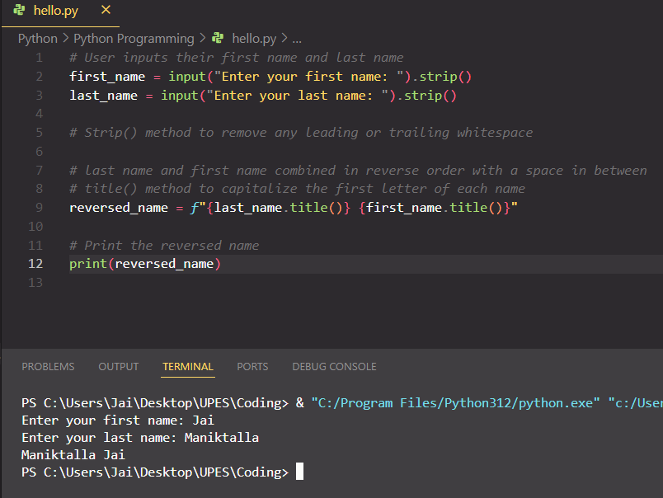

1. Numeric Data Types and Conversion Functions

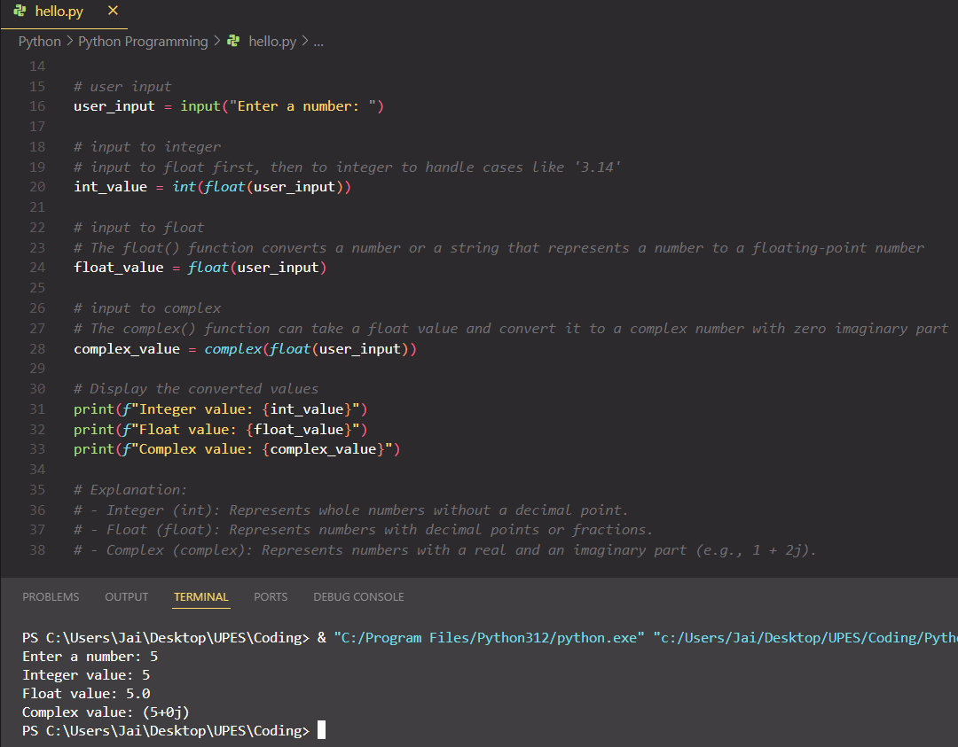

1. Simple Input and Output

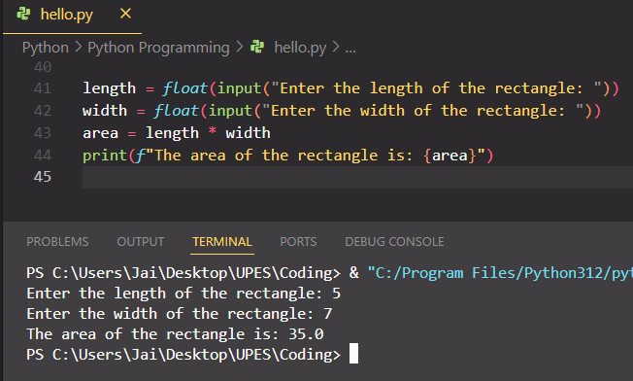

1. Using the format method

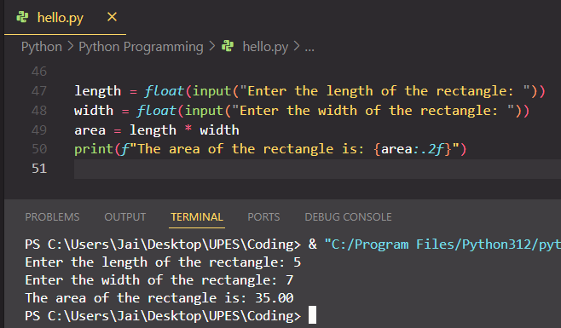

1. The % method and print function

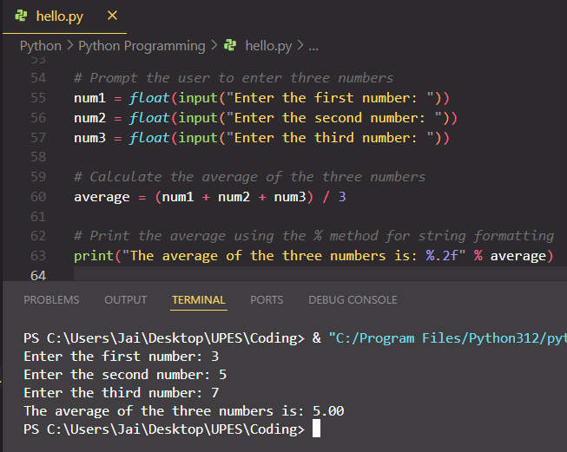

Part 3: Language Components

1. Control Flow (if statements and loops)

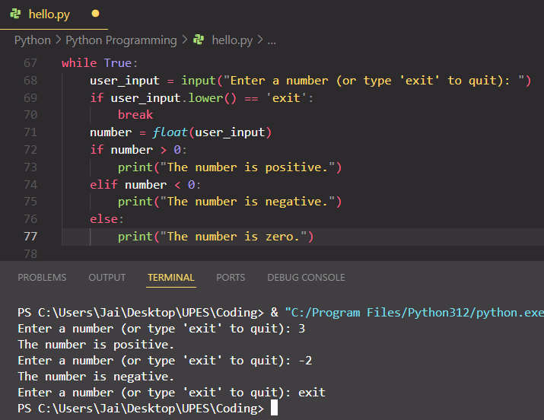

1. Relational and Logical Operators

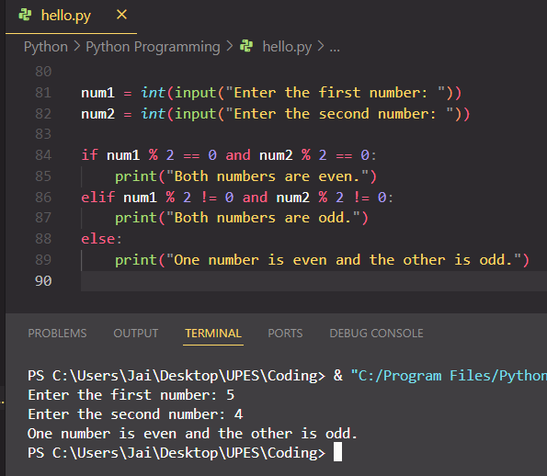

1. For Loop and Bitwise Operators

