FINAL SPACE INVADERS

Space Invaders was an alien-shooting game created in 1978 by Tomohiro Nishikado. Although shooting games were popular at the time, they were mostly time-based; the user would try to shoot as many enemies/aliens/things etc before the clock ran out. Nishikado, introduced a lives system and interactive gameplay where multiple enemies attacked the player. Additionally, the player could hide behind shields that were chipped away with each enemy shot as the enemies traversed towards the player with increasing speed.

Nishikado initially experimented with shooting at tanks but felt that it didn’t quite work. Inspired by H.G. Wells' "War of the Worlds," he instead opted for an alien invasion theme.

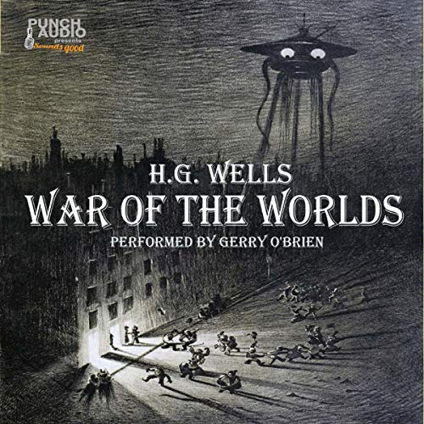

(https://www.audible.com/pd/War-of-the-Worlds-Audiobook/1982741880?overrideBaseCountry=true&ipRedirectOverride=true&ref_pageloadid=not_applicable&pf_rd_p=3b01d5da-1bf0-4646-924a-440835f79703&pf_rd_r=6P84GSXSZNX1HNJ4JC6B&pageLoadId=2cbDKNKoMA5Jd0zQ&creativeId=7e5ef24f-29c2-42b4-9ad7-cdff92184a00)

Interestingly, Space Invaders was considered a dud when it was first released, “It got low marks from vendors at the product launch because it was viewed as difficult to play” said creator, Tomohiro Nishikado. (Grannell 2023) But once it fell into the dextrous hands of gamers, who did not find it too difficult to play, it became the opposite of dud - extremely successful chartbusting, victorious, blockbuster megahit (an internet search told me these are the antonyms of “dud”).

Nishikado recalls a defining moment: "A couple of weeks after the game went on sale, I went on location to investigate a bug. I was told by the person in charge of the site that customers would not leave the game alone."Soon after, the demand for Space Invaders became so high that production sites had to work through the night to keep up.

Space Invaders allowed video gamers at the time to test their skills. The lukewarm reception and the ensuing roaring popularity show that, contrary to humankind’s ongoing attempts to make our lives easier, what we often actually crave is to do something that is almost “too difficult to play”.

Grannell, C 2023, ‘The “Space Invaders” Creator Reveals the Game’s Origin Story | WIRED’, *Wired*, 12 April, viewed 18 April 2023, <https://www.wired.com/story/space-invaders-45-years-tomohiro-nishikado/>.

[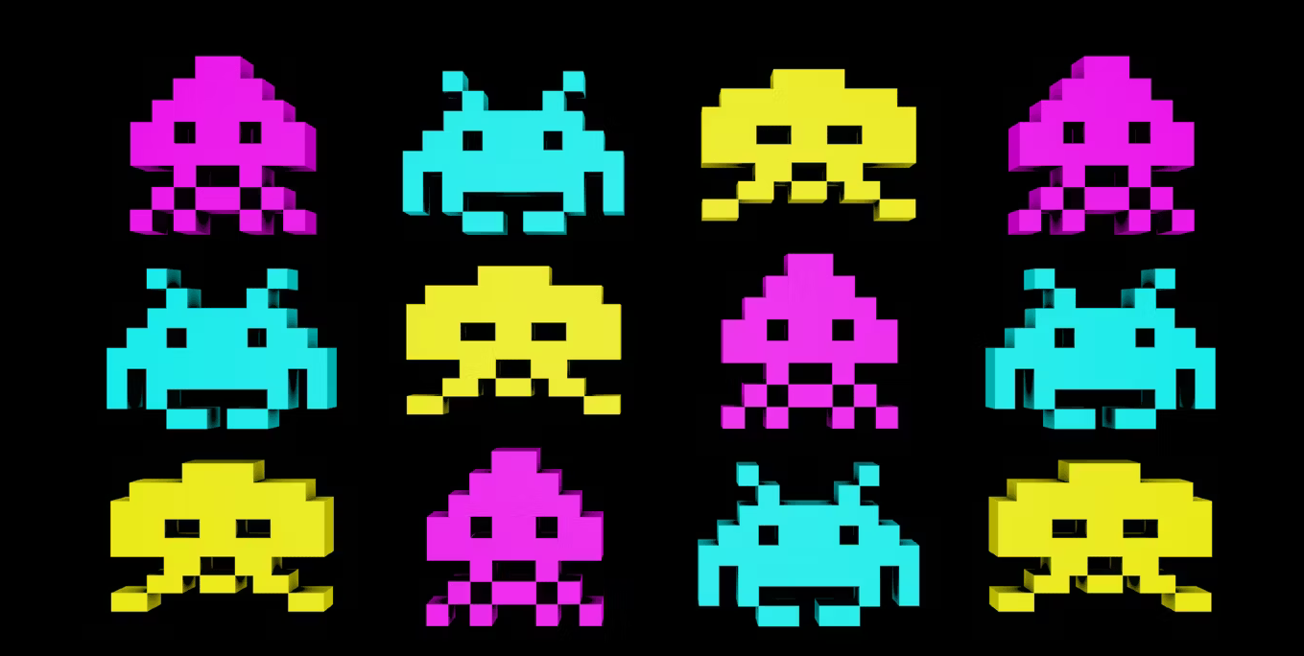](https://gamerant.com/space-invaders-sake-alcohol-japan/)

<https://gamerant.com/space-invaders-sake-alcohol-japan/>

They is even space invaders Sake

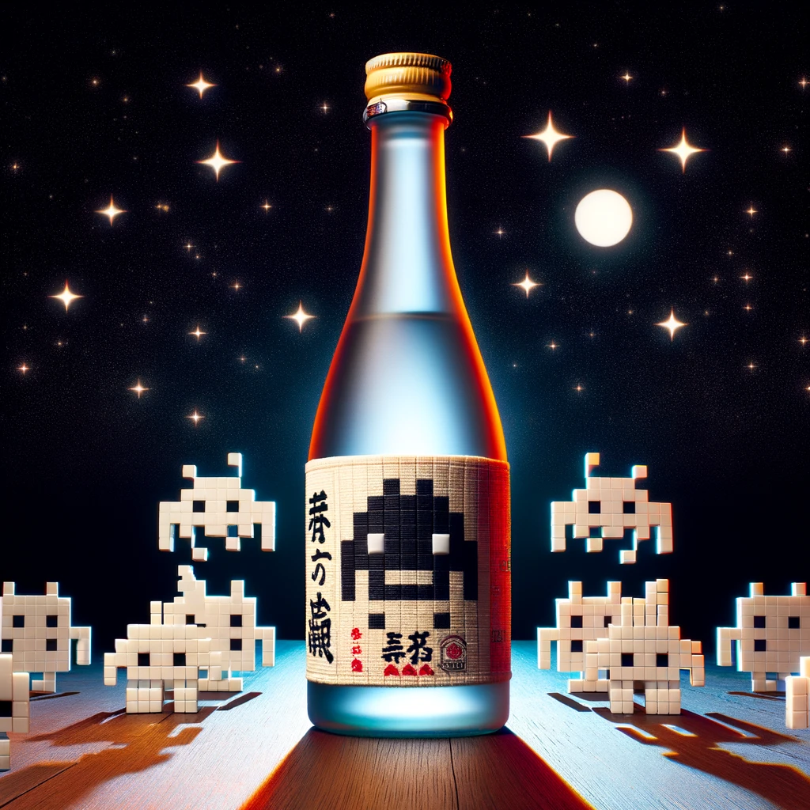

FINAL TETRIS

In 1984, Russian scientist Alexey Pajitnov, created the game Tetris. Pajitnov was inspired by his favourite boardgame [Pentominoes](https://boardgamegeek.com/boardgame/154934/pentominoes) which requires players to take turns placing cubic shapes on a board without overlapping each other. Tetris involved a single player fitting together a set of 7 distinct geometric pieces, each composed of four squares. These pieces, known as "tetriminos," fall at increasing speeds.

The name "Tetris" itself is a portmanteau, combining "tetra" (the Greek word meaning "four") and "tennis," Pajitnov's favorite sport. (Tetris Holding 2024)

Players are tasked with rotating and moving these pieces left and right to form a neat, gapless line at the bottom of the playing area. Once a complete row is formed, it vanishes, providing both relief and headroom for the player to continue the game. How do you lose this deceptively difficult game? If your tetriminos touch the top of the playing area, you lose Tetris.

But do you know who didn’t lose Tetris? Willis Gibson. At the beginning of 2024, Gibson “won” Tetris by reaching such a high level in the game that it couldn’t continue. ([Watch Gibson's Gameplay](https://www.youtube.com/watch?v=J9oVQ43j22g&t=2334s)).

But be careful, there are risks of playing this game too. "The Tetris Effect" (Tetris Holding 2024) is when you become such a Tet-head that you begin seeing Tetriminos in everyday situations.



If you can’t see the difference between these two images, you might have succumbed to the Tetris Effect.

Much of the game’s appeal comes from ordering a chaotic environment. The deep satisfaction one achieves when clearing multiple lines as the Tetriminos are getting a bit too high is spiritual.

The official website offers a modern version of the game ([Play Tetris Here](https://tetris.com/play-tetris/?utm_source=flyout_button&utm_medium=web_button&utm_campaign=playNow_btm_flyout&utm_content=button_play_now_flyout)). I spent 30 minutes playing it while researching which is a testament to Tetris’ ability to distract me from real-world responsibilities, which means that it’s still a good game.

Blue, S 2024, *The First Time Somebody Has Ever ‘Beat’ Tetris*, www.youtube.com, viewed 7 January 2024, <https://www.youtube.com/watch?v=J9oVQ43j22g&t=2334s>.

Tetris Holding 2024, *Tetris | The addictive puzzle game that started it all!*, Tetris.

**Title: Pac-Man: The Maze Chase That Charmed the World**

**Content:**

The forever-hungry, forever-hunted yellow circle, Mr. Pacman was a game-changer, figuratively and literally. Designed by Toru Iwatani and released in 1980, Pac-Man was not like other games at the time. Iwatani wanted to build a game that would be appealing to non-traditional video gamers which, at the time, consisted predominantly of men who like to shoot aliens. His inspiration came from the Japanese comic book "Obake no Q-Taro", "Casper the Friendly Ghost," and Popeye’s superhuman spinach-derived strength with the inclusion of 'power pellets' that give Pac-Man special powers. (CNN 2020)

“Arcades were very much where men hung around and all the games were mostly about beating up aliens. That’s when I started to think about making a game with simple game rules that will appeal to women and people who don’t typically play games. I decided to make a game around the theme of eating.” (CNN 2020)

Pac-Man's is the never-ending journey of a yellow, circular character. Like a shark, Pac-Man is always moving, running from his nemeses, the dastardly quartet of ghosts: Blinky, Pinky, Inky, and Clyde. These ghosts weren't just NPC Pac-Man junkies; each one, thanks to the programming skills of Funaki-san, had their own way of hunting Pac-Man due to each ghost being programmed with a different algorithm, giving them a rudimentary personality.

The name "Pac-Man" comes from a Japanese onomatopoeia "paku-paku," as in "paku paku taberu", which means to gobble down. (CNN 2020)

Pac-Man merchandise is odd and adorable too, see this Pac-Man phone (image: [Pacman Phone](https://insider.si.edu/wp-content/uploads/2016/01/NMAH2004-08511.jpg)) and Pac-Man spaghetti (image: [Pacman Spaghetti](https://a57.foxnews.com/static.foxnews.com/foxnews.com/content/uploads/2018/09/1920/1080/Even-Pac-Man-Eats-Chef-Boyardee.jpg?ve=1&tl=1)) to understand just how adorably odd it can be.

Pac-Man expanded our understanding and expectation of what video games could be and who they could appeal to, and is an example of how thinking beyond the existing landscape, promoting inclusivity and using your imagination can impact an entire industry.

Play pac man here <https://freepacman.org/>

](https://freepacman.org/)

CNN 2020, *The true story behind Pac-Man and his ghosts*, www.youtube.com, viewed 7 January 2024, <https://www.youtube.com/watch?v=rvp9E8GWPLw>.