1. Capture the results of the uname –a command. What is the purpose of the uname command? How did you find information on the uname command?

jaimew@cslinux:~$ uname -a

Linux cslinux 3.2.0-53-generic #81-Ubuntu SMP Thu Aug 22 21:01:03 UTC 2013 x86_64 x86_64 x86_64 GNU/Linux

Print system information, print information about the machine and operating system it is run on.

2. Capture a detailed list of ALL files and directories, including dot files, in the /lib directory. By editing your text file, indicated which lines refer to: files, directories and links. – You don’t need to do this for all the files, just a few to illustrate you understand the difference. (2 of each)

Cmd line

file

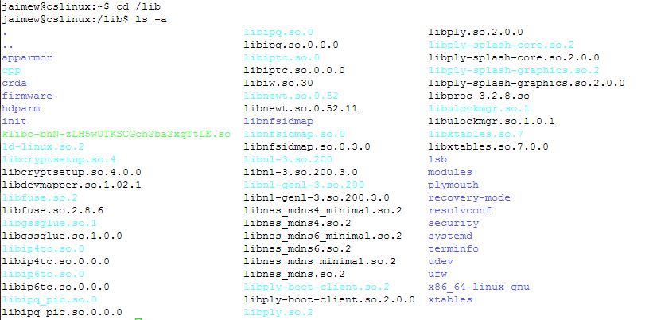

executable file

Directory

Link

3. Capture the command and a detailed listing of the file properties of the .bashrc file in your home directory. Add a comment below this capture that explains all the file properties of .bashrc.

jaimew@cslinux:~$ ls -al .bashrc

-rw-r--r-- 1 jaimew IT-GenericLinuxGroup 3103 Sep 20 2012 .bashrc

User has read write, group has read, other has read, hard link count is 1, owner is jaimew, group owner is IT-GenericLInuxGroup, file size is 3103, most recent mod of file was on Sep 20th 2012 and filename is .bashrc.

4. Create a subdirectory called cscd240 in your home directory. Capture the command that created the directory and the output of an ls command that shows that the new directory exists.

jaimew@cslinux:~$ ls -al cscd240

total 8

drwxr-xr-x 2 jaimew IT-GenericLinuxGroup 4096 Sep 29 07:20 .

drwx------ 26 jaimew IT-GenericLinuxGroup 4096 Sep 29 07:20 ..

5. Create another subdirectory inside cscd240 that is named lab1. Capture the command that created the directory and the output of an ls command that shows that the new directory exists. NOTE: The creation of the directory lab1 must be made from /home/yourhomedirectory

jaimew@cslinux:~$ mkdir cscd240/lab1

jaimew@cslinux:~$ ls cscd240/

lab1

6. With the home directory still as your current working directory, capture the command that copies the .bashrc file from your home directory to a file called copy.bashrc in the lab1 directory.

jaimew@cslinux:~$ mv .bashrc cscd240/lab1/copy.bashrc

7. Within the home directory, capture a detailed listing of all the files in the lab1 directory.

jaimew@cslinux:~$ ls -al cscd240/lab1/

total 12

drwxr-xr-x 2 jaimew IT-GenericLinuxGroup 4096 Sep 29 07:29 .

drwxr-xr-x 3 jaimew IT-GenericLinuxGroup 4096 Sep 29 07:26 ..

-rw-r--r-- 1 jaimew IT-GenericLinuxGroup 3103 Sep 20 2012 copy.bashrc

8. Change to the lab1 directory capture the change directory command and capture a command that renames the copy.bashrc in lab1 to my.copy.bashrc.

jaimew@cslinux:~$ cd cscd240/lab1/

jaimew@cslinux:~/cscd240/lab1$ mv copy.bashrc my.copy.bashrc

9. Capture a detailed listing of all the files in the lab1 directory.

jaimew@cslinux:~/cscd240/lab1$ ls -al

total 12

drwxr-xr-x 2 jaimew IT-GenericLinuxGroup 4096 Sep 29 07:34 .

drwxr-xr-x 3 jaimew IT-GenericLinuxGroup 4096 Sep 29 07:26 ..

-rw-r--r-- 1 jaimew IT-GenericLinuxGroup 3103 Sep 20 2012 my.copy.bashrc

10. Starting in your lab1 directory, capture a command that uses a relative pathname to make cscd240 the current working directory.

jaimew@cslinux:~/cscd240/lab1$ cd ..

11. Use the pwd command to indicate the current working directory.

jaimew@cslinux:~/cscd240$ pwd

/home/EASTERN/jaimew/cscd240

12. Starting in /usr/bin, (you will have to change to /usr/bin) (Prove you are in /usr/bin with pwd) capture the command using an absolute path that will make your home directory the current working directory. Prove the directory change with pwd.

jaimew@cslinux:~$ cd /usr/bin

jaimew@cslinux:/usr/bin$ pwd

/usr/bin

jaimew@cslinux:/usr/bin$ cd /home/EASTERN/jaimew

jaimew@cslinux:~$ pwd

/home/EASTERN/jaimew

13. Capture the command and output using rmdir (with no other commands) to delete the lab1 subdirectory. Does it delete the directory? Why or why not?

jaimew@cslinux:~$ rmdir cscd240/lab1

rmdir: failed to remove `cscd240/lab1': Directory not empty

14. Change directory so you are working from within the lab1 directory. Once in the directory:

a. Capture the command that will create 6 files using the touch command. The files will be named test, test1, test21, test3, something, nothing.

b. Capture the use of PICO or NANO to add text to the file test1.

c. Capture the long listing of test1 to show the size changed.

jaimew@cslinux:~$ cd cscd240/lab1/

1. jaimew@cslinux:~/cscd240/lab1$ touch test test1 test21 test3 something nothing
2. 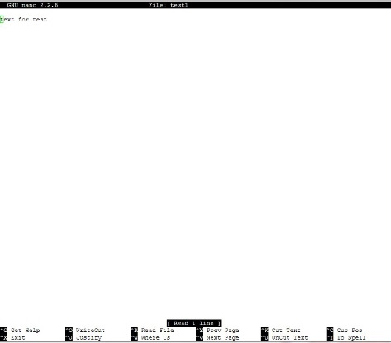

C. jaimew@cslinux:~/cscd240/lab1$ ls -al test1

-rw-r--r-- 1 jaimew IT-GenericLinuxGroup 14 Sep 29 07:47 test1

15. Capture the command to create a tar file named files.tgz that contains all the files from #14. Capture the ls command to show the tar file was created. (Hint tar)

jaimew@cslinux:~/cscd240/lab1$ tar -czf files.tgz nothing something test test1 test21 test3

jaimew@cslinux:~/cscd240/lab1$ ls -al files.tgz

-rw-r--r-- 1 jaimew IT-GenericLinuxGroup 238 Sep 29 07:57 files.tgz

16. Capture the command echo $PS1.

a. Capture the command PS1=”prompt : ”

b. Explained what happened

jaimew@cslinux:~/cscd240/lab1$ echo $PS1

\[\e]0;\u@\h: \w\a\]${debian_chroot:+($debian_chroot)}\u@\h:\w\$

A. jaimew@cslinux:~/cscd240/lab1$ PS1="prompt: "

prompt:

B. Changed environmental variable.

17. Capture the df command

a. What is the purpose of the df command

b. Capture the df command that allows the output in human readable format

A. df displays the amount of disk space available on the file system containing each file name argument. If no file name is given, the space available on all currently mounted file systems is shown.

jaimew@cslinux:~/cscd240/lab1$df

Filesystem 1K-blocks Used Available Use% Mounted on

/dev/sda1 11533592 9510968 1436744 87% /

udev 1016948 4 1016944 1% /dev

tmpfs 410308 508 409800 1% /run

none 5120 0 5120 0% /run/lock

none 1025760 0 1025760 0% /run/shm

/dev/sda2 1074136 711812 362324 67% /var

//netstorage.ewu.edu/oanderson93 2576980380 1288692536 1288287844 51% /mnt/ns-oanderson93

//netstorage.ewu.edu/jaimew 2576980380 1079869188 1497111192 42% /mnt/ns-jaimew

146.187.135.18:/home/EASTERN/oanderson93 865108416 46027488 775135936 6% /home/EASTERN/oanderson93

146.187.135.18:/home/EASTERN/jaimew 865108416 46027488 775135936 6% /home/EASTERN/jaimew

B.

jaimew@cslinux:~/cscd240/lab1$df -h

Filesystem Size Used Avail Use% Mounted on

/dev/sda1 11G 9.1G 1.4G 87% /

udev 994M 4.0K 994M 1% /dev

tmpfs 401M 508K 401M 1% /run

none 5.0M 0 5.0M 0% /run/lock

none 1002M 0 1002M 0% /run/shm

/dev/sda2 1.1G 696M 354M 67% /var

//netstorage.ewu.edu/oanderson93 2.5T 1.3T 1.2T 51% /mnt/ns-oanderson93

//netstorage.ewu.edu/jaimew 2.5T 1.1T 1.4T 42% /mnt/ns-jaimew

146.187.135.18:/home/EASTERN/oanderson93 826G 44G 740G 6% /home/EASTERN/oanderson93

146.187.135.18:/home/EASTERN/jaimew 826G 44G 740G 6% /home/EASTERN/jaimew

18. Capture the output of the command “history”

a. How many lines were displayed?

b. How do you execute the last command without retyping it?

c. How do you believe you change the number commands saved in the history file? (Hint: bashrc)

A. 385 history

B. Up arrow

C. 