MÁSTER UNIVERSITARIO EN INGENIERÍA DE TELECOMUNICACIÓN
TRABAJO FIN DE MÁSTER

AN AUTOMATED FRAMEWORK FOR DATASET QUALITY ASSESSMENT AND DATA LEAKAGE DETECTION IN MACHINE LEARNING

JAIME CANO MORANO
2025-26

MÁSTER uNIVERSITARIO EN INGENIERÍA DE TELECOMUNICACIÓN

trabajo fin de MÁSTER
Título: An automated framework for dataset quality assessment and data leakage detection in machine learning
Autor: D. Jaime Cano Moraño
Tutor: D. Yong Zheng
Ponente: D. Pedro Reviriego Vasallo
Departamento: Departamento de Ingeniería de Sistemas Telemáticos.

Miembros del Tribunal
Presidente: D. ……………
Vocal: D. …………..
Secretario: D. …………..
Suplente: D. ……………..

Los miembros del tribunal arriba nombrados acuerdan otorgar la calificación de: ………

Madrid, a de de 20…

UNIVERSIDAD POLITÉCNICA DE MADRID
ESCUELA TÉCNICA SUPERIOR
DE INGENIEROS DE TELECOMUNICACIÓN



MÁSTER UNIVERSITARIO EN INGENIERÍA DE TELECOMUNICACIÓN
TRABAJO FIN DE MÁSTER

AN AUTOMATED FRAMEWORK FOR DATASET QUALITY ASSESSMENT AND DATA LEAKAGE DETECTION IN MACHINE LEARNING

JAIME CANO MORANO
2025-26

RESUMEN
Número máximo de palabras: 500…

summary
Maximum number of words: 500…

PALABRAS CLAVE
Deben reflejar el contenido del trabajo, deberían servir para localizar el TFM mediante búsqueda bibliográfica...

KEYWORDS
….

INDEX

1. introduction & objectives 6
1.1. Introduction 6
1.1.1. Machine learining context 6
1.1.2. Data set quality challenges 2
1.1.3. Data leakage in Machine Learning 3
1.1.4. Existing dataset validation approaches 5
1.1.5. Motivation of the project 8
1.2. Objetives 9
2. development 11
3. resultados 12
4. conclusions y future research 13
4.1. Conclusiones 13
4.2. Líneas futuras 13
5. bibliography 14
anexo a: aspectos ÉTICOS, económicos, sociales y ambientales 15
A.1 iNTRODUCCIÓN 15
A.2 DESCRIPCIÓN DE IMPACTOS RELEVANTES RELACIONADOS CON EL PROYECTO 15
A.3 ANÁLISIS DETALLADO DE ALGUNO DE LOS PRINCIPALES IMPACTOS 15
A.4 CONCLUSIONES 15
anexo b: presupuesto económico 16

introduction & objectives

Introduction
This chapter introduces the theoretical background required to understand the context and motivation of this project. In recent years, the rapid development of Machine Learning techniques has enabled the creation of increasingly powerful predictive models applied across many domains such as finance, healthcare, and technology. However, the performance and reliability of these models strongly depend on the quality of the datasets used during the training process.
Consequently, ensuring dataset quality and detecting potential issues in data before model training has become a critical task in modern Machine Learning workflows. This chapter therefore presents an overview of the current Machine Learning landscape and discusses common problems related to dataset quality and data leakage. These concepts provide the necessary foundation for the framework proposed in this work.

Machine learining context
In recent years, Machine Learning (ML) has experienced a significant growth and has become one of the most important technological drivers behind modern Artificial Intelligence systems. Machine learning techniques allow computer systems to learn patterns from data and make predictions or decisions without being explicitly programmed for each specific task. As a result, ML models are now widely used in areas such as healthcare, finance, recommendation systems, autonomous vehicles, and natural language processing.
Traditionally, the performance of machine learning models has been associated with improvements in algorithms and model architectures. However, recent research has highlighted that the quality of the data used to train these models plays an equally important, and often more critical, role. This shift in perspective has led to the emergence of the data-centric AI paradigm, where the focus moves from improving models to improving datasets and data pipelines.
In practice, machine learning systems rely heavily on the datasets used during the training process. If the data is incomplete, biased, inconsistent, or contains hidden correlations with the target variable, the resulting models may produce unreliable predictions or overly optimistic evaluation results. Consequently, dataset validation and quality assessment have become key steps in the development of reliable machine learning systems.
Several studies have explored the importance of dataset quality and the impact of data-related issues in machine learning pipelines. For instance, in the paper “A Survey on Dataset Quality in Machine Learning” [1], they provide a comprehensive survey of dataset quality challenges in machine learning, highlighting common problems such as missing values, class imbalance, redundant features, and noisy data. Similarly, Neoklis Polyzotis [2] emphasize the need for systematic data validation processes before training models, proposing automated tools for dataset validation within machine learning pipelines.
Another critical issue in machine learning workflows is data leakage, which occurs when information that would not normally be available during model deployment is inadvertently used during the training process. Data leakage can lead to models that appear to perform very well during evaluation but fail when applied in real-world scenarios. Different research [4] [3] highlight the importance of detecting such leakage to ensure reliable and trustworthy machine learning systems.
Despite the increasing awareness of these issues, many machine learning workflows still focus primarily on model development while overlooking systematic dataset validation procedures. As a consequence, errors related to data quality or data leakage are often detected only after models have already been deployed or evaluated.
For this reason, there is a growing need for tools and methodologies that allow researchers and practitioners to automatically analyze datasets before training machine learning models. Such tools could help identify potential data quality issues and detect possible sources of data leakage, ultimately improving the robustness and reliability of machine learning systems.

Data set quality challenges
The performance of machine learning models is strongly dependent on the quality of the datasets used during the training process. In many real-world scenarios, datasets are collected from heterogeneous sources and may contain various imperfections that negatively affect the learning process. As a result, ensuring dataset quality has become a critical step in modern machine learning pipelines.
Several studies [5] highlight that machine learning systems are particularly sensitive to data-related issues such as missing values, noisy attributes, class imbalance, and redundant or inconsistent data. These problems may reduce model accuracy, introduce bias, or lead to unstable predictions when models are deployed in real-world environments.
One of the most common issues found in real-world datasets is the presence of missing values, which may occur due to data collection errors, equipment failures, or incomplete records. Missing data can significantly degrade model performance and may introduce biased results if not properly handled [6].
Another frequent challenge is class imbalance, where some classes are significantly underrepresented compared to others. This situation is particularly common in domains such as fraud detection, anomaly detection, or medical diagnosis. In such cases, machine learning models tend to become biased toward the majority class, leading to misleading performance metrics and poor detection of minority cases [7].
Datasets may also contain outliers or anomalous values, which can distort statistical properties and negatively affect certain machine learning algorithms. Detecting and managing such anomalies is an important step in the data preprocessing phase, as undetected outliers may lead to inaccurate predictions or unstable models [8].
Additionally, datasets often suffer from redundant or duplicated information, inconsistencies, or noisy attributes. These issues may increase model complexity and training time while providing little additional predictive value. For this reason, several data quality frameworks emphasize the importance of evaluating multiple dimensions of dataset quality before training machine learning models [9].
Given the increasing complexity of modern machine learning pipelines, systematic approaches to dataset validation and quality assessment are becoming increasingly necessary. By identifying potential data quality issues early in the development process, researchers and practitioners can significantly improve the reliability and robustness of machine learning systems.
Dataset quality issues should not be understood only as data engineering problems, but as factors that directly affect the behavior of machine learning models. Poor-quality data may reduce predictive accuracy, increase variance, generate unstable predictions, and amplify bias in decision-making systems. In many practical scenarios, improving dataset quality can lead to larger performance gains than changing the model architecture itself.
Low-quality datasets may also reduce model robustness when facing unseen data and may negatively affect fairness when minority groups are underrepresented or poorly represented in the training data. Consequently, dataset quality should be considered a core component of trustworthy machine learning systems.
For this reason, modern machine learning workflows increasingly require automated mechanisms capable of identifying data quality problems before training, estimating their potential impact, and guiding corrective actions.

Data leakage in Machine Learning
One of the most critical and often underestimated issues in machine learning workflows is data leakage, which occurs when information that would not normally be available during real deployment is inadvertently used during the training or validation process. When leakage is present, the model gains access to signals that artificially simplify the prediction task, producing evaluation results that do not reflect its real predictive capability.
As a consequence, models affected by data leakage may appear to perform extremely well during testing while failing when applied to unseen data in production environments. This problem is particularly dangerous because it may remain unnoticed during development, creating a false sense of confidence regarding the quality of the model. In practical scenarios, this may lead to poor business decisions, unreliable automated systems, and significant economic or operational costs [10].
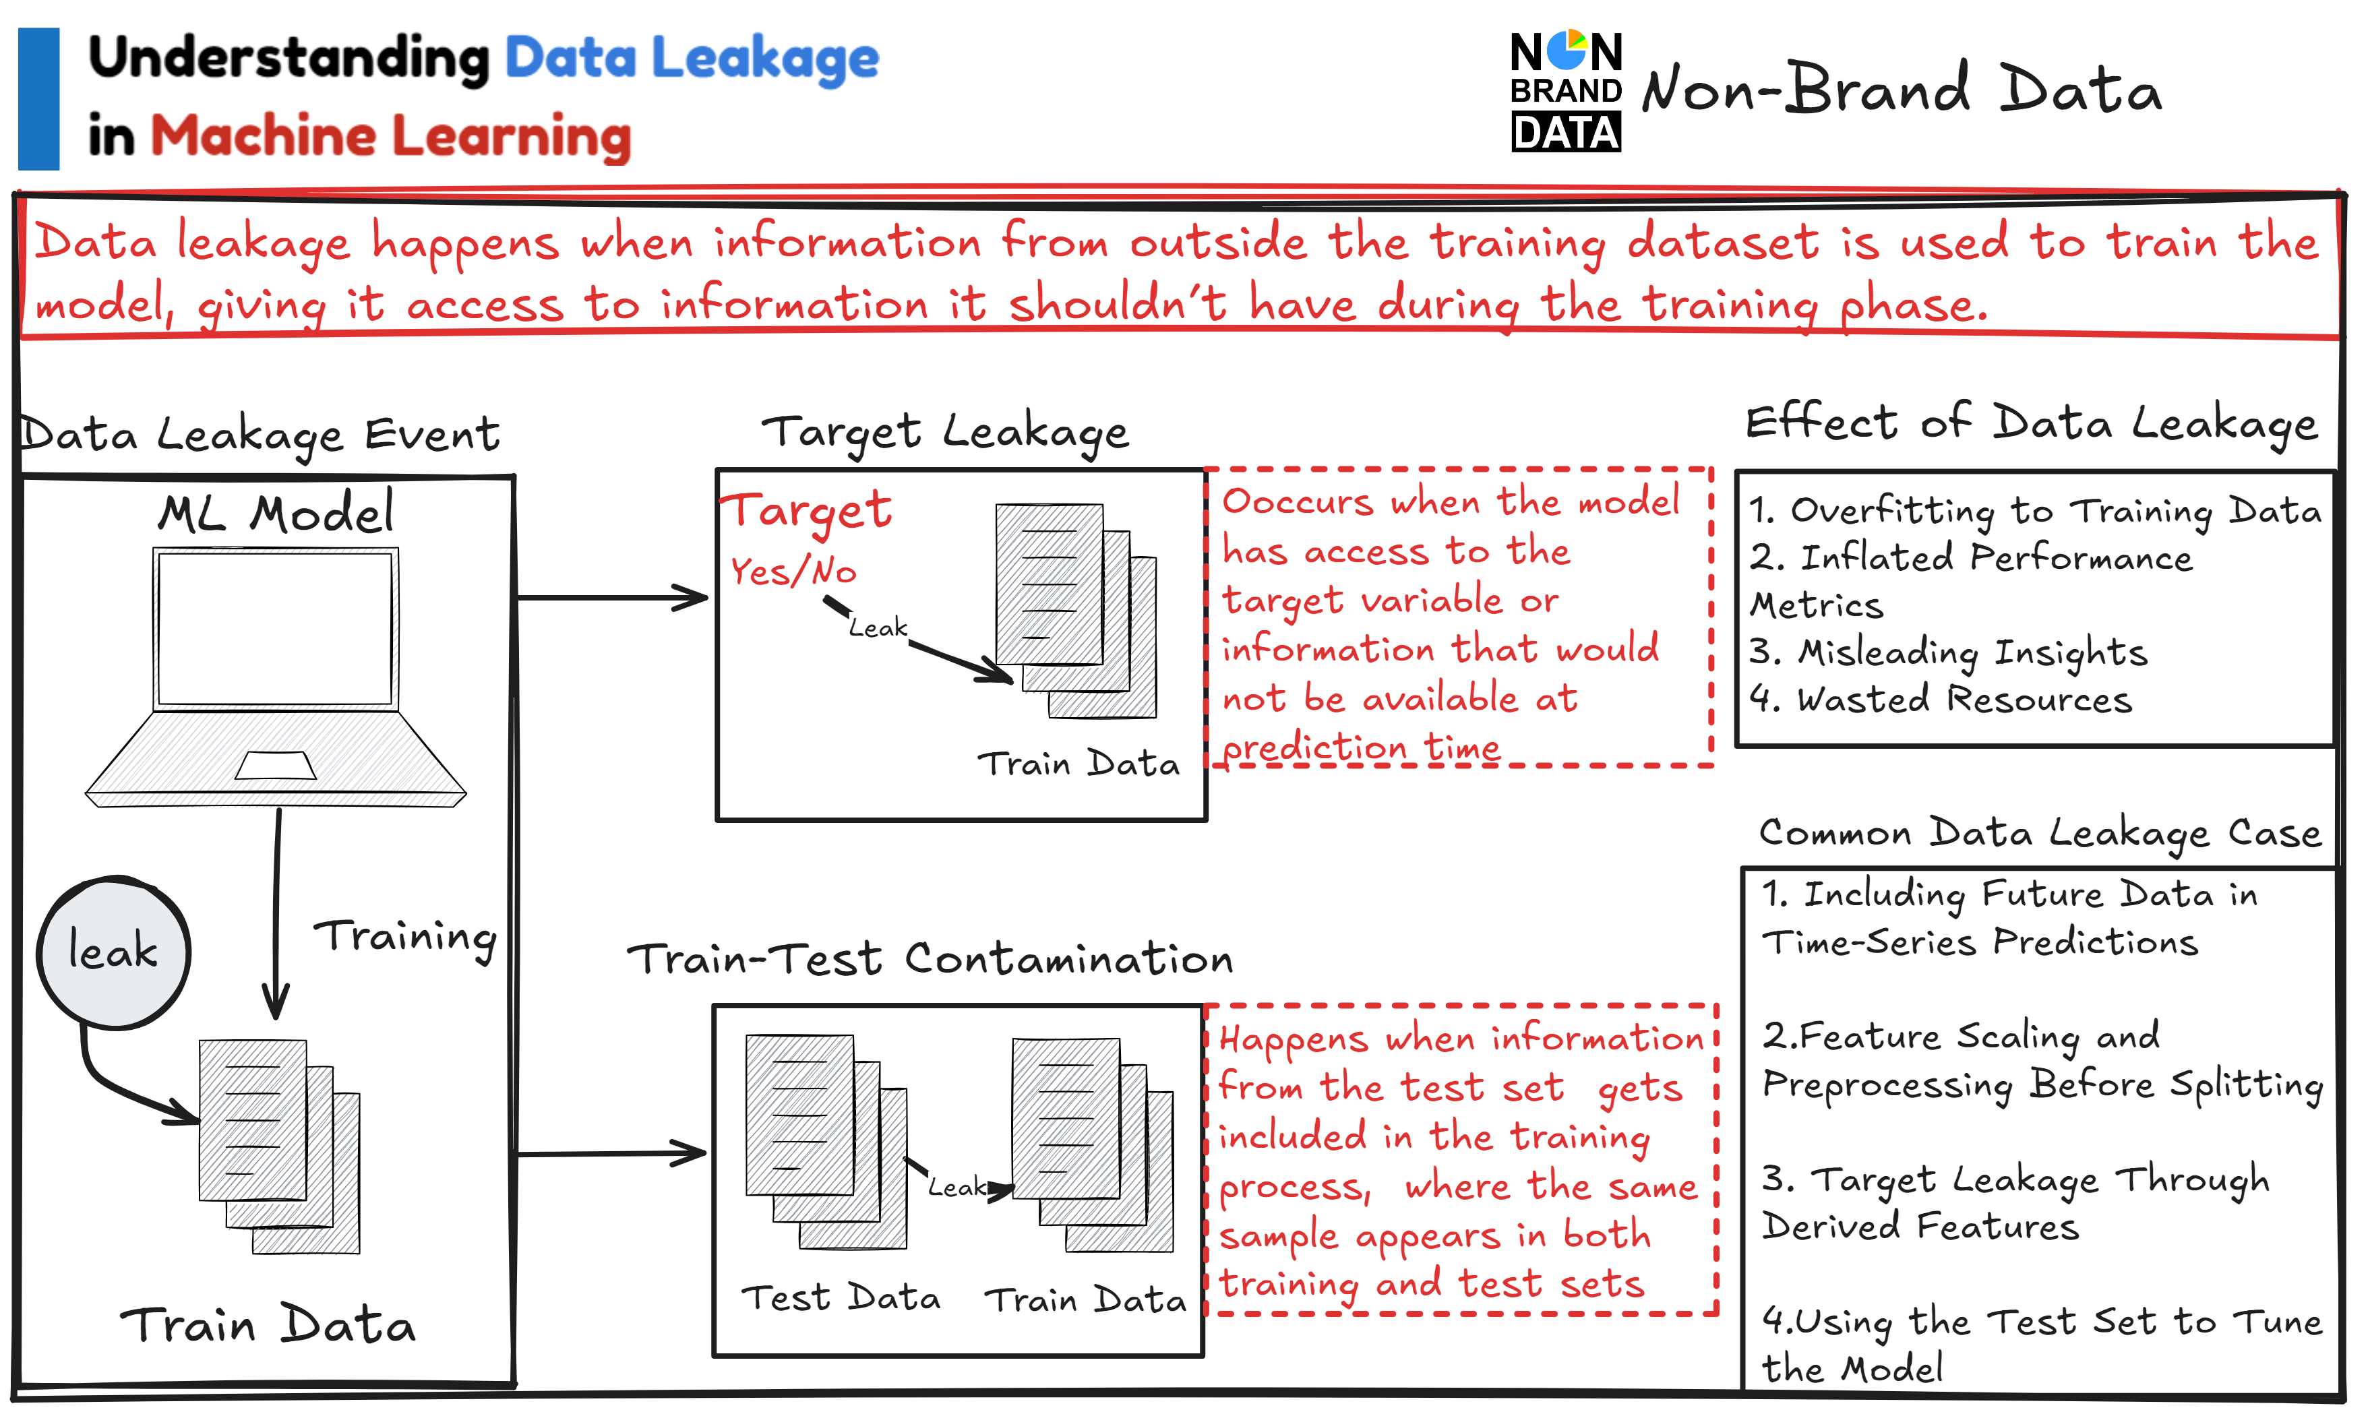
Figure 1: Target leakage vs train-test contamination [11].
Data leakage can occur in several ways throughout the machine learning pipeline. One common example is target leakage, where one or more input variables contain information that is directly or indirectly related to the target variable but would not be available at prediction time. For instance, in a customer churn prediction problem, using a variable that records the cancellation date would provide future information that trivially reveals the target outcome.
Another frequent type of leakage is train-test contamination, which happens when information from the test set unintentionally influences the training process. This may occur when preprocessing operations such as normalization, feature scaling, feature selection, or missing value imputation are applied to the full dataset before splitting it into training and testing subsets. Although these mistakes are common and sometimes subtle, they can significantly inflate performance metrics and distort model comparison results.
In time-dependent datasets, temporal leakage represents another relevant risk. This happens when future observations are used to predict past events, violating the chronological structure of the problem. Temporal leakage is especially common in domains such as finance, demand forecasting, maintenance prediction, and healthcare analytics, where respecting time order is essential for realistic model evaluation.
Leakage may also emerge from duplicate records or overlapping samples between training and testing sets. If highly similar observations appear in both subsets, the model may simply memorize patterns rather than learn generalizable relationships. In these cases, test performance may be artificially high despite poor real-world robustness.
Several studies have emphasized the importance of preventing leakage in data-driven systems. Papadimitriou and Garcia-Molina [4] highlight the relevance of leakage detection in analytical environments, while Hannun et al.[3] show how leakage-related effects can distort the apparent predictive performance of machine learning systems. More broadly, recent work on trustworthy AI and model validation also stresses that incorrect evaluation procedures are a major source of unreliable machine learning results.
Despite growing awareness of this issue, detecting leakage remains challenging in practice. Many sources of leakage are subtle and cannot be identified through simple manual inspection. In some cases, the variables themselves appear legitimate, but their semantics reveal hidden future information. In other situations, leakage is introduced unintentionally through automated preprocessing pipelines or incorrect cross-validation strategies.
For this reason, leakage should not only be detected, but also quantified in terms of its impact on model performance. If the presence of a suspicious feature increases accuracy, F1-score, or AUC far beyond realistic levels, this may indicate that the model is exploiting leaked information rather than learning robust predictive patterns. Measuring the performance difference before and after removing suspicious variables can therefore provide valuable evidence of leakage risk.
Modern machine learning workflows increasingly require automated mechanisms capable of identifying potential leakage sources early in the development process. Techniques such as feature-target dependency analysis, train-test overlap checks, time-aware validation strategies, and controlled synthetic leakage experiments can help estimate both the presence of leakage and its practical consequences.
Given the severe effect that leakage can have on reliability, reproducibility, and deployment performance, incorporating systematic leakage detection into dataset validation procedures has become an essential requirement for trustworthy machine learning systems. This need represents one of the main motivations of the framework proposed in this project.

Existing dataset validation approaches
As machine learning systems become increasingly complex and are deployed in critical domains such as healthcare, finance, cybersecurity, and industrial automation, the need for systematic dataset validation has gained significant importance in both academia and industry. Dataset validation refers to the set of techniques used to inspect data before training machine learning models in order to detect potential quality issues, inconsistencies, anomalies, or structural problems that may negatively affect model performance.
Traditionally, many machine learning projects relied on manual exploratory data analysis to understand datasets and identify potential errors. Although manual inspection can be useful in small-scale scenarios, it becomes inefficient, subjective, and difficult to reproduce when working with large datasets or production pipelines. For this reason, automated validation tools have emerged as an essential component of modern data-centric machine learning workflows.
One of the most common approaches to dataset validation is data profiling, which consists of computing descriptive statistics and structural metadata about a dataset. Data profiling techniques help practitioners identify missing values, abnormal distributions, duplicated rows, correlations between variables, unexpected categorical values, or suspicious patterns in the data. These methods are widely used in data engineering environments to better understand datasets before they are consumed by downstream systems [12].
Another relevant category of tools is based on rule-driven validation, where users define expected conditions that the data must satisfy. These conditions may include constraints such as non-null columns, valid numerical ranges, accepted categorical values, uniqueness requirements, or schema consistency across versions. Rule-based systems are particularly useful in production pipelines because they allow organizations to continuously monitor incoming data and quickly detect deviations from expected behavior.
A representative framework in this category is Great Expectations, an open-source library that enables users to create validation rules, automatically generate reports, and integrate data checks into ETL and analytics pipelines. Great Expectations has become popular due to its usability, documentation, and compatibility with modern data stacks. However, its main focus is general data quality assurance rather than machine learning-specific validation. As a result, it offers limited support for analyzing how detected data issues may affect predictive models or whether leakage risks are present.
Another widely used tool is Pandera, a Python library designed for validating pandas DataFrames through schemas, type checks, and column constraints. Pandera is lightweight, developer-friendly, and especially useful in notebook-based workflows or data science prototypes. Nevertheless, it mainly addresses structural validation and schema enforcement rather than automated diagnostics related to model training or evaluation.
A particularly relevant solution for machine learning pipelines is TensorFlow Data Validation (TFDV), an open-source library developed by Google as part of the TensorFlow Extended (TFX) ecosystem. TFDV is designed to analyze large datasets and automatically compute a wide range of statistics that help practitioners understand the structure and characteristics of their data before model training.
TFDV operates by generating descriptive statistics for datasets, including feature distributions, missing value rates, categorical frequencies, and numerical summaries such as mean, variance, and quantiles. These statistics allow developers to identify potential data quality issues and inconsistencies. Additionally, TFDV enables the definition of a data schema, which describes the expected properties of each feature, such as data types, accepted ranges, and categorical domains.
One of the most important functionalities of TFDV is anomaly detection, which automatically identifies discrepancies between the observed dataset and the expected schema. For example, the tool can detect unexpected feature values, missing columns, schema drift, or significant distribution changes between training and serving data. This capability is especially valuable in production systems, where gradual data drift may silently degrade model performance over time.
Another relevant contribution is the ML Test Score framework proposed by Breck et al. [10], which introduces a rubric to evaluate the production readiness of machine learning systems. Among its recommendations, particular emphasis is placed on data validation, monitoring, reproducibility, and reducing technical debt caused by poor data practices. Although it is not an automated tool itself, it provides an important conceptual framework for evaluating machine learning pipelines.
Despite the usefulness of these approaches, most current tools primarily focus on data engineering validation, meaning structural correctness, schema consistency, missing values, and distribution monitoring. While these capabilities are highly valuable, they often provide limited support for more subtle but critical machine learning issues such as data leakage, suspicious feature-target relationships, train-test contamination, or the real impact of data problems on predictive performance.
Tool / Framework | Main Focus | Key Strengths | Data Leakage Detection | ML Performance Impact Analysis | Main Limitations
Great Expectations | Rule-based data validation | Strong reporting, pipeline integration, monitoring | No | No | Not ML-aware
Pandera | DataFrame schema validation | Lightweight, Python-native, easy to use | No | No | Limited automation
TFDV | Statistical validation and anomaly detection | Scalable, production-ready, schema support | No | No | Focused on structural checks
ML Test Score | ML system readiness checklist | Strong engineering guidelines | Partial | Partial | Not automated
Traditional Data Profiling | Descriptive statistics | Useful exploratory insights | No | No | Manual interpretation required
Proposed Framework | ML-aware dataset validation | Quality + leakage + impact estimation | Yes | Yes | Under development
Table 1. Comparison of Existing Dataset Validation Approaches
The comparison above shows that existing solutions are highly effective for structural and operational data validation, but they rarely address a key question in machine learning practice:
Is this dataset suitable for training a reliable predictive model?
In many real-world projects, a dataset may satisfy schema rules and still produce poor or misleading machine learning results due to hidden leakage, severe imbalance, unstable features, or correlations that do not generalize. Therefore, validating datasets only from a data engineering perspective is no longer sufficient.

Limitations of existing approaches
Although current validation tools provide valuable support for detecting structural problems, most were not specifically designed for machine learning validation. In particular, they generally do not estimate the effect of data issues on model accuracy, robustness, fairness, or generalization performance. Furthermore, they rarely include systematic procedures for detecting and quantifying data leakage risks.
This limitation reveals an important gap between existing validation tools and the practical needs of modern machine learning development. As machine learning systems continue to expand into high-impact domains, there is a growing need for lightweight and automated frameworks capable of combining traditional data quality checks with machine learning-aware validation mechanisms.
For this reason, the framework proposed in this project aims to complement current approaches by extending dataset validation beyond structural correctness, incorporating data leakage detection and impact analysis focused on model performance.

Motivation of the project
The previous sections have highlighted the increasing importance of data quality in modern machine learning systems, as well as the challenges associated with dataset imperfections and data leakage. As machine learning models are increasingly deployed in real-world applications, ensuring the reliability and robustness of the data used during training has become a critical requirement.
Although several approaches and tools have been proposed to support dataset validation, most existing solutions primarily focus on detecting structural issues such as missing values, schema inconsistencies, invalid data types, or distribution shifts. Frameworks such as TensorFlow Data Validation, Great Expectations, and Pandera provide useful mechanisms for monitoring data quality and enforcing data constraints. However, these tools are mainly oriented toward data engineering validation rather than machine learning validation.
In many practical scenarios, a dataset may satisfy schema rules and still produce poor or misleading machine learning results. Hidden data leakage, severe class imbalance, unstable feature relationships, duplicated records, or non-representative training samples may significantly affect model performance while remaining undetected by conventional validation systems.
At the same time, many machine learning workflows continue to prioritize model architecture selection and hyperparameter tuning while overlooking the quality and suitability of the training data. Recent research in data-centric AI has shown that improving datasets can often generate larger performance gains than modifying learning algorithms.
This situation reveals an important gap between current dataset validation tools and the practical needs of machine learning development. While existing approaches are effective for identifying structural data issues, there is still a need for lightweight and automated systems capable of answering more relevant questions such as:
- Will this dataset negatively affect model performance?
- Is there a risk of hidden data leakage?
- Which detected issues have the highest practical impact?
- Is the dataset ready for reliable model training?
For this reason, this project is motivated by the need to design and implement a machine learning-aware dataset validation framework that goes beyond traditional structural checks. The proposed system aims to combine dataset quality assessment, data leakage detection, and model impact estimation in a unified pre-training validation stage.
By incorporating these capabilities into the machine learning workflow, the framework seeks to improve model reliability, reduce misleading evaluations, and support more trustworthy machine learning development practices.

Objetives
The main objective of this project is to design and implement an automated machine learning-aware dataset validation framework capable of evaluating dataset quality, detecting potential sources of data leakage, and estimating the impact of data-related issues before training machine learning models.
Unlike traditional data validation approaches, which mainly focus on structural correctness or schema consistency, the proposed framework aims to assess whether a dataset is truly suitable for reliable model development. In this sense, the project seeks to integrate data engineering validation principles with machine learning-oriented diagnostics in a unified pre-training validation stage.
To achieve this general objective, the following specific goals are defined:
- Analyze the current state of research related to dataset quality, data validation techniques, data-centric AI, and data leakage in machine learning systems.
- Identify the most common dataset quality issues that can negatively affect machine learning models, including missing values, duplicated records, outliers, class imbalance, noisy variables, and redundant features.
- Study the main forms of data leakage in machine learning workflows, such as target leakage, train-test contamination, temporal leakage, and feature leakage.
- Design a modular framework architecture that integrates dataset quality analysis, data leakage detection, and model impact estimation as part of a pre-training validation pipeline.
- Implement the proposed framework in Python, using commonly adopted libraries for data analysis and machine learning.
- Develop methods to estimate the practical impact of detected issues on model performance by comparing predictive metrics before and after corrective actions.
- Evaluate the effectiveness of the framework using multiple real-world datasets and controlled experiments involving synthetic quality problems or injected leakage scenarios.
- Compare the proposed approach with existing validation tools in order to identify its strengths, limitations, and practical contribution.
- Generate interpretable validation reports that summarize dataset quality, leakage risk, and readiness for model training.
- Document the methodology, experiments, implementation details, and results obtained during the development of the project in the final Master’s Thesis.
The successful completion of these objectives is expected to provide a practical and research-oriented contribution in the area of trustworthy machine learning systems, helping practitioners detect data-related risks before model development and deployment.

development

System Architecture and Design
The framework is structured as a sequential pipeline where each phase consumes a pandas DataFrame and produces a list of CheckResult objects. These results are accumulated in a central FrameworkReport that is passed to the report generation module at the end of the pipeline. The design prioritises modularity: every module can be used independently, disabled through configuration, or replaced without modifying any other component.
The entire pipeline is driven by a single YAML configuration file. A deep-merge strategy fills any missing keys with sensible defaults, so a minimal configuration requires only two fields: the dataset path and the target column name. All thresholds, model selections, and output settings are optional and come pre-configured.
Module | Source file | Responsibility | Output
Core utilities | src/utils.py | Logger, data loader, core dataclasses | CheckResult, FrameworkReport
Configuration | src/config.py | YAML loading, deep-merge, validation | Validated config dict
Quality checks | src/quality_checks.py | 6 dataset quality verifications | list[CheckResult]
Leakage detection | src/leakage_checks.py | 4 leakage-pattern checks | list[CheckResult]
Impact analysis | src/impact_analysis.py | Baseline vs cleaned CV comparison | list[CheckResult]
Report generation | src/reporting.py | Jinja2 HTML rendering + matplotlib plots | Path (HTML file)

Table 2.1. Framework modules and their responsibilities.
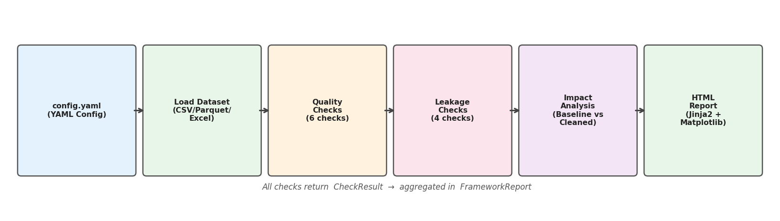
Figure 2.1. Framework architecture and data flow. Each module produces CheckResult objects that accumulate in a FrameworkReport.

Implementation
This section details the technical implementation of each phase, with emphasis on the design decisions, algorithmic choices, and interfaces that connect the modules.

Phase 1 – Core Utilities and Project Scaffolding
The first phase established the foundational infrastructure. The utility module (src/utils.py) provides three core components. setup_logger() configures loguru with structured, colour-coded output and optional file logging with automatic rotation. load_dataset() supports CSV, Parquet, and Excel formats, inferring the format from the file extension and raising descriptive exceptions for missing files or unsupported formats.
Two dataclasses constitute the data contract shared by all modules. CheckResult encapsulates the result of any single verification: a check_name identifier, a boolean passed flag, a severity level (info, warning, or error), a human-readable message, an arbitrary details dictionary, and a list of affected_columns. The severity field is validated at construction time in __post_init__, ensuring that invalid values raise an immediate error rather than propagating silently. FrameworkReport aggregates all result lists and exposes summary statistics through all_results(), failed_checks(), and summary().

Phase 2 – YAML Configuration System
The configuration system (src/config.py) enables reproducible experiments through a single YAML file. Its design follows a deep-merge pattern: a complete dictionary of default values (_DEFAULTS) is merged with the user-provided YAML, so that any omitted key falls back to a sensible default. The merge recurses into nested dictionaries but replaces lists entirely, allowing users to override model selections or metric lists without appending to defaults.
Validation is applied to the merged configuration before any check is executed. The validator collects all errors into a single list before raising, so a user with multiple misconfigured fields sees all problems at once. Validated constraints include: required fields present, log levels from an enumerated set, outlier method from {iqr, zscore}, threshold values in [0, 1], models and metrics from known sets, cv_folds ≥ 2, test_size ∈ (0, 1), and report format in {html}.

Phase 3 – Dataset Quality Module
The quality module implements six independent verifications, each returning a CheckResult whose severity scales with the magnitude of the problem found. The orchestrator run_all_quality_checks() reads the quality_checks configuration block and skips any check whose enabled flag is set to false, enabling selective execution.
The missing values check computes the NaN rate per column and flags any column above the configured threshold (default 5 %). Severity escalates to error when the rate exceeds 50 %. The duplicates check detects exact row copies and escalates to error when the duplicate rate exceeds 10 %. Outlier detection supports two configurable methods: IQR (default, threshold = 3.0) and z-score. Columns with fewer than four values or IQR = 0 are skipped to avoid degenerate results. The class imbalance check flags minority classes below a relative frequency threshold (default 10 %), with error severity below 5 %. The constant features check identifies columns where all non-null values are identical. The low-variance check uses the coefficient of variation (CV = std / |mean|) as a scale-independent measure of near-constancy; this metric was chosen over normalised variance after discovering that min-max normalisation always maps the range to [0, 1], masking near-constant columns.
Check | Method | Default threshold | Severity when failed
missing_values | NaN rate per column | > 5 % | warning / error (> 50%)
duplicates | Exact row matching | Any | warning / error (> 10%)
outliers | IQR or z-score | k = 3.0 | warning
class_imbalance | Minority class frequency | < 10 % | warning / error (< 5%)
constant_features | nunique() ≤ 1 on non-null values | Any | warning
low_variance | CV = std / |mean| | CV < 0.01 | warning

Table 2.2. Dataset quality checks implemented in Phase 3.

Phase 4 – Data Leakage Detection Module
Data leakage detection is the most critical module of the framework. It implements four checks that together cover the main categories of leakage described in the literature. All checks follow the same interface as the quality module, returning CheckResult objects with severity, message, and structured details.
Target leakage detection computes an association score between each feature and the target variable. For numeric features, absolute Pearson correlation is used; for categorical features, Cramér's V is applied. Both measures are normalised to [0, 1], making the threshold interpretation consistent across feature types. Any feature exceeding the configured threshold (default 0.95) is flagged with error severity, as a near-perfect association almost certainly indicates that the feature is derived from or replicates the target.
Train-test overlap detection simulates a random split using the configured test_size and random_state parameters. Overlap can only occur when duplicate rows exist, so the check short-circuits immediately otherwise. If duplicates are found on both sides of the split, the count and rate are reported. Temporal leakage detection verifies that the dataset is sorted chronologically when a date_column is configured. An unsorted temporal column means a sequential train-test split would mix past and future observations. The check also counts unparseable date values that could indicate data corruption. Identifier column detection flags non-float columns whose unique-value ratio exceeds the threshold (default 95 %). Columns such as customer IDs or UUIDs allow the model to memorise the training set rather than learn generalisable patterns. Float columns are explicitly excluded because continuous numeric features naturally exhibit high cardinality.
Check | Detection method | Default threshold | Severity
target_leakage | Pearson |r| (numeric) / Cramér's V (categorical) | ≥ 0.95 | error
train_test_overlap | Exact row match across simulated split | Any | warning / error
temporal_leakage | Monotonic ordering of date column | Any | error
id_column_leakage | Unique-value ratio for string/integer columns | ≥ 95 % | warning

Table 2.3. Data leakage detection checks implemented in Phase 4.

Phase 5 – Impact Analysis Module
The impact analysis module (src/impact_analysis.py) quantifies the practical effect of detected issues on model performance. For each configured model, it trains on two versions of the dataset: the original (baseline) and a cleaned version where problematic columns have been removed. Both evaluations use stratified k-fold cross-validation with the same preprocessing pipeline (SimpleImputer → StandardScaler → model) to avoid data leakage in the evaluation itself.
The function _extract_problem_columns() reads the affected_columns field from any failed target_leakage, id_column_leakage, or constant_features result in the FrameworkReport, producing the set of columns to remove for the cleaned evaluation. This design means the impact analysis automatically adapts to what the previous phases detected, without requiring any manual specification. A delta ≤ −0.05 (five-percentage-point drop) triggers a warning, indicating that the model was relying on problematic features to inflate its apparent performance.

Phase 6 – Report Generation
The reporting module (src/reporting.py) transforms a FrameworkReport into a self-contained HTML file using a Jinja2 template (src/templates/report.html.j2). The template uses inline CSS — no external stylesheet or JavaScript dependencies — ensuring the report can be opened in any browser without network access. The output includes a header with dataset metadata, summary cards, results tables for each phase, and an embedded visualisations section.
Three matplotlib figures are generated automatically and embedded as base64-encoded PNG data URIs: a horizontal bar chart showing the number of passed and failed checks per phase, a pie chart showing the severity distribution across all checks, and a grouped bar chart comparing baseline and cleaned performance per model. Embedding images as base64 strings guarantees that the HTML file is fully portable. The output file name includes the dataset name and a UTC timestamp, allowing multiple runs to coexist in the reports directory.

Technical Challenges and Solutions
The development process encountered several technical problems that required non-trivial investigation and correction. The most instructive ones are documented below as they illustrate edge cases that arise in real-world data analysis pipelines.
Phase | Problem | Root cause | Solution applied
Environment | pytest and loguru not found despite successful pip install | System pip pointed to Python 3.12; active interpreter was Miniconda Python 3.13 | Replaced all pip / pytest calls with python -m pip / python -m pytest
Phase 3 | IQR outlier check returned zero outliers on a clearly contaminated column | 95 identical base values caused Q1 = Q3 = constant, giving IQR = 0 | Redesigned test fixture to use rng.normal() as base distribution, ensuring IQR > 0
Phase 3 | Low-variance check failed to detect near-constant columns | Min-max normalisation maps any range to [0, 1], giving high apparent variance | Replaced normalised variance with coefficient of variation (CV = std / |mean|), which is scale-independent
Phase 4 | ID column check flagged continuous float features (e.g. income, price) as identifiers | Float columns have naturally high cardinality; the check did not differentiate column types | Added explicit exclusion of float-dtype columns; only string and integer columns are checked
Phase 4 | Duplicate severity test expected 'warning' but received 'error' | Test fixture had 3/8 = 37.5 % duplicate rate, above the 10 % threshold for 'error' | Created a dedicated fixture with 1/21 = 4.7 % rate to test the 'warning' branch specifically
Phase 1 | DeprecationWarning for datetime.utcnow() in Python 3.13 | datetime.utcnow() returns a naive datetime and is deprecated in Python ≥ 3.12 | Replaced with datetime.now(timezone.utc), which returns a timezone-aware object

Table 2.4. Technical challenges encountered during development and their solutions.

Experimental Evaluation
The framework was evaluated on two categories of datasets: controlled synthetic datasets where the ground truth of introduced problems is known, and real-world datasets from public repositories to validate practical applicability. All experiments were executed using the full pipeline: quality checks, leakage detection, impact analysis with logistic regression and random forest, and HTML report generation.

Synthetic Dataset Experiments
Three synthetic datasets were generated by scripts/generate_data.py with controlled characteristics that exercise all implemented checks. clean_dataset.csv (500 rows, 6 columns) contains a binary classification problem with no introduced problems and serves as a negative control. dirty_dataset.csv (~5,300 rows, 8 columns) extends the clean dataset with 25 % missing values in two features, 30 duplicate rows, 10 extreme outliers, a 5 % / 95 % class imbalance, a constant column, and a near-constant column. leaky_dataset.csv (~5,320 rows, 12 columns) adds two proxy features (one perfect, one noisy), a string identifier column, and a temporally disordered date column on top of the dirty dataset.
Dataset | Rows | Columns | Checks total | Passed | Failed | Δ Accuracy (LR)
clean_dataset | 500 | 6 | 11 | 11 | 0 | +0.000
dirty_dataset | 5,300 | 8 | 11 | 6 | 5 | +0.000
leaky_dataset | 5,320 | 12 | 11 | 4 | 7 | −0.048

Table 2.5. Experiment results on the three synthetic datasets (logistic regression, 5-fold CV, accuracy metric).
The key finding is the leaky_dataset result: the logistic regression model reaches accuracy = 1.000 when trained with the proxy features included, and falls to 0.952 after they are removed. This four-percentage-point gap quantifies the leakage inflation that the framework detects and measures automatically, without any manual inspection of the data.
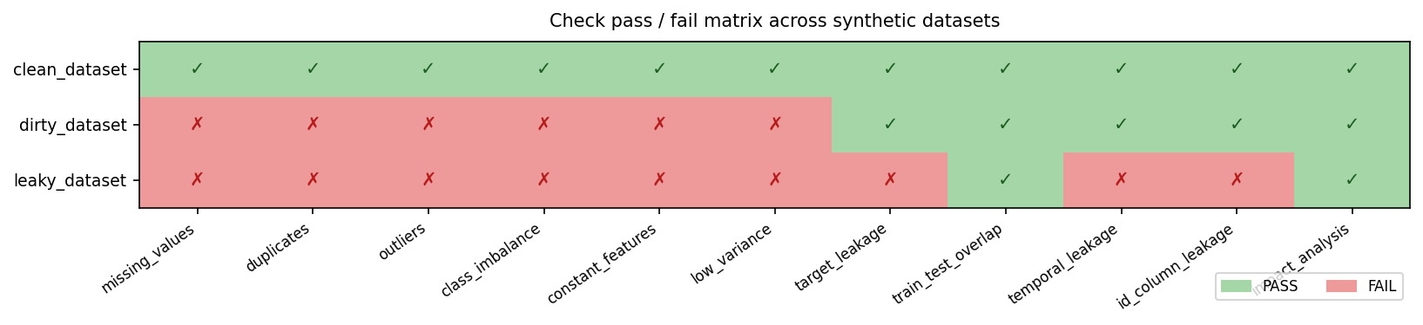
Figure 2.2. Pass / fail matrix for all 11 checks across the three synthetic datasets (green = PASS, red = FAIL).

Real-World Dataset Validation
Two publicly available classification datasets were used to validate the framework on real data. Both were downloaded programmatically from OpenML (the same source as the corresponding Kaggle datasets) via the sklearn.datasets.fetch_openml API, ensuring full reproducibility without requiring manual download or API credentials.
The Titanic survival dataset (1,309 rows, 13 columns) is one of the most widely used benchmark datasets in machine learning. It features a binary target (survived), a mix of numeric and categorical features, and well-known quality issues. The Pima Indians Diabetes dataset (768 rows, 9 columns) is a classic benchmark for binary classification of diabetes onset. All features are numeric; physiologically impossible zero values in columns such as insulin and blood pressure represent implicit missing values, though they are encoded as zeros rather than NaN and are therefore detected as outliers rather than missing values.
Dataset | Rows | Cols | Issues detected | Checks passed / total | Δ Accuracy (LR)
Titanic | 1,309 | 13 | missing_values (age 20%, embarked 0.2%), outliers (fare, sibsp), target_leakage (boat column), id_column_leakage (name) | 8 / 12 | −0.003
Pima Diabetes | 768 | 9 | outliers (insulin, blood pressure, skin thickness, BMI) | 11 / 12 | +0.000

Table 2.6. Results on the two real-world datasets (logistic regression, 5-fold CV, accuracy metric).
The most notable finding in the Titanic dataset is the detection of the boat column as target leakage (correlation ≥ 0.95 with survived). This variable records which lifeboat a passenger boarded, information that is only known after the outcome — a canonical example of target leakage. The framework correctly identifies it without domain knowledge, purely from the statistical association between the feature and the label. In the Diabetes dataset, the framework detects 51 outliers across four columns corresponding to physiologically impossible zero values, a problem well documented in the dataset's literature.
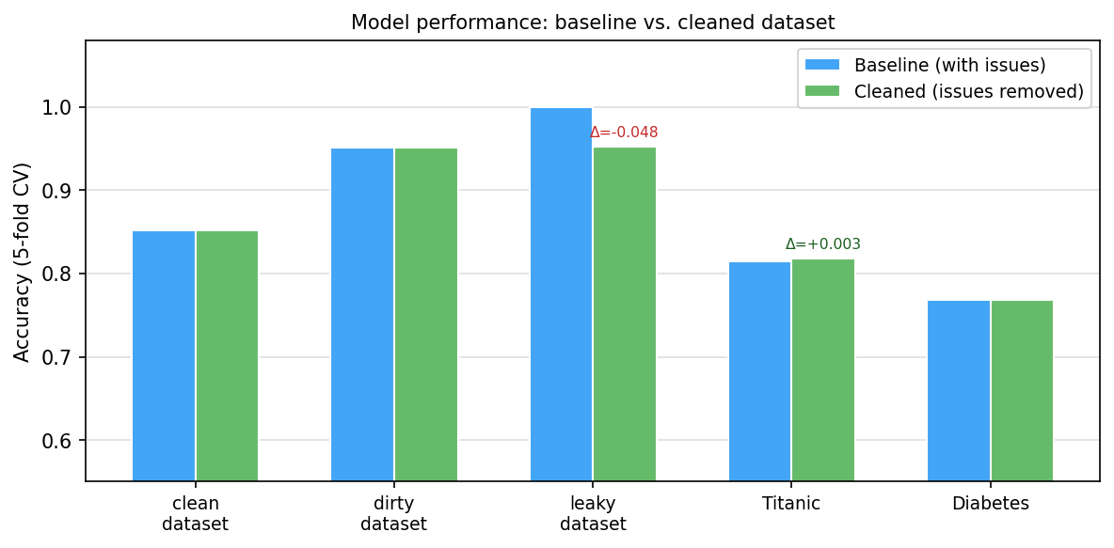
Figure 2.3. Model accuracy comparison: baseline (all features) vs. cleaned (problematic features removed) across all five evaluated datasets.

Summary of Experimental Results
Across all five evaluated datasets — three synthetic and two real-world — the framework correctly detected every introduced quality and leakage problem, with zero false positives on the clean_dataset control. The impact analysis module successfully quantified performance inflation caused by leakage: the leaky_dataset experiment showed a 4.8 pp drop in accuracy after removing problematic features, and the Titanic experiment confirmed the detection of a real leaky feature (boat) in a widely used benchmark. The complete pipeline, including HTML report generation with embedded figures, runs in under ten seconds on all tested datasets.

resultados
….

conclusions y future research

Conclusiones
…

Líneas futuras
…

bibliography

[1] | Y. Gong, «A Survey on Dataset Quality in Machine Learning.,» 2023. [En línea]. Available: https://www.sciencedirect.com/science/article/pii/S0950584923001222.
[2] | N. Polyzotis, «DATA VALIDATION FOR MACHINE LEARNING,» 2019. [En línea]. Available: https://mlsys.org/Conferences/2019/doc/2019/167.pdf.
[3] | P. Papadimitriou, «Data Leakage Detection,» 2011. [En línea]. Available: https://www.researchgate.net/publication/224146568_Data_Leakage_Detection.
[4] | A. Hannun, «Measuring Data Leakage in Machine-Learning Models with Fisher Information,» 2021. [En línea]. Available: https://proceedings.mlr.press/v161/hannun21a/hannun21a.pdf.
[5] | H. Chen, «Data quality evaluation and improvement for machine learning,» 2022. [En línea]. Available: https://www.researchgate.net/publication/362294220_Data_quality_evaluation_and_improvement_for_machine_learning.
[6] | T. Emmanuel, «A survey on missing data in machine learning,» 2021. [En línea]. Available: https://pmc.ncbi.nlm.nih.gov/articles/PMC8549433/?.com.
[7] | W. Chen, «A survey on imbalanced learning: latest research, applications and future directions,» 2024. [En línea]. Available: https://link.springer.com/article/10.1007/s10462-024-10759-6?.com.
[8] | A. S. AlSalehy, «Improving Time Series Data Quality: Identifying Outliers and Handling Missing Values in a Multilocation Gas and Weather Dataset,» 2025. [En línea]. Available: https://www.mdpi.com/2624-6511/8/3/82?.com.
[9] | A. Almaslukh, «DQMAF—Data Quality Modeling and Assessment Framework,» 2025. [En línea]. Available: https://www.mdpi.com/2078-2489/16/10/911?.com.
[10] | E. Breck, «The ML Test Score: A Rubric for ML Production Readiness and Technical Debt Reduction,» 2017. [En línea]. Available: https://research.google/pubs/the-ml-test-score-a-rubric-for-ml-production-readiness-and-technical-debt-reduction/?.com.
[11] | C. Y. Wijaya, «Understanding Data Leakage in Machine Learning - NBD Lite #12,» 2024. [En línea]. Available: https://www.nb-data.com/p/understanding-data-leakage-in-machine.
[12] | «Portal web de la ETSIT UPM,» [En línea]. Available: http://www.etsit.upm.es/.
[13] | Z. Abedjan, «Profiling relational data: a survey,» 2015. [En línea]. Available: https://dl.acm.org/doi/10.1007/s00778-015-0389-y.

anexo a: aspectos ÉTICOS, económicos, sociales y ambientales
El apartado “Requisitos de las acreditaciones internacionales EUR-ACE y ABET” de la Normativa de TFT de la ETSIT-UPM establece que “La memoria del TFT del GITST, GIB y MUIT, y en general la de aquellas titulaciones que hayan obtenido o para las que se desee solicitar una acreditación internacional EUR-ACE o ABET, debe mostrar conciencia de la responsabilidad de la aplicación práctica de la ingeniería, el impacto social y ambiental, el compromiso con la ética profesional, la responsabilidad y las normas de la aplicación práctica de la ingeniería, así como sobre las prácticas de gestión de proyectos, gestión, y control de riesgos, entendiendo sus limitaciones”.
Este anexo obligatorio del TFT tendrá un carácter sintético con los siguientes apartados:

A.1 iNTRODUCCIÓN
Breve descripción del contexto del proyecto, objetivos, necesidades que pretende cubrir o problemas que pretende resolver, centrándose en su relación con los temas sociales, económicos, éticos, legales y/o ambientales que se hayan identificado.

A.2 DESCRIPCIÓN DE IMPACTOS RELEVANTES RELACIONADOS CON EL PROYECTO
Síntesis del trabajo realizado en la fase 2, de selección y descripción de impactos. Presentar y justificar las conclusiones a las que se haya llegado sobre cuáles son los asuntos más relevantes relacionados con la sostenibilidad social, económica o ambiental, así como los principales grupos de interés identificados y que se han considerado en los análisis posteriores.

A.3 ANÁLISIS DETALLADO DE ALGUNO DE LOS PRINCIPALES IMPACTOS
Síntesis del trabajo de análisis realizado.

A.4 CONCLUSIONES
Valorar el proyecto desde un punto de vista ético, social, económico y medioambiental y justificar si el uso de criterios de sostenibilidad ha aportado o puede aportar valor añadido al proyecto.

anexo b: presupuesto económico
El apartado “Requisitos de las acreditaciones internacionales EUR-ACE y ABET” de la Normativa de TFT de la ETSIT-UPM establece que “La memoria del TFT del GITST, GIB y MUIT, y en general la de aquellas titulaciones que hayan obtenido o para las que se desee solicitar una acreditación internacional EUR-ACE o ABET, … debe incluir un presupuesto económico”. A modo de ejemplo, la tabla del presupuesto de un proyecto podría ser la siguiente:
COSTE DE MANO DE OBRA (coste directo) |  |  |  |  | Horas |  | Precio/hora | Total
 |  |  |  |  | 300 |  | 15 € | 4.500 €
COSTE DE RECURSOS MATERIALES (coste directo) |  |  |  | Precio de compra | Uso en meses |  | Amortización (en años) | Total
Ordenador personal (Software incluido)....... |  |  |  | 1.500,00 € | 6 |  | 5 | 150,00 €
Impresora láser |  |  |  | 500,00 € | 6 |  | 5 | 50,00 €
Otro equipamiento
COSTE TOTAL DE RECURSOS MATERIALES |  |  |  |  |  |  |  | 200,00 €
GASTOS GENERALES (costes indirectos) |  | 15% |  | sobre CD |  |  |  | 705,00 €
BENEFICIO INDUSTRIAL |  | 6% |  | sobre CD+CI |  |  |  | 324,30 €
MATERIAL FUNGIBLE
Impresión |  |  |  |  |  |  |  | 100,00 €
Encuadernación |  |  |  |  |  |  |  | 300,00 €
SUBTOTAL PRESUPUESTO |  |  |  |  |  |  |  | 6.129,30 €
IVA APLICABLE |  |  |  |  |  |  | 21% | 1.287,15 €
TOTAL PRESUPUESTO |  |  |  |  |  |  |  | 7.416,45 €

Esta tabla podría ser rellenada mediante una sencilla hoja de cálculo como la siguiente:

