MMF 1941 - Project 1
5-Minute Presentation Script and Understanding Guide
Comparative Analysis of Bid-Ask Spread Estimators Across Asset Classes
The one sentence to remember: The project asks whether spread estimators built from daily OHLC data can reproduce a reasonable intraday trading-cost benchmark, and whether their performance changes across asset classes and liquidity levels.

1. The project in one simple picture
For each asset-day, you will build two things: (1) a spread estimate from daily data using CS, AR or EDGE, and (2) a benchmark from one-minute intraday data. Then you compare the two.
Same asset-day | Daily side | Intraday side
Example: AAPL on one day | Daily OHLC -> CS / AR / EDGE | 1-minute OHLCV -> benchmark
What it gives | Estimated bid-ask spread | Reference trading-cost proxy
Final comparison | Estimate - benchmark | Bias, absolute error, RMSE, negative/failure rate

Very important: You need BOTH daily data and intraday data. The estimators are intentionally daily-data estimators. The intraday data are used to build the benchmark that the daily estimators will be judged against.

2. Five-minute presentation script
Use this as a natural guide, not something you need to memorize word for word.
Slides 1-2 | 0:00-0:45
My project asks how well three daily OHLC bid-ask spread estimators - Corwin-Schultz, Abdi-Ranaldo and EDGE - match an intraday benchmark across different asset classes and liquidity levels from 2015 to 2025.
The final unit of observation will be an asset-day. For each asset-day, I will have one estimate from each daily estimator and one intraday benchmark.
My working hypothesis is that EDGE will have lower error and fewer negative estimates, especially compared with the other methods in less liquid or less continuous markets. But this is only a hypothesis to test, not a result I am trying to obtain.
At this checkpoint I have not compared the estimators yet. I first want to make sure the data and benchmark are defined correctly.
Slides 3-4 | 0:45-1:25
The project uses two main data channels. All one-minute intraday data come from the local RiskLab First Rate archive. Bloomberg is used only for daily, end-of-day and reference data.
I verified local intraday files for stocks, ETFs, futures and crypto. FX is listed in the metadata, but the physical FX folder is not available in my mounted archive, so I report it as unresolved instead of replacing it with another source.
The futures pilot uses individual contracts, such as ES_Z24 and CL_Z24, so I am not treating them as a continuous futures history.
Slide 5 | 1:25-1:55
I also completed a small Bloomberg pilot using AAPL and SPY from November 4th to November 15th, 2024.
The point of this pilot was not to collect the final sample. It was to check that I can retrieve the required fields, understand what the fields mean, document identifiers, currency, timing and adjustments, and save the extraction in a reproducible way before doing a large pull.
For the final study, once the equity and ETF universe is fixed, I will need the required daily Bloomberg fields over the 2015 to 2025 study period for those sampled equities and ETFs.
Slide 6 | 1:55-2:30
For the local intraday pilot I used eight assets: AAPL, GME, SPY, IWM, two futures contracts, and BTC and ETH.
The raw files all use the same six-column structure: timestamp, open, high, low, close and volume.
The pipeline scanned just over 18 million observations inside the 2015 to 2025 project window. In these diagnostics I found no duplicate timestamps, invalid OHLC rows, or missing or non-numeric values. Zero-volume rows were kept and flagged instead of being deleted.
I also checked ten raw observations manually, and all ten checks passed.
Slide 7 | 2:30-3:15
This graph is one of the most important results from the exploratory analysis.
I use the same November 2024 window for all eight pilot assets and count the number of raw minute bars observed on each calendar date. I do not fill missing minutes and I do not assume an expected number of bars.
Stocks and ETFs have zero observations on the weekend. Crypto continues every calendar day. Futures follow another pattern.
The main point is not that one asset class has better data. The point is that the raw calendar structure is different across asset classes. So I cannot use one common session rule for everything without first defining it carefully.
Slide 8 | 3:15-3:55
The second graph looks at where observations fall across the recorded 24-hour clock.
Stocks and ETFs are concentrated in part of the day. Futures have a different pattern. Crypto is almost uniform across all 24 hours.
The y-axis shows the share of each asset's own observed rows, so this describes activity, not coverage.
The timestamp timezone is still not confirmed, so I am not calling these hours final trading sessions. This graph tells me that timezone and session rules must be resolved before I aggregate the one-minute data into a daily benchmark.
Slides 9-10 | 3:55-4:35
The workflow is reproducible. Raw files remain read-only, the code reads large files in chunks, no minute bars are added or forward-filled, and tables and figures are generated from code.
The main preliminary finding is therefore methodological, not a result about which estimator wins.
In the common window, BTC and ETH show 1,440 raw bars per calendar date, while equities, ETFs and individual futures contracts have different calendar and clock structures.
So class-specific session and calendar rules need to be fixed before I build a comparable intraday benchmark.
Slide 11 | 4:35-5:00
The next step is to freeze the design. I need to confirm timezone and session metadata, resolve the FX issue, define the exact intraday benchmark, decide how to treat negative or undefined estimator values, choose the final liquidity-stratified universe, and set the futures contract rule.
After that, I can do the full Bloomberg daily pull, build the asset-day dataset, and finally estimate and compare CS, AR and EDGE.
The main feedback I am looking for is whether the benchmark and the class-specific session rules are appropriate.

3. Understand the graphs: Graph 1 - raw bars by calendar date
This is the key graph for your presentation. It is not an estimator result. It is a data-structure diagnostic.
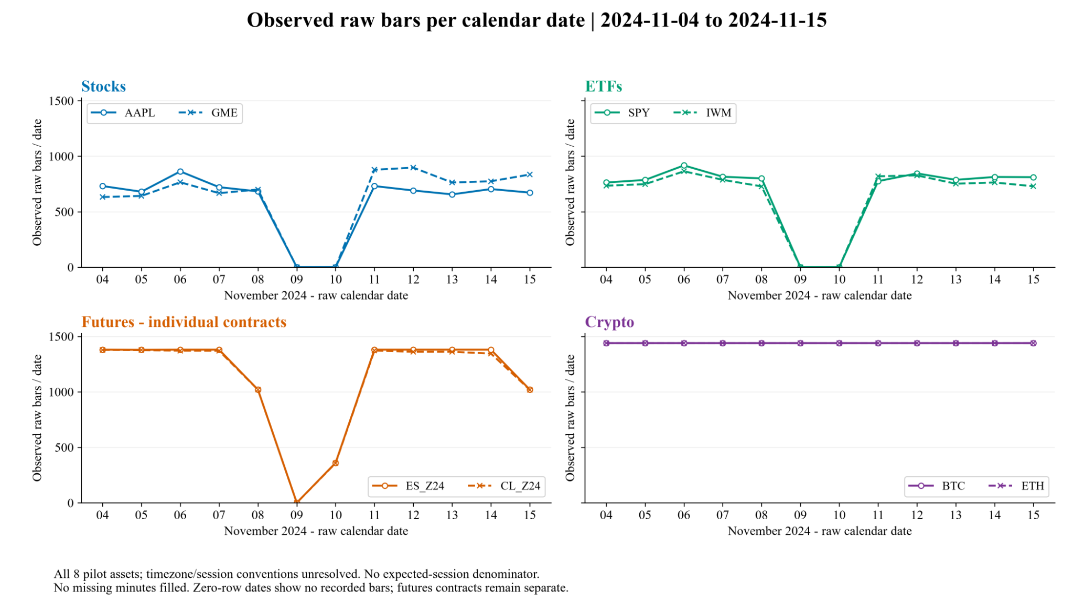
How to read it
- The x-axis is the raw calendar date from 4 to 15 November 2024.
- The y-axis is the number of one-minute rows that actually exist in the raw file on that date.
- A value of zero means no rows were recorded for that calendar date. You did not create or fill missing minutes.
- BTC and ETH show 1,440 rows on each date. Since 24 x 60 = 1,440, the raw crypto files contain one row per minute across the whole calendar day in this window.
- Stocks and ETFs have zero-row weekend dates. On observed trading dates they have fewer than 1,440 bars because their market structure is not 24/7 and the files contain a different set of recorded hours.
- The futures contracts show another pattern. They are individual contracts, and their market/session structure is different from both equities and crypto.
What you can say: The raw bar structure differs clearly across asset classes before any session rule is imposed.

What you should NOT say: Do not call this a coverage percentage, and do not say that 390, 1,380 or 1,440 is the correct denominator until the timezone and session rules are confirmed.

Why this matters for the final project
Your benchmark will eventually be built from one-minute data and summarized at the asset-day level. If you define the day incorrectly, the benchmark can change. For example, including overnight trading, excluding it, or assigning bars to the wrong calendar date can change the daily range or other cost proxy. That would change the number against which CS, AR and EDGE are compared.

4. Understand the graphs: Graph 2 - hourly distribution
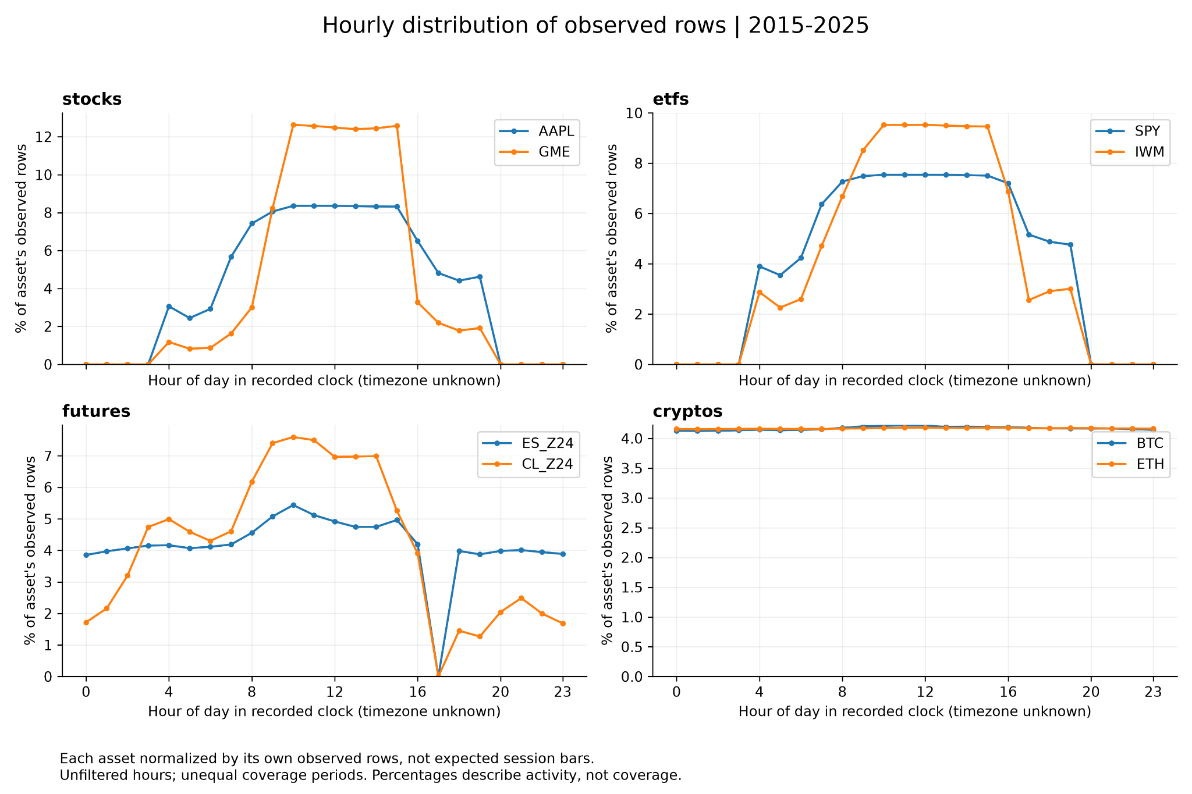
How to read it
- The x-axis is the hour in the recorded timestamp. The timezone is still unknown.
- The y-axis is the percentage of that asset's own observed rows that fall in each hour.
- Because each asset is normalized by its own total number of rows, this graph shows when activity appears in the raw clock. It does not show data coverage.
- Stocks and ETFs concentrate observations in a limited part of the recorded day, with some apparent extended-hours activity.
- Futures show a much broader clock pattern and a different daily break.
- BTC and ETH are almost flat across 24 hours. A flat line near 4.17% makes sense because 100% / 24 hours is about 4.17%.
Best explanation in one sentence: The graph shows that each asset class has a different raw-clock structure, so I need to confirm timezone and class-specific sessions before building the daily intraday benchmark.

If the professor asks why you did not simply use 09:30-16:00
Say: 'That may be appropriate for US equity regular trading hours, but it would not be appropriate for crypto or futures. I also need to confirm what timezone the raw timestamps use. I want to freeze a defensible session rule for each class before I calculate the benchmark.'

5. What exactly is the Bloomberg pilot for?
Yes: your understanding is correct. The Bloomberg pilot is a small test before the full download. It proves that the extraction works and, more importantly, that you understand exactly what you are downloading.
Pilot checks | Why it matters
Can I retrieve the fields? | Avoid discovering access or entitlement problems during the full pull.
Are the field definitions correct? | PX_BID, PX_ASK, OHLC and volume must mean what the study assumes they mean.
Are dates, currency and units correct? | Prevents bad joins or comparing values in different units.
What adjustment convention is being used? | Splits/dividends can change OHLC history and estimator values.
Can I reproduce the pull? | BDP/BDH formulas, source log and hashes make the process auditable.
Does a small sample look sensible? | You validate a few observations before scaling to years of data.

The project guide explicitly says to test two representative securities over about ten dates, validate metadata and field meaning, and save the pilot before scaling the retrieval.
Do you eventually need Bloomberg data for 2015-2025?
For the sampled equities and ETFs: yes. Once the final equity/ETF universe is fixed, the project brief asks you to obtain the required daily Bloomberg data over the study period. The assigned Bloomberg data are daily OHLC, bid, ask, volume, quoted-spread information and security identifiers.
Your pilot only covered AAPL and SPY for ten dates because it was a validation step. It is not the final Bloomberg dataset.
But are the intraday data not the main data?
The intraday data are essential, but they do a different job. The whole project is a comparison between DAILY estimators and an INTRADAY benchmark:
- Daily data -> inputs for CS, AR and EDGE.
- One-minute local data -> build the realized-cost / range benchmark.
- Same asset-day -> compare the daily estimate with the intraday benchmark.
Important boundary: Bloomberg daily PX_BID/PX_ASK or a daily quoted spread is not the intraday benchmark. The benchmark must come from the local one-minute data.

6. What is the final universe?
The 'universe' simply means the set of assets that will be included in the final study.
The approved design says the final study should include stocks, ETFs, futures, FX and crypto, with a liquidity-stratified sample in each class. The current eight assets are only a pilot universe used to test the pipeline. They are not automatically the final sample.
Are you choosing assets randomly?
Not from the whole market. The project file does not give a final selection rule or sample size, so this is still a design decision. A sensible approach is to select assets in a reproducible way within each asset class and make sure the sample includes different liquidity levels.
A simple possible rule for the final design would be:
- Start with assets that have enough data over the required period.
- Choose a liquidity measure within each asset class, for example average or median trading volume / dollar volume where appropriate.
- Rank assets within each class and split them into high-, medium- and low-liquidity groups.
- Select a fixed number of assets from each group using a rule chosen before looking at estimator performance.
- Keep the rule documented so another person could reproduce the same universe.
Key point: The exact liquidity metric, number of assets and sampling rule are NOT fixed by the project brief yet. They should be frozen before the main estimator comparison. Random sampling within a tier could be used, but it is not required; the rule mainly needs to be pre-specified, reproducible and not chosen to favor one estimator.

7. What are liquidity tiers?
Liquidity tiers are groups of assets with different levels of trading activity and ease of trading.
Tier | Simple meaning | Typical pattern
High liquidity | Trades often and is easy to buy/sell | More continuous trading, usually tighter spreads
Medium liquidity | In between | Moderate trading activity
Low liquidity | Trades less often | More sparse trading, usually wider spreads and more price jumps

Why does this matter? Because the project hypothesis says estimator errors may be larger for thinly traded or non-continuous assets. If you only tested very liquid names like AAPL or SPY, you would not really test that part of the hypothesis.
8. What does 'meme names' mean?
'Meme names' is an informal label for stocks that became especially popular with retail traders and social-media discussion, often with unusual volatility and trading activity. GME is a familiar example.
In your project files, 'meme names' refers to a narrow local daily PX_BID/PX_ASK spot-check dataset. It is not a separate asset class and it does not mean your final stock universe should consist of meme stocks. Think of those files as limited local quote checks, not the core final sample.

9. Questions the professor may ask
Q: Why have you not calculated CS, AR and EDGE yet?
A: Because the benchmark, timezone and session rules can change the answer. I want those choices fixed before looking at estimator performance, so the methodology is not chosen after seeing the results.
Q: What is the intraday benchmark?
A: It will be a daily trading-cost proxy built from the local one-minute data. The project allows a realized spread / range style benchmark, but the exact definition is still an open design decision that must be frozen before the main results.
Q: Why do stocks have more than 390 rows on many days?
A: Because the raw files include recorded hours beyond regular US equity trading hours. I have not filtered to 09:30-16:00 yet because the timestamp timezone and session convention still need to be confirmed.
Q: Why do BTC and ETH have 1,440 rows per day?
A: There are 1,440 minutes in 24 hours. In the common window, the raw crypto files contain one row per minute across the calendar day.
Q: Why do futures have around 1,380 rows on many days?
A: The raw pattern is consistent with a different, almost continuous futures session with a daily break, but I have not formally verified the exchange session and timezone yet, so I do not treat 1,380 as a final expected denominator.
Q: What does a negative spread estimate mean?
A: A statistical estimator can sometimes return a negative number even though an economic bid-ask spread should not be negative. That is why negative-estimate rate is one of the performance measures, and the treatment of negative values must be decided before the main comparison.
Q: What will you finally compare?
A: For each asset-day I will compare CS, AR and EDGE with the same intraday benchmark, then study bias, absolute error, RMSE and negative/failure rates across asset classes and liquidity tiers.
Q: Why use Bloomberg if you already have intraday data?
A: Because the estimators are daily-data estimators and the project specifically assigns Bloomberg daily/reference acquisition for the sampled equities and ETFs. The intraday files have a separate role: they build the benchmark.
Q: What is the final sample?
A: It is not fixed yet. The final universe will include a liquidity-stratified sample from the approved asset classes. The pilot assets were chosen to test data structure, not to define the final sample.
If you get stuck: Come back to this sentence: 'The purpose of this checkpoint was to make sure the benchmark is economically and statistically comparable before I use it to judge the estimators.'

