1.. Clone <https://github.com/smugford/terraform_ansible_demo.git>

2.. Create a AWS Key Pair .pem and download

3... Change the permission of the downloaded keypair

- sudo chmod 400 tf-ans-demo-keypair.pem

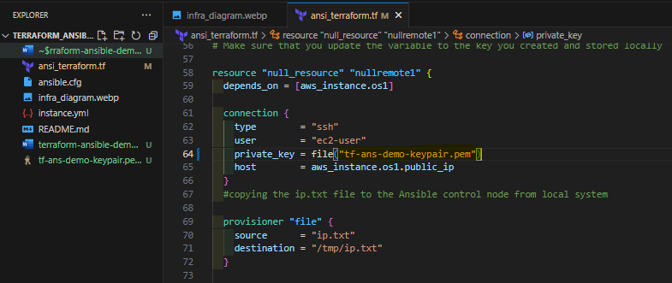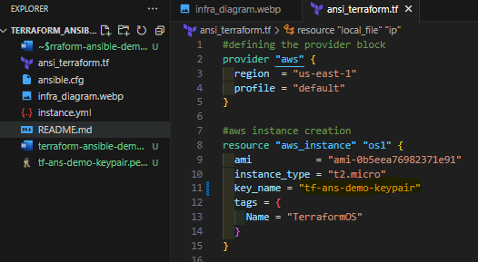4.. Update the private key across .tf file

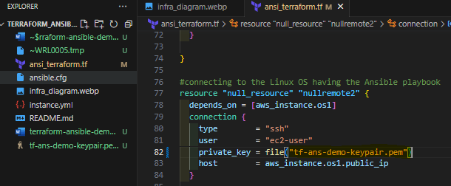

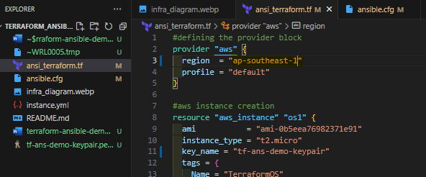5. Make sure the region is correct

6. Make sure the ami is updated

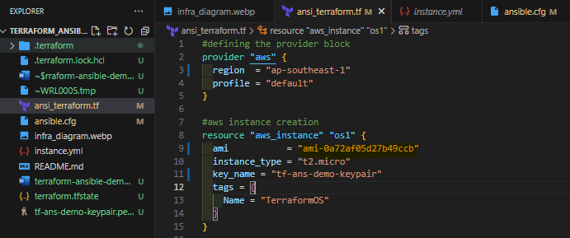To get ami id, get it from Instances > Launch Instance > select the type of AMI > copy AMI ID

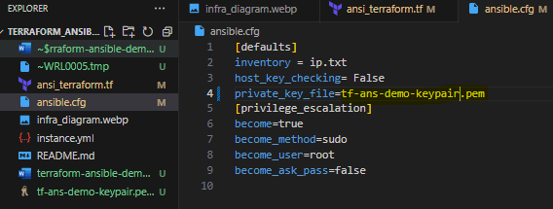7. Update the private key on ansible.cfg file

8. Terraform init, and terraform apply -auto-approve

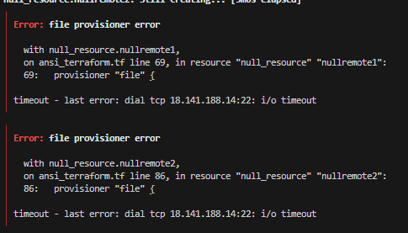Error: file provisioner error

Solution: Configure security groups

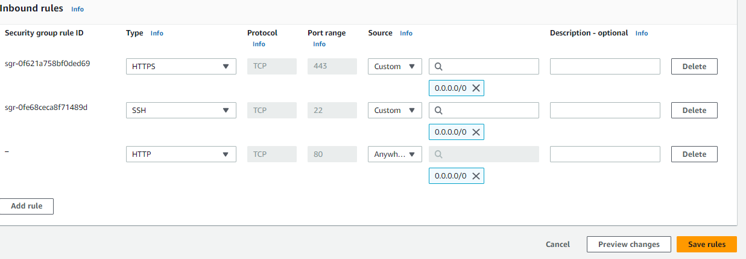 Go to Instances > select the running EC2 instance > Security Groups > Security Groups (default) > Edit inbound rules > add http, https, ssh

Error: timeout - last error: SSH authentication failed (ec2-user@18.141.188.14:22): ssh: handshake failed: ssh: unable to authenticate, attempted methods [none

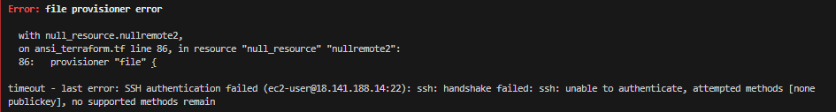│ publickey], no supported methods remain

Solution: I can’t fix it on local (vscode), I migrated to Cloud9….. it is fixed!

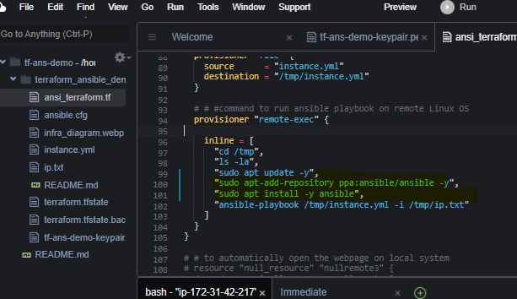9. Update the details, make it ubuntu friendly instead of Amazon Linux 2

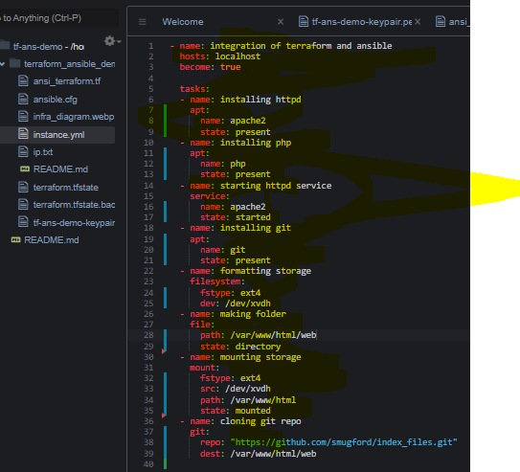

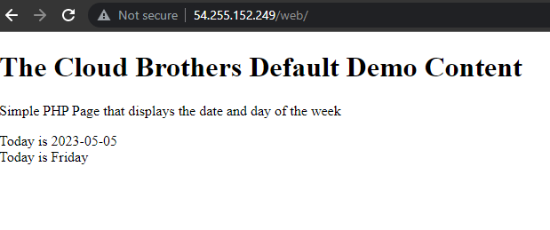10. Access the opt1 = “<public-ip-address>/web” on the browser