03-01 Instrucción y exposiciones

Definición y clasificación

Clasificación

Lógica simbólica
De Albert Meyer, Ronitt Rubinfeld: 6.042J / 18.062J Mathematics for Computer Science, Fall 2005, Course Notes (http://ocw.mit.edu/NR/rdonlyres/Electrical-Engineering-and-Computer-Science/6-042JFall-2005/63D98655-F5D8-4900-9953-3038C851C466/0/slides1f.pdf )

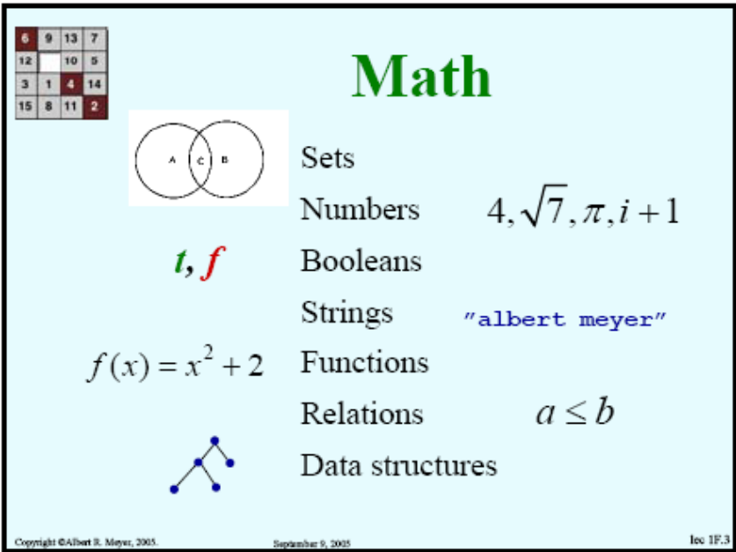

Síntesis de símbolos, para álgebra booleana y lógica proposicional
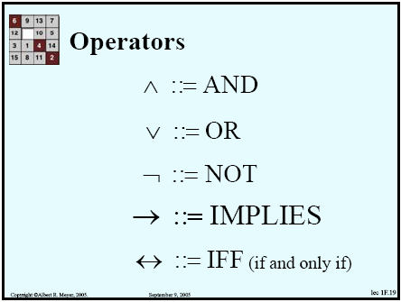
De Meyer, Rubinfeld: 6.042J / 18.062J Mathematics for Computer Science, Fall 2005.
(Véase también la sección de notación para conjuntos y lógica, en el módulo sobre fundamentos de las matemáticas.)

ASL
The Association for Symbolic Logic: http://www.aslonline.org

Lógica proposicional
De Albert Meyer, Ronitt Rubinfeld: 6.042J / 18.062J Mathematics for Computer Science, Fall 2005, Course Notes (http://ocw.mit.edu/NR/rdonlyres/Electrical-Engineering-and-Computer-Science/6-042JFall-2005/24EDE9CB-F22E-4383-8329-C48A15E63153/0/ln1.pdf)

Prueba
Mathematics also has a specific notion of “proof.”
Definition. A formal proof of a proposition is a chain of logical deductions leading to the proposition from a base set of axioms.

Implicación
In order to prove that P implies Q:
- Write, “Assume P.”
- Show that Q logically follows.

Contrapositivo
An implication (“P implies Q”) is logically equivalent to its contrapositive “not Q implies not P”; proving one is as good as proving the other. And often proving the contrapositive is easier than proving the original statement. If so, then you can proceed as follows:
- Write, “We prove the contrapositive:” and then state the contrapositive.
- Proceed as in Method #1.

Probar “si, y sólo si”
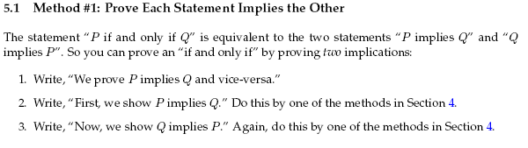
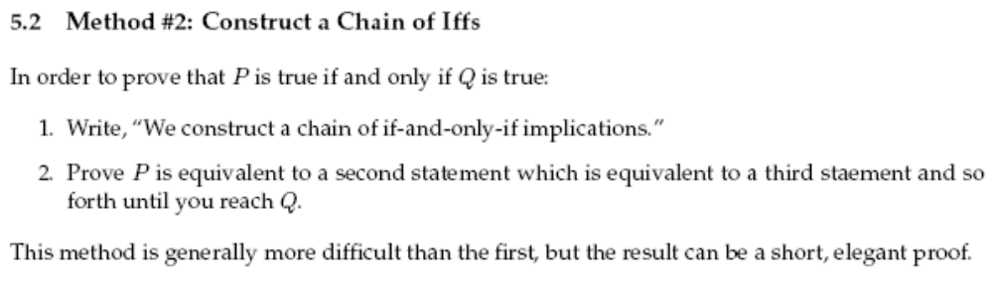

Proposición (definición)
Definition. [In boolean logic] proposition is a statement that is either true or false.
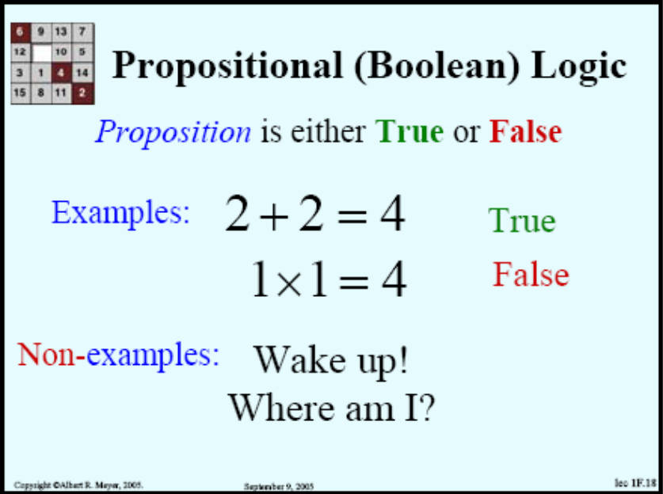

Proporcionar evidencia vs. probar
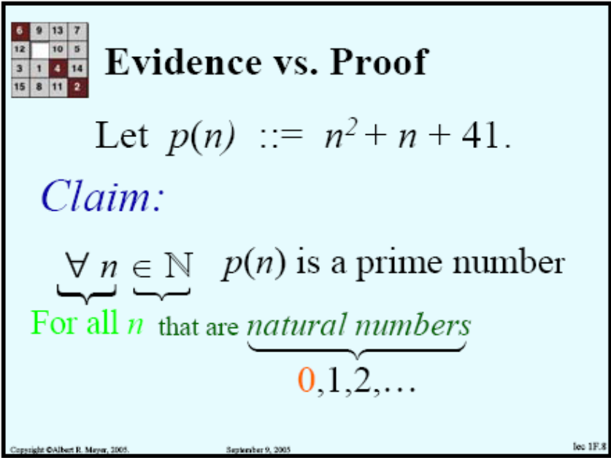
Evidencia:
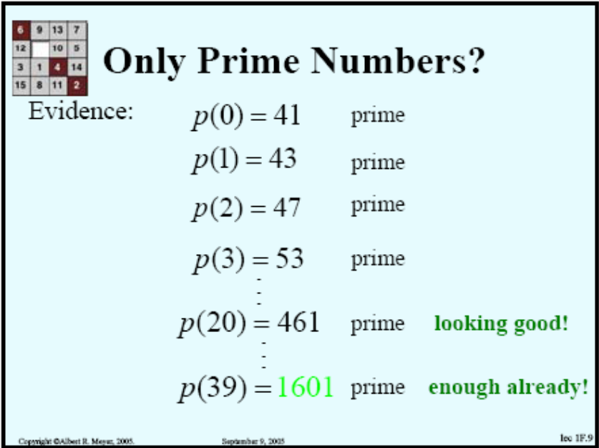
Pero...
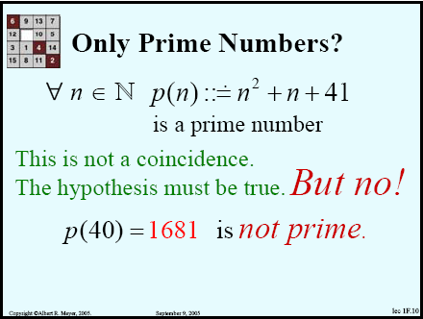
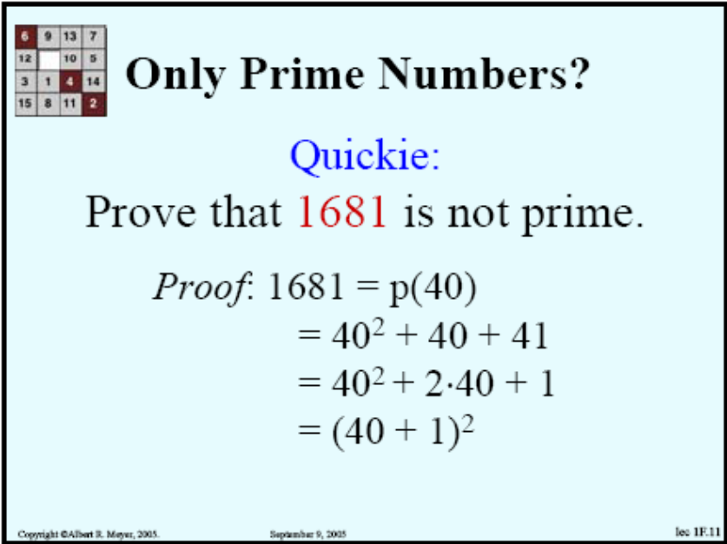

Conclusión: hay una limitante de las pruebas sobre series infinitas
...in general you can’t check a claim about an infinite set by checking a finite set of its elements, no matter how large the finite set.

Ejemplo:
Proposition 2.6 (Goldbach). Every even integer greater than 2 is the sum of two primes.
No one knows whether this proposition is true or false. This is the “Goldbach Conjecture,” which dates back to 1742.

Axiomas, teoremas, lemas y corolarios
De Meyer y Rubinfeld: 6.042J / 18.062J Mathematics for Computer Science.
There are several common terms for a proposition that has been proved. The different terms hint at the role of the proposition within a larger body of work.
• Important propositions are called theorems.
• A lemma is a preliminary proposition useful for proving later propositions.
• A corollary is an afterthought, a proposition that follows in just a few logical steps from a theorem.
The definitions are not precise. In fact, sometimes a good lemma turns out to be far more important than the theorem it was originally used to prove.

Axiomas
De Meyer y Rubinfeld: 6.042J / 18.062J Mathematics for Computer Science.
Propositions ... that are simply accepted as true are called axioms.
Euclid’s axiom and proof approach, now called the axiomatic method, is the foundation for mathematics today. In fact, there are just a handful of axioms, called ZFC, which, together with a few logical deduction rules, appear to be sufficient to derive essentially all of mathematics.
The ZFC axioms are important in studying and justifying the foundations of Mathematics. But for practical purposes, they are much too primitive— by one reckoning, proving that 2+2= 4 requires more than 20,000 steps.

Teoremas
De http://eom.springer.de/T/t092520.htm
A mathematical statement whose truth has been established by means of a proof.
The concept of a theorem developed and became more precise together with the concept of a mathematical proof. With the use of the axiomatic method, the theorems in a theory under consideration are defined as statements deduced in a purely logical way from previously chosen and fixed statements called axioms. Since axioms are assumed to be true, theorems ought to be true as well. A further refinement of the concepts of a proof and a theorem was connected with the investigation, undertaken in mathematical logic, of the concept of a logical consequence, as a result of which for a wide class of mathematical theories it became possible to reduce the process of logical deduction to transformations of formulas, that is, of mathematical statements written in a suitably formalized language, using exactly formulated rules (deduction rules, cf. Derivation rule) about merely the form (and not the content) of the propositions. In formal theories arising in this manner the name proof is given to a finite sequence of formulas each of which either is an axiom or is obtained from certain preceding formulas of this sequence according to the deduction rules. A formula is called a theorem if it is the last formula in a proof.

Deducciones
... using this notation, “If P and not Q, then R” would be written:
(P∧¬Q) → R
This symbolic language is helpful for writing complicated logical expressions compactly. But in most contexts ordinary words such as “or” and “implies” are much easier to understand than symbols such as ∧ and →. So we’ll use this symbolic language sparingly, and we advise you to do the same.

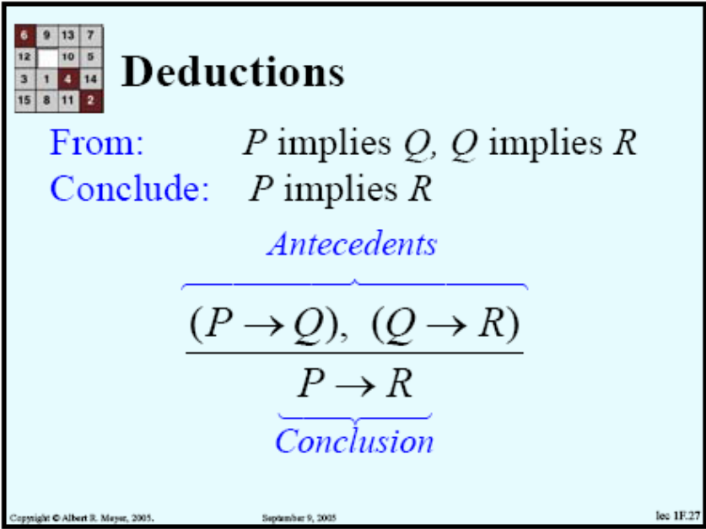

Implicaciones de equivalencia lógica
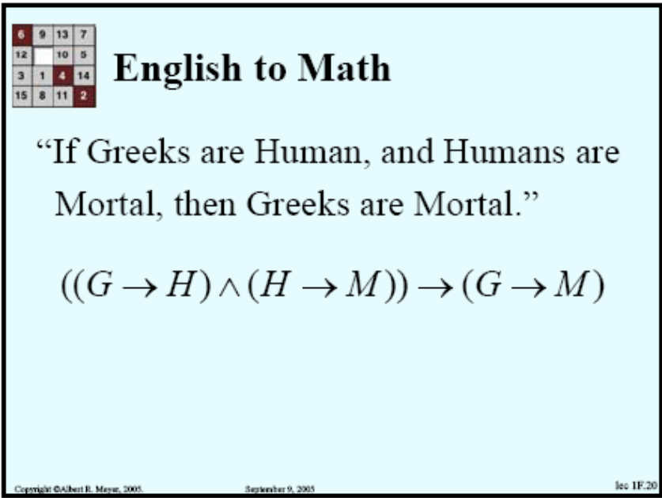

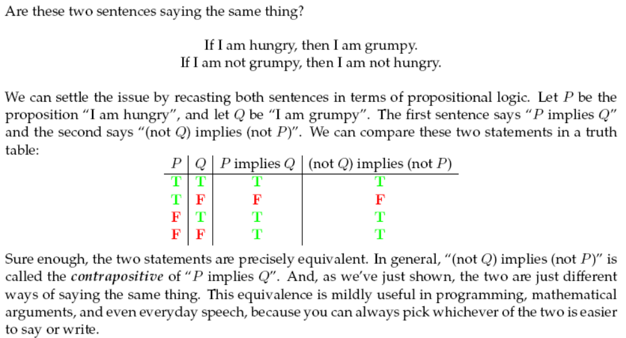

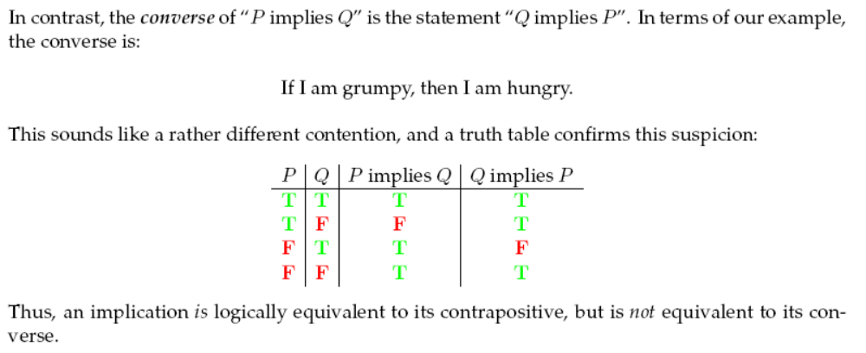
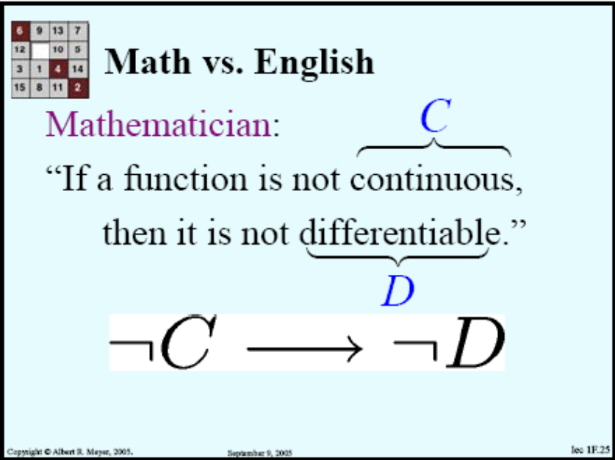

Pero...
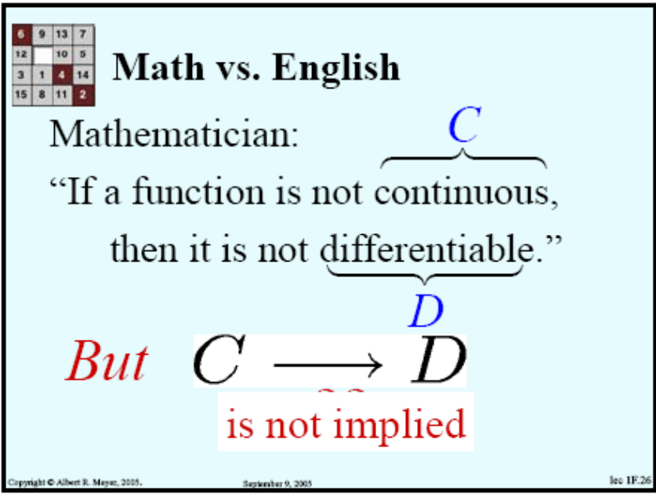

Deducciones

Modus ponens
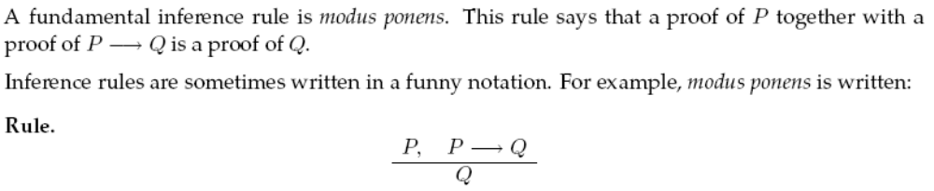
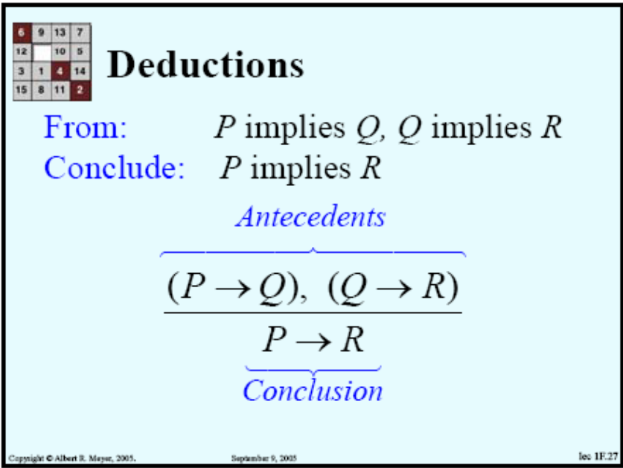
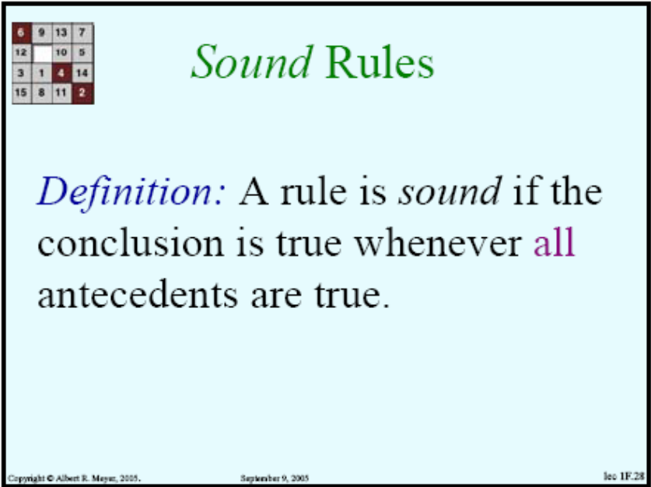

Prueba por contradicción
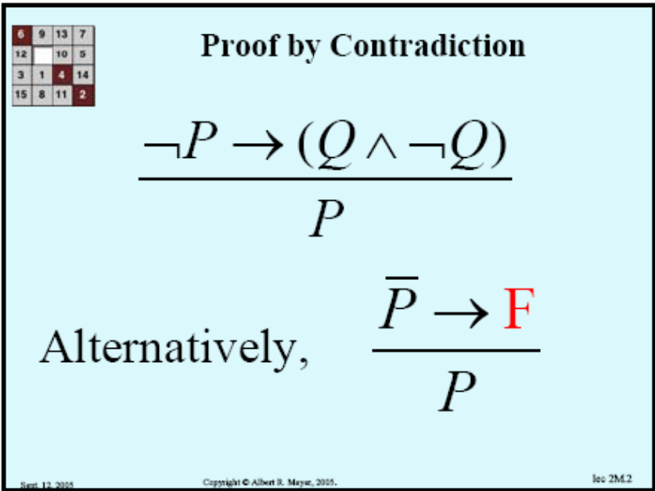
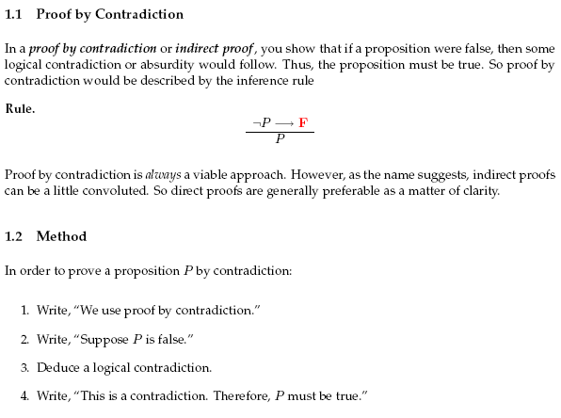

Otras reglas de inferencia
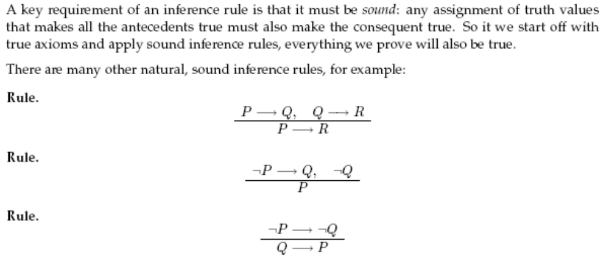

Affirming the consequent
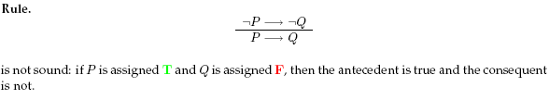
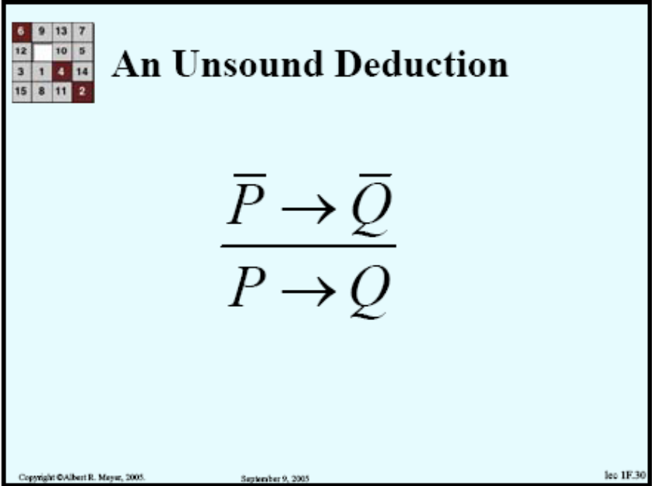
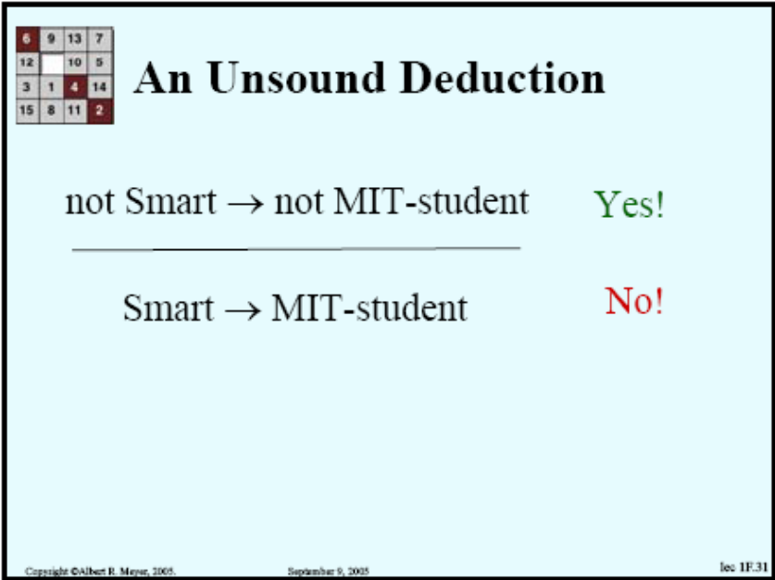

Demostración por casos

SAT
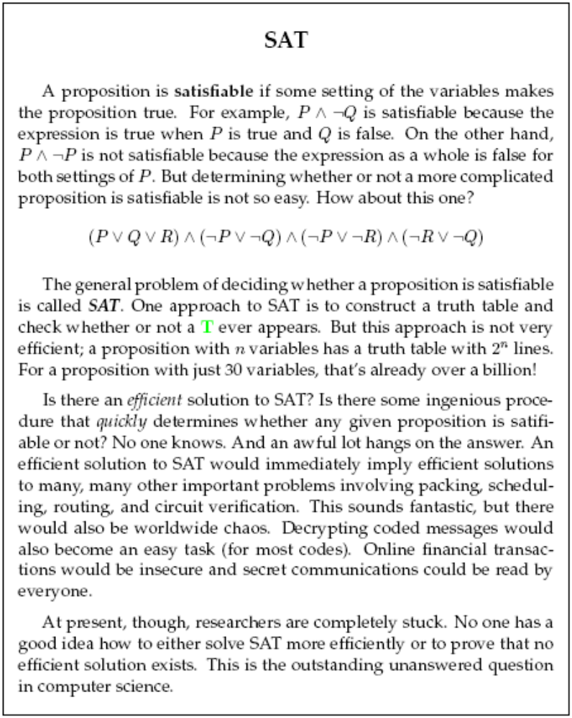

Predicados
A predicate is a proposition whose truth depends on the value of one or more variables. For example,
“n is a perfect square”
is a predicate whose truth depends on the value of n. The predicate is true for n =4 since 4 is a prefect square, but false for n =5 since 5 is not a perfect square.

