03H05 Modelos lógicos no estándar

La dialéctica en las matemáticas
De Willian Byers: How Mathematicians Think (Princeton University Press, 2007), Introduction, pg. 6: http://press.princeton.edu/chapters/i8386.html
Logic abhors the ambiguous, the paradoxical, and especially the contradictory, but the creative mathematician welcomes such problematic situations because they raise the question, “What is going on here?” Thus the problematic signals a situation that is worth investigating. The problematic is a potential source of new mathematics. How a person responds to the problematic tells you a great deal about them. Does the problematic pose a challenge or is it a threat to be avoided?
[...]
What is it that makes mathematics mathematics? What are the precise characteristics that make mathematics into a discipline that is so central to every advanced civilization, especially our own? Many explanations have been attempted. One of these sees mathematics as the ultimate in rational expression; in fact, the expression “the light of reason” could be used to refer to mathematics. From this point of view, the distinguishing aspect of mathematics would be the precision of its ideas and its systematic use of the most stringent logical criteria. In this view, mathematics offers a vision of a purely logical world. One way of expressing this view is by saying that the natural world obeys the rules of logic and, since mathematics is the most perfectly logical of disciplines, it is not surprising that mathematics provides such a faithful description of reality. This view, that the deepest truth of mathematics is encoded in its formal, deductive structure, is definitely not the point of view that this book assumes. On the contrary, the book takes the position that the logical structure, while important, is insufficient even to begin to account for what is really going on in mathematical practice, much less to account for the enormously successful applications of mathematics to almost all fields of human thought.
[Contrástese con Alan Lightman:] “Mathematics contrasted strongly with the ambiguities and contradictions in people. The world of people had no certainty or logic.” (http://www.randomhouse.com/catalog/display.pperl/9780375423598.html ). For him, mathematics is the domain of certainty and logic. On the other hand, he is also a novelist who “realized that the ambiguities and complexities of the human mind are what give fiction and perhaps all art its power.” This is the usual way that people divide up the arts from the sciences: ambiguity in one, certainty in the other.

Ambigüedad
De Byers: How Mathematicians Think, Ch. 1, pg. 28.
[The writer Arthur Koestler] said that creativity arises in a situation where “a single situation or ideas is perceived in two self-consistent but mutually incompatible frames of reference.” I shall take the above to be the definition of ambiguity. To repeat:
Ambiguity involves a single situation or idea that is perceived in two self-consistent but mutually incompatible frames of reference.

Los números reales como series infinitas
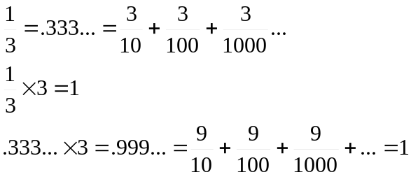
Lo que se comprueba también porque:
Sea x = .999...
10x = 9.999...
9x = 10x-x = 9.999...-.999 = 9
Entonces: x = 1

Lógica vs. ambigüedad
Logic moves in one direction, the direction of clarity, coherence, and structure. Ambiuity moves in the other direction that of fluidity, opennes, and release.
De Willian Byers: How Mathematicians Think, Ch. 1, pg. 78.

Contradicción
De Byers: How Mathematicians Think, Ch. 2, pg. 82.
One of the fundamental pillars on which mathematics—not to say all of science—is built is the logical notion of noncontradiction. In such a system of thought it should no be possible to assert that a proposition P is true while simultaneously asserting the truth of its negation, not P. Thus mathematics from the time of Euclid has involved creating domains of noncontradiction.

