003E30 Teoría axiomática de conjuntos

Definición y clasificación
Weisstein, Eric W. "Axiomatic Set Theory," MathWorld--A Wolfram Web Resource. http://mathworld.wolfram.com/DescriptiveSetTheory.html .

De http://www.encyclopediaofmath.org/index.php/Axiomatic_set_theory

Axiomas ZFC

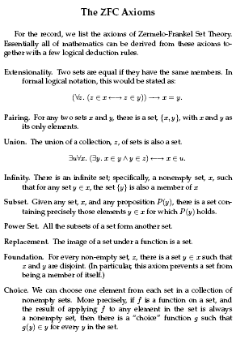
De Meyer, Rubinfeld: 6.042J / 18.062J Mathematics for Computer Science (http://ocw.mit.edu/NR/rdonlyres/Electrical-Engineering-and-Computer-Science/6-042JFall-2005/24EDE9CB-F22E-4383-8329-C48A15E63153/0/ln1.pdf)

