26 Funciones reales

26-01 Obras generales de referencia

Definiciones
De Weisstein, Eric W. "Real function," MathWorld--A Wolfram Web Resource. : http://mathworld.wolfram.com/RealFunction.html
A function whose range is in the real numbers is said to be a real function, also called a real-valued function.

Definición de “función”
Consúltese http://www.encyclopediaofmath.org/index.php/Function Análisis real
De Weisstein, Eric W. "Real Analysis." From MathWorld--A Wolfram Web Resource. http://mathworld.wolfram.com/RealAnalysis.html:
That portion of mathematics dealing with functions of real variables. While this includes some portions of topology, it is most commonly used to distinguish that portion of calculus dealing with real as opposed to complex numbers.

Definición de “análisis real”
Consúltese también http://es.wikipedia.org/wiki/An%C3%A1lisis_real :
El análisis real o teoría de las funciones de variable real es la rama del análisis matemático que tiene que ver con el conjunto de los números reales. En particular, estudia las propiedades analíticas de las funciones y sucesiones de números reales; su límite, continuidad y el cálculo de los números reales

Definición de “análisis matemático”
De http://www.encyclopediaofmath.org/index.php/Mathematical_analysis:
The part of mathematics in which functions (cf. Function) and their generalizations are studied by the method of limits (cf. Limit). The concept of limit is closely connected with that of an infinitesimal quantity, therefore it could be said that mathematical analysis studies functions and their generalizations by infinitesimal methods.
The name "mathematical analysis" is a short version of the old name of this part of mathematics, "infinitesimal analysis".
Véase también Wikipedia: http://en.wikipedia.org/wiki/Mathematical_analysis

Origen del término “cálculo”
Earliest Known Uses of Some of the Words of Mathematics

Clasificación
Véase: http://msc2010.org/mscwiki/index.php?title=26-XX
Consúltese también: http://www.math.niu.edu/~rusin/known-math/index/26-XX.html
Real functions are those studied in calculus classes; the focus here is on their derivatives and integrals, and general inequalities. This category includes familiar functions such as rational functions.
Calculus information goes here, perhaps. It is the express intention to exclude from this site any routine examples or theorems from comparatively elementary subjects such as introductory calculus.

Límites
De http://eom.springer.de/L/l058820.htm:
One of the fundamental concepts in mathematics, meaning that a variable depending on another variable arbitrary closely approaches some constant as the latter variable changes in a definite manner. In the definition of a limit, the concept of nearness of the objects under consideration plays a fundamental role: only after a definition of nearness does a limit acquire an exact meaning. The following fundamental concepts of mathematical analysis are connected with that of a limit: continuity, derivative, differential, integral. One of the simplest cases of a limit is the limit of a sequence.

De Strang, Gilbert: Calculus (smtp://ocw.mit.edu/ans7870/resources/Strang/strangtext.htm):
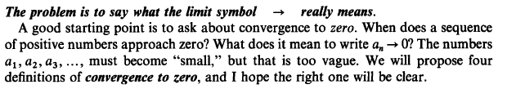
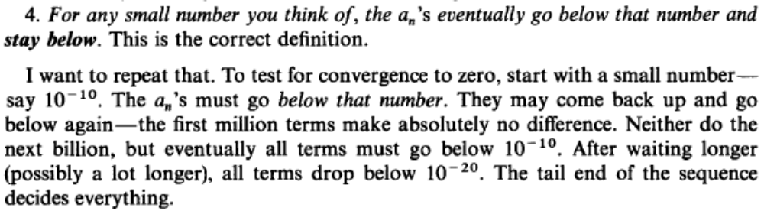

Limites en Maxima
(%i1) f(x):= (x+1)^(1/x);
1/x
(%o1) f(x) := (x + 1)
(%i2) limit(f(x),x,0);
(%o2) %e

Derivación
(De Wikibooks: http://en.wikibooks.org/wiki/Calculus/Differentiation#Definition_of_the_Derivative)

If the two points are on a function f(x) and f(x_{i}) = y_{i} and we let:
, then , and , and of course y₁ = f(x₁),
we find that by substituting these into the former equation, we can express it in terms of two variables (Δx and x₁):
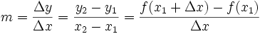.
We then, to find the slope at a single point, let to become any point x. This also defines .
By defining and x, we have defined the slope -- or derivative -- of any function at any single point x as the limit
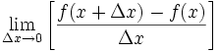

La tangente a la curva en R²
Véase Strang, Gilbert: Calculus, ch. 2.

Derivada de una función de función, y regla de la cadena (chain rule)
(De Granville, Cálculo, Art. 38, p. 46.)
Para derivar 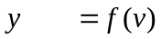 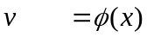
Primer paso: 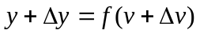 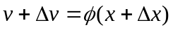
Segundo paso:
(restar f s)
_________________ _________________
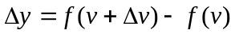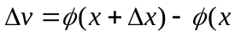
Tercer paso: 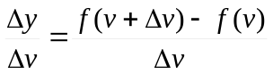 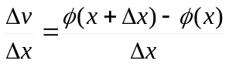
Los miembros de la izquierda expresan la razón del incremento de cada función al incremento de la variable correspondiente y los miembros de la derecha expresan las mismas razones en otra forma. Antes de pasar al límite, formemos el producto de las dos razones, tomando las formas de la izquierda. Resulta:
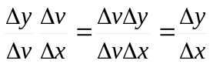
Cuarto paso: Cuando 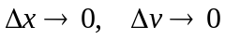. Pasando al límite:
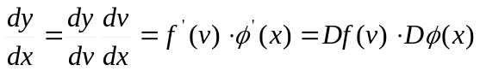

Véase Strang, Gilbert: Calculus smtp://ocw.mit.edu/ans7870/resources/Strang/strangtext.htm, ch. 4.

De Wikibooks, http://en.wikibooks.org/wiki/Calculus/More_Differentiation_Rules:
The function f(x) = (x + 5)² can be consolidated into two nested parts f(x) = u², where u = m(x) = (x + 5). Therefore:
if
and
Then:
Then

Chain Rule
If a function F(x) is composed to two differentiable functions g(x) and m(x), so that F(X)=g(m(x)), then F(x) is differentiable and,
We can now investigate the original function:
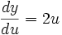
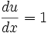
Therefore
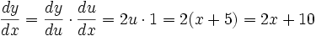Diferenciación de funciones implíticas
Véase Strang: Calculus, ch. 4.

Derivación de funciones inversas
Véase Strang: Calculus, ch. 4.

Ecuaciones paramétricas
(Véase Granville, Cálculo, Art. 81, p. 138.)
A menudo, las coordenadas x y y de de una curva se expresan como funciones de una tercera variables t, llamada parámetro, en la forma
x = f(t)
y = φ(t)
(De http://en.wikipedia.org/wiki/Parametric_equation)
For example, the simplest equation for a parabola,
can be parametrized by using a free parameter t, and setting
Although the preceding example appears somewhat trivial, consider the following parametrization of a circle of radius a:
Parametric equations are convenient for describing curves in higher-dimensional spaces. For example:
describes a three-dimensional curve, the helix, which has a radius of a and rises by 2πb units per turn. (Note that the equations are identical in the plane to those for a circle; in fact, a helix is just "a circle whose ends don't have the same z-value".)
(Véase también la sección sobre "Ecuaciones paramétricas y funciones vectoriales", en el capítulo Vectores, y la sección sobre Ecuaciones paramétricas, en el Acordeón para graficación con Maxima, en “Espacio euclidiano, dimensiones, geometría analítica”.)

Derivadas sucesivas
Véase Strang: Calculus.

Mínimos y máximos
Véase Strang: Calculus.

Iteraciones
Véase Strang: Calculus.

Ejemplos de iteración en Maxima

La siguiente iteración converge a 0:

(%i49) (1/2);
1
(%o49) -
2
(%i50) %^2;
1
(%o50) -
4
(%i51) %^2;
1
(%o51) --
16
(%i52) %^2;
1
(%o52) ---
256
(%i53) %^2;
1
(%o53) -----
65536
Porque 0 es un atractor:
(%i44) ev(%o38,x=0);
(%o44) 0

La siguiente iteración diverge:
(%i56) 1.01^2;
(%o56) 1.0201
(%i57) %^2;
(%o57) 1.04060401
(%i58) %^2;
(%o58) 1.08285670562808
(%i59) %^2;
(%o59) 1.172578644923699
(%i60) %^2;
(%o60) 1.374940678531098

Porque 1 es repelente para esta función:
(%i48) ev(%o38,x=1);
(%o48) 2

Si iteramos la función para 2, diverge hacia infinito:
(%i61) 2^2;
(%o61) 4
(%i62) %^2;
(%o62) 16
(%i63) %^2;
(%o63) 256
(%i64) %^2;
(%o64) 65536
(%i65) %^2;
(%o65) 4294967296

Porque:
(%i45) ev(%o37,x=2);
(%o45) 4

Véase hoja de cálculo para iteraciones: Iteraciones.xls

Obtención de raíces reales por el método de Newton
Véase Strang: Calculus.

Diferenciales
(De Granville: Cálculo, Capítulo IX, p. 165)
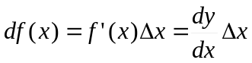
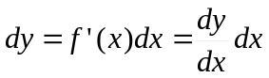
Pág. 172:
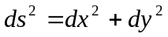
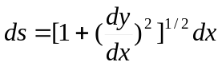
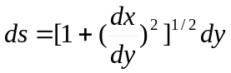
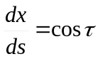
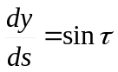
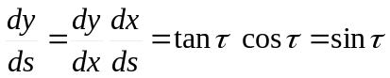

El teorema del valor medio
(Strang: Calculus, 3.8, p. 146)

Teorema de Rolle

Granville: Cálculo, Capítulo XI, p. 207.

La regla de l’Hôpital
Strang: Calculus, 3.8, p. 149.

Guillaume De l'Hôpital (1661-1704)
De J J O'Connor y E F Robertson, (http://www-history.mcs.st-andrews.ac.uk/Biographies/De_L'Hopital.html):
L'Hôpital's fame is based on his book Analyse des infiniment petits pour l'intelligence des lignes courbes (1696) which was the first text-book to be written on the differential calculus. In the introduction L'Hôpital acknowledges his indebtedness to Leibniz, Jacob Bernoulli and Johann Bernoulli but L'Hôpital regarded the foundations provided by him as his own ideas.
In this book is found the rule, now known as L'Hôpital's rule, for finding the limit of a rational function whose numerator and denominator tend to zero at a point.

Sumatoria
http://en.wikibooks.org/wiki/Calculus/Summation_notation
Summation notation allows an expression that contains a sum to be expressed in a simple, compact manner. The greek letter sigma, Σ, is used to denote the sum of a set of numbers.
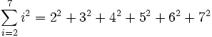
Let f be a function and N,M are integers with N < M. Then
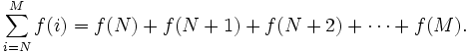
We say N is the lower limit and M is the upper limit of the sum.
Notice that we can replace the letter i with any other variable. For this reason i is referred to as a dummy variable. So
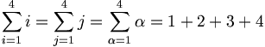

Ejemplo de sumatoria en Maxima

/* Inicializamos dos matrices */
(%i2) vecU:matrix[4,6,5,0];
(%o2) matrix
4, 6, 5, 0
(%i3) vecV:matrix[1,-3,2,0];
(%o3) matrix

1, - 3, 2, 0
/* Obtenemos su producto escalar mediante una sumatoria */
(%i129) sum (vecU[i]*vecV[i], i, 1, length(vecU));
(%o129) - 4

Integración
(De Wikibooks: http://en.wikibooks.org/wiki/Calculus/Integration)
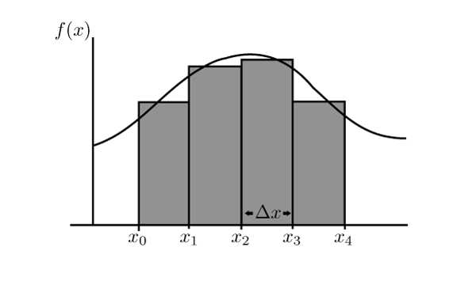
Suppose first that f is positive and a<b. We pick an integer n and divide the interval [a,b] into n subintervals of equal width (see Figure 2). As the interval [a,b] has width b-a each subinterval has width
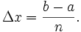
We denote the endpoints of the subintervals by
so
Now for each
pick a sample point in the interval [x_{i},x_{i + 1}] and consider the rectangle of height and width Δx (see Figure 3). The area of this rectangle is
.
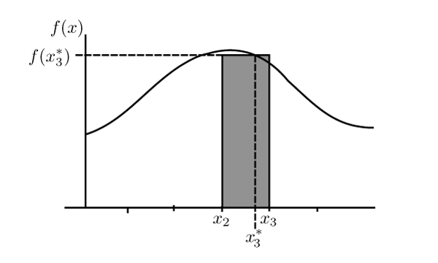
By adding up the area of all the rectangles for we get that the area S is approximated by
A more convenient way to write this is with the summation notation as
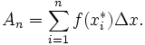
For each number n we get a different approximation. As n gets larger the width of the rectangles gets smaller which yields a better approximation (see Figures 4 and 5). In the limit as A_{n} as n tends to infinity we get the area of S.

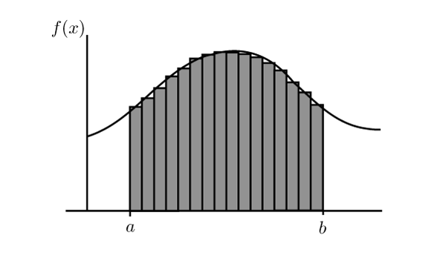

Integral definida
Suppose f is a continuous function on [a,b] and 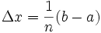. Then the definite integral of f between a and b is 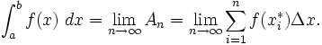
where are any sample points in the interval [x_{i − 1},x_{i}].

Véase Strang: Calculus, 6.2 “The exponential e”

Integración con métodos numéricos en Maxima

Ejemplo de uso de quad_qag
Comprobación de una sustitución trigonométrica:
(%i2) f1(x):=(1-x**2)**(1/2);
2 1/2
(%o2) f1(x) := (1 - x )
(%i3) plot2d([f1],[x,0,1],[gnuplot_term,jpeg],[gnuplot_out_file,"Raiz1-xCuadr.jpeg"]);

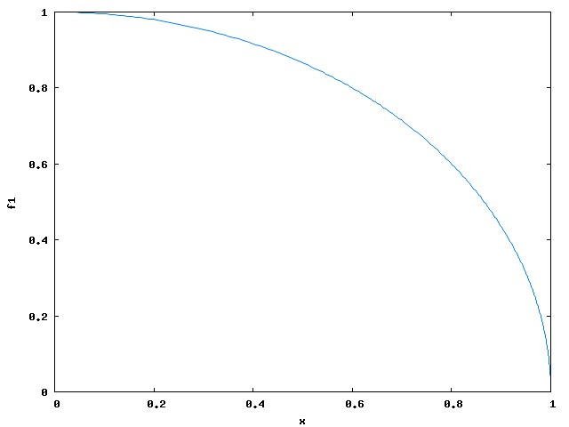

(%i4) f2(theta):=(cos(theta))**2;
2
(%o4) f2(theta) := cos (theta)
(%i5) plot2d([f2],[theta,0,(%pi/2)],[gnuplot_term,jpeg],[gnuplot_out_file,"cosCuadr.jpeg"]);

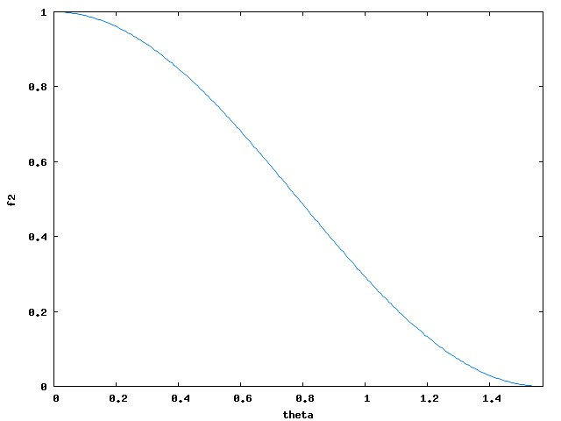

(%i9) quad_qag( f1 ,x,0,1,0 );
(%o9) [0.78539816340066, 5.3860658134314929E-9, 465, 0]

(%i10) quad_qag( f2 ,theta,0,%pi/2,0 );
(%o10) [0.78539816339745, 8.7196712450215814E-15, 15, 0]

(%i15) integrate((1-x**2)**(1/2),x,0,1);
%pi
(%o15) ---
4
(%i16) %,numer;
(%o16) 0.78539816339745

Integrales impropias
http://en.wikibooks.org/wiki/Calculus/Improper_integrals
Type I: Infinite Integrals
An integral with infinite region includes ± included in the interval such as
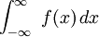.
We cannot simply find the antiderivative and plug in . We can however rewrite the integral using a limit. Let 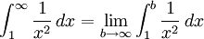
Now this represents a definite integral so we can find the antiderivative and see if the integral converges. 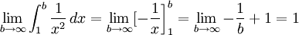
We can now define the the type 1 integral:
(a) If there is some value b where and 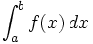exists, then
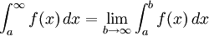

(c) We can also define 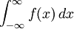as
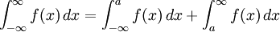assuming that both integrals converge.
**note that if the limits fail to exist, we say that the integral diverges and if the improper integrals yield a finite solution, the integral converges.
Lets look at an example: Evaluate the integral if it converges.
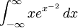
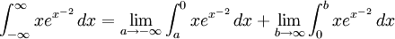
Use the chain rule to find the antiderivative with
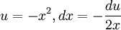
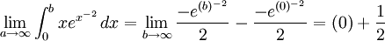
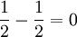This shows that the integral converges to 0.

El teorema fundamental del cálculo
Véase Strang: Calculus, 5.7, “The Fundamental Theorem and its Applications”.

