34-XX Ecuaciones diferenciales ordinarias

De http://www.encyclopediaofmath.org/index.php/Differential_equation,_ordinary :
Differential equation, ordinary
An equation with a function in one independent variable as unknown, containing not only the unknown function itself, but also its derivatives of various orders.
The term "differential equations" was was proposed in 1676 by G. Leibniz. The first studies of these equations were carried out in the late 17th century in the context of certain problems in mechanics and geometry.

De Mattuck: OCW 18.03, Differential Equations, Lecture 1, notes.
18.03 Class 1, Feb 8, 2006
[3] A DIFFERENTIAL EQUATION is a relation between a function and its derivatives.
Véase también Strang: Calculus, 6.5 “Separable equations Including the Logistic Equation”.

Graficación de la función logística
plot2d( 1/(1+(%e^-t)),[t,-6,6]); | 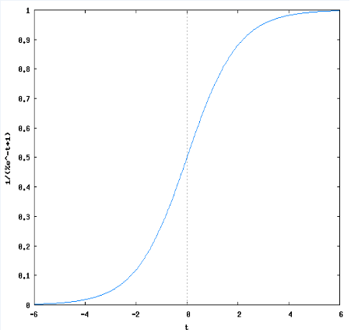

Ecuaciones diferenciales lineales de primer orden
De Mattuck: OCW 18.03, Differential Equations, Lecture 3.
18.03 Class 3, Feb 13, 2006
First order linear equations: Models
[1] If I had to name the most important general class of differential equations it would be "linear equations." They will occupy most of this course. Today we look at models giving first order linear equations.
Definition: A "linear ODE" is one that can be put in the "standard form"
x' + p(t)x = q(t)
[...]

Solución, paso por paso (anotado a partir del video)
The equation looks like this:
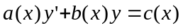 (1)
To conveert it to the standard linear form, we divide by a, and restante b/a and c/a as follows:
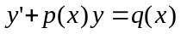 (2)
What is so important about this equation? Well, it can always be solved...
The standard first order form, which we will never use in this course:
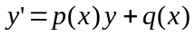 (3)
although half the books on DEs in the world do...
The difference is only in the sign of p, but if you don’t get the sign of p correctly, it is just disaster from that point on. A trivial little change of sign produces functions with a totally different behaviour...
So we will use (2), which is always solvable, as the standard form. I’m goint to solve this equation by finding the integrating factor: u(x) What is an integrating factor? Rather than giving a definition, I’ll show you what it is.
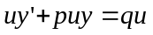
If it turns out to be the derivative of something, because I’ve chosen u so cleverly, then all I’ll have to do is to is to integrate (the LHS) with respect to x, and integrate (the RHS) with respect to x, and the equation is solved!
There are many things to try, but there is ony one thing that is reasonable, and that is the derivative of u times y:
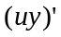
See how reasonable that is, because according to the product rule:
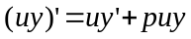
Works if (véase minuto 27 del video, en adelante):
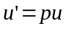
Separate variables, and you get:
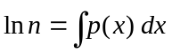
The formula for our integrating factor is:
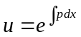
Method for solving y’+py=q:
- Must be in standard linear form. You’ll be get the right p, otherwise you are sunk.
- Calculate the integrating factor 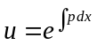
- Multiply both sides by u
- Integrate

Example 1: solve 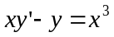
- Must be in standard linear form: 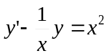
- Calculate the integrating factor: 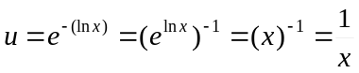
- Multiply both sides by u : 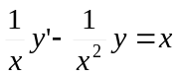
- Check (up), which I always recommend because there is always a chance you made a mistake.
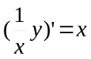
- And then integrate: 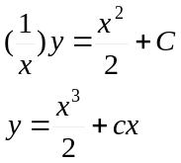

Example 2: Heat conduction
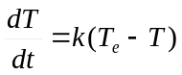
- Put it in standard linear form: 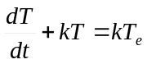
- Calculate the integrating factor: 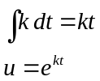
- Multiply both sides by u : 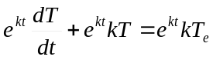
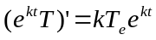
- And then integrate: 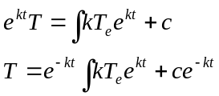

“The most important differential equation in applied mathematics”
De Strang: Calculus, 6.3 “Growth and decay in Science and Economics”

Crecimiento y decadencia con ingresos y egresos
De Strang: Calculus, 6.3, p. 246

Solución por separación de variables
De Strang: Calculus, 6.3, p. 260

Ecuaciones diferenciales homogéneas
Mattuck: OCW 18.03, Differential Equations, Lecture 3.
A first order linear equation is homogeneous if the right hand side is zero:
(1) x’+ p(t)x =0.
Homogeneous linear equations are separable, and so the solution can be expressed in terms of an integral. The general solution is
(2) 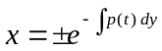 or x =0.

Bernoulli equations
De Mattuck: OCW 18.03, Differential Equations, Lecture 4.
18.03 Class 4, Feb 15, 2006
First order substitution methods: Bernoulli and Homogeneous equations.
“Learn methods, not final formulas”

An equation of the form:
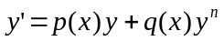
Is called a Bernoulli equation.

Ecuaciones diferenciales autónomas
De Mattuck: OCW 18.03, Differential Equations, Lecture 5.
18.03 Class 5
Se le llama ecuaciones “autónomas” a las ODEs que carecen de variable en el segundo miembro:
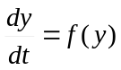
Este tipo de ecuaciones tiene puntos críticos donde f(y) = 0.

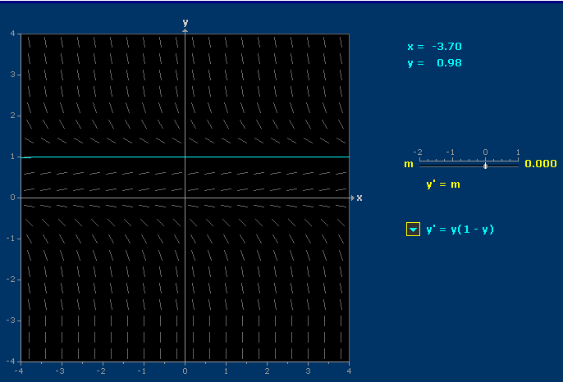

Puntos críticos ------->
-------->
donde f(y) = 0

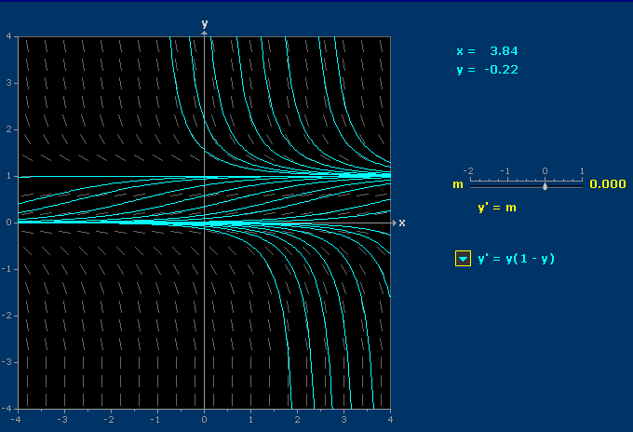
Significado de los puntos críticos:
Punto crítico estable ---->
Punto crítico inestable---->

Ejemplos: Crenshaw
De Crenshaw: http://embedded.com/showArticle.jhtml?articleID=172300631:
As you get deeper into the math of functions, you'll find that almost all of them represent solutions to differential equations. The sine function, for example, represents the solution to the equation:
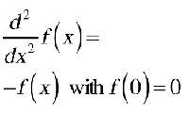(10)
The cosine function is the same, except for the initial condition:
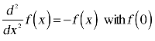(11)
The function we're interested in at the moment, the exponential function, happens to be the solution of the equation:
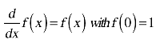(12)

Ejemplo: El oscilador armónico
(Feynman: Física, Cap. 21, 21-2)
"Vamos a llamar x a este desplazamiento hacia arriba y vamos a suponer también que el resorte es totalmente lineal, en cuyo caso la fuerza que tira en contra cuando el resorte está estirado es precisamente proporcional a la cantidad de estiramiento. O sea, la fuerza es -kx (con un signo para recordarnos que tira en contra). Luego, la masa por la aceleración debe ser igual a -kx:
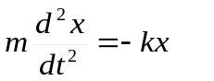(21.2)
"Para simplificar, supongamos que suceda (o cambiamos nuestra unidad de medida de tiempo) que el cociente k/m = 1. Primero estudiaremos la ecuación:
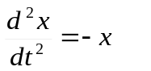(21.3)
"Ya hemos analizado la ecuación (21.3) en detalle numéricamente..."
(Feynman: Física, Cap. 9, p. 9-9. Véase hoja de cálculo Analisis050EcuacionesDifMetodosNumer.xls.)
(Cont. Feynman: Física, p. 21-3)
"La función es x = cos t... Ahora que sabemos que x = cos t podemos calcular un valor preciso del tiempo en el cual debe pasar por x = 0. La respuesta es t = π /2 ó 1.57108."
"... encontramos que debemos alterar la escala de tiempo. En otras palabras, la ecuación (21.2) tiene una solución de la forma
x = cos ω₀ t (21.4)
"... La ecuación d²x/dt² = -ω₀²x es la misma que la ecuación (21.2) si ω₀² = k/m."
(Feynman: Física, p. 21-4)
"... toda solución de la ecuación diferencial d²x/dt² = -ω₀²x que exista en el mundo se puede escribir:
(a) x = a cos ω₀ (t - t₁),
(b) x = a cos (ω₀ t + Δ), (21.6)
(c) x = A cos ω₀ t + B sen ω₀ t .
(Feynman: Física, p. 21-5)
"... ω₀ se llama frecuencia angular; es el número de radianes que cambia la fase en un segundo. [...] Podríamos decir que Δ es un defasaje con respecto a algún cero definido."

