40 Sucesiones, series, sumabilidad
De http://es.wikipedia.org/wiki/Sucesi%C3%B3n_matem%C3%A1tica
En matemática, se llama sucesión o secuencia al conjunto de elementos encadenados o sucesivos.
Véase también:
http://mathworld.wolfram.com/Sequence.html
http://en.wikipedia.org/wiki/Sequence
http://www.encyclopediaofmath.org/index.php/Sequence

Series de Madhava
De J J O'Connor y E F Robertson, en http://www-gap.dcs.st-and.ac.uk/~history/Biographies/Madhava.html
Jyesthadeva wrote Yukti-Bhasa in Malayalam, the regional language of Kerala, around 1550. ... Gupta gives a translation of the text and this is also given in ... other sources. Jyesthadeva describes Madhava's series as follows:-
The first term is the product of the given sine and radius of the desired arc divided by the cosine of the arc. The succeeding terms are obtained by a process of iteration when the first term is repeatedly multiplied by the square of the sine and divided by the square of the cosine. All the terms are then divided by the odd numbers 1, 3, 5, .... The arc is obtained by adding and subtracting respectively the terms of odd rank and those of even rank. It is laid down that the sine of the arc or that of its complement whichever is the smaller should be taken here as the given sine. Otherwise the terms obtained by this above iteration will not tend to the vanishing magnitude.
This is a remarkable passage describing Madhava's series, but remember that even this passage by Jyesthadeva was written more than 100 years before James Gregory rediscovered this series expansion. Perhaps we should write down in modern symbols exactly what the series is that Madhava has found. The first thing to note is that the Indian meaning for sine of q would be written in our notation as r sin q and the Indian cosine of would be r cos q in our notation, where r is the radius. Thus the series is
r q = r(r sin q)/1(r cos q) - r(r sin q)³/3r(r cos q)³ + r(r sin q)⁵/5r(r cos q)⁵- r(r sin q)⁷/7r(r cos q)⁷ + ...
putting tan = sin/cos and cancelling r gives
q = tan q - (tan³q)/3 + (tan⁵q)/5 - ...
which is equivalent to Gregory's series
tan⁻¹q = q - q³/3 + q⁵/5 - ...
Now Madhava put q = π/4 into his series to obtain
π/4 = 1 - 1/3 + 1/5 - ...
and he also put q = π/6 into his series to obtain
π = √12(1 - 1/(33) + 1/(53²) - 1/(73³) + ...
We know that Madhava obtained an approximation for π correct to 11 decimal places when he gave
π = 3.14159265359
which can be obtained from the last of Madhava's series above by taking 21 terms. In [5] Gupta gives a translation of the Sanskrit text giving Madhava's approximation of π correct to 11 places.
Perhaps even more impressive is the fact that Madhava gave a remainder term for his series which improved the approximation. He improved the approximation of the series for π/4 by adding a correction term R_{n} to obtain
π/4 = 1 - 1/3 + 1/5 - ... 1/(2n-1) R_{n}
Madhava gave three forms of R_{n} which improved the approximation, namely
R_{n} = 1/(4n) or
R_{n} = n/(4n² + 1) or
R_{n} = (n² + 1)/(4n³ + 5n).

James Gregory (1638-1675)
De J J O'Connor y E F Robertson, en http://www-history.mcs.st-andrews.ac.uk/history/Biographies/Gregory.html

Newton y la series infinitas
Consúltese Maor: e: The Story of a Number, p. 71 en http://books.google.com.mx/books?id=eIsyLD_bDKkC&pg=PA71: “Newton's first major mathematical discovery involved infinite series”.

Newton: De analysi...
De http://en.wikipedia.org/wiki/De_analysi_per_aequationes_numero_terminorum_infinitas
De analysi per aequationes numero terminorum infinitas (On analysis by infinite series / On Analysis by Equations with an infinite number of terms ) / On the Analysis by means of equations of an infinite number of terms / About completely loosening infinity by way of number equalizations limits c.f. { aequatio, analysi = ἀναλύω , de } is a mathematical work of Isaac Newton.
Composed in 1669, during the mid-part of that year probably, from ideas Newton had acquired during the period 1665–1666. [...]
The explication was written to remedy apparent weaknesses in the logarithmic series [infinite series for log(1+x)], that had become republished due to Nicolaus Mercator, or through the encouragement of Isaac Barrow in 1669, in order to ascertain the knowing of the prior authorship of a general method of infinite series. The writing was circulated amongst scholars as a manuscript in 1669, including John Collins a mathematics intelligencer [14] for a group of British and continental mathematicians. His relationship with Newton in the capacity of informant proved instrumental in securing Newton recognition and contact with John Wallis at the Royal Society. Both Cambridge University Press and Royal Society rejected the treatise from publication, being instead published in London in 1711 by William Jones, and again in 1744, as Methodus fluxionum et serierum infinitarum cum eisudem applicatione ad curvarum geometriam in Opuscula mathematica, philosophica et philologica by Marcum-Michaelem Bousquet at that time edited by Johann Castillioneus.

Content
The exponential series, i.e. tending toward infinity, was discovered by Newton and is contained within the Analysis. The treatise contains also the sine series and cosine series and arc series, the logarithmic series and the binomial series.

Series
(Véase http://en.wikibooks.org/wiki/Calculus/Series )

Suma de una serie de números naturales
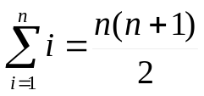

Serie geométrica
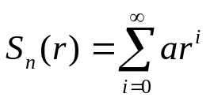
De Wikipedia: http://en.wikibooks.org/wiki/Calculus/Series :
Perhaps a more surprising and interesting fact is that for | r | < 1, S_{n}(r) will converge to a finite value. Specifically, it is possible to show that
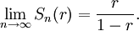
Indeed, consider the quantity
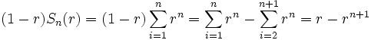
Since as for | r | < 1, this shows that as . The quantity 1 - r is non-zero and doesn't depend on n so we can divide by it and arrive at the formula we want.

Serie de potencias (power series)
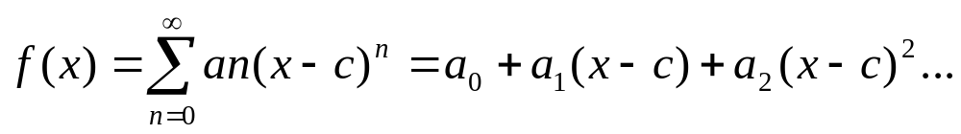
De http://www.encyclopediaofmath.org/index.php/Series
A sequence of elements (called the terms of the given series) of some linear topological space and a certain infinite set of their partial sums (called the partial sums of the series) for which the notion of a limit is defined. Here are the simplest examples of series.

Hoja de cálculo
Series.xls

Series de Taylor

El patrón general del orden de las ecuaciones
(De Crenshaw, http://embedded.com/showArticle.jhtml?articleID=166402556)
Let's review where we've been so far. For the three orders of polynomials, our fitting equations turn out to be:
(0th order) (28)
(1st order) (29)
(2nd order) (30)
Now we can begin to see a deeper structure behind the solution. All of the equations have the y-intercept, y(0), as the constant term. In the case of the constant function, it's the only term, since the function value doesn't change with x. In the first-order fit, the next coefficient is the slope, m, and it also doesn't change with x. For the quadratic, the last coefficient is C. As it turns out, this one represents the curvature of the curve, and it doesn't depend on x, either
Let's agree that the slope of the function, at any x, is m(x), which is now not a constant. Using these rules of differentiation, the derivative of the quadratic function is:
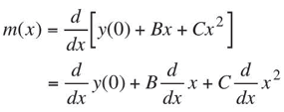 | (33)
or
(34)
What is this slope when x = 0? Clearly, it's:
(35)
Now we see what the value of B represents: It's the slope when x = 0. A slope-intercept, if you will. Now let's go back to Equation 30, which we can write:
(36)
Looking at this equation, it's tempting to assume that C must represent the "y-intercept" of curvature. That is, it's the second derivative. But that would be wrong, as we can see by differentiating Equation 34 one more time:
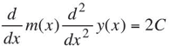 | (37)
So C isn't exactly the second derivative; it's only proportional to it. Therefore we must write, for the quadratic:
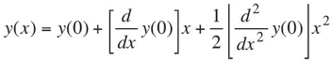 | (38)
Once you see that point, it's not hard to believe that the nth derivative of the function relates to its "y-intercept" by a ratio that's equal to a factorial. This inspires us to guess, for the next order,
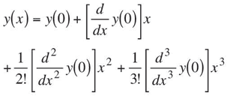 | (40)
This concept is important enough that it deserves a new notation. Let us write:
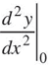
to mean the derivative of y(x), evaluated at x = 0. We can then write Equation 40 in the form:
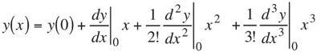 | (41)
Taylor's insight
Equation 41 is getting very close to the Taylor series. We originally derived it for the case of a quadratic function, but then we extended the result to the cubic polynomial. It doesn't take much of a stretch to believe that we can continue to add terms, to higher and higher orders of polynomials.
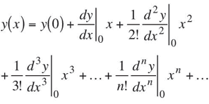(42)
(Ecuación 2, en sig. artículo de Crenshaw)
This equation looks like an infinite series, and indeed it may be. But bear in mind that it's not infinite if the original function is a polynomial. In that case, the order of the derivative is reduced at each step, and we will eventually reach zero. In other words, Equation 42 naturally truncates itself for polynomials.
Taylor's insight, however, goes much deeper. He conjectured that the same rule applies to all functions, polynomial or not. Equation 42 is the Taylor series.
[Continuación de Crenshaw, sobre serie de Taylor, en http://embedded.com/showArticle.jhtml?articleID=172300631]
As bad as the equation looks—and admittedly it looks horrible--it's based upon a rather simple and very reasonable conjecture: if I know both the value of some function at some point (we've been using x = 0 for simplicity), plus each order of derivative evaluated at the same point, I should be able to reconstruct the function. Each term like:
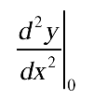
in Equation 2 is intended to represent one of those derivatives. If you feel comfortable with derivatives, you can prove the conjecture for yourself by choosing some function, evaluating the derivatives, and stuffing them into Equation 2.

Ejemplo: Serie de Taylor para la función exponencial
[De Crenshaw, http://embedded.com/showArticle.jhtml?articleID=172300631]
The function we're interested in at the moment, the exponential function, happens to be the solution of the equation:
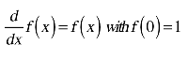(12)
In other words, the function is its own derivative. In graphical terms, the slope of the function at some value of x is equal to the function value itself. This function is one of the most important ones in all of mathematics and physics, not to mention all of engineering. It shows up everywhere, from the decay of radioactive elements to the discharge of a capacitor.
I'm going to give you the solution in laborious detail. If you already know all this stuff, bear with me. My main motivation is to show that there's no magic, black or white, involved. It's pretty simple mathematics, though there is a smidge of calculus involved. Let's start by assuming the most general form of a power series:
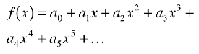(13)
Where, again, we don't yet know the values of the a's. It's our goal to discover them by using Equation 12. You do need to know how to differentiate a power of x. In case you forgot, the rule is:
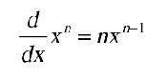(14)
Differentiating Equation 13 gives:
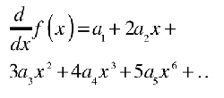(15)
Now, Equation 12 says that the two power series in Equations 13 and 15 have to be equal. Not only do they have to be equal, they have to be equal for all possible values of x. The only way this can be true is if the coefficients of each power of x are equal, term by term. That means:
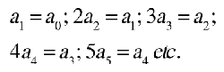(16)
Solving for each higher-order coefficient, we get:
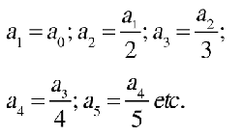(17)
Since every coefficient now depends on the one before it, we can solve for all of them if we know a₀. And we do, because the initial condition in Equation 12 requires that:
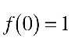(18)
Since all the other terms in the series vanish when x = 0, this requires that:
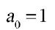(19)

Now we can solve for the other coefficients, and get:
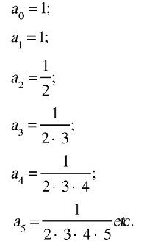(20)
The last step is to observe that the numerators of all these coefficients are equal to the factorials 1!, 2!, 3!, and so on. Putting it all together, we can substitute the value for the a's back into the power series to get:
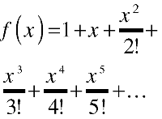(21)
I must emphasize: despite my use of the generic form f(x), the power series in Equation 21 doesn't apply to just any old function f(x), but rather the function that represents the solution to Equation 12. To differentiate this function from all others, we give it a name:
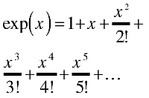(22) ]
Any scientific programmer will recognize this function. If you're staying one step ahead of me, you know that the mathematical notation for the same function is:
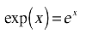(23)
[...]
On the other hand, if you know (and believe in the truth of) the Taylor series, there's another approach that makes the solution completely trivial. Since the function in Equation 12 is its own derivative, it will probably not shock you too much to discover that it's also its own second, third, or nth order derivative:
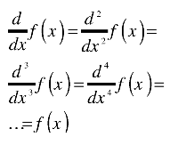(24)
What's more, the value of all these derivatives, evaluated at x = 0, is simply f(0), which is 1. Applying Taylor's series gives us the power series in just a couple of steps:
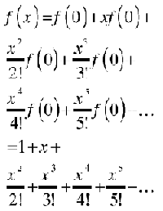(25)
which agrees with Equation 21.
There's a lesson to be learned here, and an important one: the purpose of advanced methods of mathematics, like calculus in general and the Taylor series in particular, is not to make life harder for struggling math students; it's to make it easier by providing ways to solve problems that either couldn't be solved at all or only solved with difficulty. What's more, these methods typically require less thinking and reasoning power, by reducing the solution to a turn-the-crank, no-thought-required sort of procedure.

Teorema de Taylor
De http://en.wikipedia.org/wiki/Taylor%27s_theorem:
The precise statement of the theorem is as follows: If n ≥ 0 is an integer and f is a function which is n times continuously differentiable on the closed interval [a, x] and n + 1 times differentiable on the open interval (a, x), then we have
Here, n! denotes the factorial of n, and R_{n} is a remainder term, denoting the difference between the Taylor polynomial of degree n and the original function. The remainder term R_{n} depends on x and is small if x is close enough to a. Several expressions are available for it.
The Lagrange form^{[1]} of the remainder term states that there exists a number ξ between a and x such that
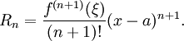
This exposes Taylor's theorem as a generalization of the mean value theorem. In fact, the mean value theorem is used to prove Taylor's theorem with the Lagrange remainder term.
The Cauchy form^{[2]} of the remainder term states that there exists a number ξ between a and x such that
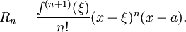

Para series geométricas
(http://en.wikibooks.org/wiki/Calculus/Taylor_series):
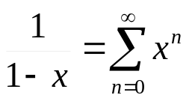 para |x| < 1

Para el logaritmo natural
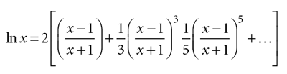
O bien (http://en.wikibooks.org/wiki/Calculus/Taylor_series):
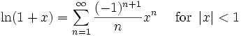

Para la función exponencial
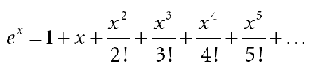(4)

Que también se puede representar mediante (http://en.wikibooks.org/wiki/Calculus/Taylor_series):

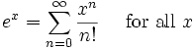

Para funciones trigonométricas
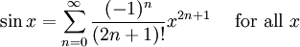
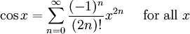
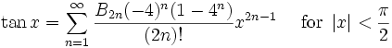
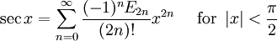
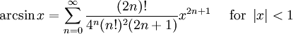
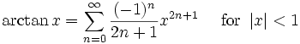

Formas de representación de la serie de Taylor
Véase Crenshaw: "More on the Rosetta Stone". Embedded.com 9 Dec. 2006, http://www.embedded.com/columns/showArticle.jhtml?articleID=175002472
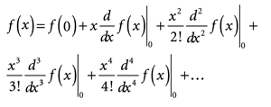
ó:
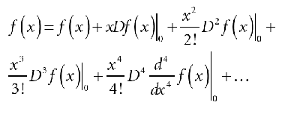
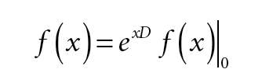(14)
Véase también http://en.wikibooks.org/wiki/Calculus/Taylor_series
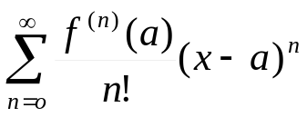

Radio de convergencia
(http://en.wikibooks.org/wiki/Calculus/Power_series)
We can only use the equation
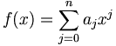
to study f(x) when the power series converges. This may happen for a finite range, or for all real numbers.
This interval in which the power series converges to the function is known as the radius of convergence.
E.g,
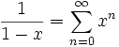(a geometric series)
this converges when |x|<1, so the radius of convergence is 1.
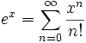
Using the ratio test, this series converges when the ratio of successive terms is less than one,
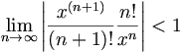
or 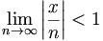
which is always true, so this power series has an infinite radius of convergence.

Diferenciación e integración de series
(http://en.wikibooks.org/wiki/Calculus/Power_series)
Within its radius of convergence a power series can be differentiated and integrated term by term.
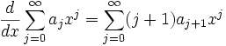
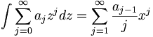
Both the differential and the integral have the same radius of convergence as the original series.
This allows us to sum exactly suitable power series. E.g
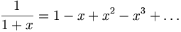
This is a geometric series, which converges for |x|<1. Integrate both sides, and we get
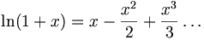
which will also converge for |x|<1. When x=-1 this is the harmonic series, which diverges. When x=1 this is an alternating series with diminishing terms, which converges to Ln 2.

Serie de Fourier
Véase la sección sobre el teorema de Fourier, en C:\Refer\Matemat\Analisis040Series.doc

