Factorización de operadores
Véase Crenshaw: "More on the Rosetta Stone". Embedded.com 9 Dec. 2006, http://www.embedded.com/columns/showArticle.jhtml?articleID=175002472
Now comes the really neat step. Watch carefully, and notice there's nothing up my sleeve. Imagine that I can "factor out" the function itself:
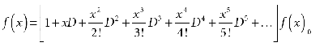
(12)
Whoa! What happened there? Can this possibly be right? Can we factor out the operand of an operator? Of course we can.
Now look at the form of the series in brackets, in Equation 12. It's identical to the form of the exponential function. Hence we can write:
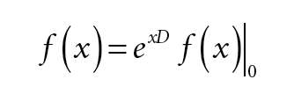
(14)
If factoring the operand out of the Taylor series seemed weird to you, taking the exponential of an operator must really blow your mind. Remember, though, that the symbols used don't matter. The expressions of Equations 11 and 14 are identical, because we've already established what the terms mean. Equation 14 doesn't relieve us of any effort. It only allows us to express the chore in a more compact way.
Continuación en:
Crenshaw: "Two different worlds"
http://www.embedded.com/columns/pt/showArticle.jhtml?articleID=186100323
A couple of other operators are useful. The first is the forward difference operator, Δ. This operator, working in the discrete domain, is the difference between two successive table entries.
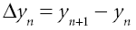
(10)
Similarly, the backward difference operator (del) is:
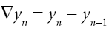
(11)
Note that the only difference between the two operators is that one looks forward in the table, one backward. In other words:
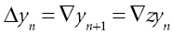
(12)
And so
(13)
In a similar fashion, we can derive quite a number of relationships between the discrete operators, all examples of operational calculus in action. A few are:
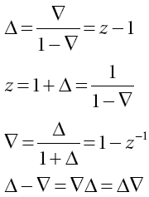
(14)
The last line of Equation 14 must surely be one of the few cases where a difference of two things is also equal to their product.

La piedra de Rosetta: discreto a contínuo
Now suppose that we've got an embedded computer hooked up to some real, physical system--the cruise control on a car, perhaps. We can arrange for the speedometer to generate a voltage proportional to the speed, and measure that voltage using an analog-to-digital converter (A/D). The voltage, like the speed, is a continuous function of time, v(t), as shown in Figure 1.
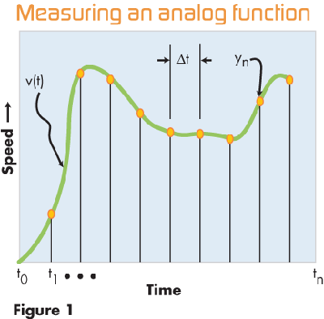
Although the voltage is continuous, that's not the view our computer gets of it. It can only read the A/D at specific times, controlled by our software. Those measured values are represented by the orange dots in Figure 1. I'll call them y⁰,y¹, . . . y^{n}. For the record, the set isn't infinitely long. While it may go back in time for a long time, it can't go forward beyond the current time, t^{n}.
In general, it's not enough to know what the measured voltages are at each point; we must also know what time the measurements were taken. In the parlance of mathematics, each of the yellow dots in Figure 1 represent an ordered pair, {t_{i},y_{i}}. To fully represent the measured data, we'd have to store the time values along with the measured voltage. Data of this kind is called time-tagged data.
However, in Figure 1, I've shown the measurements being taken using uniform time intervals, Δt. We almost always do this, if possible, because the math gets very much harder if we allow the data to be taken with unequal time intervals. For all the control systems you're likely to see, the measurement intervals will be as uniform as we can possibly make them. In such cases, we don't need to store the time tags, because we can compute them from:
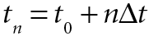
(15)
When dealing with the Rosetta Stone operators, you can safely assume that the time intervals will always be uniform.
Now, here's the important part: Despite the fact that the array y_{n} represents measurements of the voltage v(t), they are very, very different animals. The voltage is a continuously varying function of time, represented by the smooth curve. The measurements y_{n} are a discrete set, corresponding only to specific times. To the computer, it makes no sense to talk about intermediate values like y_{4.5}. To the computer, those intermediate values don't exist. The y_{n} are all there is.
On the other hand, we're trying to control a device that's continuously varying. We want to control v(t), not y_{n}. This, then, is the crux of the relationship between the worlds of continuous time and discrete time. In the computer, we're measuring the voltage only at discrete points, but we must use those measurements to infer something about the continuous function. That's where the Rosetta Stone comes in.
[...]
The second step is both subtle and profound. Remember that we said that the measured values, {y₀, y₁, ..., y_{n}}, are the values of v(t) at times {t₀, t₁, ..., t_{n}}. That is:
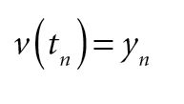
(19)
It would certainly seem reasonable, then, to write Equation 18 as:
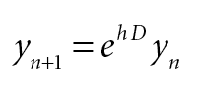
(20)
Never forget how the expression is to be interpreted. Again, we're using notation that is more compact but must be interpreted to mean exactly the same thing as the original Taylor series. Specifically, terms like Dy_{n} are to be interpreted as:
• First take the derivative of v(t)
• Then evaluate the derivative at t = t_{n}
[...]
I'll get back to the usefulness of Equation 20 in a moment. For now, let's complete the transformation. The z operator is one that operates on tables of discrete data, rather than continuous functions. Its purpose is to advance the "pointer" one step forward in the table. Thus, by definition:
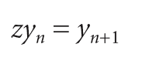
(21)
We're now in position to take the final step in the transformation from Taylor series to Rosetta Stone. Substitute the left side of Equation 21 into Equation 20, to get:
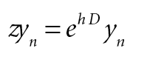
(22)
Now we have an interesting situation. Both z and e^{hD} are operators, operating on the tabular values y_{n}. But the operand is the same on both sides of the equation. So, following in Heaviside's footsteps, we can "factor out" the y_{n}, to get the Rosetta Stone equation in its purest form:
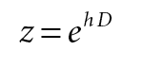
(23)

Continuación en:
Crenshaw: "Two different worlds"
http://www.embedded.com/columns/pt/showArticle.jhtml?articleID=186100323
OPERATING ON OPERATORS
At last we get to the part where we can use the Rosetta Stone, Equation 1, to manipulate functions and measurements of them to attain useful goals. In the process, we get to apply operational calculus to its most profound effect. Remember, in operational calculus we lean on Heaviside's observation that even though the operators must operate on something, we can manipulate them in equations like Equation 1 just as though they were algebraic variables. In 1885 Heaviside observed that if he did such manipulations naively, as though the operators were variables, he always got the right answer. He suggested that this would always be true, and he was right. As the simplest example, consider an operation we often want to do: estimate the derivative of a function by processing its sampled values. Reverting Equation 1 without regard for the nature of the function ƒ(x) gives, simply:
(15)
What does this mean? To use the form of Equation 1, we had to understand that we must replace the function e^{x} by its power series form. Then e^{hD} became a power series in derivatives, which is another way of saying, Taylor series. In a similar way, we must expand the logarithm function into its equivalent power series.
There are two ways we can do this. My table of integrals doesn't give a power series for ln(x), per se, but it does give a series for ln(1+x):
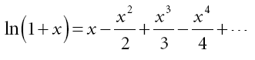
(16)
But from Equation 14:
(17)
Making the substitution, we get:
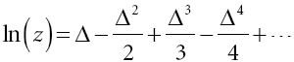
(18)
And therefore our estimate of the derivative is:
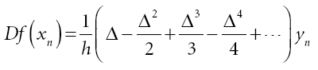
(19)
I should mention that the power series for ln(x) is a notoriously slowly converging series. Unlike the series for sin(x), cos(x), or e^{x}, there are no factorials in the denominators to speed convergence. Fortunately, this isn't really a problem in our case, because we must assume that the sampling rate is high enough so that the entries don't change much between intervals. For that reason, the differences are small, and higher-order differences, smaller yet. In practical cases, you'll find that you'll get a good estimate with only a few orders of Δ.
It may not seem so to you yet, but Equation 19 is a highly practical way of estimating a derivative. Here's how.
In the "good old days" before computers, astronomers used difference tables to compute the orbits of planets and comets. They would create a table with a list of measurements taken at successive time intervals. That's { y_{n}}. Next, they'd take the difference between each entry and the one following it. That column is {Δ y_{n}}. Not surprisingly, the next column is the second difference, {Δ² y_{n}}. Once they had enough columns, they'd apply Equation 19 to get the result.
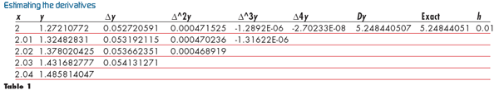
You can build your own tables (can you say, "spreadsheet"?). In Table 1, I've generated the values for a function defined in my book (Math Tookit for Real-Time Programming, CMP Books, 2000):
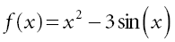
(20)
For the record, I got the table wrong in the book, tabulating the derivative rather than the function. It's correct in Table 1. The result is exact to nine digits.
There's only one problem with our result: It's rather useless.
Remember, Δ is the forward difference operator, which means that to compute the difference for x = 2, we need the value one step further along. To get higher differences, we need to look even further ahead. This may not be a problem if we're not working in real time. But if we are, then looking ahead means looking into the future, which we can't do.
Fortunately, there's an easy fix. Instead of using the forward difference Δ, use the backward difference, . From Equation 14, we see that:
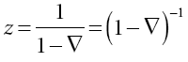
(21)
The power series gives:
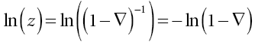
(22)
we can use the same power series as before, substituting - for Δ. The series becomes:
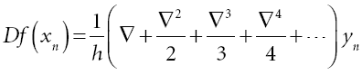
(23)
The new table looks like Table 2.
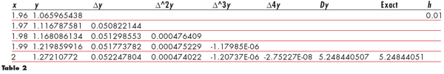
The operations we need now involve looking only backwards in the table (that's why is called the backward difference operator!). This, we can easily do by retaining a few past values of y.
Hoja de conversión de mediciones discretas a funciones contínuas
Veáse hoja de cálculo: Rosetta.xls

Uso de z, en lugar de h
WHY NOT Z?
Forward or backward differences might have worked fine for the old astronomers, but in the modern world, we usually find it better to work directly with z. As you can see from Table 2, using the differences requires us to save not only past values of y but past values of the differences as well. We'd prefer to save only past values of y.
Can we do this? Absolutely. Remember from Equation 14:
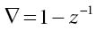
(24)
We could have written the estimate of the derivative directly in terms of z, or rather z⁻¹. The equation becomes:
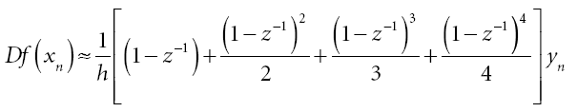
(25) Expanding the series to fourth order, we get:
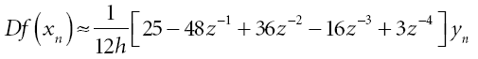
(26)
Using this formula, we can clearly write the derivative in terms of only present and past values of y_{n}. So what's the problem? To see it, try expanding Equation 25 to one less power of z⁻¹. Write:
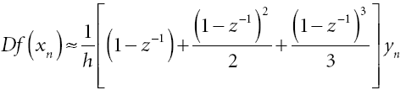
(27)
And expand to get:
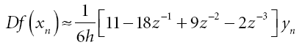
(28)
Our formula is completely different!
This is the essence of the problem with using powers of z. It's true enough that to get a practical algorithm for estimating a derivative, we're going to need to truncate the series to some order. But the pattern of the terms in Equation 23 is easy to see, so we can either truncate the series or extend it to higher order, with little effort. On the other hand, we can't just use Equation 25 as written because we have no idea how to evaluate the powers of 1-z⁻¹. To get the result in a useful form, we have no choice but to expand the polynomials and collect terms. As soon as we do so, we get a set of coefficients that are different than the ones for higher or lower orders.
When I have to implement the derivative estimate in a digital control system, do I use or z⁻¹? Actually, I use z⁻¹. In the control system, I want to do the minimum amount of work and save the minimum number of terms. I get that by using a form like Equation 28. But for analysis, I'm better off with Equation 23. So while I'm doing my design and analysis, I keep the series in powers of . That way, I can keep my options open until I know how many orders I'm going to need. That number will depend on the sample rate and other factors, so determining the order is an integral part of the design.
But once I've completed the design

Continuación... del mismo autor:
http://www.embedded.com/columns/pt/showArticle.jhtml?articleID=188101114
La piedra de Rosetta y la transformada bilineal
De Crenshaw: "Lose ends". Embedded.com 9 Aug. 2006, http://www.embedded.com/columns/pt/showArticle.jhtml?articleID=191801176#1
As I've been emphasizing for months, a digital computer does things in discrete steps. We tell it what to do in the language of discrete time, which for us means the delay operator, z⁻¹. However, many controls engineers still think and do their design work in the domain of continuous time. The connection, of course, is the Rosetta Stone equation:
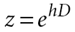
(1)
Some dark day, you may be given a transfer function based on s. Your challenge is to turn it into an equivalent, discrete-time form using z⁻¹. That's where the bilinear transform comes in. The transform, in turn, comes straight from the Rosetta Stone equation. Reverting Equation 1 (and substituting s for D) gives:
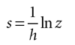
(4)
Remember the rule, which came from the Taylor series: we can't use functions like e^{x} or ln x directly; we don't know how to take the logarithm of an operator. Instead, we must consider such functions to be simply shorthand for expressing a power series. To proceed, we need a power series for the logarithm.
You'll find that series in any good engineering handbook:
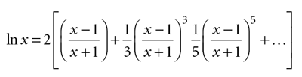
(5)
Chop the series off after the first term, and you get the bilinear transform:
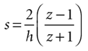
(6)

