08 Sistemas algebraicos

Síntesis y notas

Expresión matemática
De http://en.wikipedia.org/wiki/Expression_%28mathematics%29 :
In mathematics, an expression is a finite combination of symbols that is well-formed according to rules that depend on the context.

Ecuación
De http://en.wikipedia.org/wiki/Equation :
An equation, in a mathematical context, is generally understood to mean a mathematical statement that asserts the equality of two expressions.
Consúltese http://www.encyclopediaofmath.org/index.php/Equation .

Variable libre
Véase http://www.encyclopediaofmath.org/index.php/Free_variable

Coeficiente
Véase http://www.encyclopediaofmath.org/index.php/Coefficient
A numerical factor in an algebraic expression, a known factor in front of a power of an unknown or a constant factor multiplying a variable quantity.

Definición de variables en Maxima
(%i14) x:4;
(%o14) 4
(%i15) x**2+x-20;
(%o15) 0

Acordeón de Maxima para ecuaciones
(%i8) x**2+1*x-20=0;
2
(%o8) x + x - 20 = 0
(%i9) solve(%);
(%o9) [x = - 5, x = 4]

(%i50) ec1: 3*x^3 + 5*x^2-x+6;
3 2
(%o50) 3 x + 5 x - x + 6
(%i51) solve(ec1,x);

SQRT(3) %I 1
34 (---------- - -)
2 2 SQRT(13331) 1843 1/3 SQRT(3) %I 1
(%o51) [x = -------------------------- + (----------- - ----) (- ---------- - -)
SQRT(13331) 1843 1/3 54 SQRT(3) 1458 2 2
81 (----------- - ----)
54 SQRT(3) 1458

SQRT(3) %I 1
34 (- ---------- - -)
5 SQRT(13331) 1843 1/3 SQRT(3) %I 1 2 2
- -, x = (----------- - ----) (---------- - -) + --------------------------
9 54 SQRT(3) 1458 2 2 SQRT(13331) 1843 1/3
81 (----------- - ----)
54 SQRT(3) 1458

5 SQRT(13331) 1843 1/3 34 5
- -, x = (----------- - ----) + -------------------------- - -]
9 54 SQRT(3) 1458 SQRT(13331) 1843 1/3 9
81 (----------- - ----)
54 SQRT(3) 1458

Raíz (y “raíz de una ecuación”)
Véase: http://www.encyclopediaofmath.org/index.php/Root
Véase también: http://mathworld.wolfram.com/Root.html
The roots (sometimes also called "zeros") of an equation
f(x) = 0
are the values of x for which the equation is satisfied.

Acordeón de Maxima para obtener las raíces reales de una ecuación
(%i1) eq1:x**2-4;
2
(%o1) x - 4
(%i2) realroots(eq1);
(%o2) [x = - 2, x = 2]

Ecuación algebraica
Consúltese http://www.encyclopediaofmath.org/index.php/Algebraic_equation

Soluciones de ecuaciones algebraicas en EqWorld
Véase http://eqworld.ipmnet.ru/en/solutions/ae/ae-toc1.htm

Polinomio
De http://www.encyclopediaofmath.org/index.php/Polynomial

Un enfoque moderno hacia los polinomios
Consúltese Tignol: Galois' Theory of Algebraic Equations, http://books.google.com.mx/books?id=hO6HYckIYxsC, capítulo 5.

Ejemplos de manejo de polinomios en Maxima
Consúltese http://maxima.sourceforge.net/docs/intromax/intromax.html#tth_sEc4
(%i1) (x + 3*y + x^2*y)^3;
2 3
(%o1) (x y + 3 y + x)
(%i2) expand (%);
6 3 4 3 2 3 3 5 2 3 2
(%o2) x y + 9 x y + 27 x y + 27 y + 3 x y + 18 x y
2 4 2 3
+ 27 x y + 3 x y + 9 x y + x
Supongamos que quiséramos substituir x con 5/z en la expresión anterior:
(%i3) %o2, x=5/z;

2 3 2 3
135 y 675 y 225 y 2250 y 125 5625 y 1875 y
(%o3) ------ + ------ + ----- + ------- + --- + ------- + ------
z 2 2 3 3 4 4
z z z z z z
2 3
9375 y 15625 y 3
+ ------- + -------- + 27 y
5 6
z z

Operaciones con polinomios en Maxima
(%i1) P:2*x+3*y+5;
(%o1) 3 y + 2 x + 5
(%i2) Q:2*x+5*y+x*y+1;
(%o2) x y + 5 y + 2 x + 1
(%i3) P*Q;
(%o3) (3 y + 2 x + 5) (x y + 5 y + 2 x + 1)
(%i5) expand(%o3);
2 2 2 2
(%o5) 3 x y + 15 y + 2 x y + 21 x y + 28 y + 4 x + 12 x + 5)

Factorización en Maxima

(%i1) u: expand ((x + y)^6);

6 5 2 4 3 3 4 2 5 6
(%o1) y + 6 x y + 15 x y + 20 x y + 15 x y + 6 x y + x
(%i2) diff(u,x);
5 4 2 3 3 2 4 5
(%o2) 6 y + 30 x y + 60 x y + 60 x y + 30 x y + 6 x
(%i3) factor(%o2);
5
(%o3) 6 (y + x)
(%i4)

Ecuaciones lineales (ecuaciones de primer grado)
De Wikipedia: http://en.wikipedia.org/wiki/Linear_equation:
A linear equation is an algebraic equation in which each term is either a constant or the product of a constant times the first power of a variable. Such an equation is equivalent to equating a first-degree polynomial to zero. These equations are called "linear" because they represent straight lines in Cartesian coordinates. A common form of a linear equation in the two variables x and y is
In this form, the constant m will determine the slope or gradient of the line; and the constant term c will determine the point at which the line crosses the y-axis. Equations involving terms such as x², y^{1/3}, and xy are nonlinear.

General form
where A and B are not both equal to zero. The equation is usually written so that A ≥ 0, by convention. The graph of the equation is a straight line, and every straight line can be represented by an equation in the above form. If A is nonzero, then the x-intercept, that is the x-coordinate of the point where the graph crosses the x-axis (y is zero), is −C/A. If B is nonzero, then the y-intercept, that is the y-coordinate of the point where the graph crosses the y-axis (x is zero), is −C/B, and the slope of the line is −A/B.

Standard form
where A, B, and C are integers whose greatest common factor is 1, A and B are not both equal to zero and, A is non-negative. The standard form can be converted to the general form, but not always to all the other forms if A or B is zero.
Slope–intercept form

Y-axis formula
where m is the slope of the line and b is the y-intercept, which is the y-coordinate of the point where the line crosses the y axis. This can be seen by letting x = 0, which immediately gives y = b.

X-axis formula
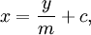
where m is the slope of the line and c is the x-intercept, which is the x-coordinate of the point where the line crosses the x axis. This can be seen by letting y = 0, which immediately gives x = c.

Point–slope form
where m is the slope of the line and (x₁,y₁) is any point on the line. The point-slope and slope-intercept forms are easily interchangeable.
The point-slope form expresses the fact that the difference in the y coordinate between two points on a line (that is, y − y₁) is proportional to the difference in the x coordinate (that is, x − x₁). The proportionality constant is m (the slope of the line).
Occasionally point-slope form appears as the following:
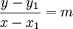
However, in this form x = x₁ does not satisfy the equation.

Intercept form
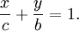
where c and b must be nonzero. The graph of the equation has x-intercept c and y-intercept b. The intercept form can be converted to the standard form by setting A = 1/c, B = 1/b and C = 1.

Two-point form
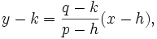
where p ≠ h. The graph passes through the points (h,k) and (p,q), and has slope m = (q−k) / (p−h).

Parametric form
and
Two simultaneous equations in terms of a variable parameter t, with slope m = V / T, x-intercept (VU−WT) / V and y-intercept (WT−VU) / T.
This can also be related to the two-point form, where T = p−h, U = h, V = q−k, and W = k:
and
In this case t varies from 0 at point (h,k) to 1 at point (p,q), with values of t between 0 and 1 providing interpolation and other values of t providing extrapolation.

Normal form
where φ is the angle of inclination of the normal and p is the length of the normal. The normal is defined to be the shortest segment between the line in question and the origin. Normal form can be derived from general form by dividing all of the coefficients by and if C > 0 multiply all coefficients by -1 to have the last constant negative. This form also called Hesse standard form, named after a German mathematician Ludwig Otto Hesse.

De Crenshaw, en http://www.embedded.com/columns/programmerstoolbox/166402556?_requestid=915722:
Table 2: A straight line
x | y(x)
0 | 1.23
1 | 2.69
2 | 4.15
3 | 5.61
4 | 7.07
5 | 8.53
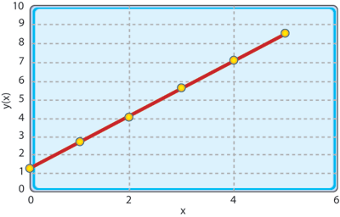
Figure 4: Hello, line
From your college algebra, you might remember the concept of a slope. We can find the slope of a straight line by picking two points—it doesn't matter which two, since the line is straight—and plugging the values into the formula:
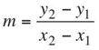(slope) (7)
For no good reason, I'll use:
x₁ = 0 y₁ = 1.23
x₂ = 5 y₂ = 8.53
Equation 7 gives:
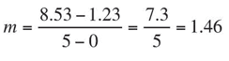(8)
The slope of the curve is 1.46, which means that every time x advances by one unit, y will advance by 1.46 units. From this, we can guess that when x is 6, y will have advanced to:
(9)
More importantly, we can guess what y will be for any new value of x. One form of the equation is based on the y-intercept, which is the value of y when x is zero. The equation is:
(10)
Plug in x = 6 to get:
(11)

Solución de ecuaciones lineales en EqWorld
Consúltese http://eqworld.ipmnet.ru/en/solutions/ae/ae0101.pdf

Graficación de funciones en R² con Maxima
f(x):= 1.23 + 1.46*x ;
plot2d(f,[x,0,6]);

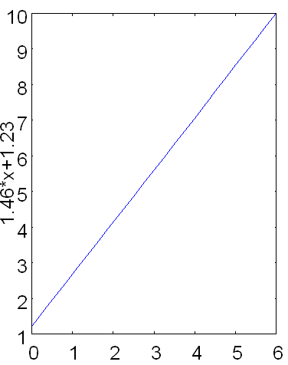

Ecuaciones cuadráticas (ecuaciones de segundo grado)
De http://en.wikibooks.org/wiki/Algebra/Quadratic_Equation:
The solutions to the general-form quadratic function ax² + bx + c = 0 can be given by a simple equation called the quadratic equation. To solve this equation, recall the completed square form of the quadratic equation derived in the previous section:
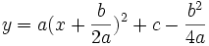
In this case, y = 0 since we're looking for the root of this function. To solve, first subtract c and divide by a:
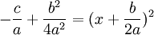
Take the (plus and minus) square root of both sides to obtain:
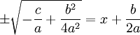
Subtracting from both sides:
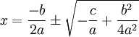
This is the solution but it's in an inconvenient form. Let's rationalize the denominator of the square root:
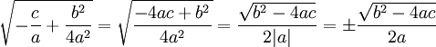
Now, adding the fractions, the final version of the quadratic formula is:
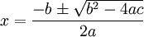

Ejemplo de solución de una cuadrática en Maxima

(%i58) /* Resolvamos la ecuación para los números triangulares */

triang = ( x * (x+1) ) / 2 ;
x (x + 1)
(%o58) triang = ---------
2

(%i59) /* La incógnita x va a ser el número base del triangular */

rhs(%) - lhs(%);
x (x + 1)
(%o59) --------- - triang
2

(%i60) /* Aunque no es indispensable, pasemos la ecuación al formato
a*x^2 + b*x + c */

expand(%);
2
x x
(%o60) -- + - - triang
2 2

(%i61) /* Solicitemos las soluciones de esta ecuación */

solve(%,x);
sqrt(8 triang + 1) + 1 sqrt(8 triang + 1) - 1
(%o61) [x = - ----------------------, x = ----------------------]
2 2

(%i62) /* La solución positiva es: */

rhs(%[2]);
sqrt(8 triang + 1) - 1
(%o62) ----------------------
2

(%i63) /* Creamos una funcion para probar esta solución */

f(triang) := ( sqrt( (8*triang)+1 ) - 1 ) / 2;

sqrt(8 triang + 1) - 1
(%o63) f(triang) := ----------------------
2

(%i64) /* Probemos con los primeros ocho números triangulares */
makelist( f(triang), triang, [1,3,6,10,15,21,28,36] );
(%o64) [1, 2, 3, 4, 5, 6, 7, 8]
(%i65) "La respuesta corresponde a los primeros ocho números base de
los primeros ocho triangulares”;

Solución de cuadráticas en EqWorld
Consúltese http://eqworld.ipmnet.ru/en/solutions/ae/ae0102.pdf

Truco para polinomios de segundo grado
De: Steven Strogatz: “The Joy of x” (NYT 28 Feb. 2010), http://opinionator.blogs.nytimes.com/2010/02/28/the-joy-of-x/?hp
‘Don’t you know how to square numbers near 50?’ he says. ‘You square 50 — that’s 2500 — and subtract 100 times the difference of your number from 50 (in this case it’s 2), so you have 2300. If you want the correction, square the difference and add it on. That makes 2304.’ ”
Bethe’s trick is based on the identity
(50 + x)² = 2500 + 100x + x².
He had memorized that equation and was applying it for the case where x is –2, corresponding to the number 48 = 50 – 2.
For an intuitive proof of this formula, imagine a square patch of carpet that measures 50 + x on each side.
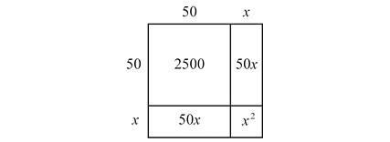
Then its area is (50 + x) squared, which is what we’re looking for. But the diagram above shows that this area is made of a 50 by 50 square (this contributes the 2500 to the formula), two rectangles of dimensions 50 by x (each contributes an area of 50x, for a combined total of 100x), and finally the little x by x square gives an area of x squared, the final term in Bethe’s formula.

Teorema de Viète
Consúltese Tignol: Galois' Theory of Algebraic Equations, http://books.google.com.mx/books?id=hO6HYckIYxsC, capítulo 4, p. 34.
In later works, such as “De Recongnitione Aequationum” (On Understanding Equations), published posthumously in 1615, Viète also stressed the importance of understanding the structure of equations, meaning by this the relation between roots and coefficients. However, the theoretical tools at his disposal were not sufficiently developed, and he failed to grasp these relations in their full generality.

De EqWorld: http://eqworld.ipmnet.ru/en/solutions/ae/ae0102.pdf:
Vieta’s theorem:
x1 + x2 = −b/a,
x1x2 = c/a.

Consúltese Tignol: Galois' Theory of Algebraic Equations, http://books.google.com.mx/books?id=hO6HYckIYxsC, capítulo 4, p. 35.
The structure of equations was eventually discovered in its proper generality and in its simplest form by Albert Girard (1595-1632).

De http://en.wikipedia.org/wiki/Vi%C3%A8te%27s_theorem#Basic_formulas :
Any general polynomial of degree n
(with the coefficients being real or complex numbers and an ≠ 0) is known by the fundamental theorem of algebra to have n (not necessarily distinct) complex roots x1, x2, ..., xn. Vieta's formulas relate the polynomial's coefficients { ak } to signed sums and products of its roots { xi } as follows:
Equivalently stated, the (n − k)th coefficient an−k is related to a signed sum of all possible subproducts of roots, taken k-at-a-time:
for k = 1, 2, ..., n (where we wrote the indices ik in increasing order to ensure each subproduct of roots is used exactly once).
The left hand sides of Vieta's formulas are the elementary symmetric functions of the roots.

Consúltese también Viète theorem on roots en http://eom.springer.de/V/v096630.htm

Ejemplo de ecuación cuadrática y teorema de Viète en Maxima

(%i1) 3*(x**2) + 5*x - 15 = 0;
2
(%o1) 3 x + 5 x - 15 = 0

(%i3) solve(%i1,x);
sqrt(205) + 5 sqrt(205) - 5
(%o3) [x = - -------------, x = -------------]
6 6
(%i5) %o4[1];
sqrt(205) + 5
(%o5) x = - -------------
6
(%i6) %o4[2];
sqrt(205) - 5
(%o6) x = -------------
6
(%i11) %o4[1],numer;
(%o11) x = - 3.219636843879393
(%i12) %o4[2],numer;
(%o12) x = 1.552970177212726
(%i15) rhs(%o11)+rhs(%o12);
(%o15) - 1.666666666666667
(%i16) -5/3;
5
(%o16) - -
3
(%i17) %,numer;
(%o17) - 1.666666666666667;
(%i18) rhs(%o11)*rhs(%o12);
(%o18) - 5.000000000000001
(%i19) 15/3;
(%o19) 5

Coeficiente binomial
De http://www.encyclopediaofmath.org/index.php/Binomial_coefficients

Acordeón de Maxima: binomial

(%i2) expand((x+y)^2);
2 2
(%o2) y + 2 x y + x
(%i3) binomial(2,0);
(%o3) 1
(%i4) 2!/(0!*(2-0)!);
(%o4) 1
(%i5) binomial(2,1);
(%o5) 2
(%i6) 2!/(1!*(2-1)!);
(%o6) 2
(%i7) binomial(x,2);
(x - 1) x
(%o7) ---------
2
(%i14) binomial(7,2);
(%o14) 21

Binomio de Newton
http://eom.springer.de/n/n066500.htm

Expansión binominal (generalizada) de Newton
Dunham, Willian: The Calculus Gallery,
Chapter 1. Newton
GENERALIZED BINOMIAL EXPANSION
By 1665, Isaac Newton had found a simple way to expand—his word was “reduce”—binomial expressions into series. For him, such reductions would be a means of recasting binomials in alternate form as well as an entryway into the method of fluxions. This theorem was the starting point for much of Newton’s mathematical innovation.
As described in the epistola prior, the issue at hand was to reduce the binomial (P + PQ)^{m/n} and to do so whether m/n “is integral or (so to speak) fractional, whether positive or negative” [3]. This in itself was a bold idea for a time when exponents were sufficiently unfamiliar that they had first to be explained, as Newton did by stressing that “instead of etc. I write a1/2, a1/3, a5/3, and instead of 1/a, 1/aa, 1/a³, I write a ⁻¹, a⁻², a⁻³” [4]. Apparently readers of the day needed a gentle reminder. Newton discovered a pattern for expanding not only elementary binomials like (1 + x) ⁵ but more sophisticated ones like
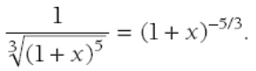
The reduction, as Newton explained to Leibniz, obeyed the rule
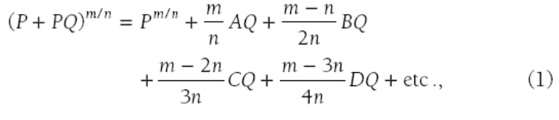
where each of A, B, C, . . . represents the previous term, as will be illustrated below. This is his famous binomial expansion, although perhaps in an unfamiliar guise.
Newton provided the example of
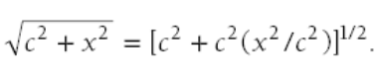
Here, P = c², m = 1, and n = 2. Thus,
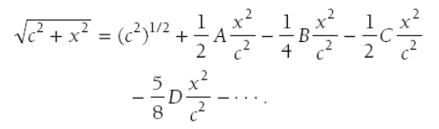
To identify A, B, C, and the rest, we recall that each is the immediately preceding term. Thus, A = (c²)^{1/2} = c, giving us
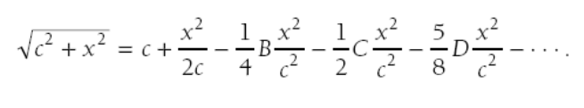
Likewise B is the previous term—i.e.,
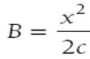
—so at this stage we have
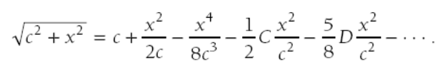
The analogous substitutions yield
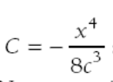
and then
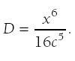
Working from left to right in this fashion, Newton arrived at
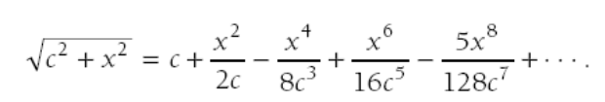
Obviously, the technique has a recursive flavor: one finds the coefficient of x8 from the coefficient of x6, which in turn requires the coefficient of x4, and so on. Although the modern reader is probably accustomed to a “direct” statement of the binomial theorem, Newton’s recursion has an undeniable appeal, for it streamlines the arithmetic when calculating a numerical coefficient from its predecessor.
For the record, it is a simple matter to replace A, B, C, . . . by their equivalent expressions in terms of P and Q, then factor the common P^{m/n} from both sides of (1), and so arrive at the result found in today’s texts:

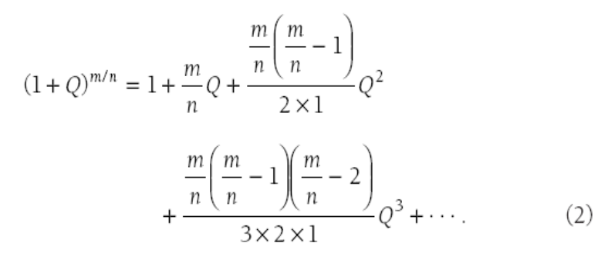

Fórmula generalizada para números racionales, reales y complejos

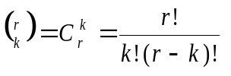
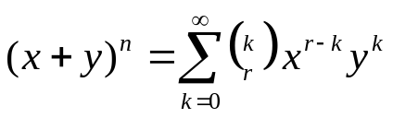

Acordeón de Maxima para binomios
(%i3) (x+y)^2;
2
(%o3) (y + x)
(%i4) expand(%);
2 2
(%o4) y + 2 x y + x
(%i5) (x+y)^15;
15
(%o5) (y + x)
(%i6) expand(%);
15 14 2 13 3 12 4 11 5 10
(%o6) y + 15x y + 105x y + 455x y + 1365x y + 3003x y
6 9 7 8 8 7 9 6 10 5
+ 5005x y + 6435x y + 6435x y + 5005x y + 3003x y
11 4 12 3 13 2 14 15
+ 1365 x y + 455 x y + 105 x y + 15 x y + x

(%i26) x^(r) +
r * x^(r-1) * y +
(r*(r-1) /2!) * x^(r-2) * y^2 +
(r*(r-1)*(r-2) /3!) * x^(r-3) * y^3 +
(r*(r-1)*(r-2)*(r-3)/4!) * x^(r-4) * y^4
;

r - 4 4 r - 3 3
(r - 3) (r - 2) (r - 1) r x y (r - 2) (r - 1) r x y
(%o26) ----------------------------------- + ---------------------------
24 6
r - 2 2
(r - 1) r x y r - 1 r
+ ------------------- + r x y + x
2

(%i36) x + (y^2/(2*x)) - (y^4/(8*x^3));

4 2
y y
(%o36) - ---- + --- + x
3 2 x
8 x

(%i37) %i36,x=9,y=16;
8737
(%o37) ----
729
(%i38) %,numer;
(%o38) 11.98491083676269

Acordeón de Maxima: multinomial_coeff
Función multinomial_coeff (k_1, ..., k_n)
Donde: n es el exponente del polinomio; k_1, ..., k_n son las posiciones de los coeficientes que se buscan, tal que la suma de k_1, ..., k_n = n
Véase en el ejemplo siguiente la forma alternativa de obtener el coeficiente multinomial, mediante la fórmula del teorema multinomial.

(%i29) multinomial_coeff(2,0,0);
(%o29) 1
(%i30) 2!/(2!*0!*0!);
(%o30) 1
(%i31) multinomial_coeff(1,1,0);
(%o31) 2
(%i32) 2!/(1!*1!*0!);
(%o32) 2
(%i33) multinomial_coeff(0,2,0);
(%o33) 1
(%i34) 2!/(0!*2!*0!);
(%o34) 1
(%i35) (x+y+z)^2;
2
(%o35) (z + y + x)
(%i36) expand(%);
2 2 2
(%o36) z + 2 y z + 2 x z + y + 2 x y + x
(%i37) multinomial_coeff(1,0,1);
(%o37) 2
(%i38) 2!/(1!*0!*1!);
(%o38) 2
(%i39) multinomial_coeff(0,1,1);
(%o39) 2
(%i40) 2!/(0!*1!*1!);
(%o40) 2
(%i41) multinomial_coeff(0,0,2);
(%o41) 1
(%i42) 2!/(0!*0!*2!);
(%o42) 1
(%i44) multinomial_coeff(5,1,1);
(%o44) 42
(%i45) 7!/(5!*1!*1!);
(%o45) 42
(%i46)

Ecuaciones cúbicas (ecuaciones de tercer grado)
Véase una exposición de la historia de las soluciones a las ecuaciones cúbicas en el capítulo 2, pg. 13, de Tignol: Galois' Theory of Algebraic Equations (http://books.google.com.mx/books?id=hO6HYckIYxsC ).

Fórmulas generales para la solución de cúbicas
http://eqworld.ipmnet.ru/en/solutions/ae/ae0103.pdf

Ejemplo de solución de cúbica y teorema de Viète en Maxima
(%i20) x^3 - 3*x^2 + 5*x = 15;
3 2
(%o20) x - 3 x + 5 x = 15
(%i21) solve(%);
(%o21) [x = - sqrt(5) %i, x = sqrt(5) %i, x = 3]
(%i22) rhs(%o21[1])+rhs(%o21[2])+rhs(%o21[3]);
(%o22) 3
(%i23) ( rhs(%o21[1])*rhs(%o21[2]) ) + ( rhs(%o21[1])*rhs(%o21[3]) ) +
( rhs(%o21[2])*rhs(%o21[3]) );
(%o23) 5
(%i24) rhs(%o21[1])*rhs(%o21[2])*rhs(%o21[3]);
(%o24) 15

Ecuaciones cuártica (ecuación de cuarto grado)
Véase el capítulo 3, pg. 21, de Tignol: Galois' Theory of Algebraic Equations (http://books.google.com.mx/books?id=hO6HYckIYxsC ).

Acordeón para solución de cuárticas en Maxima
(%i1) x^4 + x^3 - 3*x^2 + 5*x - 15 = 0;
4 3 2
(%o1) x + x - 3 x + 5 x - 15 = 0
(%i2) solve(%);
(%o2) ...

Ecuaciones simultáneas
Barile, Margherita. "Simultaneous Equations." From MathWorld: http://mathworld.wolfram.com/SimultaneousEquations.html

A finite set of equations in the same unknowns of which the common solutions have to be determined.

De http://en.wikipedia.org/wiki/Simultaneous_equation:
In mathematics, simultaneous equations, or systems of equations, are a set of equations containing multiple variables. To solve simultaneous equations, the solver needs to use the provided equations to find the exact value of each variable. The solver may then use a graphical method (by plotting both lines and/or curves in the same graph and finding the exact coordinates of their intersection), the matrix method, the substitution method, and/or the elimination method. Some textbooks refer to the elimination method as the addition method, since it involves adding equations (or constant multiples thereof) to one another, as detailed later in this article.
Consider the following set of equations:
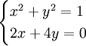
When plotted in a graph, the first equation will appear as a circle, while the second will be a straight line. The graph of an equation is the set of all possible solutions, so the intersections of the graphs of multiple equations represent common solutions to these equations. For equations of the nature of this example (linear equation with a circle), there are three possible solution types:
The line does not intersect the circle at all. This way, there are no solutions.
The line is a tangent to the circle. This way, there is only one solution (the single point at which the line touches the circle).
The line cuts the circle. There are two points of intersection, and thus two solutions.

Solución de ecuaciones simultáneas con Maxima
(%i5) solve([x+y+z=5,3*x-5*y=10,y+2*z=3],[x,y,z]);
45 1 19
(%o5) [[x = --, y = --, z = --]]
13 13 13

Sistema algebráico
Véase http://www.encyclopediaofmath.org/index.php/Algebraic_system
A set with operations and relations defined on it. An algebraic system is one of the basic mathematical concepts and its general theory has been developed in depth. This was done in the 1950s, and the work took place on the interface between algebra and mathematical logic.

Operación algebraica
Véase http://www.encyclopediaofmath.org/index.php/Algebraic_operation

Propiedades de las operaciones algebraicas
(Véanse también, más adelante, los axiomas de campos para las ecuaciones algebraicas.)

Asociatividad
Véase http://www.encyclopediaofmath.org/index.php/Associativity

Conmutatividad
Véase http://www.encyclopediaofmath.org/index.php/Commutativity
a * b = b * a

Distribuibilidad
De http://www.encyclopediaofmath.org/index.php/Distributivity
Distributivity, distributivity law, distributive property, of one operation with respect to another
The property of a pair of binary algebraic operations (cf. Algebraic operation), expressed by one of the following identities:

where are the symbols of the binary operations, and are object variables. If in a set two specific binary operations , are defined, i.e. two mappings
are given, and the symbols are interpreted as the symbols of the respective operations in , one can speak of the truth or falsehood of each one of the formulas D1 and D2 in . If both these formulas are true in , the operation is called distributive with respect to the operation in .

Funciones simétricas
Véase http://en.wikipedia.org/wiki/Symmetric_function
In mathematics, the term "symmetric function" can mean two different concepts.
A symmetric function of n variables is one whose value at any n-tuple of arguments is the same as its value at any permutation of that n-tuple. While this notion can apply to any type of function whose n arguments live in the same set, it is most often used for polynomial functions, in which case these are the functions given by symmetric polynomials. There is very little systematic theory of symmetric non-polynomial functions of n variables, so this sense is little-used, except as a general definition.
In algebra and in particular in algebraic combinatorics, the term "symmetric function" is often used instead to refer to elements of the ring of symmetric functions, where that ring is a specific limit of the rings of symmetric polynomials in n indeterminates, as n goes to infinity. This ring serves as universal structure in which relations between symmetric polynomials can be expressed in a way independent of the number n of indeterminates (but its elements are neither polynomials nor functions). Among other things, this ring plays an important role in the representation theory of the symmetric groups.

Véase también http://www.encyclopediaofmath.org/index.php/Symmetric_function

De Funkhouser: “A Short Account of the History of Symmetric Functions of Roots of Equations”. http://www.jstor.org/discover/10.2307/2299273:
The simplest ones are those involved in the relations between coefficients and roots of a quadratic equation.

Ejemplo de relación entre raíces y coeficientes en Maxima

(%i2) x**4-4*x**3-7*x**2+34*x-24;

4 3 2
(%o2) x - 4 x - 7 x + 34 x - 24
(%i3) solve(%);
(%o3) [x = 4, x = - 3, x = 1, x = 2]

(%i12) 4-3+1+2;
(%o12) 4

(%i17) (4*-3)+(4*1)+(4*2)+(-3*1)+(-3*2)+(1*2);
(%o17) - 7

(%i25) (4*-3*1)+(-3*1*2)+(1*2*4)+(2*4*-3);
(%o25) - 34

(%i20) (4*-3*1*2);
(%o20) - 24

