62 Estadística

Definición y clasificación
The science of collecting and analyzing data for the purpose of drawing conclusions and making decisions.
Tanhane, Ajit C.; Dunlop, Dorothy: Statistics and Data Anlysis from Elementary to Intermediate (Prentice Hall, 2000).
De Weisstein, Eric W. “Statistics.” From MathWorld--A Wolfram Web Resource. http://mathworld.wolfram.com/Statistics.html:
The mathematical study of the likelihood and probability of events occurring based on known information and inferred by taking a limited number of samples. Statistics plays an extremely important role in many aspects of economics and science, allowing educated guesses to be made with a minimum of expensive or difficult-to-obtain data.

Clasificación
Consúltese http://msc2010.org/mscwiki/index.php?title=62-XX
Véase también:
http://www.math.niu.edu/~rusin/known-math/index/62-XX.html
http://planetmath.org/msc_browser/62-XX

62-01 Material para exposición e instrucción
Las siguientes definiciones (salvo que explícitamente se señale algo diferente, están tomadas de Rumsay: Statistics for dummies. Ch.3, Subch.: "Grabbing Some Basic Statistical Jargon."

Población ("Universo")
For virtually any question that you may want to investigate about the world, you have to center your attention on a particular group of individuals (for example, a particular group of people, cities, animals, rock specimens, exam scores, and so on)...
The group of individuals that you wish to study in order to answer your research question is called a population. Populations, however, can be hard to define. In a good study, researchers define the population very clearly, while in a bad study, the population is poorly defined.

Muestra
Researchers want to find out something about a population, but they don't have time or money to study every single individual in the population. So what do they do? They select a small number of individuals from the population, study those individuals, and use that information to draw conclusions about the whole population. This is called a sample.

Muestra aleatoria (random sample)
What this really means is that people don't select themselves to participate, and no one in the population is favored over another individual in the selection process.

Variable, variable estadística
es.wikipedia.org:
Variable es una característica (magnitud, vector o número) que puede ser medida, adoptando diferentes valores en cada uno de los casos de un estudio.

Variable aleatoria (variate, random variable)
En gran número de experimentos aleatorios es necesario, para su tratamiento matemático, cuantificar los resultados de modo que se asigne un número real a cada uno de los resultados posibles del experimento. De este modo se establece una relación funcional entre elementos del espacio muestral asociado al experimento y números reales.
Formalmente se dice que una variable aleatoria (v.a.) X es una función real definida en el espacio muestral asociado a un experimento aleatorio, Ω.[1] [2]
Se llama rango de una v.a. X y lo denotaremos R_{X}, al conjunto de los valores reales que esta puede tomar, según la aplicación X. Dicho de otro modo, el rango de una v.a. es el recorrido de la función por la que esta queda definida:

Sesgo (Bias)
Bias is a word you hear all the time, and you probably know that it means something bad. But what really constitutes bias? Bias is systematic favoritism that is present in the data collection process, resulting in lopsided, misleading results.
Bias can occur in any of a number of ways.
In the way the sample is selected: For example, if you want to get an estimate of how much Christmas shopping people in your community plan to do this year, and you take your clipboard and head out to the mall on the day after Thanksgiving to ask customers about their shopping plans, you have bias in your sampling process. Your sample tends to favor those die-hard shoppers at that particular mall who were braving the massive crowds that day.
In the way data are collected: Poll questions are a major source of bias. Because researchers are often looking for a particular result, the questions they ask can often reflect that expected result. For example, the issue of a tax levy to help support local schools is something every voter faces at one time or another. A poll question asking, "Don't you think it would be a great investment in our future to support the local schools?" does have a bit of bias. On the other hand, so does the question, "Aren't you tired of paying money out of your pocket to educate other people's children besides your own?" Question wording can have a huge impact on the results. See Chapter 16 for more on designing polls and surveys.

Conjunto de datos (data set, dataset)
A data set is the collection of all the data taken from your sample.

Datos categóricos
(De Rumsay: Statistics for dummies. Ch. 5, Subch.: "Summarizing Categorical Data")
Categorical data capture qualities or characteristics about the individual, such as a person's eye color, gender, political party, or opinion on some issue (using categories such as agree, disagree, or no opinion). Categorical data tend to fall into groups or categories pretty naturally. "Political party", for example, typically has four groups: Democrat, Republican, Independent, and other. Categorical data often come from survey data, but they can also be collected in experiments. For example, in an experimental test of a new medical treatment, researchers may use three categories to assess the outcome of the experiment: Did the patient get better, worse, or stay the same while undergoing the treatment?

Datos numéricos
(De Rumsay: Statistics for dummies. Ch. 5, Subch.: "Summarizing Numerical Data")
With numerical data, measurable characteristics such as height, weight, IQ, age, or income are represented by numbers. Because the data have numerical meaning, you can summarize them in more ways than is possible with categorical data. Certain characteristics of a numerical data set can be described using statistics, such as where the center is, how spread out the data are, and where certain milestones are. These kinds of summaries occur often in the media, so knowing what these summary statistics say and don't say about the data helps you better understand the research that's presented to you in your everyday life.

Estadístico
A statistic is a number that summarizes the data collected from a sample.
Capítulo 5: A statistic is a number that summarizes some characteristic about a set of data.

El paquete descriptive en Maxima
El paquete descriptive contiene funciones para realizar cálculos y gráficos estadísticos descriptivos. Junto con el código fuente se distribuyen tres conjuntos de datos: pidigits.data, wind.data y biomed.data.
Cualquier manual de estadística se puede utilizar como referencia al paquete descriptive
(%i1) load(descriptive);
(%o1) C:/PROGRA~2/MAXIMA~1.1/share/maxima/5.20.1/share/contrib/descriptive/des\
criptive.mac

Media (promedio)
The mean, also referred to by statisticians as the average, is the most common statistic used to measure the center, or middle, of a numerical data set. The mean is the sum of all the numbers divided by the total number of numbers.
Capítulo 5:
Adding all the [LA Lakers] salaries, the total payroll for this team is $54,184,907. Dividing by the total number of players (n = 13) gives an average salary of $4,168,069.77. That's a pretty nice average salary, isn't it? But notice that Shaquille O'Neal is at the top of this list, and in that year, his salary was the highest in the entire league. If you take the average salary of all of the Lakers players besides Shaq, you would get an average of $32,756,335 ÷ 12 = $2,729,694.58. This is still a hefty amount, but one that's significantly lower than the average salary of all players including Shaquille O'Neal...

Los valores promedio (mean values) y los valores atípicos (outliers)
In some cases, the average may be a bit misleading, and this is one of those cases. That's because every year, a few top-notch players (like Shaq) make much more money than anybody else (and, like Shaq, they also tend to be taller than anyone else, by the way). These are called outliers (numbers in the data set that are extremely high or extremely low, compared to the rest of the data).

 | Nombre del jugador | Salario | Contar (n) | Promedio (μ)
1 | Shaquille O'Neal | $21,428,572 | 13 | $4,168,070
2 | Kobe Bryant | $11,250,000
3 | Robert Horry | $5,300,000
4 | Rick Fox | $3,791,250
5 | Lindsey Hunter | $3,425,760
6 | Derek Fisher | $3,000,000
7 | Samaki Walker | $1,400,000
8 | Mitch Richmond | $1,000,000
9 | Brian Shaw | $963,415
10 | Devean George | $834,250
11 | Mark Madsen | $759,960
12 | Jelani McCoy | $565,850
13 | Stanislav Medvedenko | $465,850
 |  | $54,184,907

The Mean μ
Vose: Risk Analysis, Ch.3.
The mean, also known as the expected value or average, is given by
(3.4) | 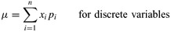

(3.5) | 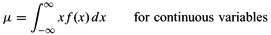
The mean is known as the first moment about zero. It can be considered to be the centre of gravity of the distribution. If one was to cut out the probability density function drawn on a piece of card, the mean is the value at which the distribution would balance.

La media en Maxima
(%i1) load(descriptive)$
(%i2) mean([1,2,3,4,5]);
(%o2) 3

(%i11) s1 : read_list (file_search ("pidigits.data"))$
(%i12) mean(s1);
471
(%o12) ---
100

Mediana
Rumsay: Statistics for dummies:
In a numerical data set, the median is the point at which there are an equal number of data points whose values lie above and below the median value. Thus, the median is truly the middle of the data set.
Chapter 5:
Here are the steps for finding the median of a data set:
- Order the numbers from smallest to largest.
- If the data set contains an odd number of numbers, choose the one that is exactly in the middle.
This is the median.
- If the data set contains an even number of numbers, take the two numbers that appear exactly in the middle and average them to find the median.

 | Nombre del jugador | Salario
1 | Shaquille O'Neal | $21,428,572
2 | Kobe Bryant | $11,250,000
3 | Robert Horry | $5,300,000
4 | Rick Fox | $3,791,250
5 | Lindsey Hunter | $3,425,760
6 | Derek Fisher | $3,000,000
7 | Samaki Walker | $1,400,000
8 | Mitch Richmond | $1,000,000
9 | Brian Shaw | $963,415
10 | Devean George | $834,250
11 | Mark Madsen | $759,960
12 | Jelani McCoy | $565,850
13 | Stanislav Medvedenko | $465,850

La mediana en Maxima
(%i1) load(descriptive)$
(%i2) median([1,2,3,4,5]);
(%o2) 3

Rumsay: Statistics for dummies, Ch. 11.
The U.S. Census Bureau estimates the median household income for the United States and breaks it down by each state in its yearly report from the Current Population Survey. Why estimate the median (middle number) and not the mean (average) household income? (See Chapter 5 for more discussion on the mean versus the median.) Because household income tends to be skewed, with many folks at the lower end of the income spectrum, and fewer individuals at the extreme upper end.
To estimate the median household income, the Census Bureau takes a random sample of about 28,000 households and asks questions (household income is among those questions). Based on the sample data of 28,000 homes, the Bureau calculates the median household income for this sample: For the year 2000, the sample median household income was $42,228.
The Census Bureau uses the sample median household income (a statistic) to estimate the median household income for the whole U.S. (the parameter).

Del histograma hasta la función de distribución

Histograma
(Rumsay: Statistics for dummies.)
A histogram is a type of graph that organizes and displays numerical data in picture form, showing groups of data and the number or percentage of the data that fall into each group. (See Chapter 4 for more information on histograms and other types of data displays.) If the data have outliers on the upper end, the histogram of the data will be skewed to the right, and the mean will be larger than the median. (See the top histogram in Figure 5-1 for an example of data that is skewed to the right.) If the data have outliers on the lower end, the histogram of the data will be skewed to the left, and the mean will be smaller than the median. (The middle histogram in Figure 5-1 shows an example of a histogram that shows data that is skewed to the left.) If the data are symmetric (have about the same shape on either side of the middle), the mean and the median will be about the same. (The bottom histogram in Figure 5-1 shows an example of symmetric data in a histogram.)
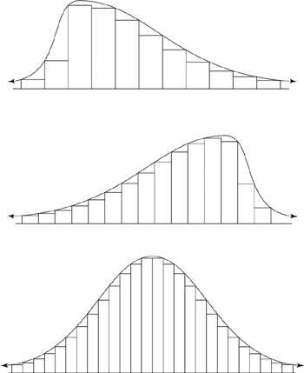

Figure 5-1: Data skewed to the right; data skewed to the left; and symmetric data.

Asimetría (skew)
De Wikipedia: http://en.wikipedia.org/wiki/Skewness
In probability theory and statistics, skewness is a measure of the asymmetry of the probability distribution of a real-valued random variable.
Skewness, the third standardized moment, is written as γ₁ and defined as
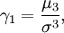
where μ₃ is the third moment about the mean and σ is the standard deviation. Equivalently, skewness can be defined as the ratio of the third cumulant κ₃ and the third power of the square root of the second cumulant κ₂:
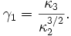

El coeficiente de asimetría en Maxima
(%i1) load(descriptive)$
(%i2) skewness([1,2,3,4,5]);
(%o2) 0

Analyzing mothers' ages
(Cont. Rumsay: Statistics for dummies.)
In one birth statistics example (refer to Table 4-3), the age of the mother is shown for various years from 1975 to 2000. For any year on the table, the age variable is divided into groups, and you're given the number of mothers in each group. Because you're given the total numbers, you can make a histogram of mothers' ages showing either the frequencies or the relative frequencies, whichever is the most appropriate in terms of the point you want to make.
Suppose you want to compare the ages of mothers in 1975 and 2000. You can make two histograms, one for each year, and compare the results. Figure 4-15 shows two such histograms for 1975 (top) and 2000 (bottom). Notice that the relative frequencies (or percentages) are shown on the vertical axis, and the age groups for the mothers are shown on the horizontal axis.
A histogram can summarize the features of numerical data quite well. One of the features that a histogram can show you is the so-called shape of the data (in other words, how the data are distributed among the groups). Are the data distributed evenly, in a uniform way? Are the data symmetric, meaning that the left-hand side of the histogram is a mirror image of the right-hand side of the histogram? Does the histogram have a U-shape, with lots of data on extreme ends and not much in the middle? Does the histogram of the data have a bell-shape, meaning that it looks like a mound in the middle with tails trailing off in either direction as you move away from the center? Or is the histogram skewed, meaning that it looks like a lopsided mound with one long tail either going off to the right (indicating the data are skewed right) or going off to the left (indicating the data are skewed left)?

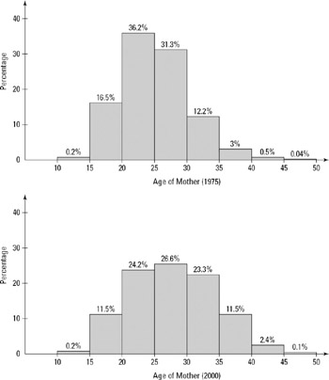
Figure 4-15: Colorado live births, by age of mother for 1975 and 2000.

Interpreting a histogram
Rumsay (cont.):
You can use a histogram to tell you three main features of numerical data:
- How the data are distributed (symmetric, skewed right, skewed left, bell-shaped, and so on)
- The amount of variability in the data
- Where the center of the data is (approximately)

Schuyler: Risk and Decision Analysis in Projects, Ch. 1:
Suppose that you and forty-nine other professionals estimate Project Cost. The collected values range from $26.7 million to $76.0 million. We can display the fifty estimates as a frequency histogram, as illustrated in Figure 1.3.
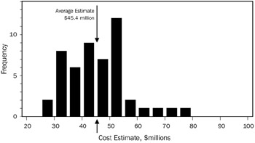
Figure 1.3: Frequency Histogram of Fifty Cost Estimates
Here is the procedure for charting a frequency histogram. First divide the range of values into (typically) five to fifty intervals (segments, bins) of equal width. Next, count the number of values occurring within each interval. Now, draw a bar graph—one bar per interval—with the bar heights proportional to the number (or frequency) of occurrences within each interval. If you desire, label the y-axis with either numbers of values in the interval or percents of the total. Labeling the y-axis is optional, because anyone viewing such a chart expects that all of the data values are represented.

Cómo se convierte en función de distribución de probabilidad
Schuyler: Risk and Decision Analysis in Projects, Ch. 1 (cont.):
Suppose that, instead, we have 500 data points. More data and smaller value segment partitions provide the additional detail shown in Figure 1.4. We obtain a more accurate estimate of a central, average value as the number of data points increases.
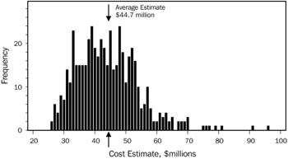
If we obtain a great many data points and use smaller intervals, the frequency distribution converges into a smooth and continuous curve, a probability density function (p.d.f.), or, simply, a probability distribution.
A probability distribution can completely represent one's judgment about a chance event. If one or more inputs to an analysis are probability distributions, then project cost and other outputs will be probability distributions also.
A p.d.f. represents the population of all possible outcomes. Suppose that we want to judge the uncertainty in a new cost estimate coming from the same population as values obtained for Figures 1.3 and 1.4.
Figure 1.5 shows a probability distribution for the next sample for a Project Cost estimate. The units of the y-axis are not important; the y-axis is scaled so that the area under the curve equals 1. This figure shows the relative likelihood of estimate values along the x-axis. Fitting such a curve to lots of representative data, this function would represent our best judgment of the distribution of cost estimates.

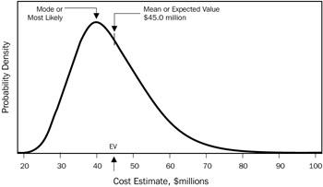
Figure 1.5: Probability Distribution for Project Cost
As such, the p.d.f. represents a judgment about uncertainty. In the case of Figure 1.5, it represents a judgment about new cost estimates. Unlike a frequency distribution, the p.d.f. is not representing data.

Diferencia entre media y moda
Schuyler: Risk and Decision Analysis in Projects, Ch. 1:
There are two especially important statistics annotated in Figure 1.5:
- The most likely value is about $40 million. Statisticians call this peak the mode. The mode is more probable than any other value, and we expect more data samples to be near this value than any other point. This statistic is useful in describing a distribution's shape, yet has little application in decision making.
- The expected value, $45 million, is the probability-weighted average. Statisticians call this the mean, and use a Greek letter μ symbol. It represents the average of many values sampled from the population of project cost estimates represented by this probability distribution. If we know the probability distribution, then we know that the EV is the probability-weighted average of the distribution. This is the most important and most useful statistic: It is the best single measure of value under uncertainty.

Definición de la función de densidad de probabilidad (pdf)
Probability Density Function (pdf)
Vose: Risk Analysis: A Quantitative Guide. Ch.3, " Risk Analysis: A Quantitative Guide":
If a random variable X is continuous, i.e. it may take any value within a defined range (or sometimes ranges), the probability of X having any precise value within that range is vanishingly small because we are allocating a probability of 1 between an infinite number of values. In other words, there is no probability mass associated with any specific allowable value of X. Instead, we define a probability density function f(x) as:
(3.2) | 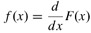
i.e. f(x) is the rate of change (the gradient) of the cumulative distribution function. Since F(x) is always non-decreasing, f(x) is always non-negative.
So, for a continuous distribution we cannot define the probability of observing any exact value. However, we can determine the probability of lying between any two exact values (a, b):
(3.3)

Ley de los grandes números
http://eom.springer.de/L/l057720.htm
Law of large numbers
A general principle according to which under certain very general conditions the simultaneous action of random factors leads to a result which is practically non-random. That the frequency of occurrence of a random event tends to become equal to its probability as the number of trials increases (a phenomenon which was probably first noted for games of chance) may serve as the first example of this principle.

Moda (definición)
De http://es.wikipedia.org/wiki/Moda_%28estad%C3%ADstica%29
En Estadística, la moda es el valor que cuenta con una mayor frecuencia en una distribución de datos.
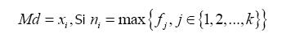

Distribución de probabilidad
Schuyler: Risk and Decision Analysis in Projects, Ch. 1:
The p.d.f., shown in Figure 1.5, is easily converted into a cumulative (probability) density function (c.d.f.) curve. Figure 1.6 shows two versions of cumulative distributions. The solid curve sloping upward to the right is the c.d.f. To translate the p.d.f. distribution in Figure 1.5, sum the area under the curve, moving from left to right. This is equivalent to progressively integrating the p.d.f. Notice that the cumulative distribution ranges from 0 to 1 on the y-axis.
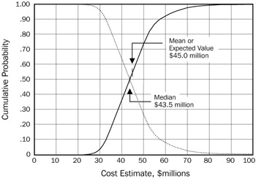
Figure 1.6: Cumulative Probability Distribution
The dotted curve in Figure 1.6, sloping downward to the right, is the reverse cumulative distribution.
Either cumulative curve contains exactly the same information as the p.d.f. The cumulative format allows us to read confidence levels and intervals directly. Here are example interpretations of the solid curve in Figure 1.6:
- Project Cost estimates are equally likely to be above or below $43.5 million. This centermost value, at 50 percent probability, is the median (annotated in Figure 1.6). This is another central measure, and widely used with demographics to indicate "average" values, such as house prices or salaries [1].
- About 74 percent of the Project Cost estimates are below $50 million. The 74 percent (less-than) confidence limit or confidence level is $50 million.
- About 80 percent of the Project Cost estimates are between $33 million and $57 million. This $33 to $57 million range represents an 80 percent confidence interval.
The c.d.f. (solid curve in Figure 1.6) that we have been discussing is often called "the cumulative less-than distribution." Some people—most in fact—prefer to "flip over" this cumulative curve, rotating it around a horizontal axis. Then we have the reverse cumulative distribution, which is also called the "exceedance" or "greater-than" form of cumulative probability distribution (dotted curve in Figure 1.6). This format is especially popular when larger x-axis values are better, because management is accustomed to viewing "better" on graphs as being upward or rightward.
Often, the inequality symbols "<" or "≤" or ">" or "≥" are used when labeling the cumulative functions. The use of the "=" part of the symbol is common, though this is optional and irrelevant with continuous distributions, because the probability of realizing the precise boundary value is virtually zero.
Figure 1.3 and Figure 1.4 illustrate sampled data. More commonly, one works instead with a judgment about a distribution for a cost of a single project, such as in Figure 1.5 and Figure 1.6. Suppose we characterize a population with a p.d.f. If we obtain many data from this population, the frequency distribution's shape converges to the p.d.f. This is perhaps the most important concept in statistics.

Definición de la distribución de probabilidad
Cumulative Distribution Function (cdf)
Vose: Risk Analysis, Ch.3:
The (cumulative) distribution function, or probability distribution function, F(x) is the mathematical equation that describes the probability that a variable X is less than or equal to x, i.e.
F(x) = P(X ≤ x) for all x
where P(X ≤ x) means the probability of the event X ≤ x.
A cumulative distribution function has the following properties:
F(x) is always non-decreasing, i.e.
F(x) = 0 at x = -∞
F(x) = 1 at x = ∞

Distribución
(Rumsay: Statistics for dummies, Ch. 8)
The first step in determining where a particular result stands is to get a listing or picture of all of the possible values that the variable can take on in the population and how often those values occur; this is called a distribution.

Distribución, tipo de
De http://eom.springer.de/d/d033540.htm:
A set of probability distributions of random variables, each obtainable from the others by means of linear transformations. An exact definition in the one-dimensional case is as follows: Probability distributions of random variables and are said to have the same type if there are constants such that the distributions of and coincide. The corresponding distribution functions are then connected by the relation
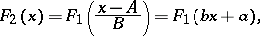
where and .

Distribución normal
(Rumsay: Statistics for dummies.)
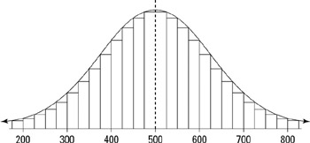
Figure 3-1: Bell-shaped curve.
Statisticians have another name for the bell-shaped curve when many possible values for the data exist; they call it the normal distribution. This distribution is used to describe data that follow a bell-shaped pattern, including what the range of values is expected to be and where an individual score stands in relation to the others. For example, if the data have a normal distribution, you can expect most of the data to lie within two standard deviations of the mean
.
Rumsay: Statistics for dummies, Ch. 8:

Characterizing the normal distribution
Every bell-shaped curve (normal distribution) has certain properties. You can use these properties to help determine the relative standing of any particular result in the distribution. The following is a list of properties shared by every normal distribution. These properties are explained in more detail in the following sections.
- The shape of the curve is symmetric.
- It has a bump in the middle, with tails going off to the left and right.
- The mean is directly in the middle of the distribution. The mean of the population is designated by the Greek letter μ.
- The mean and the median are the same value, due to symmetry.
- The standard deviation represents a typical (almost average) distance between the mean and all of the data. The standard deviation of the population is designated by the Greek letter σ.
- About 95% of the values are within two standard deviations of the mean.

La distribución normal como función de e
Strang: Calculus, 6.2 “The exponential e”, p. 238
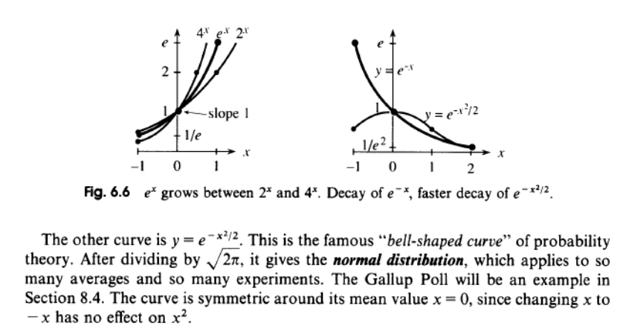

La curva de campana en Maxima
(%i1) f(x):=%e^(-x^2/2);
2
- x
----
2
(%o1) f(x) := %e
(%i2) plot2d(f,[x,-5,5]);

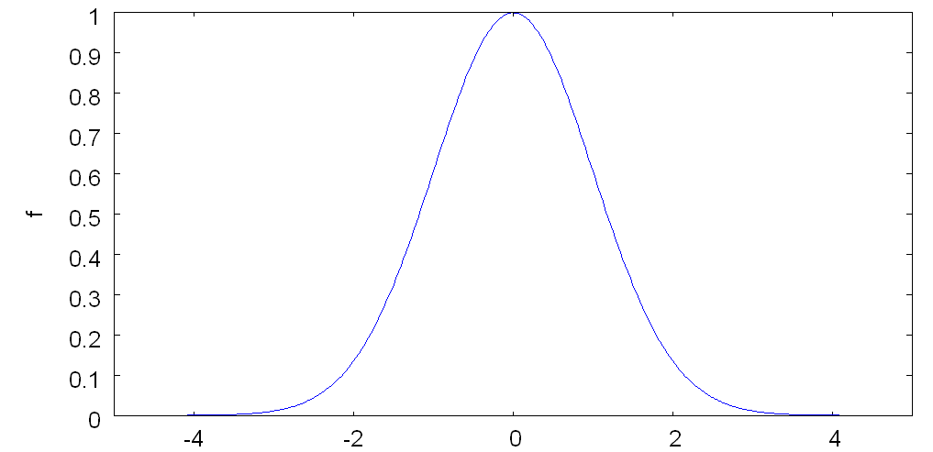

Probability Mass Function (pmf)
If a random variable X is discrete, i.e. it may take any of a specific set of n values x_{i}, i = 1 to n, then:
P(X = x_{i}) = p(x_{i})
p(x) is called the probability mass function.

Rango estadístico
Many times, the media will report the range of a data set as a way to measure the variability. The range is the largest value in the data set minus the smallest value in the data set. The range is easy to find; all you do is put the numbers in order (from smallest to largest) and do a quick subtraction. Maybe that's why the range is used so often; it certainly isn't because of its interpretative value.
 | HEADS UP | The range of a data set is almost meaningless. It depends on only two numbers in the data set, both of which could reflect extreme values (outliers). My advice is to ignore the range and try to find the standard deviation, which is a more informative measure of the variability in the data set.

Nombre del jugador | Salario | Rango
Shaquille O'Neal | $21,428,572 | $20,962,722
Kobe Bryant | $11,250,000
Robert Horry | $5,300,000
Rick Fox | $3,791,250
Lindsey Hunter | $3,425,760
Derek Fisher | $3,000,000
Samaki Walker | $1,400,000
Mitch Richmond | $1,000,000
Brian Shaw | $963,415
Devean George | $834,250
Mark Madsen | $759,960
Jelani McCoy | $565,850
Stanislav Medvedenko | $465,850

Mínimos, máximos y rangos en Maxima
(%i1) load(descriptive)$
(%i20) mini([1,2,3,4,5]);
(%o20) 1
(%i21) maxi([1,2,3,4,5]);
(%o21) 5
(%i22) range([1,2,3,4,5]);
(%o22) 4

Percentil
(Rumsay: Statistics for dummies.)
The percentile reported for a given score is the percentage of values in the data set that fall below that certain score. For example, if your score was reported to be at the 90th percentile, that means that 90% of the other people who took the test with you scored lower than you did (and 10% scored higher than you did).

Calculating percentiles
To calculate the k^{th} percentile (where k is any number between one and one hundred), do the following steps:
- Put all of the numbers in the data set in order from smallest to largest.
- Multiply k percent times the total number of numbers, n.
- Take that result and round it up to the nearest whole number.
- Count the numbers from left to right (from the smallest to the largest number) until you reach the value from Step 3.

 | Nombre del jugador | Salario | Percentil 50
 | Shaquille O'Neal | $21,428,572 | 7
 | Kobe Bryant | $11,250,000
 | Robert Horry | $5,300,000
 | Rick Fox | $3,791,250
 | Lindsey Hunter | $3,425,760
 | Derek Fisher | $3,000,000
7 | Samaki Walker | $1,400,000
6 | Mitch Richmond | $1,000,000
5 | Brian Shaw | $963,415
4 | Devean George | $834,250
3 | Mark Madsen | $759,960
2 | Jelani McCoy | $565,850
1 | Stanislav Medvedenko | $465,850

Tip | The 50th percentile is the point in the data where 50% of the data fall below that point and 50% fall above that point. You may recognize this under a different name — the median. Indeed, the median is a special percentile; it's the 50th percentile.

 | HEADS UP | A high percentile doesn't always constitute a good thing. For example, if your city is at the 90th percentile in terms of crime rate compared to cities of the same size, that means that 90% of cities similar to yours have a crime rate that is lower than yours, which is not good for you.

Cuartil
De http://es.wikipedia.org/wiki/Cuartil
Dados una serie de valores X₁,X₂,X₃...X_{n} ordenados en forma creciente,
Definimos:
Primer cuartil (Q₁) como la mediana de la primera mitad de valores.
Segundo cuartil (Q₂) como la propia mediana de la serie.
Tercer cuartil (Q₃) como la mediana de la segunda mitad de valores.
En estadística descriptiva Los cuartiles son los tres valores que dividen al conjunto de datos ordenados en cuatro partes porcentualmente iguales.
Hay tres cuartiles denotados usualmente Q₁, Q₂, Q₃. El segundo cuartil es precisamente la mediana. El primer cuartil, es el valor en el cual o por debajo del cual queda un cuarto (25%) de todos los valores de la sucesión (ordenada); el tercer cuartil, es el valor en el cual o por debajo del cual quedan las tres cuartas partes (75%) de los datos.
Datos Agrupados
Como los cuartiles adquieren su mayor importancia cuando contamos un número grande de datos y tenemos en cuenta que en estos casos generalmente los datos son resumidos en una tabla de frecuencia. La fórmula para el cálculo de los cuartiles cuando se trata de datos agrupados es la siguiente: k= 1,2,3
Donde:
Lk = Límite real inferior de la clase del cuartil k
n = Número de datos
Fk = Frecuencia acumulada de la clase que antecede a la clase del cuartil k.
fk = Frecuencia de la clase del cuartil k
c = Longitud del intervalo de la clase del cuartil k
Si se desea calcular cada cuartil individualmente, mediante otra fórmula se tiene lo siguiente:
El primer cuartil Q₁, es el menor valor que es mayor que una cuarta parte de los datos; es decir, aquel valor de la variable que supera 25% de las observaciones y es superado por el 75% de las observaciones.
Fórmula de Q₁, para series de Datos agrupados:
Donde:
L1 = limite inferior de la clase que lo contiene
P = valor que representa la posición de la medida
f1 = la frecuencia de la clase que contiene la medida solicitada.
Fa-1 = frecuencia acumulada anterior a la que contiene la medida solicitada.
Ic = intervalo de clase

El segundo cuartil Q₂, (coincide, es idéntico o similar a la mediana, Q2 = Md), es el menor valor que es mayor que la mitad de los datos, es decir el 50% de las observaciones son mayores que la mediana y el 50% son menores.
Fórmula de Q2, para series de Datos agrupados:
Donde:
L1 = limite inferior de la clase que lo contiene
P = valor que representa la posición de la medida
f1 = la frecuencia de la clase que contiene la medida solicitada.
Fa-1 = frecuencia acumulada anterior a la que contiene la medida solicitada.
Ic = intervalo de clase
El tercer cuartil Q₃, es el menor valor que es mayor que tres cuartas partes de los datos, es decir aquel valor de la variable que supera al 75% y es superado por el 25% de las observaciones.
Fórmula de Q₃, para series de Datos agrupados:
Donde:
L1 = limite inferior de la clase que lo contiene
P = valor que representa la posición de la medida
f1 = la frecuencia de la clase que contiene la medida solicitada.
Fa-1 = frecuencia acumulada anterior a la que contiene la medida solicitada.
Ic = intervalo de clase.
Otra manera de verlo es partir de que todas las medidas no son sino casos particulares del percentil, ya que el primer cuartil es el 25% percentil y el tercer cuartil 75% percentil.

Experimento
An experiment is a study that imposes a certain amount of control on the study's subjects and their environment (for example, restricting their diets, giving them certain dosage levels of a drug or placebo, or asking them to stay awake for a prescribed period of time). The purpose of most experiments is to pinpoint a cause-and-effect relationship between two variables.

Varianza y fluctuación
De http://es.wikipedia.org/wiki/Varianza:
En teoría de probabilidad y estadística, la varianza es una medida de la dispersión de una variable aleatoria respecto a su esperanza . Se define como la esperanza de la transformación : esto es,
Está relacionada con la desviación estándar o desviación típica, que se suele denotar por la letra griega σ (sigma) y que es la raíz cuadrada de la varianza,
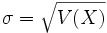o bien

La varianza en Maxima
(%i1) load(descriptive)$
(%i2) var([1,2,3,4,5]);
(%o2) 2

(%i11) s1 : read_list (file_search ("pidigits.data"))$
(%i16) var(s1);
84259
(%o16) -----
10000

Fluctuación
en.wikpedia.org :
In phyisics, a fluctuation is a variation in an extensive or intensive quantity, suchs as energy, density or voltage, from its spatial or temporal averabe. The mean-square fluctiation <X>² is equivalent to the variance in statistics. If X_{i} is the ith data point of X, the mean-square fluctuation is calculated as
X_{i} = < X_{i}² > - < X_{i} >²

Law of averages
(Rumsay.)
who defied the odds by winning 50 games and losing only 12 in the first 3 months of the season, were now starting to lose, giving in to the law of averages. Or maybe the context was gambling ("The law of averages is bound to catch up with me — I'm on too hot of a winning streak!"). What is the law of averages, exactly, and are people using this term properly?
The law of averages is a rule of probability. It says that, in the long term, results will average out to their expected value, but in the short term, no one knows what will happen. For example, casinos set up all of their games so that the chances of the house winning are slightly in their favor. That means that in the long term, as long as people keep playing, the casinos are going to come out ahead, on average. Of course there will be some winners, that's what keeps people playing, knowing they could be among them. But in the long term, the losers outweigh the winners (not to mention the fact that many times people who win big just put their money back into the games again and end up losing). For more on the law of averages, see Chapter 7.

Desviación estándar
(Rumsay: Statistics for dummies.)
The standard deviation is a way statisticians use to measure the amount of variability (or spread) among the numbers in a data set. As the term implies, a standard deviation is a standard (or typical) amount of deviation (or distance) from the average (or mean, as statisticians like to call it). So, the standard deviation, in very rough terms, is the average distance from the mean.
The standard deviation is also used to describe where most of the data should fall, in a relative sense, compared to the average.
(Chapter 5:)
The standard deviation of an entire population of data is denoted with a Greek letter v. The standard deviation of a sample from the population is denoted with the letter s.
The formula for standard deviation(s) is
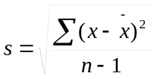
To calculate the sample standard deviation, s, do the following steps:
- Find the average of the data set.
To find the average, add up all the numbers and divide by the number of numbers in the data set, n.
- Take each number and subtract the average from it.
- Square each of the differences.
- Add up all of the results from Step 3.
- Divide the sum of squares (found in Step 4) by the number of numbers in the data set, minus one (n – 1).
- Take the square root of the number you get.

Statisticians divide by n − 1 instead of n in the formula for s so that the sample standard deviation has nice properties that work out with all of their theory. (Believe me, that's more than you want to know about that issue.) For example, dividing by n − 1 makes sure that the standard deviation isn't biased (off target) on average. In case you weren't confused enough already, here's more: If you do ever get the entire population of data and you want to find the population standard deviation, σ, use the same formula as the one for s, except do divide by n, not n − 1!
Nombre del jugador | Salario | (Salario - Promedio)**2 | Promedio (μ) | Mediana | Desv Estándar (función Excel)
Shaquille O'Neal | $21,428,572 | $297,924,937,258,390 | $4,168,070 | $1,400,000 | $5,977,723
Kobe Bryant | $11,250,000 | $50,153,735,793,483
Robert Horry | $5,300,000 | $1,281,266,047,329
Rick Fox | $3,791,250 | $141,993,138,483
Lindsey Hunter | $3,425,760 | $551,023,793,495
Derek Fisher | $3,000,000 | $1,364,386,985,791
Samaki Walker | $1,400,000 | $7,662,210,247,329
Mitch Richmond | $1,000,000 | $10,036,666,062,714
Brian Shaw | $963,415 | $10,269,812,189,954
Devean George | $834,250 | $11,114,354,253,714
Mark Madsen | $759,960 | $11,615,212,199,126
Jelani McCoy | $565,850 | $12,975,987,265,837
Stanislav Medvedenko | $465,850 | $13,706,431,219,683
 | $54,184,907 | $428,798,016,455,328
Desviación estándar (fórm. estadíst.) | 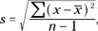 | $5,977,723

La desviación estándar (o típica) en Maxima
(%i1) load(descriptive)$
(%i2) std([1,2,3,4,5]);
(%o2) sqrt(2)

Puntos de inflexión en una distribución estándar
Rumsay: Statistics for dummies, Ch. 8:
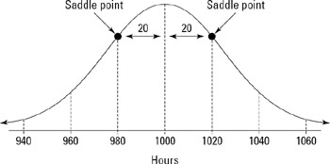
Figure 8-3: Distribution of the lifetimes of light bulbs from Lights Up.
Variability in a distribution is measured and marked off in terms of number of standard deviations. (See Chapter 3 for the formula for standard deviation.) On a normal distribution, the standard deviation has a special significance because it's the distance from the mean to a place on the distribution called the saddle point. Each normal distribution has two saddle points; each is the same distance from the mean. To find a saddle point, start at the mean and move either right or left until the curvature changes from being an upside-down bowl (concave down) to a right-side-up bowl (concave up).

Estimación
One of the biggest uses of statistics is to guesstimate something (the statistical term is estimation), as in the following examples:
- What's the average household income in America?
- What percentage of households tuned in to the Academy Awards this year?
- What's the average life expectancy of a baby born today?
- How effective is this new drug?
- How clean is the air today, compared to ten years ago?

Parámetro
Rumsay: Statistics for dummies, Ch. 11.
Most statistics are used to estimate some characteristic about a population of interest, such as average household income, the percentage of people who buy Christmas gifts online, or the average amount of ice cream consumed in the United States every year (maybe that statistic is better left unknown). Such characteristics of a population are called parameters. Typically, people want to estimate (take a good guess at) the value of a parameter by taking a sample from the population and using statistics from the sample that will give them a good estimate.

Intervalo de confianza
When you combine your estimate with the margin of error, you come up with a confidence interval. For example, suppose the average time it takes you to drive to work each day is 35 minutes, with a margin of error of plus or minus 5 minutes. You estimate that the average time to work would be anywhere from 30 to 40 minutes. This estimate is a confidence interval.

Rumsay: Statistics for dummies, Ch. 11:
The best way to estimate a parameter (a characteristic of an entire population) is to come up with a statistic, plus or minus a margin of error, that's based on a large sample. In this way, your result presents an estimate based on your sample, along with some indicator of how much that estimate could vary from sample to sample.
A statistic plus or minus a margin of error is called a confidence interval:
- The word interval is used because your result becomes an interval. For example, say the percentage of kids who like baseball is 40 percent, plus or minus 3.5 percent. That means the percentage of kids who like baseball is somewhere between 40% −3.5% = 36.5% and 40% + 3.5% = 43.5%. Thus, the lower end of the interval is your statistic minus the margin of error, and the upper end is your statistic plus the margin of error.
- The word confidence is used because you have a certain amount of confidence in the process by which you got your interval. This is called your confidence level.
Rumsay: Statistics for dummies, Ch. 12:
Aconfidence interval is a fancy phrase for a statistic that has a margin of error to go along with it.

Estimación PERT
Wikipedia: “PERT (Program Evaluation and Review Technique) fue inventada 1958 por la Oficina de Proyectos Especiales de la Armada Norteamericana, del Departamento de Defensa de los EUA, como parte del proyecto móvil de lanzamiento de cohetes Polaris. Dicho proyecto fue una respuesta directa a la llamada ‘crisis Sputnik’”
Newell: Preparing for the PMP Certification Examination (2002), pgs. 68-73:
Estimación optimista: se estima que el desempeño del equipo de trabajo y los proveedores será sobresaliente.
Estimación pesimista: enfocada al riesgo.
Estimación media, o satisfactoria: considera un nivel de riesgos moderado.
<x>=
EV = (a + 4m + b) / 6
<x>=EV = valor esperado, esperanza
a, m y b son las estimaciones optimista, media y pesimista

Desviación estándar, en PERT
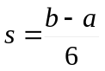En una distribución normal (curva de campana):

Para toda la ruta:

EV ± 2SD = intervalo de valores dentro del cual hay 95% de probabilidad de acertar.

EV ± 3SD = intervalo de valores dentro del cual hay 99% de probabilidad de acertar.
(Véase siguiente sección, sobre la regla empírica de la estadística.)

 |  |  | Estimación optimista | Estimación pesimista | Más probable
l | Esfuerzo total estimado |  | 80.00 | 120.00 | 90.00
 | Fase o actividad | Por-centaje asigna-do | Estimación optimista | Estimación pesimista | Más probable | Valor esperado (EV) | Desv. estándar (SD) | SD^2
1 | Concepción | 5.00% | 4.00 | 6.00 | 4.50 | 4.67 | 0.33 | 0.1111111111
2 | Elaboración | 25.00% | 20.00 | 30.00 | 22.50 | 23.33 | 1.67 | 2.7777777778
3 | Construcción | 60.00% | 48.00 | 72.00 | 54.00 | 56.00 | 4.00 | 16.0000000000
4 | Transición | 10.00% | 8.00 | 12.00 | 9.00 | 9.33 | 0.67 | 0.4444444444
5 |  |  | 0.00 | 0.00 | 0.00 | 0.00 | 0.00 | 0.0000000000
 | Sumas | 100.00% | 80.00 | 120.00 | 90.00 | 93.33 |  | 4.3969686528
 | EV + 2(SD) |  |  |  |  | 102.13
 | EV - 2(SD) |  |  |  |  | 84.54
 | EV + 3(SD) |  |  |  |  | 106.52
 | EV - 3(SD) |  |  |  |  | 80.14

Regla empírica de la estadística
Rumsay: Statistics for dummies, Ch. 8:

Looking for most of the values: The empirical rule
As long as a distribution has a mound shape in the middle — and the normal distribution certainly fits that criterion — you can make some general statements about where most of the values will be, using distances of 1, 2, or 3 standard deviations from the mean to mark off certain milestones. The rule that allows you to do this is called the empirical rule.
The empirical rule says that if a distribution has a mound shape, then:
- About 68% of the values lie within 1 standard deviation of the mean (or between the mean minus 1 times the standard deviation, and the mean plus 1 times the standard deviation). In statistical notation, this is represented as: μ ± σ.
- About 95% of the values lie within 2 standard deviations of the mean (or between the mean minus 2 times the standard deviation, and the mean plus 2 times the standard deviation). The statistical notation for this is: μ ± 2σ.
- About 99% (actually, 99.7%) of the values lie within 3 standard deviations of the mean (or between the mean minus 3 times the standard deviation and the mean plus 3 times the standard deviation). Statisticians use the following notation to represent this: μ ± 3σ.

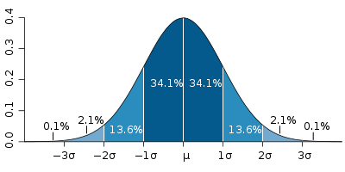

(Tomado de Wikipedia.)

Intervalo de confianza (confidence interval)
When you combine your estimate with the margin of error, you come up with a confidence interval. For example, suppose the average time it takes you to drive to work each day is 35 minutes, with a margin of error of plus or minus 5 minutes. You estimate that the average time to work would be anywhere from 30 to 40 minutes. This estimate is a confidence interval.

<EV> ± σ es el intervalo de valores dentro del cual hay una probabilidad de acertar de aprox. 68%
<EV> ± 2σ es el intervalo de valores dentro del cual hay una probabilidad de acertarde 95.5%
<EV> ± 3σ es el intervalo de valores dentro del cual hay una probabilidad de acertar mayor a 99%

Limitación de la regla empírica
Rumsay, Ch. 8:
The empirical rule does not apply when a distribution doesn't have a mound shape in the middle. You can still approximate or determine where certain milestones are in the data by making a histogram and/or finding percentiles (see Chapters 4 and 5 for more on histograms and percentiles, respectively).

Puntuación estándar, o puntuación Z (Z)
The standard score represents the number of standard deviations above or below the mean (without caring what that standard deviation or mean actually are).
The formula for standard score is
where
x is the average of all the scores
s is the standard deviation of all the scores

 | Nombre del jugador | Salario | (Salario - Promedio)**2 | Standard score  (Z)
1 | Shaquille O'Neal | $21,428,572 | $297,924,937,258,390 | 2.88747124
2 | Kobe Bryant | $11,250,000 | $50,153,735,793,483 | 1.18472044
3 | Robert Horry | $5,300,000 | $1,281,266,047,329 | 0.1893581
4 | Rick Fox | $3,791,250 | $141,993,138,483 | -0.0630373
5 | Lindsey Hunter | $3,425,760 | $551,023,793,495 | -0.1241794
6 | Derek Fisher | $3,000,000 | $1,364,386,985,791 | -0.1954038
7 | Samaki Walker | $1,400,000 | $7,662,210,247,329 | -0.4630643
8 | Mitch Richmond | $1,000,000 | $10,036,666,062,714 | -0.5299794
9 | Brian Shaw | $963,415 | $10,269,812,189,954 | -0.5360996
10 | Devean George | $834,250 | $11,114,354,253,714 | -0.5577073
11 | Mark Madsen | $759,960 | $11,615,212,199,126 | -0.5701351
12 | Jelani McCoy | $565,850 | $12,975,987,265,837 | -0.6026074
13 | Stanislav Medvedenko | $465,850 | $13,706,431,219,683 | -0.6193362
 |  | $54,184,907 | $428,798,016,455,328
 | Desviación estándar (fórm. estadíst.) |  | $5,977,723

La forma convencional de designar al standard score es Z:
.
With a little algebra, you can rewrite this equation so that you can convert from a standard score (Z) back to the original score (x). That formula looks like this: x = Zσ + μ.
To convert an original score to a standard score:
  - Find the mean and the standard deviation of the population that you're working with.
  - Take the original score, and subtract the mean.
  - Divide your result by the standard deviation.

Prueba de hipótesis
Basically, a hypothesis test is a statistical procedure in which data are collected and measured against a claim about a population.

P-value
Hypothesis tests are used to confirm or deny a claim that is made about a population. This claim that's on trial, in essence, is called the null hypothesis. The evidence in the trial is your data and the statistics that go along with it. All hypothesis tests ultimately use a p-value to weigh the strength of the evidence (what the data are telling you about the population). The p-value is a number between 0 and 1 that reflects the strength of the data that are being used to evaluate the null hypothesis. If the p-value is small, you have strong evidence against the null hypothesis. A large p-value indicates weak evidence against the null hypothesis. For example, if a pizza chain claims to deliver pizzas in less than 30 minutes (this is the null hypothesis), and your random sample of 100 delivery times has an average of 40 minutes for the delivery time (which is more than 2 standard deviations above what the average delivery time is supposed to be) the p-value for this test would be small, and you would say you have strong evidence against the pizza chain's claim.

Statistically significant
Whenever data are collected to perform a hypothesis test, the researcher is usually typically looking for a significant result. Usually, this means that the researcher has found something out of the ordinary. (Research that simply confirms something that was already well known doesn't make headlines, unfortunately.) A statistically significant result is one that would have had a very small probability of happening just by chance. The p-value reflects that probability.
For example, if a drug is found to be more effective at treating breast cancer than the current treatment is, researchers say that the new drug shows a statistically significant improvement in the survival rate of patients with breast cancer (or something to that effect). That means that based on their data, the difference in the results from patients on the new drug compared to those using the old treatment is so big that it would be hard to say it was just a coincidence.
 | HEADS UP | Sometimes, a sample doesn't represent the population (just by chance) and this results in a wrong conclusion. For example, a positive effect that's experienced by a sample of people who took the new treatment may have just been a fluke. (Assume for the moment that you know that the data were not fabricated, fudged, or exaggerated.) The beauty of medical research is that as soon as someone gives a press release saying that he or she found something significant, the rush is on to try to replicate the results, and if the results can't be replicated, this probably means that the original results were wrong, for some reason. Unfortunately, a press release announcing a "major breakthrough" tends to get a lot of play in the media, but follow-up studies refuting those results often don't show up on the front page.

Correlación vs. causa
Of all of the misunderstood statistical issues, the most problematic is the misuse of the concepts of correlation and causation.
Correlation means that two numerical variables have some sort of linear relationship. For example, the number of times crickets chirp per second is related to temperature; when it's cold outside, they chirp less frequently, and when it's warm outside they chirp more frequently. (This actually happens to be true!) Another example of correlation has to do with police staffing. The number of crimes (per capita) has often been found to be related to the number of police officers in a given area. When more police officers patrol an area, crime tends to be lower, and when fewer police officers are present, crime tends to be higher. However, seemingly unrelated events have also been found to be correlated. One such example is the consumption of ice cream (pints per person) and the number of murders in certain areas. Now maybe having more police officers deters crime, but does having people eat less ice cream deter crime? What's the difference? The difference is that with correlation, a link or relationship is found to exist between two variables, x and y. With causation, one makes that leap and says "a change in x will cause a change in y to happen." Too many times in research, in the media, or in the public consumption of statistical results, that leap is made when it shouldn't be. When can it be done? When a well-designed experiment is conducted that eliminates any other factors that could have been related to the outcomes. For more on correlation and causation, see Chapter 18.

Teorema del límite central
Rumsay (Cap. 9):
You may be wondering how you can assess the amount by which a sample statistic is going to vary without having to select every possible sample and look at its statistic. You may as well do a census at that point, right? Fortunately, thanks to some major statistical results (mainly the central limit theorem), you can find out how much you expect sample means or proportions to vary without having to take all possible samples (what a relief!). The central limit theorem, in a nutshell, says that the distribution of all sample means (or proportions) is normal, as long as the sample sizes are large enough. And even more impressive, the central limit theorem doesn't care what the distribution of the original population looks like. How can this be? You need to take a large enough sample, and you need to know some of the characteristics of your original population (like the mean and the standard deviation). And then the magic of statistical theory takes over from there.

Error típico (o error estándar)
Rumsay (Cap. 9)
Variability in sample means (or proportions) is measured in terms of standard errors. Standard error is the same basic concept as standard deviation; both represent a typical distance from the mean. But here is how standard error differs from standard deviation. The original population values deviate from each other due to natural phenomena (people have different heights, weights, and so on), hence the name standard deviation to measure their variability. Sample means vary because of the error that occurs in not doing a census and being able to only take samples, hence the name standard error to measure the variability of the sample means.
[...]
Remember, standard error tells you how much variability you can expect in the average if you were to take another sample.

en.wikipedia.org
The standard error of the mean (SEM) is the standard deviation of the sample mean estimate of a population mean. (It can also be viewed as the standard deviation of the error in the sample mean relative to the true mean, since the sample mean is an unbiased estimator.) SEM is usually estimated by the sample estimate of the population standard deviation (sample standard deviation) divided by the square root of the sample size (assuming statistical independence of the values in the sample):
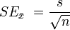

Para interpretar el error estándar
Rumsay (Cap. 9)
Applied to sample means and proportions, the empirical rule says that you can expect:
About 68% of the sample means to lie within 1 standard error of the population mean
About 95% of the sample means to lie within 2 standard errors of the population mean
About 99.7% of the sample means to lie within 3 standard errors of the population mean
Similar values for categorical (yes/no) data: 68%, 95%, or 99.7% of the sample proportions will lie within 1, 2, or 3 standard errors, respectively, of the population proportion
[...]
Consider this example: According to the U.S. Bureau of Labor Statistics, the average household in 2001... the average phone expenses for the year for this sample of 7,500 households was $914.41 per household. How much are these results expected to vary from sample to sample (that is, if different samples of 7,500 households each had been selected from the same population)? The standard error for phone expenses for this sample is $9.69. This means that 95% of the sample average phone expenses should lie within 2 × $9.69 (or $19.38) on either side of the actual population average. This shows how much the mean phone expenses are expected to vary when the sample size is 7,500.

El teorema del límite central y el error estándar
Rumsay (Cap. 9)
The central limit theorem says that for any population with mean μ and standard deviation σ:
- The distribution of all possible sample means, x, is approximately normal for sufficiently large sample sizes. That means you can use the normal distribution to answer questions or to draw conclusions about your sample mean. (See Chapter 8 for the normal distribution.)
- The larger the sample size (n) is, the closer the distribution of the sample means will be to a normal distribution. (Most statisticians agree that if n is at least 30, it will do a reasonable job in most cases.)
- The mean of the distribution of sample means is also μ.
- The standard error of the sample means is . It decreases as n increases.
- If the original data have a normal distribution, the sample means will always have an exact normal distribution, no matter what the sample size is.
If the population standard deviation, σ, is unknown (which will be the case most of the time), you can estimate it using s, the sample standard deviation, for standard error in the preceding formula.
[...]
The CLT is good news for people who are trying to interpret sample results. As long as the sample size is large enough (and the data are credible and unbiased), the information reported will be close to the truth. (But remember, I said as long as the results are credible and unbiased.)

(Fuente ¿)
The central limit theorem says that for any population of data with p as the overall population percentage:
The distribution of all possible sample proportions is approximately normal, provided that the sample size is large enough.
The larger the sample size (n) is, the closer the distribution of sample proportions will be to a normal distribution. (That means you can use the normal distribution to answer questions or to draw conclusions about your sample proportion.)
The mean of the distribution of sample proportions is also p.
The standard error of the sample proportions is

Ejemplo: Cantidad libre de defectos
p = (cant. libre de defectos / n)
n = tamaño de la muestra

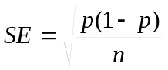

Ejemplo: p = 900/1000 = 0.9
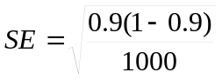 = 0.0095

¿Qué tan grande debe ser la muestra?
How large is large enough for the central limit theorem to work for categorical data? Most statisticians agree that you should have n × p and n × (1 −p) both be greater than or equal to 5. This takes care of any situations in which the proportion is very close to either 1 or 0 (in other words, those extreme situations where either almost everybody or almost nobody is in the group of interest). In these extreme situations, you'd need a larger sample to ensure that all the groups are represented, even those that don't contain many people. Most surveys and polls easily sample enough people to take care of this condition.

Margen de error
De Rumsay (Ch. 10):
The margin of error is supposed to measure the maximum amount by which the sample results are expected to differ from those of the actual population. Because the results of most survey questions can be reported in terms of percentages, the margin of error most often appears as a percentage, as well.
The margin of error doesn't mean someone made a mistake; all it means is that you didn't get to sample everybody in the population, so you expect your sample results to be "off" by a certain amount. In other words, you acknowledge that your results could change with subsequent samples, and are only accurate to within a certain range, which is the margin of error.

Table 10-1: Z-Values for Selected (Percentage) Confidence Levels
Percentage Confidence | Z-Value
80 | 1.28
90 | 1.64
95 | 1.96
98 | 2.33
99 | 2.58

Calculating margin of error for a sample proportion
When the polling question asks people to choose from a range of answers (for example, "Do you approve, disapprove, or have no opinion about the president's performance?"), the statistic used to report the results is the proportion of people from the sample who fell into each group, otherwise known as the sample proportion, or sample percentage. The general formula for margin of error for your sample proportion is , where is the sample proportion, n is the sample size, and Z is the appropriate Z-value for your desired level of confidence (from Table 10-1).
Here are the steps for calculating the margin of error for a sample percentage:
- Find the sample proportion, , and the sample size, n.
- Multiply × (1 - ).
- Divide the result by n.
- Take the square root of the calculated value.
You now have the standard error.
Multiply the result by the appropriate Z-value for the confidence level desired.
Refer to Table 10-1. The Z-value is 1.96 if you want to be about 95% confident in your results.

Looking at an example involving whether Americans approve of the president, you can find the margin of error. First, assume you want a 95% level of confidence, so Z = 1.96. The number of Americans in the sample who said they approve of the president was found to be 520. This means that the sample proportion, is 520 ÷ 1, 000 = 0.52. (The sample size, n, was 1, 000.) The margin of error for this polling question is calculated in the following way:
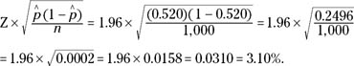

Calculating margin of error for a sample average
When a research question asks people to give a numerical value (for example, "How many people live in your house?"), the statistic used to report the results is the average of all the responses provided by people in the sample, otherwise known as the sample average.
The general formula for margin of error for your sample average is
,
where s is the sample standard deviation, n is the sample size, and Z is the appropriate Z-value for your desired level of confidence (from Table 10-1).
Here are the steps for calculating the margin of error for a sample average:
- Find the sample standard deviation, s, and the sample size, n
Fore more information on how to calculate the average and standarddeviation, see Chapter 5.
- Devide the sample standard deviation by the square root of the sample size.
You now have standard error.
- Multiply by the appropriate Z-value (refer to Table 10-1).
The Z-value is 1.96 if you want to be about 95% confident.
De Wikipedia:
