65-00 Analisis Numerico
Síntesis y notas

Soluciones numéricas
De Mattuck: OCW 18.03, Differential Equations, Lecture 2.
18.03 Class 2, February 10, 2006
Numerical Methods
[1] The study of differential equations rests on three legs:
. Analytic, exact, symbolic methods
. Quantitative methods (direction fields, isoclines ....)
. Numerical methods
Even if we can solve symbolically, the question of computing values remains. The number e is the value y(1) of the solution to y' = y with y(0) = 1. But how do you find that in fact e = 2.718282828459045.... ? The answer is: numerical methods.
This (namely, the numerical) is the main way differential equations are solved.
The following is an IVP (Initial Value Problem):
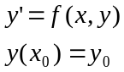
Euler’s method:
Here is our starting point, x₀,y₀. So what information do we have?
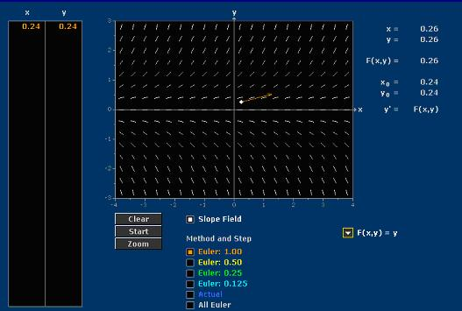
At that point all we have is a little line element, whose slope is given by f(x,y). So the only way the solution could go is to start off in that direction. At least it has the correct direction at x₀,y₀ , but of course it’s not likely to have the correct direction anywhere else.
So you choose a uniform step size, h, and you recalculate what the line element is here. That is the new direction you should start with.
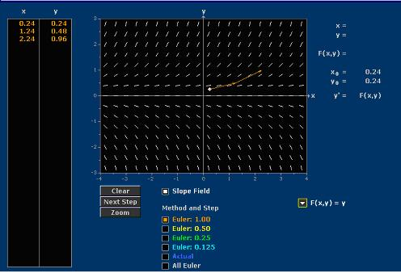
That is two steps of Euler’s method. Notice it produces a broken line approximation. And you continue....
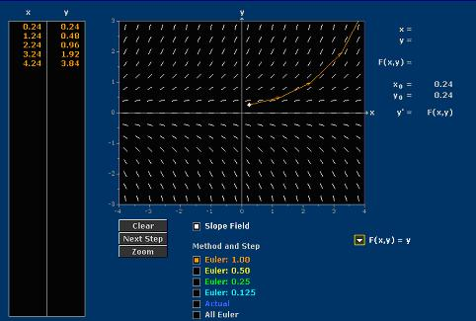
That’s what there is to the method. The interesting part is:
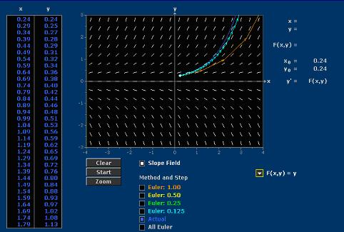

Euler’s equations:
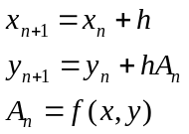
So it is these three equations which define Euler’s method. It is not as bad at it seems, but it is not the world’s best method...
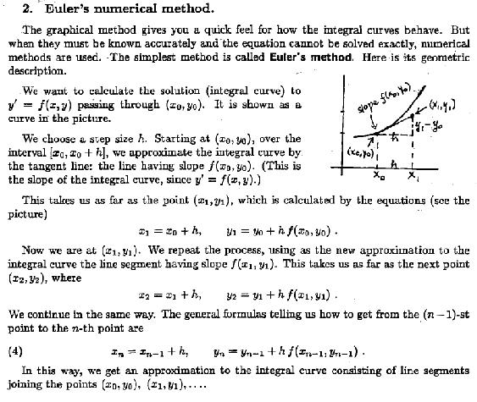
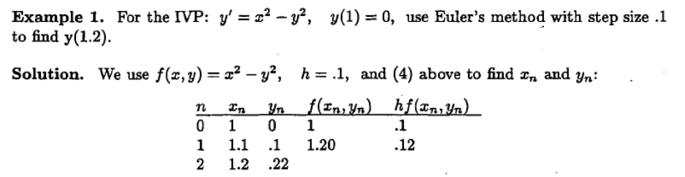
So the question is, how do you get a better method?
The bigger the step size, the larger the error; the smaller the step size, the smaller the error... Halve de step size, and you will (asymptotically) halve the error...
e~c₁h
A still better method: find a better value for the slope: RK2 (Runge-Kutta 2). For second order methods...
e~c₂h²
[4] The way to address the problem of variability of the direction field is to poll the values of the direction field in the area that the next strut in the Euler polygon plans to traverse, and use that information to give a better derivative for the next strut. These polling methods can be very clever.
If you poll once at the midway point and simply take the average, you get the "improved Euler method" (also known as Heun's method).
If you poll four times sequentially (in a certain very clever way) you get"RK4."
[Véase: http://en.wikipedia.org/wiki/Runge%E2%80%93Kutta_methods ]

It is interesting to compare these methods. Here's a comparison using the ODE y' = y, y(0) = 1; the solution is y = e^x, and we study y(1) = e.
Equal cost:
Method | Steps | Evaluations | Error
RK1 = Euler | 1000 | 1000 | 1.35 x 10^{-3}
RK2 = Heun | 500 | 1000 | 1.81 x 10^{-6}
RK4 | 250 | 1000 | 7.99 x 10^{-15}

Each evaluation of the direction field costs money - it takes time.Heun polls twice per step, and RK4 polls 4 times, so the cost of

