06E Álgebra booleana

Consúltese http://mathworld.wolfram.com/BooleanAlgebra.html

De http://www.encyclopediaofmath.org/index.php/Boolean_algebra
Boolean lattice
A partially ordered set of a special type. It is a distributive lattice with a largest element "1" , the unit of the Boolean algebra, and a smallest element "0" , the zero of the Boolean algebra, that contains together with each element also its complement — the element , which satisfies the relations
The operations sup and inf are usually denoted by the symbols and , and sometimes by and respectively, in order to stress their similarity to the set-theoretical operations of union and intersection. The notation or may be employed instead of . The complement of an element in a Boolean algebra is unique.
A Boolean algebra can also be defined in a different manner. Viz. as a non-empty set with the operations , , which satisfy the following axioms:
1) ,
2) ,
3) ,
4) ,
5) ,
If this approach is adopted, the order is not assumed to be given in advance, and is introduced by the following condition: if and only if .
Other axiomatics are also possible. The axioms of a Boolean algebra reflect the analogy between the concepts of a "set" , an "event" and a "statement" . The "order" relation in a Boolean algebra can be interpreted in various ways — as set-theoretical inclusion, as causal follow-up of events, as logical follow-up of statements, etc.

De http://en.wikibooks.org/wiki/Digital_Circuits/Logic_Operations#Boolean_Algebra
Boolean Algebra was created by George Boole (1815 - 1864) in his paper An Investigation of the Laws of Thought, on Which Are Founded the Mathematical Theories of Logic and Probabilities, published in 1854. It had few applications at the time, but eventually scientists and engineers realized that his system could be used to create efficient computer logic. The Boolean system has two states: True (T) or False (F). This can be represented in several different ways as on or off, one or zero, yes or no, etc. These states are manipulated by three fundamental operations called logical operators: AND, OR and NOT. These operators take certain inputs and produce an output based on a predetermined table of results. For example, the AND operator takes two (or more) inputs and returns an 'on' result only when both (or all) inputs are 'on'.

Circuitos digitales y operaciones lógicas
De http://en.wikibooks.org/wiki/Digital_Circuits/Logic_Operations#Boolean_Algebra
Boolean algebra is a bit of an oddity in the math world. Boolean algebra uses, as its fundamental values, the states of "true" and "false". To facilitate mathematics, we will turn "true" values into the number 1, and we will turn "false" values into the number 0. Then, we will go over some of the basic rules of boolean algebra:
addition
1 + 1 = 1.
1 + 0 = 1.
0 + 0 = 0.
There are only 2 values in boolean algebra, so there is no place to store the carry from an addition operation. The strangest part of boolean algebra is that 1 + 1 = 1. It's strange, but it's important
multiplication
1 * 1 = 1.
1 * 0 = 0.
0 * 0 = 0.
These results seem pretty normal.

Inversión (negación)
De http://en.wikibooks.org/wiki/Digital_Circuits/Logic_Operations#Boolean_Algebra
Inversion, or a NOT operation changes a 1 to a 0, and changes 0 to 1. Mathematically, we will use the symbol "!" (exclamation point) to denote the logical inversion of a quantity or a variable. For instance:
!1 = 0
!0 = 1
Since you are using base 2 and since there are only two states then it stands to reason that if it's NOT "one" then it is "zero" and if it's NOT "zero" then it is "one"
If we want to talk about a variable that is always inverted, we will use the following notation:
Where the bar over top of the x denotes the fact that this value is always the opposite of the value.

De Meyer, Rubinfeld: 6.042J / 18.062J Mathematics for Computer Science:
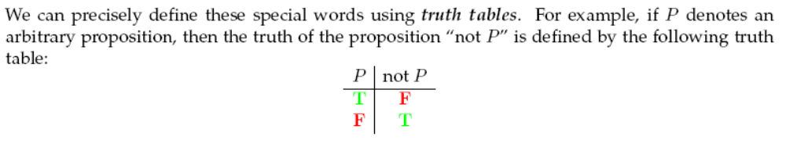

Conjunción y disyunción
De http://en.wikibooks.org/wiki/Digital_Circuits/Logic_Operations#Boolean_Algebra
In terms of math, AND gates are implemented by multiplication. OR gates are implemented by Addition. Remember, in Boolean algebra, there are no carrys in addition.
To understand the difference between AND and OR, let's examine the following truth tables:
AND OR
X Y RESULT X Y RESULT
0 0 0 0 0 0
0 1 0 0 1 1
1 0 0 1 0 1
1 1 1 1 1 1
In the case of AND, both must be 1 for the result to be 1.
In the case of OR, at least one must be a 1 for the result to be 1.

De Meyer, Rubinfeld: 6.042J / 18.062J Mathematics for Computer Science
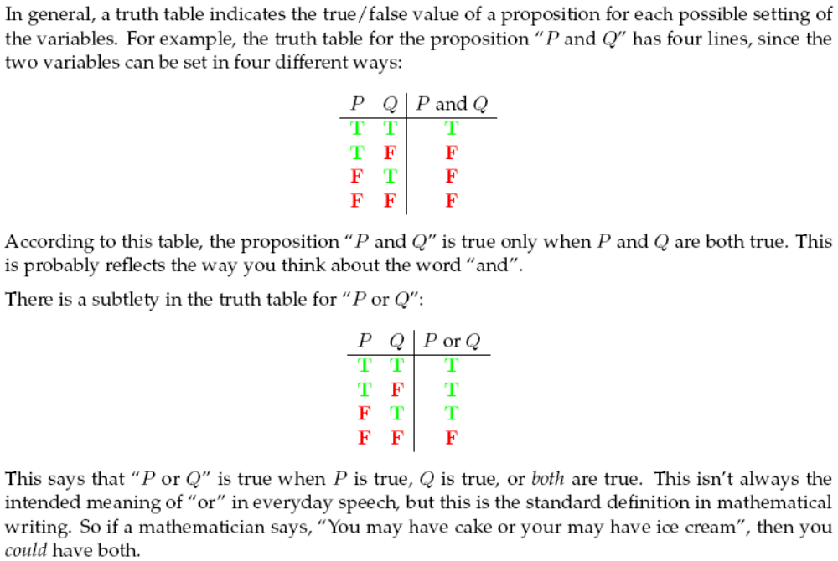
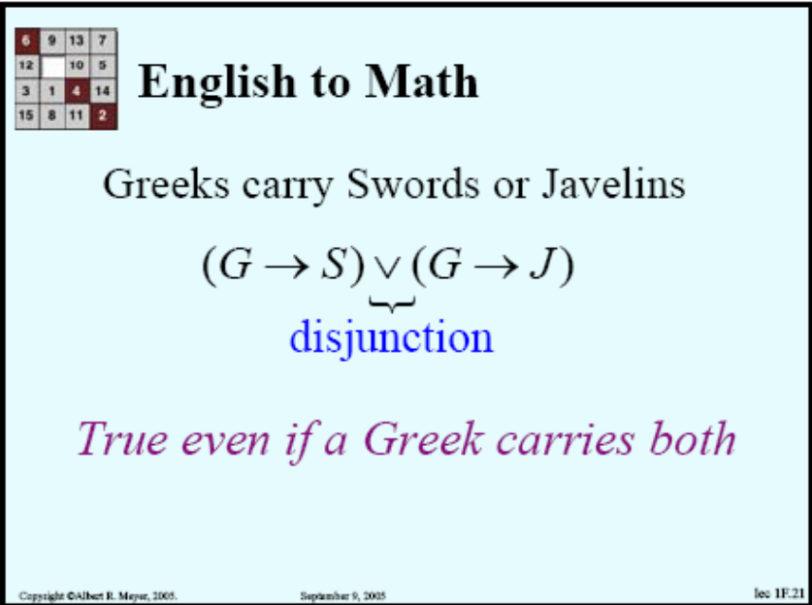
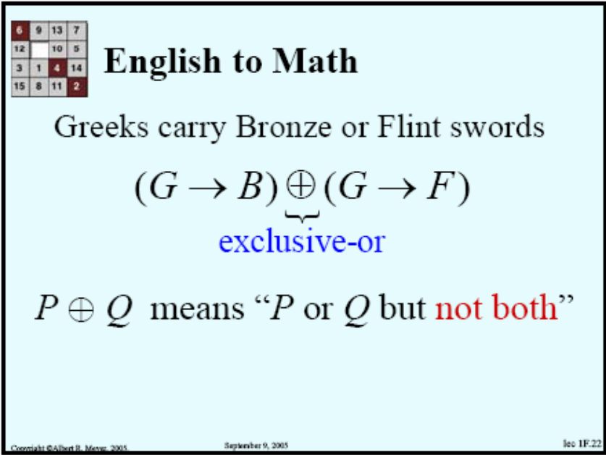

De http://en.wikibooks.org/wiki/Digital_Circuits/Logic_Operations#Boolean_Algebra
In these tables T means "True", or "Yes", or 1 (in electronics), and
F means "False", or "No" or 0 (in electronics).
For example, the 1st line of the AND table says that if A is F and B is F then the result also is F. This is also said often as If A is 0 and B is also 0, then A AND B = 0 times 0 = 0
Also at the bottom of the AND table 1 times 1 is 1.
Looking at the OR table, use plus instead of times: 0 plus 0 is 0, where again 0 is F and 1 is T. Only 0 and 1 exist, therefore if the result of the addition is more than 1, then change it to 1.
The 3rd table shows NEGATION: whatever it is, change it to the other; 0 is changed into 1, and 1 is changed into 0.
Truth Tables
  AND
  A | B
  F | F | F
  F | T | F
  T | F | F
  T | T | T
  OR
  A | B
  F | F | F
  F | T | T
  T | F | T
  T | T | T
  NOT
  A
  F | T
  T | F

Implicación
De Meyer, Rubinfeld: 6.042J / 18.062J Mathematics for Computer Science:
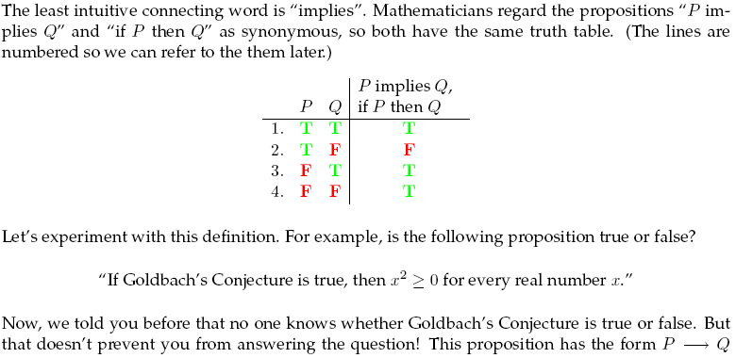
(De Strang, Gilbert: Calculus http://ocw.mit.edu/ans7870/resources/Strang/strangtext.htm)
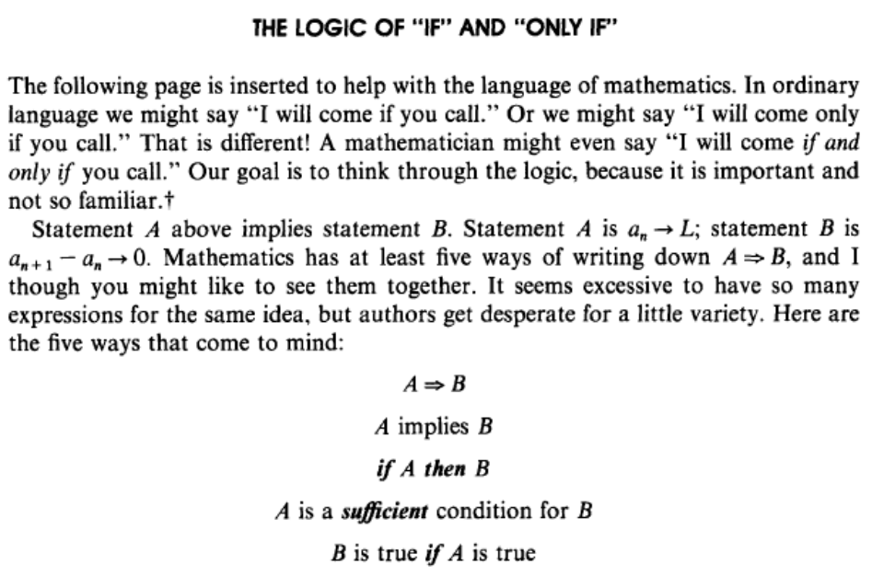

Si y sólo si
De Meyer y Rubinfeld:
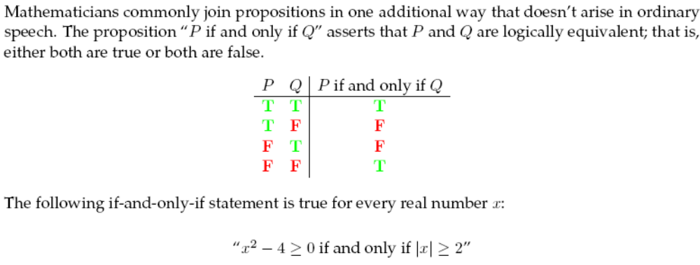
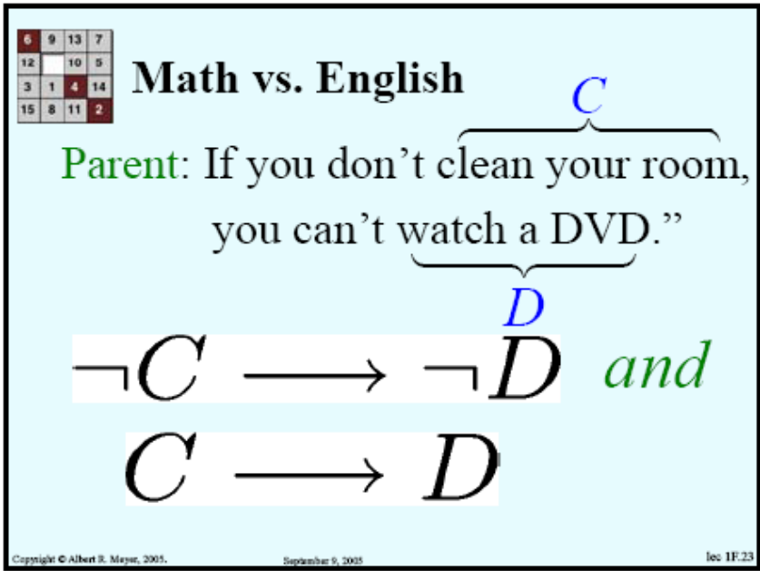
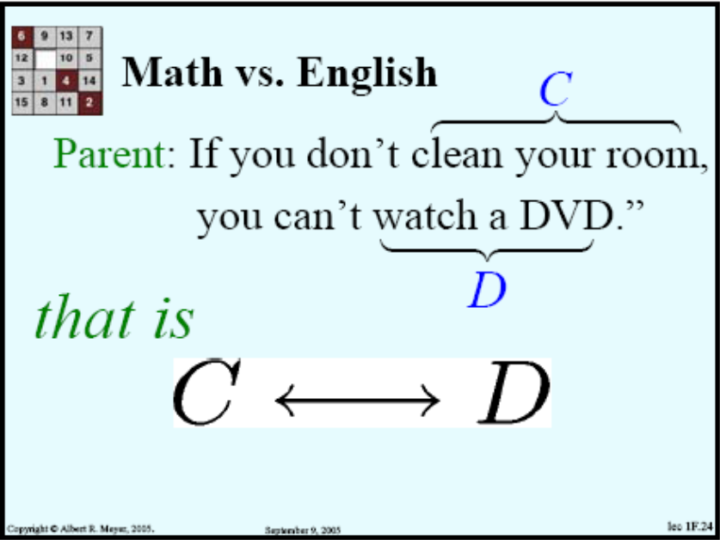

XOR
De http://en.wikibooks.org/wiki/Digital_Circuits/Logic_Operations#Boolean_Algebra
The XOR Gate has the following truth table:
Either X OR Y (Not Both) for Z to be True
X | Y | Z
0 | 0 | 0
0 | 1 | 1
1 | 0 | 1
1 | 1 | 0

NOR y NAND
De http://en.wikibooks.org/wiki/Digital_Circuits/Logic_Operations#Boolean_Algebra
If these three operators are combined, then the NOR and NAND can be created. So A NOR B is or . (This last one has been rendered wrong, the bar should extend all the way over both A and B). NAND is or . (The last one has once again been rendered wrong.) The reason for the double notation is because, unfortunately, computer science, engineering and mathematics seem unable to establish a consensus. The point is that this book is not the only source of information. Other books have various notations, so if other books are consulted, then the other notation needs to be known.
The NOR gate has the followint truth table:
It is simply "NOT of OR".
X | Y | Z
0 | 0 | 1
0 | 1 | 0
1 | 0 | 0
1 | 1 | 0
The NAND gate has the following truth table:
It is simply "NOT of AND".
X | Y | Z
0 | 0 | 1
0 | 1 | 1
1 | 0 | 1
1 | 1 | 0

Leyes del álgebra booleana
De http://en.wikibooks.org/wiki/Digital_Circuits/Logic_Operations#Boolean_Algebra
Boolean Algebra, like regular algebra, has certain rules. These rules are Associativity, Distributivity, Commutativity and De Morgan's Laws. Associativity, Commutativity and Distributivity only apply to the AND and OR operators. Some of these laws may seem trivial in normal Algebra but in other algebras they are not.

Associativity
Associativity is the property of algebra that the order of evaluation of the terms is immaterial.
Or

Distributivity
Distibutivity is the property that an operator can be applied to the terms within the brackets.
Or

Commutativity
Commutativity is the property that order of application of an operator is immaterial.
Or

De Morgan's Law
De Morgan's Law is a consequence of the fact that the not or negation operator is not distributive.
Or
De Morgan's laws tell us that a Nand gate gives the same output as an Or gate with inputs complemented and a Nor gate gives the same output as an And gate with outputs complemented. These complemented input gates are also known as bubbled gates because of the way that they are indicated on a symbol, i.e, by including a small 'bubble' on each input, similar to the circle drawn on the output of the Not, Nand and Nor gates.
De Morgan's laws are the most useful while simplifying a boolean expression. That these laws are true can be verified by constructing the corresponding truth table.

