33B10 Funciones exponenciales y trigonométricas

Consúltese el concepto de trascendencia en: 11JXX Números y funciones trascendentes (números trascendentes, π, exponenciales, logaritmos, orígenes del concepto...

Funciones trigonométricas

Plimpton 322
Maor: Trigonometric delights (Princeton Univ. Press), "Plimpton 322: The Earliest Trigonometric Table?", p. 30.

Las funciones trigonométricas
The trignometric functions
http://www-history.mcs.st-andrews.ac.uk/history/HistTopics/Trigonometric_functions.html

Trigonometría en Grecia antigua y en el mundo helenístico
Maor: Trigonometric delights, Cap. 2, pgs. 22-24.
http://press.princeton.edu/books/maor/chapter_2.pdf
Trigonometry in the modern sense of the word began with Hipparchus of Nicaea (ca.190–120 b.c.), considered the greatest astronomer of antiquity.
[...]
The first major work on trigonometry to have come to us intact is the Almagest by Claudius Ptolemaeus, commonly known as Ptolemy (ca. 85–ca. 165 a.d.).

Claudio Ptolomeo (85-165)
http://www-history.mcs.st-andrews.ac.uk/history/Biographies/Ptolemy.html
One of the most influential Greek astronomers and geographers of his time, Ptolemy propounded the geocentric theory in a form that prevailed for 1400 years.

http://www-history.mcs.st-andrews.ac.uk/history/HistTopics/Trigonometric_functions.html
Ptolemy was the next author of a book of chords, showing the same Babylonian influence as Hipparchus, dividing the circle into 360° and the diameter into 120 parts. The suggestion here is that he was following earlier practice when the approximation 3 for π was used. Ptolemy, together with the earlier writers, used a form of the relation sin2 x + cos2 x = 1, although of course they did not actually use sines and cosines but chords.
Similarly, in terms of chords rather than sin and cos, Ptolemy knew the formulas
sin(x + y) = sinx cos y + cosx sin y
a/sin A = b/sin B = c/sin C.

Trigonometría en la India, alrededor de los. años 400 a 550
Maor: Trigonometric delights, Cap. 3, p. 35.
An early Hindu work on astronomy, the Surya Siddhanta (ca. 400 a.d.), gives a table of half-chords based on Ptolemy’s table (fig. 15). But the first work to refer explicitly to the sine as a function of an angle is the Aryabhatiya of Aryabhata (ca. 510), considered the earliest Hindu treatise on pure mathematics.1 In this work Aryabhata (also known as Aryabhata the elder; born 475 or 476, died ca. 550)2 uses the word ardha-jya for the halfchord, which he sometimes turns around to jya-ardha (“chordhalf”); in due time he shortens it to jya or jiva.

Bhaskara I (600-680)
De http://www-history.mcs.st-andrews.ac.uk/history/Biographies/Bhaskara_I.html
We have very little information about Bhaskara I's life except what can be deduced from his writings. Shukla deduces from the fact that Bhaskara I often refers to the Asmakatantra instead of the Aryabhatiya that he must have been working in a school of mathematicians in Asmaka which was probably in the Nizamabad District of Andhra Pradesh. If this is correct, and it does seem quite likely, then the school in Asmaka would have been a collection of scholars who were followers of Aryabhata I and of course this fits in well with the fact that Bhaskara I himself was certainly a follower of Aryabhata I.
[...]
Bhaskara I included in his treatise the Mahabhaskariya three verses which give an approximation to the trigonometric sine function by means of a rational fraction. These occur in Chapter 7 of the work. The formula which Bhaskara gives is amazingly accurate and use of the formula leads to a maximum error of less than one percent. The formula is
sin x = 16x (π - x)/[5π2 - 4x (π - x)]
and Bhaskara attributes the work as that of Aryabhata I. We have computed the values given by the formula and compared it with the correct value for sin x for x from 0 to π/2 in steps of π/20.
[…]
One of the approximations used for π for many centuries was √10. Bhaskara I criticised this approximation. He regretted that an exact measure of the circumference of a circle in terms of diameter was not available and he clearly believed that π was not rational.

Mohammad Abu'l-Wafa Al-Buzjani (940-998)
De http://www-history.mcs.st-andrews.ac.uk/history/Biographies/Abu%27l-Wafa.html

http://www-history.mcs.st-andrews.ac.uk/history/HistTopics/Trigonometric_functions.html
The Arabs worked with sines and cosines and by 980 Abu'l-Wafa knew that
sin 2x = 2 sin x cos x
although it could have easily have been deduced from Ptolemy's formula sin(x + y) = sin x cos y + cos x sin y with x = y.

William Oughtred
Maor: Trigonometric Delights, Cap. 4

In England three individuals made substantial contributions to trigonometry in the first half of the seventeenth century. John Napier’s (1550–1617) invention of logarithms in 1614 enormously aided numerical calculations, particularly in trigonometry. William Oughtred (1574–1660) was the first to attempt a systematic use of trigonometric symbols: in his work Trigonometrie, or, The manner of Calculating the Sides and Angles of Triangles, by the Mathematical Canon, demonstrated (London, 1657), he used the abbreviations s, t, se, s co, t co, and se co for sine, tangent, secant, cosine (“sine complement”), cotangent, and cosecant, respectively. (In contrast to its long title, the work itself contains, besides the tables, only thirty-six pages of text.)

Funciones trigonométricas
Véase http://eom.springer.de/T/t094210.htm

Círculo unitario
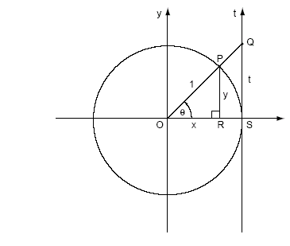
(Tomado de Maor: Trigonometric Delights, Apéndice 1)

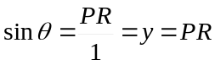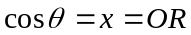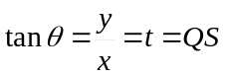
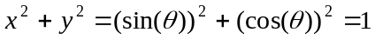

tan x
De Maor: Trigonometric Delights, Cap. 12 (http://press.princeton.edu/books/maor/chapter_12.pdf ).
Of the numerous functions we encounter in elementary mathematics, perhaps the most remarkable is the tangent function. The basic facts are well known: f(x) = tan x has its zeros at x = nπ (n = 0, ±1, ±2...), has infinite discontinuities at x = (2n+1)π/2) , and has period π (a function f(x) is said to have a period P if P is the smallest number such that f(x+P) = f(x) for all x in the domain of the function). This last fact is quite remarkable: the functions sin x and cos x have the common period 2π, yet their ratio, tan x, reduces the period to π. When it comes to periodicity, the ordinary rules of the algebra of functions may not be valid: the fact that two functions f and g have a common period P does not imply that f + g or fg too have the same period.
As we saw in chapter 2, the tangent function has its origin in the “shadow reckoning” of antiquity.

[Véase el “triángulo de Pascal de tangentes” en la página 154]

Other formulas involving tan x are just as elegant; for example, if α, β and γ are the three angles of any triangle, we have

tan α + tan β + tan γ = (tan α) (tan β ) (tan γ).

Hoja de cálculo, funciones trigonométricas
Funcs_trigonom.xls

Representación alternativa de las funciones

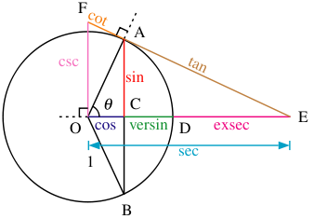
(Tomado de Wikipedia, Trigonometric Functions)

Funciones trigonométricas inversas
De http://eom.springer.de/i/i052410.htm

Ley de los senos
Maor: Trigonometric Delights, Apéndice 1
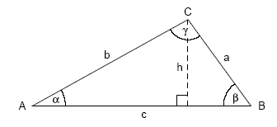

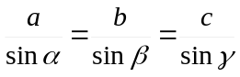

Ley de los cosenos (o teorema de Al-Kashi)
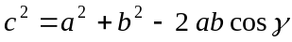

Ley de las tangentes
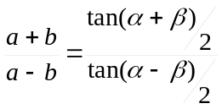

Identidades trigonométricas

Véase Wikipedia, “List of trigonometric identities”: http://en.wikipedia.org/wiki/List_of_trigonometric_identities

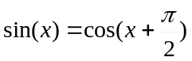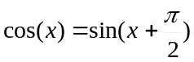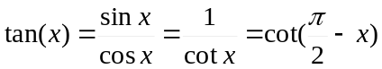

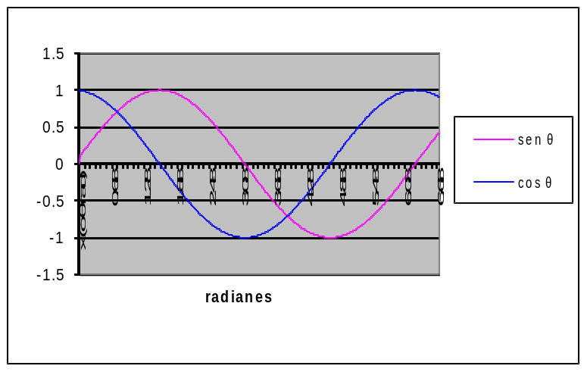
Periodicidad: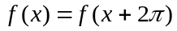

Véase un resumen en Granville: Cálculo, Capítulo 1, Resumen de fórmulas, pg. 4:
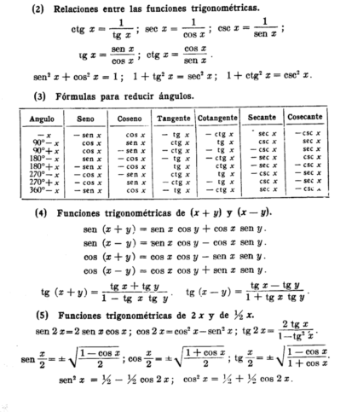

Maor: Trigonometric Delights, Ch. 11.

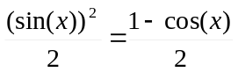

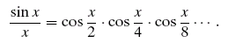

Maor: Trigonometric Delights, Ch. 12:
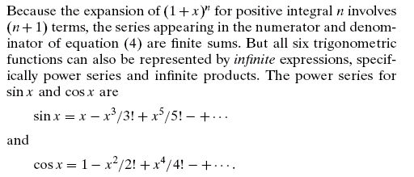

También de Maor: Trigonometric Delights, apéndice 3:
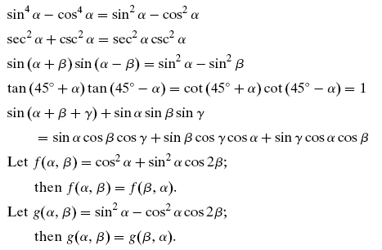

Acordeón de Maxima para funciones trigonométricas
(%i1) sin(t)*cos(t);
(%o1) cos(t) sin(t)
(%i2) trigreduce(%);
sin(2 t)
(%o2) --------
2

(%i8) sin(t)/cos(t);
sin(t)
(%o8) ------
cos(t)
(%i9) trigreduce(%);
(%o9) tan(t)

(%i17) 1+tan(t)^2;
2
(%o17) tan (t) + 1
(%i18) trigreduce(%);
2
(%o18) sec (t)

Teorema de De Moivre
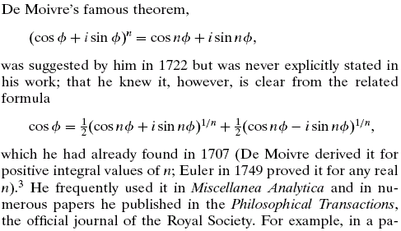
(Tomado de Maor: Trigonometric Delights, p. 83)

Logaritmos naturales

Historia de e
Véase http://www-history.mcs.st-andrews.ac.uk/HistTopics/e.html Logaritmos y la función exponencial

John Napier (1550-1617)
Véase http://www-history.mcs.st-andrews.ac.uk/history/Biographies/Napier.html:
Napier's discussion of logarithms appears in Mirifici logarithmorum canonis descriptio in 1614. Two years later an English translation of Napier's original Latin text was published, translated by Edward Wright.

Charles Hermite (1822-1901)
De http://www-history.mcs.st-andrews.ac.uk/history/Biographies/Hermite.html
The 1870s saw Hermite return to problems which had interested him earlier in his career such as problems concerning approximation and interpolation. In 1873 Hermite published the first proof that e is a transcendental number. This is another result for which he is rightly famous. Using method's similar to those of Hermite, Lindemann established in 1882 that π was also transcendental.

El número e
De Strang: Calculus, 6.2 “The Exponential e”, pg. 228:

I believe that the equation dy/dx = y has to be emphasized above techniques of integration. The laws of nature are expressed by differential equations, and at the center is e^{x}. Its applications are to life sciences and physical sciences and economics and engineering (and more—wherever change is influenced by the present state).

Véase también Strang: Calculus, 6.2 “The Exponential e”, pg. 236.

[De Crenshaw, http://embedded.com/showArticle.jhtml?articleID=172300631]
So far, we haven't talked much about the constant, e, itself. It's called the Euler constant, and it's one of the fundamental constants of mathematics, much like π. Equation 35 gives us a good way of computing it. Simply set x to 1, and get:
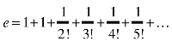 (35)

(Véase serie de Taylor para e^{n} en Logaritmos.xls, pestaña "Logaritmos".)

De Byers: How Mathematicians Think, Ch. 5, “The idea as an organizing principle”, pgs. 226-229:
... e^{x} can be represented as a power series...

La función exponencial y las funciones hiperbólicas
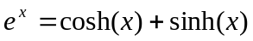
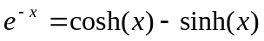

El gudermaniano
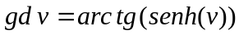
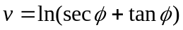
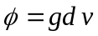

Función exponencial, números complejos y funciones trigonométricas (fórmula de Euler)
In his work Harmonia mensurarum (Harmony of mensuration), published posthumously in 1722, the English mathematician Roger Cotes (1682–1716) gave the equivalent of the formula (in modern notation)
... This, of course, is equivalent to Leonhard Euler’s famous formula... (Maor: Trigonometric Delights, Cap. 4, p. 52).

De http://www-history.mcs.st-andrews.ac.uk/history/Biographies/Cotes.html:
Cotes was particularly pleased with his rectification of the logarithmic curve as he made clear in a letter to his friend William Jones in 1712. In particular his work on logarithms led him to study the curve r = a/q which he named the reciprocal spiral. Cotes extended the work of Varignon when he rectified the Archimedean spiral and the parabola of Apollonius, a problem first proposed by Fermat, showing that both have the same integral. His work here was based on the formula
ln(cos q + i sin q) = i q.
Jones urged Cotes to publish his work in the Philosophical Transactions of the Royal Society, but Cotes resisted this, wishing to support Cambridge and publish with Cambridge University Press. His early death was to prevent publication in his lifetime.
Cotes discovered an important theorem on the nth roots of unity, gave the continued fraction expansion of e, invented radian measure of angles, anticipated the method of least squares, published graphs of tangents and secants, and discovered a method of integrating rational fractions with binomial denominators. His substantial advances in the theory of logarithms, the integral calculus, in numerical methods particularly interpolation and table construction of integrals for eighteen classes of algebraic functions led Newton to say:-
... if he had lived we might have known something.

Feynman et. al: Física (Addison-Wesley, México, varias eds), vol. 1, p. 22-14:
Resumimos con esto la fórmula más notable de la matemática:
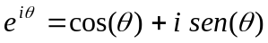 (22.9)
Esta es nuestra joya.
Podemos relacionar la geometría con el álgebra, representando los números complejos en un plano; la posición horizontal de un punto es x, la posición vertical de un punto es y (Fig. 22-2). Representamos cualquier número complejo x + iy. Luego si la distancia radial a este punto la llamamos r y el ángulo se designa por θ, la ley algebráica es que x + iy se escribe de la forma re^{iθ}, donde las relaciones geométricas entre x, y, r y θ son como se indican. Esta es entonces, la unifiación del álgebra y la geometría.

Equivalente de la Fig. 22-2 de Feynman:
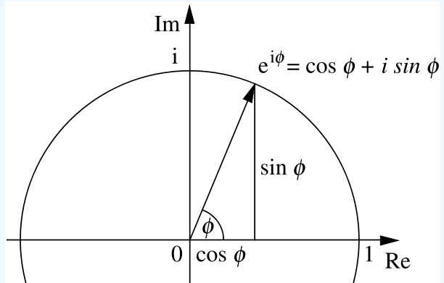
(De Wikipedia, "Contributions of Leonhad Euler to Mathematics", http://en.wikipedia.org/wiki/Contributions_of_Leonhard_Euler_to_mathematics)

De la fórmula de Euler, se pueden obtener las siguientes identidades:
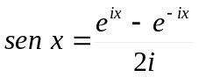
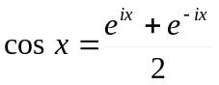
De estas últimas se puede obtener la derivada de sen x y cos x.
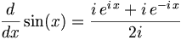
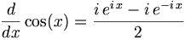
(Tomado de Wikibooks, Calculus, More differentiation rules.)

Funciones trascendentales con Maxima
(Véase el Acordeón para graficación con Maxima, “Espacio euclidiano, dimensiones, geometría analítica”.)

Análisis de Fourier

Jean Baptiste Joseph Fourier (1768 - 1830)
Véase http://www-history.mcs.st-andrews.ac.uk/history/Biographies/Fourier.html

Teorema de Fourier

De Maor: Trigonometric Delights, Ch. 4, p. 54:
In his most important work, Th´eorie analytique de la chaleur (Analytic theory of heat, 1822), Fourier showed that almost any function, when regarded as a periodic function over a given interval, can be represented by a trigonometric series of the form
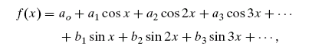
where the coefficients ai and bi can be found from f (x). by computing more general than the familiar Taylor expansion of a function in a power series; for example, while the Taylor series can be applied only to functions f(x). that are continuous and have continuous derivatives, the Fourier series may exist even if f(x). is discontinuous.

De: Maor: Trigonometric Delights, Cap. 15: “Fourier's Theorem”
C:\Refer\Matemat\1998\1998MaorTrig\Ch15Fourier.pdf
We form the finite sum

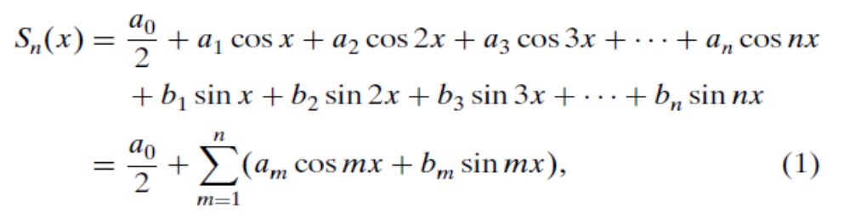
where the coefficients am and bm are real numbers (the reason for dividing a0 by 2 will become clear later); the subscript n under the S(x) indicates that the sum depends on the number of sine and cosine terms present. Since S(x) is the sum of terms of the form cos mx and sin mx for m = 1, 2, 3..., it is a periodic function of x with period 2; the nature of this function, of course, depends on the coefficients am and bm (as well as on n).

Análisis de Fourier con Maxima

(%i48) f1(x):=( a*sin(m*x) ) + ( b*sin(n*x) ); f2(x):=( a*cos(m*x) ) + ( b*cos(n*x) ); f3(x):=( a*sin(m*x) ) + ( b*cos(n*x) );
(%o48) f1(x) := a sin(m x) + b sin(n x)
(%o49) f2(x) := a cos(m x) + b cos(n x)
(%o50) f3(x) := a sin(m x) + b cos(n x)
(%i51) a:1;
(%o51) 1
(%i52) b:1/2;
(%o52) 1 -
2
(%i53) m:1;
(%o53) 1
(%i54) n:2;
(%o54) 2
(%i55) plot2d([f1],[x,-10,10]);
(%o55)

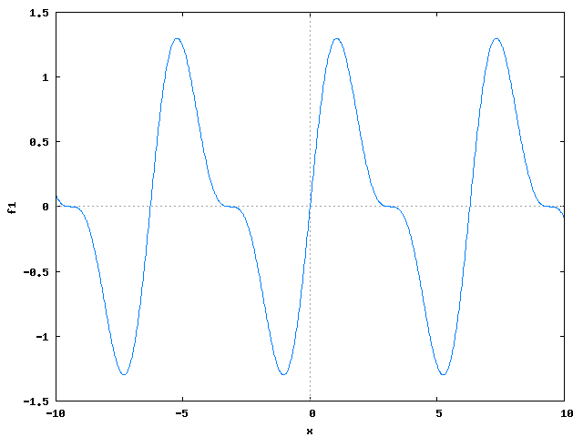
(%i56) plot2d([f2],[x,-10,10]);
(%o56)

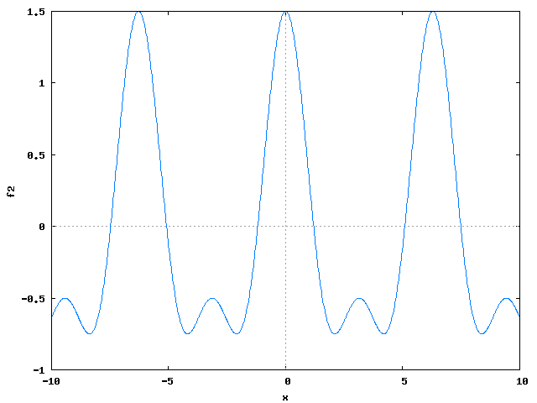

(%i57) plot2d([f3],[x,-10,10]);
(%o57)

