01A17 Babilonia, Mesopotamia
Klein continúa en la página 4:
The Babylonians were the first of these two early civilizations [Babylonians and Egyptians] to contribute to the main course of mathematics.
Klein, Morris: Mathematical thought from ancient to modern times, I.2 “Political History in Mesopotamia”, p. 4
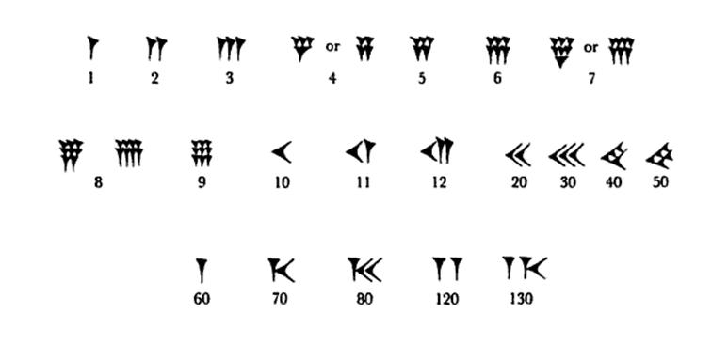
Página 7:
