97C40 Inteligencia y aptitudes

Dyscalculia

Dyscalculia: From Brain to Education
De: http://www.sciencemag.org/content/332/6033/1049.full
Science 27 May 2011:
Vol. 332 no. 6033 pp. 1049-1053
DOI: 10.1126/science.1201536
Review
- Brian Butterworth1,*,
- Sashank Varma2, and
- Diana Laurillard3

Abstract
Recent research in cognitive and developmental neuroscience is providing a new approach to the understanding of dyscalculia that emphasizes a core deficit in understanding sets and their numerosities, which is fundamental to all aspects of elementary school mathematics. The neural bases of numerosity processing have been investigated in structural and functional neuroimaging studies of adults and children, and neural markers of its impairment in dyscalculia have been identified. New interventions to strengthen numerosity processing, including adaptive software, promise effective evidence-based education for dyscalculic learners.
[...]

What Is Dyscalculia?
Recent neurobehavioral and genetic research suggests that dyscalculia is a coherent syndrome that reflects a single core deficit. Although the literature is riddled with different terminologies, all seem to refer to the existence of a severe disability in learning arithmetic. The disability can be highly selective, affecting learners with normal intelligence and normal working memory (11), although it co-occurs with other developmental disorders, including reading disorders (5) and attention deficit hyperactivity disorder (ADHD) (12) more often than would be expected by chance. There are high-functioning adults who are severely dyscalculic but very good at geometry, using statistics packages, and doing degree-level computer programming (13).
[…]
Converging evidence of dyscalculia as a distinct deficit comes from studies of impairments in the mental and neural representation of fingers. It has been known for many years that fingers are used in acquiring arithmetical competence (21).
[…]
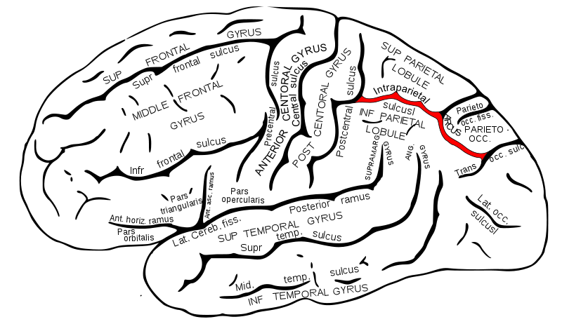
De http://en.wikipedia.org/wiki/File:Gray726_intraparietal_sulcus.svg

What Do We Know About the Brain and Mathematics?
The neural basis of arithmetical abilities in the parietal lobes, which is separate from language and domain-general cognitive capacities, has been broadly understood for nearly 100 years from research on neurological patients (24). One particularly interesting finding is that arithmetical concepts and laws can be preserved even when facts have been lost (25), and conversely, facts can be preserved even when an understanding of concepts and laws has been lost (26).

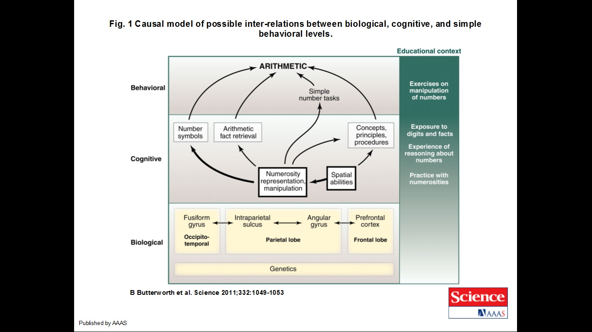

[Véanse las referencias, y el estado de la comprensión de las habilidades mentales para las matemáticas.]

Prodigios matemáticos

Nat Neurosci. 2001 Jan;4(1):103-7.

Mental calculation in a prodigy is sustained by right prefrontal and medial temporal areas.
Pesenti M, Zago L, Crivello F, Mellet E, Samson D, Duroux B, Seron X, Mazoyer B, Tzourio-Mazoyer N.
Source
Unité de Neuropsychologie Cognitive, Université Catholique de Louvain, place Mercier 10, 1348 Louvain-la-Neuve, Belgium.
Abstract
Calculating prodigies are individuals who are exceptional at quickly and accurately solving complex mental calculations. With positron emission tomography (PET), we investigated the neural bases of the cognitive abilities of an expert calculator and a group of non-experts, contrasting complex mental calculation to memory retrieval of arithmetic facts. We demonstrated that calculation expertise was not due to increased activity of processes that exist in non-experts; rather, the expert and the non-experts used different brain areas for calculation. We found that the expert could switch between short-term effort-requiring storage strategies and highly efficient episodic memory encoding and retrieval, a process that was sustained by right prefrontal and medial temporal areas.

