Intermediate R Workshop

Reproducible Workflow

Jaime Hsu, Department of Sociology, UT Austin

2025-03-25

Table 1: Descriptive Statistics by Gender-Relational Contexts

|  | **Full Sample** | **By Family Types** | | | |
| --- | --- | --- | --- | --- | --- |
| **Variables** | **N = 830**1 | **Man w/Man**  N = 2461 | **Man w/Wom**  N = 1221 | **Wom w/Man**  N = 1221 | **Wom w/Wom**  N = 3401 |
| Depressive Symptoms | 17.14 (5.39) | 16.72 (5.33) | 16.95 (5.27) | 18.02 (5.48) | 17.19 (5.43) |
| Spousal Support | 3.86 (0.82) | 3.86 (0.78) | 3.65 (0.84) | 3.62 (0.88) | 4.01 (0.78) |
| Respodent's Gender |  |  |  |  |  |
| Female | 462 (56%) | 0 (0%) | 0 (0%) | 122 (100%) | 340 (100%) |
| Male | 368 (44%) | 246 (100%) | 122 (100%) | 0 (0%) | 0 (0%) |
| Partner's Gender |  |  |  |  |  |
| Female | 462 (56%) | 0 (0%) | 122 (100%) | 0 (0%) | 340 (100%) |
| Male | 368 (44%) | 246 (100%) | 0 (0%) | 122 (100%) | 0 (0%) |
| Years Lived Together | 15.27 (8.17) | 16.21 (7.69) | 16.36 (8.79) | 16.36 (8.79) | 13.80 (7.86) |
| Respndent's Age | 48.55 (8.39) | 49.83 (8.24) | 46.88 (8.25) | 45.34 (7.78) | 49.36 (8.39) |
| Race |  |  |  |  |  |
| nh white | 719 (87%) | 214 (87%) | 102 (84%) | 100 (82%) | 303 (89%) |
| non-white | 111 (13%) | 32 (13%) | 20 (16%) | 22 (18%) | 37 (11%) |
| College and Above |  |  |  |  |  |
| college and less | 404 (49%) | 123 (50%) | 77 (63%) | 63 (52%) | 141 (41%) |
| postgrad | 426 (51%) | 123 (50%) | 45 (37%) | 59 (48%) | 199 (59%) |
| Household Income |  |  |  |  |  |
| $1-$24,999 | 12 (1.4%) | 0 (0%) | 5 (4.1%) | 5 (4.1%) | 2 (0.6%) |
| $25,000-$49,999 | 44 (5.3%) | 6 (2.4%) | 11 (9.0%) | 11 (9.0%) | 16 (4.7%) |
| $50,000-$74,999 | 96 (12%) | 12 (4.9%) | 20 (16%) | 20 (16%) | 44 (13%) |
| $75,000-$99,999 | 142 (17%) | 28 (11%) | 33 (27%) | 33 (27%) | 48 (14%) |
| $100,000-$149,999 | 220 (27%) | 52 (21%) | 28 (23%) | 28 (23%) | 112 (33%) |
| $150,000 or more | 316 (38%) | 148 (60%) | 25 (20%) | 25 (20%) | 118 (35%) |
| Having Kids under 18 |  |  |  |  |  |
| None/older child | 518 (62%) | 216 (88%) | 44 (36%) | 43 (35%) | 215 (63%) |
| Child age 18 and under | 312 (38%) | 30 (12%) | 78 (64%) | 79 (65%) | 125 (37%) |
| 1N (Percentage in Parentheses) | | | | | |
| Data from HARP T1 | | | | | |

## `geom_smooth()` using formula = 'y ~ x'

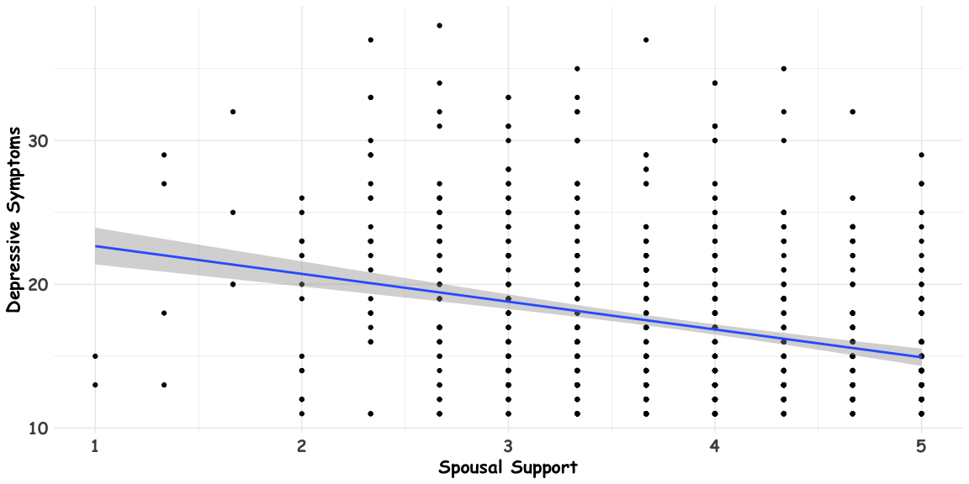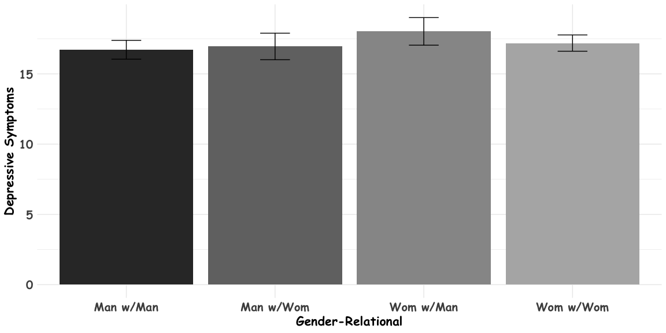

## aic bic r2.conditional r2.marginal icc rmse nobs  
## 1 5068.237 5120.172 0.2686324 0.111638 0.1767234 4.233286 830

Mixed-Effects Models on Dep. Symptoms

|  | DS 1 | DS 2 |
| --- | --- | --- |
| Spousal Support | -1.85*** | -1.74*** |
|  | (0.22) | (0.42) |
| Man w/Wom (Ref = M/M) | -0.47 | 0.95 |
|  | (0.59) | (2.62) |
| Wom w/Man | 0.66 | 2.34 |
|  | (0.59) | (2.55) |
| Wom w/Wom | 0.87+ | 0.50 |
|  | (0.47) | (2.21) |
| Spousal Support x MW |  | -0.38 |
|  |  | (0.69) |
| Spousal Support x WM |  | -0.46 |
|  |  | (0.67) |
| Spousal Support x WW |  | 0.09 |
|  |  | (0.55) |
| Age | -0.03 | -0.03 |
|  | (0.03) | (0.03) |
| Rel. Duration (Year) | -0.01 | -0.01 |
|  | (0.03) | (0.03) |
| non-White (Ref = White) | 0.89+ | 0.93+ |
|  | (0.53) | (0.53) |
| >College (Ref = College or Less) | -1.55*** | -1.54*** |
|  | (0.36) | (0.36) |
| N | 830 | 830 |
| AIC | 5,068 | 5,071 |
| BIC | 5,120 | 5,137 |
| Cond. R-Squared | 0.27 | 0.27 |
| + p < 0.1, * p < 0.05, ** p < 0.01, *** p < 0.001 | | |
| Data from HARP 2015 | | |

## x predicted std.error conf.low conf.high group  
## 1 1.000000 22.39428 1.2751208 19.89137 24.89718 Man w/Man  
## 2 1.000000 22.95787 1.5028904 20.00789 25.90786 Man w/Wom  
## 3 1.000000 24.27955 1.4443855 21.44441 27.11470 Wom w/Man  
## 4 1.000000 22.98364 1.1267133 20.77204 25.19523 Wom w/Wom  
## 5 1.333333 21.81354 1.1419488 19.57203 24.05504 Man w/Man  
## 6 1.333333 22.24983 1.3337954 19.63176 24.86791 Man w/Wom  
## 7 1.333333 23.54610 1.2849038 21.02400 26.06821 Wom w/Man  
## 8 1.333333 22.43291 1.0165001 20.43765 24.42818 Wom w/Wom  
## 9 1.666667 21.23279 1.0109927 19.24834 23.21725 Man w/Man  
## 10 1.666667 21.54179 1.1680467 19.24906 23.83452 Man w/Wom  
## 11 1.666667 22.81265 1.1291381 20.59630 25.02901 Wom w/Man  
## 12 1.666667 21.88219 0.9081538 20.09960 23.66479 Wom w/Wom  
## 13 2.000000 20.65205 0.8832388 18.91837 22.38574 Man w/Man  
## 14 2.000000 20.83375 1.0072971 18.85656 22.81095 Man w/Wom  
## 15 2.000000 22.07920 0.9788638 20.15781 24.00059 Wom w/Man  
## 16 2.000000 21.33147 0.8024310 19.75640 22.90654 Wom w/Wom  
## 17 2.333333 20.07131 0.7603029 18.57893 21.56369 Man w/Man  
## 18 2.333333 20.12572 0.8543735 18.44869 21.80274 Man w/Wom  
## 19 2.333333 21.34575 0.8370441 19.70274 22.98876 Wom w/Man  
## 20 2.333333 20.78075 0.7005206 19.40571 22.15578 Wom w/Wom  
## 21 2.666667 19.49057 0.6449460 18.22462 20.75652 Man w/Man  
## 22 2.666667 19.41768 0.7143194 18.01556 20.81980 Man w/Wom  
## 23 2.666667 20.61230 0.7087720 19.22107 22.00353 Wom w/Man  
## 24 2.666667 20.23003 0.6043541 19.04376 21.41630 Wom w/Wom  
## 25 3.000000 18.90983 0.5420292 17.84590 19.97377 Man w/Man  
## 26 3.000000 18.70964 0.5962738 17.53922 19.88005 Man w/Wom  
## 27 3.000000 19.87885 0.6027600 18.69571 21.06199 Wom w/Man  
## 28 3.000000 19.67931 0.5171460 18.66421 20.69440 Wom w/Wom  
## 29 3.333333 18.32909 0.4599795 17.42621 19.23197 Man w/Man  
## 30 3.333333 18.00160 0.5155817 16.98957 19.01362 Man w/Wom  
## 31 3.333333 19.14540 0.5324735 18.10022 20.19058 Wom w/Man  
## 32 3.333333 19.12858 0.4442042 18.25667 20.00050 Wom w/Wom  
## 33 3.666667 17.74835 0.4114751 16.94067 18.55602 Man w/Man  
## 34 3.666667 17.29356 0.4910177 16.32975 18.25736 Man w/Wom  
## 35 3.666667 18.41195 0.5128188 17.40535 19.41855 Wom w/Man  
## 36 3.666667 18.57786 0.3935430 17.80539 19.35034 Wom w/Wom  
## 37 4.000000 17.16761 0.4086414 16.36550 17.96972 Man w/Man  
## 38 4.000000 16.58552 0.5304378 15.54433 17.62670 Man w/Wom  
## 39 4.000000 17.67850 0.5492585 16.60037 18.75662 Wom w/Man  
## 40 4.000000 18.02714 0.3743209 17.29240 18.76189 Wom w/Wom  
## 41 4.333333 16.58687 0.4523373 15.69899 17.47475 Man w/Man  
## 42 4.333333 15.87748 0.6217893 14.65698 17.09797 Man w/Wom  
## 43 4.333333 16.94505 0.6321656 15.70418 18.18591 Wom w/Man  
## 44 4.333333 17.47642 0.3912000 16.70854 18.24430 Wom w/Wom  
## 45 4.666667 16.00613 0.5312018 14.96344 17.04881 Man w/Man  
## 46 4.666667 15.16944 0.7462381 13.70467 16.63421 Man w/Wom  
## 47 4.666667 16.21160 0.7462093 14.74688 17.67631 Wom w/Man  
## 48 4.666667 16.92570 0.4400455 16.06194 17.78945 Wom w/Wom  
## 49 5.000000 15.42539 0.6322081 14.18444 16.66633 Man w/Man  
## 50 5.000000 14.46140 0.8900072 12.71443 16.20837 Man w/Wom  
## 51 5.000000 15.47815 0.8793579 13.75208 17.20422 Wom w/Man  
## 52 5.000000 16.37498 0.5117851 15.37041 17.37955 Wom w/Wom

